Prototype
Highlighted features within the flow diagram are the features which will be included in the prototype.

Start
Load Form
Log in screen
Forgotten Password
Back to log in
Menu
Invoices
Payroll
Pupil Details
Tutor Details
Bookings
Reports
Add New report
View/Edit Reports reports
Add New Invoice
Search/edit Invoice
Add New Payroll
Search/edit Payroll
Print Invoice
Print Payslip
Log in confirm
Add New Pupil
Search/edit Details
Search/edit Details
Book new lesson
View/edit bookings
Log in confirm
Log in confirm
Log in confirm
Log in confirm
Add New Tutor
Back to log in

Reasons for selecting these features
Log in Screen – This is the opening menu, which all staff will see when first opening up the system. I would like to involve this menu in the prototype, so all staff know what to expect when opening the system. The log in screen will allow staff to create an account, select a feature to retrieve their forgotten password and access the main system, (depending if the user is tutor or admin). This will also allow the user to see the transition between different forms.
Add new Tutors Form – This form allows the user to save all personal details and to create log in details so the user can log into the system. This is useful to include in the prototype as it can show the users what details will be saved on them and the process involved into creating a new account.
Sub menu’s (Bookings, Pupils, Tutors and Reports) – These sub menus will show the user how they’re transferred between different form and what each form will give them access too. Each form has different functions, and this will provide the user with the right idea of what functions will be available in the system.
Add new report Form – This will allow the user to test how more efficient creating reports on children using the software rather than using paper. It can also show the user what information is stored and we can get feedback from the user to see if they’d rather more or less data stored on the reports.
Book new lesson form – Booking lessons is a difficult process but crucial to employees pay and the earnings for the company. This is why it’s crucial to involve bookings in the prototype to see what the user would like to be added and what to be changed for the final system. This will also show the user what data is stored for booking lessons.
View/Edit bookings form – For the same reasons as the booking lessons form, bookings is very crucial to the general process of the company. So, editing and viewing booked lessons can be crucial to check for overlap in lessons/lessons cancelled. How the lessons are displayed can be important to the user so its important that I gain feedback on how the lessons are displayed.
Add Pupils form – Pupils details such as contact details, name and what subject they want to be tutored in is vital information for the company. This is why I think it’ll be best for the user to see what data is stored on Pupils, and what data should be added.
Search/edit tutor/pupil details Forms: These forms will allow the user to view Pupils and tutors’ details. It will also allow the user to edit data on pupils and tutors. This is important for changed contact details, as well as changing passwords/usernames. This data is very important, and I believe it is important for the user to see how the data is processed.
I have not included the forms payroll and invoices as this is only used by admins, the other functions will be used by all employees so I would prefer feedback on the functions which are used more frequently. Payroll and invoices are only used once a month. Furthermore, the way the data is stored and accessed will be very similar to how bookings will be stored and searched for. Moreover, the business is already familiar to the process of payrolls and invoices and will most likely prefer the system to not change much about how they already process payrolls and invoices. Another form which wont be used is the forgotten password form this wont be used as the prototype wont be requiring the use to be logging into the system so there is no use for it.

Solution of Prototype
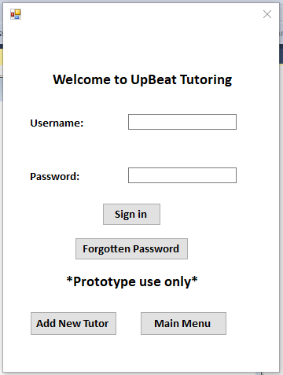
Log in form:

The first form shown to the user is a log in form. From this log in form you can transfer to admin meu, tutor menu and add a new tutor. It requires a username and password and depending on the log in details after clicking sign in it will transfer you to a menu.
In the prototype version the sign in button and forgotten password button is not available. If they’re clicked it will display the message “Under construction – not available for prototype”.
Add a new tutor button will transfer the user to the add new tutor form.
Main menu button will transfer the user to the admin menu form.
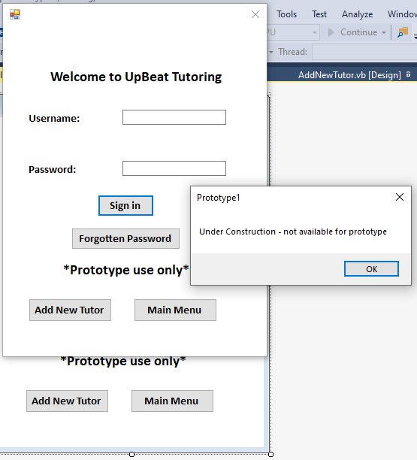

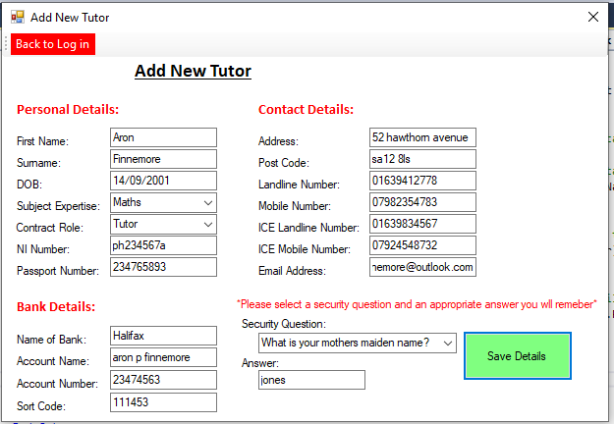
Add New Tutor
This form allows the user to add a new tutor. It requires the user to add their personal details, bank details and contact information. All of this data is used in payroll and bookings. This form also requires the user to add a security question and add an answer, this is a security feature in case the user forgets their username and password.
Once the save button is clicked all data is saved to contact details, tutor details and passwords databases.
When the save button is clicked and all data entered is entered correctly, the save button will output: “Data has been saved” then “Username - ####” and “Password - ####”.
If data is inputted incorrectly, when the save button is clicked it will output an error message telling the user what data needs to be corrected.
The back to log in button allows the user to transfer back to the log in screen.
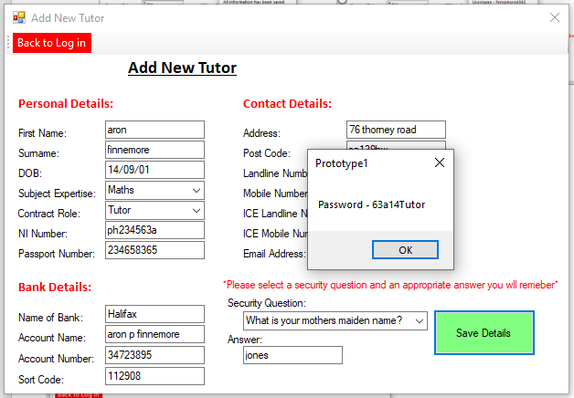
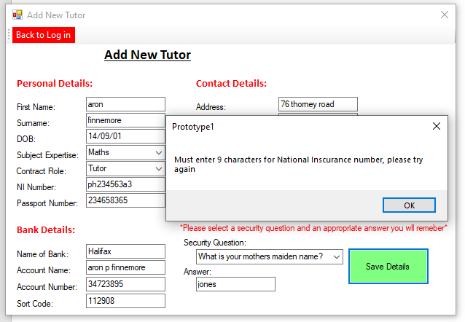
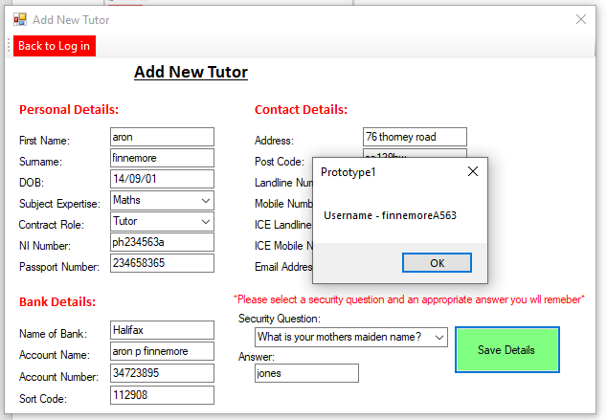
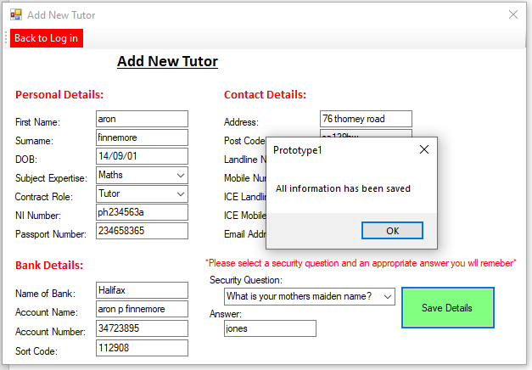

Admins Menu form
The admins menu is the main menu the admin will see after logging in. It will provide full access to pupil details, tutor details, bookings, payroll, invoices and reports.
Each button on the form transfers to a sub menu on that particular subject. This provides easy access to different sections of the system with clear labels to prevent any confusion.
Payroll and invoices buttons when click output “Under construction – not available for prototype “.
There is also another button which allows the user to return back to the log in page.
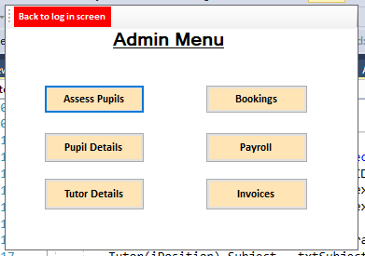
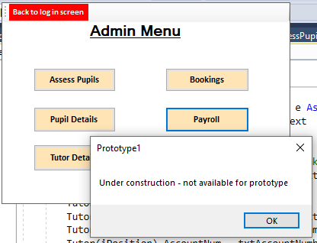

Pupils Menu
This is a sub menu accessed from the admins menu. This gives the option to the user to add a new pupil or view current pupils. The menu also allows the user to return to the admins menu.
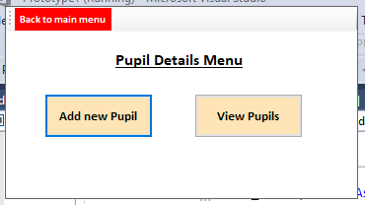

Tutor Menu
This is another sub menu which can be accessed from the admin menu. This menu allows the user to view tutors and edit tutor details. The menu also allows the user to return to the admin’s menu.

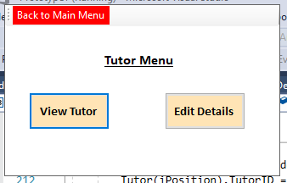
Assess Pupils menu
From the admin menu you can also access assess pupil’s menu. This is a section of the system which allows the user to add reports on lessons for individual pupils. This menu allows the admin to add new reports. The view reports button will display “currently under construction – not available for prototype” It also allows the user to return to the admin’s menu.

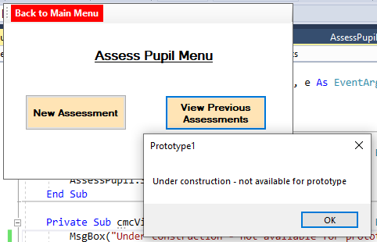
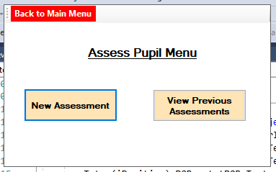

Bookings Menu
Finally, the final sub menu which can be accessed in the prototype from the admin’s menu is the bookings menu. This allows the admin to book lessons, view booked lessons and edit any bookings. This menu also allows the user to return back to the admin’s menu.
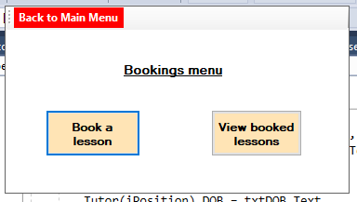

View tutor form
This form allows the user to view all tutors saved in the database. This form allows the user to enter the tutor username and then click the search button.
The search button (once clicked) will then open the tutor details database and search for the data matching the tutor username entered.
The data will then be outputted in the correct textboxes.
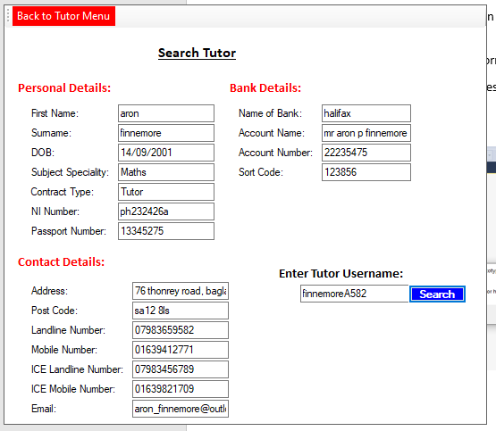
If the entered username is incorrect a message will be outputted telling the user that the tutor entered has not been found.

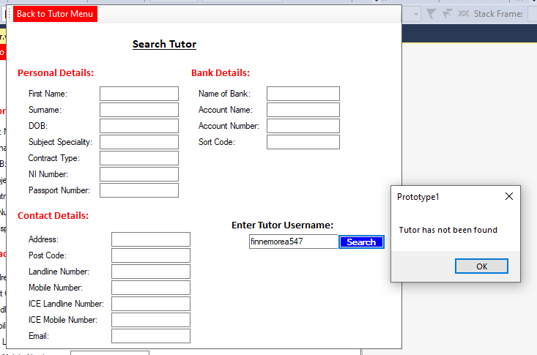

Edit tutor form
The main purpose for this form is to allow the user to edit the tutors contact details and personal details. The textboxes will simply display all data stored on the tutor and the user can then edit the data stored on that tutor and click the “Save Changes button “which will overwrite the previous data stored on that tutor. Once clicked it will also display a message “Tutor details have been changed.”
There are other features to the form. The “Next” and “Previous” button allows the user to change what tutor is displayed. The “Next button” goes to the next tutor which is saved on the database. Once it gets to the end of the database it will loop back to the first saved tutor in the database.
The “Previous” Button displays the tutor stored previously to the current tutor displayed on the form. Once it gets to the start of the database it will loop back to the end of the database displaying the last tutor stored on the data base.
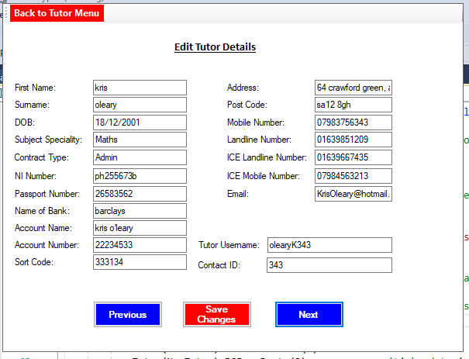
Original Data:

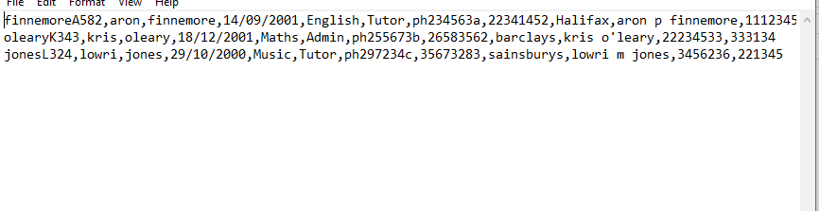

Changed Data:
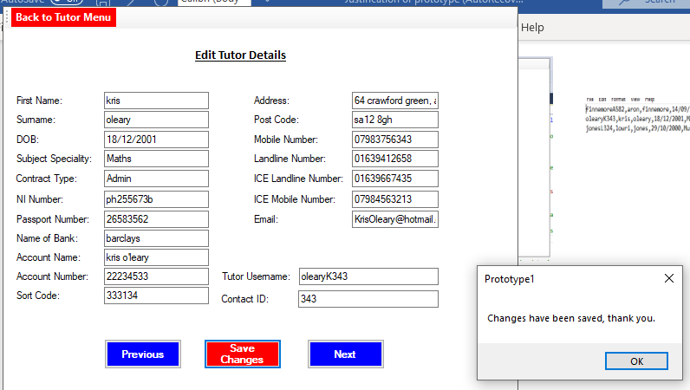

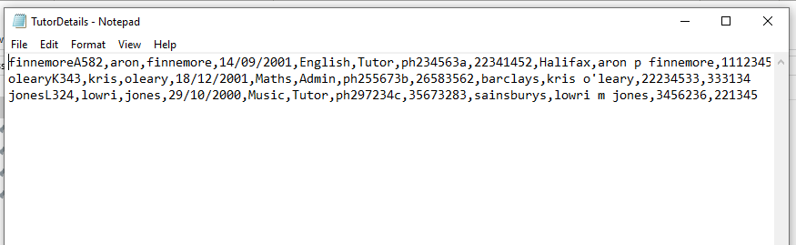

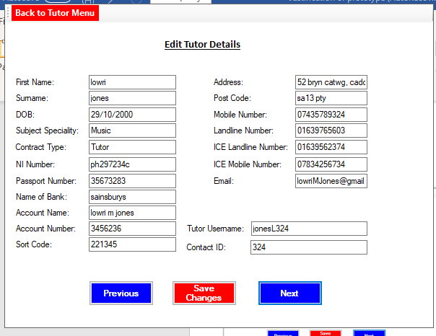
Next Button:

Previous button:

Book a Lesson form
This form allows the user to book lessons for different tutors with different pupils. The foreign keys used in this booking are PupilID and TutorID.
Once a lesson is booked it displays the booking ID in a textbox. This is a unique key which gives each lessons a unique ID so they can be easily searched for. The foreign keys are used to access personal data on the tutor and Pupil.
The data, which is required to be entered includes, date, time, duration and subject.
If the format for date is entered incorrectly the system will output a warning message informing the user, the date has been entered incorrectly. It will then not save the lesson until the date has been entered correctly.
Subject has a combo box, which provides a drop-down list to the user allowing them to select a particular subject without making a mistake.
There is presence validation on Pupillid and TutorID so if the user has not entered the ID’s the system will display a warning message indicating that they haven’t entered PupilID/TutorID.
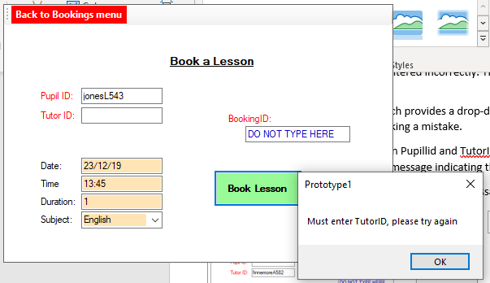
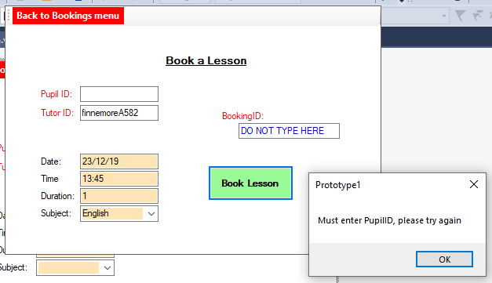
Once the data is saved the system displays a message telling the user that the lesson is booked.

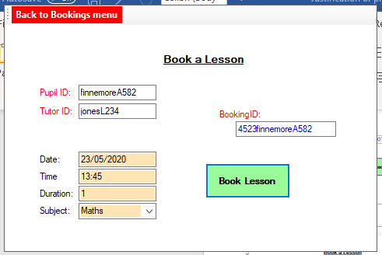
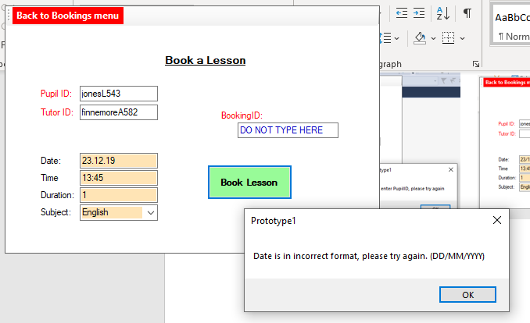
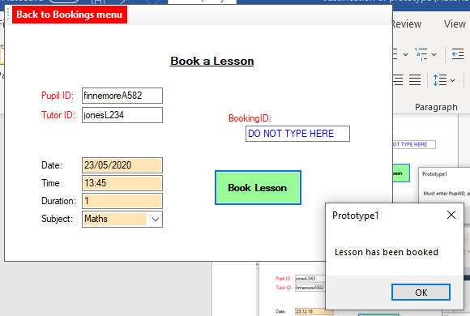

View Booked Lessons
This form allows a user to search for already booked lessons and edit any details about the lessons. The form requires the user to enter a booking id and then once the search button is clicked it will then display all the information in the correct textboxes.
If the search button is clicked without entering a booking ID the system will display a warning message saying they must enter a booking ID before clicking the search button.
Once all the data has been displayed in the textboxes the user can then edit the data in the textboxes and click the save changes button.
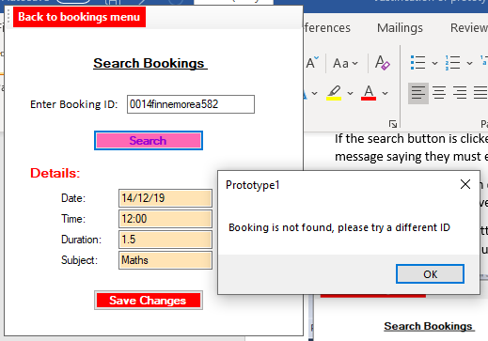
Once the save changes button is clicked it will overwrite the old data with the new data and output a message indicating to the user that the data has been changed.
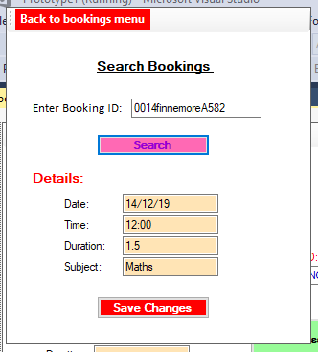

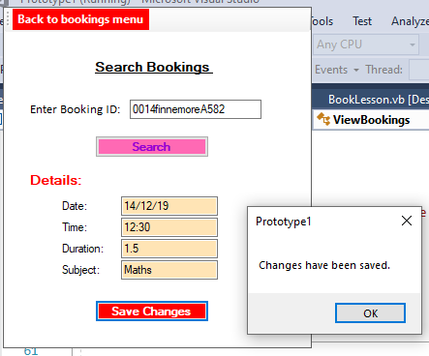

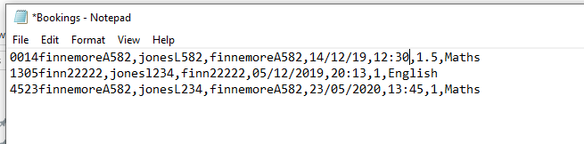

Add a Pupil Form
The purpose for this form is to add new pupils to the business storing personal details and contact details.
The information which is required to be entered by the user is, first name, surname, age, parents name, subject and medical conditions. The contact details stored are the same as the contact details stored on tutors. This includes email address, mobile number, landline number etc...
There is a presence check on the first name and surname. This means that if the user doesn’t enter the pupils first name or surname the system will stop the subroutine and display a message informing the user that the pupils first name/surname must be entered.
Another validation is on the age entered for the pupil. If the age entered is below 0 then the system will stop the subroutine from running and display a warning message stating that the age entered must not be below 0.
Finally the last validation is the character length on the mobile number entered. If the mobile number entered is below or above 11 characters this is an invalid mobile number. Therefor the system will display a warning message and prevent the subroutine from running.
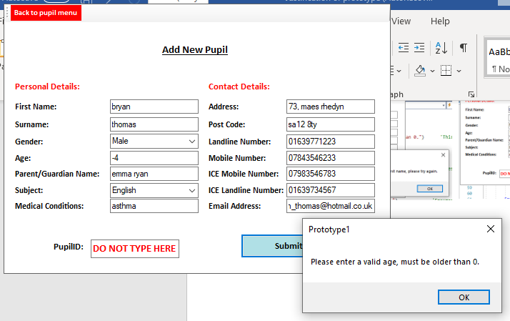
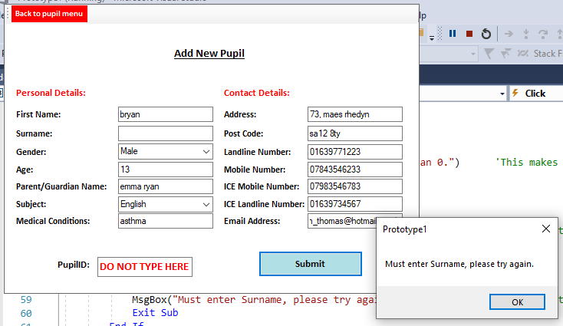
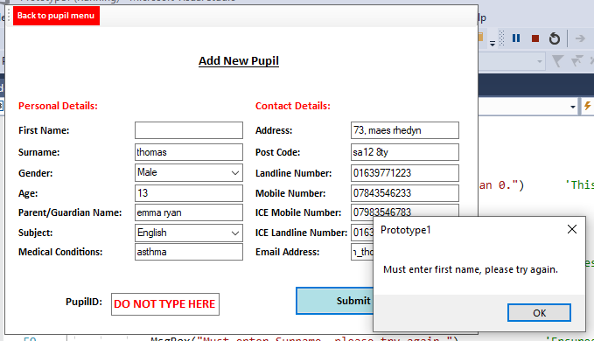
Once all data is entered correctly when the “submit” button is clicked the new data will be emended to the pupil details database. The system will also generate a unique pupil ID and will display it in the PupilID textbox. This ID is made up of the pupils last name first letter of their first name and last 3 digits of their mobile number.
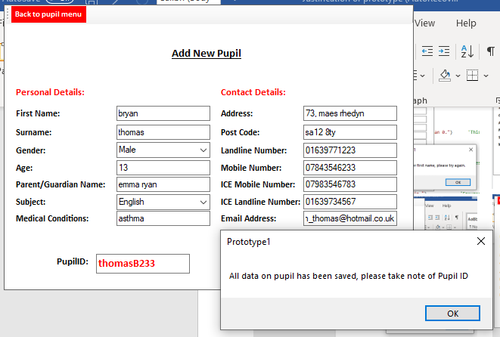
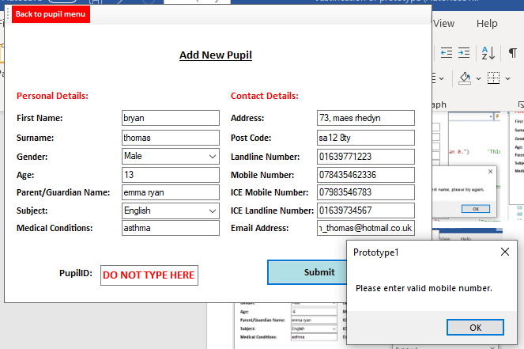

View Pupil Form
There are two purposes for this form. One of the purposes is to be able to enter a pupil ID to search for the pupil’s details. Another purpose is once the pupil is searched for the details can be edited and saved back into the database overwriting the original version of the data.
The main validation for this form is a presence check. If the search button is clicked and the PupilID isn’t entered the system will stop the subroutine from running, and display to the user that they must enter a PupilID before searching.
Once a PupilID is entered and the search button is clicked the database will then search for the correct pupil which matches the entered ID. If the pupil isn’t found the system will output a message informing the user that there is no pupil which matches the entered ID.
If the entered Pupil ID is correct once the pupil is found the data of the pupil will be displayed in the correct textboxes. The user can then edit the data in the textbox and click the save changes button which will then output “changes have been saved”. The new data will then replace the original data.
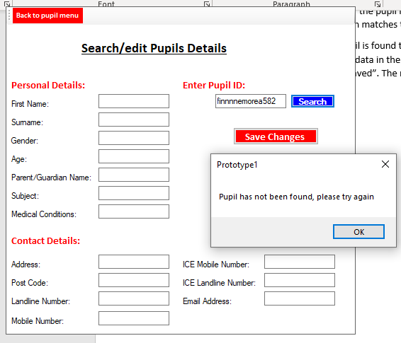
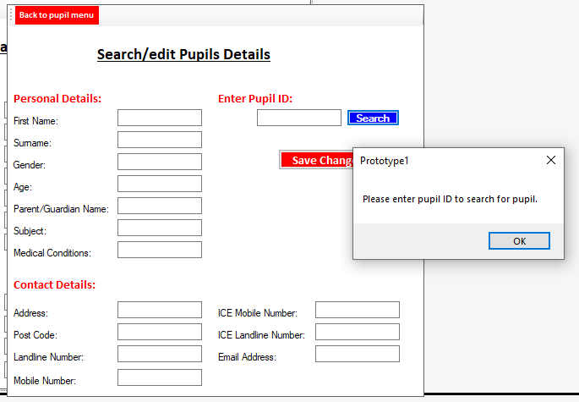

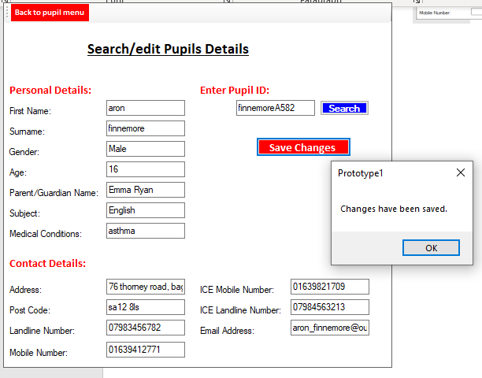
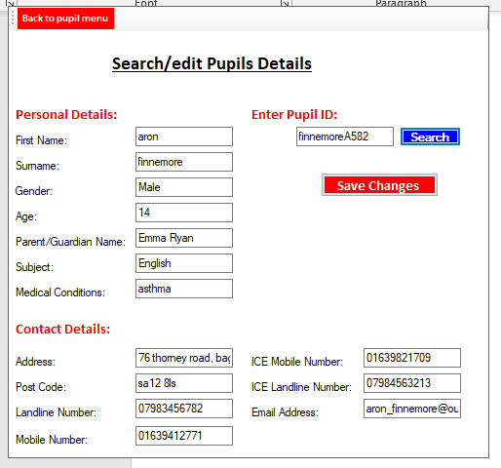

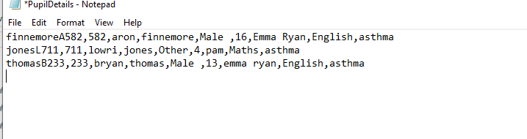

Assess Pupils form
This form allows a tutor to assess a pupil they have taught to track their progress and to record what topics have been covered in that lesson.
The data this form requires you to enter are:
- Pupil ID
- Tutor ID
- Date
- Time
- Skill 1
- Skill 2
- Skill 3
- Progress
- Additional info
The pupil ID and tutor ID are required to be entered so the report can easily be identified when being accessed.
The skill input boxes these are available so the tutor can input skills which have been covered in the lesson. Following there is a progress textbox so the tutor can make a comment on how well the pupils coped with the skills.
There is a presence check on tutor ID and Pupil ID so if the user hasn’t entered either ID’s and click save, the system will exit the subroutine and output a warning message to the user informing them they must enter a pupil/tutor ID.
Format validation is present in the date textbox, if the user enters a date which isn’t the correct format the system will output a warning message telling the user what format the date needs to be in.
There is also format validation on the time textbox to ensure the user will input the correct format. If the correct format isn’t entered the system will display a warning message.
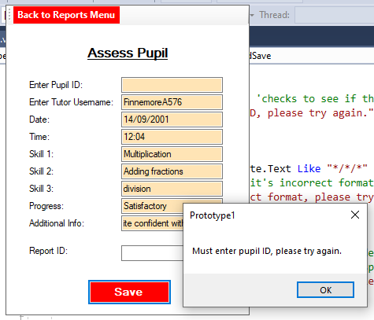
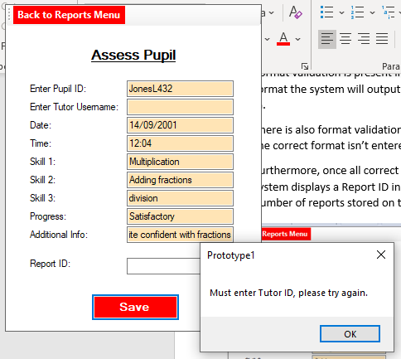
Furthermore, once all correct data is entered the data is amended to the reports database and the system displays a Report ID in the textbox. The reportID consists of the word REPORT and the total number of reports stored on the end of it. Example : “REPORT26”.
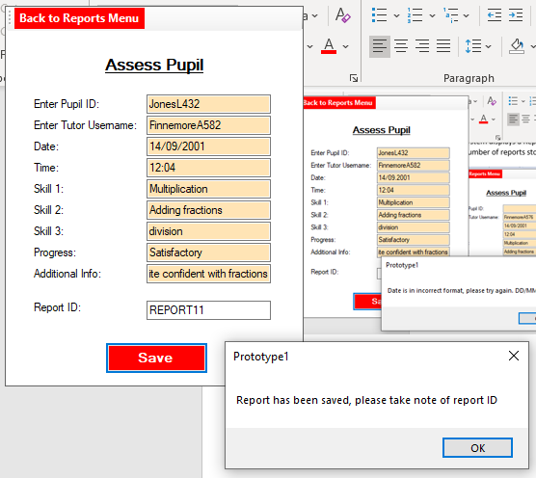
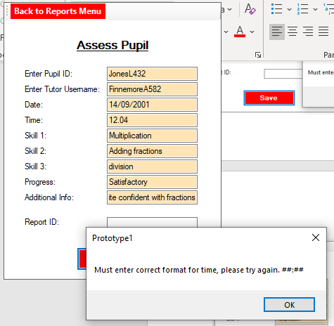
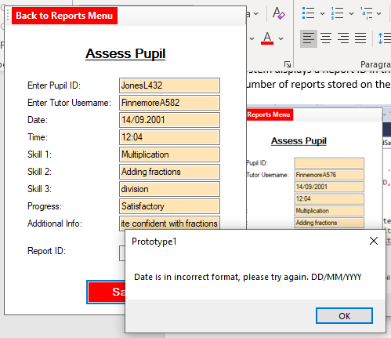

Evaluation
The main purpose for this protype was to show the basic functioning of the system. I wanted the system to show how data will be processed, stored and accessed.
After completing the prototype, I am happy with the functionality of the system. The system provides buttons to allow the user to transfer between forms with ease without any complications which enables the user to access different sections of the system. The forms flow with one another without any confusions and there are clear titles indicating to the user what form is which. There is clear validation on each form ensuring the system is robust. There is presence, length, list, format and range validation in the system which prevent the user entering incorrect data. If any incorrect data is entered the system outputs appropriate warning messages and prevents the data from being saved. There are also clear messages displayed to the user when data is saved to ensure the user that the new data has been stored.
When data is being saved the system simply amends the data to the end of a specific database. This works quite effectively in the prototype without any errors as the validation ensures the data saved is correct. The prototype makes use of primary keys and foreign keys. Unique keys are displayed to the user after the system saves specific data. The primary and foreign keys allow links between different databases. For example, Pupil ID is a foreign key in bookings database this means that the prototype enables a pupil to make multiple bookings. This allows one to many relationships between databases. This enables data to be easily searched for as it gives all data a unique id so prevents multiple data being the exactly the same.
The protype has used simple processing to search for data in their databases. Pupil data is searched for by the user entering the pupils unique ID the prototype will then use linear search to search through the pupil’s database until the pupil is found. Once the pupil is found all data is displayed in the correct textboxes. This makes the data easily visible and labelled so the user can easily view what data is stored on the pupil. If the pupil is not found the system can output a message to the user telling them that the pupil is not found. This process is similar to searching for bookings. It allows an efficient way to search for specific data, and labels all data correctly ensuring there is no confusion with the user. The prototype also allows the user to search multiple times without resetting the system over and over again.
As there isn’t as many tutors compared to pupils there is a user-friendly process for the searching through the tutor details database. On the form there is a next and previous button which allows the user to scroll through each tutor. The system processes this correctly displaying the next tutor in the correct textboxes when the next button is clicked and displays the correct tutor in the textboxes when the previous button is clicked. To make the system more robust the next button loops back to the beginning of the database when the system reaches the end of the database. The previous button also loops to the end of the database when it gets to the beginning of the database. This prevents any errors in the system.
Another function in the system which works effectively is that the prototype allows the user to edit pupils, tutor and bookings data. As the data is displayed in textboxes when the data is search for this allows the user to click on textboxes and rewrite the data in the textbox. Once the save changes button is clicked the new data will be overwritten with the old data in the textboxes. This works efficiently and displays a message informing the user that the data has been changed. This allows the user to edit any data which has been entered incorrectly.
The design of the prototype has clear labels and buttons with textboxes and combo boxes ensure the user is user friendly, the textboxes and buttons have different colours depending on their functions. This again reduces the amount of confusion the user could have using the system. The clear buttons and large font ensure that all instructions are presented clearly to the user.
As well as the advantages of the prototype there are improvements which need to be made in the final system. A big issue with the prototype is that when the system is searching for data it requires the user to enter the data’s unique ID. Even though this doesn’t seem like a problem it does require the user to remember a lot of unique ID’s and once more and more data is stored on the system it requires the user to most likely remembers thousands of unique ID’s. A simple solution to this is to instead to require the user to enter a more memorable data and from that data the system will search for its unique key to access all the other data. For example, instead of entering a pupils ID it would require the user to enter a pupils name which is more memorable.
Another issue I have come across in the prototype is that the contact details is not normalised. I have built the system so that it has a one to one relationship with tutor/pupil details when it should have a one to many relationships. An improvement will be requiring the user to enter the contact details on a separate form. On that form the user will select what contact type they would like to enter and then the contact details. This will then be stored with a unique primary key and the pupil/tutor ID as a foreign key. This will then allow the user to enter multiple contact details for the pupils/tutors. Searching/editing the contact details will also have to be on a separate form. It will be searched by the user entering the pupils/tutors name the system will then search for the pupils/tutors unique ID. Once the unique ID is found the system will search through the contact details database and find the foreign key which matches the pupil/tutor unique ID. Once that is found the data will then be outputted to the user.
Other small improvements can be combo boxes for the data time to prevent further errors. Also make better use of radio buttons/ checkboxes I would also like the system to use pictures on the forms. This would limit the use of textboxes and limit the amount the user has to type in. This ensures the system to be more robust and prevents further error.
Another improvement which can be useful in the new system is using a sorting algorithm. More specifically it could be useful to use a bubble sort algorithm when on the search tutor form. This means that the tutors will be displayed in alphabetical order. This will make the system more user friendly as it won’t be displaying tutors in a random order.
All improvements will be used in the new system. Furthermore, all good aspects of the prototype will also be used in the new system.

