Post Prototype refinement
After my personal evaluation of the prototype I emailed the head of Upbeat Tutoring asking for feedback on the prototype and sent the prototype to her via email.
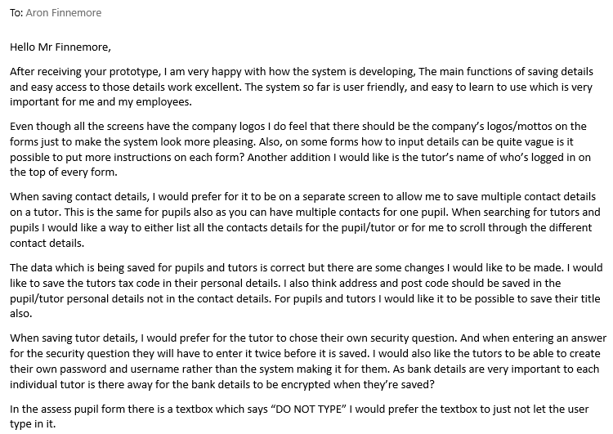
Received Feedback:
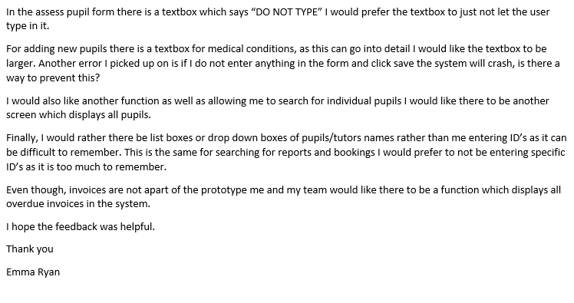

Copy of Email:
Hello Mr Finnemore,
After receiving your prototype, I am very happy with how the system is developing, The main functions of saving details and easy access to those details work excellent. The system so far is user friendly, and easy to learn to use which is very important for me and my employees.
Even though all the screens have the company logos I do feel that there should be the company’s logos/mottos on the forms just to make the system look more pleasing. Also, on some forms how to input details can be quite vague is it possible to put more instructions on each form? Another addition I would like is the tutor’s name of who’s logged in on the top of every form.
When saving contact details, I would prefer for it to be on a separate screen to allow me to save multiple contact details on a tutor. This is the same for pupils also as you can have multiple contacts for one pupil. When searching for tutors and pupils I would like a way to either list all the contacts details for the pupil/tutor or for me to scroll through the different contact details.
The data which is being saved for pupils and tutors is correct but there are some changes I would like to be made. I would like to save the tutors tax code in their personal details. I also think address and post code should be saved in the pupil/tutor personal details not in the contact details. For pupils and tutors I would like it to be possible to save their title also.
When saving tutor details, I would prefer for the tutor to choose their own security question. And when entering an answer for the security question they will have to enter it twice before it is saved. I would also like the tutors to be able to create their own password and username rather than the system making it for them. As bank details are very important to each individual tutor is there away for the bank details to be encrypted when they’re saved?
In the assess pupil form there is a textbox which says “DO NOT TYPE” I would prefer the textbox to just not let the user type in it.
For adding new pupils there is a textbox for medical conditions, as this can go into detail I would like the textbox to be larger. Another error I picked up on is if I do not enter anything in the form and click save the system will crash, is there a way to prevent this?
I would also like another function as well as allowing me to search for individual pupils I would like there to be another screen which displays all pupils.
Finally, I would rather there be list boxes or drop down boxes of pupils/tutors names rather than me entering ID’s as it can be difficult to remember. This is the same for searching for reports and bookings I would prefer to not be entering specific ID’s as it is too much to remember.
Even though, invoices are not apart of the prototype me and my team would like there to be a function which displays all overdue invoices in the system.
I hope the feedback was helpful.
Thank you
Emma Ryan
Changes/Additions to initial Design
After my own evaluation and my third-party feedback, I have changes to be made in the initial design document and some additions to be made also.
Changes =
Changes have been made to the system flow diagram.
Load Form
Log in screen
Forgotten Password
Back to log in
Menu
Invoices
Payroll
Pupil Details
Tutor Details
Bookings
Reports
Add New report
View/Edit Reports reports
Add New Invoice
Search/edit Invoice
Add New Payroll
Search/edit Payroll
Print Invoice
Print Payslip
Log in confirm
Add New Pupil
Search/edit Details
Search/edit Details
Book new lesson
View/edit bookings
Log in confirm
Log in confirm
Log in confirm
Log in confirm
Add New Tutor
Back to log in
Start
Overdue invoice form
Add Contact Details
Create log in details
Add Contact Details
Add Contact Details

Description of additional forms:

- Add contact details – this form is a separate form to adding pupils/tutors personal details as it can add multiple contacts for one pupil/tutor.
- Create log in Details – This form allows the user to create a username and password. Also, it allows the user too add security questions in case the user forgets their password.
- Overdue invoices form – This will display a list of all invoices which are overdue and need to be paid.

From the feedback I have decided to make some changes to the pupils, tutors, invoices and contacts details data structure tables.
Contact Details data structure table:
File description – This file holds all relevant contact details on pupils AND tutors/employees. These contact details are for emergencies, enquiries or any relevant information from the pupils or tutors. The contact details could consist of mobile, email, landline etc….
File Capacity – Number of items stored will increase as pupils and tutors can have more than one type of contact.
File Access – File access will be serial access so data can be searched through and edited. Data can also be loaded into an array which has random access.
Key - ** = Foreign Key
Field Name | Primary Key | Data Type | Size | Validation
ContactID | Yes | Integer | 9 | Presence check Example:  If ContactID = “” then print “Error”
TutorID** | No | Integer | 9
PupilID** | No | Integer | 9
Contact Type | No | String | 15 | List check  Example: if contact type <> “mobile” or “Landline” or “email” output “Incorrect contact type”
Contact Data | No | String | 50 | Contact data must match with contact type. For example if “mobile” is selected for contact type then the contact data must be 11 characters long.
Pupil Details Data Structure
File description – This file will store all data related to the pupils who are registered with Upbeat Tutoring. These details would include, name, dob, address...
File capacity – The number of items in this file could increase as additional pupils will join.
Field Name | Primary Key | Data Type | Size | Validation
PupilID | Yes | Integer | 9 | Presence check. Example:  If PupilID = “” then print ”Error”
Title | No | String | 4
First Name | No | String | 25
Surname | No | String | 25
Gender | No | String | 6 | List check example:  If <> “M” or “F” or “Other” print “Error”
Age | No | Integer | 3 | Range Check  Example:  If Age< 0 then print “Error”
Parent/Guardian Name | No | String | 25
Subject | No | String | 10 | List check example:  Subject = “Maths” or “English” or “Science”
Address | No | String | 50
Town | No | String | 25
Post Code | No | String | 8
Medical Conditions | No | String | 100
File access – This file will be accessed serially so the user can search through the details using certain criteria to find the pupils details. As the file access is serial this also allows the pupils details to be edited if needed. Data can be loaded into an array which has random access.

Tutor Details Data Structure
File description – This file holds individual employee details. These details would include bank details, personal information, and any other useful information.
File capacity – The number of items in the file is most likely to increase. Due to new employees.
File access – This file will be serially accessed this will allow the user to search for details and edit details. Data can be loaded into an array which can be random access.
Field Name | Primary Key | Data Type | Size | Validation
TutorID | Yes | Integer | 9 | Presence check example:  If TutorID = “” then print “Error”
Title | No | String | 4
First Name | No | String | 25
Surname | No | String | 25
DOB | No | String | 10 | Format check Example:  Correct like */*/*  If dob <> correct then print “Error”
Address | No | String | 50
Town | No | String | 25
Post Code | No | String | 8
Contract Type | No | String | 10 | List check  Example:  contract = “Admin” or “Tutor”…
National Insurance Number | No | String | 9
Passport Number | No | String | 9
Name of bank | No | String | 25
Name on bank card | No | String | 50
Account Number | No | String | 9 | Presence check Example:  If Account = “” then print “Error”
Sort Code | No | String | 6 | Presence check Example:  If Sort = “” then print “Error”
Tax Code | No | String | 4

Invoice Details Data Structure
File description – This file will store all details on pupils, including what lessons have been booked with pupils, rate of pay for lessons and how many lessons a specific pupil has had in a month. The purpose of this is to use this data to calculate the amount due to be paid by pupils/parents to the company.
File capacity – The number of items stored will increase due to new invoices every month and additional pupils.
File Access – This file will be serial access, and data can be loaded into arrays which are random access so specific data can be searched/ edited for.
Key - ** = Foreign Key
Field Name | Primary Key | Data Type | Size | Validation
Invoice ID | Yes | Integer | 9 | Presence check Example:  If InvoiceID = “” then print “Error”
Pupil ID** | No | Integer | 9 | Presence check Example:  If PupilID = “” then print “Error”
Date Issued | No | String | 10 | Format check  Example:  Correct = like */*/* if correct = False then print”Error”
Lesson Dates | No | String | 10
Number of hours | No | Real | 6
Completed invoices | No | Boolean | 1
Unit price | No | Real | 6
Total Amount | No | Real | 7 | Range check  Example:  If amount < 0.00 then print “Error”

Changes to form designs
There are certain design changes I will be doing to the form designs when developing the system. After considering feedback I have decided to add company logos/mottos on all the forms. I would also like every form to display the tutors name (whose logged into the system) at the top of every form. One more addition to every form would be instructions for certain inputs. They would click this button and it will display a set of instructions for that input. This help button would look like this:
?

New forms:

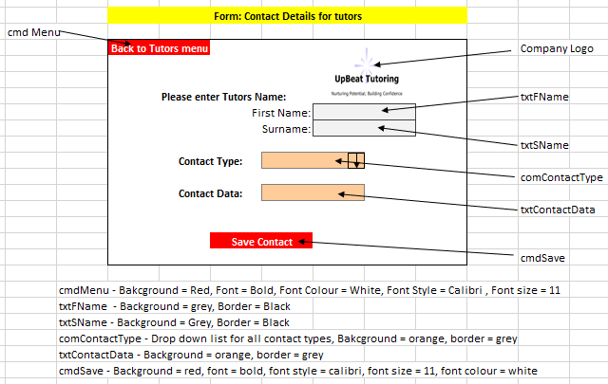
Contact Details form for tutors

Algorithm:
Count = 0 ContactID = “” TutorID = “”
If Save button is clicked:
If txtFName and SName = “” then output “Must enter first name and surname to add a contact” exit sub
Open Tutor Details Database
Loop through database to find correct tutor entered then retrieve tutorID and store in tutor ID Variable
Open Contact Details Database
For I in range 0 to end of contact details database
Count = Count + 1
End Loop
ContactID = Contact & Count
Ammend ContactID, TutorID,, contact type and contact data to contact details database then output “Contact Saved”

Contact Details form for Pupils
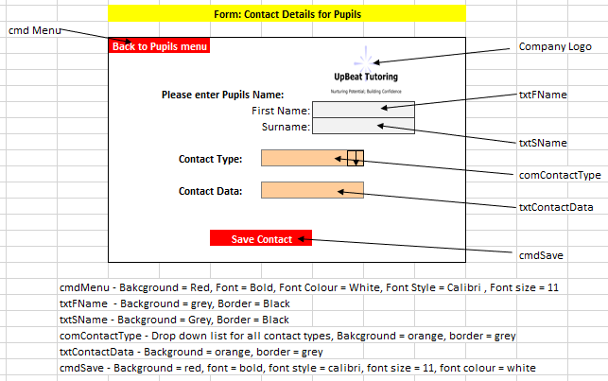

Algorithm:
Count = 0 ContactID = “” PupilID = “”
If Save button is clicked:
If txtFName and SName = “” then output “Must enter first name and surname to add a contact” exit sub
Open Pupil Details Database
Loop through database to find correct tutor entered then retrieve PupilID and store in PupilID Variable
Open Contact Details Database
For I in range 0 to end of contact details database
Count = Count + 1
End Loop
ContactID = Contact & Count
Ammend ContactID, PupilID, contact type and contact data to contact details database then output “Contact Saved”

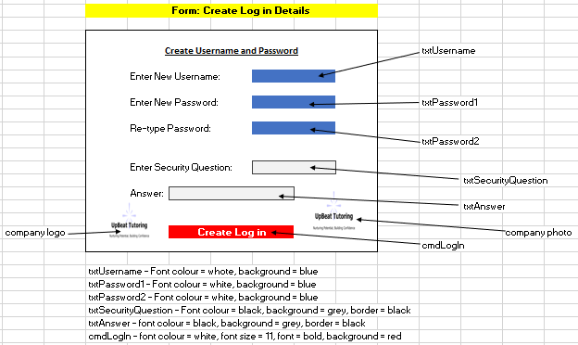
Log In Details form
Algorithm:
Check_username = “”
If cmdLogIn is clicked then
Open Passwords database
Loop through database find username which equal txtUsername
Store Username in Check_username
If txtUsername = Check_username then output “This username is already taken, please try again” exit sub
If txtPassword1 <> txtPassword2 then output “Passwords do not match, please try again” exit sub
Retrieve tutorID from global variable
Ammend txtUsername, txtPassword, tutorID, txtSecurityQuestion, txtAnswer to Passwords database
Close Passwords Database
Open Log In form

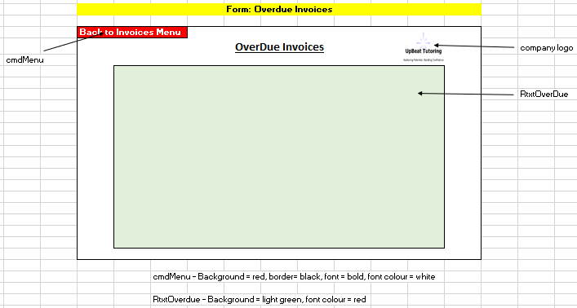
Overdue Invoices form
Algorithm:
If cmd Menu is clicked then
Open Invoices menu
Close current form
When form loads in:
Open invoices database
For I in range 0 to len(InvoicesDatabase)
If InvoicesDatabase.completedinvoice(I) = false then
Display InvoiceDatabase(I) in RtxtOverdue

Search for Pupil Details
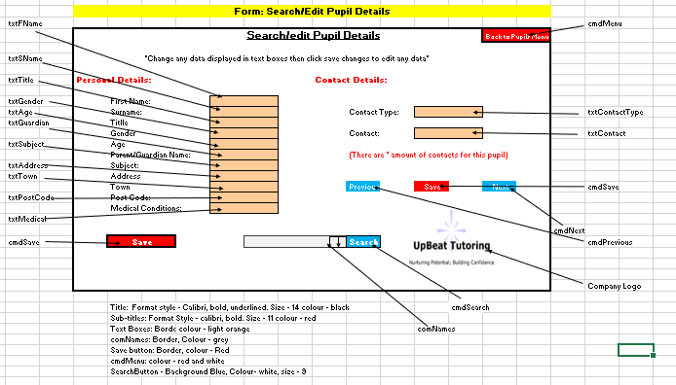
The following form has been changed by removing the option to enter Pupil ID and instead have a drop-down box which displays all of the pupil’s names.

Algorithm:
PID =”” Contacts[] = “” Count = 0 Position = 0
If cmdSearch is clicked then:
If comNames = “” then output “Must select a name” Open Pupil Details database
Loop through Pupil Details database until comNames is found retrieve PupilID PID = PupilID Display all details in correct textboxes
Open Contact Details Database
For I = 0 to end of contact details database
If PupilID = PID then Count = Count + 1 Save contact details in Contacts[] Display Contacts[Position] in correct textboxes
If cmdNext is clicked then
Position = Position + 1 if Contacts[Position] = “” then output “There are no more contacts stored on this pupil” Else Display Contacts[Position] in correct textboxes
If cmdPrevious is clicked then
Position = Position – 1 if Contacts[Position] = “” then output “There are no more contacts stored on this pupil” Else Display Contacts[Position] in correct textboxes
If cmdSave1 is clicked then overwrite old data with data in personal details textboxes then close Pupil Details Database
If cmdSave2 is clicked then overwrite old data with data in contact details textboxes then close Contact Details Database

Search for Tutor Details
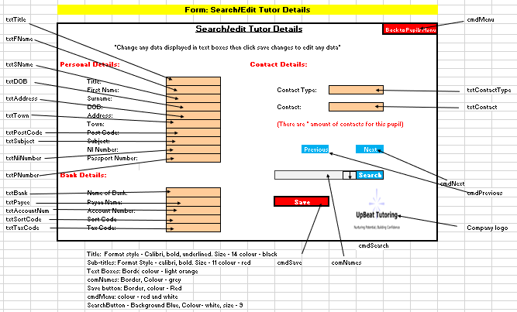
Similar to searching for pupils details the option to enter tutor ID has been removed and instead there is a drop-down box which will display all the tutor names.

Algorithm:
TID =”” Contacts[] = “” Count = 0 Position = 0
If cmdSearch is clicked then:
If comNames = “” then output “Must select a name” Open Tutor Details database
Loop through Pupil Details database until comNames is found retrieve TutorID TID = TutorID Display all details in correct textboxes
Open Contact Details Database
For I = 0 to end of contact details database
If TutorID = TID then Count = Count + 1 Save contact details in Contacts[] Display Contacts[Position] in correct textboxes
If cmdNext is clicked then
Position = Position + 1 if Contacts[Position] = “” then output “There are no more contacts stored on this pupil” Else Display Contacts[Position] in correct textboxes
If cmdPrevious is clicked then
Position = Position – 1 if Contacts[Position] = “” then output “There are no more contacts stored on this pupil” Else Display Contacts[Position] in correct textboxes
If cmdSave is clicked then
overwrite old data with data in personal details textboxes then close Tutor Details Database
overwrite old data with data in contact details textboxes then close Contact Details Database

Search Reports
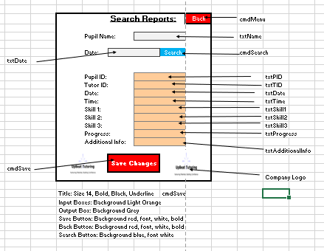
This form now allows the user to enter a pupils name and the date at which the report was saved, this is easier than remembering individual report ID’s.
Algorithm:
If cmd Search is clicked then
Open Reports file
Loop through Reports File
If First Name and Surname = txtName and Date = txtDate then Display all data in textboxes
If cmdSaveChanges is clicked then
Overwrite new data with old data in reports file

Search Bookings
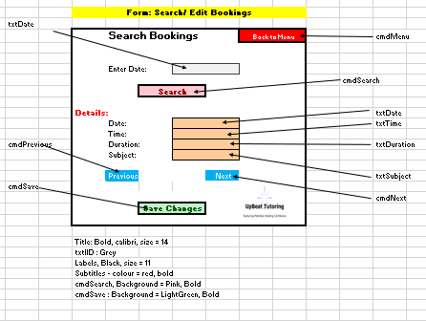
Bookings form will now allow the user to enter a date, this will display all bookings made for this date.

Algorithm:
Booking[] = “” position = 0
If cmdSearch is clicked then
Open Bookings Database
Loop through Database
If txtDate = Date
Save data to array Booking[]
Display Booking[Position] in correct textboxes
If cmd next is clicked then
Position = position + 1
Display Booking[Position] in correct textboxes
If cmdPrevious is clicked then
Position = position - 1
Display Booking[Position] in correct textboxes
If cmdSave is clicked then
Overwrite new data with old data
Close Bookings Database

Security within system
In the feedback Mrs Ryan would like me to make the bank details and passwords more secure as they can be easily seen in the databases. To do this I am going to encrypt the bank details and passwords saved by using Caesar Cypher.
Caesar Cypher is an easy but efficient way to encrypt data. Any data which is entered when is saved each letter will change to the following letter in the alphabet.
Example:
Username : RyanE246
Encrypted Data : SzboF357
This data is much more secure as if the databases are breached the data will not be easily accessed.
This process will be in place when new tutors are being added to encrypt crucial bank details, and passwords.

