Investigation
Introduction
In this project I have decided to work with Upbeat Tutoring to computerise their paper-based system. The business is currently local but is looking to expand out further and to do this they need to computerise their system so access speed and reliability can be much better including backups and better protection of data. The business currently uses a paper-based system for progress reports on children, booking lessons and cover lessons, tutor and pupil details, Invoices and payrolls for staff. The system I will be designing will be faster and a much better access speed to reports on children. Invoices and payrolls will be less time consuming and more reliable to meet deadlines at the end of the month. A computerised system will also prevent mixed bookings and overlaps in lessons as it will eliminate human error.
What the company does
“Upbeat Tutoring” is a tutoring business devoted to help children progress in their English, mathematical and enhance their musical skills. The manager of this business is a previous schoolteacher and left to devote herself to give extra help to children outside school. The business now has multiple tutors specialised in their own subjects and are dedicated to get their students back on track and progress through their subject. This business is very popular with students with additional needs, so the business needs to make reports on each lesson ensuring the correct resources are used and how the child is developing with their assigned tutor. During school term this is is where the business is most popular especially leading up to exam season, the business provides tutoring at the students’ own home or at the tutors’ home depending on what the student wants. Schools are now connecting with the tutors, so the child gets the best support during their additional lessons and ensure the child is being taught on the correct curriculum.
Analysing the existing system
To design and implement a new computerised system I first have to undertake a study on the existing system. I will study the present system in detail and use the most appropriate investigating method so I can gather as much information as possible on the existing system. When carrying out my investigation I will use the information to see what best needs improvement and what is best suited for the business. I will need to know:
- What data is stored on tutors and how is it collected and stored
- What data is stored on pupils and how is it collected and stored
- What access rights are there in the company, is it only the manager which can access pupil’s data, or can all tutors access the data?
- How regular do they make reports on students?
- Are these reports presented to the parents?
- The main issues of the existing system so I can ensure they will be improved on
- What data is used in the Invoices and how it is calculated
- Rates of pay on tutors and how the payrolls are calculated and sent out
Stakeholders
Stake holders are involved with every business. These are people who have an interest or concern in the company. Upbeat Tutoring has stakeholders who are passionate and committed to the company. Stakeholders are key people to ask questions, observe and analyse as they have the main roles within the company. If I want to find out how the system runs these are the people I will need to talk too:
- Owner- Owns the business oversees all employees and is usually in control of the financial side of the business. The owner is also in charge of welcoming new pupils and recruiting new tutors for the business.
- Manager – The manager is in control of the tutors over seeing how they plan/construct their lessons. They also oversee the bookings for lessons and cover for tutor.
- Employees/Tutors – The employees take the lessons with the pupils; they are crucial to the business financial income so it is important they compose themselves professionally and provide lessons with very high standards.
- Customers/Parents/Pupils – These are the people who are provided with lessons by the tutors and pay monthly for high standard lessons.
All these stakeholders are very important to investigate. They can provide information about different features of the company. Stakeholders can also provide information of what they expect from the new system and how certain features can improve how the company functions.

The methods I will be using to analyse the existing system are:
- Observation: - I will observe the system being used by the tutors and manager making notes on what data is stored and how it is used appropriately. This will be good as I will get a first eye view on the system and can see for myself the disadvantages of the existing system. I will not be observing for a long period of time as it could result with distraction to the working employees. This method may confirm issues which have come up in other analysis methods.
- Questionnaires: - I will be handing out questionnaires to employees and parents to get feedback on regular reports, how on time payroll is released for staff. I will also be gathering data on invoices to see how reliable they are and how often parents would have to correct the invoices sent out as they have been over charged for lessons. This is all important information as it could show me how unreliable a paper-based system is and the improvement it would make if the business had a computerised system. It will also give me an idea of the performance requirements for the system.
- Interviews: - I will be interviewing the manager of the business as this will allow me to dive into major problems with great detail and will allow myself to reply to the answers of my questions. I can find out a lot about the system whilst interviewing the manager and gather information on what data is collected and how it is handled.
- Looking at documents: - I will also look at the data stored and look at what key data needs to be collected. As well as this I can gather information on how that data is filed and secured, and how often it is backed up.
All four of these analysis methods need to be used as it will paint a big picture of the existing system giving me all the important information in detail so I can go on and design a new and improved computerised system.

Interview
I have arranged a formal interview with Mrs Ryan the owner of “Upbeat Tutoring”. I have prepared some questions I intend to discuss throughout the interview so my knowledge of the process of their existing system has a deeper understanding.
The questions I intend to ask are:
- What data do you collect pupils and tutors?
- Do you back up this data?
- How many staff members do you have?
- Do you look for new tutors often?
- Are there any problems with your existing system?
- Who needs to access the data you store and where are they accessing it from?
- How often is the data updated?
- How often do you report on children’s progress?
- What’s your complaints from your current system?
- Are your current processes reliable?
- What would you like to change or add to your existing system?
- What is the owners job role in the business and what responsibilities does the owner have?
The Interview
Name of interviewer: Aron
Name of owner: Mrs Ryan
Aron: Hello, Mrs Ryan. Before I begin, I appreciate you meeting with me so we can discuss your business. As you’re aware this interview is very important for me to collect as much detail as possible on your existing system so I can further analyse some processes which I can develop and improve on when designing the new system. This should allow me to identify any strengths and weaknesses in your paper-based system. I have also prepared a few questions to ask you which should help me require specific information which is important to me.
Mrs Ryan: Hello, Aron. I hope this interview will provide the information you need when designing the new system and will answer all questions to the best of my knowledge.
Aron: Before we begin, I would like to learn more about your business and what exactly your business provides to customers.
Mrs Ryan: Well this business provides tutors to children who need additional help in their education. The children are referred to their best suited tutor and is given all the support the tutor can provide in their lessons. When a child is referred to a tutor the first three lessons are analysed to make sure the child is comfortable with the tutor and is focusing well through the lesson. If this isn’t the case, which rarely happens, I then refer the pupil to a new tutor and the same process happens again until the child has the best tutor for his/hers needs. Every lessons the tutors report on the children’s progress and send the reports to me where I store them for when parents want to view how their child is progressing in lessons. This increases contact time with the parents and provides extra support for the tutor in lessons.
Aron: From what I infer this is a very thought out tutoring business. As you just said about children being referred to their best suited tutor do you have many issues in the analysis process?
Mrs Ryan: Very rarely as the tutors are very well trained and know how to approach their pupil through different angles to get the best result in lessons.
Aron: Thank you, I will consider the analysis process for new pupils in my design to make it easier and more reliable when you refer a pupil to a better suited tutor. Now, as you’re the owner of this business, what are your main roles in the company?
Mrs Ryan: That would be very helpful as everything in the analysis process is recorded on paper and can easily get lost or mixed up with other data. As this is only a small business, I have many roles in the company. I myself is a tutor in the company and am currently tutoring 25 pupils. As well as this I am also in charge of the invoices being sent out to parents. Booking lessons with other tutors and dealing with holidays when tutors are needing cover. I am also in charge of calculating payroll for my employees. I also process all the reports on children and store them in a filing cabinet in my office.
Aron: As you have all these roles in the company, do certain processes become unreliable or do you struggle to meet deadlines?
Mrs Ryan: My main complaints from parents is the invoices. I often get caught up in reports and my lessons and don’t meet the deadline date each month for invoices so the parents can pay for their lessons. Also, Payroll can be unreliable as its me calculating the pay I do sometimes have errors in the amount the employees are being paid.
Aron: Would you say these are the main weaknesses in the company? Are there any more problems which you face with your existing system?
Mrs Ryan: These are some of the weaknesses with the current system. The biggest flaw with the system is that it is very time-consuming writing and calculating everything on paper and making sure it is stored correctly and no data is being lost. It is a lot of pressure and can result with errors in the company which lead to complaints. There are other problems such as the booking system. As it is all on paper the tutors need to regularly update me, so I know what days or time slots they’re available to teach. As this is a case there is the occasional issue where a child is booked on with a tutor and the tutor isn’t available.
Aron: This sounds like a very complicated process to be done by one person. Involving the booking system does it need to be regularly updated? Are the parents able to book catch up lessons with the tutors and do tutors need cover booked often?
Mrs Ryan: It is a complicated process and does result with errors. The booking system does need to be updated regularly as parents sometimes need to change the times of their lessons in a week so I will then have to update the booking system to see where the tutor is available so the child can book in. After school holidays where the business becomes the busiest, we get a lot of children who book catch up lessons and results with an ever-changing booking system which ends up being very complicated and results in double bookings with tutors and mx up in lessons.
Aron: Is the booking system refreshed after payroll and invoices are sent out or do you keep all records of bookings?
Mrs Ryan: I keep Past records of bookings for up to 2 months just in case I have complaints off parents about invoices or complaints about payroll.
Aron: Is the booking system used to calculate invoices and payroll?
Mrs Ryan: Yes. This is why its very important the booking system is constantly updated and very accurate. As a simple error could result with employees being underpaid or parents being over charged which gives a bad look to the business whereas I want the business to look reliable where I believe a computerised system could be very helpful in accuracy in bookings.
Aron: I can tell this is very important to how your business is run and will look into improving it. Now as for my next question, what data do you collect and store on staff and pupils?
Mrs Ryan: I am very wary of the data protection act and only store data which will be relevant to the lessons. For the pupils I store their name, date of birth, parent/guardian phone number, parent email address and any additional information such as additional needs. For staff I store their name, date of birth, national insurance number, passport number, bank details, home address, phone number and email address. There is a lot more data stored on staff as its crucial for pay rolls and as my staff work for children, they need to be DBS checked so a lot of data needs to be collected on them.
Aron: How do you store this data? Are there any security processes in place to protect the data? And how often do you update it?
Mrs Ryan: This data is stored in a filing cabinet in my office locked with a padlock where only I know the code, the door to my office is also locked with a key. I do not let my staff access the data as its personal to the pupils and to other staff and I make sure only myself can access it. However, as there’s not much storage available to me I only make updates to data when necessary, for example if staff needed another DBS check or if a parent changed their phone number. There is very limited storage in the filing cabinet to do regular updates and backups.
Aron: Looking closer into storing data, how often do you regularly add new tutors and gain new pupils?
Mrs Ryan: When there is a high demand of pupils needing tutoring in a certain subject I will then look to recruit new tutors best suited for that subject. We regularly gain new pupils on average three a week, however coming up to school holidays we regularly lose some pupils as theyre done with their school year.
Aron: Okay thank you, just to refer back to pay roll and invoices how would you calculate the amount to charge parents and pay staff?
Mrs Ryan: Well when calculating pay roll, I often refer to the booking system and check how many hours that specific tutor has worked that month, I will then multiply those number of hours to the tutor’s rate of pay. When involving tax, I have to use a HMRC regulated software which calculates the amount the specific tutor is being taxed. I have to use this software otherwise I will be breaking HMRC rules. For Invoices the parents pay up front for their lessons. So, they book a certain amount of lessons and pay for them before the lessons being. I calculate this by multiplying the number of hours of lessons by 20. The parents pay up front so in circumstances where the pupils don’t show up for lessons the company isn’t losing out on money.
Aron: Thank you, that was very useful information. For my last question is there anything about your existing system you would like changed or added?
Emma Ryan: I would like to change the process for booking lessons as this can be very complicated, I would prefer to have a system where I will click a button and it will tell me all available slots for pupils. I would also like to add a process where I can cancel lessons without scribbling slots out on a time sheet. We are further looking into adding discounts on lessons for new pupils which would be a nice addition to have in the new system. The payrolls and invoices are very difficult to calculate by myself and is very time consuming making it difficult to meet deadlines, so I would like that changed. I would prefer an easier way to store reports on children also as right now if I was to retrieve a report on a child, it is very hard to find as they’re all stored in order of date and can be difficult to retrieve to meet parent’s needs. I believe a computerised system would be ideal for my company as it will reduce human error, provide better accuracy with data and increase storage space. It will also reduce time consuming tasks and can help me meet deadlines in the company.
Aron: Thank you, I will consider all the information I have gathered today in the design process, thank you for your time.
Mrs Ryan: Thank you, goodbye.

Staff questionnaire
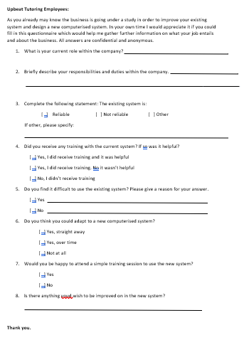
For my second method of investigation I will be handing out questionnaires to staff at Upbeat tutoring. Questionnaire:
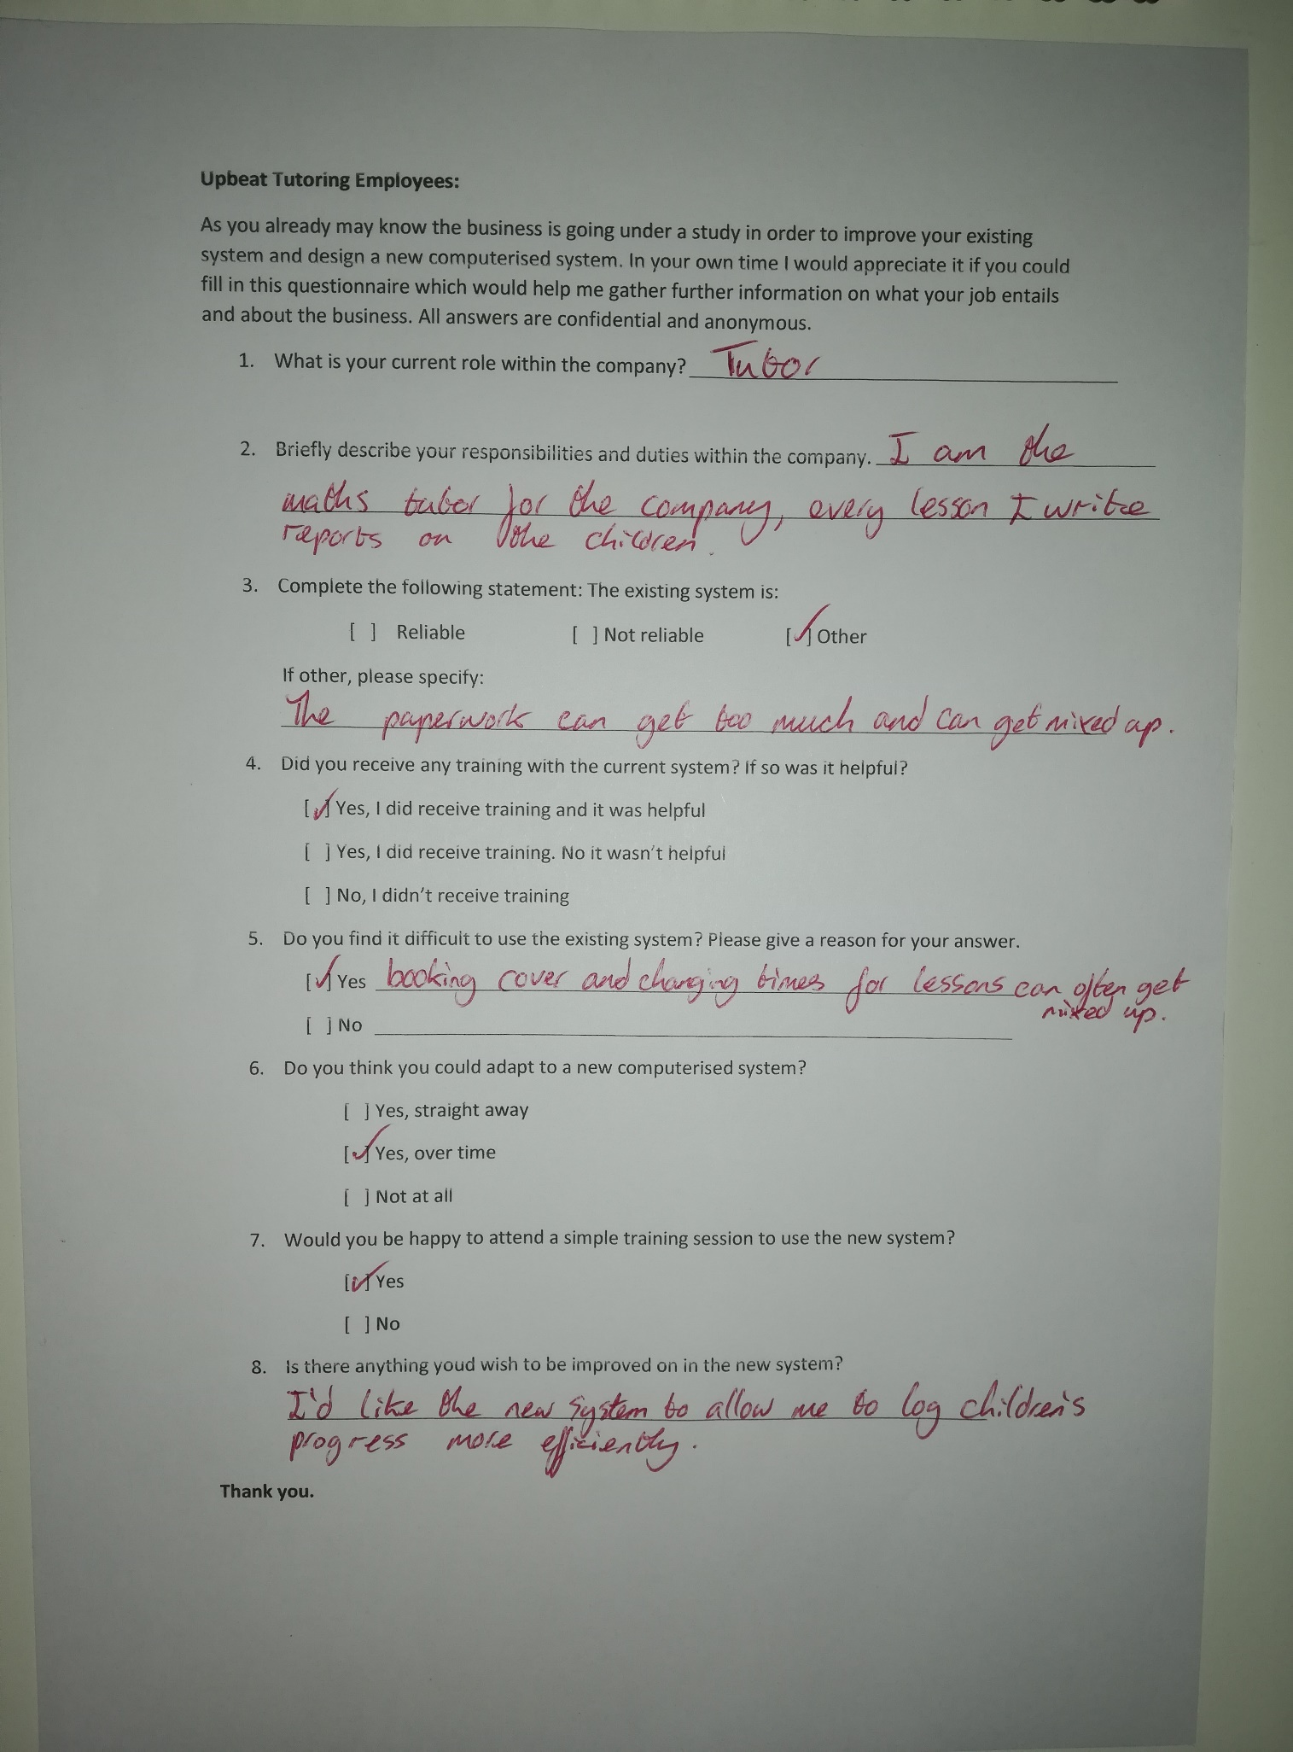
Example of a completed staff questionnaire:
The questionnaire was beneficial as the staff use the existing system regularly. When handing out the questionnaires, I decided to use random sampling. Random sampling is the most unbiased out of all the methods of sampling. I did this by giving each staff member a number. I put all numbers into a hat and picked each number out of the hat until I got a sample of 15. This is the most efficient sampling method as I will have a mixture of different employee’s perspectives on the system which will give me a better image of the existing system.
Observation
Throughout my observation, I came to analysis most processes which occurred in the system. I was able to reserve how data is saved and retrieved. I also observed how reports are dealt with pupils. I had the opportunity to observe the admin calculating payrolls and invoices. I also was able to analyse how the booking system is managed. To show a good representation of these processes I will use data flow diagrams.
Data flow diagrams show processes within a system. They’re a good representation of how data is stored and retrieved within the system.
The following symbols are used in a data flow diagram:

External Entity:
An external entity is the source or destination of the data

Process:
A process is an action performed on the data


Data Store:
A data store is a location that holds data e.g. file cabinet, folder or notebook.

Data Flow:
The direction the data flows throughout the diagram.

Storing reports on children
New report on pupil
Find pupils file
Pupils report filing cabinet

Retrieving Pupils Report

Retrieve Pupils report
Pupils Parent
Find Pupils File
Pupils report file cabinet
Pupils report file cabinet

Adding new pupil
New Pupil
Fill registration form
Pupil Details Cabinet

Adding new customer
New Customer
Fill registration form
Customer Details Cabinet
Editing/updating existing pupil data
Retrieve record of pupil to edit
Existing pupil
Edit/update fields of record with new data
Pupils details filing cabinet
Pupils details filing cabinet

Editing/updating existing customer data
Retrieve record of Customer to edit
Existing Customer
Edit/update fields of record with new data
Customers details filing cabinet
Customers details filing cabinet

Adding new Payroll
Fill in the pay roll record and complete calculations
New pay roll record
Payroll filing cabinet

Adding new Invoice

Fill in the Invoice record and complete calculations
New Invoice record
Invoice filing cabinet

Pupil booking a lesson
Pupil
Admin
Contacts to book a lesson
Fills booking information in
Refers pupil to best suited tutor
Booking filing cabinet

Tutors booking time off work
Tutor
Admin
Contacts admin to book cover
Fills booking information in
Finds tutor available to cover
Booking filing cabinet

Observation
Through this section of analysis, I will be visiting upbeat Tutoring main office, to observe how the business is run from the admins point of view. I will be visiting the business at the end of the month so hopefully I will be fortunate to observe how the payroll forms were handled and how invoices were distributed to parents. Mrs Ryan has informed the rest of her employees that I will be observing their work and to work as normal so I can gather a true representation of the existing system. Observing the system will give me a true representation of how the system works and will widen my knowledge to the complexity of the system. I arrived at the main office at 16:30 pm. Mrs Ryan welcomed me into the office. As I arrived a tutor had just finished a lesson with a pupil. This was very fortunate as I was able to observe the tutor complete a report on the lesson. The report was nice and short but precise, stating if the pupil has continued to progress in the lesson, what subject was focused on and how the pupil felt about that subject. The report also had additional information if the pupil had any incidents in the lesson. This report then was left for Mrs Ryan who then retrieved the pupils record from the report filing cabinet and placed the report in the record. However, it was short and precise, and I did notice how full the pupils record was becoming and soon will come to maximum storage capacity which can be an issue. The tutor also had to stay half hour after the lesson had finished to complete the report making her late for plans after work.
Shortly after the tutor had left and report had been stored securely the office phone rang. The person on the other end of the phone was a parent of a child asking for a maths tutor with regular weekly lessons up to GCSE level. This provided me with the opportunity to observe how pupil’s data was gathered. I viewed the process of Mrs Ryan gathering all necessary information from the parent about the pupil, making a new record with a unique pupil ID. Once the form was complete it was placed in the Pupils details filing cabinet. Mrs Ryan then went onto retrieve the booking system to see availability lessons to fit the new pupil in with the correct tutor. She first filters the booking system by eliminating the tutors which wouldn’t be best for the pupil. Then compares the pupil’s availability to tutor’s availability and places the pupil on an available time which is good for the pupil and the tutor. Unfortunately, this time there was no availability spaces for the new pupil which was informed to the parent of the pupil and the new pupil was placed on the waiting list. The pupils on the waiting list would be placed into lessons when availability becomes available. The pupils which have been on the waiting list the longest are a priority. Whilst observing this process I noticed a lot of paperwork spread a long a desk which looked complicated to keep up with. The pupil’s details were gathered, and storage space had to be made to store the details whilst a back up of the form was also made and placed in a box. I noticed the parent of the pupil had to wait up to 10 minutes whilst Mrs Ryan scanned through the booking system to find availability for the pupil just to tell the parent that there aren’t any available bookings at the moment. I can imagine that the booking system can cause a lot of complaints due to waiting time. The waiting list for new pupils has to constantly be checked by Mrs Ryan to ensure that they were provided with lessons as soon as possible.
As it was the end of the month, I was given the opportunity to watch how the payroll forms were handled and stored. Using the booking system and tutor’s unique ID’s Mrs Ryan gathered how many hours each tutor had worked since the first working day of the month. As there were mistakes from the last payroll, she also had to look back into the previous month also to make sure the tutors were kept up to date with their pay to try and prevent complaints. She then individual went through each tutor and multiplied the number of hours worked to their rate of pay which was £9.00 per hour. Once the total pay was calculated she then worked out if any of the tutors were taxed for their pay and how much. She would work out 20% of the total pay that month and then deduct that from the total pay. Mrs Ryan then declared the amount paid to each tutor and if any pay was taxed to the HMRC system and the taxed amount of money was sent off too HMRC. This was a long-complicated process as scanning through 2 months of lessons meant retrieving the correct paperwork and relying that the paperwork is accurate. She then had to calculate the total pay herself which meant there could easily be human error involved. This is evidence due to some tutors being underpaid the previous month. I noticed this process required patience and was very time consuming, the pay cannot be sent out until it is approved by HMRC which is why it is vitally important to calculate the total pay as soon as it is possible otherwise tutors will have delayed pay.
After my observation I thanked Mrs Ryan for her time. I gathered further knowledge into the system and with the use of a stopwatch it made me realise how much of a time delay the paper base system was. It also surprised me the amount of paperwork there was and the lack of use of computers in the work.

Inspecting current documents
As my final analysis method, I have decided to look at some aspects of the current documents to further understand what data is collected, how invoices are dealt with and how are reports processed.
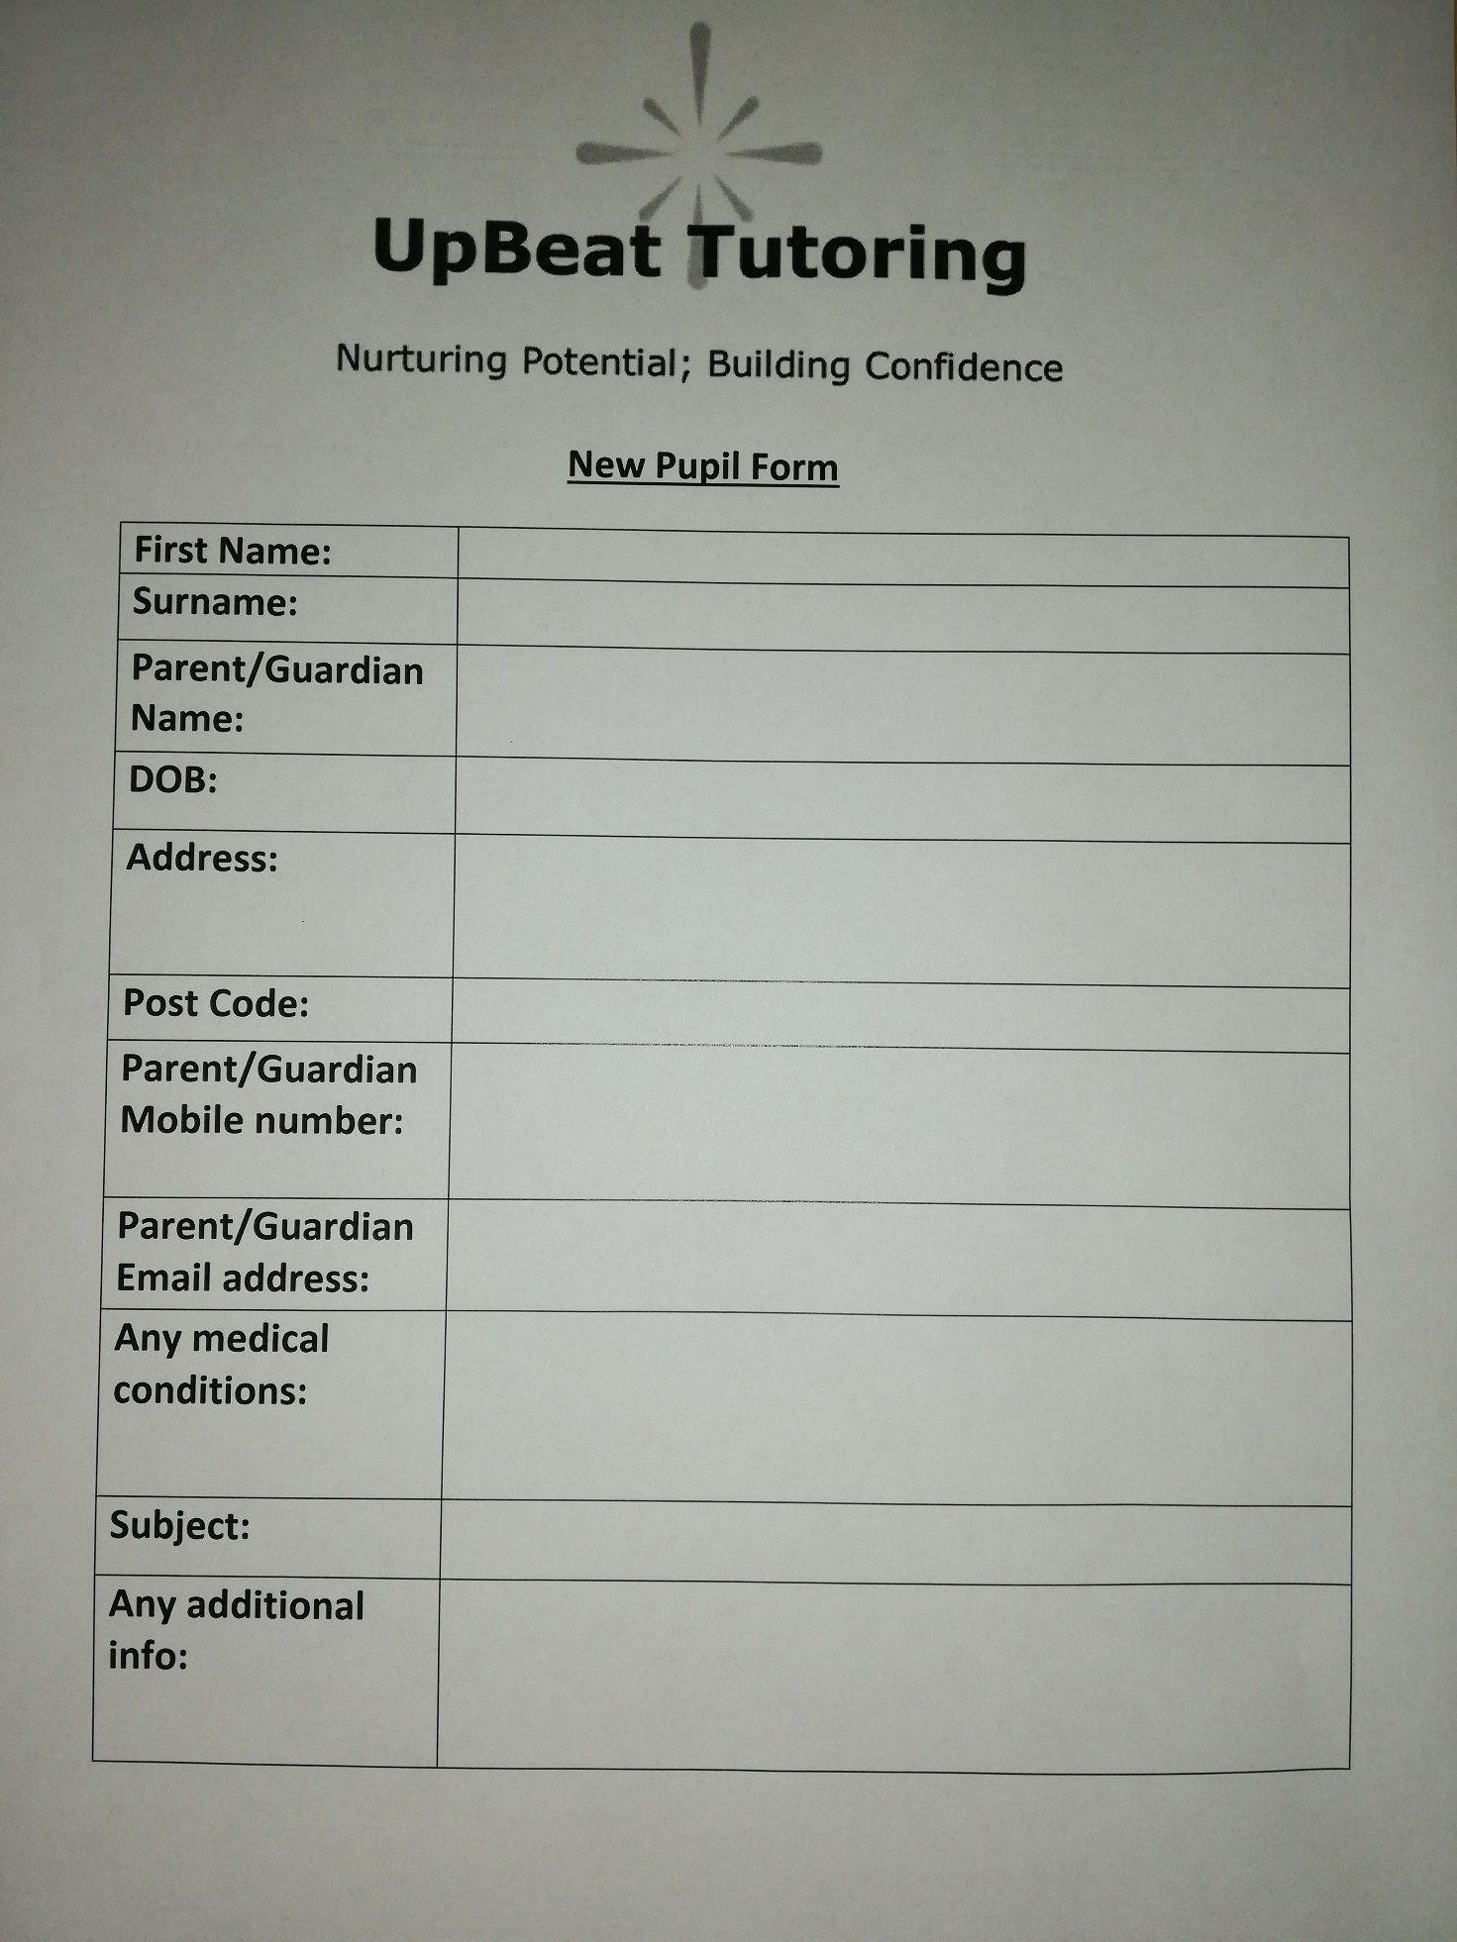
These are templates of certain documents:
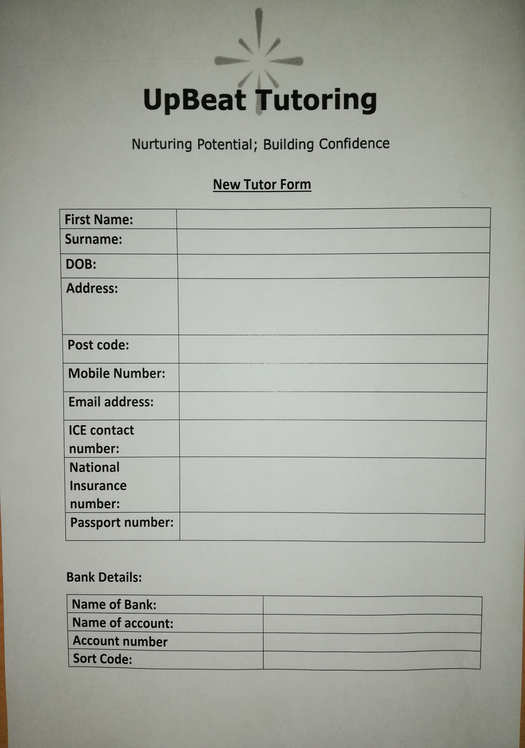
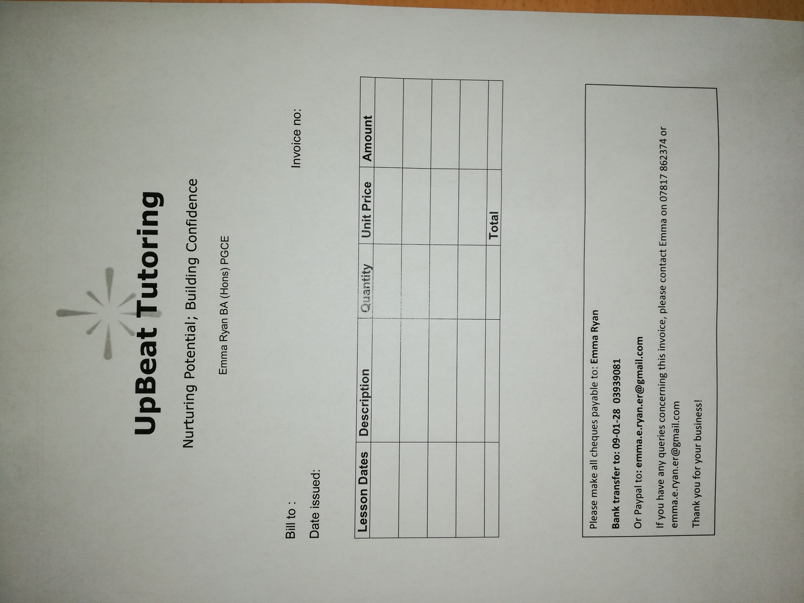
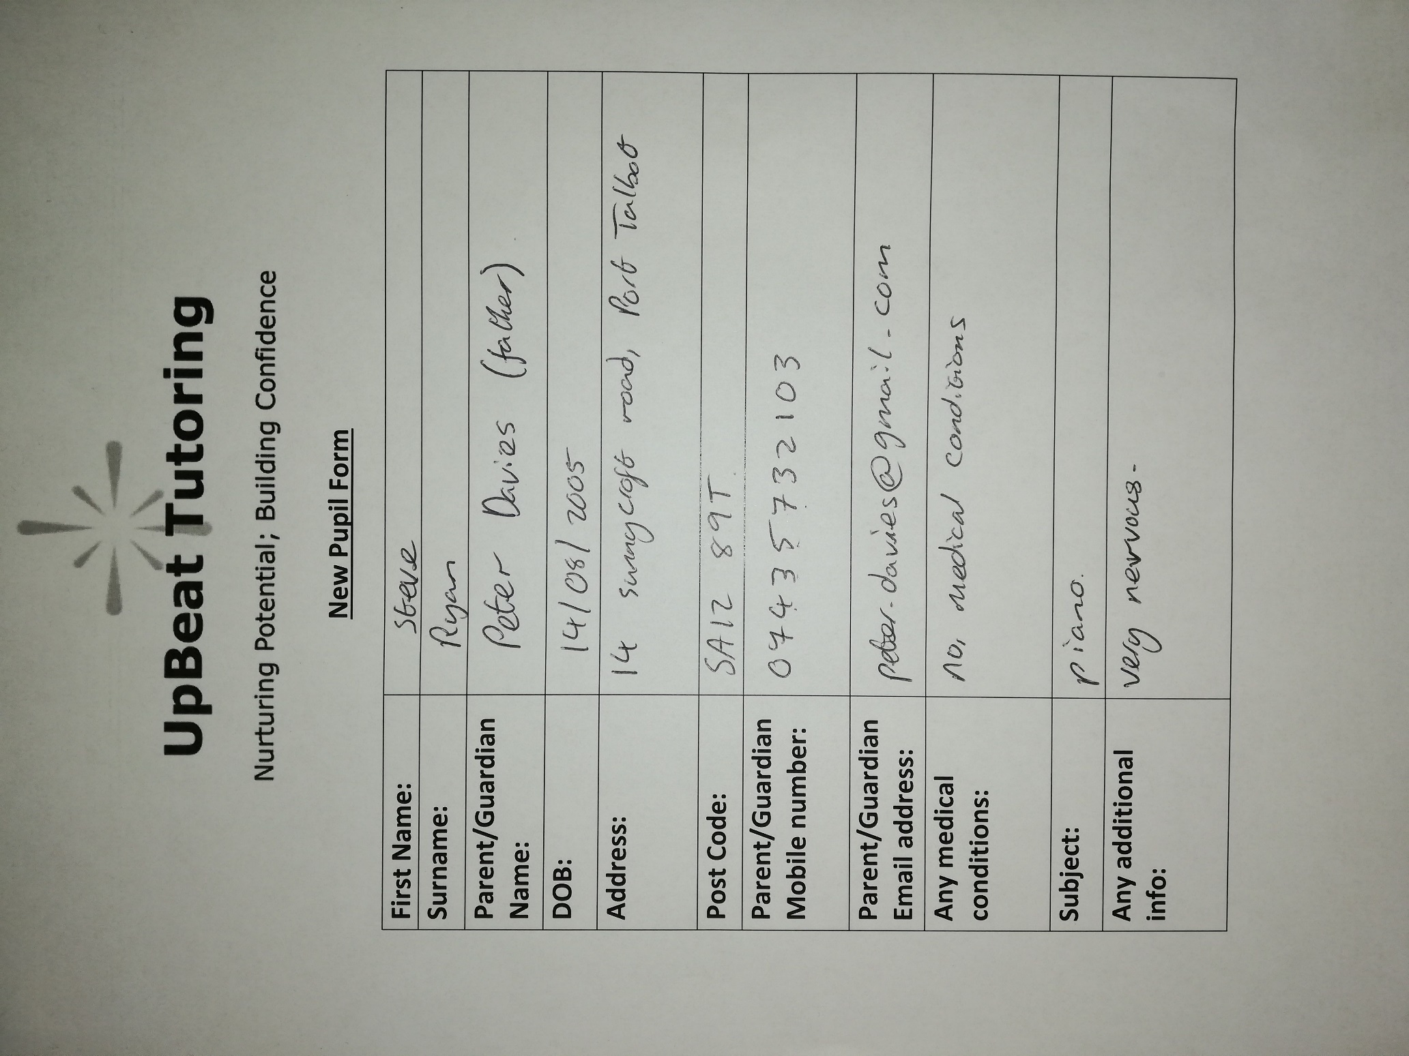
I then looked at examples of filled in forms:
In this next form as you can see the tutor had changed the phone number so the old one had been crossed out and a new one added:
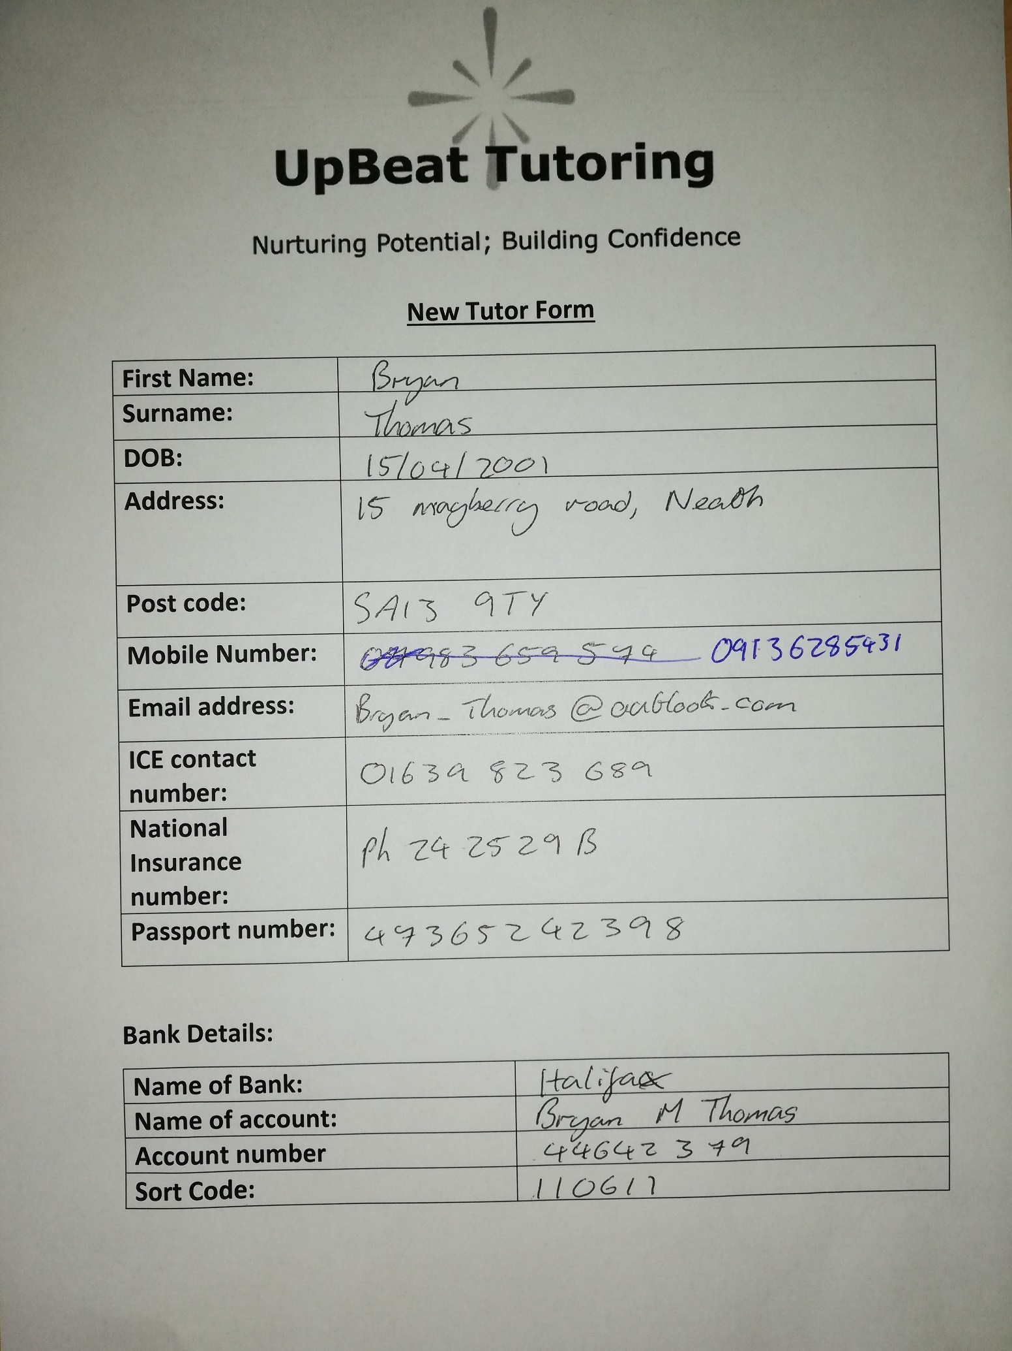
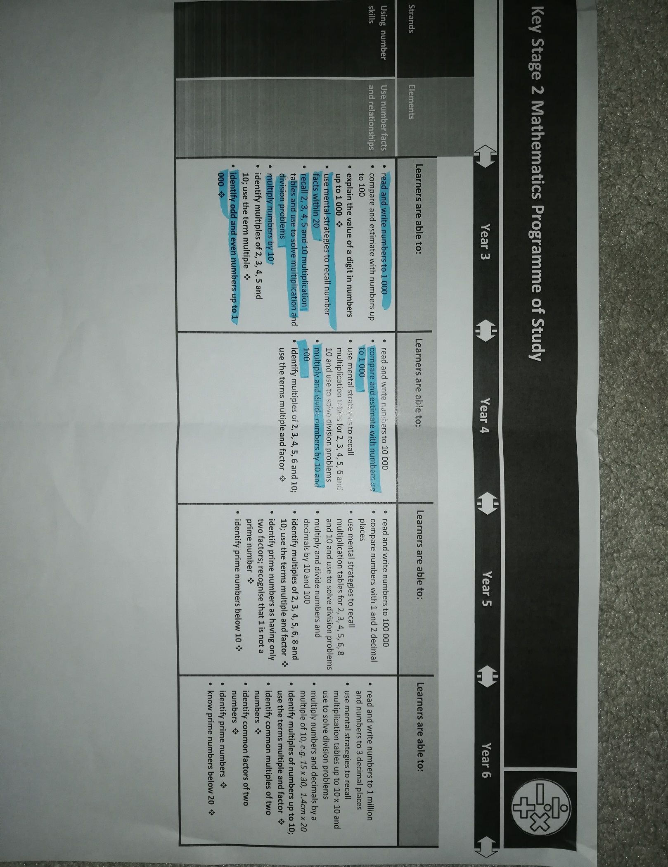
This next document is a skill set document; this is used so the tutors can keep track of the skills achieved by the pupils by highlighting certain skills. This is then transferred into a rough report.
Concluding and analysing all data found and collected
Interview:
Throughout the interview I discussed Mrs Ryan’s main roles in the company and certain processes involving adding new pupils, booking system, payrolls and invoices. The interview was very useful as I was able to discuss issues in further detail and be able to ask about certain answers Mrs Ryan replied with.
In the interview Mrs Ryan explained how her main roles in the business, are managing the booking system, calculating payroll, sending out invoices and adding new pupils and new tutors. Along with this Mrs Ryan also has her own pupils to teach. From this I gathered that a computerised system will be extremely beneficial for Mrs Ryan as the amount of paperwork which she deals with can be very stressful and complicated for one person.
I further asked in the interview about the process involved to accept a new pupil. First there is the process of gathering the pupil’s data. Then she must analyse the data given to her to refer the pupil to the best suited tutor. Usually the tutor would specialise in the subject the pupil is asking for. During this, the pupil goes through a trial process of 3 weeks with their new tutor. The tutor will report on how the child is working and then Mrs Ryan will make the decision whether to keep the pupil with that tutor or transfer the pupil with another tutor. This was very useful information to gather as this can be implanted into the new computerised system, which will allow the admin to analyse the process of the new pupil more closely and an algorithm can be in place which would refer the pupil to the best fitted tutor.
Further on in the interview we discussed payrolls and invoices. From the discussion I came to realise that invoices for parents are sent out at the start of the month. This means all lessons need to be pre-booked before the start of the month, so invoices are sent out. This ensures that Upbeat tutoring are still making money even if pupils don’t show up for lessons. However, this is a difficult process and due to it all being worked out on paper the main complaint from parents is that invoices are sent out late. Payrolls are another big issue, as it is all calculated off the booking system and often Mrs Ryan have to look back a few months to make sure employees are up to pay. Often employees are underpaid due to lack of updating the boking system and getting lessons mixed up.
During the interview, Mrs Ryan had pushed the idea of the booking system being computerised. She would prefer the booking system, to allow her to book tutors cover, edit when lesson times and days have been changed. She would also like it to show when tutors are available and what tutors are suitable for what pupils. From what I inferred it came across as if the booking system was the most crucial part of the processes in the business so this is what I will focus on the most during the design process.

Questionnaire:
In the questionnaire I decided to focus on how the employees feel about the current system they use. I asked about the difficulties they come across in the current system and if training was useful. From this I gathered information on what parts of the system are the biggest issue. This will then give me a good idea on what to focus on the most when designing the new system. I also asked about training as if they found training useful with the current system perhaps, I could design a training leaflet/programme which could aid them when using the new system.
These are the main results from the questions asked.
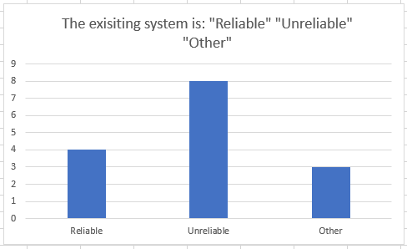

The employees ticked “Other” gave reasons such as: “The paperwork can get too much and can get mixed up”, “Not unreliable but there is times where it gets very complicated”, “Sometimes keeping track of lessons worked in a month is difficult”.
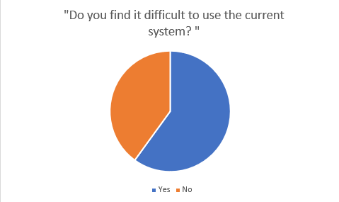

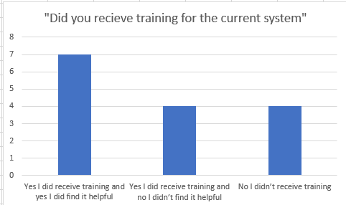
This question shown that the majority of the employees said “Yes” when answering the question if the existing system is difficult to use. With this question I asked the employees to provide reasons for their answer. After analysing the reasons given, I will include the majority reasons. For the employees who answered “yes” the majority reasons spoke about the booking system being difficult to use when changing lessons and booking cover. Others spoke about being underpaid from the payroll system. Furthermore, the employees who answered “No” the majority reasons spoke about using the skill sets document to construct a report was very useful and found it easy to use.

This graph shows that the majority received training for the current system and that they thought it was helpful. If the employees found training useful with their paper-based system, perhaps a simple leaflet or training programme could be used for the new system to aid employees when using the new system.
The reason answers provided in the questionnaires have also been taken into consideration. When finalising my aims and objectives I will consider the entire scope of my results from the questionnaire. However, the answers I have analysed are the most important and are a priority to be taken into consideration.

Observation and analysing current documents:
Throughout the observation I was able to watch the step by step of processes within the system. This was very useful as it shown what data is used frequently, any security processes involved and what data is actually stored.
In the observation I recognised that the filing cabinet held all data which is stored by the business. This filing cabinet was locked with a key which was in the possession of the admin. This was very useful to note as this means any data processed or added to the filing cabinet must be admin access only. As a result, apart from reports on children being constructed all other processes in the new system must be admin access only.
During the observation process, I was analysed the method used to construct reports after lessons. The crucial factors in the report involved; how the pupil has progressed that lesson, what subject/skill was focused on in lesson, how the pupil felt about subject/skill, and any other additional information about the lesson. This information was the most focused on in the report, keeping the report precise and short. This was useful as it can be simplified into a computerised system to speed the process of report writing. A problem I did notice that it had taken the tutor 20 minutes extra after the lesson to finalise the report on the lesson. They are not paid for this time so the new system could speed this process up to prevent tutors working unpaid overtime.
I also watched the admin process a new pupil into the system. First the admin collected all necessary data on the pupil then stored the details into a filing cabinet. The admin then used a booking system to compare pupil’s details to tutor details to choose which tutor is best for the pupil. The pupil is then added to an available slot for the tutor in their subject area. However, from the observation I recognised there was a waiting list for pupils where there weren’t any available spaces to fit them in. This waiting list works as a data structure queue. As in it is a First in First out process, for when lessons become available for pupils on the waiting list. This is very useful to know and will be considered into the aims and objectives for when there isn’t availability for pupils.
When I was inspecting current documents, I was able to gather what data is stored on Pupils, Tutors and invoices.
Pupils Data
- First name
- Surname
- Parent/Guardian Name
- DOB
- Address
- Post Code
- Parent/Guardian mobile number
- Parent/Guardian email address
- Any medical conditions
- Subject
- Any additional info
Tutors data
- First Name
- Surname
- DOB
- Post Code
- Mobile number
- Email Address
- ICE contact number
- National Insurance number
- Passport number
- Name of bank
- Name of account
- Account number
- Sort code
Invoice data
- Bill to (Parents Name)
- Invoice number
- Data issued
- Lesson Dates
- Description
- Quantity
- Unit Price
- Amount
- Total
All this data is very useful and will be considered when designing the system. Other documents looked at included, skills set document. This was not filled in but highlighted for what skills were completed. There are multiple skills and it would be useful to be integrated into the new system and will be considered.

Desk Based Research
I have decided to go into research on other computerised systems looking at payrolls, booking systems and any other concepts which may come into use for when I design the new system.
To begin with I went into research with different booking systems, from restaurants online booking, swimming lessons booking, cinema bookings etc... In doing this I will develop an idea of the main features in a booking system and what data is gathered throughout the process.
First, I looked at Prezzo, a restaurant in mumbles, booking system. [https://www.prezzorestaurants.co.uk/]
Screenshots of booking system:


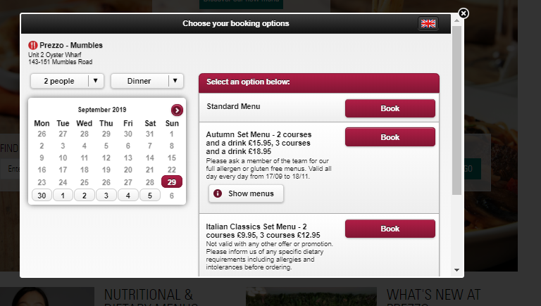

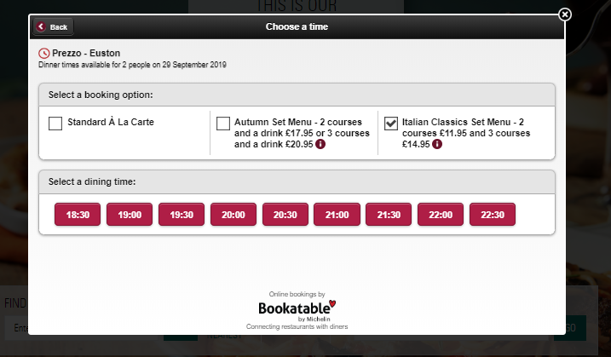

This booking system is simple and effective. First as there are multiple restaurants you select the restaurant closest to you. Then it brings up a new screen with the following features:
- Drop down box to select amount of people
- Drop down box so you can select lunch or dinner
- Section to book for what type of menu
- Provides different available times for dinner at the chosen restaurant
- Once selected provides booking confirmation
Another booking system I looked at was Reel Cinemas booking system [https://reelcinemas.co.uk/]
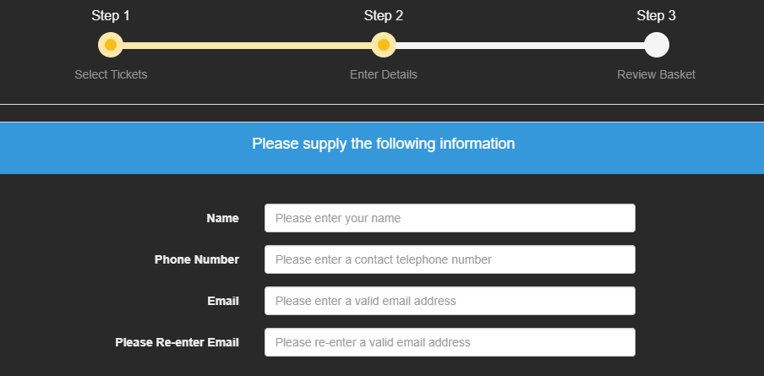
Screenshots of booking system:
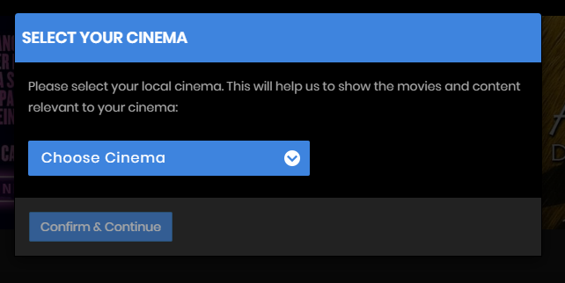

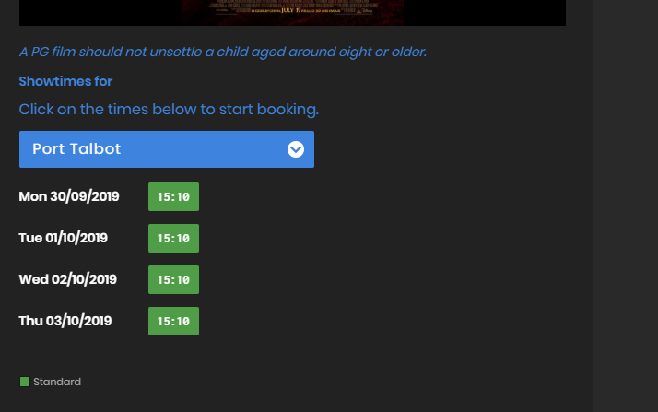

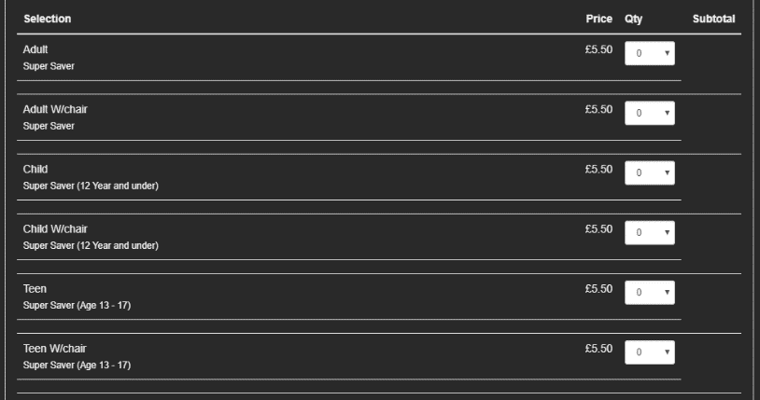

This booking system had more detail involved than the Prezzo booking system.
The features in this booking system included:
- Drop down box to select what cinema
- Shows available times for the film you like to watch in the cinema
- Then a selection of different prices depending if youre an adult or child.
- Finally gathers data like, Name, phone number and email.
- Once payment is finalised customer receives booking confirmation via email
This was useful information; similar features can be used in the new system such as instead of allowing a user to select what cinema instead allowing a user to select what subject to be tutored. Other features such as showing available times would also be good to use in the new system. I can also use the subject selected to filter available times with specific users.
The functions with drop down boxes and data collected in this booking system can be used/modified for my own booking system. These booking systems keeps it clear with step by step work for the user by switching to a new form after a user has completed a certain number of tasks. This makes it easier for the user to fill in forms without mistakes. This can be very useful for my own booking system by switching to a new form after a certain amount of data has been inputted.
Payroll system – I decided to also research into payroll systems as this can be a very complicated process. The payroll system I have decided to analyse is found on the link, https://gs.12cloudpayroll.com/12cpay/signin/SignIn.do, I have taken numerous screenshots of the system. To access deeper into the payroll system forms had to be completed so any personal data has been blanked out.
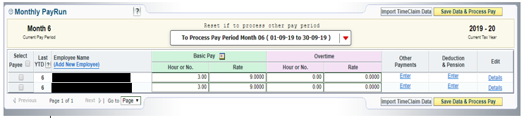
Screenshots of payroll system:

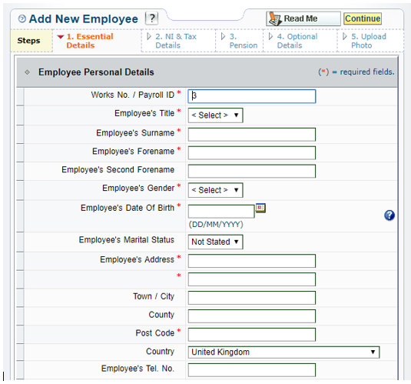
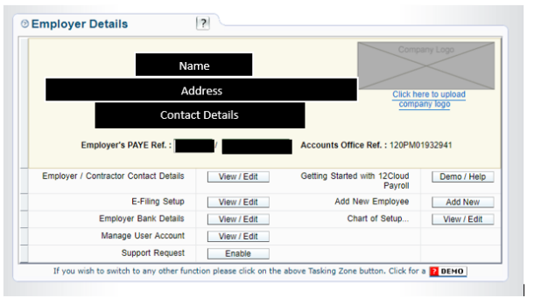

This pay roll system allowed me to get an accurate view on what data should be stored on employees, what data is collected to calculate pay and finally what roles should an admin have with a payroll system.
The system had the following features:
- Employer details (Name, address, contact details)
- Employers PAYE ref number
- Accounts office ref number
- Menu for employer to access different data
- A button to select which payees are being paid
- Data to gather to calculate payroll:
  - Employee name
  - Basic pay – number hours worked and rate of pay
  - Overtime – number hours worked and rate of pay
- Button to save and calculate payroll
- Employees personal details stored
  - Payroll ID
  - Title
  - First name
  - Surname
  - Gender
  - DOB
  - Marital status
  - Address
  - Post code
  - Email/mobile number
All this information is very useful especially how the system is structured seems a reasonable way to design a payroll system. Some of the system is very complex so some features may not be included in the new system unless they’re necessary. Data which is stored on employees was the biggest part of this research as it confirms what Mrs Ryan already stores on her employees.
A good feature in this payroll system is that it had a menu with multiple buttons which would take the user to different functions of the system depending on what button was selected. This is better than all the functions being on one form and can be very complex for the user to use.
Another good feature on the system is the variable “Payroll ID” this gives each employee a unique ID. A unique ID allows the system to identify the employee far more efficiently and lowers the complexity in the programme. When the payroll ID is referred to in that system all the data stored on the employee in the relational data table can be easily accessed. This prevents data being inputted repeatedly and easily stored. This is a feature which is very important for me to use in my own system.
Limitations of existing system
From the research into the existing system I have now gathered enough information to report on the limitations of the existing system with detail. I have had the privilege to analyse different processes within the paper-based system such as the booking, report writing, payroll and invoices.
The booking system is the main process of the paper-based system. If the booking process is incorrect this will affect the payroll system and the invoices system. There are many limitations to the booking system such as due to low storage space it is only backed up by 2 months. As a result of this there is no longer any evidence available if an employee claims they have been underpaid in previous months. As it is all updated onto paper, when employees are to cancel lessons their name is simply crossed out and replaced with another tutor name if that employee has cover. This can be an issue as it could not be clear on paper and mistakes can be made. Due to parents cancelling lessons and employees cancelling lessons there has to be constant communication between tutors and admins, and between parents and admins. This is because if a tutor cancels the parent has to be notified and must be logged on the booking system, so the parent is refunded for that lesson. As it is all done on paper there can be mix ups and if a lot of tutor’s book time off at the same time it can get very complicated when notifying the correct parents about the correct dates.
Payroll is a process within the system which relies heavily on the booking system. If there are mistakes on the booking system this will result with employees being underpaid/overpaid. Payroll is calculated at the end of every month; the admin refers to the booking system to observe how many hours each employee has worked. The pay is then also calculated by the admin. This also opens up the payroll system to human error when calculating the pay. Another limitation to the payroll system is that all pay calculated that work year must be stored for HMRC. This limits the company’s storage space and results in re-using payroll documents and simply editing data by writing over the data with a pen. This is not ideal for the company and can result with problems.
Another process which relies on the booking system is the invoices. This can have the same effect as the payroll as if the booking system is incorrect it can result with parents not being charged enough for lessons. Invoices are dealt with at the beginning of the month this ensures the company will still be paid if parents decide to not show up. As this is the case the booking system is updated after invoices are sent out. This can have limitations as if a tutor cancels a lesson after invoices are sent out this will result with parents having to be refunded for lessons and invoices edited. This can out the company in a bad light if parents are often refunded for lessons.
Report writing is a process within the company which only badly affects the employees. After pupils have finished their lessons, tutors must report on their progress and any problems within the lesson. This results with tutors staying behind approximately 20 mins after lessons this overtime is not paid for. As the overtime is not paid this can cause unhappy employees which can result with lower standard of lessons.

Finally, the final limitation in this system is adding new pupils. Once all data is gathered on the pupil it takes approximately 10 minutes for the admin to find the best fitted tutor and see if there any available times for that tutor. Throughout this the parent is left waiting on the phone and due to high demand in some subjects the parents after waiting are often told there are no available places and the pupil is placed on the waiting list. This is a very time-consuming process. The waiting list is another limitation to the company as it has to be regularly checked by the admin to see for any available places. As available spaces can come up regularly and the waiting list is not checked it could result with the company losing out on pupils.

Specification of the new system
From the research I have undertook into the current system I have decided to create a specification for the system I will be designing. This specification includes, what data is inputted and saved, what data is outputted, some validation of data inputs and security.
The data inputted would include data from report writing, pupil’s data, tutors’ data, invoices, payroll and booking system.
All data which will be inputted and saved:
- Log in screen
  - Username
  - Password
- Report writing:
  - Pupils Name
  - Subject
  - Duration of lesson and date
  - What skills were focused on
  - How the pupil did at achieving those skills
  - Any additional information
- Pupils Data:
  - First name
  - Surname
  - Parent/Guardian Name
  - DOB
  - Address
  - Post Code
  - Parent/Guardian Email Address
  - Parent/Guardian Mobile number
  - Medical conditions
  - Type of subject
  - Any additional info
- Tutors Data:
  - First Name
  - Surname
  - Subject specialised in
  - DOB
  - Address
  - Post Code
  - Email Address
  - ICE Contact Number
  - National Insurance number
  - Passport Number
  - Name of bank
  - Account recipient
  - Account Number
  - Sort Code
  - Tax Code
  - DBS checked (Yes or no)
- Invoice:
  - Bill to
  - Invoice Number
  - Date Issued
  - Lesson Dates
  - Description
  - Quantity
  - Unit Price
  - Amount
  - Total
- Payroll:
  - Payroll ID
  - Employees Name
  - Basic Pay
    - Hours worked
    - Rate of pay
  - Overtime Pay
    - Hours worked
    - Rate of pay
- Booking system:
  - Dates of lessons
  - What tutors are with what pupils
  - Time tutors are available
  - What dates need cover booked
  - What lessons have been cancelled
All this data listed will be inputted and saved into the system. All individual process will allow the user to search and retrieve data stored.
This is a list of all data outputted:
- Report Writing
  - Specific Pupils reports
  - Specific date of reports
  - All reports written by individual tutors
- Pupils Data:
  - Retrieves all data of specific pupils (admin only)
  - For non admins can only retrieve contact details of pupils
  - Pupils ID will be outputted once all data is inputted. This ID is saved and can be retrieved by admin
  - Pupils data will be able to be edited by admin
- Tutors Data:
  - All data can be retrieved/edited by admin
  - Tutors can access their own data but no one else’s
  - Once tutor details are inputted, unique tutor ID will be generated for tutor and outputted to admin
- Booking system:
  - What tutors are available at what time and days
  - Pupils still on waiting list
  - What tutors need cover
  - What lessons have been cancelled
  - What lessons parents did not show up
  - What subjects are taught by what tutors.
- Payroll:
  - Employees Name
  - Address
  - Post Code
  - Pay Date
  - Tax code
  - National Insurance number
  - Number of hours worked
  - Rate of pay
  - Total Pay
  - Any tax deductions
  - Total Net Pay
Most of this data outputted by the new system the majority only the admin will be able to see. This is why there will be security processes involved.
At the beginning of the system there will be a log in screen where every tutor will have a unique username and password. If the admin logs in it will take the admin to a new menu giving the admin full access to all data. Too make it even more secure every time the admin selects a process to access the admin must enter a passcode. When Tutors log in it will give them limited access to data and their main role will be in the report writing section within the system.
Within the system I would like all data to be validated for presence, format, range, and length. These validations will prevent data inputted being incorrect as it can result with major problems with the data protection act. All data listed in the input section will be validated with a presence check. Then data with specific formats/ranges such as mobile number and email address must be validated with the correct validation rules (Format and length).

Objectives and Success Criteria
My objectives and success criteria will suggest what functions in the new system are desirable and essential. This information will be used to asses how successful the new system is.
Essential Functions:
- Add new pupil (Admin Only)
- Add new Tutor (Admin Only)
- Allows tutors and admins to search for specific pupil
- Search for specific tutors (Admin Only)
- Admin can have access to payslip history with employees.
- Admin can have access to invoice history with pupils
- Can edit pupil/tutor details (admin only)
- Can search for available lessons with which tutors with 1 click of a button
- Can book cover for tutors through booking system
- Booking system stores all data on times/days of lessons, what tutor teaches on what day, and what pupils have lessons on what day
- Log in screen for tutors and admin
- Tutors have a sperate welcome page to admin
- Admin has to enter security pin before editing any details or viewing personal details.
- Can calculate payroll and invoice efficiently
- Monthly report on payslips/invoices
- Allows tutors to construct reports on lessons more efficiently
- Can easily back up system
- Reports can be accessed by admin
Desirable functions:
- Tutors have a personal menu which allows them to track their pay history
- Tutors can access a part of the booking system which allows them to see how many hours they have worked
- For new pupils there’s a 3-week analysis period there must be a function which analyses the reports taken on the pupil to assign to the best tutor
- Adds pupils onto waiting list if there is no availability for lessons
- A button which checks waiting list to see if lessons have come available for pupils
- Tutors can book cover through booking system which then notifies admin
- Alerts admin for what lessons have been cancelled or unattended.
- Companies logo printed as background on the system to make it look professional
- Very user friendly, large print, very basic use
- Alerts tutors for any reports not done/unfinished
- Allows admin to print off specific reports
- Good use of list boxes to prevent spelling error when searching for data
Justification of Visual Basic
For the new system I will be using visual basic to design and implement a computerised system for Upbeat Tutoring.
From the information I have gathered from the investigation I have discovered that employees and admins may not be IT experts so a command line interface may not be suitable for them. Visual Basic uses a GUI which can have drop down lists, buttons, text boxes, menus etc... This makes the system user-friendly and suitable for the employees at Upbeat Tutoring.
Visual basic can use data structures like arrays and records. Arrays are useful as they can be used to store data like the pay for tutors and certain ID’s in the system. A loop can also be in place to search through the array to find specific data, this is useful as it matches with my success criteria for the new system. Records can also be used in Visual basic and are very useful as they can store multiple data types. This will be suitable for the new system as pupils/Tutors’ details holds multiple data types as well as the booking system.
Visual basic is able to access data with both serial and random file access. Random file access can be very useful as there can be a lot of pupils and to access a pupils file random access is very suitable instead of going through each pupil one by one. Serial access will also be suitable when saving data into text files and as such making visual basic suitable for the solution.
Throughout the system validation will be a key point to ensure the system is as robust as possible and to prevent incorrect data being stored. Visual basic allows you to use format, presence, range, list and length check which will all be suitable for the new system. Data like contact details, usernames, bank details, national insurance will be crucial to validate making visual basic suitable.
As there will be IDs such as booking ID which will be used multiple times this is where global variables can come into use so it can be referenced in every form. Other times local variables are suitable as it prevents data being passed outside of the form. Visual basic allows both of these and is therefore suitable for this new system.
The new system requires a programme that can deal with multiple data types. It will need to be able to deal with string, integer, Boolean, real and char. These data types can be used on visual basic therefor making visual basic suitable.
After looking at all the advantages of using visual basic I believe it is suitable for the new system.

