Discussion
Upbeat Tutoring
I have been contracted by upbeat tutoring to investigate solutions to the problems which have been occurring with their paper-based system. Upbeat Tutoring have enquired me too produce a computerised system.
Upbeat Tutoring is a tutoring business based in Port Talbot. They have many pupils at different range of ages and different abilities. Some of their pupils are home-schooled and others are entering their GCSE exams in school. There are also tutors which go out to the pupil’s homes to tutor and others which tutor from their own home. Upbeat Tutoring are now also tutoring through skype and other social media. Within a tutoring business there is a high standard from the parents expecting high progress from their children. In this case the business keeps records of every lesson with every pupil so when a parent enquires about their children’s progress upbeat tutoring can refer back to the reports. However, as this is paper based it is resulting with reports being lost, so back up system and becoming very time consuming to find the correct reports. By having a computerised system there will be plenty of storage to store the reports and there can also be a more sufficient way of constructing the reports after every lesson. Furthermore, with random access these reports can be retrieved much more efficiently and there can be a backup system for the reports also. This will result with the parents being happier and more confident that their children are progressing, and also it provides a simple way for the tutors to remind themselves what occurred in previous lessons so they can plan ahead for future lessons.
One of the main problems for their paper-based system is the invoices. As it is all done on paper huge amounts of records needs to be stored on what pupils have had lessons on what dates and with which tutor. As this is the case this is a massive workload for the head of the business and results in records being lost and missed placed and not easily accessed. As invoices are the main profit for the company if records are lost, or mis read it results with the company losing money. This has the same affect with the payroll for the tutors as the number of hours they have done has more of a chance of being wrong and can result with the tutors being underpaid. This would be fixed by a computerised system as a hard drive can store millions of records in a physical small and compact device, furthermore when calculating payrolls, it will eliminate human error and use simple algorithms.
- When creating this system there will be a log in screen for the parents where they can log in and read the reports stored on their child only and observe the amount their child has progressed.
- Staff will also have a separate log in, this allows them to make reports, take registration. Furthermore, they will be able to search through their own pupils to gather additional notes on those pupils and can plan for further lessons looking at how their pupils have progressed.
- There will also be an admin account that will be able to register new pupils and new staff. Manage invoices for parents and manage payroll. Furthermore, admin can also look at all reports on pupils if needed.
With a computerised system there are many limitations that can affect Upbeat Tutoring. For a computerised system, all tutors must have access to a computer meaning that Upbeat tutoring might have to provide staff with correct technology which could end up being expensive. There could also be issues with viruses and hacking, this could result with unauthorised people having access to customer details which is a breach of the data protection act and can result with Upbeat Tutoring in legal issues. Even though computerised systems do eliminate some human error it still depends on a human inputting information. If the inputted information is entered incorrectly it will result with the information being outputted wrong. This could end up being another breach of the data protection act as it could result with storing inaccurate details on customers and staff. User ability can be an issue with a computerised system as if staff/customers do not know how to use the system, Upbeat Tutoring would have to provide training to use the system. Viruses could be another limitation as it could result with unauthorised access to files and loss of data.
Another limitation with this system that it can only be used in main office and not online, this means that you would have to go into Upbeat Tutoring to access the system.
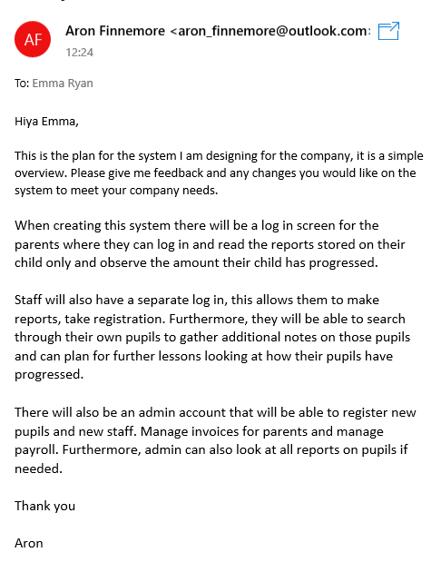
To get feedback for my system plan I emailed Emma, the manager of Upbeat Tutoring, my plan. Below is a screen capture that I sent to Emma. I received an email back from Emma with feedback on the system plan.
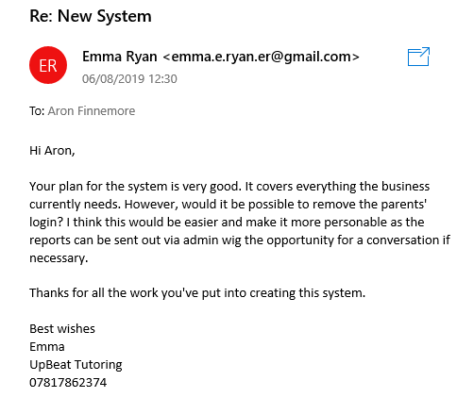

As shown above, Emma was very happy with the system plan but would prefer it if the parents did not have a log in screen so admins/tutors can be in closer contact with the parents. In this case I will remove the idea of parents having a log in screen and instead add a booking function into the system so tutors and admins can book sessions with their pupils and book when cover is needed etc...
Updated aims are below:
- When creating the system there will be a log in screen for tutors and admins. This will allow the tutors to create reports and save additional notes on their own pupils. It will also allow them to book holidays which can be viewed by the admin.
- The admin login will allow them to access all pupils’ reports, edit pupils’ details, add and remove pupils. It will also allow them to book different sessions with different tutors. Furthermore, admin will also be able to manage invoices and payrolls.
- For the tutors and admins there will also be a request section as there may be requirements for certain classes such as specific textbooks, it will allow them to check what resources are available and if not they can request them.

After speaking to the manager of the business, I decided to speak to my teacher and fellow students to get further feedback on my aims for my system and how I can improve the system further.
The main feedback I had off my teacher and students is too make my aims for the system much clearer. They would want to know if I’m saving data on students, pupils, parents, subject and bookings. Is there going to be a search function for all the data saved so it can be accessed. Who is going to access the data, and what processes are involved with invoices and payroll.
From this feedback I have updated my aims further:
- There will be a log in screen for tutors and admin.
- The tutors will be able to log detailed reports on pupils and how they’re progressing on lessons and will be able to log if they have attended their lesson. They will also be able to book cover on the booking system, which has to be approved by the admin.
- The tutors will also be able to search through their own pupil’s reports and contact details for parents so they can plan for further lessons with their pupils and accessing the contact details will be used to change times on lessons or in case of emergencies.
- The admin log in will allow them to save data on tutors, pupils and parent contact details. It will also allow the admin to manage invoices, payroll and booking system.
- The data saved on tutors will be like first name, surname, national insurance number, mobile number, phone number and home address. There will be a search function so the admin can search through each tutors data to manage payrolls and get in contact with tutors.
- Pupils and parents contact details data will include name, mobile number, email address and DOB. There will also be a search function to search through pupil’s data.
- Invoices will be managed by the admin, the system will allow the admin to calculate how much money is owed by the parents so the correct invoices are sent out.
- Payrolls will also be managed by the admin, and the system will calculate amount to be paid to tutors depending on their hourly rate.
- The booking system will allow the tutors and admins to book cover for lessons, change times for lessons and there will be a search function to see what lessons are booked for certain tutors, and what tutors need cover on what days.

