Developmental Testing
Welcome form:
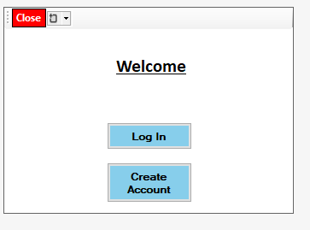

When this form loads in it should create databases if they’re not there. First, I will try and create one database and if it works I will do the same for the rest of the databases.
Code:
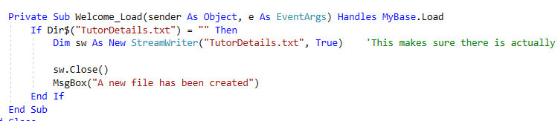
Before Loading form:
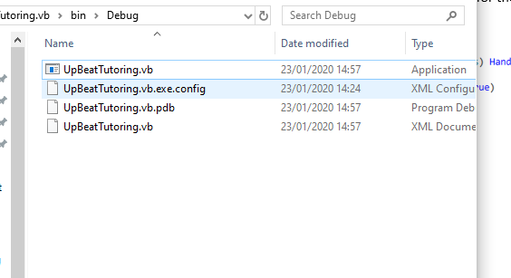
After loading form:
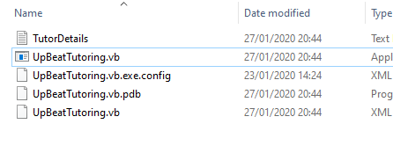
As you can see there is now a database in the debug folder for the system. I will now do the same for the rest of the databases.
Create account form:

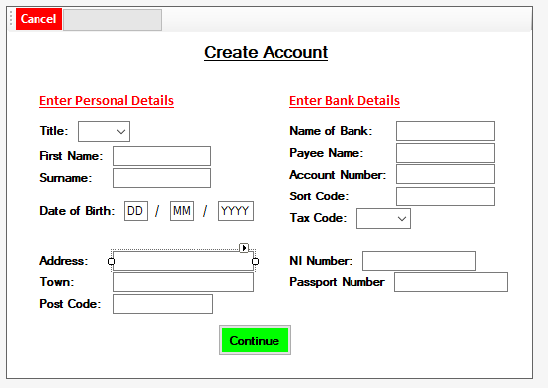
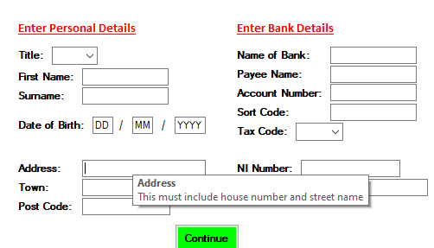
I want to add tool tips to this form to display further information when the mouse cursor hovers over different components. To test this, I will only put a tool tip on address and run the program to see if it works.

This test was successful.
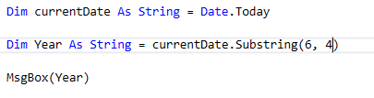
When user clicks continue I want to validate the DOB entered by ensuring that the user is over 16. First by doing this when I click a button I will use the code:
This code will display the current year.

I will run the program to see if this works:
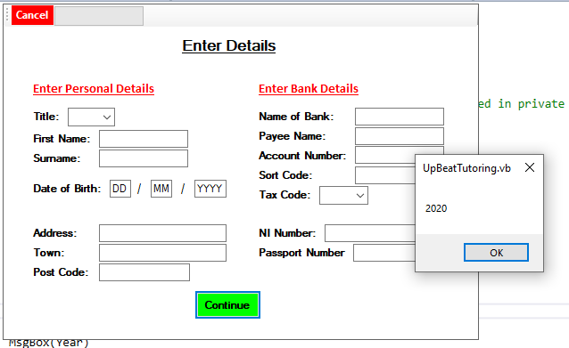

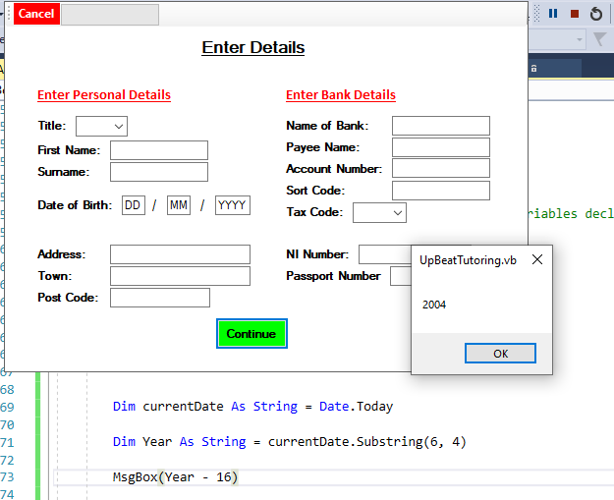
This was successful now I will have to subtract 16 from this, this is to see what year the 16 year olds were born in. I will then output the result in a message box.
This was succeful, I can now validate this using an if statement so if the year is greater than the year shown the user is under 16.

To test this I will input an incorrect year and if successful the system should output “You must be older than 16”.
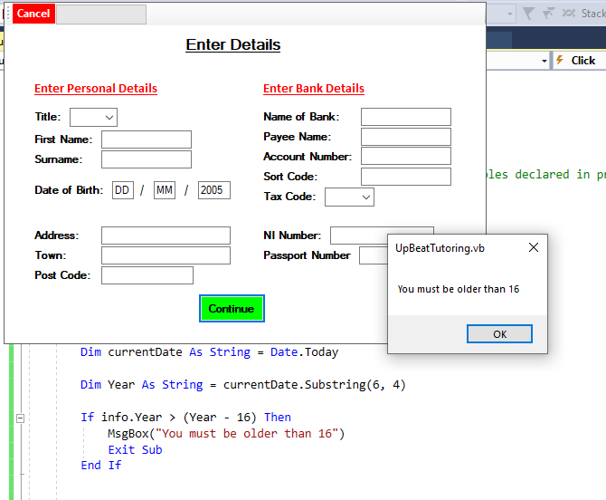
This test was successful, however a problem with this is that they could be turning 16 in this current year but haven’t turned 16 yet as their months are later on.
For example if they input the DOB: 19/12/2004
And todays date is: 28/01/2020
This means they haven’t turned 16 yet.
To fix this problem I will have to validate day and month as well as the year.
First, I will run the program and test if the current day and month can be outputted and stored in a variable. By doing this I will use breakpoint to view the values of variables.
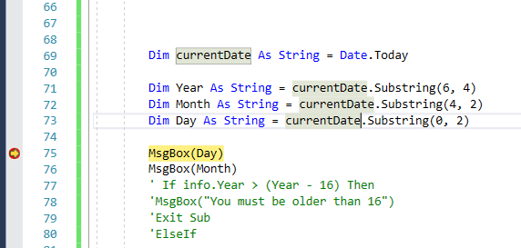
When I hover my mouse over the month variable it shows the value of month as “1/” this is not the current month so needs to be corrected.
For the variable Day it shows “28” which is the correct day so the test was successful for day.
Too correct the variable month I will try : Dim Month as string = currentdate.substring(3,2).
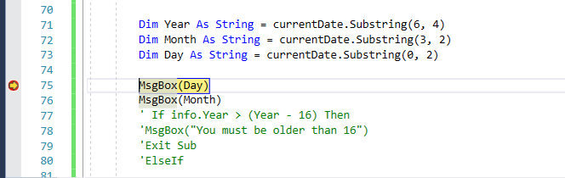

After running the code, hovering my mouse over the variable month it displayed the correct month “01”
To test the validation will work I will input worst case scenario data. First I will input the user is 1 day too young, if message output is “Must be older than 16” test is successful.

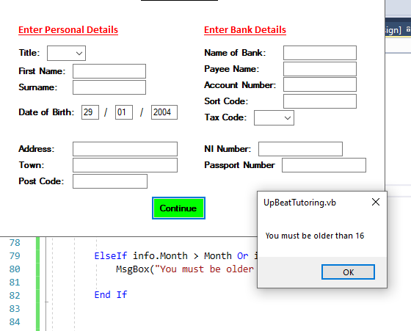
This is successful. I will now enter the DOB as a month too young to check if that is successful also.

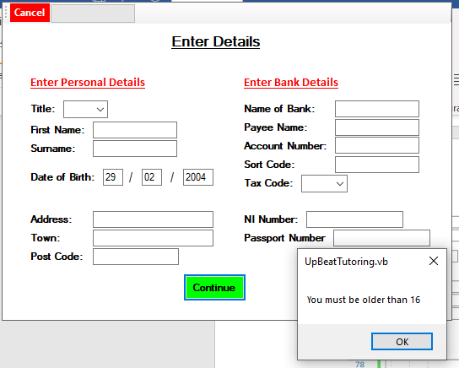
This test was successful, therefor the DOB is validated correctly.
The next test for this form is if the system saves all data inputted by the user. To do this I will input realistic data into the system then look at the database to see if the data has been saved appropriately.
Inputted Data:
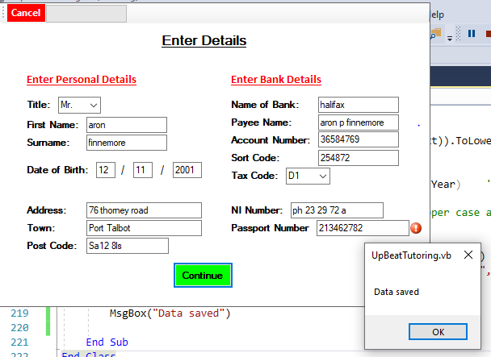

Database:
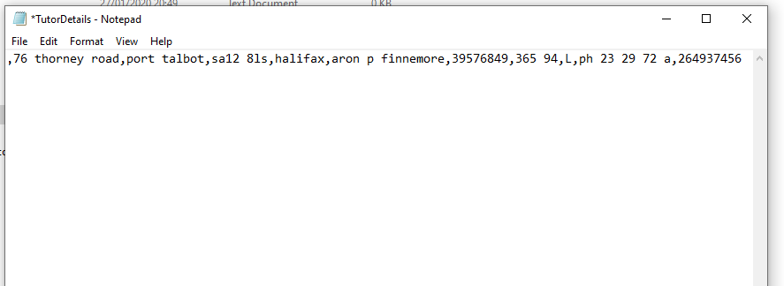

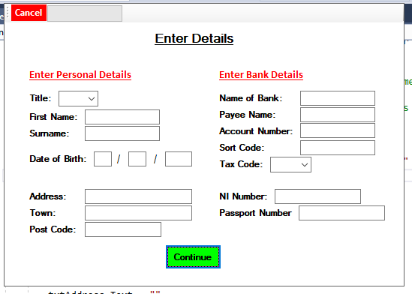
Two issues which I have noticed is that I have saved the NI number with white space so I must save the variable which erases the white space in the NI number. Another issue is that after data is saved the textboxes keep all the data in the textboxes. Therefore, after saving I will make it so the textboxes clear the data in the textboxes.
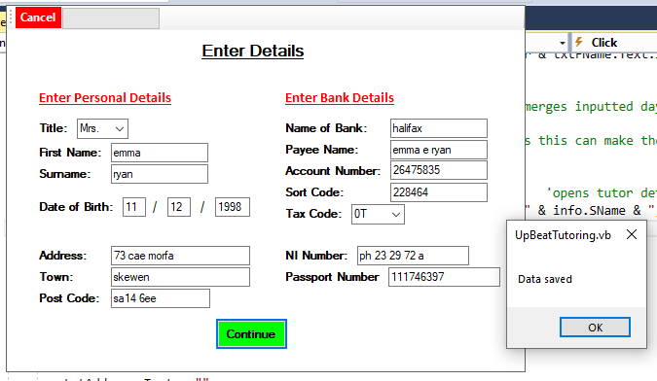

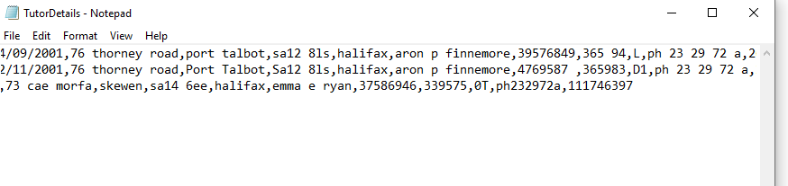
As shown above the data in the textboxes is now cleared after the data is saved, and the national insurance number white space has also been removed.

Contact Details Tutor Form:
To generate a unique ID I created a loop which counted how many contact details are saved. Then the new contact ID would be “CONTACT” & (Amount of contacts saved).
I ran the program and outputted the ID in a message box. There are 0 contacts currently saved so the ID should be “CONTACT0”
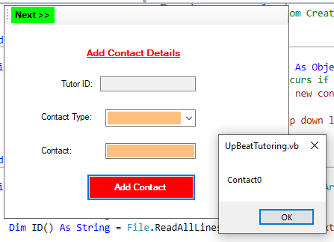

This test was successful.
I will now test to see if the contact details have been saved. To do this I will input real data into the form then check the database to see if the data has been saved.
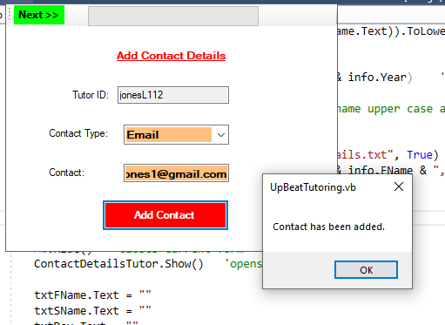

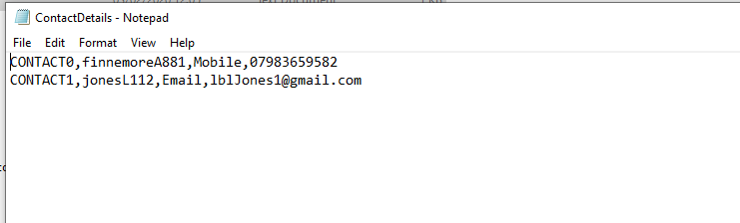
This test was successful and contact ID has been generated correctly when data is being saved.

Create Password form:
I have put in place validation to for a strong password. First I will test to see if the validation for capital letters and lower case letters will work. To do this I will first enter a password all in caps. Then all in lower case and finally a mixture of both. If the password is weak it will output “Password weak” if not it will output “Password strong”.
When entering all caps password and all lower case the system should output “Password Weak”
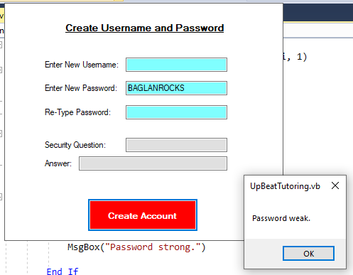
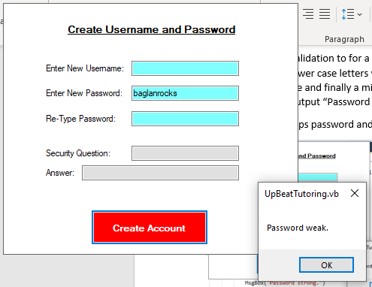
Test successful.
For the next test it should output “Password Strong”
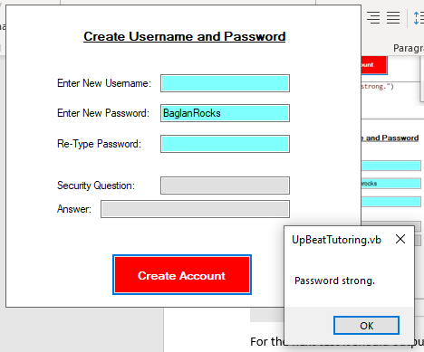
These tests were successful.
Finally, I will test if the data is saved correctly. I will enter real data and then check the data base to see if the data has been saved.
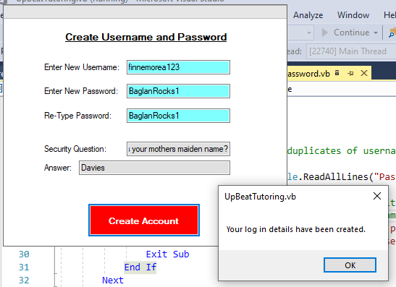
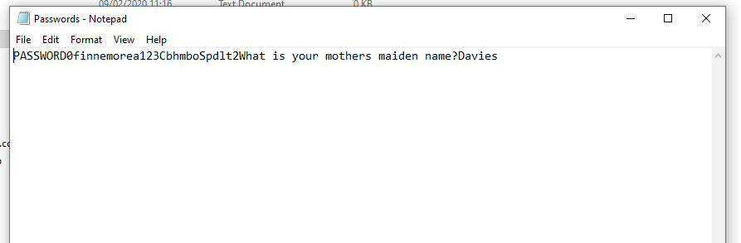
This test was successful in that the data was saved. However, I haven’t split the data with commas which can result in issues when searching for key information. I have changed the code so the data will be split and I will try again.
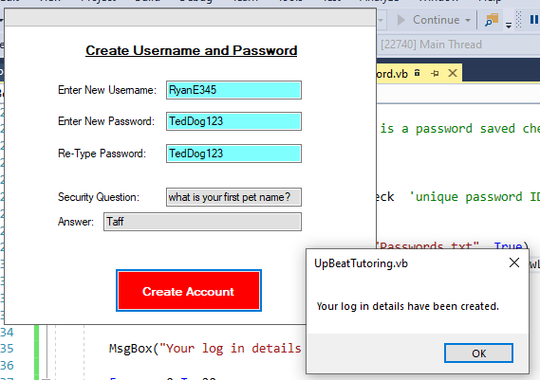

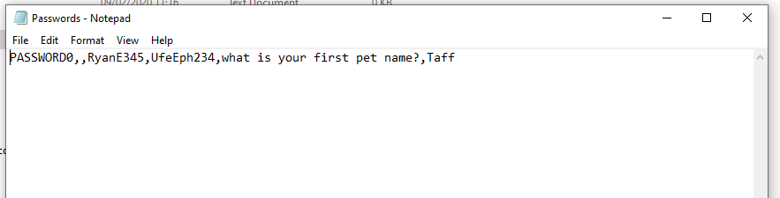
This test was successful.
Log in Form:
When the user is logging in the system will need to decrypt all passwords saved and then check if the user has entered the correct password.
First, I will test if the system decrypts the passwords already saved. To do this I will run the system and if the test is successful it will output a decrypted password.
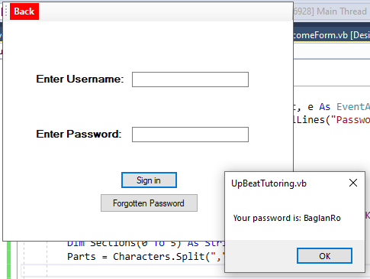
This test is successful as this is the decrypted version of the password saved.
Next I will save multiple passwords to get the system to output more than one decrypted password.
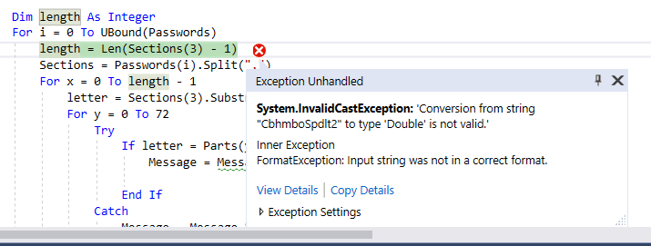
This error occurred whilst decrypting multiple Passwords.
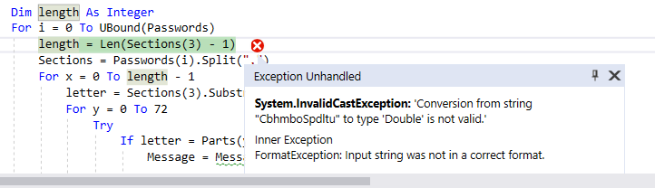
First I checked to see if it was the number in the string which affected it so I changed the number to a letter but still the same error popped up.
I will now switch the line with “Length = len(sections(3) -1)” with “Sections = Passwords(i).split(“,”)” as I believe the code is not moving to the next password before counting the number of characters.
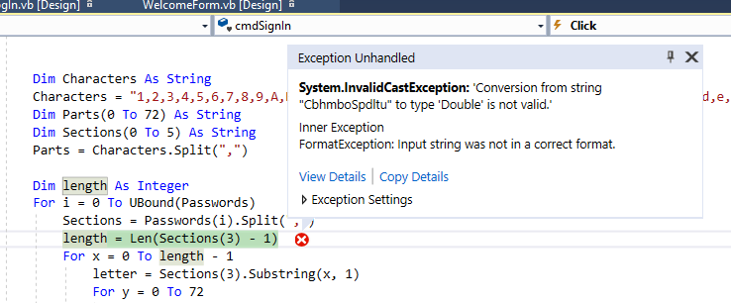
This error has still come up after the lines of code has been switched. I will now try to take – 1 outside of the bracket.
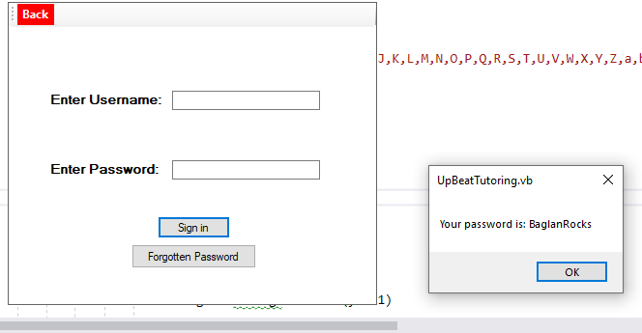
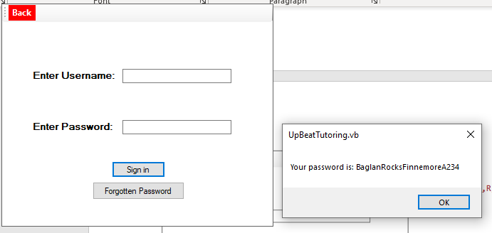

This time no error has popped up but the decrypted passwords are being joined together instead I want them as a separate string.
So to fix this I will clear the output box after it has outputted and this should then output all decrypted passwords separately.
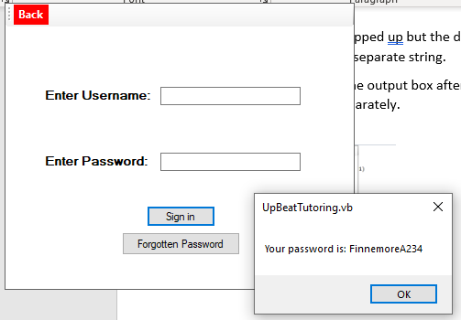
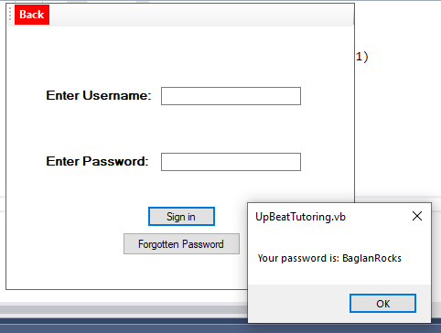

The system can now decrypt multiple passwords and store them separately in a variable. This test was successful. The next stage is to now input a password and compare it to all decrypted passwords.
To test this I will first enter a password which matches one of the decrypted passwords and if successful it will output (“Password correct”).
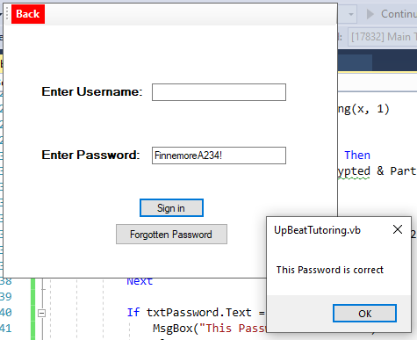
This test was successful. I will now test this by inputting an incorrect password. If successful it will output “Password is incorrect.”
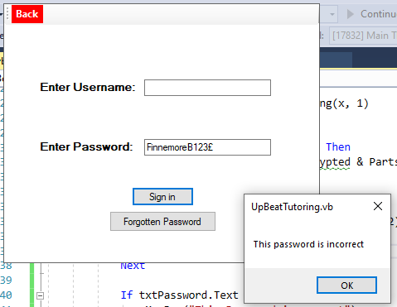
This test was successful.
Finally to test the log in, I will first log in as a admin and if the system takes me to the admin menu then the test is successful.
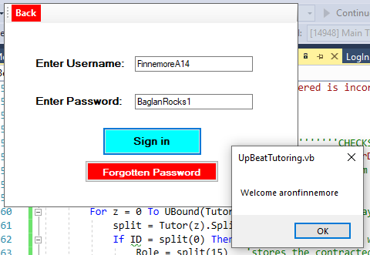
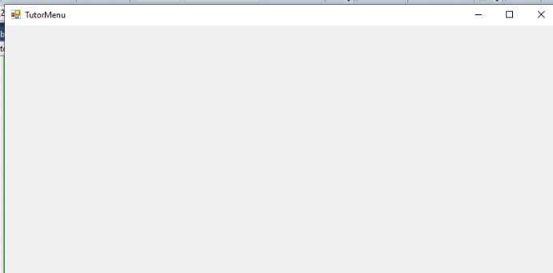

This took me to the tutor menu. This test was successful. Now I will enter an admin and if it takes me to the admin menu then the test is successful.
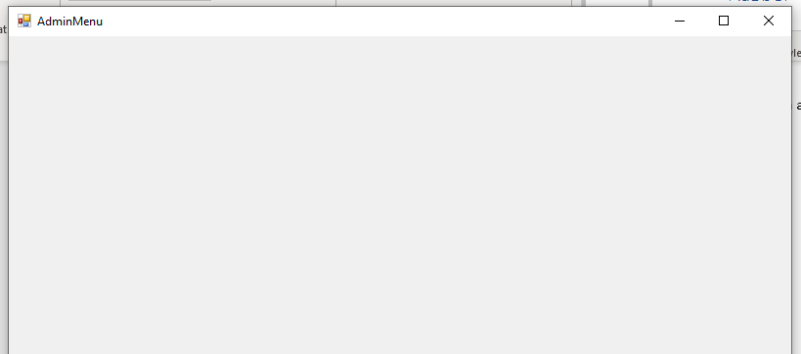
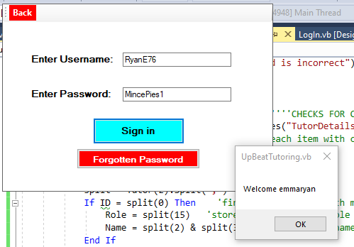

Forgotten Password Form:
I am going to test if the system can recognise if the user has entered the correct answer to the security question. If this test is successful it will display the username and password in the text boxes.
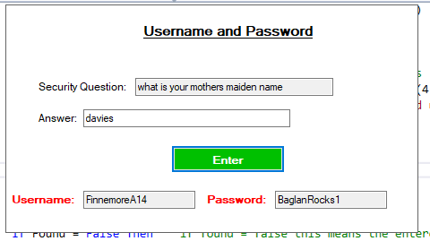
This test was successful as it displayed the expected username and password.
I will now test if the system displays an error message if I enter an incorrect answer.
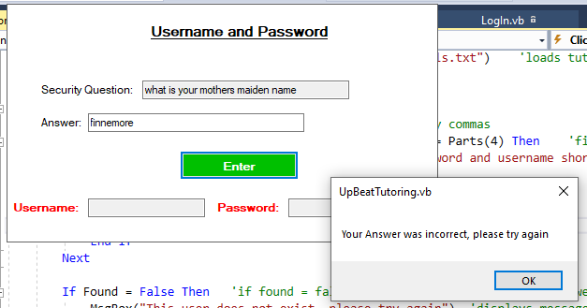

This test was successful.

Add New Pupil Form
First, I will test the subject drop down box. When I select other the system should allow me to add a new subject to the drop-down box.
To test this I will first select “other” then type “NewSubject” this then should be added to the drop down list.
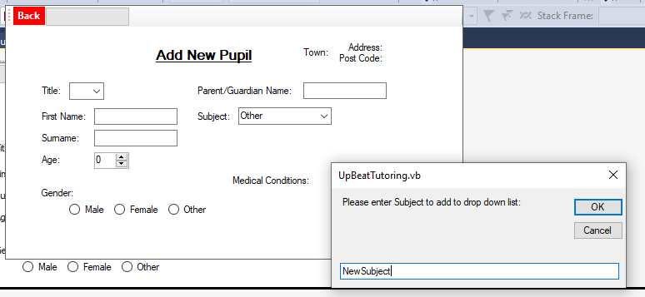

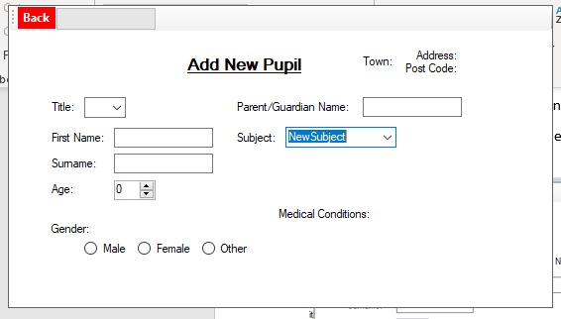
This test was successful.
Next I will test the radio buttons. By doing so any button I select (Male, female, other) it should output in a message box.

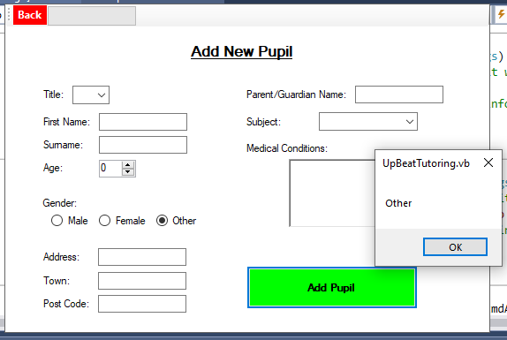
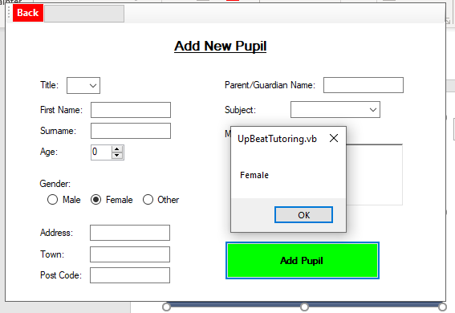
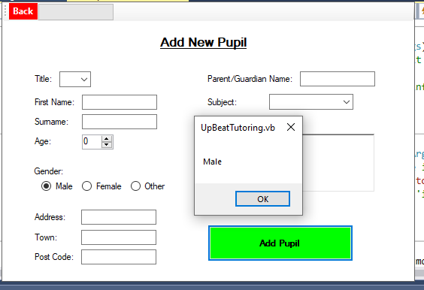

Next I am going to test if the form saves all data entered correctly. By doing this I will save real data then check in the text file if the data has saved.
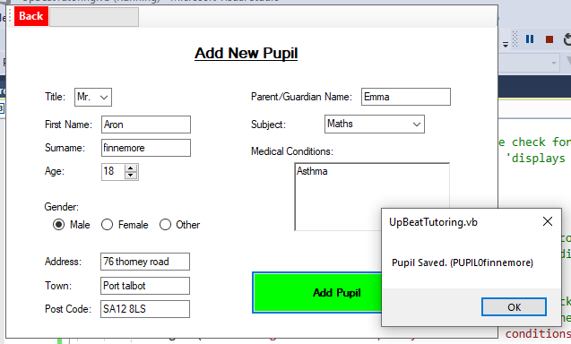
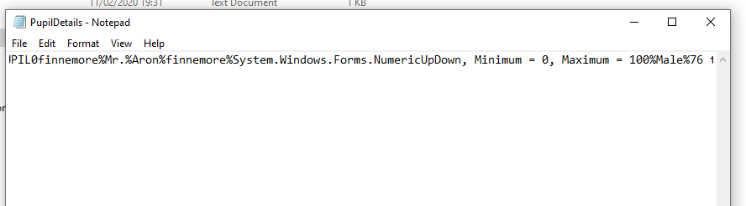
Data has been saved incorrectly. Age has been saved as “System.Windows.Forms.NumericUpDown”. I have changed the code so it saves as txtAge.Value. I will retry to save data.
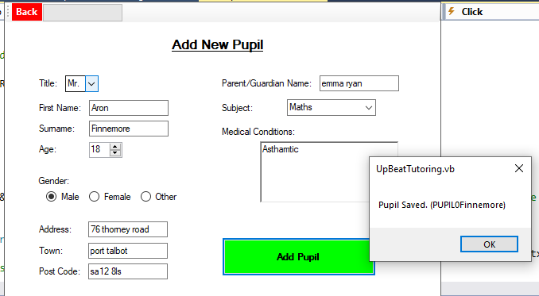

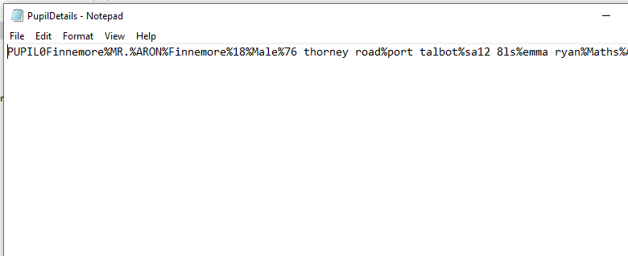
Data has been saved correctly, test is successful.

Search Pupils form
First, I will be testing if when the form opens it will sort the database into ascending order. To do this I will organise the data in the database so its mixed up and then after I have opened the form I will check if the data has been sorted. To sort the data, I will be using bubble sort.
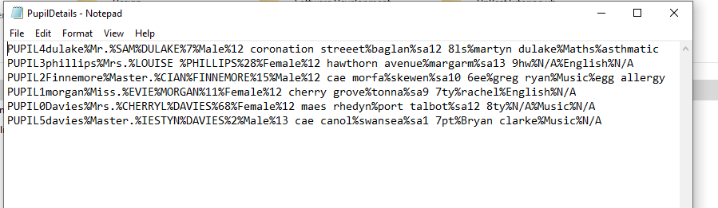
I have organised the data, so it is worst case scenario.
In the unique ID there is a number, I want to be able to store just that number in a variable as it’ll make the array. I will first get the system to output just the number in all the ID’s so I know they can be accessed.
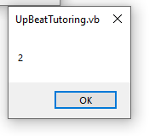
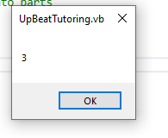
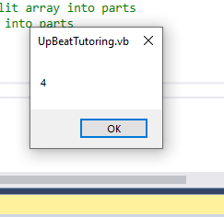

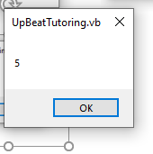
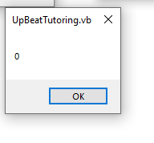
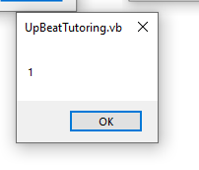

This test was successful.
I will now sort the array and save it back into the database, I will compare the original data with the sorted data to see if it was successful.
Sorted Data:
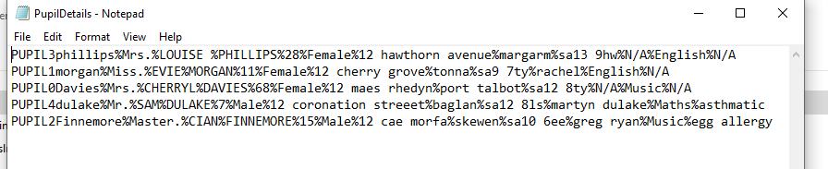
Original Data:

This test was unsuccessful. It only sorted Pupil4dulake up until the one but last. And it has removed the final data Pupil5davies.
To fix this I will retrieve the number in the ID in the inner loop instead of doing it in the outer loop. This should fix the sort. I will then create a completely separate loop to re-save the array into the text file.
I will now re-test the system.
Sorted data:
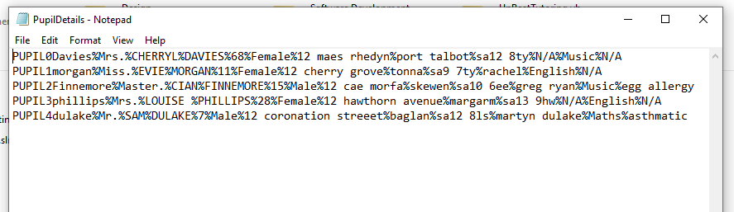
Original Data:
This test the data was sorted into ascending order therefor the test is successful.
Next I will be testing if the new data entered will overwrite the original data in the textbox. To do this I will change data for a certain pupil click save and then check the database to see if it worked.
Original data:
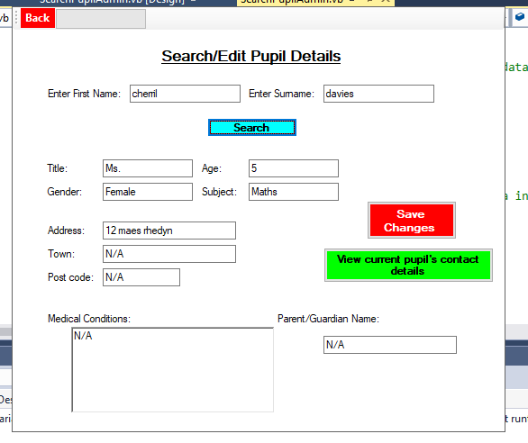

Edited data:
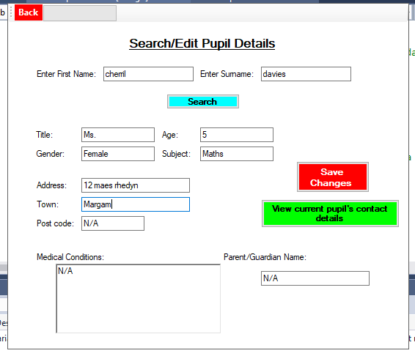

Changed town to “margam”
Database:
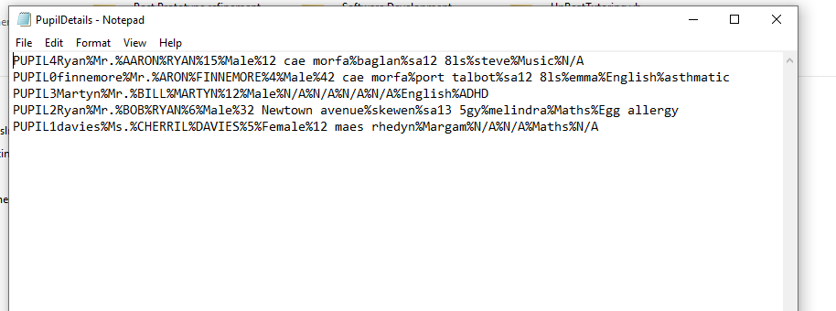
Edited data has been changed in database therefor test was successful.
View Pupils contact details form:
I will test if the form displays all contact details for pupil (“Cherril davies”).
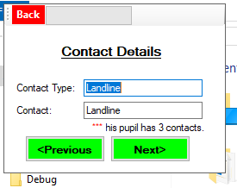
This is an error with displaying the correct data. It has displayed the contact type twice. Also the label for displaying a message to the user has some spelling issues, which needs to be fixed but has displayed the correct number of contacts for that pupil.

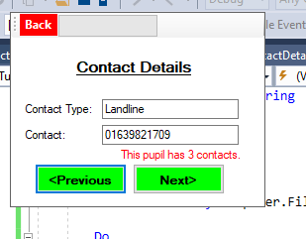

It is now displaying the correct data, however when I am clicking next or previous it will not change to the next data in the array. Therefor there must be an error in the code in the next and previous buttons. This error could be the display code.
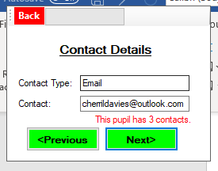
I have changed the code and re-tested it:
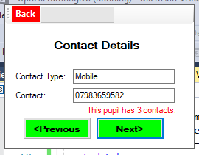
I was able to click the next and previous buttons to display the data. Therefor test is successful.
Add Bookings form
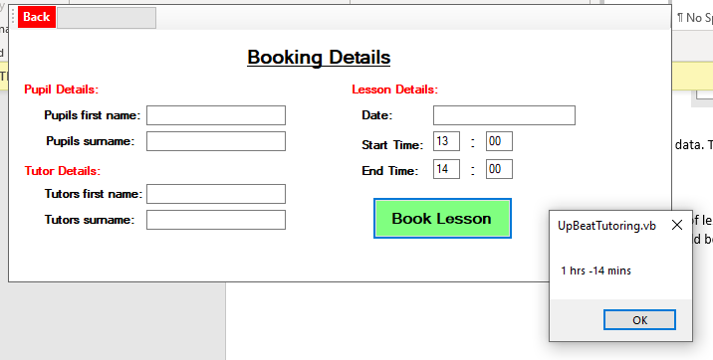
To begin with I want to test if the system calculates the duration of lessons correctly. I will input 13:00 for start time and 14:00 for end time the output should be 1 hr and 00 mins.

The hour has been calculated correctly. However, the minutes haven’t. I will make changes to the code and try again.
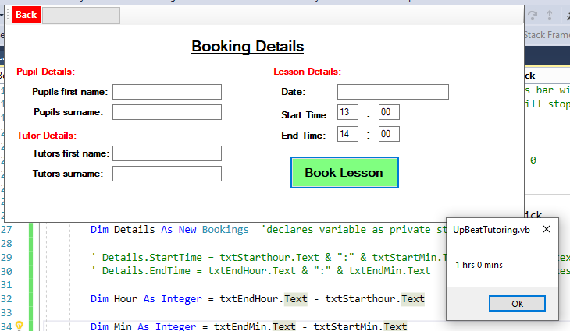

Everything has been calculated correctly. Therefor test is successful.
Next, I will test if the details have been saved in the bookings database. I will enter real data and then check the database to see if the data has been saved correctly.
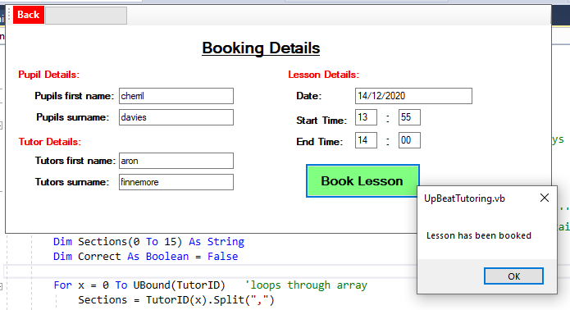
Database:
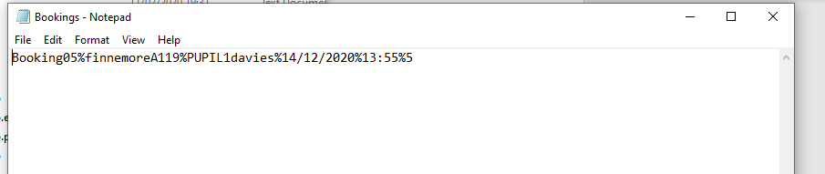
Data has been saved correctly. Therefor test was successful.
View Bookings form:
First I will test the system for searching for the correct tutor. I will input an existing tutors name e.g. “Aron Finnemore” and it should output the tutors ID e.g. “finnemoreA119”.
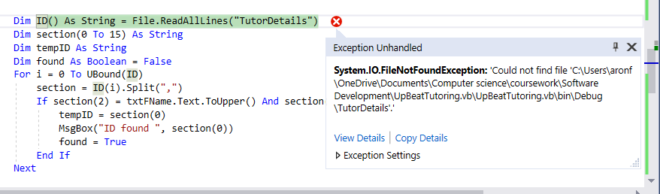
This error occurred. An easy fix I will add “.txt” on the end and then test again.
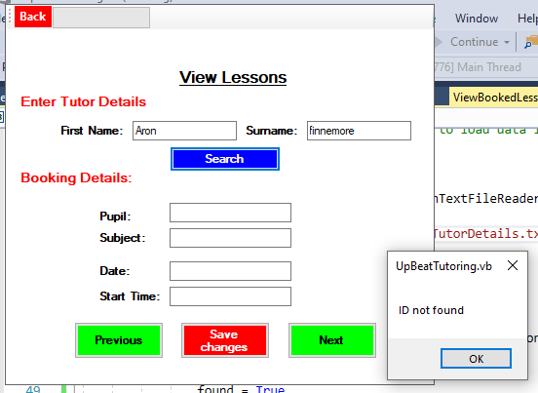
This is an error as it has outputted ID not found for an existing tutor. This is an error with the searching code. I will fix this and try again.
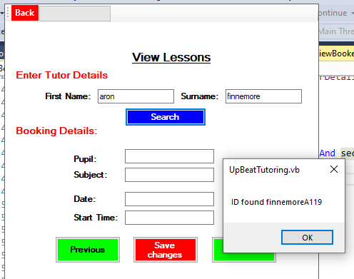
This test was successful. I will now input a non existing tutor and see if it output ID not found.
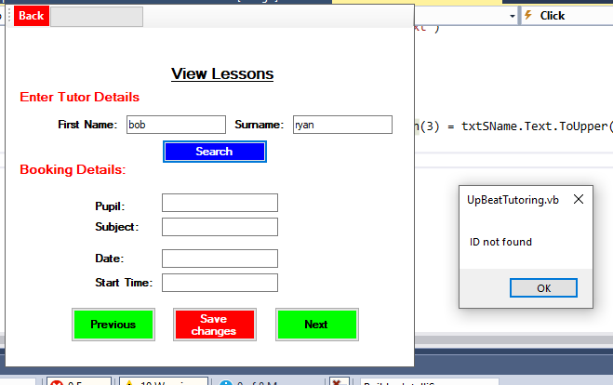
This test was successful.
Next I will test if the system searches for the bookings for a particular tutor. It should also allow the user to click next or previous to see other bookings. All bookings displayed should be the date following todays date which is 25/02/2020.
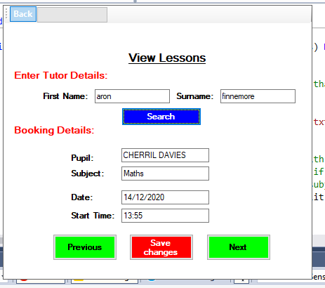
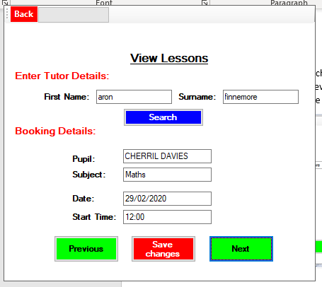

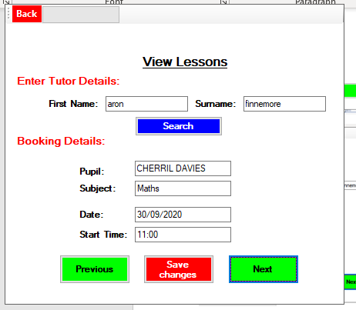
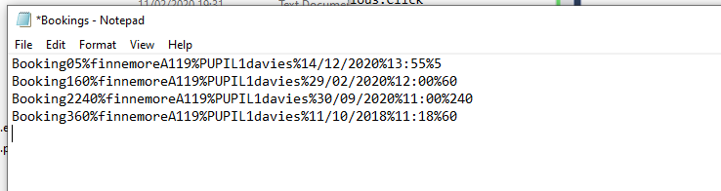

This is the data stored. As you can see the system didn’t output the booking with date 11/10/2018 as it’s before todays date. Therefor this test was successful.
Next, I want the bookings details to be outputted in ascending order.
To do this I have used an insertion sort.
I will test this and run through the next button to see if the system outputs the earliest date first and the latest day last.
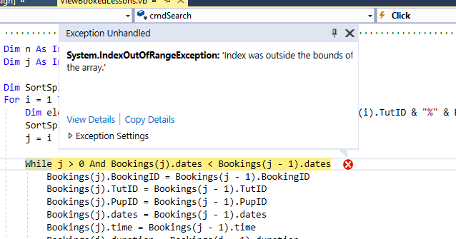
This error means that the system has tried to search for a value outside the range of the array. I will change the code and re-test.
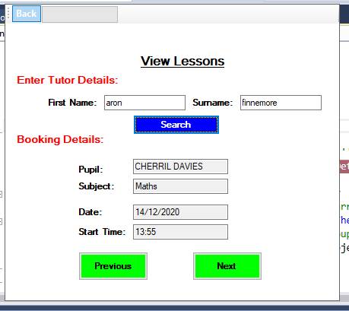
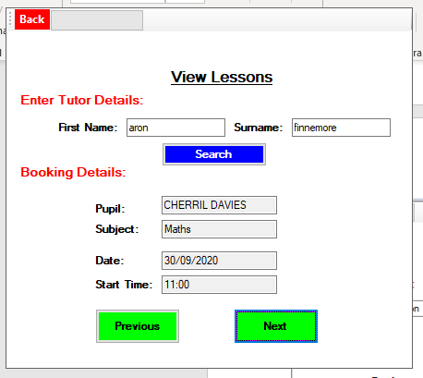
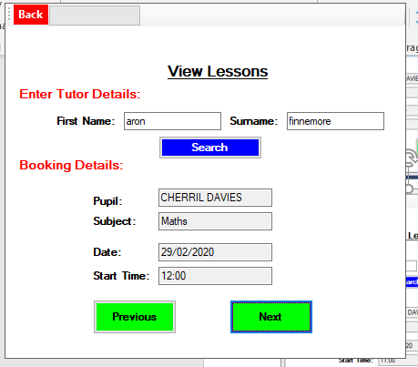
This is displaying the data in descending order, when I would prefer it to be in ascending order. I will change the code and try again.
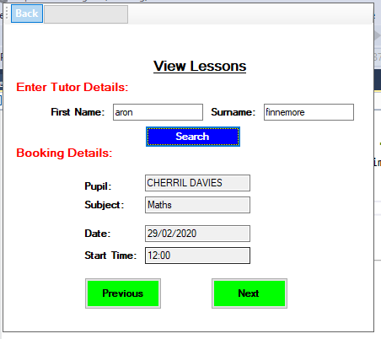
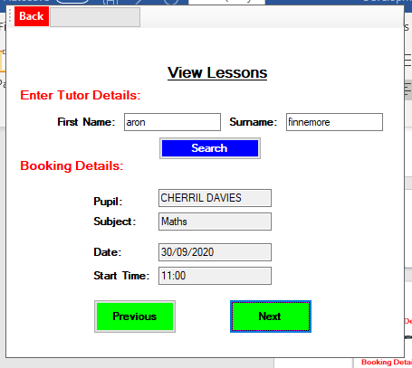
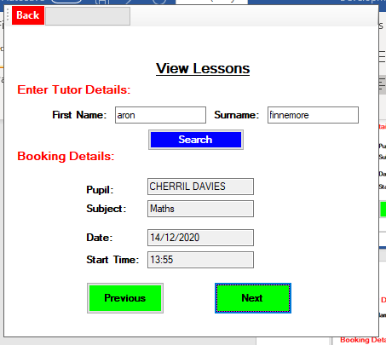
This is now in ascending order. Therefor test was successful.

Search/Edit Tutor details
For the drop-down box I would like to show the tutor names in alphabetical order. To do this I have used a bubble sort. I will test this by running the program and clicking on the drop-down box and if it is in alphabetical order then the test will be successful.
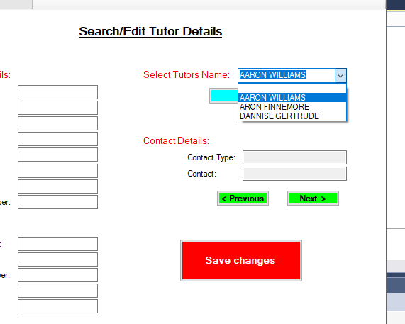
This array is sorted but however it has removed a tutor, “Emma Ryan” I will change code and try again.
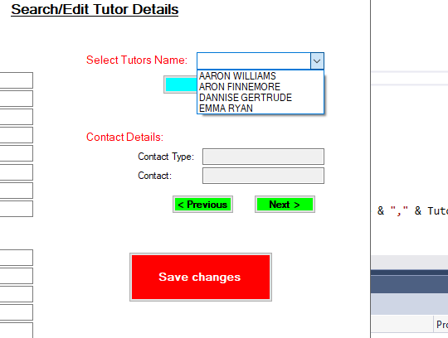
This test was successful as the tutor names have been ordered alphabetically.

Next, I have loaded the contact details for the tutor they’re searching for into an array. I will test this by outputting the initial values in the contacts array into the textboxes.
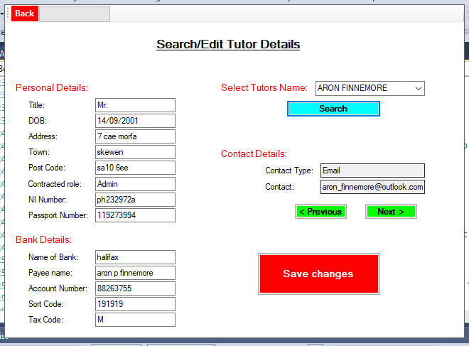
This displays the original contacts in the array for the tutor “Aron Finnemore”. Therefor test is successful.
Next, I want to save any changes made to the tutor. To begin with I have to encrypt the new bank details entered. I will test this by inputting new bank details and then the system should output the encrypted versions of those bank details.
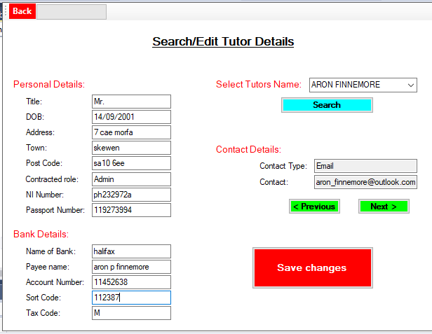
The new bank details are in the textboxes account number and sort code.

Encrypted versions:
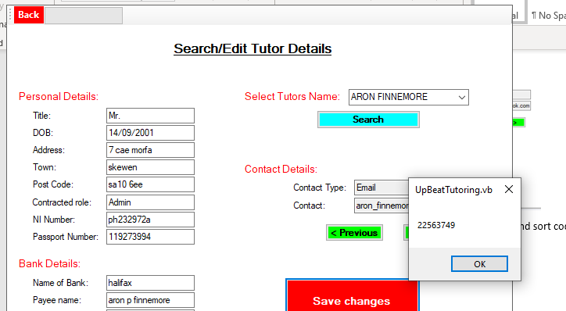
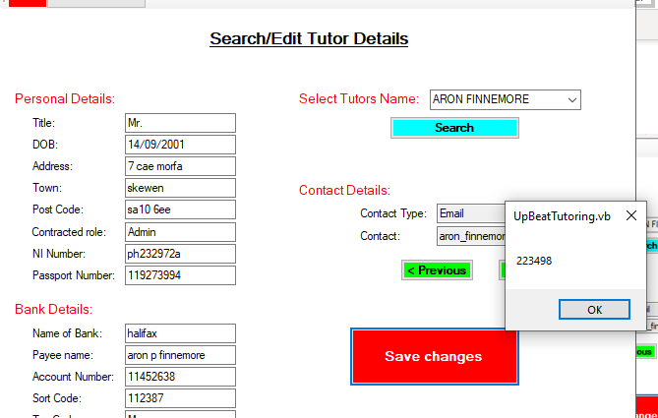
This test is successful.
Next, I will test if the old data is overwritten with any changes to the new data. I will change the data in the textboxes and click save. I will then compare the old data with the new data.
Original data:
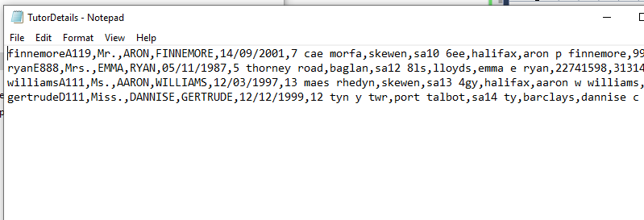

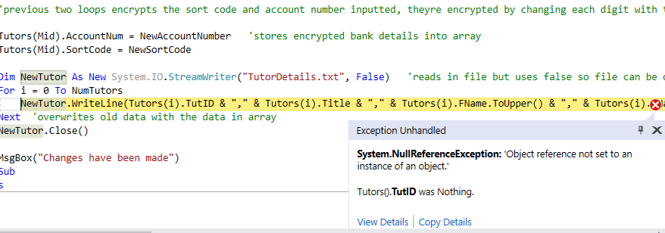
This error occurred meaning the tutor ID is not set to anything.
I will change the code and try again.
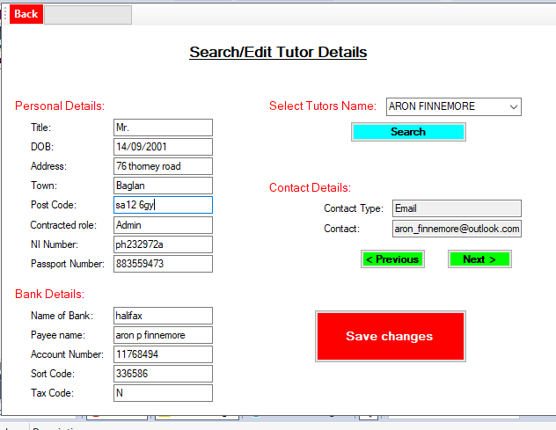

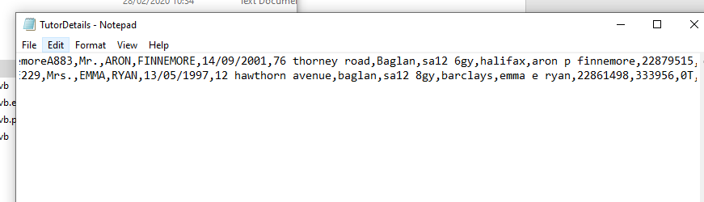
The changes have been made therefor the test is successful.
Add Report Form:
I want to validate the time entered for the beginning of the lesson by doing a range check. First I will test if the system will display an error if I entered a number greater than 60 or less than 00, for the minutes of the time.
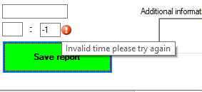
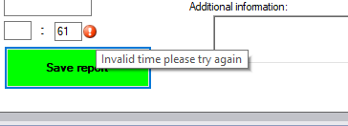
This test was successful. I will now validate the hour for time, I will enter an hour greater than 23 and less than 00. If it displays an error message then the test is successful.
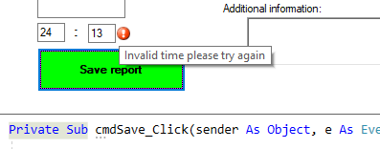
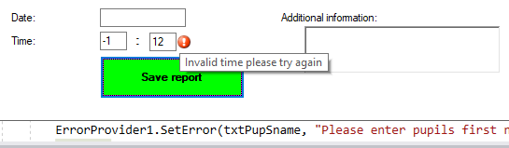
This test was successful.
Next I will test if the report has been saved correctly. I will enter real data click save and then check the file to see if the data has been saved.
Data inputted:
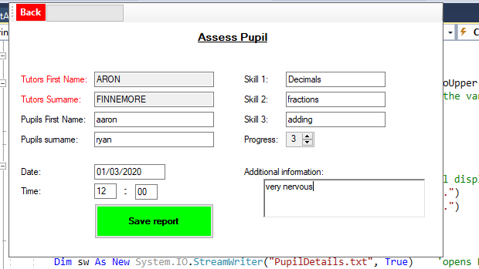
Database:
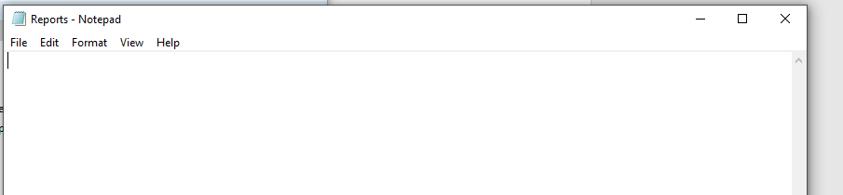
The file is blank, the data got saved to the wrong file. I will change the code then input the same data.
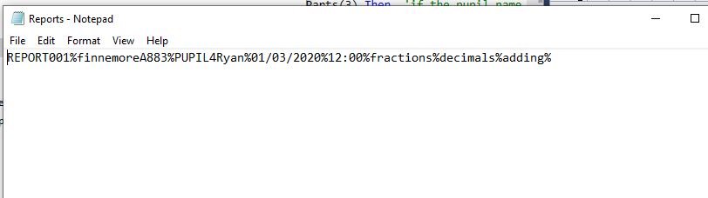
Data has been saved but the progress and additional information wasn’t saved as well. I will change the code and try again.
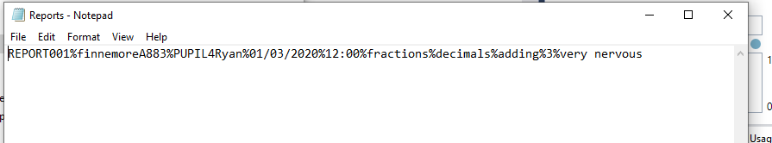
All data has been saved correctly. Therefor test was successful.
Search Reports form:
First, I will test if the system is able to search for a pupil. By testing this I will input an existing pupils name and the system should output that pupils ID if found.
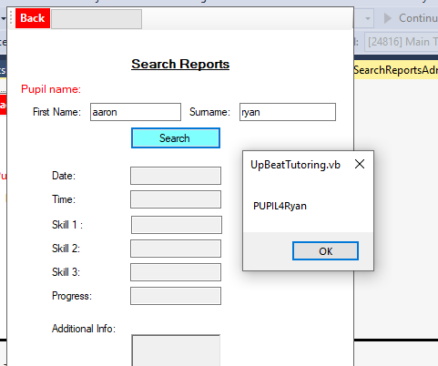
Pupil was found therefor test was successful.
Next I will test if the system outputs the data in ascending order. I have saved reports on a pupil in descending order. When the system runs it should output this data in ascending order by date.
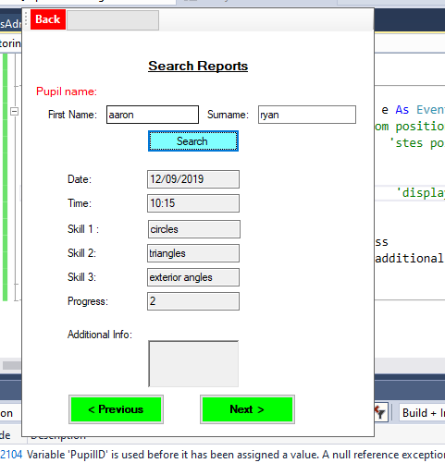
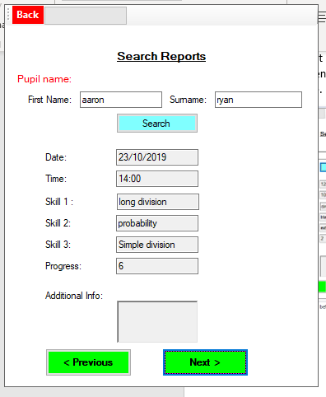
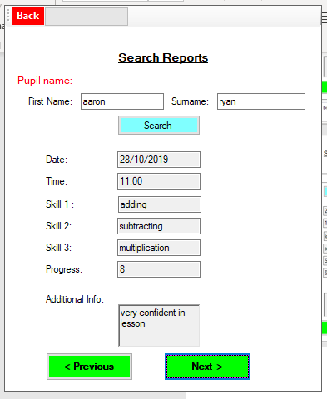
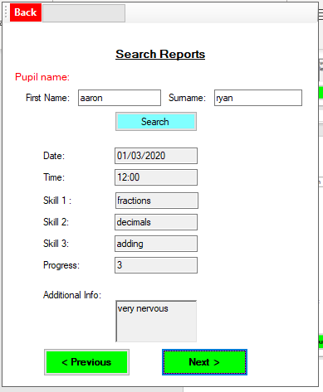
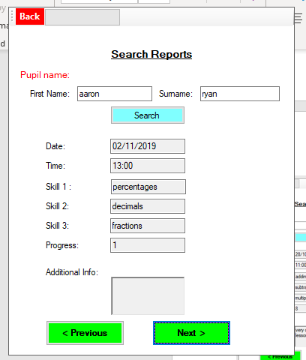

Create Payroll Form:
First, I will select a tutor from the drop down box, and test if the system outputs all the correct data on that tutor (not including account number and sort code).
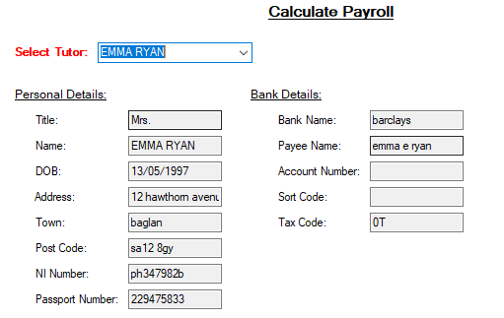
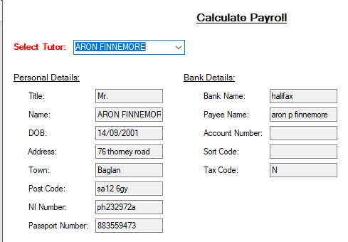
This test was successful.
Next I will test if the payroll data is saved correctly. I will enter real data and click save. I will then check the payroll file to see if the data has been saved correctly.

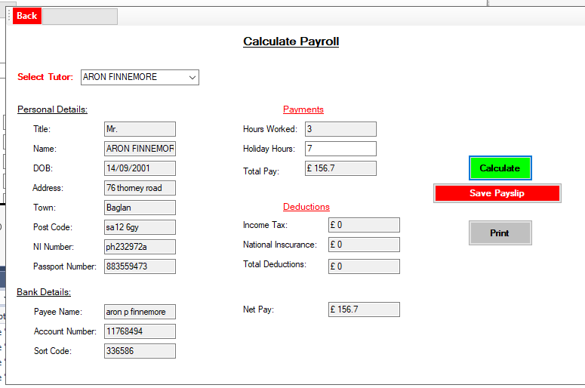
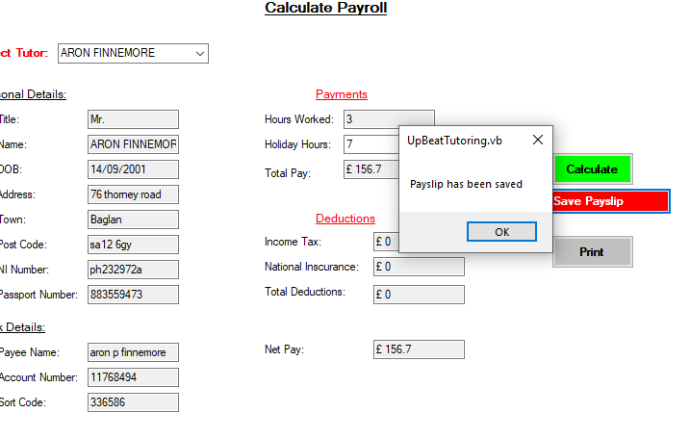
Database:
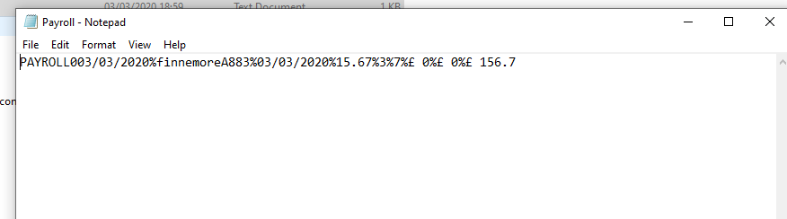
Data has been saved correctly. Therefor test is successful.

Search Payroll:
First I want to load in the payslips for a specific tutor selected, this data will be loaded into an array. To test if the data has been loaded into the array properly. I will get it to output each Payroll ID stored in the array.
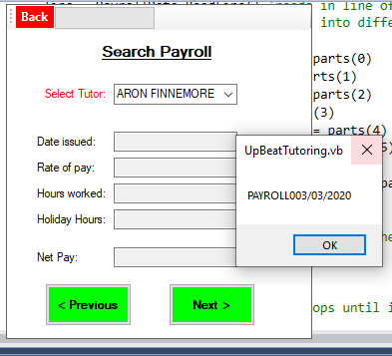
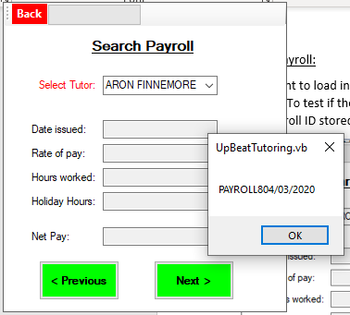
These are all the payrolls for the tutor selected therefor test is successful.

Next, I will test if the payrolls for a specific tutor is outputted in order.
I will select a tutor and screenshot all payrolls outputted on that tutor.
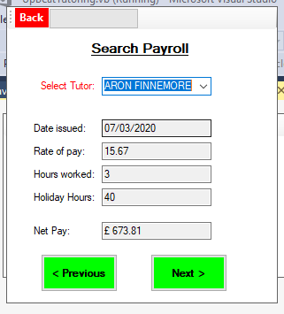
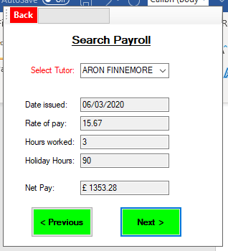
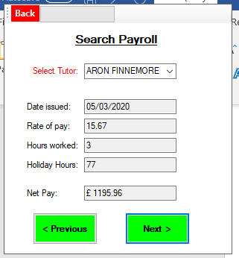
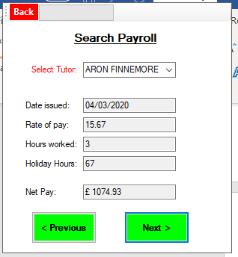
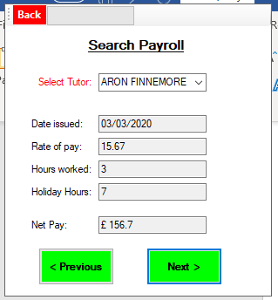
This test was successful as it outputs the most recent date first.
Add New invoice form
First I want the pupils names to be displayed in alphabetical order. I will run the code and click the drop down box to see if it has been sorted correctly.
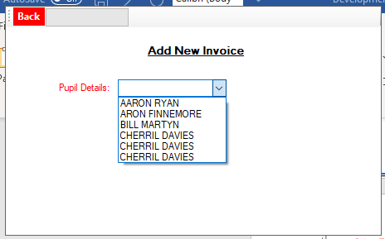
This test was unsuccessful as its displayed Cherril Davies 3 times.

I have changed the code, I will test again.

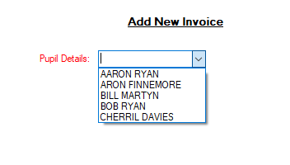
Names have been displayed in alphabetical order therefor test was successful.
Next I will test if the invoice has been saved correctly.
I will enter real data then click save and check file to see if the data has been saved.
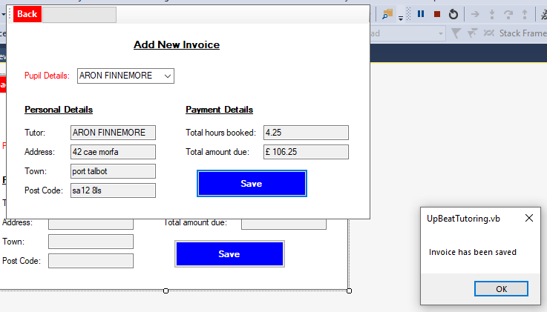
Data base:
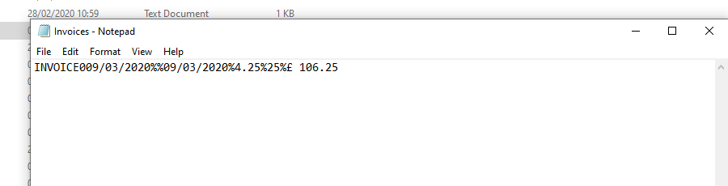
All data has been saved apart from pupil ID therefor this attempt was unsuccessful.
Changed code and retryed test.
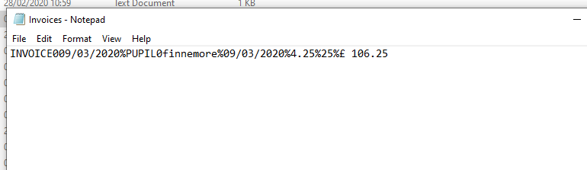
This time the pupillid has been saved therefor the test was successful.
Search Invoices Form
First, I will test if the system stores the correct pupillid for the selected pupil name. I will search for a selected pupil where the pupillid will be stored in a variable. I will output the variable to check if it is the correct pupil.
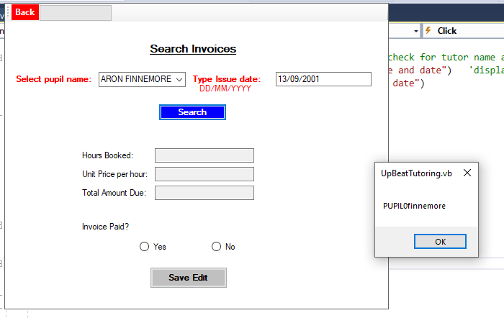
This is the correct pupillid for the selected pupil.
Next I will test if it finds the correct Invoice for the date entered by outputting the information in the textboxes.
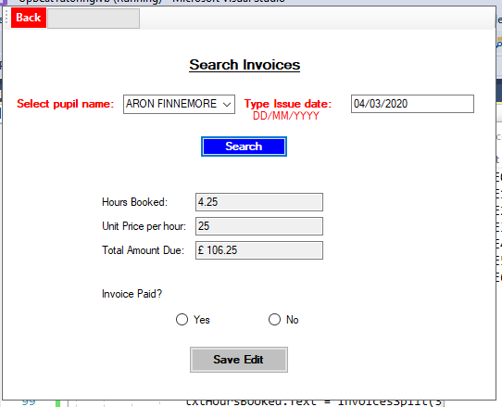
The correct details have been outputted therefor the test was successful.
Next I will test if the data can be saved in the database Over Due invoices. The data saved should be the overdue invoices primary key, invoices ID foreign key and if the pupil has paid its fee.
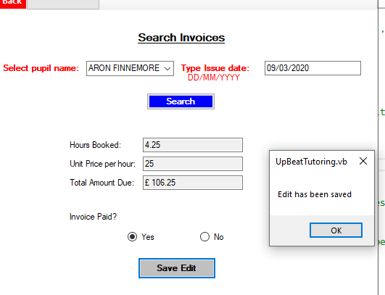

Database:
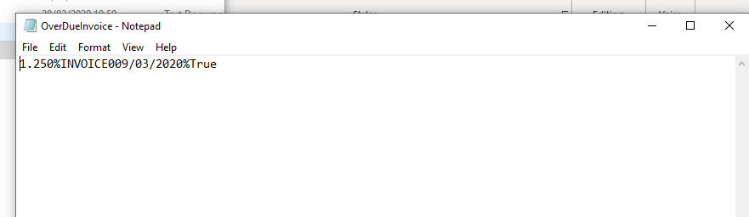
Data has been saved correctly therefore test was successful.

Overdue Invoice form
I will test if the rich textbox displays all the pupils who have not paid their invoice. It is only overdue if it is 14 days after the issue date.
I will compare the database to the textfile.
Database:
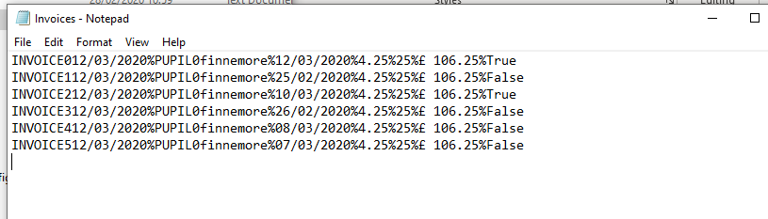

Form:
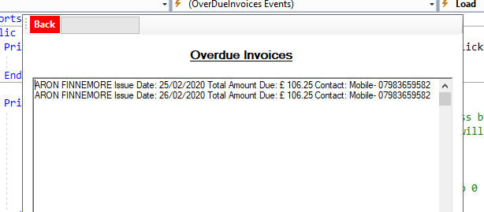
This displays only the invoices which are 14 days after the issue date who haven’t paid. Therefor the test was successful.

Own Details form
This form will display all details of the tutor who has logged in. It also has a next and previous button for the contact details saved on that pupil.
I will open the form and test if all the details displayed is correct.
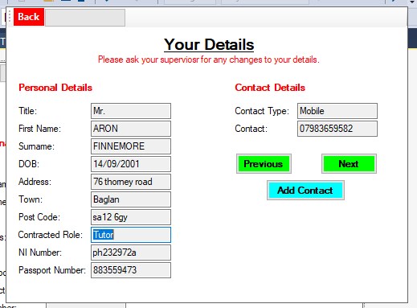

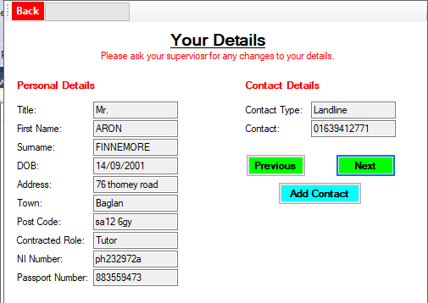
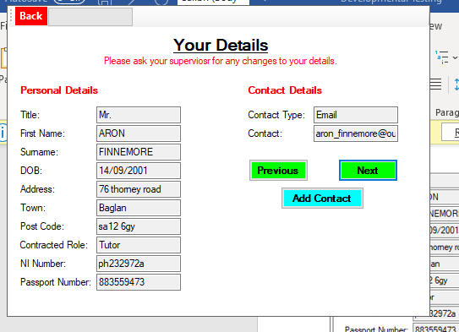
This showed all the details of the tutor, also shows the next and previous buttons working fine therefor this test was successful.
ViewOwnBookings form
I will first test if the data is displayed in order of date.
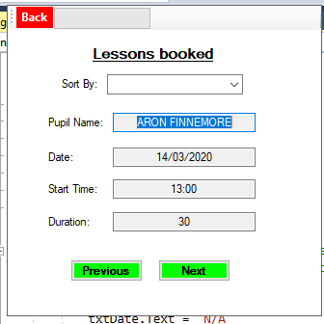
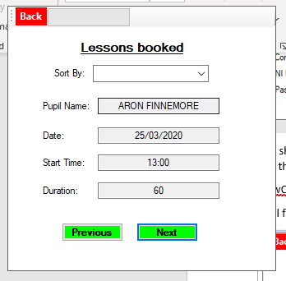
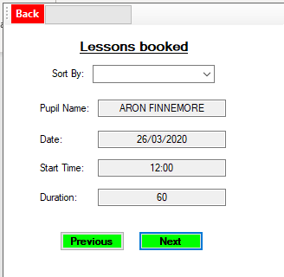
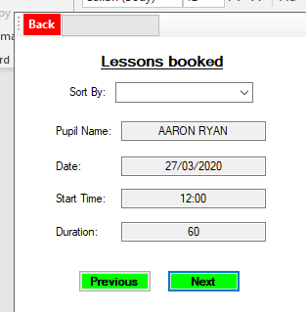
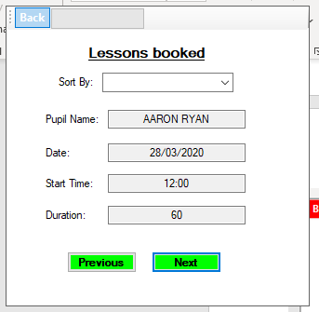
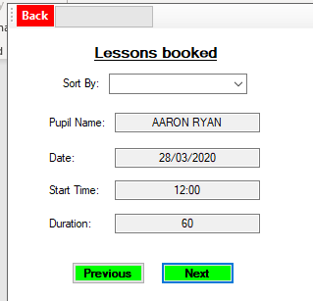
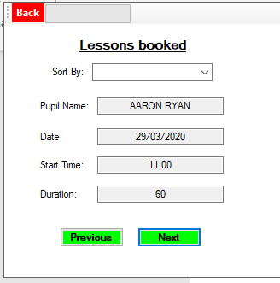
These dates were displayed in ascending order. I tested this by opening the form then clicking the next button which displays the next data item in the booking array. Therefor the test was successful.

