Design

Overview of the system (Admin access) Admins have full access to the program
Start
Load Form
Log in screen
Forgotten Password
Back to log in
Menu
Invoices
Payroll
Pupil Details
Tutor Details
Bookings
Reports
Add New report
View/Edit Reports reports
Add New Invoice
Search/edit Invoice
Add New Payroll
Search/edit Payroll
Print Invoice
Print Payslip
Log in confirm
Add New Pupil
Search/edit Details
Search/edit Details
Book new lesson
View/edit bookings
Log in confirm
Log in confirm
Log in confirm
Log in confirm
- Load form – Welcomes user
- log in – unique sign in details depending on stakeholder to log into the program.
- Menu – Gives options of what functions are available to user
- Log in confirm – simple passcode to strengthen security.
- Invoice – Allows user to add new invoices/edit and search. Also prints new invoices.
- Payroll – Allows user to add new payroll and edit/search. Prints new payslips
- Pupils Details - Adds new pupils. Search/edit details
- Tutor Details –Search/edit details.
- Bookings – Book new lessons, change bookings times and view bookings
- Reports – Create new reports on pupils, view all reports/edit
Add New Tutor
Back to log in

Overview of the system for tutors. Tutors have restricted access to the program.
Sign In
Main Menu
Reports
Tutor’s Pupils details
Bookings
Own Details
Create new Report
View previous Reports
Print Report
Search for own pupils

View own booked lessons

View/edit own details

- Sign in – User signs in with unique log in details
- Main menu – Gives user different options within the program
- Reports – Creates new reports, Views previous reports. Can also print reports
- Tutors pupils’ details – Gives access to only pupils allocated to that tutor. Tutor can only view emergency contact details and any medical conditions.
- Bookings – View booked lessons for that tutor
- Own details – Allows user to view personal details of themselves and can edit them if necessary.
- Sign in allows user to create new account by adding a new tutor. And if user has forgotten their log in details they can also access the forgotten passwords form to retrieve their password
Add New Tutor
Back to log in
Forgotten Password
Back to log in
Start

Files
- File Name – Pupil Details
File description – This file will store all data related to the pupils who are registered with Upbeat Tutoring. These details would include, name, dob, address...
File capacity – The number of items in this file could increase as additional pupils will join.
Field Name | Primary Key | Data Type | Size | Validation
PupilID | Yes | Integer | 9 | Presence check. Example:  If PupilID = “” then print ”Error”
First Name | No | String | 25
Surname | No | String | 25
Gender | No | String | 6 | List check example:  If <> “M” or “F” or “Other” print “Error”
Age | No | Integer | 3 | Range Check  Example:  If Age< 0 then print “Error”
Parent/Guardian Name | No | String | 25
Subject | No | String | 10 | List check example:  Subject = “Maths” or “English” or “Science”
Medical Conditions | No | String | 50
File access – This file will be accessed serially so the user can search through the details using certain criteria to find the pupils details. As the file access is serial this also allows the pupils details to be edited if needed. Data can be loaded into an array which has random access.

- File Name – Tutor Details
File description – This file holds individual employee details. These details would include bank details, personal information, and any other useful information.
File capacity – The number of items in the file is most likely to increase. Due to new employees.
File access – This file will be serially accessed this will allow the user to search for details and edit details. Data can be loaded into an array which can be random access.
Field Name | Primary Key | Data Type | Size | Validation
TutorID | Yes | Integer | 9 | Presence check example:  If TutorID = “” then print “Error”
First Name | No | String | 25
Surname | No | String | 25
Dob | No | String | 10 | Format check Example:  Correct like */*/*  If dob <> correct then print “Error”
Contract Type | No | string | 10 | List check  Example:  Contract = “Tutor” or “Admin”…
National Insurance Number | No | String | 9
Passport Number | No | String | 9
Name of bank | No | String | 25
Name on bank card | No | String | 50
Account Number | No | String | 9 | Presence check Example:  If Account = “” then print “Error”
Sort Code | No | String | 6 | Presence check Example:  If Sort = “” then print “Error”

- File Name - Passwords
File Description – This file will store all security information on the admins and employees. This will include unique usernames and passwords. Along with this there are security questions and simple passcodes. This data will be used so employees and admins can log into separate accounts and allow security within the system.
File Capacity – Number of items in this file will increase as more accounts are created for new employees.
File Access – This file will be serially accessed so log in details can be compared to data entered to allow access to users.
Key - ** = Foreign Key
Field Name | Primary Key | Data Type | Size | Validation
Username | Yes | Integer | 10 | Presence check Example:  If username = “” then print “Error”
Password | No | String | 10 | Length check Example if len(Password) < 4 or > 10 then print “Error””
TutorID** | No | String | 9
Security Question 1 | No | String | 10
Security Question 2 | No | String | 10
Security Question 3 | No | String | 10
Passkey | No | Integer | 6
Contract Type | No | String | 5 | List check:  If role <> “Admin” and “Tutor” then output”Error”

- File Name – Payroll
File description – This file will store the payroll details of individual employees such as rate of pay, hours worked, bank details etc This data is essential for payroll as it will be used to calculate employees pay and enable the user to print valid payslips.
File capacity – This will vary depending on additional employees
File Access- Access to this file will be serial allowing the user to search payrolls. However, there will be arrays which will be used for random access to load specific data in for editing/removing.
Key - ** = Foreign key
Field Name | Primary Key | Data Type | Size | Validation
Payroll ID | Yes | Integer | 9 | Presence check Example:  If PayrollID = “” then print “Error”
TutorID** | No | Integer | 9 | Presence check Example:  If TutorID = “” then print “Error”
Date of issue | No | String | 10 | Format check Example:  Correct = like */*/*  If correct = False then print “Error”
Rate of Pay | No | Real | 5 | Range check  Example:  If pay > 100.00 or < 0.00 then print”Error”
Hours worked | No | Real | 6
Holiday hours | No | Real | 7
Income Tax | No | Real | 7
National Inscurance | No | Real | 7
Net Pay | No | Real | 8

- File Name – Invoices
File description – This file will store all details on pupils, including what lessons have been booked with pupils, rate of pay for lessons and how many lessons a specific pupil has had in a month. The purpose of this is to use this data to calculate the amount due to be paid by pupils/parents to the company.
File capacity – The number of items stored will increase due to new invoices every month and additional pupils.
File Access – This file will be serial access, and data can be loaded into arrays which are random access so specific data can be searched/ edited for.
Key - ** = Foreign Key
Field Name | Primary Key | Data Type | Size | Validation
Invoice ID | Yes | Integer | 9 | Presence check Example:  If InvoiceID = “” then print “Error”
Pupil ID** | No | Integer | 9 | Presence check Example:  If PupilID = “” then print “Error”
Date Issued | No | String | 10 | Format check  Example:  Correct = like */*/* if correct = False then print”Error”
Number of hours | No | Real | 6
Unit price | No | Real | 6
Total Amount | No | Real | 7 | Range check  Example:  If amount < 0.00 then print “Error”

- File Name – Booking
File description – This file stores all data involving what lessons are booked for what pupil and with which tutor. It stores what day and what time lessons are booked, which tutors need cover, what lessons have been cancelled etc...
File capacity – The number of items stored on this file will increase with new bookings.
File access – This file can be serial access, allowing the user to search for data. The data can also be loaded into an array for random access.
Key - ** = Foreign Key
Field Name | Primary Key | Data Type | Size | Validation
Booking ID | Yes | Integer | 9 | Presence check Example:  If BookingID = “” then print “Error”
Pupil ID** | No | Integer | 9 | Presence check Example:  If PupilID = “” then print “Error”
Tutor ID** | No | Integer | 9 | Presence check Example:  If TutorID = “” then print “Error”
Date | No | String | 10 | Format check  Example  Correct = */*/*  If correct = False then print “ Error”
Time | No | String | 5
Duration of lesson | No | Reel | 5

- File Name – Reports
File description – This File stores reports saved on pupils every every lesson. This is to allow management to track pupils progress and report back to parents. This will store data like, what subject, skills achieved, any improvement,
File capacity – Number of items will increase within the file as a new report will be saved every lesson.
File Access – this file can be serial access, so reports can be searched through/edited. Data items can also be stored in arrays which is random access.
Key - ** = Foreign key
Field Name | Primary Key | Data Type | Size | Validation
Report ID | Yes | Integer | 9 | Presence check Example:  If ReportID = “” then print “Error”
PupilID** | No | Integer | 9 | Presence check Example:  If PupilID = “” then print “Error”
TutorID**
Date | No | String | 10 | Fromat check Example:  Correct = like */*/*  If correct = false then print “Error”
Time | No | String | 5
Skill1 | No | String | 10
Skill2 | No | String | 10
Skill3 | No | String | 10
Progress from previous lesson | No | String | 3 | List check  Example  If <> “Yes” or “No” then print “Error”
Additional information | No | String | 25

- File Name – Contact Details
File description – This file holds all relevant contact details on pupils AND tutors/employees. These contact details are for emergencies, enquiries or any relevant information from the pupils or tutors. The contact details could consist of, address, mobile, email etc….
File Capacity – Number of items stored will increase as pupils and tutors can have more than one type of contact.
File Access – File access will be serial access so data can be searched through and edited. Data can also be loaded into an array which has random access.
Key - ** = Foreign Key
Field Name | Primary Key | Data Type | Size | Validation
ContactID | Yes | Integer | 9 | Presence check Example:  If ContactID = “” then print “Error”
TutorID** | No | Integer | 9
PupilID** | No | Integer | 9
Address | No | String | 25
Post Code | No | String | 8
Landline Number | No | String | 11 | Length Check  Example:  If len(Landline) <> 11 then print “Error”
Mobile Number | No | String | 11 | Length Check  Example:  If len(Mobile) <> 11 then print “Error”
ICE Mobile Number | No | String | 11
ICE Landline | No | String | 11
Email Address | No | String | 50 | Format Check  Example:  Correct = like *@*.*  If Correct = False then print “Error”

Validation
As shown in the data structures designs there are examples of different validation methods for different data. These validation methods consisted of presence check, length check, list check, range check and format check.
Presence check is used to prevent certain data from being left blanked before data is saved. For example, if a certain ID is left blank presence check will prevent the rest of the data being stored until the ID is filled in. This uses a simple if statement and can be very useful for vital information which is needed.
Length check is useful for data such as mobile numbers, national insurance number, passport number. All these types of data have a specific character length. A length check measures the amount of characters in the data which has been inputted and compares it to the required amount of characters. If this is incorrect the length check will prevent the program from saving the data until the correct amount of characters are entered.
Range check is useful with data with an integer data type like price and range. For example, age cannot be below 0 years old. Using a range check, it will compare the inputted data to the range of data which could be entered and if it is out of that range the range check will prevent the data from being saved until it is corrected.
List check these are used when only certain data can be entered like “Yes” or “No”. A list check will compare the inputted data to the list of data which could be entered and if the data does not match the list check will prevent the program from saving that data.
Format check is used when data has a required format like date, ##/##/####, or an email , ####@##.##. Format checks compares the inputted data’s format to the format style required and if incorrect the format check will prevent the program from saving the data.
All these validation rules are used throughout the data saved in the system. In the data structure tables it shows what data has validation and what specific validation rule along with a basic example.

ER Diagram

One to one relationship
Many to many Relationship
One to many Relationship

Foreign Key = **
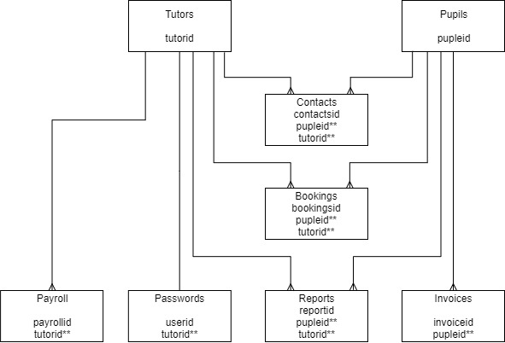

Admin Form Designs
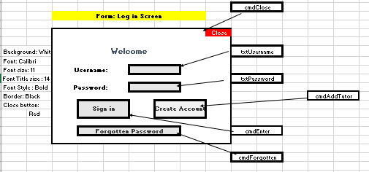
Log in Screen:
Algorithm:
Set Username as string Set Password as string Set Count as integer = 0
txtUsername = Username txtPassword = Password
Load ArrayPasswords[]
If cmdEnter clicked:
While Count < 0
For n in range 0 , len(ArrayPasswords)
If Username = ArrayPasswords[n,0] AND Password = ArrayPasswords[n,1] then
If ArrayPasswords[n,2] = “Admin” then Open Admin Menu
Elif ArrayPasswords[n,2] = TutorID then Open Tutor Menu Else Print “Incorrect username or password Count = Count + 1
If Count = 3 then
Print “You have run out of attempts, goodbye”
Close Program
If cmdForgotten clicked:
Open ForgottenPassword menu
If cmdAddTutor is clicked then Open AddTutor Form

Admin Menu:
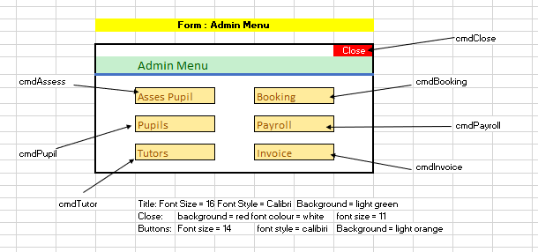
Algorithm:
If cmdAssess is clicked then
Open AssesPupil form
End if
If cmdPupils is clicked then
Open Pupils form
End if
If cmdTutor is clicked then
Open Tutors form
End if
If cmdBooking is clicked then
Open booking form
End if
If cmdPayroll is clicked then
Open Payroll form
End if
If cmdInvoice is clicked then
Open Invoice form
End if
If cmdClose is clicked then
Close form
End if

Tutor Form:
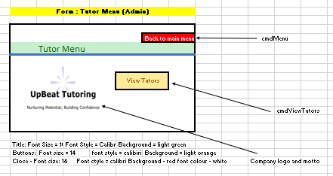
Algorithm:
If cmdViewTutors is clicked then
Show viewTutors form
End if
If cmdMenu is clicked
Show AdminMenu

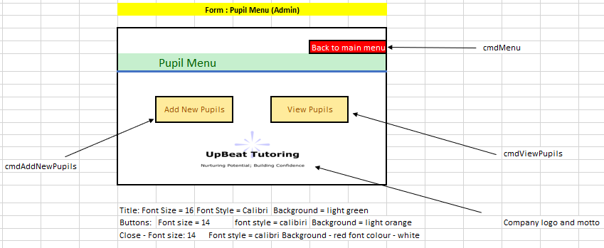
Pupil Form:
Algorithm:
If cmdAddNewPupils is clicked then
Show AddNew Pupils form
End if
If cmdViewPupils is clicked then
Show ViewPupils form
End if
If cmdMenu Is clicked then
Show Admin Menu
End if

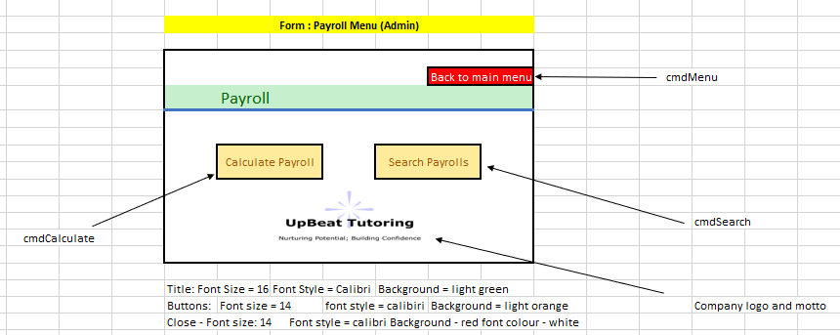
Payroll Form:
Algorithm:
If cmdCalculate is clicked then
Sow CalculatePayroll form
End if
If cmdSearch is clicked then
Show SearchPayroll form
End if
If cmdMenu is clicked then
Show AdminMenu
End if

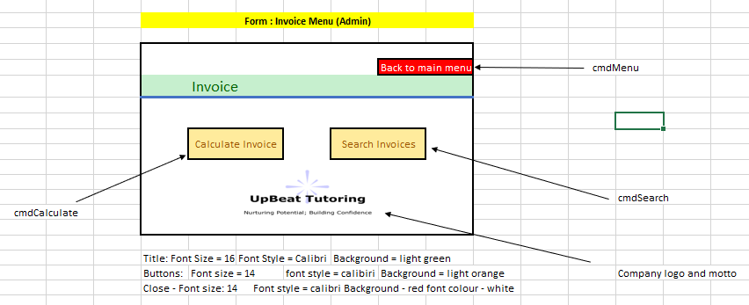
Invoice Form:
Algorithm:
If cmdCalculate is clicked then
Show CalculateInvoice form
End if
If cmdSearch is clicked then
Show Search form
End if
If cmdMenu is clicked then
Show Admin Menu
End if

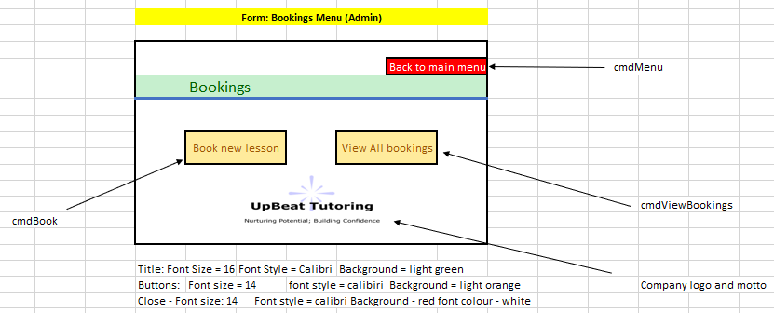
Booking Form:
Algorithm:
If cmdBook is clicked then
Show BookLesson Form
End if
If cmdViewBookings is clicked then
Show ViewBookings Form
End if
If cmdMenu is clicked then
Show Admin menu
End if

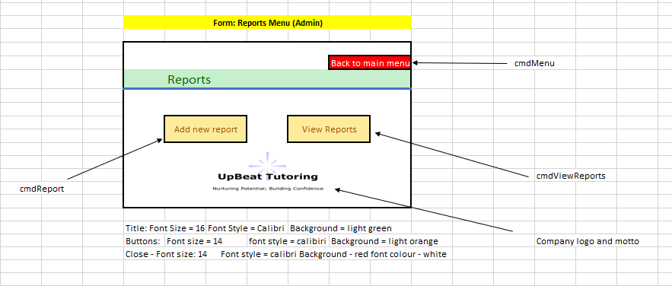
Report Menu:
Algorithm:
If cmdReport is clicked then
Show AddReport form
End if
If cmdViewReports is clicked then
Show ViewReports form
End if
If cmdMenu is clicked then
Show Admin Menu
End if

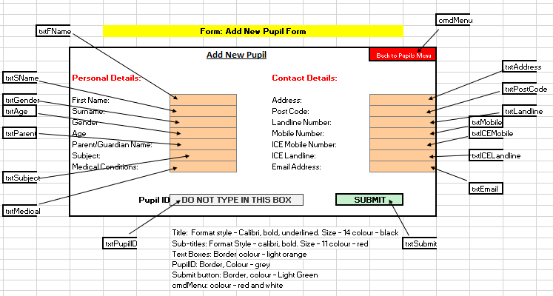
Add New Pupil Form:
Algorithm:
If cmd Submit is clicked then
Declare PupilID as string = (First Letter of FirstName + LowerCase_Surname + Last 3 digits of mobile) Display PupilID in txtPupilID.text
If PupilID <> “” then Output “Please leave PupilID Blank” exit sub If Age < 0 then Output “Age is invalid must be older than 0” exit sub If Gender <> “M” and “F” then Output “Invalid Gender entered please try again” exit sub If len(Mobile) <> 11 then Output “Mobile must be 11 characters long” exit sub Declare correct as Boolean = txtEmail like *@*.* If correct = False then Output ”Invalid email entered” exit sub
ContactsArray = [PupilID, Address, PostCode, Landline, Mobile, ICEMobile, ICELandline, Email] PupilsArray = [PupilID, FName, SName, Gender, Age, Subject, Medical, Guardian]
Emend ContactsArray to end of ContactDetails Database
Emmend PupilsArray to end of PupilDetails Database
End If

Add New Tutor Form:
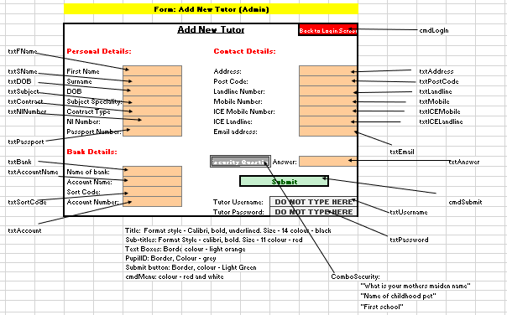

Algorithm:
If cmdSubmit is clicked then
If txtContract <> “Admin” or “Tutor” then Output “Must enter Admin or tutor for contract Type” End if
Username = (CapitalCase_FirstLetterOfFirstName + LowerCase_Surname + Last3DigitsOFNINumbe) Password = (Last3LettersOfPostCode+DateOfBirth)
txtUsername.text = Username txtPassword.text = Password
Emmend Username, Password and Contract Type, security question and answer to end of Password Database
If NI Number = “” then
Output “Must enter a NI Number” Exit sub
End if
If len(txtMobile) <> 11 then
Output “Mobile number must be 11 characters long” Exit sub
End if
Declare correct as Boolean = txtDOB like */*/* If correct = False then
Output”Incorrect Format for date of birth” Exit sub
End if Emmend New Tutor Details to end of Tutor Details Database
If cmdLogIn is clicked then Open Log in screen

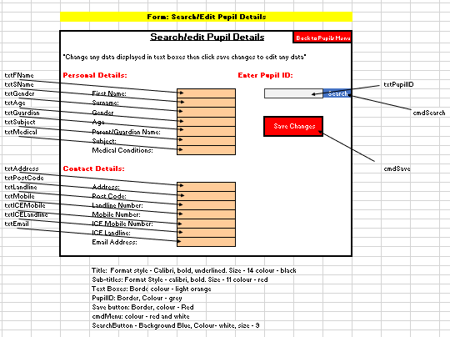
Search/Edit Pupils Details Form

Algorithm:
Load Pupils() = Pupil Details Database
If cmdSearch is clicked then
For x in range 0 to len(Pupils)
If Pupils(x,0) = txtPupilID then
Display Data in correct textboxes
Else
Output “Incorrect Pupil ID”
End if
If cmdSave is clicked then
Overwrite data in textboxes with original data in Pupils()
Emmend Pupils() at the end of Pupil Details Database

Search/Edit Tutor Details Form

Search/Edit Tutor Details Form
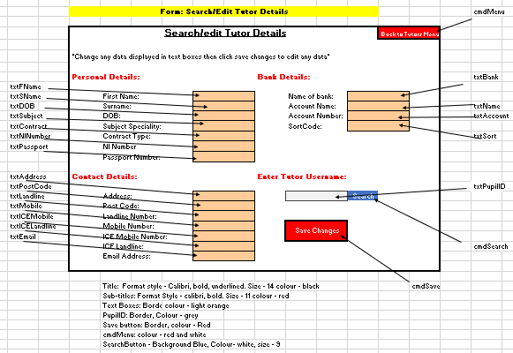
Algorithm:
Load Passwords Array
Load Tutor Details Array
Declare Found As Boolean = False
Declare ID as string = “”
If cmdSearch is clicked then
Loop through Passwords Array
If txtUsername = Passwords[n,0] then
ID = Passwords[n,2]
Found = True
End Loop
If Found = False then
Output(“Incorrect Username entered”) Exit sub
Loop through Tutor Details Array
If ID = TutorDetails[n,0] then
Output all data into correct textboxes
End if
If cmdSave is clicked then
Overwrite new data in textboxes with original data in tutor Details Database

Book a Lesson Form:
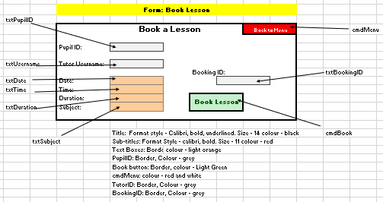

Algorithm:
If cmdBook is clicked then
BookingID = (First 3 digits of Pupil ID + first two digits of txtDate + Duration)
Display BookingID in txtBookingID
Open Bookings File
Emmend all Data including Booking ID to the end of the file
Close File
Output “Lesson has been booked”

Search/Edit Bookings
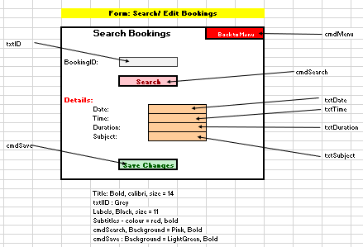

Algorithm:
Found = False
Open Bookings file
If cmdSesrch is clicked then
If txtID = “” then Output”Must enter ID” Exit sub End if` Loop through Bookings file If BookingID = txtID then Display Data in textfiles Found = True If Found = False then Output”Incorrect Booking ID” End if End if
If cmdSave is clicked then
Overwrite data in textboxes with original data in bookings file
End if

Calculate Payroll Form:
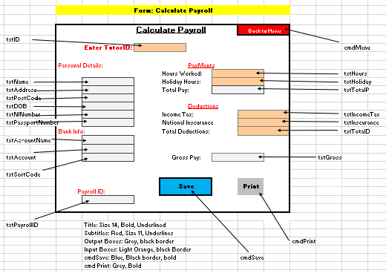
Algorithm:
Rate = 9.00
If text is entered in txtID then
Open Tutor Details file
Loop through file
If txtID = TutorID in file then Output All data in output text file Found = True
If Found = False then Output “Incorrect TutorID”
If txtHours, txtHoliday are filled in then
TotalHours = txtHours + txtHoliday Display (TotalHours*Rate) in txtTotalP
If txtIncomeTax and txtInscurance are filled in then
TotalD = txtIncomeTax + txtInscurance Display (TotalD) in txtTotalD
If txtTotalP and TotalD <> “” then
Gross = txtTotalP – TotalD Display (Gross) in txtGross
If cmdSave is clicked then
ID = (Last 3 digits of NI Number + TotalHoursWorked + Last two digits of Post Code)
Display ID in txtPayrollID
Ammend all Data to the end of Payroll File
If cmdPrint is clicked then
Print all Data shown in textboxes

Search/Edit Payroll
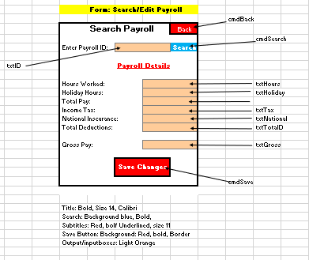
Algorithm:
If cmdSearch is clicked then
If txtID = “” then Output ”Must enter ID” exit sub
Open Payroll file Loop through file If txtID is found then Output all data into textboxes, Found = True
If Found = False then “Incorrect ID has been entered”
If cmdSave has been clicked then
Overwrite original data in Payroll file with new data

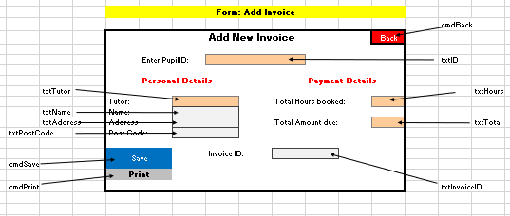
Add Invoice Form:
Algorithm:
Rate = 20.00
If txtID <> “” then
Open Pupil Details File
Loop through Pupil Details file
If txtID is found then Output Name, address and postcode into output boxes
If cmdSave is clicked then
InvoiceID = (Last 3 digits of PupilID + Total Hours Booked + Total Amount Due)
Display InvoiceID in txtInvoiceID
txtTotal = txtHours*Rate
Emmend all data to the end of Invoice Details File
If cmdPrint is clicked then
Print all data shown

Search Invoice Form:
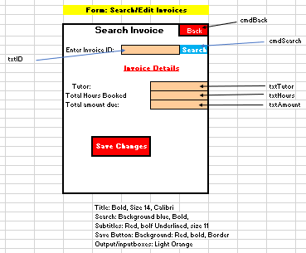

Algorithm:
If cmdSearch is clicked then
If txtID = “” then Output ”Must enter ID” exit sub
Open Payroll file Loop through file If txtID is found then Output all data into textboxes, Found = True
If Found = False then “Incorrect ID has been entered”
If cmdSave has been clicked then
Overwrite original data in Invoice file with new data

Add Report Form:
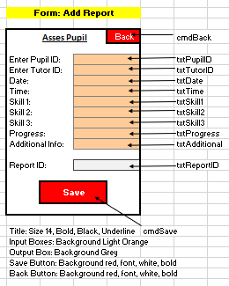
Algorithm:
If cmd Save is clicked then
If txtPupilID = “” then Output “Must enter pupil ID” exit sub If txtTutorID = “” then Output “Must enter Tutor ID” exit sub
Declare Correct as Boolean = txtDate like */*/* If Correct = False then Output “Incorrect format for date” exit sub If progress <> “Yes” And “No” then Output “Must Enter Yes or No “ exit sub ReportID = (First 2 digits of Pupil ID+ First two digits of Time + Last 3 letters of Skill 3)
Display ReportID in txtReport ID Open Reports File Emmend all data to the end of Reports File

Search/Edit Reports Form:
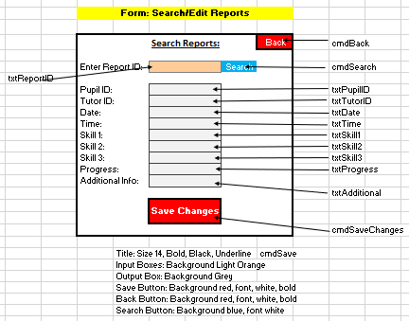
Algorithm:
If cmd Search is clicked then
Open Reports file
Loop through Reports File
If report ID = txtReportID then Display all data in textboxes
If cmdSaveChanges is clicked then
Overwrite new data with old data in reports file

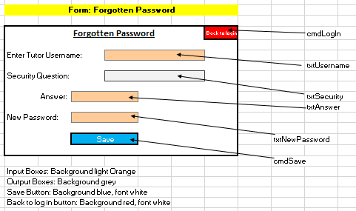
Forgotten Password Form:
Algorithm:
Temp = “”
Answer = “”
Found as boolean = False
If txtUsername <> “” then
Open Passwords File:
Loop through Passwords File
If Username = txtUsername then
Display Security question in txtSecurity Found = True
If Found = False then Output “Incorrect Username Entered”

If cmdSave is clicked then
Loop through Passwords file
If txtAnswer = Answer then
Overwrite original password with txtNewpassword in passwords file

