SYSTEM TESTING

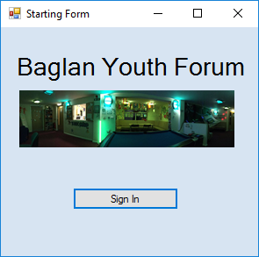
Testing – from starting form

This is the starting form, here the user will need to press ‘Sign In’ to allow them to get to the next form to put in their sign in details.
I tested this and when the button is clicked the next form opens successfully.

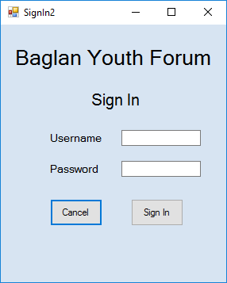

This is the 2nd form, where the user will need to enter their username and password to get to the main menu. Of course, the username and password must match to gain access.
I had previously created a file to hold the username and passwords of different accounts, so I could test to see if things work.
Firstly I entered a username and password that didn’t match, to see if the error message I had put in the code would come up.
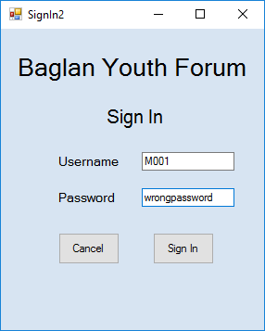
When I entered the wrong log in details, the error message expected did come up successfully.
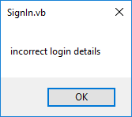

However, I then wanted to enter the correct log in details to see if the system would allow the user to sign in –
Below is the previously made file to hold the usernames and passwords.
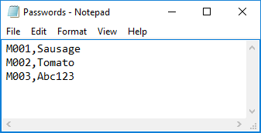

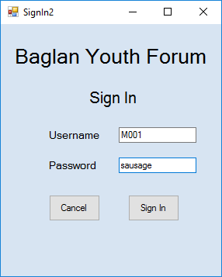

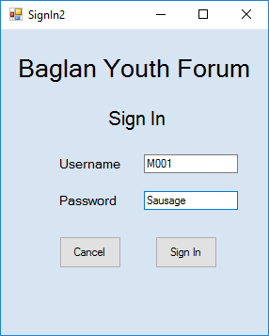
When I entered the log in details from the file, and clicked sign in, I received the same error message as if the details were incorrect, even though they were. I then thought that maybe the system was case sensitive, so I tested that next.

When I entered the sign in details with the password having a capital first letter, and clicked sign in, access was granted and the main menu opened.

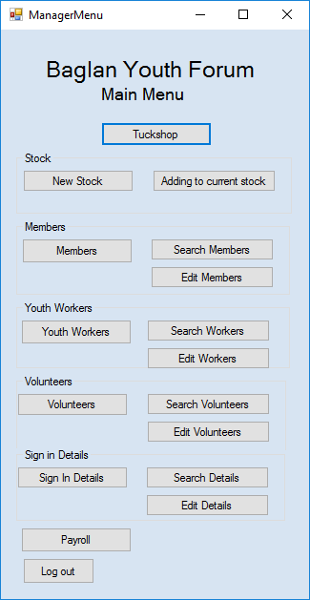

Form here, I firstly wanted to make sure all the buttons were correctly linked to the form needed.
However, I decided to do everything in order from the top of the menu down, this way I wouldn’t have to go back and forth between forms.

The first form to test is the ‘Tuck Shop’ form, which allows the user to sell items to customers, while the system also deducted the total number of items in the file by what had been sold.
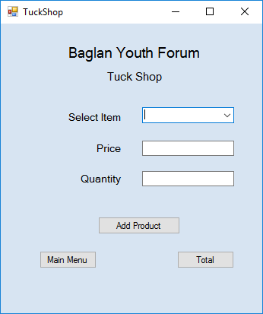

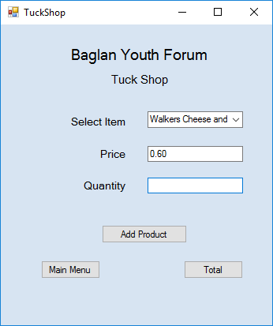
When I clicked the ‘Tuckshop’ button, the correct form loaded. In this form, the user must be able to select any of the items sold in the shop from the drop down menu. When an item is selected, the price of the item which is saved in the file must autofill the ‘Price’ box.
So I selected one of the items from the drop down menu, to see if the autofill had worked.
When I selected ‘Walkers Cheese and Onion’ from the drop down menu, the price correctly auto filled the corresponding box.

Next I need to make sure that when multiple items are sold, that the system correctly calculates the total for the user.
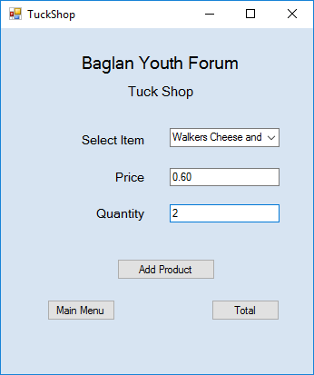
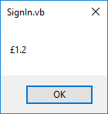
To test this I entered ‘2’ into the quantity box so the system knows that 1 items are being sold and that it would have to multiple the price by 2.
This worked successfully as the system then displayed the message box outputting the price - £1.2 (meaning £1.20)

Then I needed to make sure that the ‘Quantity’ in the main file holding the information on tuck items was deducted by the amount of items sold in that sale.
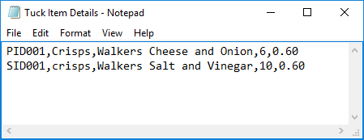
This is the file holding the information on the tuck items that can be sold.
In this file there are 6 cheese and onion crisps available, so when cheese and onion crisps are sold, this should go down.
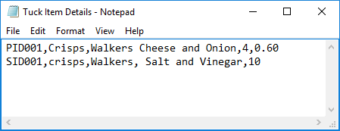
To test this I entered a sale, this would mean that the total number of crisps sold here should be deducted by 2. To check, I opened the file containing the information.
Now, it has gone down to 4, which means that the deduction was successful.

The next form to test, is ‘New Stock’. From the main menu, the user must be able to access the correct form, enter the details of a new product, which then saves to the file containing the details on stock.
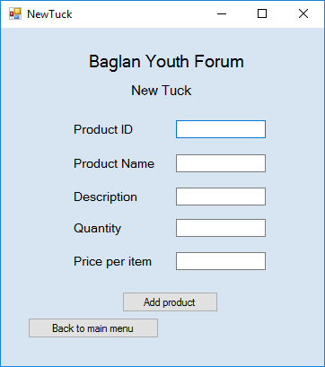
First off, the form successfully loads up from the main menu when the ‘New Stock’ button is clicked.
In this form, the user must enter all the information and click ‘Add product’ to save it.
Once the user presses ‘Add product’ they should be alerted that the details have been saved.

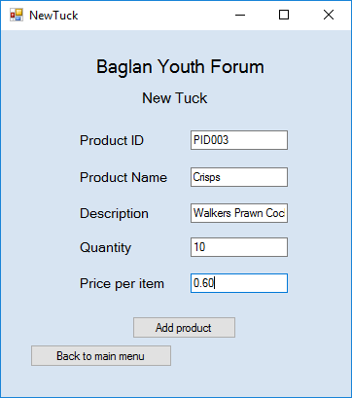
To test this I entered the details of Walkers, Prawn cocktail crisps, and clicked ‘Add product’, which did provide me with a message box:
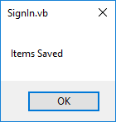

Since the system shouldn’t give the message box to the user unless it’s saved, I checked the file below just to make sure.

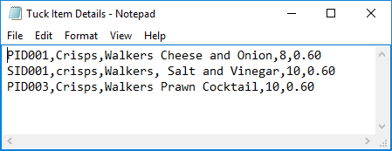
The save was successful and the details are shown –

As well as saving new stock details, the user must also be able to access the form which allows them to load previously saved data and make changes should they have a delievery and need to increase the quantity of stock.
When the ‘Adding to current stock’ button from the main menu is clicked, a message box is displayed to the user for them to enter the product ID that they are looking for.
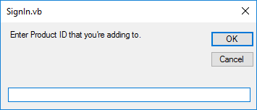
In this form, the user must enter an ID and click okay to see the details.
To test this I entered the ID of a previously saved item-
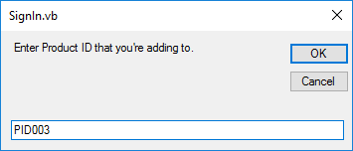

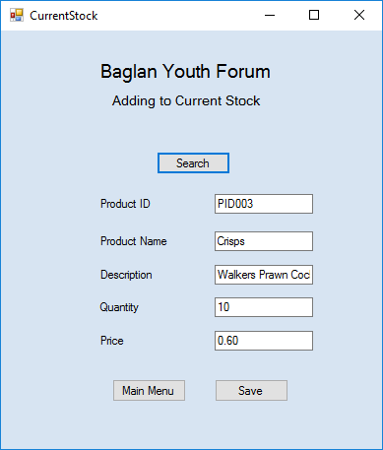
The details of the product with the ID – ‘PID003’ are now displayed in a form which allows the user to make changes and resave over the old details.

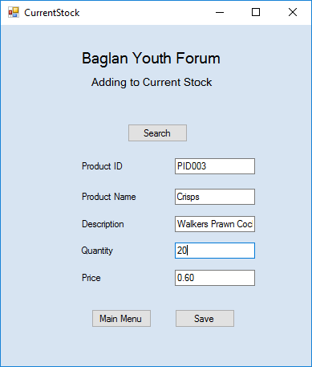
For example, if a new delivery had come in and the Youth Forum had an extra 10 packets of prawn cocktail crisps, they can change the quantity to 20 and resave the details.

To check that the saving works, I changed the quantity and clicked save.
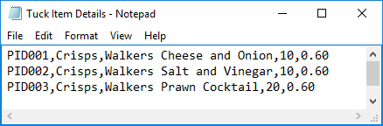

The next form from the menu is for adding new members to the system.
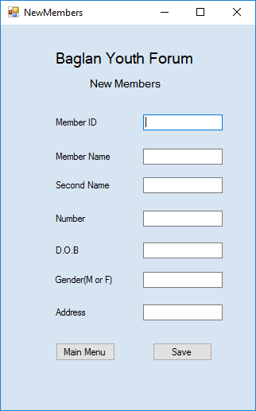
This form allows the user to enter the details for a new member and save these details in the Members file.
In this form there is also validation to ensure that there is a memberID entered and that the Number is the correct length. If either of these condition aren’t met, then the user will receive an error message telling them the problem.
To test this I entered details incorrectly:
I first entered the number incorrectly-

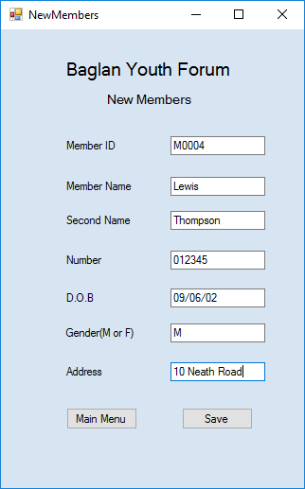

Then when I tried to save I received the error message, meaning the validation was successful

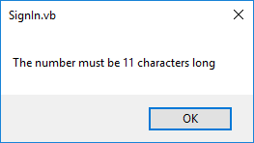

I then corrected the number, and left the Member ID blank:
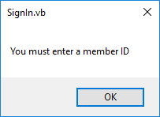
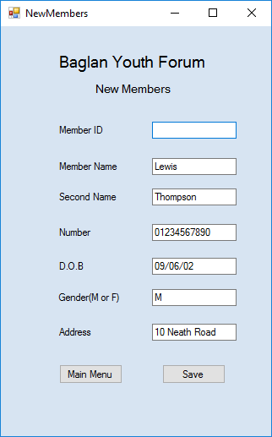
When I tried to save again, the system provided an error message, meaning this validation was also successful.

I then entered all the details correctly and checked whether or not they had been saved.
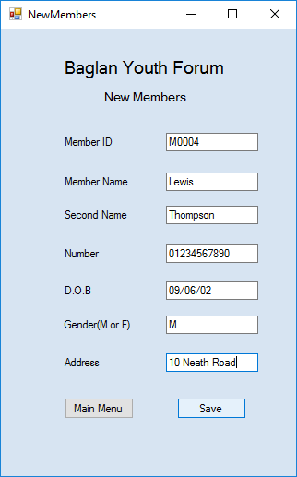

I received the correct message when I had clicked saved, and when I checked the file, the details had been saved correctly.

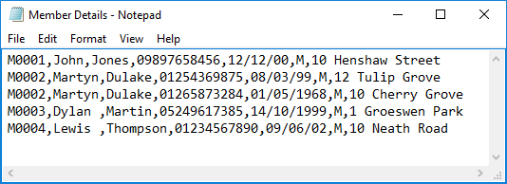

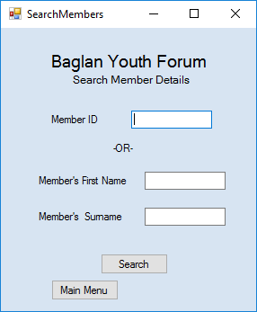
Next on the Menu was ‘Search Members’.

This form allows the user to search for the details of a member by either entering their first and last name, or their memberID.
If the entered details are in the system then the user should receive a message box containing the information.
I first tested whether the search worked using the member ID:
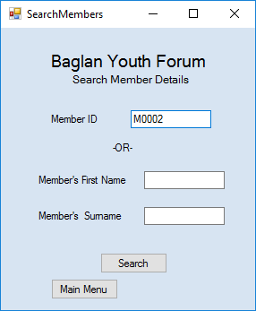

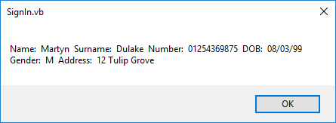
This was successful and the corresponding information was provided:

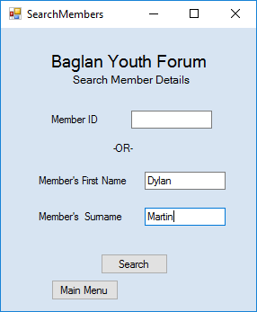
I then tested whether the search was successful using the first and second name:

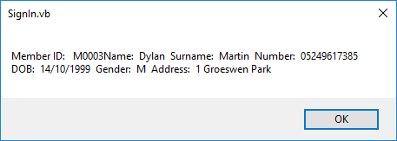
This too was successful, and the corresponding details were displayed.
The next option on the menu is ‘Edit Members’.
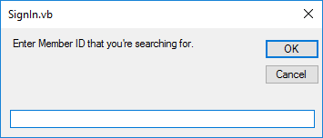
This presents an input box which asks the user to enter the member ID of the member whose details they want to edit.
Once the ID is entered, their details should be displayed in another form.
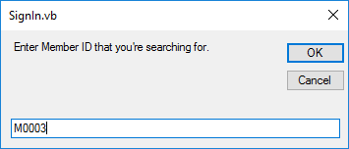
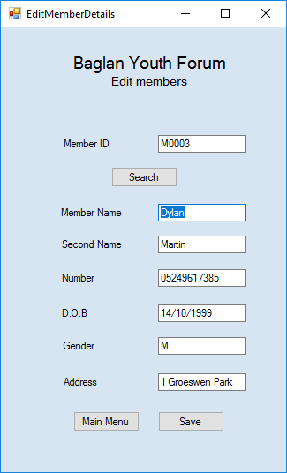
To test this worked I entered an ID from the saved details and clicked OK, the details were then displayed meaning the loading of data was successful.
I then changed some of the details (in this case the number) and saved to see whether the saving had worked.
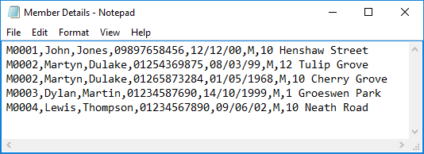
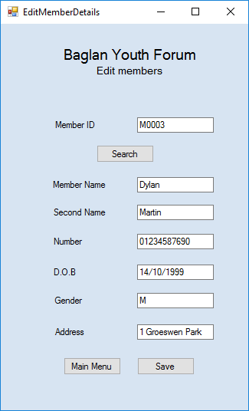
After checking the file, I found that the saving had worked.
Next is Adding/saving new youth worker details:
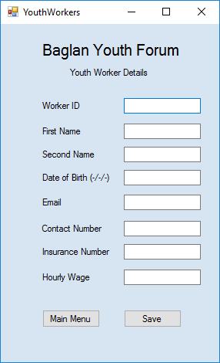

This form allows the user to enter the details of a new youth worker and save them.
This form also has validation on certain inputs-
- Presence check on Worker ID
- Length Check on contact Number

To test the validation I entered details incorrectly:
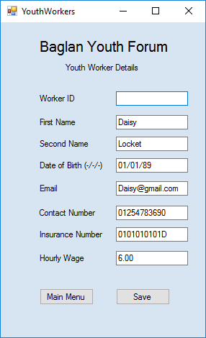

When I tried to save without a Worker ID, the system presented an error message, meaning the validation had worked.

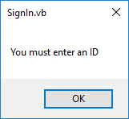
I also tested the length check by incorrectly entering a contact number.
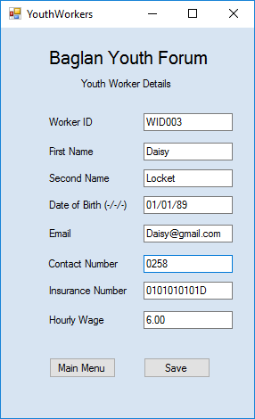

Additionally, when I tried to save without a full number, the system presented an error message meaning that the validation had worked.

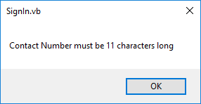

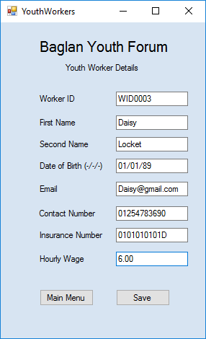
Finally, I needed to test that the saving would be successful when all the information is correct, so I entered all the correct details and clicked save.

After saving I checked the file and found that all the details had been saved correctly.
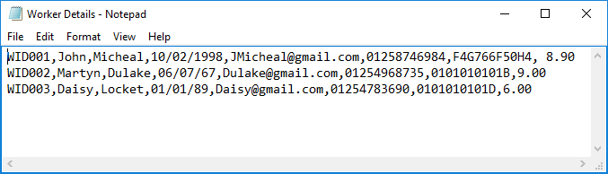

Next is to test whether the user can search for a Youth worker’s details:
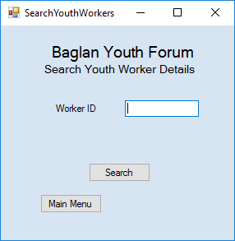
This form allows the user to enter the Worker ID they are looking for. The details of the corresponding worker should then be displayed to the user.

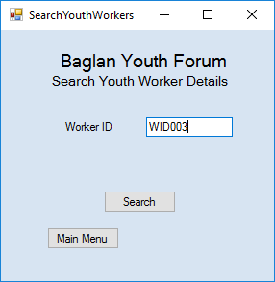

To test this worked, I entered a Worker ID and clicked search. The system then displayed their information to me, meaning the loading of data had been successful.

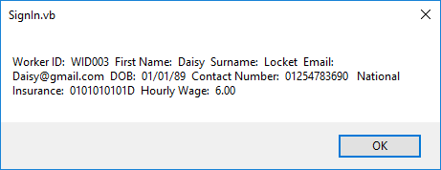
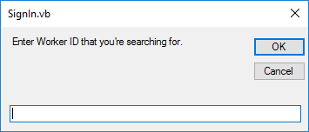
Next for testing is editing the Youth Worker data.
When the button from the menu is pressed, the user is presented with this form. This allows them to enter the worker ID of the person whose information they want to edit.
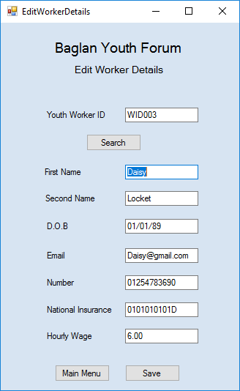
To test that the details are displayed in a new form when the correct ID is entered, I entered one from the main file.
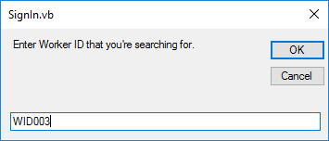
Once the details have loaded into a new form, the user can then change the information and resave the details.
To test this I changed the phone number and checked to see if it had also changed in the main file.
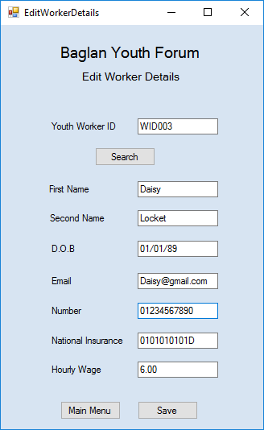

After checking the file, I found that the changes had been made successfully
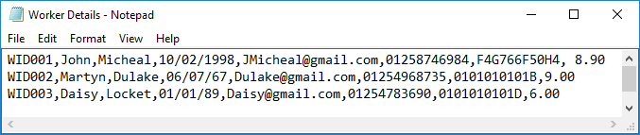
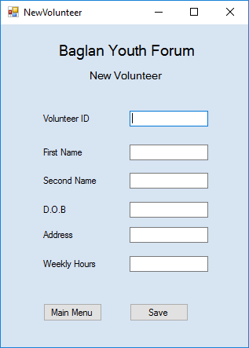
The next button on the menu is ‘Volunteers’:
This form allows the user to input the information of any new volunteers and save them to the volunteers file.
This form also contains validation on some of the inputs

- presence check on volunteer ID
  - Range check on Weekly hours.
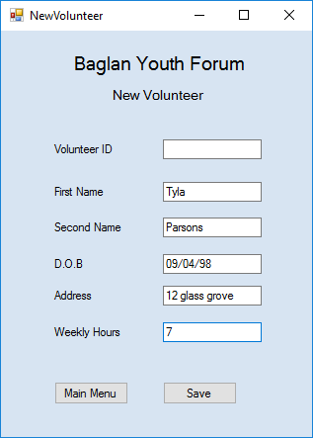
To test if these worked, I entered incorrect data:

First I tried saving without a Volunteer ID, and received an error message. This means that the validation has worked.

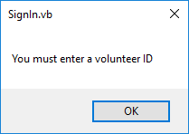
Then I tried saving with an out of rage input for the weekly hours:
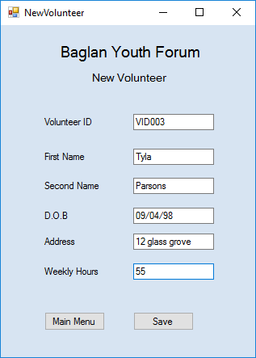

I then received this error message, which shows that the validation has worked.
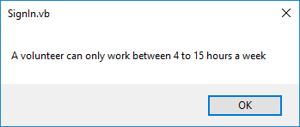

I then wanted to test that the saving off the actual data was working, and so I entered all the correct information and clicked save:
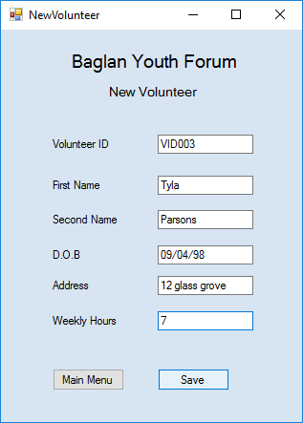
I then checked the file and found that all of the details I had entered had been saved successfully.
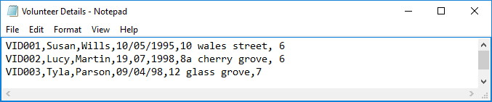

The next testing needs to be done on searching for volunteer details:
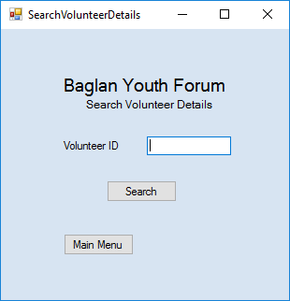
This form allows the user to enter the Volunteer ID that they are looking for.
Once they click search, the corresponding details will be presented in another form.
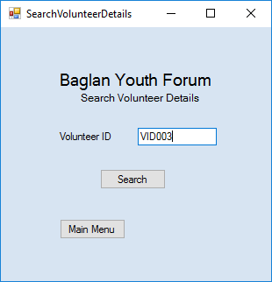
To test this worked, I entered an ID from the file:

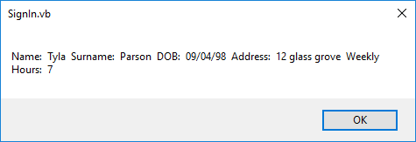
The details are displayed to the user, and this means that the search was successful

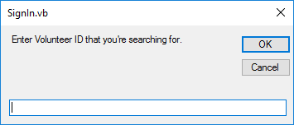
Next is editing volunteer details:
This form allows the user to enter the volunteer ID that they are searching for, and the system will display the relevant information in another form.
To test the relevant information is displayed when the correct ID is entered, I entered one from the main file:
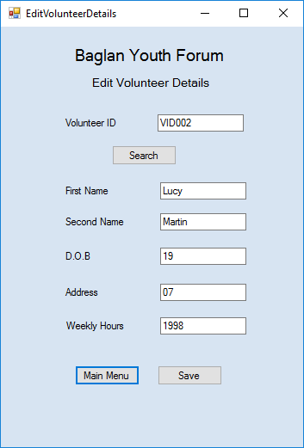
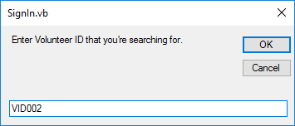

Although some of the information was successful, it seems that the volunteer’s date of birth has been placed in the wrong place.
To try and solve this, I checked the text file:

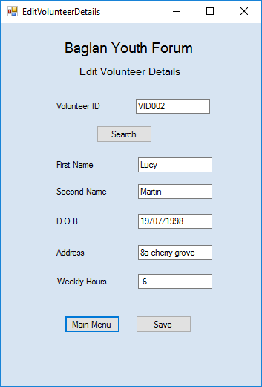
The problem here is that when previously entering a date for VID002, it was done using commas to break up the date, however commas are also used to separate different pieces of information. So by doing this the system thought the date of birth was different pieces of data and so put them in different places. To fix this, I changed the commas to ‘/’:
So now if I load the data, everything should be in the right place:
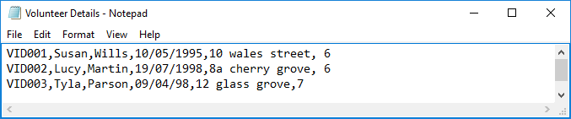
Now that the data is loading in correctly, I needed to test that if any changes were made, that they would be saved accurately:
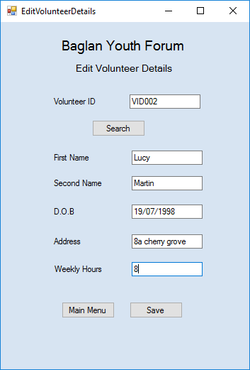
To do this I changed the number of weekly hours and clicked save:

I then checked the main volunteer file to see if the changes had been made-
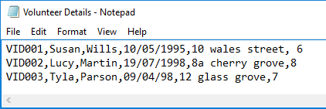
The changes were successfully saved.

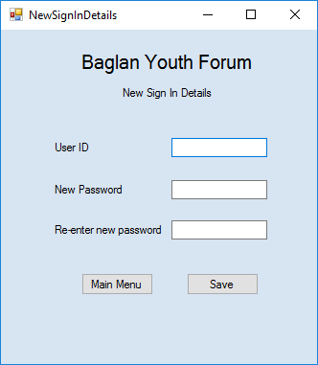
Testing new sign in details –

This form allows the user to enter new sign in details for any new workers or volunteers.
This form asks for double entry of a new password, I have written verification for the double entry which checks they are the same before saving.
To test the validation, I purposely entered passwords that were different to see if the system would output the error message I put in the code.

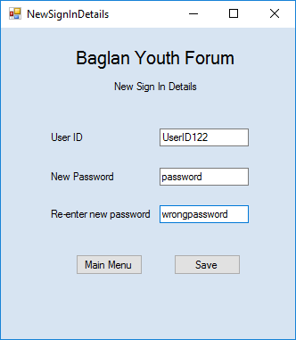
When I entered 2 passwords that were different, I received the error message which states they need to be the same. This means that the verification has worked.
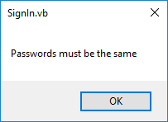

I then tested that my validation to ensure that the user has entered a user ID so that stray passwords aren’t saved without one.
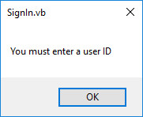
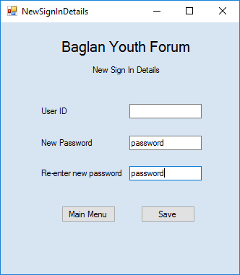

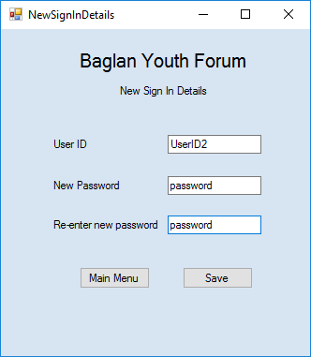
Without a userID the system provided an error message, meaning that the validation I had put in the code was working.

I then needed to make sure that the system would actually save all the details if they were all entered correctly. To test this I entered details into the form and clicked save.

I then checked the sign in details file to check that the details had actually been saved correctly.
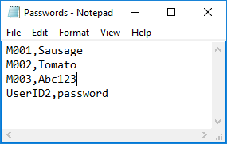
As shown, the details were correctly saved and amended onto the file.

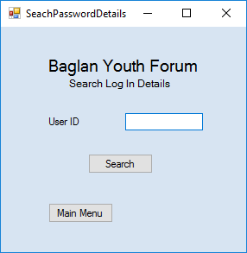
Next – Search sign in details:
This form allows the user to enter the UserID that they are going to search for.
To test this I entered the ID of a previously saved user:
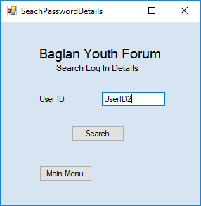

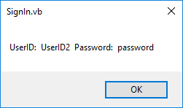

With a valid UserID entered, the system provided a message box to show the user the details.
This means that the loading of data was successful.

Next to test is the searching of sign in details, the system must be able to load data from text files and resave the data over the existing – to keep any changed made:
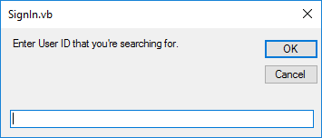
From the main menu, this from is displayed, allowing the user to input the UserID that they want to change the details for.
When a valid userID is entered, their userID will be loaded on to another form where they can change the password.
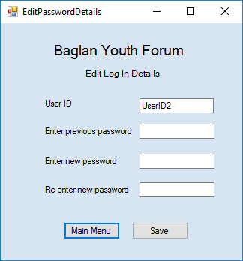
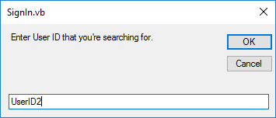
I first needed to check that the details(mainly USerID) loaded correctly when a valid UserID was entered.
From here the user will be able to change the password of the user whose ID they have entered. However, I have written validation to ensure that no changes can be made unless the text that is entered in the ‘previous password’ box, matches the password saved previously.
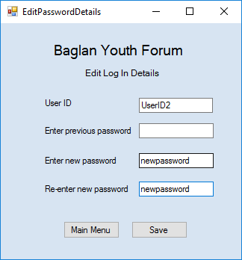
To text this I first didn’t put a password in the previous password box :

Without a previous password, an error message was displayed to say that I must enter one.
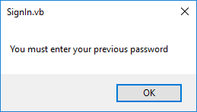

I also needed to check that when the correct previous password was entered, that the system would be able to look through the details and match them together, therefore allowing changes to be made:
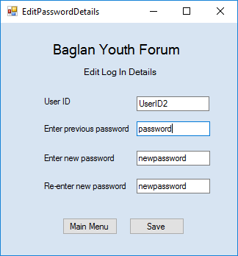
So I entered the correct previous password and a message was displayed telling me that the details had been saved.

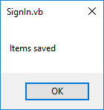

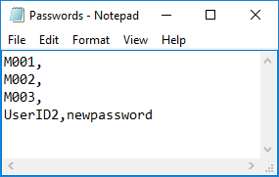
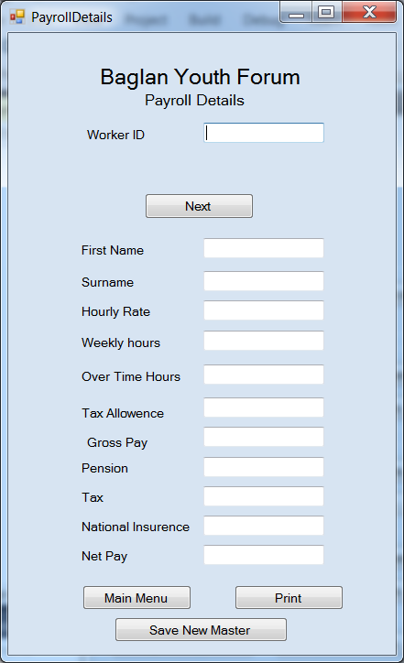
This is the text file containing the log in details, and the changes have been saved successfully because the user with the ID – UserID2, the password is no longer the original ‘password’ it is now ‘newpassword’ which is what I changed it to while testing.

Finally, the payroll system:
This form allows the user to enter the ID of the worker whose payroll they are forming, if it is a valid ID then the user will receive a message box saying to enter the number of hours that person had done. Then the systems works out all the other information and auto fills the boxes, along with saving a payslip automatically.
I first needed to test that when a valid worker ID was entered that another input message box would be displayed to the user to allow them to enter the hours worked.
I did this by entering an ID and clicking next:
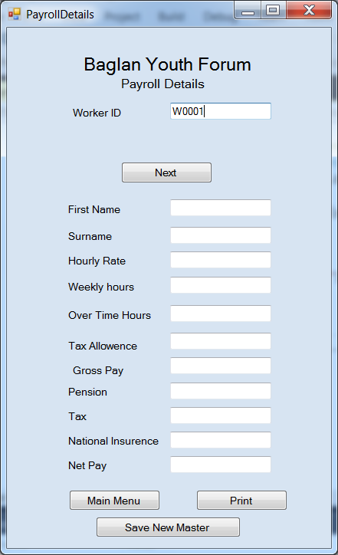
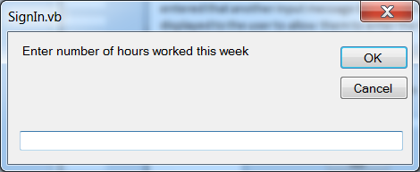
This was successful so I now needed to know if the system calculated the other information and saved a pay slip:

So I entered 37 as the number of hours worked, the system then outputted a message saying that a wage slip had been saved.

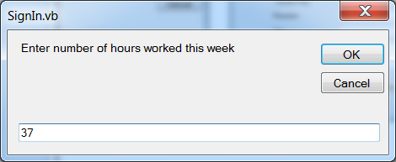
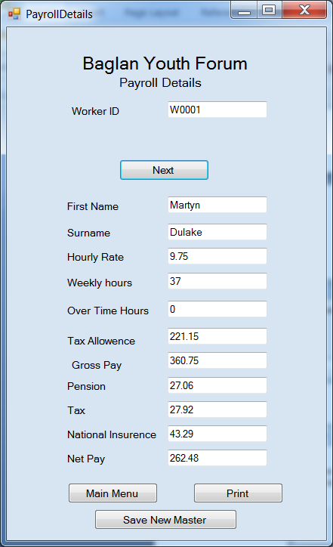

However, after entering the number of hours worked the system successfully calculated all the relevant details for payroll and autofilled the text boxes.
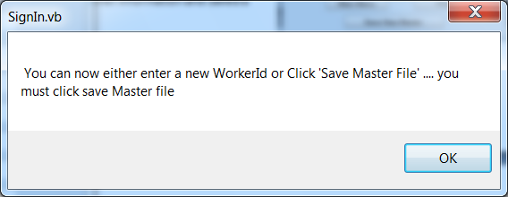
A second message was then displayed to explain to the user what they could do next:

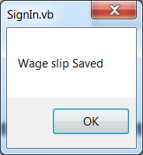
These message boxes indicate that the wage slip saves should have been successful, but I need to check the main file to make sure.

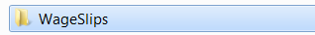

Now to check that, first of all, the wage slip was saved correctly, I will have to check the payslip folder which will have a file for each person who has been saved, along with their payslips:
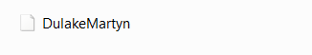
So inside this file would be a worker’s text file:

Then inside this text file will be their payslip:
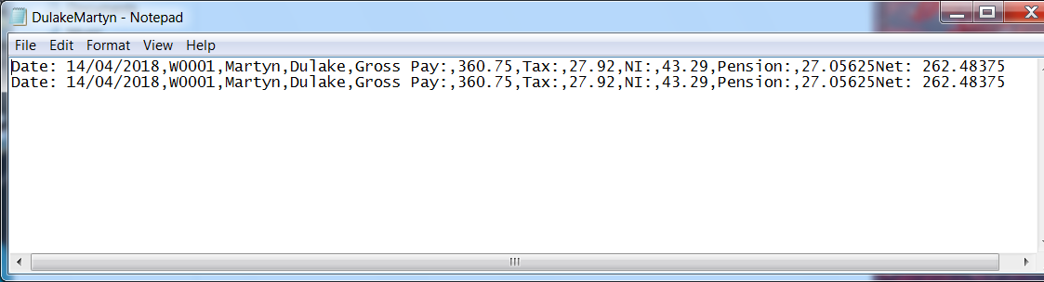
So now I needed to test that the master file was saved, so I needed to check the payroll file:
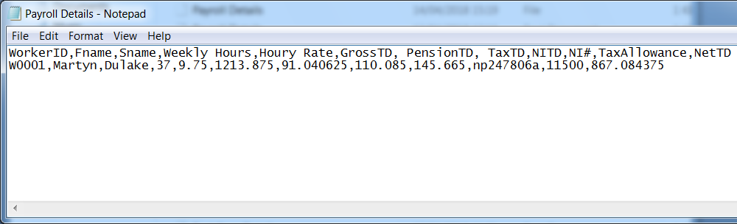

This means that the save was successful.

Improvements to refine the system taken from the testing
Within the system there are some things I could change to improve the system, these improvements were found through testing.
Firstly, where the user can search for volunteers or workers, I would change the form so that the search can be carried out using their first and last name instead of the ID, incase the user doesn’t know their userID.
During the prototype, from my feedback I decided to use the searching method of First and last name in the Members form. Since the feedback was specific to only the Members form, I didn’t think of changing the other forms, but I think to change those forms will improve the usage of the system making it more convenient for the user.
Additionally, I would also like to change the system so it has more output messages to the user. For example, in any of the edit details forms, the user is expected to input an ID to receive their information. However, often people can input things incorrectly so I would like to add an error message that is displayed if the ID entered isn’t saved in the text file. So I would like to add an error message to say that the ID either isn’t saved in the text file (ID not found) or that they may have made a mistake while typing the input (ID may be incorrect).
Also, I think it would be a good idea to change the message on some of the input display boxes for the edit forms. Currently they say ‘Enter the User ID that you are searching for’ however I was thinking that this could cause confusion for the user since it doesn’t specify that the system searches for the ID so it knows which details to display. As a result of this, it would be better if the boxes said something along the lines of ‘Enter the ID of the person whose details you would like to edit’, this may the user won’t think that they’ve somehow come across another search that is only going to display their information – like when searching for member details. For example.
Another refinement I would like to make is the format that information is displayed in the message boxes. Currently, when the user searches for someone’s details, the details are displayed along one line – e.g. ID: __ password:__ name:__

I would like the change the format so that details are displayed in a more orderly fashion so that it is easier for the user to read the information:
ID___
Password___
Name___

One of the main amendments I would make to this system is that I didn’t include the restricted menu. Therefore anyone who signs into the system is going to have access to the manager menu. This is a relatively high security flaw because from this menu the user will be able to change and save anyone’s details – including payroll. So it is important that I do add that menu in. This would also include having to change the password system from simply matching the userID and password and if correct giving access, to checking the matching username and password to see what access they have and displaying the appropriate menu.
Furthermore I found that the main Menu buttons won’t take the user back to the main menu form because it is still open when other forms are opened. So instead of using the code to display the menu (which doesn’t work because it is never stopped being displayed) I would have to shut down the form that the user is currently on so that the main menu which is hidden behind that form, is visible again.

