Baglan Youth Forum – System Code

Home Screen
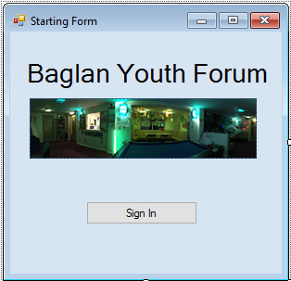
PublicClassForm1
PrivateSub SignIn_Click(sender AsObject, e AsEventArgs) Handles SignIn.Click
SignIn2.Show() 'if sign in button is clicked then the sign in 2 form is displayed
EndSub
EndClass

Sign In
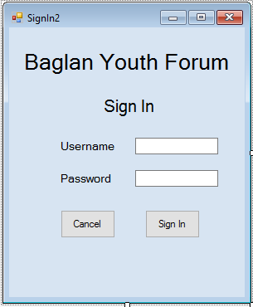

PublicClassSignIn2
PublicStructurePassword'declares structure for sign in details
Public MemberID AsString
Public Password AsString
EndStructure

PublicPasswords(0 To 1000) AsPassword'creates array for above structure

Public NumPas AsInteger = 0
Public iPosition AsInteger = 0

PrivateSub TextBox1_TextChanged(sender AsObject, e AsEventArgs) Handles txtUser.TextChanged
EndSub

PrivateSub SignIn2_Load(sender AsObject, e AsEventArgs) HandlesMyBase.Load

Dim File As System.IO.StreamReader

'set file to correct path, loads password details text file into declared password array
File = My.Computer.FileSystem.OpenTextFileReader(Path &"/Passwords")

Dim line AsString
DimParts(0 To 1) AsString

Do
line = File.ReadLine()

Parts = line.Split(",")

Passwords(NumPas).MemberID = Parts(0)
Passwords(NumPas).Password = Parts(1)

NumPas = NumPas + 1

LoopUntil (File.EndOfStream)
File.Close()

EndSub

PrivateSub SignIn_Click(sender AsObject, e AsEventArgs) Handles CmdEnter.Click
Dim Userid AsString = txtUser.Text
Dim Pass AsString = txtPass.Text
Dim flag AsBoolean = False

For n = 0 To (NumPas - 1)
'checks the userID matches the MemberID saved
If Userid = Passwords(n).MemberID Then
'checks the password matches the correct password
If Pass = Passwords(n).Password Then

flag = True
loggedin = Userid
'clears text from text boxes
txtUser.Text = ""
txtPass.Text = ""
ManagerMenu.Show()
EndIf
EndIf

Next
If flag = FalseThen
MsgBox("incorrect login details") 'error message if log in details are wrong
'clears text from text boxes
txtPass.Text = ""
txtUser.Text = ""
EndIf

EndSub

PrivateSub Cancel_Click(sender AsObject, e AsEventArgs) Handles Cancel.Click
Form1.Show()
EndSub
EndClass

Main Menu
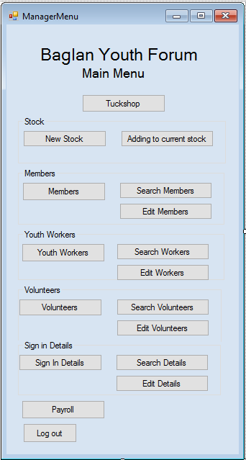
PublicClassManagerMenu
PrivateSub NewStock_Click(sender AsObject, e AsEventArgs) Handles NewStock.Click
NewTuck.Show() 'displays new tuck form if button is pressed
EndSub

PrivateSub members_Click(sender AsObject, e AsEventArgs) Handles members.Click
NewMembers.Show() 'displays New Members form if button is pressed
EndSub

PrivateSub PRoll_Click(sender AsObject, e AsEventArgs) Handles PRoll.Click
PayrollDetails.Show() 'displays Payroll Details form if button is pressed
EndSub

PrivateSub CmdTuckShop_Click(sender AsObject, e AsEventArgs) Handles CmdTuckShop.Click
TuckShop.Show() 'displays Tuck Shop form if button is pressed
EndSub

PrivateSub CmdLogout_Click(sender AsObject, e AsEventArgs) Handles CmdLogout.Click
SignIn2.Show() 'displays the sign in form if button is pressed
EndSub

PrivateSub Button2_Click(sender AsObject, e AsEventArgs) Handles Button2.Click
CurrentStock.Show() 'displays current stock form if button is pressed
EndSub

PrivateSub Button3_Click(sender AsObject, e AsEventArgs) Handles Button3.Click
SearchMembers.Show() 'displays search members form if button is pressed
EndSub

PrivateSub Button4_Click(sender AsObject, e AsEventArgs) Handles Button4.Click
EditMemberDetails.Show() 'displays edit members form if button is pressed
EndSub

PrivateSub YWorkers_Click(sender AsObject, e AsEventArgs) Handles YWorkers.Click
YouthWorkers.Show() 'displays new youth workers form if button is pressed
EndSub

PrivateSub Button5_Click(sender AsObject, e AsEventArgs) Handles Button5.Click
SearchYouthWorkers.Show() 'displays search youth workers form if button is pressed
EndSub

PrivateSub Button6_Click(sender AsObject, e AsEventArgs) Handles Button6.Click
EditWorkerDetails.Show() 'displays edit worker details form if button is pressed
EndSub

PrivateSub Button7_Click(sender AsObject, e AsEventArgs) Handles Button7.Click
SearchVolunteerDetails.Show() 'displays search volunteer details form if button is pressed
EndSub

PrivateSub Button8_Click(sender AsObject, e AsEventArgs) Handles Button8.Click
EditVolunteerDetails.Show() 'displays edit volunteer details form if button is pressed
EndSub

PrivateSub Volunteer_Click(sender AsObject, e AsEventArgs) Handles Volunteer.Click
NewVolunteer.Show() 'displays new volunteer form if button is pressed
EndSub

PrivateSub SignInDetails_Click(sender AsObject, e AsEventArgs) Handles SignInDetails.Click
NewSignInDetails.Show() 'displays sign in details form if button is pressed
EndSub

PrivateSub Button10_Click(sender AsObject, e AsEventArgs) Handles Button10.Click
SeachPasswordDetails.Show() 'displays search password details form if button is pressed
EndSub

PrivateSub Button9_Click(sender AsObject, e AsEventArgs) Handles Button9.Click
EditPasswordDetails.Show() 'displays edit password details form if button is pressed
EndSub
EndClass

Tuck Shop
PublicClassTuckShop
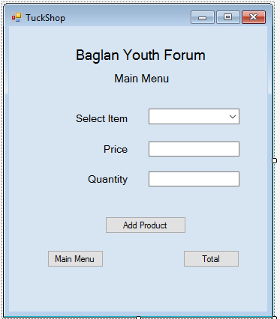
PublicStructureTuckItems'declares structure for tuck shop
Public Quantity AsString
Public ProductID AsString
Public ProductName AsString
Public Description AsString
Public Price AsString
EndStructure

PublicAllTuck(0 To 1000) AsTuckItems'creates array for above structure
Public NumTuck AsInteger = 0 'Creating an integer variable and setting it to 0
Publicparts(0 To 3) AsString
Public position AsInteger = 0 'Creating an integer variable and setting it to 0

Public Total AsString = 0

PrivateSub TuckShop_Load(sender AsObject, e AsEventArgs) HandlesMyBase.Load

Dim file As System.IO.StreamReader
Dim line AsString
DimParts(0 To 4) AsString

'set file to correct path, loads tuck item details text file into declared tuck items array
file = My.Computer.FileSystem.OpenTextFileReader(Path &"/Tuck Item Details")

Do
line = file.ReadLine()

Parts = line.Split(",")

AllTuck(NumTuck).ProductID = Parts(0)
AllTuck(NumTuck).ProductName = Parts(1)
AllTuck(NumTuck).Description = Parts(2)
AllTuck(NumTuck).Quantity = Parts(3)
AllTuck(NumTuck).Price = Parts(4)

TuckItem.Items.Add(Parts(2))

NumTuck = NumTuck + 1
LoopUntil (File.EndOfStream)

EndSub

PrivateSub Button3_Click(sender AsObject, e AsEventArgs) Handles Button3.Click
ManagerMenu.Show()
EndSub

PrivateSub TuckItem_SelectedIndexChanged(sender AsObject, e AsEventArgs) Handles TuckItem.SelectedIndexChanged

For n = 0 To NumTuck
'checks the tuck item matches the tuck description in array
If TuckItem.Text = AllTuck(n).Description Then
'displays the price of tuck item in boxes
txtPrice.Text = AllTuck(n).Price

EndIf
Next
EndSub

PrivateSub Button1_Click(sender AsObject, e AsEventArgs) Handles Button1.Click

For n = 0 To (NumTuck - 1)
IfAllTuck(n).Description = TuckItem.Text Then
'deducts the amount sold from the array
AllTuck(n).Quantity = AllTuck(n).Quantity - TxtQuantity.Text
'calculates the total
Total = Total + AllTuck(n).Price * TxtQuantity.Text

'clears the text from the text boxes
TuckItem.Text = ""
txtPrice.Text = ""
TxtQuantity.Text = ""

'below code saves the completed tuck array back into the text file
Dim Item As System.IO.StreamWriter
Item = My.Computer.FileSystem.OpenTextFileWriter(Path &"/Tuck Item Details.txt", False)
For y = 0 To (NumTuck - 1)
Item.WriteLine(AllTuck(y).ProductID &","& AllTuck(y).ProductName &","& AllTuck(y).Description &","& AllTuck(y).Quantity &","& AllTuck(y).Price)
Next y
Item.Close()

EndIf

Next

EndSub

PrivateSub Button2_Click(sender AsObject, e AsEventArgs) Handles Button2.Click
MsgBox(Total)
Total = 0

EndSub
EndClass

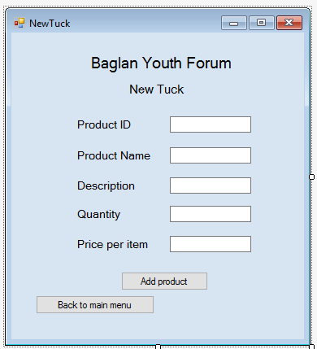
New Tuck
PublicClassNewTuck

PublicStructureTuck'declaring structure for Tuck details
Public ProductID AsString
Public ProductName AsString
Public Description AsString
Public Quantity AsInteger
Public Price AsString
EndStructure

Public AllTuck AsTuck'creates array for the structure above

PrivateSub Button2_Click(sender AsObject, e AsEventArgs) Handles cmdMainMenu.Click
ManagerMenu.Show()
EndSub

PrivateSub cmdAddProduct_Click(sender AsObject, e AsEventArgs) Handles cmdAddProduct.Click
'presence check on productID
If TxtProductID.Text = ""Then
MsgBox("You must enter a product ID") 'error message for if there's nothing present
EndIf

AllTuck.ProductID = TxtProductID.Text
AllTuck.ProductName = txtPName.Text
AllTuck.Description = TxtDescription.Text
AllTuck.Quantity = TxtQuantity.Text
AllTuck.Price = Txtprice.Text

'following code saves the completed tuck item array into the text file
Dim NewM As System.IO.StreamWriter
NewM = My.Computer.FileSystem.OpenTextFileWriter(Path &"/Tuck Item Details", True)
NewM.WriteLine(AllTuck.ProductID &","& AllTuck.ProductName &","& AllTuck.Description &","& AllTuck.Quantity &","& AllTuck.Price)
MsgBox("Items Saved")
NewM.Close()

'clears text from text boxes
TxtProductID.Text = ""
txtPName.Text = ""
TxtDescription.Text = ""
TxtQuantity.Text = ""
Txtprice.Text = ""

EndSub

PrivateSub cmdAddCurrentStock_Click(sender AsObject, e AsEventArgs)
CurrentStock.Show()
EndSub
EndClass

Adding to current stock
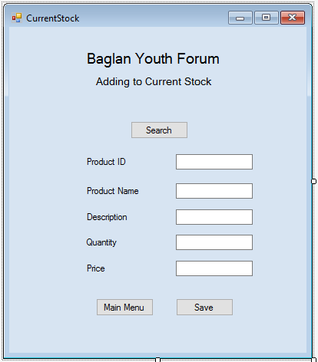
PublicClassCurrentStock

PublicStructureStock'This declares the structure for stock

Public ProductID AsString
Public ProductName AsString
Public PDescription AsString
Public PQuantity AsInteger
Public PPrice AsString

EndStructure

PublicItems(0 To 1000) AsStock'Declares an array as the structure above
Public NumItem AsInteger = 0 'Creating an integer variable and setting it to 0
Publicparts(0 To 4) AsString
Public position AsInteger = 0 'creating an integer variable and setting it to 0

'Creates message box to display to user to allow them to input the product ID
Public SearchID AsString = InputBox("Enter Product ID that you're adding to.")

PrivateSub Button3_Click(sender AsObject, e AsEventArgs) Handles Button3.Click
ManagerMenu.Show()
EndSub

PrivateSub CurrentStock_Load(sender AsObject, e AsEventArgs) HandlesMyBase.Load

Dim file As System.IO.StreamReader
Dim line AsString
DimParts(0 To 4) AsString

'set file to correct path, load Tuck Item text file into declared stock array
file = My.Computer.FileSystem.OpenTextFileReader(Path &"/Tuck Item Details")

Do
line = file.ReadLine()

Parts = line.Split(",")

Items(NumItem).ProductID = Parts(0)
Items(NumItem).ProductName = Parts(1)
Items(NumItem).PDescription = Parts(2)
Items(NumItem).PQuantity = Parts(3)
Items(NumItem).PPrice = Parts(4)

'if statement to check if the searchID entered by user is the same as productID in array
If SearchID = Items(NumItem).ProductID Then

txtPID2.Text = Items(NumItem).ProductID
txtPName.Text = Items(NumItem).ProductName
txtDescription.Text = Items(NumItem).PDescription
txtQuantity2.Text = Items(NumItem).PQuantity
txtPrice.Text = Items(NumItem).PPrice

position = NumItem
EndIf
NumItem = NumItem + 1

LoopUntil (file.EndOfStream)
file.Close()

EndSub

PrivateSub Button2_Click(sender AsObject, e AsEventArgs) Handles Button2.Click

Items(NumItem).ProductID = txtPID2.Text
Items(NumItem).ProductName = txtPName.Text
Items(NumItem).PDescription = txtDescription.Text
Items(NumItem).PQuantity = txtQuantity2.Text
Items(NumItem).PPrice = txtPrice.Text

'below code saves complete stock array back into the text file
Dim NewM As System.IO.StreamWriter
NewM = My.Computer.FileSystem.OpenTextFileWriter(Path &"/Tuck Item Details", False)
NewM.WriteLine(Items(NumItem).ProductID &","& Items(NumItem).ProductName &","& Items(NumItem).PDescription &","& Items(NumItem).PQuantity &","& Items(NumItem).PPrice)
MsgBox("Items Saved")
NewM.Close()

'clears the text from the text boxes
txtPID2.Text = ""
txtPName.Text = ""
txtDescription.Text = ""
txtQuantity2.Text = ""
txtPrice.Text = ""

EndSub
EndClass

New Members
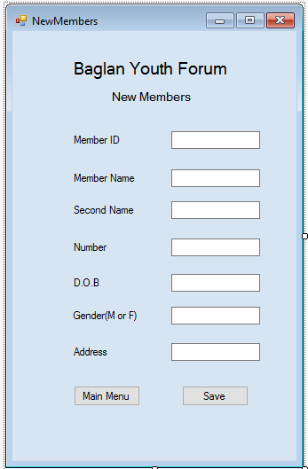
PublicClassNewMembers

PublicStructureMember'declares structure for member details
Public MemID AsString
Public MemName AsString
Public MemName2 AsString
Public number AsString
Public DOB AsString
Public Gender AsChar
Public Address AsString
EndStructure

Public Members AsMember'Declares an array as the structure above

PrivateSub Button1_Click(sender AsObject, e AsEventArgs) Handles cmdMainMenu.Click
ManagerMenu.Show()
EndSub

PrivateSub NewMembers_Load(sender AsObject, e AsEventArgs) HandlesMyBase.Load

EndSub

PrivateSub cmdSave_Click(sender AsObject, e AsEventArgs) Handles cmdSave.Click
'presence check on memberID
If TxtMemID.Text = ""Then
MsgBox("You must enter a member ID") 'error message if nothing has been entered
ExitSub
EndIf

'length check on number
IfLen(TxtNumber.Text) < 11 Or Len(TxtNumber.Text) > 11 Then
MsgBox("The number must be 11 characters long") 'error message displayed to user
ExitSub
EndIf

Members.MemID = TxtMemID.Text
Members.MemName = TxtMemName.Text
Members.MemName2 = TxtMemName2.Text
Members.number = TxtNumber.Text
Members.DOB = TxtDOB.Text
Members.Gender = TxtGender.Text
Members.Address = TxtAddress.Text

'following code saves complete member array into members text file
Dim NewM As System.IO.StreamWriter
NewM = My.Computer.FileSystem.OpenTextFileWriter(Path &"/Member Details", True)
NewM.WriteLine(Members.MemID &","& Members.MemName &","& Members.MemName2 &","& Members.number &","& Members.DOB &","& Members.Gender &","& Members.Address)
MsgBox("Items Saved")
NewM.Close()

'clears text from text boxes
TxtMemID.Text = ""
TxtMemName.Text = ""
TxtMemName2.Text = ""
TxtNumber.Text = ""
TxtDOB.Text = ""
TxtGender.Text = ""
TxtAddress.Text = ""

EndSub
EndClass
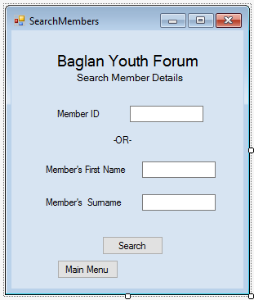
Search Members
PublicClassSearchMembers

PublicStructureMembers'declaring structure for member details
Public MemID AsString
Public MemName AsString
Public MemName2 AsString
Public number AsString
Public DOB AsString
Public Gender AsChar
Public Address AsString
EndStructure

PublicAllMembers(0 To 1000) AsMembers'creates array for the above structure
Public NumMem AsInteger = 0 'Creating an integer variable and setting it to 0
Publicparts(0 To 6) AsString
Public position AsInteger = 0 'Creating an integer variable and setting it to 0

PrivateSub Button2_Click(sender AsObject, e AsEventArgs) Handles Button2.Click
ManagerMenu.Show()
EndSub

PrivateSub SearchMembers_Load(sender AsObject, e AsEventArgs) HandlesMyBase.Load
EndSub

PrivateSub Button1_Click(sender AsObject, e AsEventArgs) Handles Button1.Click
Dim file As System.IO.StreamReader
Dim line AsString
DimParts(0 To 7) AsString

'set file to correct path, loads member details text file into declared member array
file = My.Computer.FileSystem.OpenTextFileReader(Path &"/Member Details")

Do
line = file.ReadLine()

Parts = line.Split(",")

AllMembers(NumMem).MemID = Parts(0)
AllMembers(NumMem).MemName = Parts(1)
AllMembers(NumMem).MemName2 = Parts(2)
AllMembers(NumMem).number = Parts(3)
AllMembers(NumMem).DOB = Parts(4)
AllMembers(NumMem).Gender = Parts(5)
AllMembers(NumMem).Address = Parts(6)

'checks that memberID matches the member ID in the array
If TxtMemberID.Text = AllMembers(NumMem).MemID Then
'displays information to user
MsgBox("Name: "& AllMembers(NumMem).MemName &" Surname: "& AllMembers(NumMem).MemName2 &" Number: "& AllMembers(NumMem).number &" DOB: "& AllMembers(NumMem).DOB &" Gender: "& AllMembers(NumMem).Gender &" Address: "& AllMembers(NumMem).Address)
'clears text from text boxes
TxtMemberID.Text = ""

position = NumMem
'checks to see if first and last name match the array
ElseIf txtFName.Text = AllMembers(NumMem).MemName And txtSName.Text = AllMembers(NumMem).MemName2 Then
'displays information to user
MsgBox("Member ID: "& AllMembers(NumMem).MemID &"Name: "& AllMembers(NumMem).MemName &" Surname: "& AllMembers(NumMem).MemName2 &" Number: "& AllMembers(NumMem).number &" DOB: "& AllMembers(NumMem).DOB &" Gender: "& AllMembers(NumMem).Gender &" Address: "& AllMembers(NumMem).Address)
'clears text from text boxes
txtFName.Text = ""
txtSName.Text = ""

position = NumMem
EndIf
NumMem = NumMem + 1

LoopUntil (file.EndOfStream)
file.Close()
EndSub

PrivateSub Button3_Click(sender AsObject, e AsEventArgs)
EditMemberDetails.Show()
EndSub

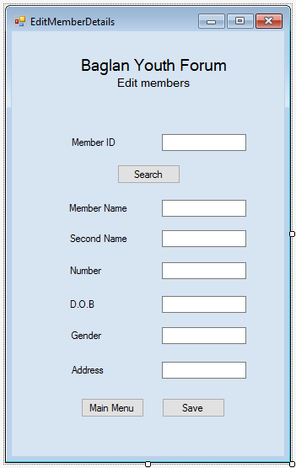
Edit Member Details
PublicClassEditMemberDetails

PublicStructureMember'Declares structure for member details

Public MemID AsString
Public MemName AsString
Public MemName2 AsString
Public number AsString
Public DOB AsString
Public Gender AsChar
Public Address AsString

EndStructure

PublicMembers(0 To 1000) AsMember'Declares an array as the structure above
Public NumMem AsInteger = 0 'Creating an integer variable and setting it to 0
Publicparts(0 To 6) AsString
Public position AsInteger = 0 'creating an integer variable and setting it to 0

'creates an input box to allow the user to enter the member ID they are searching for
Public SearchID AsString = InputBox("Enter Member ID that you're searching for.")

PrivateSub Button2_Click(sender AsObject, e AsEventArgs) Handles Button2.Click
ManagerMenu.Show()
EndSub

PrivateSub EditMemberDetails_Load(sender AsObject, e AsEventArgs) HandlesMyBase.Load

Dim file As System.IO.StreamReader
Dim line AsString
DimParts(0 To 7) AsString

'set file to correct path, loads Member Details text file into declared Member array
file = My.Computer.FileSystem.OpenTextFileReader(Path &"/Member Details")

Do
line = file.ReadLine()

Parts = line.Split(",")

Members(NumMem).MemID = Parts(0)
Members(NumMem).MemName = Parts(1)
Members(NumMem).MemName2 = Parts(2)
Members(NumMem).number = Parts(3)
Members(NumMem).DOB = Parts(4)
Members(NumMem).Gender = Parts(5)
Members(NumMem).Address = Parts(6)

'checks to see if the searchID entered by the user matches the MemberID from array
If SearchID = Members(NumMem).MemID Then

txtMemberID.Text = Members(NumMem).MemID
txtMemName.Text = Members(NumMem).MemName
txtMemName2.Text = Members(NumMem).MemName2
txtNumber.Text = Members(NumMem).number
txtDOB.Text = Members(NumMem).DOB
txtGender.Text = Members(NumMem).Gender
txtAddress.Text = Members(NumMem).Address

position = NumMem
EndIf
NumMem = NumMem + 1

LoopUntil (File.EndOfStream)
File.Close()
EndSub

PrivateSub Button1_Click(sender AsObject, e AsEventArgs)

EndSub

PrivateSub Button3_Click(sender AsObject, e AsEventArgs) Handles Button3.Click
Members(position).MemID = txtMemberID.Text
Members(position).MemName = txtMemName.Text
Members(position).MemName2 = txtMemName2.Text
Members(position).number = txtNumber.Text
Members(position).DOB = txtDOB.Text
Members(position).Gender = txtGender.Text
Members(position).Address = txtAddress.Text

'clears the text from the text boxes
txtMemberID.Text = ""
txtMemName.Text = ""
txtMemName2.Text = ""
txtNumber.Text = ""
txtDOB.Text = ""
txtGender.Text = ""
txtAddress.Text = ""

'below code saves complete member array back into the text file
Dim NewM As System.IO.StreamWriter
NewM = My.Computer.FileSystem.OpenTextFileWriter(Path &"/Member Details.txt", False)
For y = 0 To (NumMem - 1)
NewM.WriteLine(Members(y).MemID &","& Members(y).MemName &","& Members(y).MemName2 &","& Members(y).number &","& Members(y).DOB &","& Members(y).Gender &","& Members(y).Address)
Next y
NewM.Close()

EndSub
EndClass

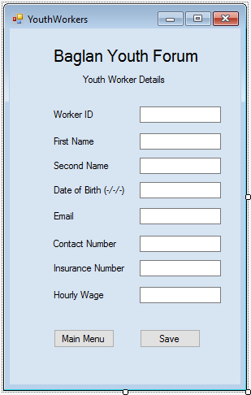
New Youth Worker
PublicClassYouthWorkers

PublicStructureWorker'declares the structure for youth workers
Public WorkerID AsString
Public WName AsString
Public WName2 AsString
Public DOB AsString
Public Email AsString
Public ContactNum AsString
Public InsuranceNum AsString
Public HrWage AsString
EndStructure

Public Workers AsWorker'creates array for the above structure

PrivateSub YouthWorkers_Load(sender AsObject, e AsEventArgs) HandlesMyBase.Load

EndSub

PrivateSub Button2_Click(sender AsObject, e AsEventArgs) Handles Button2.Click
Workers.WorkerID = txtWorkerID.Text
Workers.WName = txtFname.Text
Workers.WName2 = txtSname.Text
Workers.DOB = txtDOB.Text
Workers.Email = txtEmail.Text
Workers.ContactNum = txtContactNum.Text
Workers.InsuranceNum = txtInsuranceNum.Text
Workers.HrWage = txtHourlyWage.Text

'below code saves the completed youth workers array back into the text file
Dim NewM As System.IO.StreamWriter
NewM = My.Computer.FileSystem.OpenTextFileWriter(Path &"/Worker Details", True)
NewM.WriteLine(Workers.WorkerID &","& Workers.WName &","& Workers.WName2 &","& Workers.DOB &","& Workers.Email &","& Workers.ContactNum &","& Workers.InsuranceNum &","& Workers.HrWage)
MsgBox("Items Saved") 'display that the save was successful
NewM.Close()

'clears text from text boxes.
txtWorkerID.Text = ""
txtFname.Text = ""
txtSname.Text = ""
txtDOB.Text = ""
txtEmail.Text = ""
txtContactNum.Text = ""
txtInsuranceNum.Text = ""
txtHourlyWage.Text = ""
EndSub
EndClass

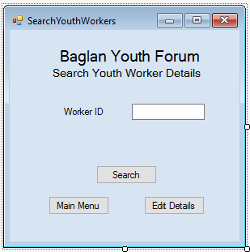
Search Youth Worker
PublicClassSearchYouthWorkers
PublicStructureWorkers'declares structure for youth worker details
Public WorkerID AsString
Public WName AsString
Public WName2 AsString
Public DOB AsString
Public Email AsString
Public ContactNum AsString
Public InsuranceNum AsString
Public HrWage AsString
EndStructure

PublicAllWorkers(0 To 1000) AsWorkers'creates an array for above structure
Public NumWork AsInteger = 0 'Creating an integer variable and setting it to 0
Publicparts(0 To 7) AsString
Public position AsInteger = 0 'Creating an integer variable and setting it to 0

PrivateSub SearchYouthWorkers_Load(sender AsObject, e AsEventArgs) HandlesMyBase.Load

EndSub

PrivateSub Button1_Click(sender AsObject, e AsEventArgs) Handles Button1.Click
Dim file As System.IO.StreamReader
Dim line AsString
DimParts(0 To 7) AsString

'set file to correct path, loads worker details text file into declared worker array
file = My.Computer.FileSystem.OpenTextFileReader(Path &"/Worker Details")

Do
line = file.ReadLine()

Parts = line.Split(",")

AllWorkers(NumWork).WorkerID = Parts(0)
AllWorkers(NumWork).WName = Parts(1)
AllWorkers(NumWork).WName2 = Parts(2)
AllWorkers(NumWork).DOB = Parts(3)
AllWorkers(NumWork).Email = Parts(4)
AllWorkers(NumWork).ContactNum = Parts(5)
AllWorkers(NumWork).InsuranceNum = Parts(6)
AllWorkers(NumWork).HrWage = Parts(7)

'checks that the workerID matches the worker ID in the array
If TxtWorkerID.Text = AllWorkers(NumWork).WorkerID Then
'displays information to the user
MsgBox("Worker ID: "& AllWorkers(NumWork).WorkerID &" First Name: "& AllWorkers(NumWork).WName &" Surname: "& AllWorkers(NumWork).WName2 &" Email: "& AllWorkers(NumWork).Email &" DOB: "& AllWorkers(NumWork).DOB &" Contact Number: "& AllWorkers(NumWork).ContactNum &" National Insurance: "& AllWorkers(NumWork).InsuranceNum &" Hourly Wage: "& AllWorkers(NumWork).HrWage)
'clears text from text boxes
TxtWorkerID.Text = ""

position = NumWork
EndIf

NumWork = NumWork + 1

LoopUntil (file.EndOfStream)
file.Close()
EndSub
EndClass

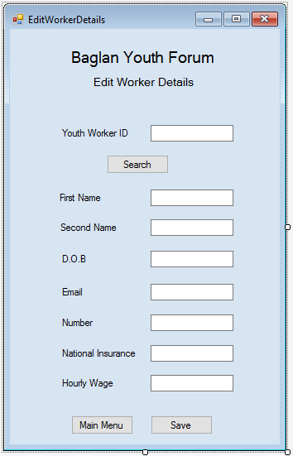
Edit Youth Worker Details
PublicClassEditWorkerDetails

PublicStructureWorkers'Declares structure for worker details
Public WorkerID AsString
Public WName AsString
Public WName2 AsString
Public DOB AsString
Public Email AsString
Public ContactNum AsString
Public InsuranceNum AsString
Public HrWage AsString
EndStructure

PublicAllWorkers(0 To 1000) AsWorkers'Declares an array as the structure above
Public NumWork AsInteger = 0 'Creating an integer variable and setting it to 0
Publicparts(0 To 7) AsString
Public position AsInteger = 0 'creating an integer variable and setting it to 0

'creates an input box to allow the user to enter the worker ID they are searching for
Public SearchID AsString = InputBox("Enter Worker ID that you're searching for.")

PrivateSub EditWorkerDetails_Load(sender AsObject, e AsEventArgs) HandlesMyBase.Load
Dim file As System.IO.StreamReader
Dim line AsString
DimParts(0 To 7) AsString

'set file to correct path, loads Member Details text file into declared Worker array
file = My.Computer.FileSystem.OpenTextFileReader(Path &"/Worker Details"
If txtWorkerID.Text = ""Then
MsgBox("You must enter a worker ID")
EndIf

Do
line = file.ReadLine()

Parts = line.Split(",")

AllWorkers(NumWork).WorkerID = Parts(0)
AllWorkers(NumWork).WName = Parts(1)
AllWorkers(NumWork).WName2 = Parts(2)
AllWorkers(NumWork).DOB = Parts(3)
AllWorkers(NumWork).Email = Parts(4)
AllWorkers(NumWork).ContactNum = Parts(5)
AllWorkers(NumWork).InsuranceNum = Parts(6)
AllWorkers(NumWork).HrWage = Parts(7)

'checks to see if the searchID enetered by the user matches the Worker ID from the array
If SearchID = AllWorkers(NumWork).WorkerID Then

txtWorkerID.Text = AllWorkers(NumWork).WorkerID
txtWorkerName.Text = AllWorkers(NumWork).WName
txtWorkerSurname.Text = AllWorkers(NumWork).WName2
txtDOB.Text = AllWorkers(NumWork).DOB
txtEmail.Text = AllWorkers(NumWork).Email
txtNumber.Text = AllWorkers(NumWork).ContactNum
txtNationalI.Text = AllWorkers(NumWork).InsuranceNum
TxtHrlyWage.Text = AllWorkers(NumWork).HrWage

position = NumWork
EndIf
NumWork = NumWork + 1

LoopUntil (file.EndOfStream)
file.Close()
EndSub

PrivateSub Button3_Click(sender AsObject, e AsEventArgs) Handles Button3.Click
AllWorkers(position).WorkerID = txtWorkerID.Text
AllWorkers(position).WName = txtWorkerName.Text
AllWorkers(position).WName2 = txtWorkerSurname.Text
AllWorkers(position).DOB = txtDOB.Text
AllWorkers(position).Email = txtEmail.Text
AllWorkers(position).ContactNum = txtNumber.Text
AllWorkers(position).InsuranceNum = txtNationalI.Text
AllWorkers(position).HrWage = TxtHrlyWage.Text

'clears text from text boxes
txtWorkerID.Text = ""
txtWorkerName.Text = ""
txtWorkerSurname.Text = ""
txtDOB.Text = ""
txtEmail.Text = ""
txtNumber.Text = ""
txtNationalI.Text = ""
TxtHrlyWage.Text = ""

'below code saves complete Worker array back into the text file
Dim NewM As System.IO.StreamWriter
NewM = My.Computer.FileSystem.OpenTextFileWriter(Path &"/Member Details.txt", False)
For y = 0 To (NumWork - 1)
NewM.WriteLine(AllWorkers(y).WorkerID &","& AllWorkers(y).WName &","& AllWorkers(y).WName2 &","& AllWorkers(y).DOB &","& AllWorkers(y).Email &","& AllWorkers(y).ContactNum &","& AllWorkers(y).InsuranceNum &","& AllWorkers(y).HrWage)
Next y
NewM.Close()

EndSub
End class
New Volunteer Details
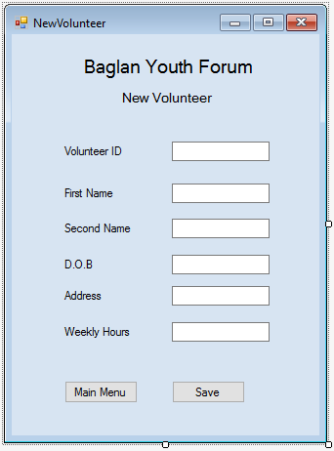
PublicClassNewVolunteer

PublicStructureVolunteer'declaring structure for volunteer details
Public VolunteerID AsString
Public Fname AsString
Public SName AsString
Public DOB AsString
Public Address AsString
Public WeeklyHrs AsString
EndStructure

Public Volunteers AsVolunteer'creating array for above structure

PrivateSub NewVolunteer_Load(sender AsObject, e AsEventArgs) HandlesMyBase.Load

EndSub

PrivateSub cmdSave_Click(sender AsObject, e AsEventArgs) Handles cmdSave.Click
'presence check for VolunteerID
If TxtVolunteerID.Text = ""Then
MsgBox("You must enter a volunteer ID") 'error message if nothing is present
EndIf
'range check for weekly hours
If TxtWklyHours.Text < 4 Or TxtWklyHours.Text > 15 Then
MsgBox("A volunteer can only work between 4 to 15 hours a week") 'error message if input is out of range
EndIf

Volunteers.VolunteerID = TxtVolunteerID.Text
Volunteers.Fname = TxtFName.Text
Volunteers.SName = TxtSName.Text
Volunteers.DOB = TxtDOB.Text
Volunteers.Address = TxtAddress.Text
Volunteers.WeeklyHrs = TxtWklyHours.Text

'following code saves the completed volunteer details array into the text file
Dim NewM As System.IO.StreamWriter
NewM = My.Computer.FileSystem.OpenTextFileWriter(Path &"/Volunteer Details", True)
NewM.WriteLine(Volunteers.VolunteerID &","& Volunteers.Fname &","& Volunteers.SName &","& Volunteers.DOB &","& Volunteers.Address &","& Volunteers.WeeklyHrs)
MsgBox("Items Saved") 'message to tell user the save has been successful
NewM.Close()

'clears text from text boxes
TxtVolunteerID.Text = ""
TxtFName.Text = ""
TxtSName.Text = ""
TxtDOB.Text = ""
TxtAddress.Text = ""
TxtWklyHours.Text = ""
EndSub

EndClass
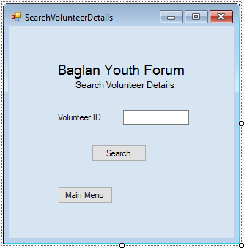
Search Volunteer Details
PublicClassSearchVolunteerDetails

PublicStructureVolunteer'declaring structure for volunteers
Public VolunteerID AsString
Public Fname AsString
Public SName AsString
Public DOB AsString
Public Address AsString
Public WeeklyHrs AsString
EndStructure

PublicAllVolunteers(0 To 1000) AsVolunteer'creates array for above structure
Public NumVol AsInteger = 0 'Creating an integer variable and setting it to 0
Publicparts(0 To 6) AsString
Public position AsInteger = 0 'Creating an integer variable and setting it to 0

PrivateSub SearchVolunteerDetails_Load(sender AsObject, e AsEventArgs) HandlesMyBase.Load

EndSub

PrivateSub Button1_Click(sender AsObject, e AsEventArgs) Handles Button1.Click
Dim file As System.IO.StreamReader
Dim line AsString
DimParts(0 To 5) AsString

'set file to correct path, loads member details text file into declared member array
file = My.Computer.FileSystem.OpenTextFileReader(Path &"/Volunteer Details")

Do
line = file.ReadLine()

Parts = line.Split(",")

AllVolunteers(NumVol).VolunteerID = Parts(0)
AllVolunteers(NumVol).Fname = Parts(1)
AllVolunteers(NumVol).SName = Parts(2)
AllVolunteers(NumVol).DOB = Parts(3)
AllVolunteers(NumVol).Address = Parts(4)
AllVolunteers(NumVol).WeeklyHrs = Parts(5)

'checks to see if the Volunteer ID entered matches the one from array
If TxtVolunteerID.Text = AllVolunteers(NumVol).VolunteerID Then
'displays information to user
MsgBox("Name: "& AllVolunteers(NumVol).Fname &" Surname: "& AllVolunteers(NumVol).SName &" DOB: "& AllVolunteers(NumVol).DOB &" Address: "& AllVolunteers(NumVol).Address &" Weekly Hours: "& AllVolunteers(NumVol).WeeklyHrs)
'clears text from text boxes
TxtVolunteerID.Text = ""

position = NumVol
EndIf
NumVol = NumVol + 1

LoopUntil (file.EndOfStream)
file.Close()
EndSub

PrivateSub Button2_Click(sender AsObject, e AsEventArgs) Handles Button2.Click
ManagerMenu.Show()
EndSub
EndClass

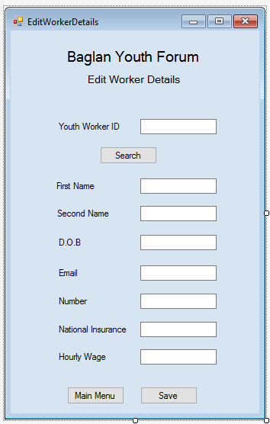
Edit Youth Worker Details
PublicClassEditWorkerDetails

PublicStructureWorkers'Declares structure for worker details
Public WorkerID AsString
Public WName AsString
Public WName2 AsString
Public DOB AsString
Public Email AsString
Public ContactNum AsString
Public InsuranceNum AsString
Public HrWage AsString
EndStructure

PublicAllWorkers(0 To 1000) AsWorkers'Declares an array as the structure above
Public NumWork AsInteger = 0 'Creating an integer variable and setting it to 0
Publicparts(0 To 7) AsString
Public position AsInteger = 0 'creating an integer variable and setting it to 0

'creates an input box to allow the user to enter the worker ID they are searching for
Public SearchID AsString = InputBox("Enter Worker ID that you're searching for.")

PrivateSub EditWorkerDetails_Load(sender AsObject, e AsEventArgs) HandlesMyBase.Load
Dim file As System.IO.StreamReader
Dim line AsString
DimParts(0 To 7) AsString

'set file to correct path, loads Member Details text file into declared Worker array
file = My.Computer.FileSystem.OpenTextFileReader(Path &"/Worker Details")

If txtWorkerID.Text = ""Then
MsgBox("You must enter a worker ID")
EndIf

Do
line = file.ReadLine()

Parts = line.Split(",")

AllWorkers(NumWork).WorkerID = Parts(0)
AllWorkers(NumWork).WName = Parts(1)
AllWorkers(NumWork).WName2 = Parts(2)
AllWorkers(NumWork).DOB = Parts(3)
AllWorkers(NumWork).Email = Parts(4)
AllWorkers(NumWork).ContactNum = Parts(5)
AllWorkers(NumWork).InsuranceNum = Parts(6)
AllWorkers(NumWork).HrWage = Parts(7)

'checks to see if the searchID enetered by the user matches the Worker ID from the array
If SearchID = AllWorkers(NumWork).WorkerID Then

txtWorkerID.Text = AllWorkers(NumWork).WorkerID
txtWorkerName.Text = AllWorkers(NumWork).WName
txtWorkerSurname.Text = AllWorkers(NumWork).WName2
txtDOB.Text = AllWorkers(NumWork).DOB
txtEmail.Text = AllWorkers(NumWork).Email
txtNumber.Text = AllWorkers(NumWork).ContactNum
txtNationalI.Text = AllWorkers(NumWork).InsuranceNum
TxtHrlyWage.Text = AllWorkers(NumWork).HrWage

position = NumWork
EndIf
NumWork = NumWork + 1

LoopUntil (file.EndOfStream)
file.Close()
EndSub

PrivateSub Button3_Click(sender AsObject, e AsEventArgs) Handles Button3.Click
AllWorkers(position).WorkerID = txtWorkerID.Text
AllWorkers(position).WName = txtWorkerName.Text
AllWorkers(position).WName2 = txtWorkerSurname.Text
AllWorkers(position).DOB = txtDOB.Text
AllWorkers(position).Email = txtEmail.Text
AllWorkers(position).ContactNum = txtNumber.Text
AllWorkers(position).InsuranceNum = txtNationalI.Text
AllWorkers(position).HrWage = TxtHrlyWage.Text

'clears text from text boxes
txtWorkerID.Text = ""
txtWorkerName.Text = ""
txtWorkerSurname.Text = ""
txtDOB.Text = ""
txtEmail.Text = ""
txtNumber.Text = ""
txtNationalI.Text = ""
TxtHrlyWage.Text = ""

'below code saves complete Worker array back into the text file
Dim NewM As System.IO.StreamWriter
NewM = My.Computer.FileSystem.OpenTextFileWriter(Path &"/Member Details.txt", False)
For y = 0 To (NumWork - 1)
NewM.WriteLine(AllWorkers(y).WorkerID &","& AllWorkers(y).WName &","& AllWorkers(y).WName2 &","& AllWorkers(y).DOB &","& AllWorkers(y).Email &","& AllWorkers(y).ContactNum &","& AllWorkers(y).InsuranceNum &","& AllWorkers(y).HrWage)
Next y
NewM.Close()

EndSub
EndClass
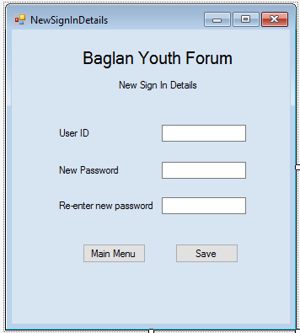
New Sign in Details
PublicClassNewSignInDetails

PublicStructureSignInDetails'declares structure for sign in details
Public UserID AsString
Public password1 AsString
Public password2 AsString
EndStructure

Public Details AsSignInDetails'declares an array for structure above

PrivateSub NewSignInDetails_Load(sender AsObject, e AsEventArgs) HandlesMyBase.Load

EndSub

PrivateSub Button2_Click(sender AsObject, e AsEventArgs) Handles Button2.Click
'presence check in user ID
If txtUserID.Text = ""Then
MsgBox("You must enter a user ID") 'error message for if there's nothing present
ExitSub
EndIf

Details.UserID = TxtUserID.Text
Details.password1 = TxtPass1.Text
Details.password2 = txtPass2.Text

'checks the password entered are the same
If Details.password1 <> Details.password2 Then
MsgBox("Passwords much be the same") 'error message for if they arent the same
ExitSub
EndIf

'following code saves the completed sign in details array into the text file
Dim NewM As System.IO.StreamWriter
NewM = My.Computer.FileSystem.OpenTextFileWriter(Path &"/Passwords", True)
NewM.WriteLine(Details.UserID &","& Details.password1)
MsgBox("Items Saved") 'msgbox to tell the user that the save has been successful
NewM.Close()

'clears text from text boxes
txtUserID.Text = ""
txtPass1.Text = ""
txtPass2.Text = ""

EndSub
EndClass

Search Sign in Details
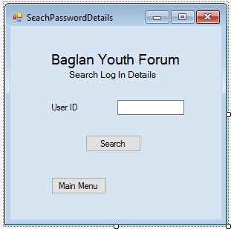
PublicClassSeachPasswordDetails

PublicStructureSignInDetails'declaring structure for sign in details
Public UserID AsString
Public password1 AsString
EndStructure

PublicAllPasswords(0 To 1000) AsSignInDetails'creates array for above structure
Public NumPass AsInteger = 0 'Creating an integer variable and setting it to 0
Publicparts(0 To 2) AsString
Public position AsInteger = 0 'Creating an integer variable and setting it to 0

PrivateSub SeachPasswordDetails_Load(sender AsObject, e AsEventArgs) HandlesMyBase.Load

EndSub

PrivateSub Button1_Click(sender AsObject, e AsEventArgs) Handles Button1.Click
Dim file As System.IO.StreamReader
Dim line AsString
DimParts(0 To 1) AsString

'set file to correct path, loads passwords text file into declared password array
file = My.Computer.FileSystem.OpenTextFileReader(Path &"/Passwords")

Do
line = file.ReadLine()

Parts = line.Split(",")

AllPasswords(NumPass).UserID = Parts(0)
AllPasswords(NumPass).password1 = Parts(1)

'checks that member ID is the same as userID from array
If TxtMemberID.Text = AllPasswords(NumPass).UserID Then
'displays the information in a messagebox
MsgBox("UserID: "& AllPasswords(NumPass).UserID &" Password: "& AllPasswords(NumPass).password1)
'clears text from text boxes
TxtMemberID.Text = ""

position = NumPass
EndIf
NumPass = NumPass + 1

LoopUntil (file.EndOfStream)
file.Close()
EndSub
EndClass
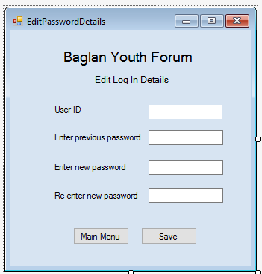
Edit Sign in Details
PublicClassEditPasswordDetails

PublicStructureSignInDetails'Declares structure for password details
Public UserID AsString
Public password1 AsString
Public password2 AsString
Public password3 AsString
Public password4 AsString
EndStructure

PublicDetails(0 To 1000) AsSignInDetails'Declares an array as the structure above
Public Numpass AsInteger = 0 'Creating an integer variable and setting it to 0
Publicparts(0 To 6) AsString
Public position AsInteger = 0 'creating an integer variable and setting it to 0

'creates an input box to allow the user to enter the user ID they are searching for
Public SearchID AsString = InputBox("Enter User ID that you're searching for.")

PrivateSub EditPasswordDetails_Load(sender AsObject, e AsEventArgs) HandlesMyBase.Load
Dim file As System.IO.StreamReader
Dim line AsString
DimParts(0 To 1) AsString

'set file to correct path, loads Member Details text file into declared password array
file = My.Computer.FileSystem.OpenTextFileReader(Path &"/Passwords")

'checks that the 2 passwords entered are the same
If txtpass2.Text <> txtpass3.Text Then
MsgBox("Passwords must be the same") 'error message if the passwords arent the same
ExitSub
EndIf

Do
line = file.ReadLine()

Parts = line.Split(",")

Details(Numpass).UserID = Parts(0)
Details(Numpass).password1 = Parts(1)

'checks to see if the searchID enetered by the user matches the UserID from the array
If SearchID = Details(Numpass).UserID Then

txtUser.Text = Details(Numpass).UserID

position = Numpass
EndIf
Numpass = Numpass + 1

LoopUntil (file.EndOfStream)
file.Close()
EndSub

PrivateSub Button2_Click(sender AsObject, e AsEventArgs) Handles Button2.Click
Details(position).UserID = txtUser.Text
Details(position).password1 = txtpass1.Text
Details(position).password2 = txtpass2.Text
Details(position).password3 = txtpass3.Text

'clears text from text boxes
txtUser.Text = ""
txtpass1.Text = ""
txtpass2.Text = ""
txtpass3.Text = ""

'below code saves complete password array back into the text file
Dim NewM As System.IO.StreamWriter
NewM = My.Computer.FileSystem.OpenTextFileWriter(Path &"/Passwords", False)
For y = 0 To (Numpass - 1)
NewM.WriteLine(Details(y).UserID &","& Details(y).password2)
Next y
NewM.Close()

EndSub
EndClass

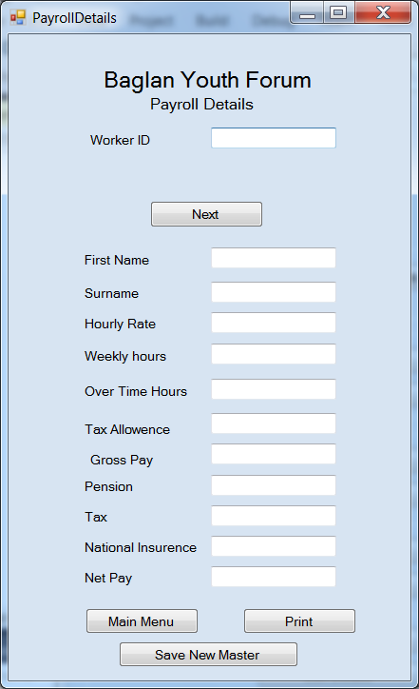
Payroll-
Public Class PayrollDetails

Public Structure Payroll 'declaring structure for payroll
Public WorkID As String
Public Fname As String
Public Sname As String
Public WeeklyHrs As String
Public HourlyR As String
Public OvertimeH As String
Public GrossTD As String
Public Pension As String
Public Tax As String
Public NI As String
Public NINum As String
Public TaxAllowance As String
Public Netpay As String
End Structure

Public AllPayroll(0 To 1000) As Payroll 'creates array for above structure
Public NumPayroll As Integer = 0 'Creating an integer variable and setting it to 0
Public parts(0 To 6) As String
Public position As Integer = 1 'Creating an integer variable and setting it to 0

Public TotalPay As Integer = 0 'Creating an integer variable and setting it to 0
Public Overtimehrs As Integer = 0 'Creating an integer variable and setting it to 0

Private Sub Button3_Click(sender As Object, e As EventArgs) Handles Button3.Click
ManagerMenu.Show()
End Sub

Private Sub PayrollDetails_Load(sender As Object, e As EventArgs) Handles MyBase.Load

Dim file As System.IO.StreamReader
Dim line As String
Dim Parts(0 To 9) As String

file = My.Computer.FileSystem.OpenTextFileReader(Path & "/Payroll Details")

Do
line = file.ReadLine()

Parts = line.Split(",")

AllPayroll(NumPayroll).WorkID = Parts(0)
AllPayroll(NumPayroll).Fname = Parts(1)
AllPayroll(NumPayroll).Sname = Parts(2)
AllPayroll(NumPayroll).WeeklyHrs = Parts(3)
AllPayroll(NumPayroll).HourlyR = Parts(4)
AllPayroll(NumPayroll).GrossTD = Parts(5)
AllPayroll(NumPayroll).Pension = Parts(6)
AllPayroll(NumPayroll).Tax = Parts(7)
AllPayroll(NumPayroll).NI = Parts(8)
AllPayroll(NumPayroll).NINum = Parts(9)
AllPayroll(NumPayroll).TaxAllowance = Parts(10)
AllPayroll(NumPayroll).Netpay = Parts(11)
NumPayroll = NumPayroll + 1

Loop Until (file.EndOfStream)
file.Close()
End Sub

Private Sub cmdNext_Click(sender As Object, e As EventArgs) Handles cmdNext.Click
Dim Worker As String
Dim Hours As Integer
Dim OTHours As Double
Dim Gross As Double
Dim Taxable As Double
Dim Tax As Double
Dim NatIn As Double
Dim HighPay As Double
Dim Pension As Double
Dim Net As Double

If txtWorkerID.Text <> "" Then 'check data entered into form
Worker = txtWorkerID.Text
Hours = InputBox("Enter number of hours worked this week")
Else 'if no data entered give error message and stop code running
MsgBox("Enter WorkerId before pushing Next")
Exit Sub
End If

For n = 1 To NumPayroll - 1 'loop through each record in payroll array
If AllPayroll(n).WorkID = Worker Then
TxtFName.Text = AllPayroll(n).Fname
TxtSName.Text = AllPayroll(n).Sname
TxtHrlyRate.Text = AllPayroll(n).HourlyR
TxtWeeklyHrs.Text = AllPayroll(n).WeeklyHrs
TxtTAllowance.Text = Math.Round((AllPayroll(n).TaxAllowance / 52), 2) 'divides yearly tax allowance by 52 and rounds to 2dp
position = n
Exit For
End If

Next

'calculate number of hours to pay at overtime rate
OTHours = Hours - AllPayroll(position).WeeklyHrs
TxtOTHours.Text = OTHours

'calculate gross pay for this week
Gross = (AllPayroll(position).WeeklyHrs * AllPayroll(position).HourlyR) + (OTHours * 1.5 * AllPayroll(position).HourlyR)
TxtGross.Text = Math.Round(Gross, 2)

'work out the amount of pay that tax will be paid on
Taxable = Gross - TxtTAllowance.Text

'caluclate amount of tax to pay
If Gross < TxtTAllowance.Text Then
Tax = 0.00
ElseIf Gross < (45000 / 52) Then
Tax = Taxable * 0.2
Else
HighPay = (Gross - (45000 / 52))
Tax = ((45000 / 52) * 0.2) + (HighPay * 0.4)
End If
TxtTax.Text = Math.Round(Tax, 2)

'calculate NI amoun to pay
If Gross < 114 Then
NatIn = 0
ElseIf Gross < 866 Then
NatIn = (Gross * 0.12)
Else
NatIn = (866 * 0.12) + ((Gross - 866) * 0.02)
End If
TxtNI.Text = Math.Round(NatIn, 2)

'calculate Pension amount to pay
Pension = Gross * 0.075
TxtPension.Text = Math.Round(Pension, 2)

'calculate Net pay
Net = Gross - Tax - Pension - NatIn

txtNetPay.Text = Math.Round(Net, 2)

'#############################################################################
'Save Totals to Payroll Array
AllPayroll(position).GrossTD = AllPayroll(position).GrossTD + Gross
AllPayroll(position).Pension = AllPayroll(position).Pension + Pension
AllPayroll(position).Tax = AllPayroll(position).Tax + Tax
AllPayroll(position).NI = AllPayroll(position).NI + NatIn
AllPayroll(position).Netpay = AllPayroll(position).Netpay + Net

' Save Wage slip for this Worker in WageSlips folder
Dim dDate As Date = Today()

Dim NewM As System.IO.StreamWriter
NewM = My.Computer.FileSystem.OpenTextFileWriter(Path & "/WageSlips/" & TxtSName.Text & TxtFName.Text, True)
NewM.WriteLine("Date: " & dDate & "," & Worker & "," & TxtFName.Text & "," & TxtSName.Text & "," & "Gross Pay:" & "," & Gross & "," & "Tax:" & "," & Tax & "," & "NI:" & "," & NatIn & "," & "Pension:" & "," & Pension & "Net: " & Net)
MsgBox("Wage slip Saved")
NewM.Close()
MsgBox(" You can now either enter a new WorkerId or Click 'Save Master File' .... you must click save Master file")

End Sub

Private Sub Save_Master_Click(sender As Object, e As EventArgs) Handles Save_Master.Click

'below code saves complete Worker array back into the text file
Dim NewM As System.IO.StreamWriter
NewM = My.Computer.FileSystem.OpenTextFileWriter(Path & "/Payroll Details", False)
For y = 0 To (NumPayroll - 1)
NewM.WriteLine(AllPayroll(y).WorkID & "," & AllPayroll(y).Fname & "," & AllPayroll(y).Sname & "," & AllPayroll(y).WeeklyHrs & "," & AllPayroll(y).HourlyR & "," & AllPayroll(y).GrossTD & "," & AllPayroll(y).Pension & "," & AllPayroll(y).Tax & "," & AllPayroll(y).NI & "," & AllPayroll(y).NINum & "," & AllPayroll(y).TaxAllowance & "," & AllPayroll(y).Netpay)
Next y
NewM.Close()

MsgBox("New Master file saved")

End Sub
End Class

