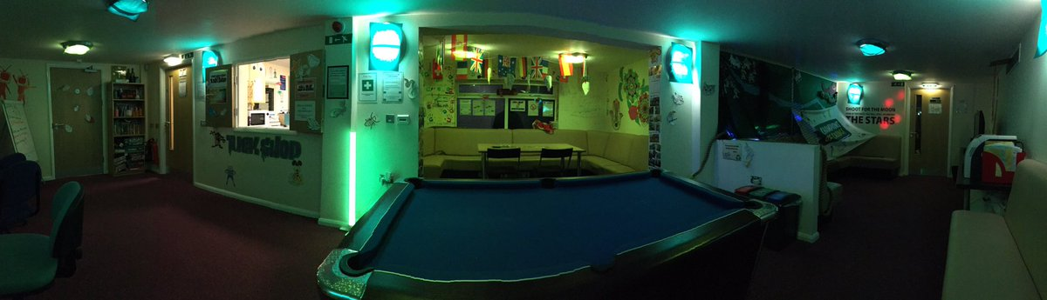
Baglan Youth Forum
Staff questionnaire
All you all know, we are working towards creating a better system for the system to run on. In order to collect as much information about the current system as possible, please would you answer all the questions in this questionnaire honestly.
All information in these questionnaires will be confidential.
*What is your role in the youth centre?
________________________________________________________

- How would you describe the security in the centre?

Not secure [ ] Secure [ ] Very Secure [ ]

- Did you require any type of training to learn how to use your current system?

Yes [ ] No [ ]

- Do you think the system is too complex?
Yes [ ] No [ ]
- Would you rather stay with your current system or change to the computerised version?
Stay with current system [ ] Change to computerised system [ ]
Give reason for your answer below.
________________________________________________________
________________________________________________________
- Would you feel more comfortable with the computerised system if you had training on how it operates before hand?

Yes [ ] no [ ]

THANK YOU FOR TAKING YOUR TIME TO ANSWER THIS QUESTIONNAIRE

