Overview of the system. (Manager Access)
Main Menu
Sign in
Load form
Forgotten password
Manager has full access to the program, since they are the only ones with the permission

Save Details
Member Details
New stock
Tuck Details
Tuckshop
Main Menu
Add to old stock
Main Menu
Edit Details
Add new stock
Search Members
Edit Members
Save Details
Y/W Details
Volunteer Details
MainMenu
Sell items
Main Menu
Save Details
Search Y/Worker
Members
Edit Y/Worker
Volunteers
Youth Workers
Payroll
Sign In Details
Stock Details
Save Details
Payroll Details
Main Menu
Main Menu
Main Menu
Search Volunteers
New Members
New Youth Worker
New Volunteer
Edit volunteers
Print payroll
New payroll
Search Details
New Details

Key – Highlighted areas will be included in the prototype.

Prototype

The reason for completing a prototype is to ensure that the company can ensure that the direction in which the program is heading is meeting the standards and requirements that the company has set. By viewing the prototype, the company will also be able to suggest and changes that they want to make to the program before the final design is produced. Additionally, the prototype will allow the company to become more familiar with the new system before it is introduced in their company.
For this prototype to provide an accurate representation of the design, it needs to include a reasonable amount of areas in the design. It’s important to produce a realistic prototype so that the company can view it as it would be. This would also hopefully avoid the company being disappointed in the final design as any suggestions can be realistic to the design.
The above diagram is a representation of what areas I will be completing in my prototype. I decided to include the areas that are different from each other, and the more complex areas to code. This way I won’t be spending time on areas that are similar to others and I can focus on the areas that will take more time to produce. I will be producing the main menu however only the areas I am producing for the prototype will be accessible for the user. I decided to base my prototype on the manager access because they will have full access to the system, rather than it being limited. Additionally, any volunteers or youth workers who are testing the system will still be able to access certain areas of the system that they would have access to in the final system.

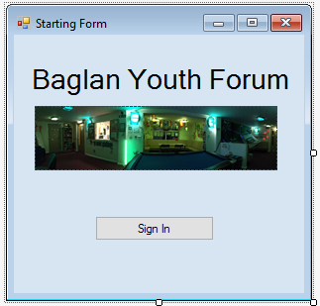
Form 1 – Starting Screen

This will be what the starting form will look like. A simple form to allow the user to access the sign in screen. This is needed for all users and that is why I included it in my prototype.

Form 2 – Sign in

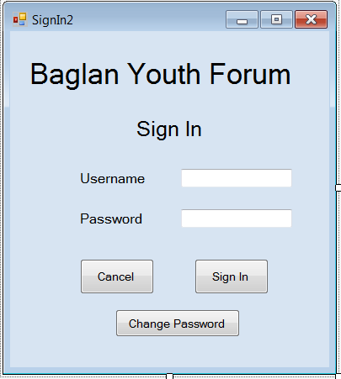
This is the Sign in form. This is where the user can input their details and gain access to the suitable menu. In this prototype, the user will only be able to gain access to the manager menu, rather than the Worker’s more restricted menu.

The user will enter their details and check that they are, first of all, correct, and that the password matches the username.

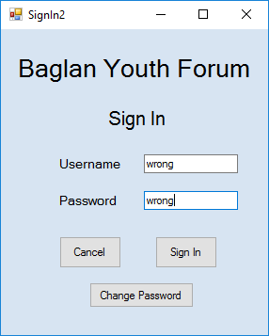
If the username or password is incorrect, then the system will display an error message to the user saying that they are incorrect.
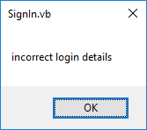

It is only once the user has entered their details correctly that they will be able to click either buttons. This means that the user won’t be able to change their password without knowing their current one. I did this as security since if someone knew someone else’s username then they would have been able to change the password, but now the user has to sign in before they can. If they have forgotten their details the manager will have access to the main file and they will be able to change it manually.

Change Password
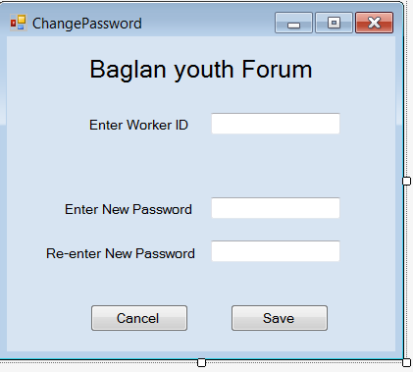

If the sign in details are correct, and the user selects the ‘Change password’ button on the previous form then they will be taken to this form.
Since they have already logged in, the Worker ID text box will be auto filled with the ID of whoever has logged in.
Then they can simply decide on a new password, enter it twice and click save.
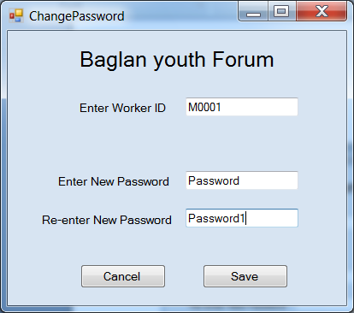
If the two new passwords are identical, then when ‘Save’ is clicked the original details will be written over which the new ones.
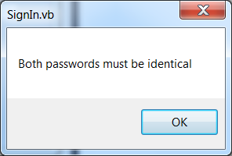
However if they aren’t the same then the user will receive a message box saying that they need to be the same.
This acts as verification to ensure that the password isn’t mixed up or entered incorrectly.
Main Menu (Manager Access)
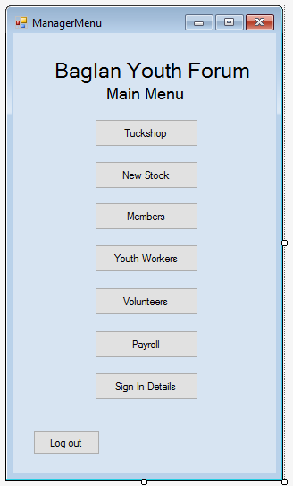

This is the Main Menu, access to this is only granted to the managers. The system will know by the username and password what position the user is, and what they have access to.

The manager will have access to all areas of the system, whereas a normal worker wouldn’t.
The menu is simple, and it will allow the user to click on any of the buttons to go wherever they need to go.

The tuckshop button will take the user to a form that will act as a shop system when young people want to buy things.
To add new stock details to the current stock details file, the user can click ‘New stock’, however this will also allow the user to add new stock to existing stock – for example is stock is reordered.
The ‘Members’ button allows the user to add new members to the system, and to search for their details.
The ‘Youth workers’ button allows the user to add any new youth workers to the system or to search for a particular worker’s details.
The ‘Payroll’ button takes the user to a form where the payroll is worked out and can be printed.
The ‘Sign in Details’ will allow the user to search for details, for example if someone has forgotten their password or username. Also this can be used is the user wants to change their password/username directly.

Tuckshop
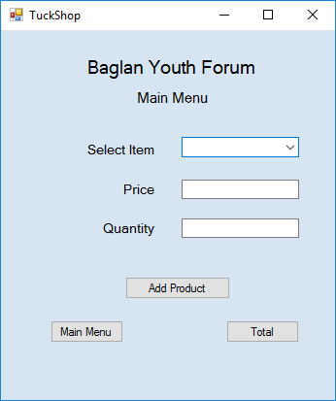
This is the form that the user will be directed to should they click the ‘Tuckshop’.
This will act as a shop for the user, where the item is selected from the drop down menu (all possible items will be in the menu) and this will autofill the ‘price’ box.
Then the user will put the quantity into the box and click ‘total’. This will display the total price for that sale.
Should a young person chose to buy more than one item, it will be the same process but the user would click ‘Add product’ before entering the next item.

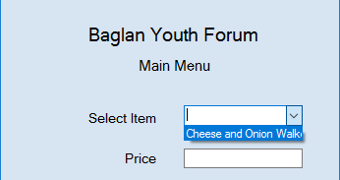
Although this is a functioning system, it seems that the total will only display if the ‘Add product’ button is clicked beforehand, regardless of how many items are bought.
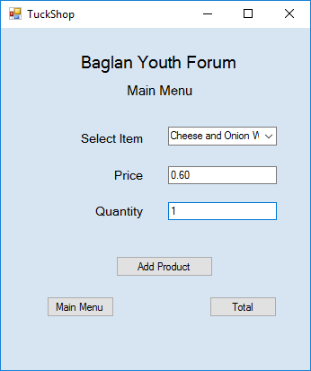
This is something I would like to change for the final system, so that if only one item is bought you do not have to click ‘Add product’ and can simply press ‘Total’ to get the price.
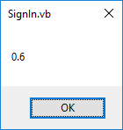

This form will also make the necessary changes to the current stock. So if an item is sold the total number of items will be deducted.

Adding New Tuck
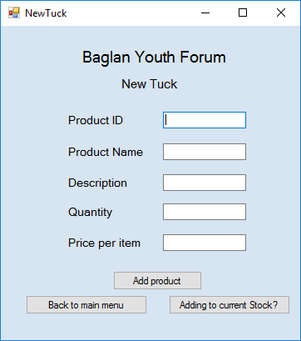

This is the main form the user will be taken to should they click ‘New Stock’ on the main menu.
In this form the user has 2 options, if they are adding new stock completely then they fill out the boxes and click ‘Add product’ to add the new details to the file. However they also have the option to add to existing stock, should they have ordered more of existing stock.

Once the information on stock has been filled in, the user can click ‘Add product’ and the items are saved into the existing Products file. Once the user clicks ‘OK’ the boxes are cleared and can be used again.
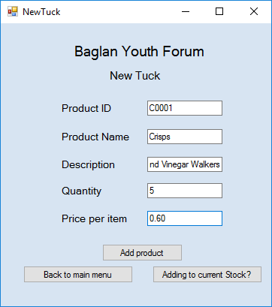
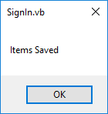

If the user is adding to current stock, they can click the other button labelled ‘Adding to current stock?’ and they will be redirected to another form.

Adding/Editing Current stock
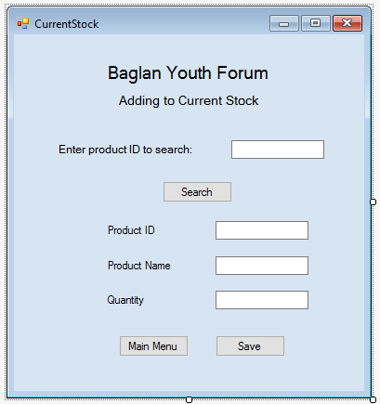

This form is where the user can edit or add to current stock. The user will enter the product ID and click search, which will go through the file and auto fill the boxes below with the relevant information on that product.
Once the boxes have been auto filled, the user can then change the details accordingly, for example if they have ordered 5 more packets of crisps they can increase the quantity by 5 and click the ‘Save’ button. This will write over the old details and make the products file up to date.
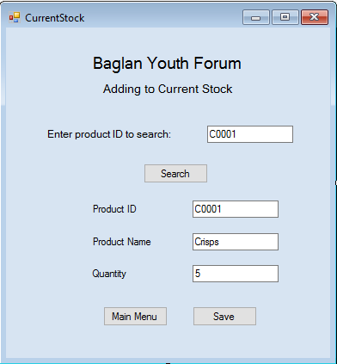

Once these items have been saved and the user clicks ‘OK’ the boxes will clear ready for new data.

Adding new members
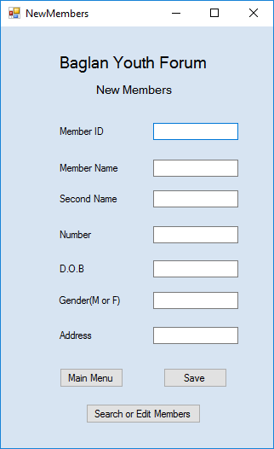
If the user needs to add new members, search or edit existing ones, then they can click the ‘Members’ button on the menu to get to this form.
This form will allow the user to enter all the needed details for the new member and once they have clicked ‘save’ the new details will be added to the current member file.
The user will be notified that the details have been saved.

There will be additional validation in the final system, for example, length checks on things like the member’s number and a format check on the date of birth.
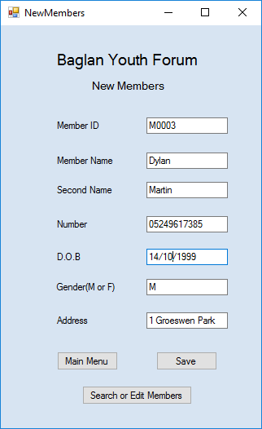

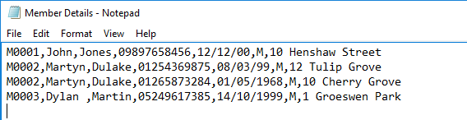
All the member’s details will be saved into a notepad file called ‘Member Details’ along with the other members’ details.

If the User then needs to edit or search for existing member details they can click the ‘Search or edit members’ button and will be taken to another form.

Search Member Details
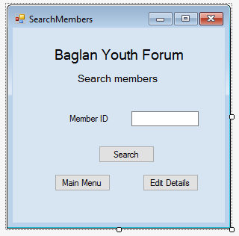

The user clicked the ‘search or edit members’ button then they will be taken to this form.

On this from they will have to enter the Member ID of the person they are searching for and click search.

There will then be a message box displaying all the saved information on that member.

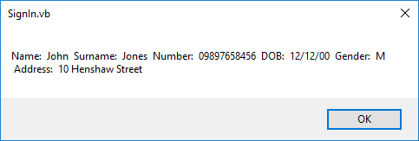
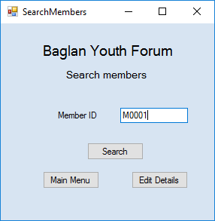
This then allows the user to see the member’s details. Once the user clicks ‘OK’ the input box will be cleared and you can search again.

The user can then select the ‘Edit Details’ button to go to the form that will allow them to do so.Additionally, in the final design there will be validation on the input , for example a format check to make sure it starts with a letter followed by 4 numbers.

Edit Member Details
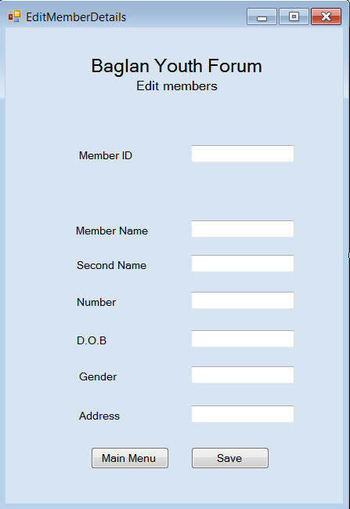
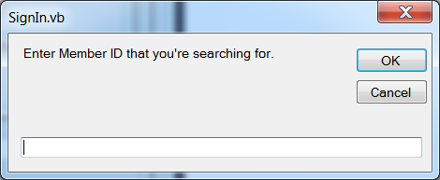
When the user selects ‘Edit details’ on the previous form, they will be greeted by a message input box asking for the Member ID that they are searching for.

When the user inputs the ID and clicks ‘OK’ they will be taken to the form shown on the lefts with all the information boxes autofilled.
Once these boxes are filled, the user will be able to make the changes they need to make and clicks save. The new details will then overwrite the old ones and the Member’s details file will be up to date.
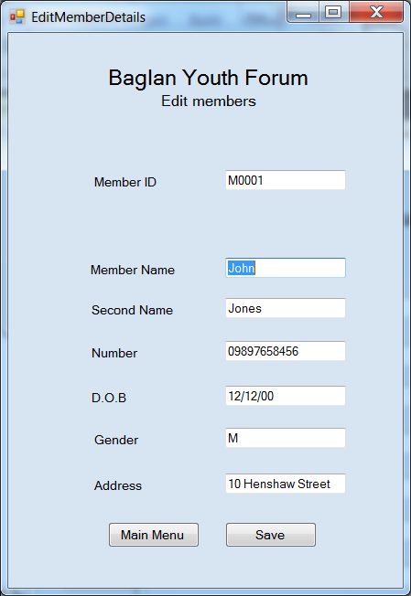
The user will then be notified about the save and the text boxes will be cleared.

Even though the user will be making changes on the details, there will still be validation in the final design to make sure things are a certain way. For example, if the user changes the phone number, there will be a length check to make sure that it’s correct.

Payroll
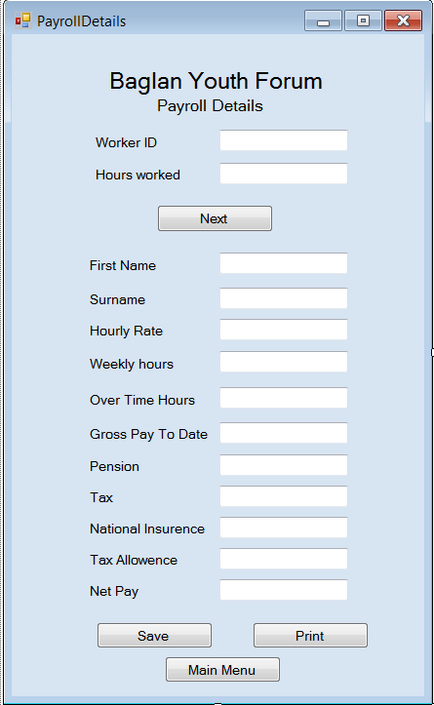

This is the payroll form, the form that is be presented should the user click the ‘Payroll’ option on the main menu.

On this form the user will need to enter only the WorkerID and hours worked of any existing member into the input boxes at the top of the form. Once they click next, the boxes below will auto fill with already saved data and new data that is worked out by the system.

This payroll system, however, will work out the payments and such for the workers to be paid monthly, not weekly.
Also, if the user has to create a payroll for a new member of staff, who won’t have any details save, then they will need to enter everything manually.
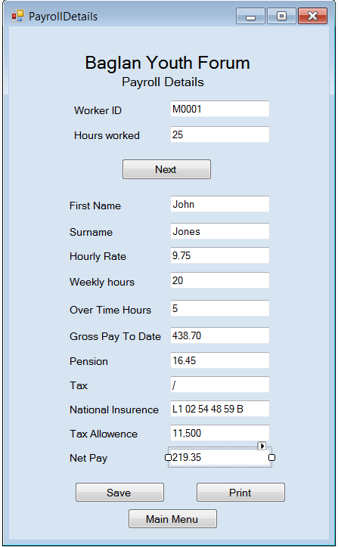

Once the boxes have been autofilled, the user can either make changes and save, or they can print out a copy of the payroll form.

SELF EVALUATION OF PROTOTYPE
After looking at my prototype, I feel that one of the best features is that all the forms are clearly designed, it would be difficult for the users of the system to get confused on how to use the system. This applies even to those who don’t have much computer experience. With everything laid out clearly and labelled, with error messages for anything done incorrectly, there shouldn’t be much trouble when it comes to using the system.
I think a drawback to my prototype is that all the forms have ‘Back to Main Menu’ buttons, however because some forms allow the user to access another one, I should add in ‘Back to Previous Form’ so that there is an option for the user to go back to the previous form instead of only being able to access the main menu form. Either that, or I could display all the forms on the main menu so that there aren’t any forms that lead to others, and so the ‘Back to Main Menu’ form is still valid, I would just have to add these buttons to all forms as well as editing the main menu.
Also while running the prototype I found that when searching for details, when they are displayed by the system, they are all displayed continuously along one line. I feel like this is a shortcoming because it can look a bit confusing, to improve this I would like to change the display so that the information is more clear, and displayed down several lines instead on continuously along one line.
Finally, when using the payroll, as well as being able to print the information for a pay slip, I feel like it would be beneficial to also save this separately to the master file so if there are any complications with payments, it would allow for the user to check individual pay slips to see where the error is.

