Feedback from others on the Prototype

To evaluate the functioning, usability and design of the prototype, I will need to gain feedback. I have decided to receive this feedback from the people who work in the centre, both youth workers and managers. I feel like their feedback will be important as they are the ones who will be using the system most often.
To do this I will be going to the Centre and showing 4 people how the system works. I will explain its current functioning and what they will need to do to do certain things. I will also let them try out the system themselves so they can really look at how it works.
I will then provide them all with a questionnaire about the system and how they found it. This will include things like how intuitive they through it was, the layout and if they thought anything should change. I will ask them to rate their answer from 1 to 10.
Rating - 1 (Terrible) – 10 (Excellent)
Youth Worker 1
Question/Statement | Rating | Comment
How beneficial do you feel this system will be? | 8 | It would be much easier to organise things, but it will take some getting used to.
How did you find the functioning of this system? | 9 | Very simple, no serious headwork needed to do the things you need to.
How did you find the design and layout of the forms? | 8 | Nice and simple, no crazy colours to make it hard to read etc.
Did you find it easy to add new members to the system? | 9 | Yes, no complicated steps involved however I’m not sure it would be easy to remember everyone’s ID
What changes do you think would improve the system? | // | Maybe add a feature to search for someone’s ID by name?

Youth Worker 2
Question/Statement | Rating | Comment
How beneficial do you feel this system will be? | 10 | Much easier to store everyone’s information, don’t need to worry about pieces of paper being kept together.
How did you find the functioning of this system? | 8 | Worked sufficiently, but no way to know if information is wrong. I knew I had entered a number wrong but hit save before I could do anything but it was gone.
How did you find the design and layout of the forms? | 8 | Nice simple layout, but I wasn’t too sure on having to go to one form to get to another option. Maybe it should be easier, quicker to get to.
Did you find it easy to add new members to the system? | 9 | Very simple, no problems but maybe the way someone’s DOB is written should be specified?
What changes do you think would improve the system? | // | Add checks for the information put in, and specify the DOB format.

Youth Worker 3
Question/Statement | Rating | Comment
How beneficial do you feel this system will be? | 10 | Much quicker to deal with information, search option is very useful
How did you find the functioning of this system? | 10 | Simple, easy
How did you find the design and layout of the forms? | 9 | Nice and clear, however maybe there should be the option to go back, instead of shutting down the form completely
Did you find it easy to add new members to the system? | 9 | Yep, very simple to use, wasn’t sure how to write the DOB though? And I think it wold be easier if we can input the additional stock quantity without having to add it to the current stock amount. Could the computer maybe do the calculations?
What changes do you think would improve the system? | // | Maybe change the background colour? Liven things up

Youth Worker 4
Question/Statement | Rating | Comment
How beneficial do you feel this system will be? | 10 | Much easier and faster to deal with customers and adding new information
How did you find the functioning of this system? | 10 | Everything i tested worked well, so it functioned well.
How did you find the design and layout of the forms? | 8 | Clear and easy to use, however I found it quite fiddly having to go to other forms to get somewhere
Did you find it easy to add new members to the system? | 9 | Very simple, although there was no indication about if the DOB needed to be written a certain way?
What changes do you think would improve the system? | // | Maybe change the menu to have new buttons that will take you exactly where you need to go, instead of using other forms to get there.

After completing my questionnaires, I have found that the people in Baglan Youth Forum are mostly happy with the prototype system. However there are a few things that were suggested as improvement.
Firstly, quite a few of the youth worker’s questionnaires said that they weren’t sure on which format to use to input the DOB for new members, since there are a variety of different ways to write it. One suggestion was to specify a method on the form so that they were all the same.
Secondly, There was mention about how it was inconvenient to have to go through other forms to get to a certain option. For example, to edit member details the user would have to go through two other forms. One suggestion that was made to restructure the main menu so that the other options are directly accessibly.
Thirdly, one suggestion was to add a ‘Back’ option onto the forms so they could return to the previous form instead of shutting it down.
Additionally, another suggestion made was to add a search for a member’s ID since it may be difficult for the youth workers to memorise all the Member Ids.

In conclusion, I found that the prototype was more or less a success, provided I conduct minor changes to the system. These will all be taken into consideration and implemented into the final design of the system. I found that trouble with the system in this prototype will mainly result in me having to add to and shuffle a few things around. Nothing too major, so these changes can be made easily.

Improvements to make-

- General alterations
Experiment with colours and find a more exciting colour that won’t look too childish
Add specific validation for inputs on most forms

- Main Menu form
Change the layout of this form to make all options present and easily accessible.
Provide all options as buttons.

- Adding new members
Specify on a format suitable for inputting the DOB.

- New Form-
Add a new form that will allow the user to search a particular ID by name.

- Current Stock
Change the input method of the quantity for stock, instead of adding the quantity of new stock to the current stock in your head and having to input the total, allow the user to only input the quantity of new stock and get the system to perform the calculations, so it adds the new quantity to the current.
Comments – Although the users from Baglan youth forum have asked for back buttons on the forms, they have also asked that all forms are present on the main menu. So if I make all forms available on the main menu, then there wont be need for back buttons since all morns have a ‘Main Menu’ button anyway to return the user to the main menu.

Refined Design after feedback
Overview of the system. (Manager Access)
Main Menu
Sign in
Load form
Manager has full access to the program, since they are the only ones with the permission
Forgotten password

Main Menu
Search Details
Main Menu
Add to old stock
Stock Details
Edit Details
New Details
Sign In Details
Save Details
Main Menu
Payroll Details
Print payroll
New payroll
Payroll
Save Details
Volunteer Details
Edit volunteers
Search Volunteers
New Volunteer
Volunteers
Main Menu
Save Details
Y/W Details
Edit Y/Worker
Search Y/Worker
New Youth Worker
Youth Workers
Save Details
Member Details
Main Menu
Edit Members
Search Members
New Members
Members
Main Menu
Add new stock
New stock
- Load Form – Welcomes the user.
- Sign in - Individual sign in details used to log into the program.
- Main menu – Provides the user with the variety of options.
- Tuck shop – Allows the user to sell products to customers.
- New Stock – allows user to alter stock details/add new.

6. Members – allows the user to add new members, search and edit details.
7. Youth workers – allows user to add new Y/W, search and edit details.
8. Volunteers – Allows user to add new volunteer, search and edit details.
9. Payroll – allows user to create payroll slips and print.
10. Logout – allows user to logout of the program.
11. Forgotten password – allows user to change their password.

Tuck Details
Sell items
Main Menu
Tuckshop
Overview of System (Standard worker access)
Load form
Standard workers has restricted access to the program.
Forgotten password
Sign in

Main Menu

- Sign in – allows user to sign into the program with unique details
- Main menu – allows user to see what is available
- Tuck shop – allows user to sell items to the customer.
- Members – allows the user to add new members, search and edit member details.
Save Details
Member Details
Sell items
Tuck Details
Main Menu
Tuckshop
Main Menu
Edit Members
Search Members
New Members
Members

Post Prototype Design
After my prototype, I am going to redesign the system so that it is more suitable for the users at Baglan Youth Forum. I have taken into account the areas where they wish for alterations to be made, and this design will demonstrate how I plan to go about changing the system.
Areas that will be changed:
- Add additional validation inputs
- Possibly change the colour scheme for forms
- Main Menu Form – Provide buttons to all options on the menu
- Current stock Form – Change the input system for the quantity of stock added.
New forms:
- Search Members 2 – allows the user to search through details by searching by name, not ID
All edited areas in this design will be highlight - ____
In addition to these areas of improvement, I will be adding the rest of my original design – since only a certain amount was done in the prototype.

FILES
- Members detail file.
File name - Member details
File description – This file will hold all the necessary details of the young people members of the centre. Examples of the details would be their name, age, address and date of birth.
File capacity – The number of items this file is going to hold is expected to gradually increase.
File access – This file will be access serially (directly) since this will allow the user to search directly for a name or certain criteria to find details. Additionally this will mean that the details can be edited.
Keys
Primary key – MemberID
Foreign Key - **
Field name | Field type | Field Size | Validation | Example
MemberID | String | 10 | Presence check  If memberID = “” | Mem0001
First Name | String | 10 | Presence check  If FName = “” | Dylan
Second Name | String | 10 | Presence check  If SName = “” | Martin
Phone number | String | 11 | Length check  If length(Num) > 11 or < 1 | 07254635895
Date of Birth | Date | 8 | Format check  __/__/__ | 11/8/14
Gender | Character | 1 | Length Check  If length(Gender) > 1 | F or M
Address | String | 40 | Presence check  If Address = “” | 10 Cherry grove

- Volunteer details file
File name - Volunteer details
File description – This file will hold all the necessary details for the volunteers in the centre. Examples of the details would be their name, age, job description(volunteer).
File capacity – The number of items this file is going to hold is expected to either stay the same or increase.
File access – This file will be access serially (directly) since this will allow the user to search directly for a name or certain criteria to find details. Additionally this will mean that the details can be edited.
Keys
Primary key – VolunteerID
Foreign Key - **
Field name | Field type | Field Size | Validation | Example
VolunteerID | String | 10 | Presence check  If VolID = “” | Vol0001
First Name | String | 10 | Presence check  If FName = “” | John
Second Name | String | 10 | Presence check  If SName = “” | Elliot
Phone number | String | 11 | Length check  If length(Num) > 11 or < 1 | 07256985472
Date of Birth | Date | 8 | Format check  __/__/__ | 9/7/14
Gender | Character | 1 | Length Check  If length(Gender) > 1 | F or M
Job Title | String | 20 | List check  If JTitle /= “Volunteer” | Volunteer

File name – Worker Details
File description – This file will hold all the necessary details for the employees in the centre. Examples of the details would be their name, age, address and insurance number.
File capacity – The number of items this file is going to hold is expected to stay the same or maybe increase. Approx 5
File access – This file will be access serially (directly) since this will allow the user to search directly for a name or certain criteria to find details. Additionally this will mean that the details can be edited.
Keys
Primary key – WorkerID
Foreign Key - **
Field name | Field type | Field Size | Validation | Example
WorkerID | String | 10 | Presence check  If WorkerID = “” | Emp0001
First Name | String | 10 | Presence check  If FName = “” | Hannah
Second Name | String | 10 | Presence check  If SName = “” | O’leary
Date of birth | Date | 8 | Format check  __/__/__ | 12/6/14
Phone number | String | 11 | Length check  If length(Num) > 11 or < 1 | 07561428531
Insurance Number | string | 9 | Length check  If length(INUM) > 9 | HY094203 M
Gender | Character | 1 | Length Check  If length(Gender) > 1 | F or M
Address | String | 40 | Presence check  If Address = “” | 10 Cherry grove

File name - Manager details
File description – This file will hold all the necessary details of only the managers in the centre. Examples of the details would be their name, age, address and insurance number.
File capacity – The number of items this file is going to hold is expected to stay the same, only details may be changed if there’s a new manager coming in after one leaves.
File access – This file will be access serially (directly) since this will allow the user to search directly for a name or certain criteria to find details. Additionally this will mean that the details can be edited.
Keys
Primary key – ManagerID
Foreign Key - **
Field name | Field type | Field Size | Validation | Example
ManagerID | String | 10 | Presence check  If managerID = “” | Man0001
First Name | String | 10 | Presence check  If FName = “” | Sophie
Second Name | String | 10 | Presence check  If SName = “” | Johns
Phone number | String | 11 | Length check  If length(Num) > 11 or < 1 | 07152493586
Insurance Number | String | 9 | Length check and presence check  If INUM = “”  If len(INUM > 9 | OL063571 F
Date of Birth | Date | 8 | Format check  __/__/__/ | 11/8/14
Gender | Character | 1 | Length Check  If length(Gender) > 1 | F or M
Address | String | 40 | Presence check  If Address = “” | 10 Cherry grove

File name – sign in records
File description – This file will hold sign in details, including their username, password and whether they are a manager or worker.
File capacity – The number of items this file is going to hold is expected to stay the same, only details may be changed if there’s a new manager coming in after one leaves.
File access – This file will be access serially (directly) since this will allow the user to search directly for a name or certain criteria to find details. Additionally this will mean that the details can be edited.
Keys
Primary key – ManagerID
Foreign Key - **

 | 0 | 1 | 2
0 | Work0001 | PASS011 | Worker
1 | Work0002 | PASS022 | Worker
2 | Work0003 | PASS033 | Worker
3 | Work0004 | PASS044 | Worker
4 | Work0005 | PASS055 | Worker
5 | Manag0001 | PASS066 | Manager

Payroll File

Name of File: Payroll
Description of the file: This file will hold all necessary details for payment to the workers/managers.
Expected number of users: The youth forum, currently has 8 members of staff, including managers. However this number could change.
Access method: I am going to use random access to save and access any details with in this file. This will allow multiple people to view the same data. This is because random access allow data to be edited and viewed while still using features of the system.
Key :
Primary/key field = Underlined
Foreign key = #
Field name | Field type | Field Size | Validation | Example
PayrollID | String | 10 | Presence check  If PayrollID = “” | PR0001
WorkerID # | String | 10 | Presence check  If WorkerID=”” | Emp0001
Month | String | 10 | Presence check  If Month = “” | December
Full Name | String | 20 | Presence check  If FullName = “” | Sophie Johns
Sort Code | String | 6 | Length check  If length(Num) > 6 or < 1  And presence chk | 095510
Account number | String | 16 | Length check and presence check  If ANUM = “”  If len(ANUM > 16 | 2345126688215546
Insurance Number | String | 9 | Presence check | 11/8/14
Hourly rate | Real number | 4 | Length Check  If length(Gender) > 1 | F or M
Hours worked | Integer | 2 | Presence check  If Address = “” | 10 Cherry grove
Tax Rate | Real | 4 | Presence check | 10.67

Stock File
Name of File: Stock File
Description of the file: This file will hold all necessary details for all the stock held and sold by the centre.
Expected number of Items: The number of items in this file is likely to increase and decrease to fit the customer demand
Access method: I am going to use random access to save and access any details with in this file. This will allow multiple people to view the same data. This is because random access allow data to be edited and viewed while still using features of the system..
Key :
Primary/key field = Underlined
Foreign key = #

Field name | Field type | Field Size | Validation | Example
ProductID | String | 10 | Presence check  If ProductID = “” | Pro0001
Item Name | String | 10 | Presence check  If ITName = “” | walkers crisps. (C+O)
Item quantity | Integer | 2 | Presence check  If ITquantity = “” | 2
Price | Real | 4 | Presence check  Price = “” | 0.60p
Supplier | String | 10 | Presence check  Sup = “” | Tesco
Number in stock | Integer | 2 | Presence check  NStock = “” | 20
Re order level | Integer | 2 | Presence check  Rlevel = “” | 10
Amount to order | Integer | 2 | Presence check  If OAmount = “” | 20

Form Designs
Starting screen
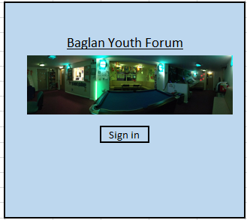
Label
Pseudo code

Begin process
If SignIn.cmd is clicked
open sign in form
exit sub

Background colour – pale blue Font style – Calibri
Font colour – black Font Size - 11
Button to other form
Image box
Sign in Form
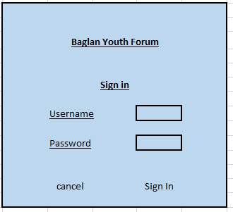

Pseudo code
Begin Process
Set textbox(username) as variable ‘username’
Set textbox(password) as variable ‘password’
Load arrayRecords

Search – for n to length of records
If arrayRecords(n,0 ) = ‘username’ then
If arrayRecords(n,1) = ‘password’ then
If arrayRecords(n,2) = manager then
Load Manager Access Main Menu form.
If arrayRecords(n,2) = Worker then
Load Standard Access Main Menu Form.
Else – Display – log in error
End if
Next n
End process

Title labels – Bold, Calibri, Underlined, size 11, black Buttons – Calibri, black, size 11
Subheadings labels – Calibri, underlined, size 11, black
Buttons
Labels
Input boxes
Labels
Main Menu form, manager access
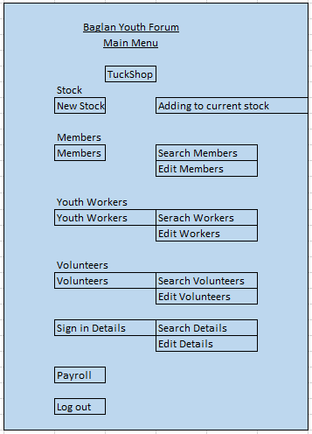
Labels

I have now changed the menu so that it provides all the options available as buttons without having to go through numerous forms.

Buttons

Pseudo code
Begin process
If CMD.tuckshop is pressed then Display form ‘Tuck Shop’
If CMD.NewStock is pressed then Display form ‘New tuck’
If CMD.AddingStock is pressed then Display form ‘Current stock’
If CMD.Members is pressed then Display form ‘NewMembers’
If CMD.SearchMembers is pressed then Display form ‘SearchMembers’
If CMD.EditMembers is pressed then Display form ‘EditMemberDetails’
If CMD.YouthWorkers is pressed then Display form ‘NewYouth Workers’
If CMD.SearchWorkers is pressed then Display form ‘Search Youth Workers’
If CMD.EditWorkers is pressed then Display form ‘EditWorkerDetails’
If CMD.Volunteers is pressed then Display form ‘NewVolunteer’
If CMD.SearchVolunteers is pressed then Display form ‘SearchVolunteers’
If CMD.EditVolunteers is pressed then Display form ‘EditVolunteers’
If CMD.Payroll is pressed then Display form ‘Payroll’
If CMD.SigninDetails is pressed then Display form ‘Sign in Details’
If CMD.searchDetails is pressed then Display form ‘Search Signin Details’
If CMD.EditDetails is pressed then Display form ‘Edit sign in Details’
If CMD.Logout is pressed then Display form ‘Starting screen’
End process

Title labels – Bold, Calibri, Underlined, size 11, black Buttons – Calibri, black, size 11
Subheadings labels – Calibri, underlined, size 11, black

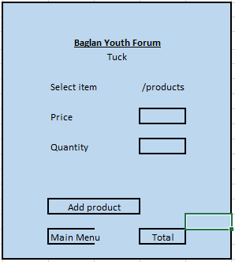
Tuck menu
Drop down menu
Labels

Display boxes (auto fill)
Back to main menu, button

Buttons

Pseudo code
Begin Process
Declare structure for products
Declare structure for sale
Declare array for product
LOAD all products into Array
AddProduct.click()
Loop for each product in array
If product in productarray(x) = to txtproductID
Get price of product
Get destination of product
Display price and description in txtbox
Get qty
Total = Qty * price
Grand total = grand total + total
Add line to list box (price and description)
Load product array
Search array for product
Deduct array(qty) by qty

End process

Title labels – Bold, Calibri, Underlined, size 11, black Buttons – Calibri, black, size 11
Subheadings labels – Calibri, underlined, size 11, black
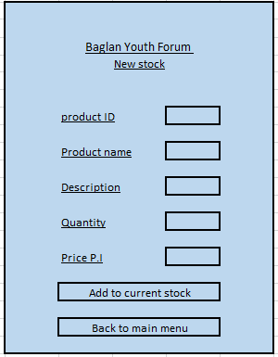
New tuck form

Input boxes

Labels

Buttons

Begin Process
Add product.click()
Load product.Array
For n = 0 to len(ProductArray)

If txtbox.productID = product.Array(n) then
Output box – “Item already exists”

If txtbox.productID not equal to productArray(n) then
Save product to array
Txtbox.productID = productArray(n,0)
Txtbox.productName = productArray(n,1)
Txtbox.Quantity = productArray(n,2)
Next n

MainMenu.click
Open form – main menu
Title labels – Bold, Calibri, Underlined, size 11, black Buttons – Calibri, black, size 11
Subheadings labels – Calibri, underlined, size 11, black

Adding to current stock
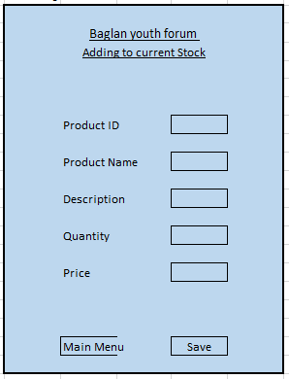
Input/output boxes

The quantity entered when filling out the current stock form will now add to the master file
Labels

Buttons

Title labels – Bold, Calibri, Underlined, size 11, black Buttons – Calibri, black, size 11
Subheadings labels – Calibri, underlined, size 11, black

Start process
Search.click()
Load product.array
For n = 0 to length(product.array)
If txt.productID = product.array(n)
Display product.array(n,0) in productID.txt
Display product.array(n,1) in productName.txt
Display product.array(n,2) in quantity.txt
….
If not
Next n
Next n
Save.click
Load Product.array
Textbox.productID = product.array(n,0)
Textbox.productName = product.array(n,1)
Textbox.quantity = product.array(n,2) + textbox.quantity
….

MainMenu.click()
Display form – Main Menu

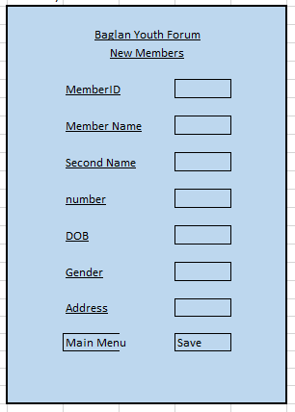
New Members
Headings

Labels
Input boxes

Buttons

Begin process.
Save.click ()
*validation*
If memberID textbox = “” then
Display message – “MemberID must be entered”
If length of number > 11 or < 1 then
Display message – “Phone number incorrect, re-enter number”
**
Emend new member detail to end of details file

MainMenu.click()
Load Main Menu.form

End process
Title labels – Bold, Calibri, Underlined, size 11, black Buttons – Calibri, black, size 11
Subheadings labels – Calibri, underlined, size 11, black

Search Members
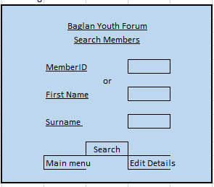
Input Box

Labels

Buttons

Title labels – Bold, Calibri, Underlined, size 11, black Buttons – Calibri, black, size 11
Subheadings labels – Calibri, underlined, size 11, black

Begin Process
Search.click()
*validation*
If MemberID textbox = “” then
Display message – “Enter MemberID to search for”
**

Load Members.Array

For n = 0 to length of Members.Array

If Members.array(x) is = MemberID textbox then
Dislay messagebox – member details – member.array(n,0)(n,1)(n,2)..
Next n

If memberID isn’t found then
Display message – “MemberID not found”

EditDetails.click()
Load edit details form

End process

Editing Member details
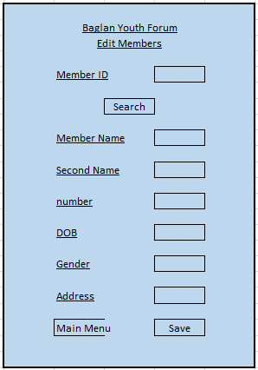
Labels

Labels
Input/output Boxes

Buttons

Title labels – Bold, Calibri, Underlined, size 11, black Buttons – Calibri, black, size 11
Subheadings labels – Calibri, underlined, size 11, black

Begin Process.
Search.click()
*Validation*
If MemberID textbox = “” then
Display box – “Please enter MemberID to receive details”
***

Load MemberID array
For n = 0 to length of array
If Members.array(x) is = MemberID textbox then
Display member details in textboxes on form
Next n

Save.click()
Over write existing details with details in text boxes.

Mainmenu.click()
Load MainMenu form

End process

New Youth worker details
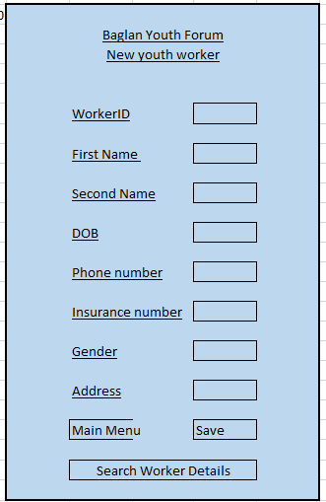
Begin process
Save.click ()
*validation*
If WorkerID textbox = “” then
Display message – “WorkerID must be entered”
If length of number > 11 or < 1 then
Display message – “Phone number incorrect, re-enter number”
If InsurenceNumber textbox = “” then
Display Message – “Enter insurance number”
**
Emend new member detail to end of details file

MainMenu.click()
Load Main Menu.form

SearchWorkerDetails.click()
Load search workers form

End process

Title labels – Bold, Calibri, Underlined, size 11, black Buttons – Calibri, black, size 11
Subheadings labels – Calibri, underlined, size 11, black

Buttons
Input boxes
Labels

Search Worker Details
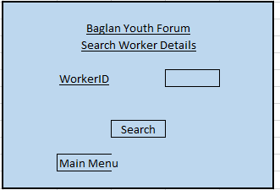
Edit details
Title labels – Bold, Calibri, Underlined, size 11, black Buttons – Calibri, black, size 11
Subheadings labels – Calibri, underlined, size 11, black

Begin Process
Search.click()
*validation*
If WorkerID textbox = “” then
Display message – “Enter WorkerID to search for”
**

Load Worker.Array

For n = 0 to length of Worker.Array

If Worker.array(x) is = WorkerID textbox then
Dislay messagebox – member details – Worker.array(n,0)(n,1)(n,2)..
Next n

If WorkerID isn’t found then
Display message – “WorkerID not found”

EditDetails.click()
Load edit details form

End process

Input Boxes
Buttons
Labels
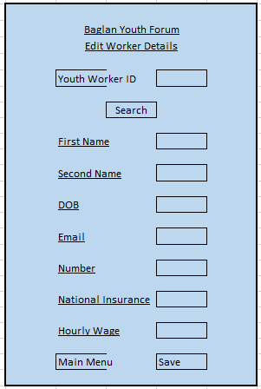
Edit Worker Details Form

Begin Process.
Search.click()
*Validation*
If WorkerID textbox = “” then
Display box – “Please enter WorkerID to receive details”
***

Load WorkerID array
For n = 0 to length of array
If Workers.array(x) is = WorkerID textbox then
Display Worker details in textboxes on form
Next n

Save.click()
Over write existing details with details in text boxes.

Mainmenu.click()
Load MainMenu form

End process
Title labels – Bold, Calibri, Underlined, size 11, black Buttons – Calibri, black, size 11
Subheadings labels – Calibri, underlined, size 11, black

Input Boxes
Labels
Buttons
New Volunteer Details
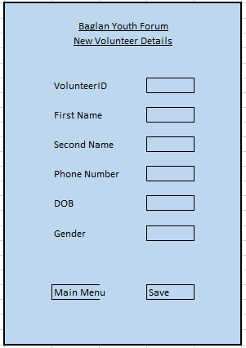

Labels

Input Boxes

Buttons

Begin process.
Save.click ()
*validation*
If VolunteerID textbox = “” then
Display message – “VolunteerID must be entered”
If length of number > 11 or < 1 then
Display message – “Phone number incorrect, re-enter number”
**
Emend new member detail to end of details file

MainMenu.click()
Load Main Menu.form

SearchWorker.click()
Load search Worker form

End process

Title labels – Bold, Calibri, Underlined, size 11, black Buttons – Calibri, black, size 11
Subheadings labels – Calibri, underlined, size 11, black

Search for Volunteer details

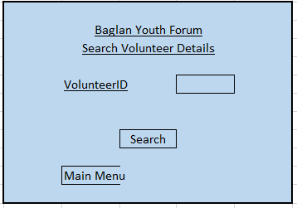
Labels
Input box

Buttons

Begin Process
Search.click()
*validation*
If VolunteerID textbox = “” then
Display message – “Enter VolunteerID to search for”
**

Load Volunteer.Array

For n = 0 to length of Volunteer.Array

If Volunteer.array(x) is = VolunteerID textbox then
Dislay messagebox – Volunteer details – Volunteer.array(n,0)(n,1)(n,2)..
Next n

If VolunteerID isn’t found then
Display message – “VolunteerID not found”

End process

Title labels – Bold, Calibri, Underlined, size 11, black Buttons – Calibri, black, size 11
Subheadings labels – Calibri, underlined, size 11, black

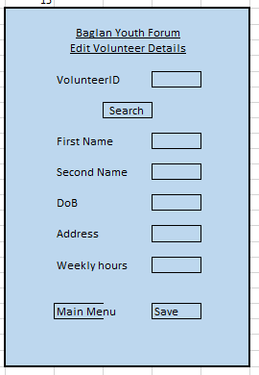
Edit volunteer details

Input/output boxes
Labels

Buttons

Begin Process.
Search.click()
*Validation*
If VolunteerID textbox = “” then
Display box – “Please enter VolunteerID to receive details”
***

Load VolunteerID array
For n = 0 to length of array
If Volunteer.array(x) is = VolunteerID textbox then
Display Volunteer details in textboxes on form
Next n

Save.click()
Validation – if volunteerIDtextbox = “” then display textbox – “Please enter VolunteerID”
Over write existing details with details in text boxes.

Mainmenu.click()
Load MainMenu form

End process
Title labels – Bold, Calibri, Underlined, size 11, black Buttons – Calibri, black, size 11
Subheadings labels – Calibri, underlined, size 11, black

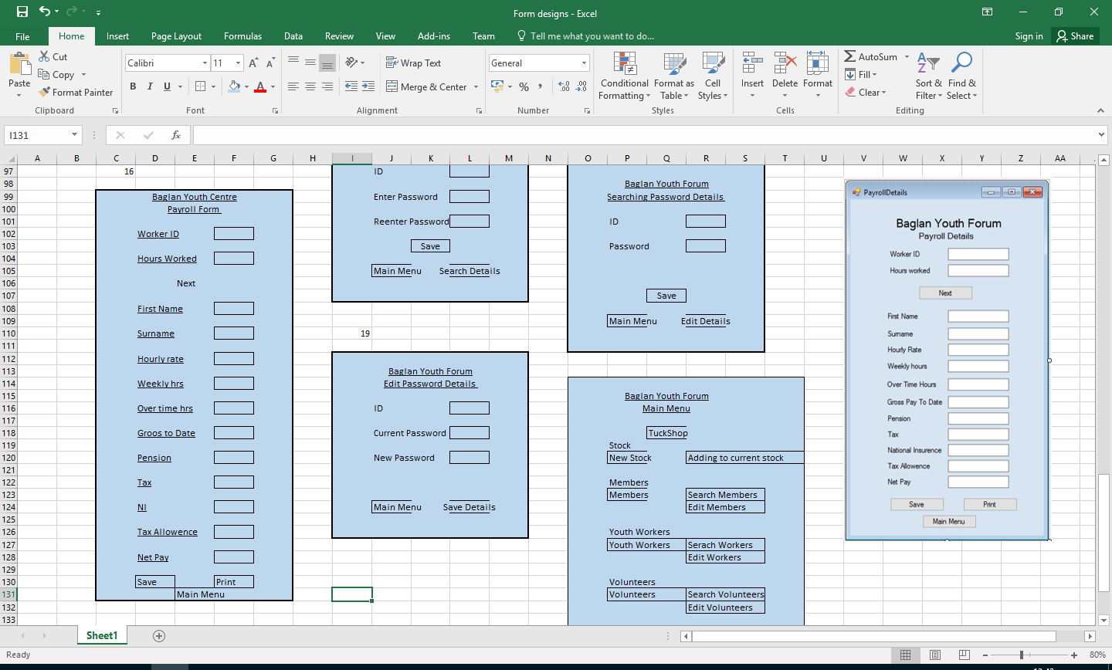
Payroll Details
Begin process.
Save.click ()
*validation*
If PayrollID textbox = “” then
Display message – “PayrollID must be entered”
If PayrollID textbox = “” then
Display message – “PayrollID must be entered”
**
Emend Payroll detail to end of payroll file

MainMenu.click()
Load Main Menu.form

Print.click()
Print form

End process

Title labels – Bold, Calibri, Underlined, size 11, black Buttons – Calibri, black, size 11
Subheadings labels – Calibri, underlined, size 11, black

Input boxes
Labels
Buttons
New Sign In Details
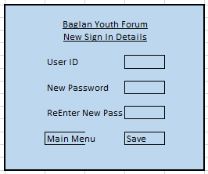
Begin process.
Save.click ()
*validation*
If ID textbox = “” then
Display message – “ID must be entered”
If Password textbox = “” then
Display message – “Password must be entered”
**
Emend Password detail to end of Password file

MainMenu.click()
Load Main Menu.form

End process

Title labels – Bold, Calibri, Underlined, size 11, black Buttons – Calibri, black, size 11
Subheadings labels – Calibri, underlined, size 11, black

Buttons
Labels
Input boxes
Search Password Details
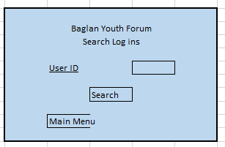
Enter ID then search
Begin process.
Search.click ()
*validation*
If ID textbox = “” then
Display message – “ID must be entered”

**
Load Password file
Search for ID
Display Password as msgbox

MainMenu.click()
Load Main Menu.form

End process

Title labels – Bold, Calibri, Underlined, size 11, black Buttons – Calibri, black, size 11
Subheadings labels – Calibri, underlined, size 11, black

Buttons
Labels
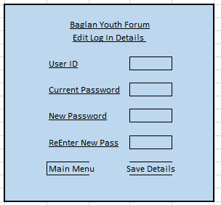
Edit Password Details

Begin process.
Save.click ()
*validation*
If ID textbox = “” then
Display message – “ID must be entered”

**
Load Password file
Search for ID
Save new password over old password

MainMenu.click()
Load Main Menu.form

End process

Title labels – Bold, Calibri, Underlined, size 11, black Buttons – Calibri, black, size 11
Subheadings labels – Calibri, underlined, size 11, black

Input Boxes
Labels

Buttons

