INVESTIGATION

Stakeholders:
As a first step in the investigation I am going to be looking at different skate holders of the company. By definition, a stakeholder is someone who, for whatever reason, is interested in the company. Baglan youth centre has many stakeholders who are both invested financially and passionately in the company. For Baglan youth forum this would include:
- The Manager
- The workers
- The volunteers
- The main funder (children in need)
Interviews
The next step in my investigation I will need to carry out interviews with some of the stakeholders to find out what kind of things the program I am making will need to include. I chose interviews because I feel that I will be able to get the answers to the questions I need quickly, and be able to expand on the answers given.
I will be carrying out interviews with the manager and some workers. I considered interviewing some of the children who went to the centre but I figured I’d get the same answers from the workers. I also won’t be interviewing anyone from Children In Need since I feel like they won’t have a very good idea of what type of information and details will be needed for the system.
I have arranged to conduct interviews with the manager of Baglan youth Forum, and some of the workers. I decided these would be the best people to interview because they will know much more about the system since they more than likely to be dealing with the system on a daily basis and they will know what needs to be included in it all. The areas that I will concentrate on in their paper based system are the following:
- What files the system contains and what data is within these files
- How are the files stored
- How are the files retrieved on demand
- How are new staff members and customers added
- How secure are the files
- How do you feel the current system runs and would you benefit by a computerised system

Interview One:
Name of interviewer: Amy
Name of interviewee: Mr Dulake
Interviewee job title: Manager at Baglan Youth Forum

Amy- Good morning, my name is Amy and I’m here today to interview you regarding your current paper based system. I need to gather a full understanding of everything the current system does to ensure that the computer system I make for you doesn’t lake in any particular areas. By understanding this systemthoroughly I will be able to ensure that the new system will vastly improve the daily use and running of the centre.
Mr Dulake-Good Morning Amy, yes I am happy to answer your questions.
Amy- okay,my first requirement is to understand what the current system includes, whatfiles are currently being stored in your paper based system?
Mr Dulake- Well the current system stored quite a few files. This can sometimes be quite difficult to look at and keep organised. Stored files include the details of the young people members, the details of volunteers, and details of the youth workers. Additionally we store signing in information for when volunteers or youth workers sign in. The young people sign in on a different file stored somewhere different to the workers/volunteers.
Amy- okay then, so what do you call your different files and where do you keep them?
Mr Dulake- Well all our files are stored separately in the main office. There are 2 small files in the tuck shop, one containing boys’ member details and one containing girl member details. Both files are stored alphabetical so when young people come in, it is quick and easy for the worker/volunteers to find out if they’re a member or not. These files are called ‘member details: boys’, and ‘member details: gurls’.The files containing working staff members is stored in a paper file, and the details for volunteers is stored in a separate paper file but they’re both in the same filing cabinet. These files are just called ‘volunteer details’ and ‘youth worker details’. All our sign in sheets for young people are kept in a different part of the filing cabinet and the workers/volunteers sign in sheets are again kept in another part of the filing cabinet. These are labelling as ‘young people sign in sheets’ and ‘volunteers and workers sign in sheets’. Finally there are the payroll details for the youth workers; this is also kept in the office’s filing cabinet. All of the records kept in the office are only accessible by the manager or the main youth worker when the manager isn’t in.
Amy- This is good, it’s pretty simple, just a lot to do. You did mention the files getting quite hard to keep organised, is this something you see as a current problem or that it will be one soon?
Mr Dulake-yes, well since our office is very small, we only have a small cabinet. This means that we are running out of room for our files quite quickly. The only one that seems to have most room is the young people members details because we don’t have too many new members at once, we have a growth at the start of each year when children turn the right age and can finally become members but it’s not often we get new members throughout the year. The main file that’s definitely full is the signing in sheets, since these are used twice every open day. There are just too many files and not enough room, I can guarantee that our files will soon flood due to lack of available storage space. That’s why I contacted you on the matter.
Amy- yes, that does make sense. I can see where you’re coming from. My next point is your security, do you have any and if so what do you have?
Mr Dulake- yes, when it comes to security were pretty good. The two files kept in the tuck shop are locked away when the centre isn’t open and I am the only person who can give permission for changes to be made to those files. The door to the office is always locked, regardless of if there centre is open or not. None of the files containing any personal details can be changed/altered by anyone without my permission, and only I can change any details on the payroll files.
Amy- regarding your payroll system, how does it work?
Mr Dulake- Well, the name of the worker is written down, and their hourly rate it written done along side the number of hours done that week. We multiply the hourly rate by the number of hours they’ve done that week and put it on their pay slip. Normally a person’s hourly rate is in their file so if that ever changes it gets changed in the actual file.
Amy- ah okay so its very simply done, would you like the computerised system to do the payroll automatically or would you like to inputeverything manually? And don’t have any real problems regarding security; however do you think you’d benefit from passwords on the computerised system? I’d definitely recommend this for you. Furthermore, I’d need to know what kind of things you would normally save in your files so I can note them.
Mr Dulake- i feel like id be more comfortable for me if i could enter things manually for the payroll, since then any mistake will come do2n to me and mot the system. And actually yes, I feel that having a password would greatly benefit us. Maybe you could add two passwords to make sure that volunteers and workers can only access certain things. I’d like to be the only person to be able to access all files. Well for the volunteers and young people, the details are pretty basic and include things like their full name, home address, age, date of birth, doctor’s name and address and any allergies. This would also include an emergency contact;the only different really would be that the volunteer file would also have their personal phone number. We wouldn’t have a number for the young person, only a parent one. The sign in sheets for young people consists of an age, full name and if they’re a member or not. The sign in sheets for the volunteers and workers will consist of the time they started, full name, and time they leave.
Amy- okay so, since I know what data you collect from each person, how do you collect the data?
Mr dulake- Well for the young people to join, they have to get parents permission. To do this they get given consent forms which go home and their parents fill out the information. The young person then brings it back and we keep the consent from in our filing cabinet. The volunteers in the centre are normally people who would come as members (young people) and become volunteers when they turned the right age, so we already have their information. If a new volunteer comes in then they just fill out a similar consent form to gather details. First workers it’s much more formal, background checks are carried out and most information is given to us when they apply for the job. We keep their CVs in the office too.
Amy-awh so it’s all very similar for young people and volunteers. Well we are coming to the end of the interview now so what are your current thoughts on the paper based system?
Mr Dulake– Well if I’m honest, the paper based system if just getting a bit out of hand. It’s getting old, it takes too long to find people’s files, and this is both a disadvantage for the staff and the customers since they have to wait too. I really look forward to having the new system up and running!
Amy- okay and one last thing, who can I talk to about working in the tuck shop?
Mr Dulake- ah that would be Jason, he’s a volunteer.
Amy- okay thank you for your time, and answering my questions.
Mr Dulake- no worries, glad to have helped.
***end of interview***
Results from interview One.
From talking to Mr Dulake, I now have a better idea about how their paper based system works. I know what files he has, what kind of data and information is held in them and then where they are kept. I’ve taken into consideration the use of two passwords, one for manager and one for the other workers and volunteers, so I’m thinking about maybe having two separate forms in the system. I’ve also acknowledged that Mr Dulake said that it took him a long time to find files when they needed them so I have concluded that I will add a search engine into the system to make it much easi3r for files to be found.
Although I thought the interview went well, I still haven’t got all the information I wanted to need. For example, I’d like to know how the tuck shops system work, how Money is taken and added into the till. To find out this information I have arranged another interview with Jason, a volunteer who works a lot in the tuck shop. During this interview I would like to find out the following:
- How Money is put into the till (price, item)
- Whether or not there is a tuck listing (to know how much tuck is received at what time)
- If there is a system to deduct tuck as it is sold
- Jason’s opinion on how the surrender paper based system works and if he thinks a computerised system would be better

Interview two
Name of interviewer – Amy
Name of interviewee- Jason
Job title of interviewee- (volunteer) tuck shop worker

Amy- Good morning Jason, I’m here today to conduct an interview with you so I can find out more about BaglanyouthForum and their current paper based system. The aim is to gather a fuller understanding of how the system works and what is required to ensure the system runs successfully and in a way that is sure to improve your day to day job and also the experience for the customers at Baglan Youth Forum.
Jason- Morning Amy, I heard your interview with Mr Dulake went well.
Amy- Yes thank you, it went very well. I seemed to have got all the information i needed at the time. He said that if I wanted to know more about the tuck system i should talk to you about it since you spend most of your voluntary hours in the shop. So the first thing I’d like to know is when someone buys something from the shop how is it entered into the cash register.
Jason- When someone buys anything from the shop; we have to enter the total price of the things they want. So if someone wants two items we have to work out how much the total would be then enter the full amount in. This is a bit of hard work since many people buy more than one thing and sometimes it can get a bit confusing when it comes to working out how much change they’d have since it isn’t shown on the register.
Amy- Yes, that does seem like a lot of effort. I could easily put something into the new system that will do all the calculations for you. Secondly, do you know if there is a list of tuck that comes in at the start of the month, or whenever you get your new tuck?
Jason- That would be great! We don’t exactly have a list that comes with the tuck (monthly). We have to count the tuck ourselves and make our own list of what there is and how much we will be selling it for.
Amy- That seems like a lot of effort, do you have the same amount of tuck in each month?
Jason- well the tuck doesn’t come to us from a company, when we run out of stock the manager will take money and buy it himself for the centre. So the variety of stock could vary from each month.
Amy- Ah I see, well do you think that the centre would benefit from the system more if it had a tuck section where you could enter the type of tuck, how many there is and how much you’d be selling it for?
Jason- Actually yes, I think that would be a good idea since our tuck isn’t always the same.
Amy-Okay noted. Thirdly, how do you deduct the tuck you have sold from the amount you had to begin with? Is the tuck noted as it goes through the register?
Jason- well at the end of every week we could what is left in the tuck shop and take that away from the original sum of tuck. We don’t list what items we sold, we just calculate it from what’s left over. Sometimes we have to use a calculator if there is a lot of tuck, also this way we can be sure that our calculations are correct.
Amy- Ah okay, so do people often make mistakes when it comes to calculating the tuck? What about when you’re entering money into the register? Are mistake normally made when working out the total price?
Jason- Well it depend on how much stock we have to begin with. For example if there is a large amount and the numbers at the end of the week don’t seem to add up then it’s obvious that someone’s made a mistake. It’s not that much of a big deal though because we can usually trace things back and get it to the right amount again. However when it comes to entering prices into the register, if someone does the calculations wrong it can’t be changed at any time, so whoever made the mistake has to write a note and leave it in the register drawer so Mr Dulake knows the reason behind if the register is too high or low.
Amy- Ah well that does seem very time consuming. Well this shouldn’t be a problem in the new system if you’re entering each item’s price individually. Just before this interview comes to a close, what is your opinion on the current paper based system?
Jason- I look forward to having the new system in place, it sounds like it’s going to be much more convenient than the current one. I feel that the current one requires too much head work. I feel like the way the current system is run isn’t very good. There are a lot of places where things could go wrong and if there do it’s a lot of effort to try and put things right again.
Amy- Seems like the centre is going to benefit greatly from the new system. Anyway, thank you for your time and helping me understand the current system more.
Jason- No worries Amy, thanks for doing this for us. Good bye!
Amy- Goodbye Jason

*** End of interview***

Results for interview 2
After talking with Jason, I know have a better understanding of how the system runs and all the complications. This has allowed me to start planning the different areas of the new system in a way that would be beneficial to the centre. I now know that their tuck deduction system isn’t very good, everything is done manually and this can be very time consuming. In the new system I will make it easier for the workers to see what tuck that have sold and how much each item is. There could be an area for new tuck and the amount that there is. This system will make everything much quicker and easier.

3. Data Flow Diagrams.
Data flow diagrams are used to represent a system using different symbols for different parts of the system. I will be using these diagrams to show people visually how the system would work. This type of diagram is also very good for seeing clearly what parts of the system are inputs and outputs. These are the following symbols and what they do:

Process: This is an action preformed on the data in the system.

External Entity: This is the destination or source of the data.

Data Flow: This is the direction in which the data is travelling.

Data store: This is where data is stores (In this case, files in the office/cabinet)

I will be making the data flow diagrams to represent the Centre’s current paper based system. Below will be images of my design to show my understanding of the centre’s current paper system following the interviews i have conducted.

ADDING NEW YOUNG PERSON AS MEMBER


Complete Consent form

New Young person

Young people details file (boy/girl)

EDITING EXISTING YOUNG PERSON DETAILS – SAME FOR VOLUNTEER – different type of form

Young people details file (boy/girl)
Find and retrieve consent form of young person

Existing young person member

Young people details file (boy/girl)
Edit the file accordingly

SEARCHING FOR EXISTING MEMBER DETAILS

Find out which member to search for – name
Filing cabinet – file ‘young people members’

Search though file cabinet for correct consent form

ADDING NEW VOLUNTEER DETAILS

Complete details from, unless previous a member; then fetch relevant file from cabinet
Volunteer

In paper file, ‘volunteer details’

EDITING EXISTING VOLUNTEER DETAILS

Retrieve file of the volunteer whose details you want to edit
Paper file – ‘Volunteer details’

The volunteer whose file it is

Paper file – ‘Volunteer details’
Edit the required details

SEARCH FOR EXISTING VOLUNTEER DETAILS

Find out which volunteer to search for
Paper file – ‘volunteer details’

Retrieve file

ADDING NEW WORKER DETAILS

Filing cabinet, file – ‘interviewee CVs and application forms’
Find the needed cv and application form

Take needed information from cv and application form

Office filing cabinet – file – ‘Worker details’
Add information from other documents to new file ‘Worker’s name’

EDITING EXISTING WORKER DETAILS

Retrieve file of worker whose details you want to edit
Paper file, ‘Worker Details’

Worker whose file it is you’re editing

Edit the file as needed
Paper file, ‘Worker Details’

SEARCH FOR EXISTING WORKER DETAILS

Find out whose file you need to look for - name
Paper file – ‘Workers details’
Retrieve file

SIGNING IN – YOUNG PEOPLE

Young people
Provide sign in sheet for session

Allow young people to write their details down collectively – name, age, paid?

Office –paper file- ‘young people sign in sheets
Collect money and sign in sheet

SIGNING IN FOR WORKERS AND VOLUNTEERS
Provide sign in sheet
Workers and volunteers
Office – paper file – ‘Workers and volunteers sign in sheets’
Collect sign in sheet
Volunteers and young people sign in by writing names, and times of entry

4. Questionnaire

I will be collecting more information about the centre’s current paper system by producing and handing out a questionnaire. Staff will be given these, young people won’t. Below is a copy of the questionnaire I made:

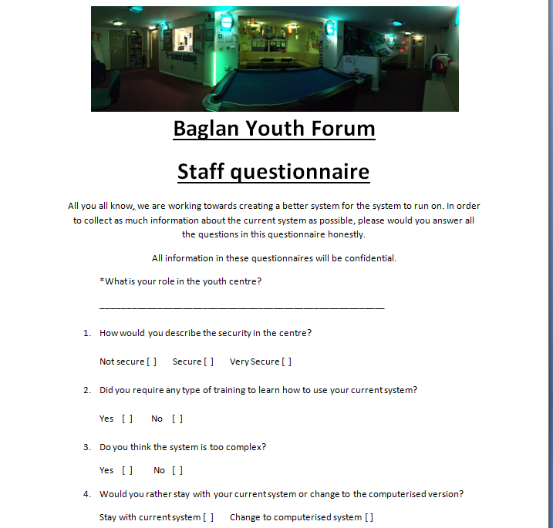
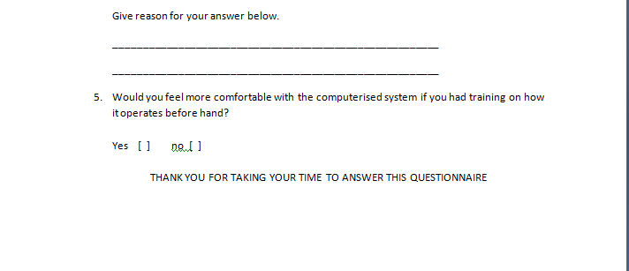
Below are two examples of the questionnaire filled in

Results of the questionnaires
To help me summarise the results, |I am going to be using tables to help represent the data. I decided to use tables because it is a quick way to see the answers, it doesn’t require lots of work to read the date. I am doing this again to fully understand the current system in the Youth Centre. I will be taking the answers into consideration while writing the new computerised system.

- How secure is the centre

- Did you require training?

- Is the current system too complex?

- Stay with the current system or move to the new system?

- Would you more comfortable with the new system if you had training beforehand?

These results show that although the paper based system in the centre is working well and everyone seems to know what they are doing, half of the people working there would rather have the new system put in place. Additionally, 10% of the workers admitted that they thought the current system was still too complex for this. This could be a problem if they don’t understand what they need to do if asked to do something by the manager or likewise.
Another problem that is concluded from the results of this questionnaire is that 20% of the workers said that they thought that the centre was not very secure. This tells me that people would be less confident to attend the centre if they thought that their details weren’t safe there. Here is where I feel the computerised system would come in very handy by adding passwords to the system to ensure no unauthorised access.
When asked if the staff at the centre would feel more confident with the new system, there was an obvious show that 70% would feel more confident. Because of this I feel that putting training programs into place would be very beneficial to the staff, especially if it means that the workers will be more comfortable with the new system
Overall I feel that the centre would benefit from the new system, even if the workers are torn 50/50 with the idea of it. Especially since the majority of responses to this question being that the current system is familiar to them whereas the new system would be a lot of effort to get their head around.

Observing the system in use
After looking at the results of the questionnaire and the responses in my interviews, I feel like observing the system is process would give me a good idea of how everything runs and how the employees use it on a day to day basis. To do this, I contacted Martyn Dulake, the manager at the centre, about observing the system for a couple of hours to widen my knowledge of the system. He seemed very happy to allow this to happen and also expressed that he would tell the volunteers and staff to continue their working day as if I was not there. By doing this, I will see how the workers and volunteers use the system naturally and it will also let me see how they deal with any problems that could arise.
My first observation in the Centre was a Monday afternoon, at 6pm. I chose this time because I knew that it was an opening time for the centre, and I would be able to see how the young people sign in and also see how the till works. When I arrived, 5 minutes early, there was a crowd of young people waiting outside the building to go in. When I got inside I was greeted by a new volunteer called Adam Lambutt. Martyn Dulake was in the office, gathering sign in sheets for the young people. I saw that the workers and volunteers that were already here had already signed in on a piece of paper in a file.
At 6pm the doors opened and the flood of young people poured into the centre and formed a semi-organised line by the window of the tuck shop. One by one, Adam asked each of the young people to write their name and age on the paper. The paper already had today’s dates on the bottom, and once the young person had given Adam 50p entrance fee and the young person was already a member, he ticked a box and the young person went off to do whatever activities he wanted.
I then watched as Adam proceeded to put the money into the till. As explained in a previous interview with another tuck shop volunteer, Adam simply entered 50 into the till and pressed enter for the till drawer to open. I noticed that when he entered things into the till, there was no way of specifying why that money went into the till. No item description.
After about 10 minutes, all the young people had signed in, Adam simple took the sign in sheet and placed it in a lower drawer in the tuck shop. I noticed there were no locks on the drawer. When I asked him about it he said that the sign in sheet stays in that drawer until the end of session in case any young people need to sign out of the centre. He told me that it was only at the end of the session that the sheet would be moved to the filing cabinet in the office.
Not long after the young people had signed in, there were several exchanges of tuck products and money. I observed how Adam would have to mentally add up the price of things one young person wanted and enter the sum into the till. Again the till didn’t display any product description and Adam again had to work out how much change the young person needed from the money they had provided.
After that burst of customers, the tuck shop went quiet for a while and Adam proceeded to make sure that the room was tidy.
The session seemed to end quickly and the young people left. There was then a half hour break before the next session opened. In this time, the gin in sheet for the previous young people was taken by the manger into the office and organised into the right place in the filing cabinet. I did notice that he didn’t seem to need to unlock the door when he went in, meaning the door had been open for the entire duration of the session. When I questioned him about it he said that he had simply forgotten to lock it.
As 7:30 came along, the next session started and the young people came in. This time they were a bit older and there seemed to be less of them. The signing in process happened as normal but this time one of the young people had never been before and wanted to be a member. Adam called for the manager and explained that she was a new young person and the manager soon rushed off to the office to collect a consent form for the young person. The form was given to the young person straight away and was told they needed to get their parents to sing the form. Since it was her first session, it was free but the in the next session, if she forgot her consent form she wouldn’t be allowed to stay in the centre until the form came.
There were less exchanges in the tuck shop this time around but the ones that did happen were smooth and Adam didn’t make any mistake while calculating the prices and the amount of change.
Half way through the session, one young person wanted to use the computers that were in the centre. Adam said it shouldn’t be a problem if they had a library account. Luckily the young person did and so Adam took the small filing book from the locked cupboard and sifted through the papers for the young person’s name. Once it was found the log in details were written on a separate piece of paper and given to the young person so they could log on.
I had arranged to leave the centre after two hours so unfortunately I didn’t stay till the end to see how they locked away their files and sign in sheets etc. However I did feel that I had a much better and closer idea of how the system works. During my time there observing the system, many smooth exchanged were made, everything seemed to be organised and the manager was able to actually sift through all the files very quickly – must be down to experience. Even though everything ran smoothly, I did notice that there weren’t very many ready printed forms for young people, staff or volunteers. Additionally, I feel like the manger’s error in forgetting to lock the door to the office was too lightly overlooked considering that the office hold lots of personal information about a lot of people, young people included and this is a huge concern with the current data protection act. Leaving the door unlocked means anyone could have gone in and taken someone’s information with means that the Centre would end up in a lot of trouble. This is where I feel like the new system would be very helpful to the centre because the system will automatically lock when not in use. This lessens the chances of the details being left open for people to access whenever they want. Overall I feel like although this system seems to run quite nicely, it isn’t a very good when is comes down to doing things efficiently – like operating the till. The operation of the till could be much better and faster if the worker didn’t have to mentally calculate all the prices and change.

Desk Based Research
Stock Control System
I have examined the specifications for a variety of stock control system. Many os the system I have looked at, however, were for much larger businesses that had much more stock income from big warehouses. Therefore these systems are not suitable for smaller businesses like Baglan Youth Centre.
I focused on some smaller systems and identified the following characteristics:
- Recording how many items have arrived in the centre/are held in stock
- Deduct items as they are sold
- Searching for product details
- Produce list of items in stock
- Set minimum and maximum stock levels
- Warn when minimum stock levels have been reached
- Produce list of sold items

Payroll Systems
After conducting some research on payroll system details, I soon realised that any payroll system would have to produce documents require by Her Majesty’s Revenue and Customs (HMRC)
HMRC state that a payroll system must:
- Record your employees’ details
- Work out your employees’ pay and deductions
- Report payroll information to HMRC
- Work out how much you need to pay HMRC
- Calculate statutory pay
In Addition, a well written system must:
- Produce Payslips
- Record pension deductions
- Pay people over different periods(weekly/monthly)

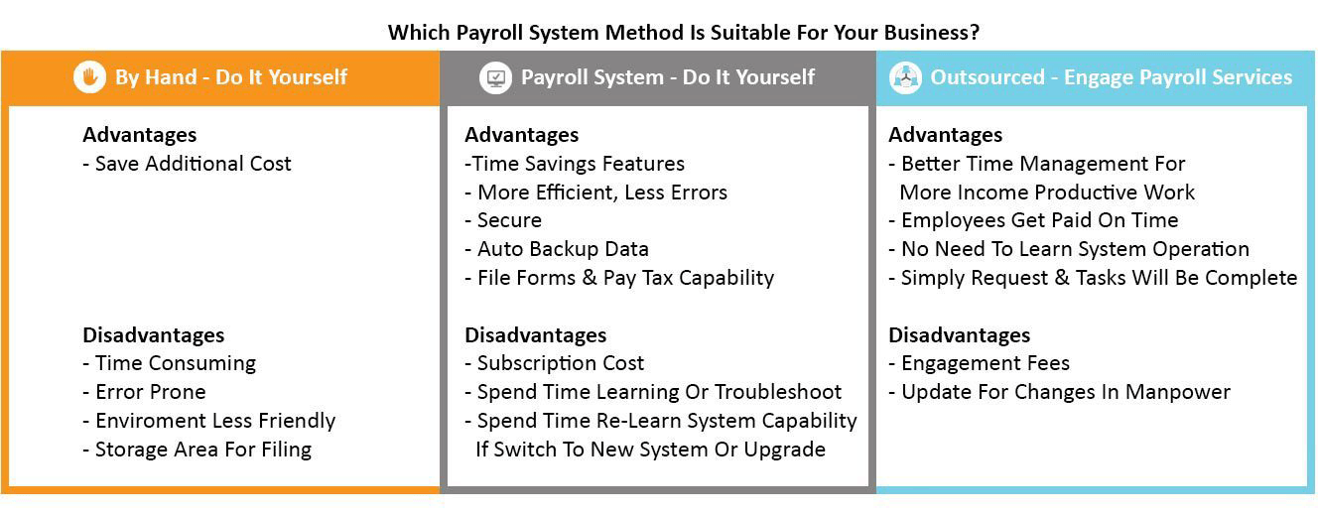
It is important to look at which sort of system method is best for your company, so below are some of the disadvantages and advantages of different system methods:
After looking at the above picture, I decided that doing a payroll system myself would be the best option for Baglan Youth Forum. Below is an example of a payroll system - Quickbooks
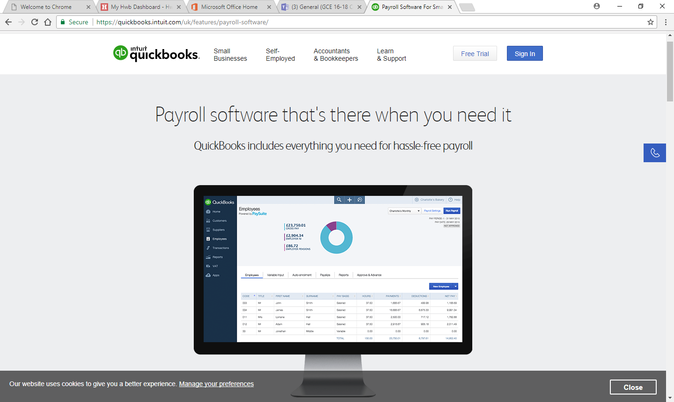
I found that I couldn’t actually use this payroll system unless I was to pay monthly by the amount of people/employees I have.
However, this site allows me to see what I would need to include in my payroll system. Things I would need to include would be:
- Estimate Tax payments
- Manage bills and payments
- Track Employee hours
- Calculate monthly pay
- Calculate and add to monthly pension payments

Looking at the current paper based system
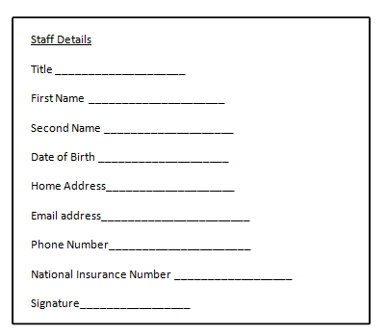

This is a staff details form that is given to the staff member after an interview has been conducted. This is what is saved in their file.

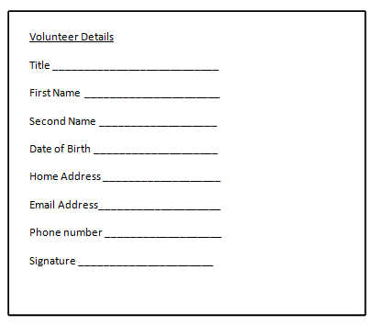

This is a volunteer details form given to someone who wants to volunteer. This is then saved in the office paper files.

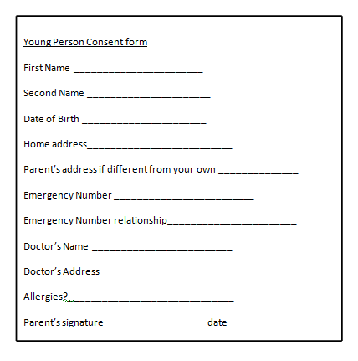

This is a Young person consent form. This is given to them to take home and get signed to make sure they can attend the centre with parent permission.

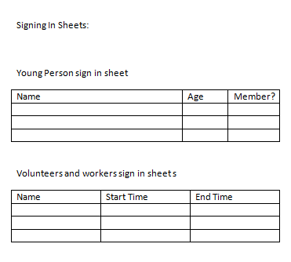

These are two signing in sheets. One for young people and one for Volunteers /workers. A new sheet is used each session for the young people and both are stored in the office



This is the stock form. Filled out monthly. The manager will fill this out and at the end of the month he will count the remaining stock to find out how much had been sold.

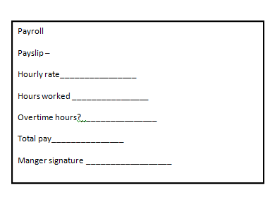

This is the payroll form. The manager will manually fill this out.

Summary and conclusion of Baglan Youth Forum’s paper based system
Currently, Baglan Youth Centre use a paper based system which can be seem above. This system is used to record all the information within the business. This includes details about young people, volunteers and workers. Because of this, it means that all data is printed out and written on by hand. All the data is then manually files in cabinets that are kept in the office. When the centre is closed the door to the office is locked, during the day it is supposed to be locked but if often forgotten about and left open. Whenever a file is needed the manager needs to go and manually open the office and cabinet before searching for the file – this can be very time consuming. In the centre there are 6 sections to the system. These are Staff Details, Volunteer details, Young person details, Payroll, Stock check, Signing in.
Staff Details
After the observation and analysis of how Staff details are stored in Baglan Youth Centre, I have concluded that there are three actions that these details are used and processed for.
Adding a new staff member
Along with all the other documents in the system, Staff details are stored in a filing cabinet in the office. When a new staff member has passed an interview, they are given a form to fill out to ensure all details about that person found in the interview are correct and to add some additionally. One this has been completed, the form is stored by the manager into the filing cabinet. The only person who should be able to access these files is the manager. Details saved in this document are:
- First name
- Second name
- Date of birth
- Home address
- Phone number
- Email address
- National Insurance number

Viewing a staff member’s details
If, for whatever reason, a staff’s details are needed to be viewed then the manager much manually sift through the filing cabinet until he finds the correct document. One the document has been found it can be viewed. This can be a time consuming process.
Editing a staff member’s details
Like wanting to view a staff member’s details, to edit their details the manager has to again search through the filing cabinet to find the relevant document. The information that then needs to be updated or changed is scribbled out on the paper, and the new details are written above it. This can lead to the forms becoming very messing and confusing when viewing.

Volunteer Details
After the observation and analysis of how volunteer details are stored in Baglan Youth Centre, I have concluded that there are three actions that these details are used and processed for.
Adding a new volunteer
Along with all the other documents in the system, Volunteer details are stored in a filing cabinet in the office. When a new Volunteer has passed an informal interview, they are given a form to fill out to ensure all details about that person found in the interview are correct and to add some additionally. One this has been completed, the form is stored by the manager into the filing cabinet. The only person who should be able to access these files is the manager. Details saved in this document are:
- First name
- Second name
- Date of birth
- Home address
- Phone number
- Email address

Viewing a volunteer’s details
If, for whatever reason, a volunteer’s details are needed to be viewed then the manager much manually sift through the filing cabinet until he finds the correct document. One the document has been found it can be viewed. This again, can be a time consuming process.
Editing a volunteer’s details
Like wanting to view a staff member’s details, to edit a volunteer’s details the manager has to again search through the filing cabinet to find the relevant document. The information that then needs to be updated or changed is scribbled out on the paper, and the new details are written above it. This can lead to the forms becoming very messing and confusing when viewing.

Young people details
Just like the previous two explanation of how documents are used, I have concluded that there are also three actions that young people details are processed and used for.
Adding a new young person as member
When a new young person comes into the centre, they are given a consent form to take come for their parents to fill out with information and to sign saying that their child can attend the centre. On this document the information stored is:
- First name
- Second name
- Date of birth
- Home address
- Parents address if different
- Emergency number
- Emergency number relationship
- Doctor’s name
- Doctor’s address
- Allergies?
- Parent’s sign

Viewing a customer’s information
If, for whatever reason, a young person’s details are needed to be viewed then the manager much manually sift through the filing cabinet until he finds the correct document. One the document has been found it can be viewed. This again, can be a time consuming process.
Editing young person’s details
Like wanting to view a young person’s details, to edit a young person’s details the manager has to again search through the filing cabinet to find the relevant document. The information that then needs to be updated or changed is scribbled out on the paper, and the new details are written above it. This can lead to the forms becoming very messing and confusing when viewing

Payroll
Following the observation and analysis of how payroll is stored and recorded in Baglan Youth Centre, I believe that there is only one actions that these details are used and processed for.
Adding payroll
The manager at Baglan youth centre, Martyn Dulake, is in charge of organising the payroll. He has to do this for every member of staff at the end of every month. He has to write this out my hand and is calculated using a calculator or just doing it in his head. I also found out recently that he makes two copies, one for the member of staff and one to go into their file in the filing cabinet. The details stored on a payroll record are the following:
- Payroll mouth/date
- Staff ID
- Payroll ID
- Full name
- Sort code
- Account number
- Hourly pay rate
- Hours worked
- Gross pay
- Amount of tax paid

Stock check
Following the observation and analysis of how the store check is stored and recorded, i believe that there is 1 action that these details are used and processed for.
Adding new products
All of the centre’s stock is recorded on a paper form when it first arrives. This too is stored in the filing cabinet in the office. Only the manager is allowed to access these filling cabinets. The manager manually records the stock that arrives, and he will go back at the end of the month, find the right form and record how much was sold. The data that is recorded onto this sheet is:
- Product description
- Size
- Price
- Number in stock
- Number sold (end of month)

Signing in
Following the observation and analysis of how the store check is stored and recorded, i believe that there is 1 action that these details are used and processed for.
Adding data to the signing in form (young people)
This is a less formal say of collecting and storing date. When young people come into the centre, once the worker/volunteer has written the important parts of the form, they are allowed to write their own details on the paper, as well as having to pay entrance fee. The data collected on this form is follows:
- Full name
- Age
- Membership tickbox
- Date(written by workers)
- Signature (workers)
Adding data to the signing in sheet(workers/volunteers)
The signing in form for the workers/volunteers is more formal. Before the centre opens, all workers and volunteers and workers much sign in, and then at the end of the sessions, they sign out. This signing in sheet collects the following:
- Full name
- Starting time
- Finishing time

Limitations and Problems with the current paper based system
After concluding my understanding of how the system runs and works, I have come become aware of some of the problems and limitations the current system at Baglan Youth centre has.
The first problem that I noticed while observing the use of the system in the centre, was the time it took to find file and edit details. During my observation, although the manager seemed to be going as quickly as he could, it took a while for certain tasks to be carried out. I believe this is because when the manager is searching for the file, he has to look through all of the files to sing the one he is looking for. And even though the files are sorted alphabetically, it still takes too long. I feel like this problem could be easily fixed in the new computerised system because I would be able to add search boxes into the program so that the user could simply type in the name or ID of a person to find their files. Another reason as to why I think the system is slow is because it is only the manager who has access to the office – where all the files are kept. In the new system, I feel like this problem could be easily fixed by allowing all users to view young people’s details. But only the manager would be able to access the other files for editing any information so it still has a level of confidentiality.
The second problem I encountered was how messy the files got while going through the editing process. There’s no way to delete the old data other can crossing it out on the original form and writing the new data on top of it. This meant that the forms got very messy after one simple edit. Additionally, the more edits the form went through the more confusing to became to read what the correct data was on the form. The editing of the files was also very time consuming due to the searching factor, yet again. This could lead to all kind of complications if there’s an emergency with one of the young people and the staff can’t read the information on the form. This could also be easily fixed in the new computerised system by adding an edit form, which will allow the user to write over the old data saved. This will allow the centre to avoid the time consuming effort of manual searching and also the messy outcome of having to cross information out and rewrite it.
Thirdly, there was the massive problem with human errorwhile making quite important calculations in both the tuck shop and in some of the payroll forms. The smaller problem about this is that the calculations made in the tuck shop while working out change or an overall price for products, however this could lead to over or undercharging the young people for what they buy. This becomes less of a problem if you’re able to explain yourself to the customer and they give you the extra money if they’ve been undercharged. However, this would be very unprofessional. This could lead to the young people not buying from the tuck shop and buying tuck from other shops before they come into the centre. The much bigger problem here would be mistakes made during payroll calculations. The manager has to do multiple calculations for each staff member and this could easily lead to getting confused and messing up calculations. This would be a major problem because staff would get annoyed if they were underpaid but also if they were overpaid the company has lost out on money income. This could lead to the failure of the company or the loss of workers if the mistakes keep happening. With the computerised system there is no chance of making mistakes in the calculations unless the actual data was wrong – like the hourly rate or the number of hours done.
Additionally, I concluded that another problem in the system was with the manual system that is that the office where the filing cabinet is kept isn’t always locked when it’s supposed to be. During my time observing the system at work, I noticed that the manager often just forgot to lock the door. This could be a major problem because all the information in the files is confidential to Baglan youth centre. But with the doors open, anyone of the young people could go in and find a file with information on anyone which someone might not want them to know. Ensuring that the cabinet is kept locked is very important especially with the current data protection acts. However, with the new computerised system there would be such a problem because the program would automatically lock when not in use. The only things the user would have to remember would their password.
The final problem i found about the current system was that everything was written out. Many people have much different handwriting and some can be particularly hard to read and so this can’t be relied on in an emergency. This kind of problem would be irrelevant in a computer based system because everything will be in text.
One of the main problems I found when using the paper based system, was that whenever anyone needed information outputted, it would have to be manually searched through and verbally displayed. I feel like this was hugely time consuming because a few times the individual looking for the information that would be ‘outputted’ could miss the information due to human error. For example, if the phone number from a member needed to be found, one of the youth workers or volunteers would have to manually search through the papers which wasn’t very efficient at all. Another thing that was problematic was the ‘outputs’ for payroll. Where a computer could automatically generate the information and figures and output them to the user, while using the paper based system, the manager had to write out to relevant information like hours worked etc, but would also have to search through other files of paper to find information on the workers, like their pay per hour and their national insurance number.

Aims for the computerised system
The main aim of this new computerised system is to hopefully improve the experience and running of Baglan Youth Centre; for all workers, volunteers and young people. The system should be accurate in order to produce the correct results and lead to no mishaps in company or employee.
Another main aim in this system is to allow the recording, saving and loading of multiple data types securely and to ensure that no unauthorised personal can access the data. This will be done with the use of passwords, one for workers and volunteers and a different one for the manager because he will have access to more.
Also, 1 aim for the system to be easy on the eye and visually attractive. Not too busy but not too plain. Hopefully this way it will appeal more to the user. Additionally this will hopefully add to the experience and ensure that the centre looks reasonably professional. By creating a visually attractive program, this will also add to the aim of it being as user friendly as possible. The more user friendly it is the more likely people are going to learn how to use it quicker, even if they haven’t used a computer in the past.
Also, with a visually attractive system, I aim to have all the information displayed clearly so there is no way for it to lead to confusion and less confusion means fewer mistakes.
Another important aim in the system is to ensure that all the staff members are paid exactly what they’re due. To do this I will be making part of the program calculate the pay for each worker without calculation errors.
Furthermore, I will aim to upgrade their stocking system so that they can enter the stock they get but it will automatically adjust when stock is sold. On the topic of stock, I will also aim to make a better tilling system. One that will allow the user to enter the price and description of an item and the system will work out the total cost and once the user has entered the amount they were given then the system will hopefully work out the change.
I also aim for the computerised system to be easily backed up by the centre so that if there’s every any trouble and the system fails, then Baglan youth centre will still have all their information and files. This way the centre can easily avoid any problems for both the young people, workers and volunteers.
And finally, I aim to create a signing in part of the program that will allow the user to sign in the young people as they come in and allow saving on the system which means there won’t be anymore excessive filing business.

Objectives for the computerised system
Since I have underlined and analysed the problems with the current paper based system i am now clear and have a good understanding with what my objectives willbe for Baglan youth centre. My objectives will be as follows:
- Allow user to add new young people members
- Allow user to edit existing young people members
- Allow user to search for existing young people members
- Allow user to add new volunteer details
- Allow user to edit volunteer details
- Allow user to search for existing volunteer details
- Allow user to add new worker details
- Allow user to edit worker details
- Allow user to search for existing worker details
- Make a simple calculator like form for the till
- Make calculator display change after amount present is entered
- Deduct stock from stocking list as it sells
- Allow user to sign in multiple young people
- Allow workers and volunteers to sign into the system
- Conduct payroll calculations successfully

Due to the aims and objectives that are required for the computerised system, I feel that using Visual Basic is my best option to produce the system. This is because VB has numerous tools to allow me to create a user friendly and professional looking system. Additionally, Using VB will allow me to load and save different types of data (strings, Integer, Boolean) in different data structures (arrays, records). This will allow for the user to load and save all of the relevant information needed for the workers, volunteers and young people(members). Additionally, by using VB all the data saved is saved externally to the system, which means that none of the data will be lost when the system is turned off or shut down. Also, by having the data saved externally, it allows for the Forum to back up the data easily, which can be done easily by copy and pasting the files that hold the data to a storage device (e.g. USB) which can then be kept in a secure place either on or off site.
By using VB to load and save data, it will also allow for the data to be loaded in serially from the file, but once it has been loaded into the program I will be able to create my own array to hold the data in whichever order I need it to be. Along with this, VB will also allow me to code validation on the inputs that the user writes. For example, when the program asks the user to enter a phone number, I can put validation in to ensure that it is checked to be the right length, so the system will recognise if the number is entered incorrectly.
By using VB it will allow me to create a visually satisfying system, which is clearly displayed and easy to use. Additionally, I have used VB before so it will be easier for me to use software I have used before instead of learning a new language.

