Discussion
I have recently been contacted by the local youth Centre in Baglan about their current paper based system. They explained to me that they had several problems with how their current system was running and enquiring into me producing a computer based system for them.
For this project, I will be making a computer-based system for Baglan Youth Centre to use after being contacted about the problems in their current system. This centre is known as a club for young people to attend during weeknights after becoming a member. As well as being a member, they will be given a login for the computers, which will also be accessible in the local library. With so many young people coming in daily, their paper-based system just is not efficient enough. In addition to this, the centre does not have enough room to keep their paper system in order. This project will have conditions that need to be met for the centre to use it successfully, these would include the following:
- Having a single log in page, which will take the user to a different page showing what they can access depending on whether they are a volunteer/worker or a manager.
- Volunteers will need to be able to access the file containing the details for current members of the club, add a new member to the members file, and access the tuck shop system. The volunteers will not be able to enter new details for any workers.
- The managers will need to be able to access all the things volunteers can access, with additional functions including details of youth workers, new youth workers, and new stock. They will have total access and be able to edit and add details for the workers.
- New stock system must keep a record of all incoming stock and managers must be able to edit the information for stock adjustments. This record must also update while the system is running for products that are sold and all adjustments and remaining stock is displayed when needed for that week.
- The system must also allow the user to search through the members and volunteers files to search for a specific person and access their details. This would include things like their name, age and address.
- All users will be able to edit the details from the members file, but only the manager will be able to edit the workers and volunteers file. This way there is a level of privacy.
- There will also need to be a payroll system, which will allow the manager to calculate the payments for each member of staff.
Throughout this project, there will be a few main problems within the system. For example, one would be data inconsistency though a file being opened by more than one user at one time. If a member of staff opens the member file to edit the data, and before the edit is saved, someone else opens the file, they are going to have the older version of the file that the other person would have changed. Then since the second person has the old version, when they save it, it will overwrite the change done by the person before. However, as a solution to this problem, when someone opens a file the file will be locked so no one else can access it until it is resaved. Although this may be a slower, there is a less likely chance of data inconsistencies.
Additionally, to have a computer-based system, the centre will have to purchase the computer equipment needed for the program to run successfully. This can be a very expensive and a problem with the computer system is that you could get a virus, which could majorly interfere with the system. In addition, if someone hacks into your system, this means that unauthorised people could get into the members/volunteers/workers files and steal their information. This would be a breach of the data protection act, which could lead to someone trying to sue the centre and costing them a lot of money.
Some limitations about the program could be things like people entering the incorrect data, not being able to access it online – you must go to the centre to track their progress and data pollution – where too much data is saved and the centre will need to update their storage, which could also be very expensive. In addition, with a computer system, the output from the computer will depend on the input. This means that if the data is inputted incorrectly then the output will be incorrect. Therefore, user ability is a limitation because if they cannot use the system properly then everything will be wrong. Some solutions for the lack of user ability could be that people who are going to use the system will have the necessary training so they know what they are doing. In addition to the incorrect data being entered into the system, when making the system I will add validation so the user can be warned if any of the data entered does not meet certain standards.

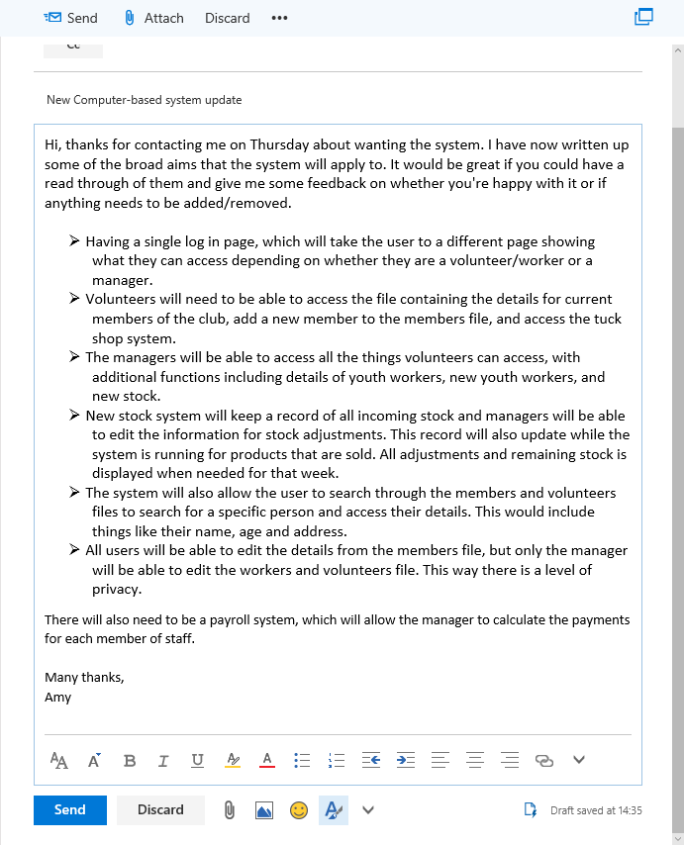
To get feedback on the aims of the system, I emailed the Centre Manager asking him to read the aims and say whether or not he is happy with it or if there are any changes he wanted me to make. Below is a screen capture of the email I send, I am now waiting for feedback.

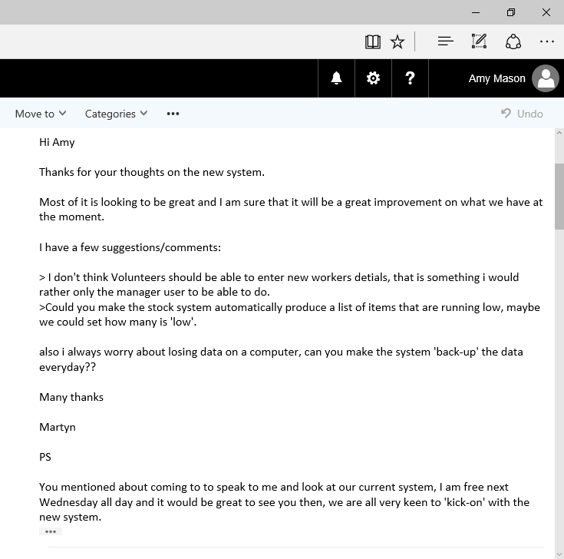
After receiving feedback, I am going to have to edit the aims and objectives. Changes to these would include:
- Volunteers will not be able to enter new details for any workers – only managers will be able to do this.
- I will introduce a stock control system where the system automatically notices when stock is running low and will either notify the manager or automatically order more stock.
- Finally, the last change I make will the system back up its data onto separate files.

