Developmental Testing
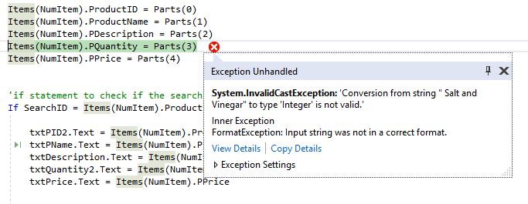
- While I was testing to search that the system would allow the user to enter and search for a current stock item. When I entered a product ID I received an error message:
To overcome this error, I checked the code and found that while declaring the structure, I set ‘PQuantity’ as an Integer. Although technically this should be correct, since the number of items entered would be a whole number, I tried changing it to ‘String’.
Then I saved and tried again..
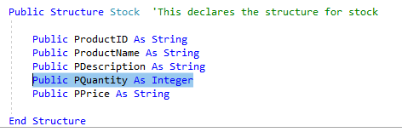

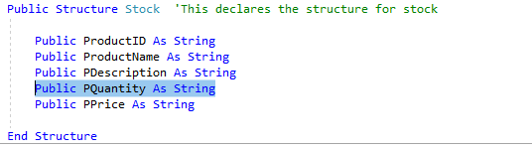

Once I had changed this piece of code, I tried again and ran the system, entering the same details as before and as a result, it worked.

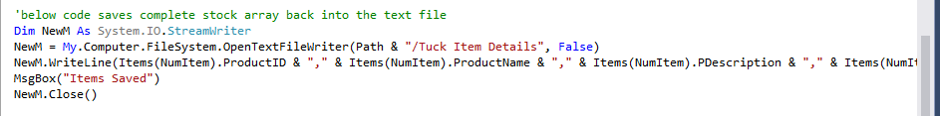
- When trying to add details to the current stock, I faced a problem that although the details were saved, it had deleted the other stock details from the system. So I had to look back at the code and see what had happened in the saving code.
The above code is what I was using to save the details of the tuck items. I compared this to over part of saving code throughout the system. Since this code is going to need to overwrite the corresponding item, I focused on looking at forms that did a similar thing.
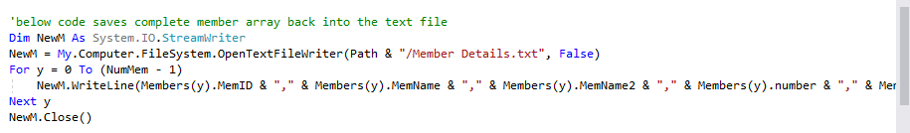
First, I looked at the ‘edit members’ saving code:
The main difference between these two pieces of code is that the edit members have a FOR loop. It would make more sense to have a FOR loop in the Stock saving code since the system needs to know which of the items it is overwriting. So I changed the saving code:
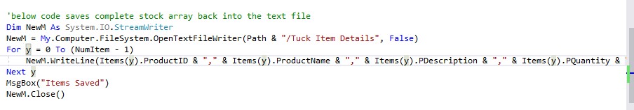
I then ran the code, selected the product, changed the quantity and saved to see if this had fixed the problem.
I then saved my code and ran the program again to check if worked, I put in the correct stock details and checked to make sure that the saving worked correctly.

- When running the change password file, I entered the correct previous password and found that I was still getting the same error message as I would get if there was nothing there:
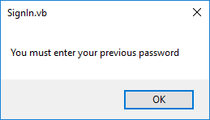
So evidently, something in my coding was wrong, to fix this I needed to go back and look at the validation code:

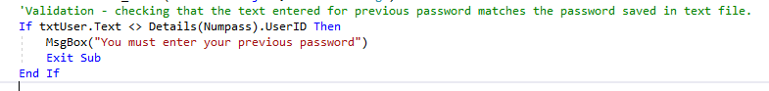
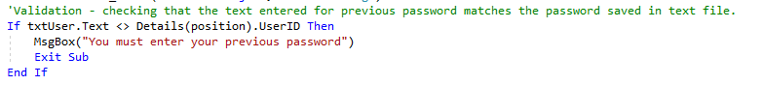
By looking at this, I could see that I had written it wrong, Details (Numpass).userID should have been:
So solve the problem I changed the code, saved and tried again, which fixed my problem.

- After completing my Edit members form and code, I ran the system to check everything worked correctly. However when I entered the memberID of a member, I received an error message:
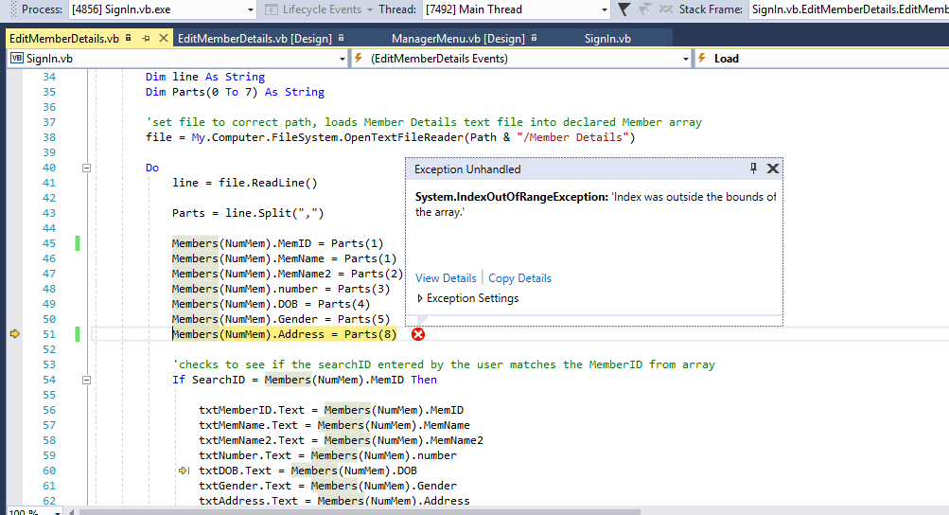
This told me that the index was outside the bounds of the array, which also tells me that there is a problem with the loading code.
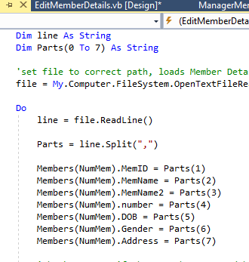

It turns out that I had set the parts to (0 to 7) but I had numbered the parts wrong when actually loading the data in.
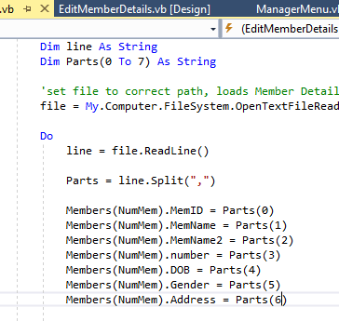
So I changed the part numbers:

And this solved the problem I was having with the loading.

- When entering the details of new volunteers I found that although the system was telling me that the items had been saved, when the details were saved it seemed to be deleting everything else in that text file.
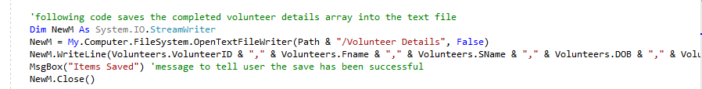
As a result I needed to look at the saving code in that form:
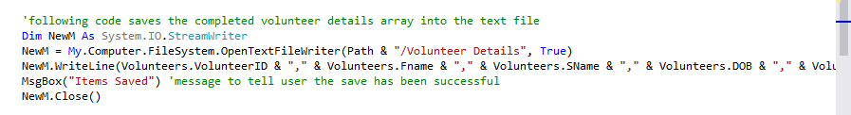
It turns out that my error was that I had written ‘False’ when saving, Instead of ‘True’. So I changed that to True so all the details would be appended on the end of the file instead of removing all the other details too.

