Overview of the system. (Manager Access)
Main Menu
Sign in
Load form
Manager has full access to the program, since they are the only ones with the permission
Forgotten password

Main Menu
Search Details
Main Menu
Add to old stock
Stock Details
Edit Details
New Details
Sign In Details
Save Details
Main Menu
Payroll Details
Print payroll
New payroll
Payroll
Save Details
Volunteer Details
Edit volunteers
Search Volunteers
New Volunteer
Volunteers
Main Menu
Save Details
Y/W Details
Edit Y/Worker
Search Y/Worker
New Youth Worker
Youth Workers
Save Details
Member Details
Main Menu
Edit Members
Search Members
New Members
Members
Main Menu
Add new stock
New stock
- Load Form – Welcomes the user.
- Sign in - Individual sign in details used to log into the program.
- Main menu – Provides the user with the variety of options.
- Tuck shop – Allows the user to sell products to customers.
- New Stock – allows user to alter stock details/add new.

6. Members – allows the user to add new members, search and edit details.
7. Youth workers – allows user to add new Y/W, search and edit details.
8. Volunteers – Allows user to add new volunteer, search and edit details.
9. Payroll – allows user to create payroll slips and print.
10. Logout – allows user to logout of the program.
11. Forgotten password – allows user to change their password.

Tuck Details
Sell items
Main Menu
Tuckshop
Overview of System (Standard worker access)
Load form
Standard workers has restricted access to the program.
Forgotten password
Sign in

Main Menu

- Sign in – allows user to sign into the program with unique details
- Main menu – allows user to see what is available
- Tuck shop – allows user to sell items to the customer.
- Members – allows the user to add new members, search and edit member details.
Save Details
Member Details
Sell items
Tuck Details
Main Menu
Tuckshop
Main Menu
Edit Members
Search Members
New Members
Members
FILES
- Members detail file.
File name - Member details
File description – This file will hold all the necessary details of the young people members of the centre. Examples of the details would be their name, age, address and date of birth.
File capacity – The number of items this file is going to hold is expected to gradually increase.
File access – This file will be access serially (directly) since this will allow the user to search directly for a name or certain criteria to find details. Additionally this will mean that the details can be edited.
Keys
Primary key – MemberID
Foreign Key - **
Field name | Field type | Field Size | Validation | Example
MemberID | String | 10 |  | Mem0001
First Name | String | 10 | Presence check  If FName = “” | Dylan
Second Name | String | 10 | Presence check  If SName = “” | Martin
Phone number | String | 11 | Length check  If length(Num) > 11 or < 1 | 07254635895
Date of Birth | Date | 8 |  | 11/8/14
Gender | Character | 1 | Length Check  If length(Gender) > 1 | F or M
Address | String | 40 | Presence check  If Address = “” | 10 Cherry grove

- Volunteer details file
File name - Volunteer details
File description – This file will hold all the necessary details for the volunteers in the centre. Examples of the details would be their name, age, job description(volunteer).
File capacity – The number of items this file is going to hold is expected to either stay the same or increase.
File access – This file will be access serially (directly) since this will allow the user to search directly for a name or certain criteria to find details. Additionally this will mean that the details can be edited.
Keys
Primary key – VolunteerID
Foreign Key - **
Field name | Field type | Field Size | Validation | Example
VolunteerID | String | 10 |  | Vol0001
First Name | String | 10 | Presence check  If FName = “” | John
Second Name | String | 10 | Presence check  If SName = “” | Elliot
Phone number | String | 11 | Length check  If length(Num) > 11 or < 1 | 07256985472
Date of Birth | Date | 8 |  | 9/7/14
Gender | Character | 1 | Length Check  If length(Gender) > 1 | F or M
Job Title | String | 20 | List check  If JTitle /= “Volunteer” | Volunteer

File name – Worker Details
File description – This file will hold all the necessary details for the employees in the centre. Examples of the details would be their name, age, address and insurance number.
File capacity – The number of items this file is going to hold is expected to stay the same or maybe increase. Approx 5
File access – This file will be access serially (directly) since this will allow the user to search directly for a name or certain criteria to find details. Additionally this will mean that the details can be edited.
Keys
Primary key – WorkerID
Foreign Key - **
Field name | Field type | Field Size | Validation | Example
WorkerID | String | 10 |  | Emp0001
First Name | String | 10 | Presence check  If FName = “” | Hannah
Second Name | String | 10 | Presence check  If SName = “” | O’leary
Date of birth | Date | 8 |  | 12/6/14
Phone number | String | 11 | Length check  If length(Num) > 11 or < 1 | 07561428531
Insurance Number | string | 9 | Length check  If length(INUM) > 9 | HY094203 M
Gender | Character | 1 | Length Check  If length(Gender) > 1 | F or M
Address | String | 40 | Presence check  If Address = “” | 10 Cherry grove

File name - Manager details
File description – This file will hold all the necessary details of only the managers in the centre. Examples of the details would be their name, age, address and insurance number.
File capacity – The number of items this file is going to hold is expected to stay the same, only details may be changed if there’s a new manager coming in after one leaves.
File access – This file will be access serially (directly) since this will allow the user to search directly for a name or certain criteria to find details. Additionally this will mean that the details can be edited.
Keys
Primary key – ManagerID
Foreign Key - **
Field name | Field type | Field Size | Validation | Example
ManagerID | String | 10 |  | Man0001
First Name | String | 10 | Presence check  If FName = “” | Sophie
Second Name | String | 10 | Presence check  If SName = “” | Johns
Phone number | String | 11 | Length check  If length(Num) > 11 or < 1 | 07152493586
Insurance Number | String | 9 | Length check and presence check  If INUM = “”  If len(INUM > 9 | OL063571 F
Date of Birth | Date | 8 |  | 11/8/14
Gender | Character | 1 | Length Check  If length(Gender) > 1 | F or M
Address | String | 40 | Presence check  If Address = “” | 10 Cherry grove

File name – sign in records
File description – This file will hold sign in details, including their username, password and whether they are a manager or worker.
File capacity – The number of items this file is going to hold is expected to stay the same, only details may be changed if there’s a new manager coming in after one leaves.
File access – This file will be access serially (directly) since this will allow the user to search directly for a name or certain criteria to find details. Additionally this will mean that the details can be edited.
Keys
Primary key – ManagerID
Foreign Key - **

 | 0 | 1 | 2
0 | Work0001 | PASS011 | Worker
1 | Work0002 | PASS022 | Worker
2 | Work0003 | PASS033 | Worker
3 | Work0004 | PASS044 | Worker
4 | Work0005 | PASS055 | Worker
5 | Manag0001 | PASS066 | Manager

Payroll File

Name of File: Payroll
Description of the file: This file will hold all necessary details for payment to the workers/managers.
Expected number of users: The youth forum, currently has 8 members of staff, including managers. However this number could change.
Access method: I am going to use random access to save and access any details with in this file. This will allow multiple people to view the same data. This is because random access allow data to be edited and viewed while still using features of the system.
Key :
Primary/key field = Underlined
Foreign key = #
Field name | Field type | Field Size | Validation | Example
PayrollID | String | 10 |  | PR0001
WorkerID # | String | 10 | Presence check  If WorkerID=”” | Emp0001
Month | String | 10 | Presence check  If Month = “” | December
Full Name | String | 20 | Presence check  If FullName = “” | Sophie Johns
Sort Code | String | 6 | Length check  If length(Num) > 6 or < 1  And presence chk | 095510
Account number | String | 16 | Length check and presence check  If ANUM = “”  If len(ANUM > 16 | 2345126688215546
Insurance Number | String | 9 | Presence check | 11/8/14
Hourly rate | Real number | 4 | Length Check  If length(Gender) > 1 | F or M
Hours worked | Integer | 2 | Presence check  If Address = “” | 10 Cherry grove
Tax Rate | Real | 4 | Presence check | 10.67

Stock File
Name of File: Stock File
Description of the file: This file will hold all necessary details for all the stock held and sold by the centre.
Expected number of Items: The number of items in this file is likely to increase and decrease to fit the customer demand
Access method: I am going to use random access to save and access any details with in this file. This will allow multiple people to view the same data. This is because random access allow data to be edited and viewed while still using features of the system..
Key :
Primary/key field = Underlined
Foreign key = #

Field name | Field type | Field Size | Validation | Example
ProductID | String | 10 |  | Pro0001
Item Name | String | 10 | Presence check  If ITName = “” | walkers crisps. (C+O)
Item quantity | Integer | 2 | Presence check  If ITquantity = “” | 2
Price | Real | 4 | Presence check  Price = “” | 0.60p
Supplier | String | 10 | Presence check  Sup = “” | Tesco
Number in stock | Integer | 2 | Presence check  NStock = “” | 20
Re order level | Integer | 2 | Presence check  Rlevel = “” | 10
Amount to order | Integer | 2 | Presence check  If OAmount = “” | 20

Form Designs
Starting screen
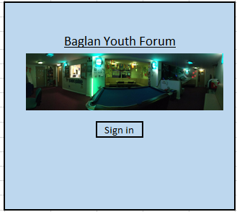
Label
Pseudo code

Begin process
If SignIn.cmd is clicked
open sign in form
exit sub

Background colour – pale blue Font style – Calibri
Font colour – black Font Size - 11
Button to other form
Image box
Sign in Form
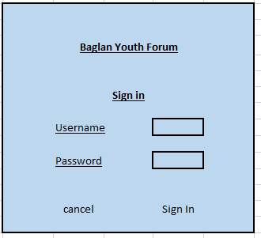

Pseudo code
Begin Process
Set textbox(username) as variable ‘username’
Set textbox(password) as variable ‘password’
Load arrayRecords

Search – for n to length of records
If arrayRecords(n,0 ) = ‘username’ then
If arrayRecords(n,1) = ‘password’ then
If arrayRecords(n,2) = manager then
Load Manager Access Main Menu form.
If arrayRecords(n,2) = Worker then
Load Standard Access Main Menu Form.
Else – Display – log in error
End if
Next n
End process

Title labels – Bold, Calibri, Underlined, size 11, black Buttons – Calibri, black, size 11
Subheadings labels – Calibri, underlined, size 11, black
Buttons
Labels
Input boxes
Labels
Main Menu form, manager access
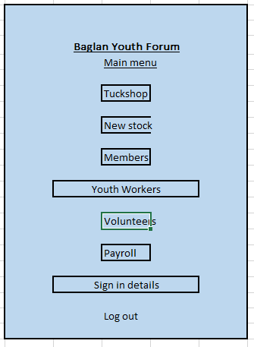

Pseudo code
Begin process
If CMD.tuckshop is pressed then Display form ‘Tuck Shop’
If CMD.NewStock is pressed then Display form ‘New tuck’
If CMD.Members is pressed then Display form ‘NewMembers’
If CMD.YouthWorkers is pressed then Display form ‘NewYouth Workers’
If CMD.Volunteers is pressed then Display form ‘NewVolunteer’
If CMD.Payroll is pressed then Display form ‘Payroll’
If CMD.SigninDetails is pressed then Display form ‘Sign in Details’
If CMD.Logout is pressed then Display form ‘Starting screen’
End process

Title labels – Bold, Calibri, Underlined, size 11, black Buttons – Calibri, black, size 11
Subheadings labels – Calibri, underlined, size 11, black
Button
Buttons
Labels

Tuck menu
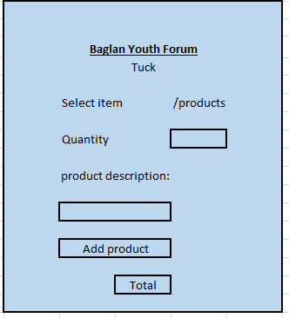
Drop down menu
Labels

Input box

Price:
Display boxes (auto fill)
Back to main menu, button

Main menu
Buttons

Pseudo code
Begin Process
Declare structure for products
Declare structure for sale
Declare array for product
LOAD all products into Array
AddProduct.click()
Loop for each product in array
If product in productarray(x) = to txtproductID
Get price of product
Get destination of product
Display price and description in txtbox
Get qty
Total = Qty * price
Grand total = grand total + total
Add line to list box (price and description)
Load product array
Search array for product
Deduct array(qty) by qty

End process

Title labels – Bold, Calibri, Underlined, size 11, black Buttons – Calibri, black, size 11
Subheadings labels – Calibri, underlined, size 11, black
New tuck form
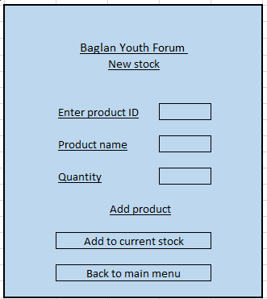

Input boxes
Labels

Buttons

Begin Process
Add product.click()
Load product.Array
For n = 0 to len(ProductArray)

If txtbox.productID = product.Array(n) then
Output box – “Item already exists”

If txtbox.productID not equal to productArray(n) then
Save product to array
Txtbox.productID = productArray(n,0)
Txtbox.productName = productArray(n,1)
Txtbox.Quantity = productArray(n,2)
Next n

AddtoProducts.click
Open form – Adding to existing stock
MainMenu.click
Open form – main menu
Title labels – Bold, Calibri, Underlined, size 11, black Buttons – Calibri, black, size 11
Subheadings labels – Calibri, underlined, size 11, black

Adding to current stock
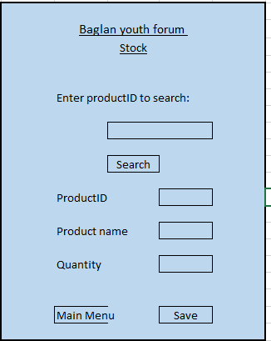

Labels

Input/output boxes

Buttons

Title labels – Bold, Calibri, Underlined, size 11, black Buttons – Calibri, black, size 11
Subheadings labels – Calibri, underlined, size 11, black

Start process
Search.click()
Load product.array
For n = 0 to length(product.array)
If txt.productID = product.array(n)
Display product.array(n,0) in productID.txt
Display product.array(n,1) in productName.txt
Display product.array(n,2) in quantity.txt
If not
Next n
Next n
Save.click
Load Product.array
Textbox.productID = product.array(n,0)
Textbox.productName = product.array(n,1)
Textbox.quantity = product.array(n,2)

MainMenu.click()
Display form – Main Menu

New Members
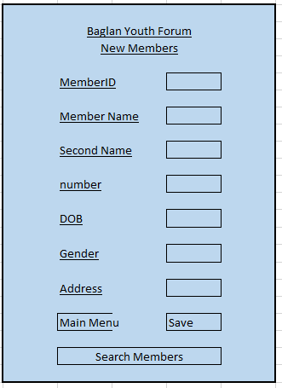
Headings

Labels
Input boxes

Buttons

Begin process.
Save.click ()
*validation*
If memberID textbox = “” then
Display message – “MemberID must be entered”
If length of number > 11 or < 1 then
Display message – “Phone number incorrect, re-enter number”
**
Emend new member detail to end of details file

MainMenu.click()
Load Main Menu.form

SearchMembers.click()
Load search members form

End process
Title labels – Bold, Calibri, Underlined, size 11, black Buttons – Calibri, black, size 11
Subheadings labels – Calibri, underlined, size 11, black

Search Members

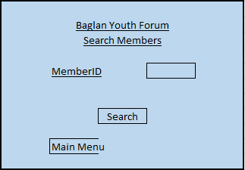
Input Box

Labels

Edit details
Buttons

Title labels – Bold, Calibri, Underlined, size 11, black Buttons – Calibri, black, size 11
Subheadings labels – Calibri, underlined, size 11, black

Begin Process
Search.click()
*validation*
If MemberID textbox = “” then
Display message – “Enter MemberID to search for”
**

Load Members.Array

For n = 0 to length of Members.Array

If Members.array(x) is = MemberID textbox then
Dislay messagebox – member details – member.array(n,0)(n,1)(n,2)..
Next n

If memberID isn’t found then
Display message – “MemberID not found”

EditDetails.click()
Load edit details form

End process

Editing Member details
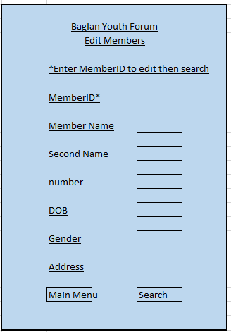
Labels

Labels
Input Box

Buttons

Save
Title labels – Bold, Calibri, Underlined, size 11, black Buttons – Calibri, black, size 11
Subheadings labels – Calibri, underlined, size 11, black

Begin Process.
Search.click()
*Validation*
If MemberID textbox = “” then
Display box – “Please enter MemberID to receive details”
***

Load MemberID array
For n = 0 to length of array
If Members.array(x) is = MemberID textbox then
Display member details in textboxes on form
Next n

Save.click()
Over write existing details with details in text boxes.

Mainmenu.click()
Load MainMenu form

End process

New Youth worker details
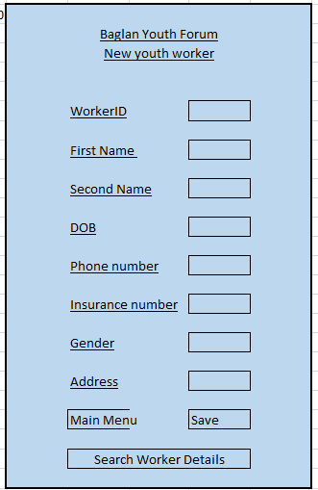
Begin process
Save.click ()
*validation*
If WorkerID textbox = “” then
Display message – “WorkerID must be entered”
If length of number > 11 or < 1 then
Display message – “Phone number incorrect, re-enter number”
If InsurenceNumber textbox = “” then
Display Message – “Enter insurance number”
**
Emend new member detail to end of details file

MainMenu.click()
Load Main Menu.form

SearchWorkerDetails.click()
Load search workers form

End process

Title labels – Bold, Calibri, Underlined, size 11, black Buttons – Calibri, black, size 11
Subheadings labels – Calibri, underlined, size 11, black

Buttons
Input boxes
Labels

Search Worker Details
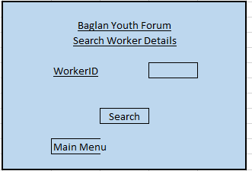
Edit details
Title labels – Bold, Calibri, Underlined, size 11, black Buttons – Calibri, black, size 11
Subheadings labels – Calibri, underlined, size 11, black

Begin Process
Search.click()
*validation*
If WorkerID textbox = “” then
Display message – “Enter WorkerID to search for”
**

Load Worker.Array

For n = 0 to length of Worker.Array

If Worker.array(x) is = WorkerID textbox then
Dislay messagebox – member details – Worker.array(n,0)(n,1)(n,2)..
Next n

If WorkerID isn’t found then
Display message – “WorkerID not found”

EditDetails.click()
Load edit details form

End process

Input Boxes
Buttons
Labels
Edit Worker Details Form
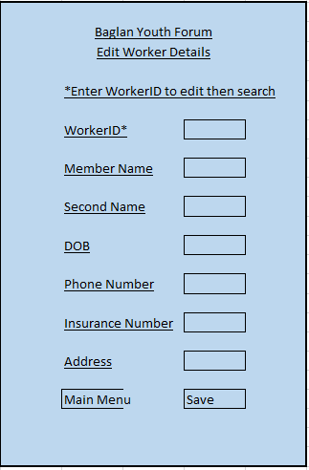
Begin Process.
Search.click()
*Validation*
If WorkerID textbox = “” then
Display box – “Please enter WorkerID to receive details”
***

Load WorkerID array
For n = 0 to length of array
If Workers.array(x) is = WorkerID textbox then
Display Worker details in textboxes on form
Next n

Save.click()
Over write existing details with details in text boxes.

Mainmenu.click()
Load MainMenu form

End process
Title labels – Bold, Calibri, Underlined, size 11, black Buttons – Calibri, black, size 11
Subheadings labels – Calibri, underlined, size 11, black

Input Boxes
Labels
Buttons
New Volunteer Details
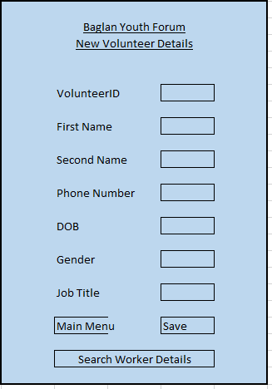

Labels
Input Boxes

Buttons

Begin process.
Save.click ()
*validation*
If VolunteerID textbox = “” then
Display message – “VolunteerID must be entered”
If length of number > 11 or < 1 then
Display message – “Phone number incorrect, re-enter number”
**
Emend new member detail to end of details file

MainMenu.click()
Load Main Menu.form

SearchWorker.click()
Load search Worker form

End process

Title labels – Bold, Calibri, Underlined, size 11, black Buttons – Calibri, black, size 11
Subheadings labels – Calibri, underlined, size 11, black

Search for Volunteer details

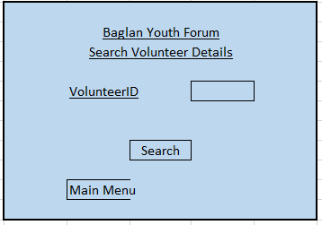
Labels
Input box

Buttons
Edit details
Begin Process
Search.click()
*validation*
If VolunteerID textbox = “” then
Display message – “Enter VolunteerID to search for”
**

Load Volunteer.Array

For n = 0 to length of Volunteer.Array

If Volunteer.array(x) is = VolunteerID textbox then
Dislay messagebox – Volunteer details – Volunteer.array(n,0)(n,1)(n,2)..
Next n

If VolunteerID isn’t found then
Display message – “VolunteerID not found”

EditDetails.click()
Load edit details form

End process

Title labels – Bold, Calibri, Underlined, size 11, black Buttons – Calibri, black, size 11
Subheadings labels – Calibri, underlined, size 11, black

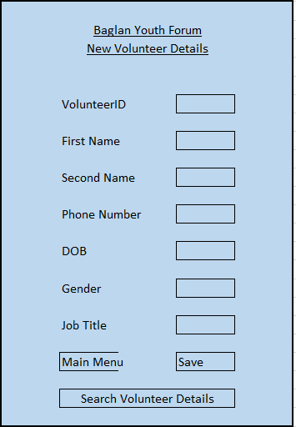
Edit volunteer details

Input/output boxes
Labels

Buttons

Begin Process.
Search.click()
*Validation*
If VolunteerID textbox = “” then
Display box – “Please enter VolunteerID to receive details”
***

Load VolunteerID array
For n = 0 to length of array
If Volunteer.array(x) is = VolunteerID textbox then
Display Volunteer details in textboxes on form
Next n

Save.click()
Validation – if volunteerIDtextbox = “” then display textbox – “Please enter VolunteerID”
Over write existing details with details in text boxes.

Mainmenu.click()
Load MainMenu form

End process
Title labels – Bold, Calibri, Underlined, size 11, black Buttons – Calibri, black, size 11
Subheadings labels – Calibri, underlined, size 11, black

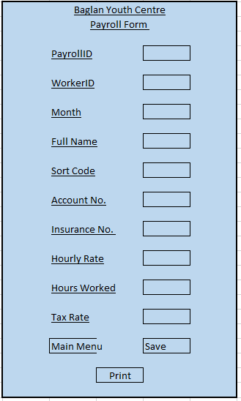
Payroll Details
Begin process.
Save.click ()
*validation*
If PayrollID textbox = “” then
Display message – “PayrollID must be entered”
If PayrollID textbox = “” then
Display message – “PayrollID must be entered”
**
Emend Payroll detail to end of payroll file

MainMenu.click()
Load Main Menu.form

Print.click()
Print form

End process

Title labels – Bold, Calibri, Underlined, size 11, black Buttons – Calibri, black, size 11
Subheadings labels – Calibri, underlined, size 11, black

Input boxes
Labels
Buttons
New Sign In Details
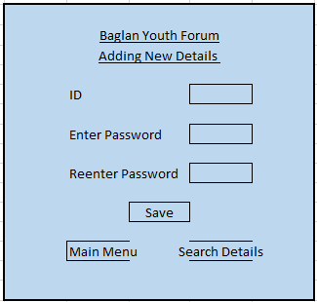
Begin process.
Save.click ()
*validation*
If ID textbox = “” then
Display message – “ID must be entered”
If Password textbox = “” then
Display message – “Password must be entered”
**
Emend Password detail to end of Password file

MainMenu.click()
Load Main Menu.form

SearchDetails.click()
Open SearchDetails form

End process

Title labels – Bold, Calibri, Underlined, size 11, black Buttons – Calibri, black, size 11
Subheadings labels – Calibri, underlined, size 11, black

Buttons
Labels
Input boxes
Search Password Details
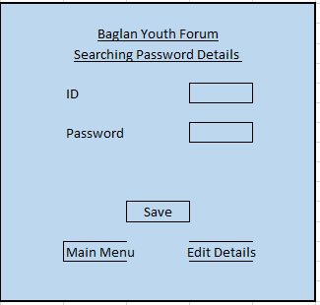
Input boxes
Enter ID then search
Begin process.
Search.click ()
*validation*
If ID textbox = “” then
Display message – “ID must be entered”

**
Load Password file
Search for ID
Display Password

MainMenu.click()
Load Main Menu.form

EditDetails.click()
Open EditDetails form

End process

Title labels – Bold, Calibri, Underlined, size 11, black Buttons – Calibri, black, size 11
Subheadings labels – Calibri, underlined, size 11, black

Display boxes
Buttons
Labels
Edit Password Details
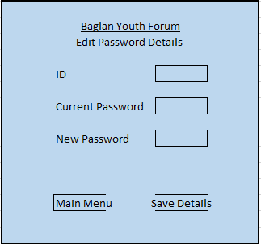
Begin process.
Save.click ()
*validation*
If ID textbox = “” then
Display message – “ID must be entered”

**
Load Password file
Search for ID
Save new password over old password

MainMenu.click()
Load Main Menu.form

End process

Title labels – Bold, Calibri, Underlined, size 11, black Buttons – Calibri, black, size 11
Subheadings labels – Calibri, underlined, size 11, black

Input Boxes
Labels

Buttons

