Testing the Dynamic Rock System
Test 1
The first form that should be displayed when the program is opened is the log in form. This is so that users can only access their authorised area of the system. To test this, I started the system to see if only to log in form was displayed. The log in form was the only and first form displayed.
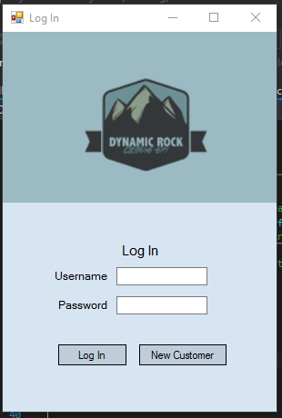

Test 2
For my second test I am going to ensure that a message box appears if no information is entered into either text box. When nothing was entered a message box did appear to let the user know. Therefore, this presence check does work.
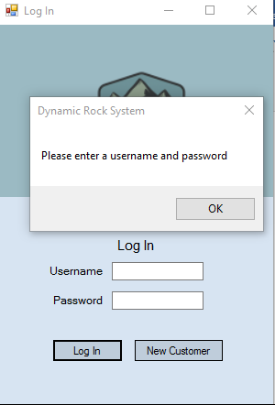

Test 3
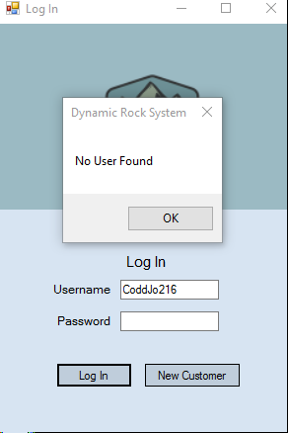
I then wanted to test if by just entering a username the system wouldn’t continue to open a menu. I tested this to ensure the security was strong. By just entering a username the system did not continue. This adds more security to the system. I then did the same by just entering the password. I got the same message. This also shows my security method is strong.
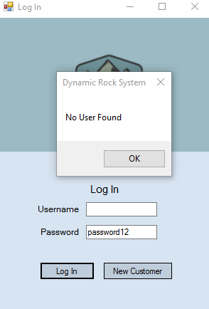

Test 4
My next phase of testing is to ensure that customer ID and passwords open the customer menu when entered into the log in section. I am going to do this by looking in the customer file and typing in username and passwords to see if they only open the customer menu and nothing else.
Below is the customer file with customer information. The customer ID is the first piece of data in each line of the document for example ‘CoddJo216’. The password is the 4th piece of data for example ‘maisie’.
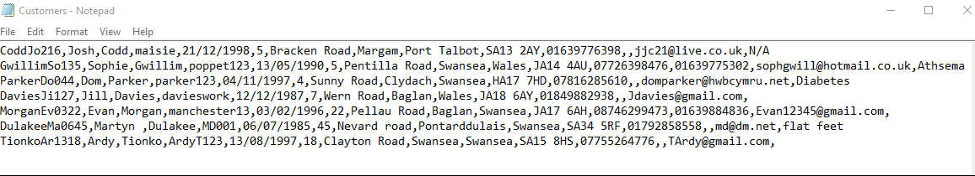
I will enter the first 3 customer’s usernames and passwords to ensure the log in system works correctly for customers and only displays the customer menu.

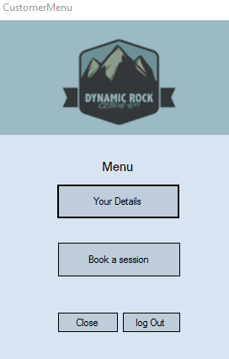
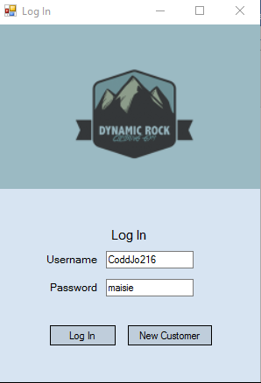
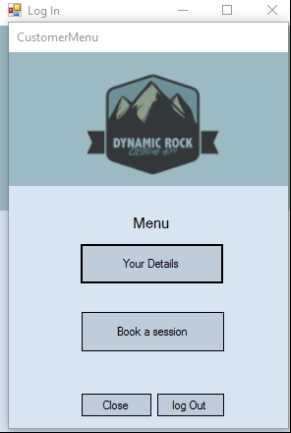
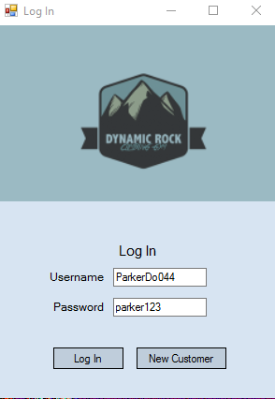
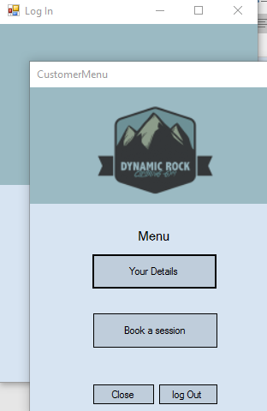
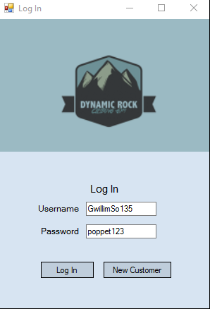

As seen above the test shows the system is successful as when I enter the customers log in information the only form that opens is the customer menu. This can be seen by the customer menu name at the top of the form. This is important so that the customer can only see their details and not have access to the staff menu in which all customer details can be seen, this would be breaching the data protection act.

Test 5
My next phase of testing is to ensure that staff ID and passwords open the staff menu when entered into the log in section. I am going to do this by looking in the staff file and typing in username and passwords to see if they only open the staff menu and nothing else.
Below is the staff file with staff information. The staff ID is the first piece of data in each line of the document for example ‘StaffMo7’. The password is the last piece of data for example ‘password12’.
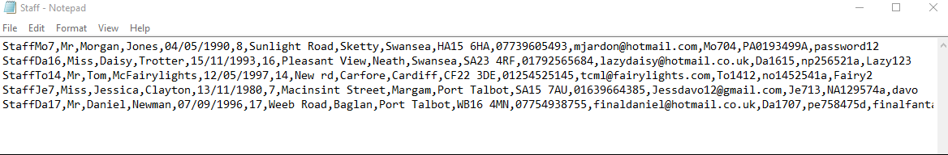
I will enter the first 3 staff’s usernames and passwords to ensure the log in system works correctly for staff and only displays the staff menu.
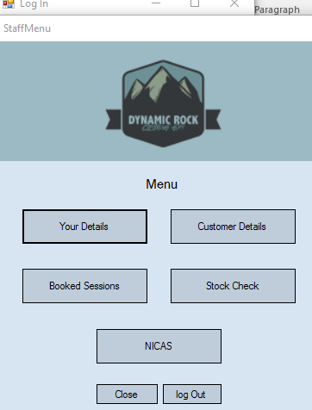
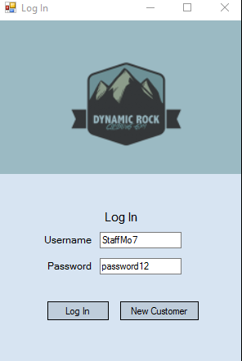
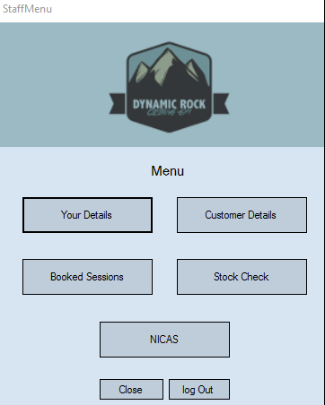
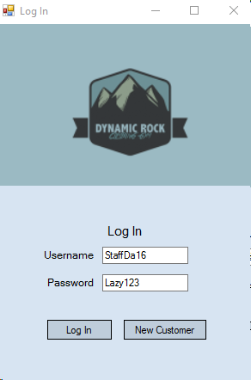

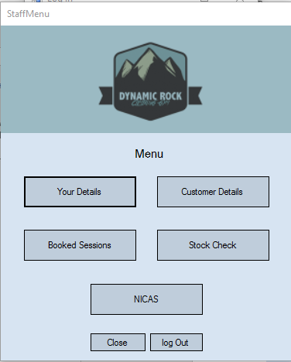
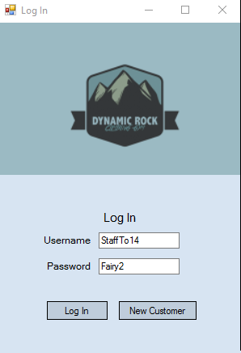

As seen above the test proves that the system runs successfully and only opens the staff menu when staff credentials are entered into the log in dialogs.

Test 6
To access the admin menu there is a set password to access. This is ‘admin’ and ‘dynamicrock’. I am going to enter these credentials to ensure the admin menu opens when done.
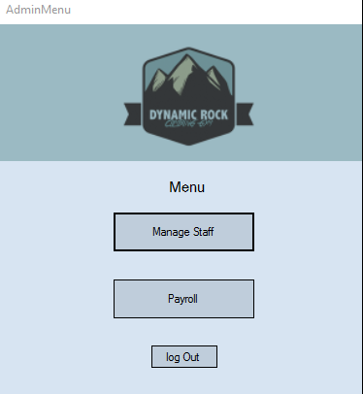
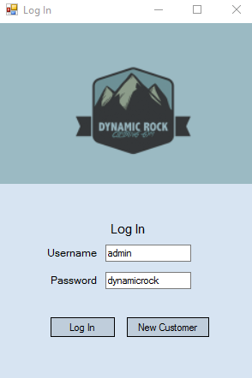

The test shows that when these credentials are entered then only the admin menu is shown.

Test 7
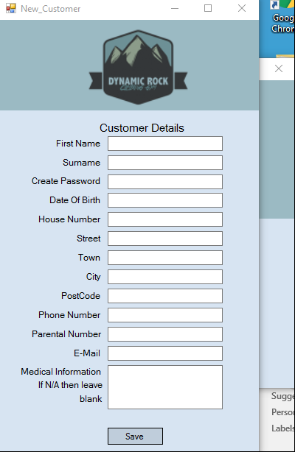
I am now going to test to ensure the add Customer form is displayed when the new customer button is clicked on the log in form.
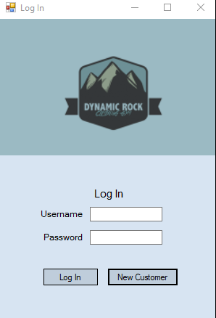

When I clicked the new customer button then in fact the new customer form did open. This is important so that new customers are able to create an account to be able to use the system without bothering any staff members who are instructing.

Test 8
I am now going to test the validation on the new customer form. I am first going to test the presence checks. There are presence checks on all fields except, parental phone, house number and medical information. To test these checks I am going to try and save a new customer but leave out the validated fields to ensure they’re flagged with a message box reading ‘Information Missing’
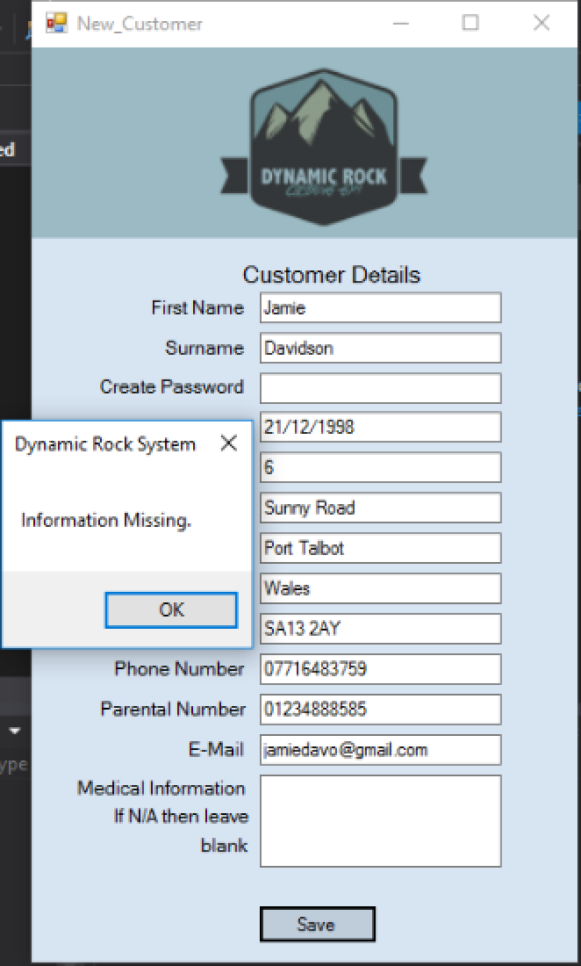
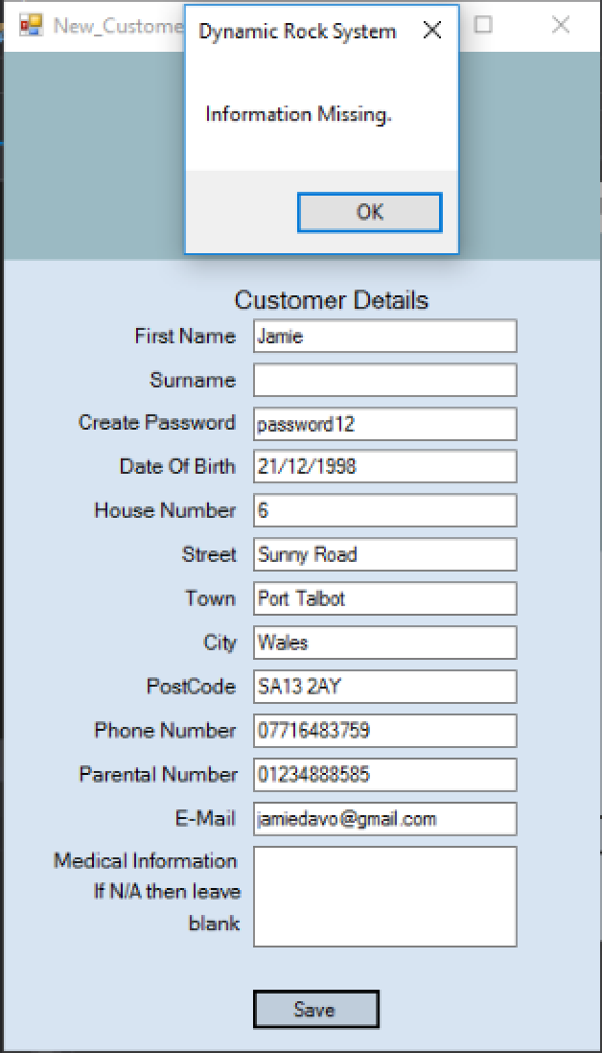
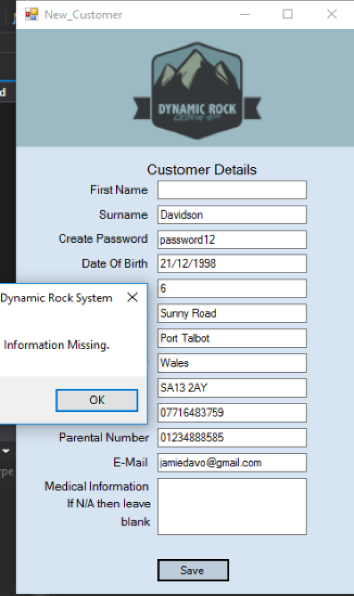

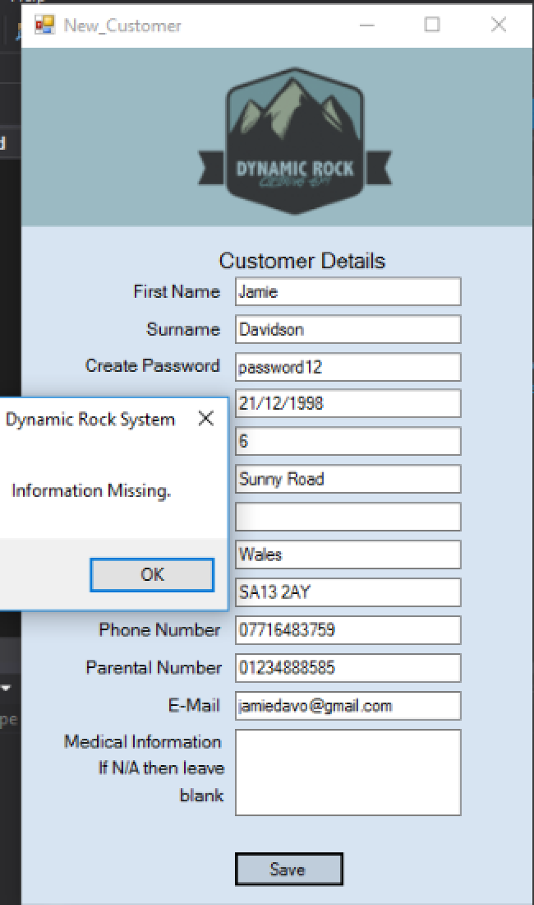
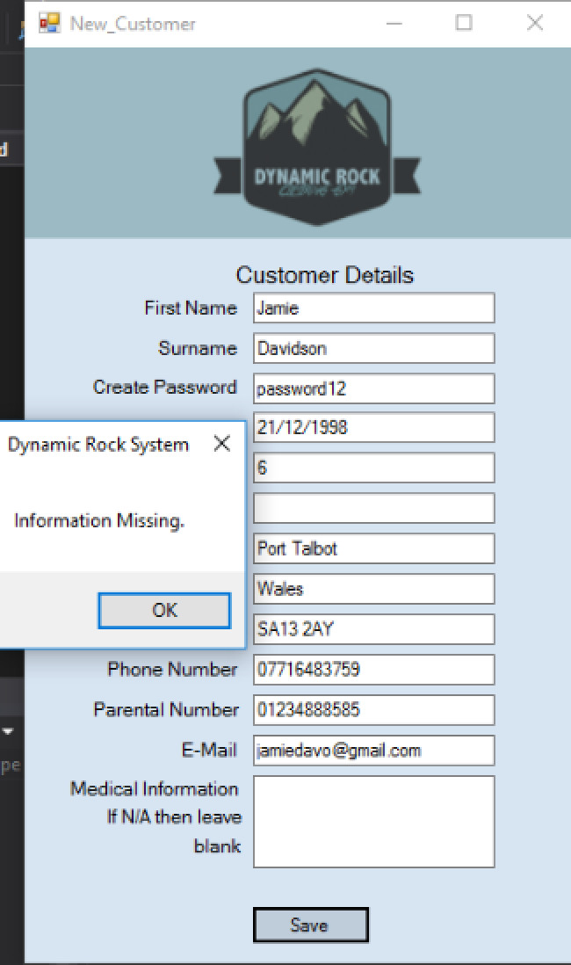
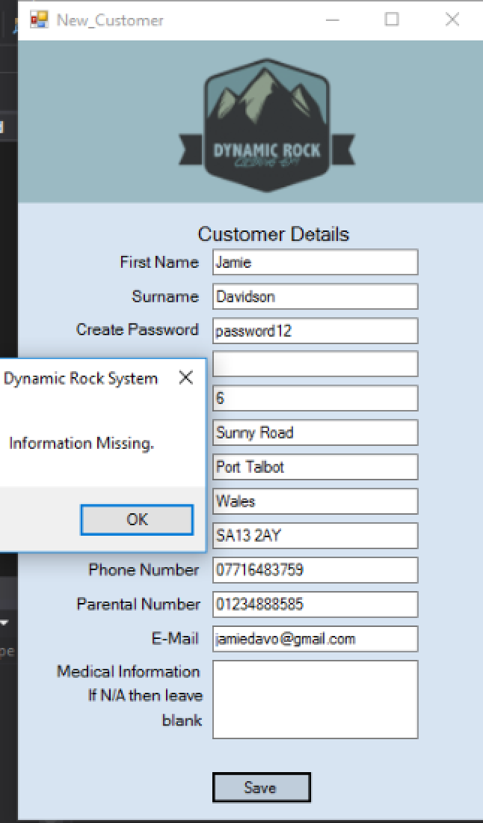

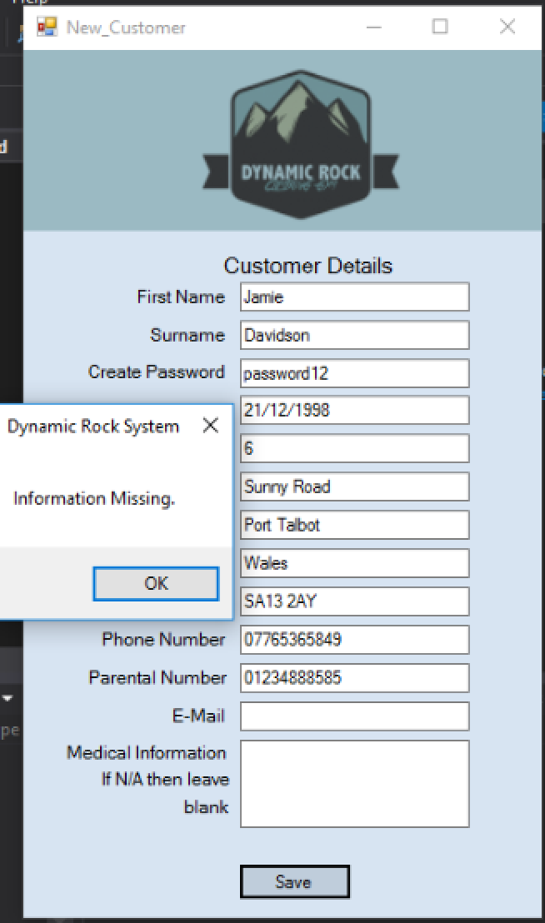
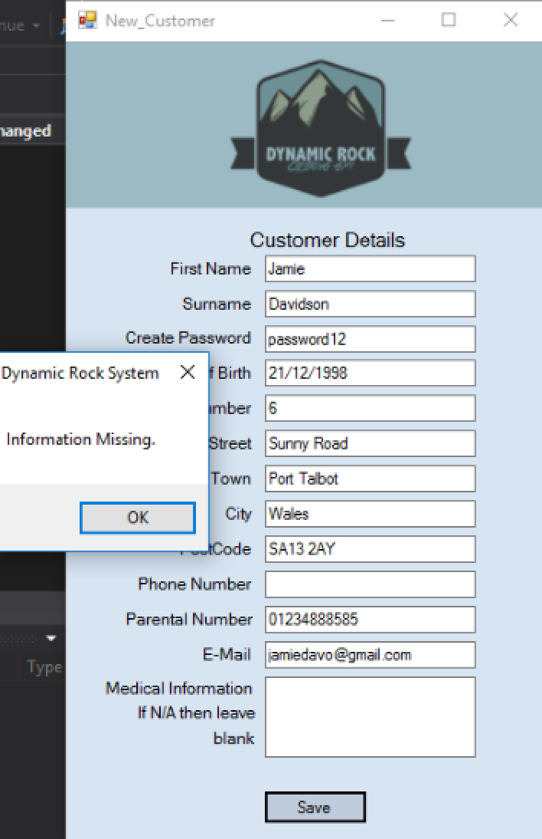
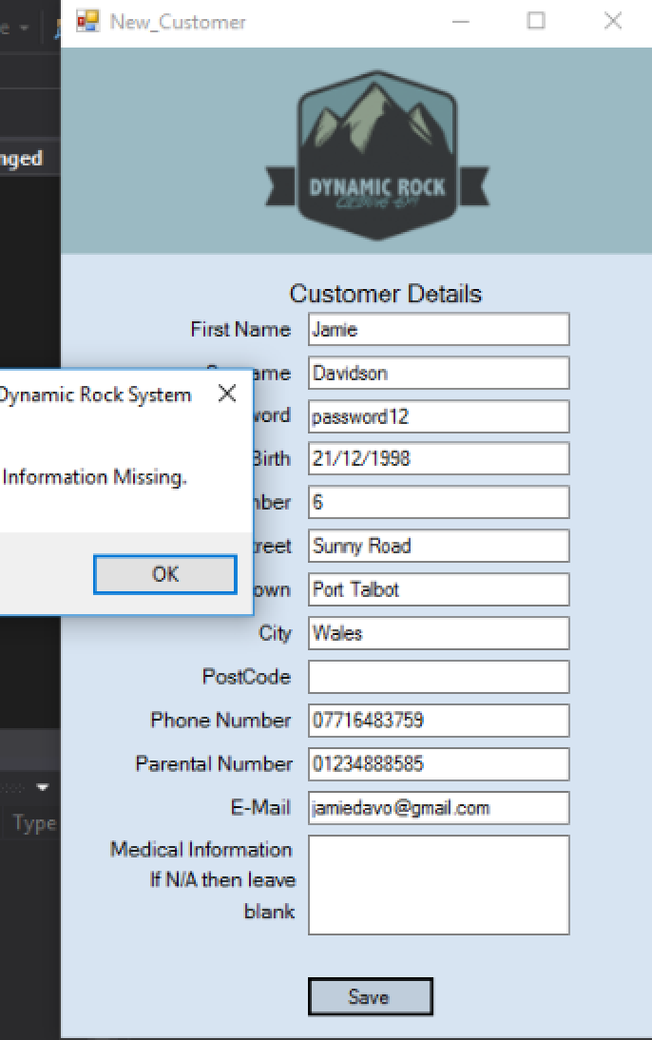
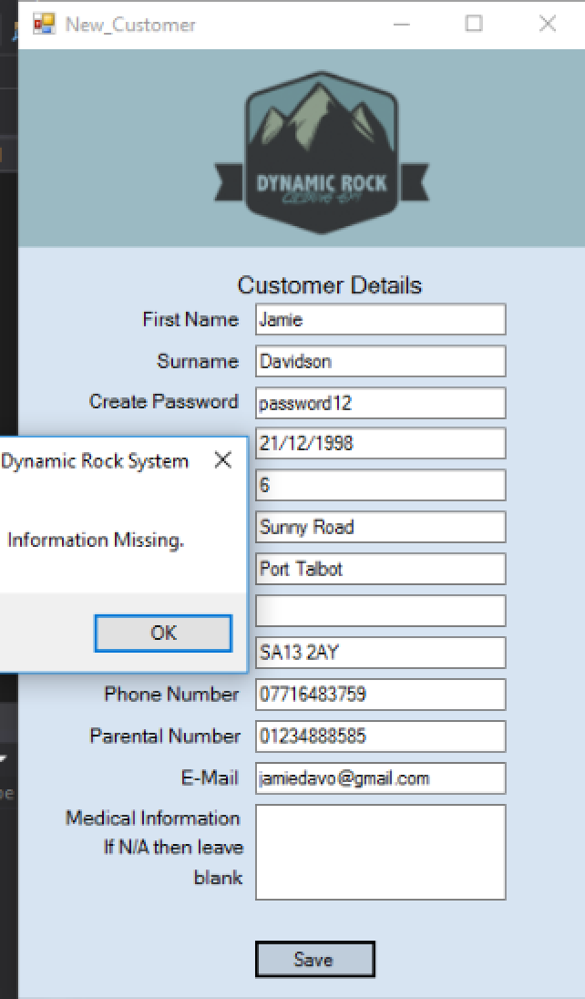

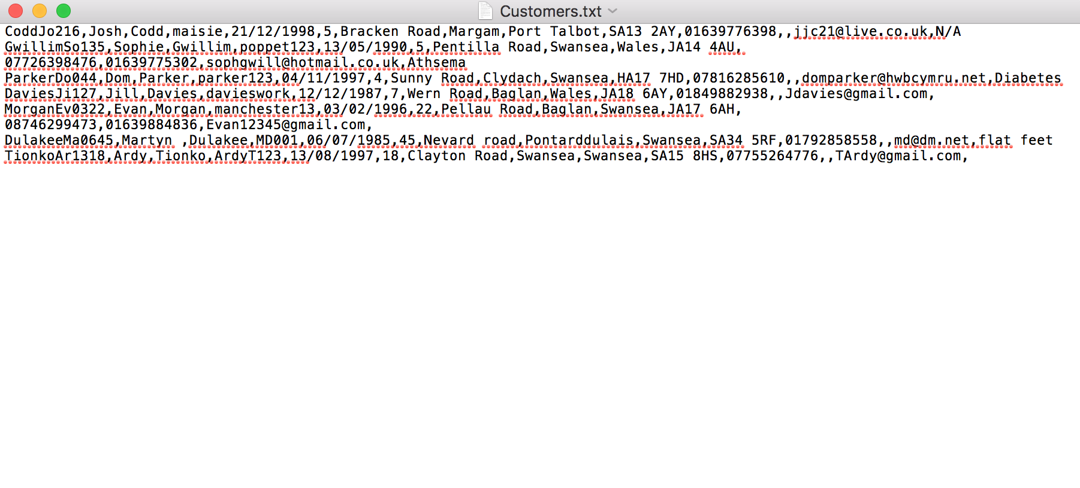

As seen by the above images my presence check validation on my new customer form works perfects. Each time a piece of required information is not entered a message box appears to ensure the user that information is missing. I have also checked the customer details folder as seen above to check that the details were still not saved even though the message box had appeared. The details had not saved, and therefore shows that the validation works correctly.

Test 9 + 10
I am now going to test my length check on my new customers form I will also test to ensure the customer details do save when the information is correct. This length check ensures that the phone number entered Is 11 characters long. To test this I am going to enter a number with 10 characters, then one with 12 characters and then one with 11 characters to see if the validation works.
10 characters
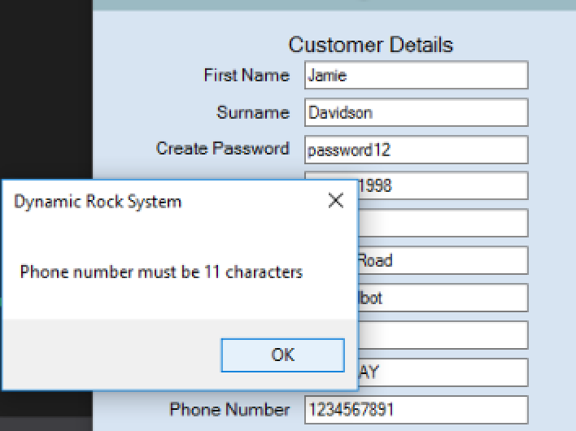

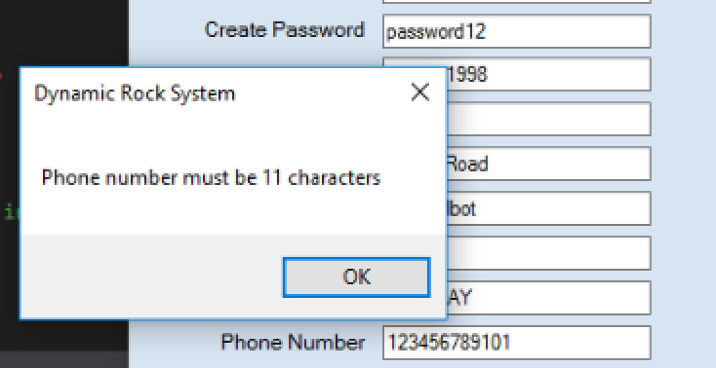
12 characters

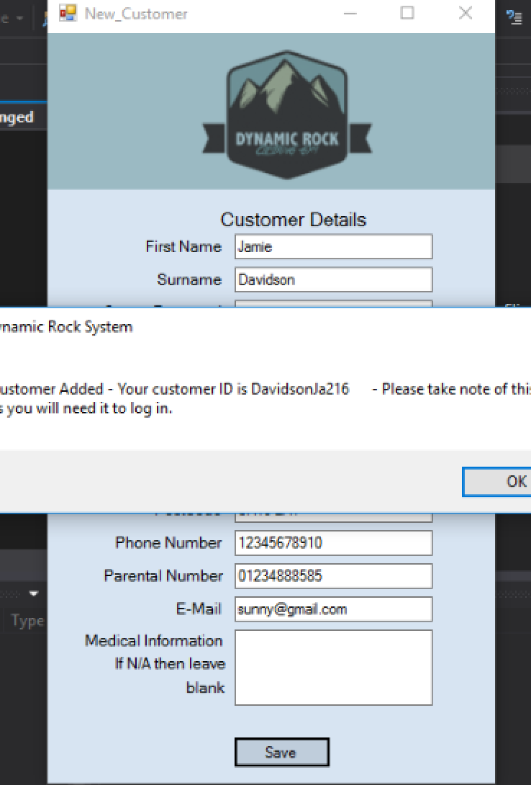
11 characters

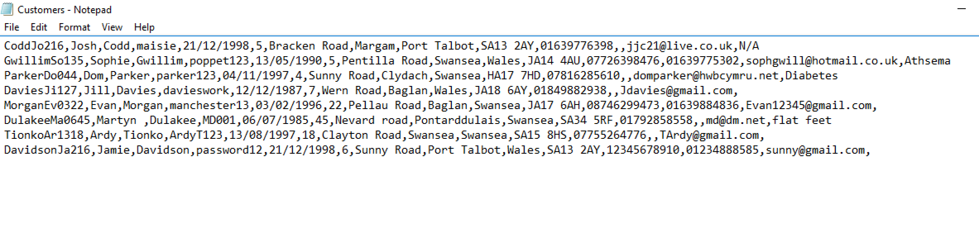

As seen above when I entered 10 and 12 characters the system did not save the details and informed the user that the mobile number was not of correct length. When I entered 11 characters the system saved the details. I have added a screenshot of the customer details folder and the new details can be seen. Therefore the correct details have been saved and the validation works correctly.

Test 11
I am now going to test the customer menu to ensure navigation works correctly. I am going to do this by clicking the buttons on the menu and check they open the correct form.
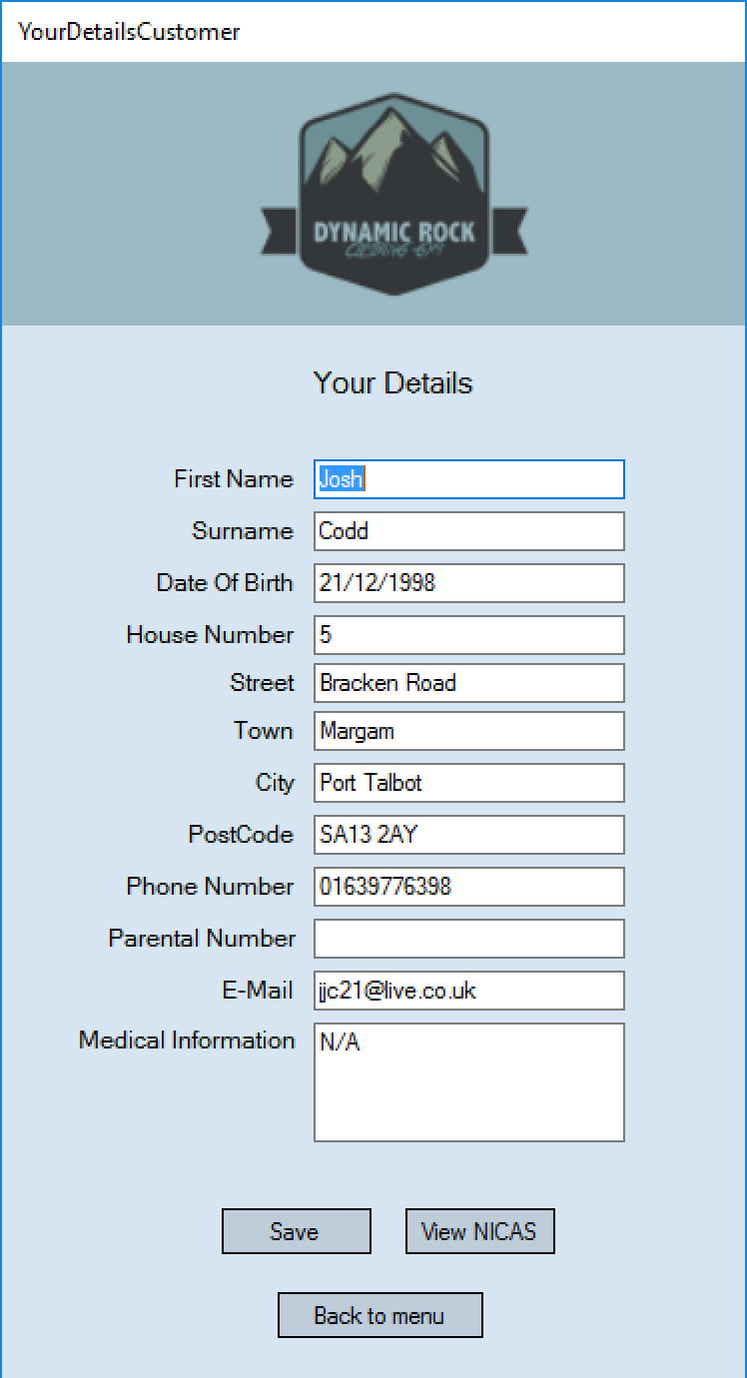
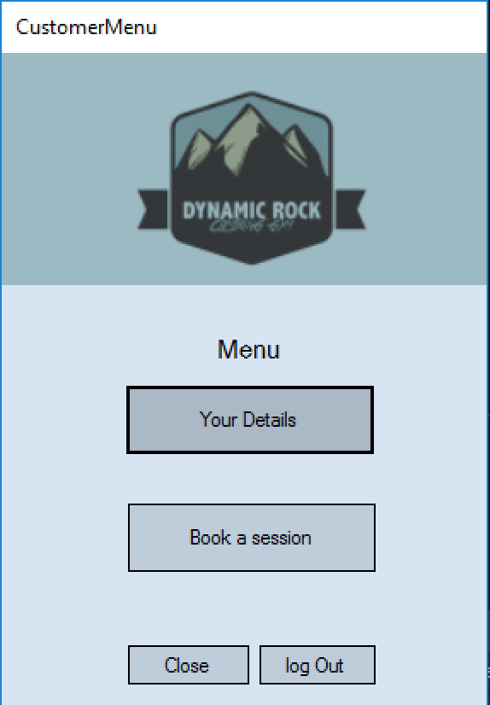

When I clicked the your details button it correctly did open the your details form and displayed my log in details which is the account I logged in with. I also tested the back to menu button. When clicked it did take me back to the menu.
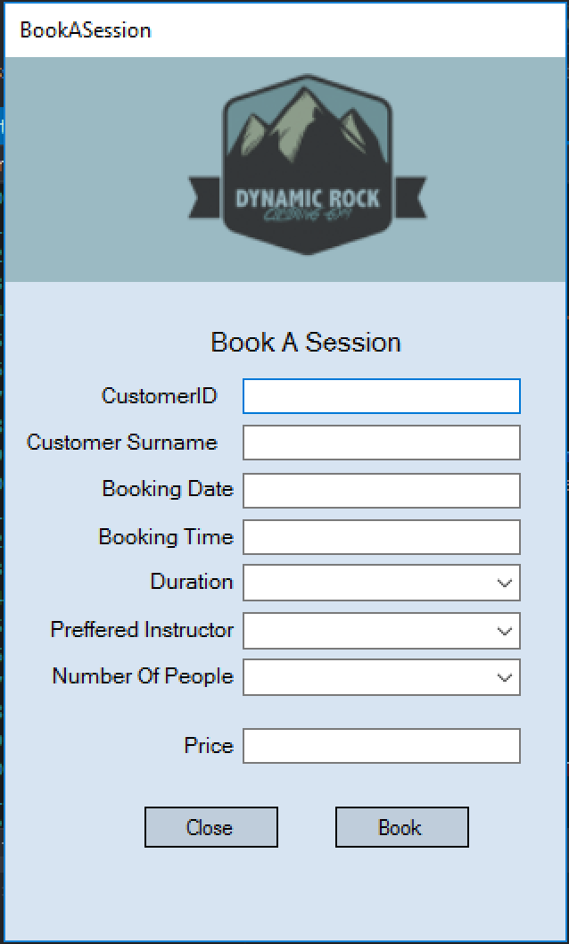
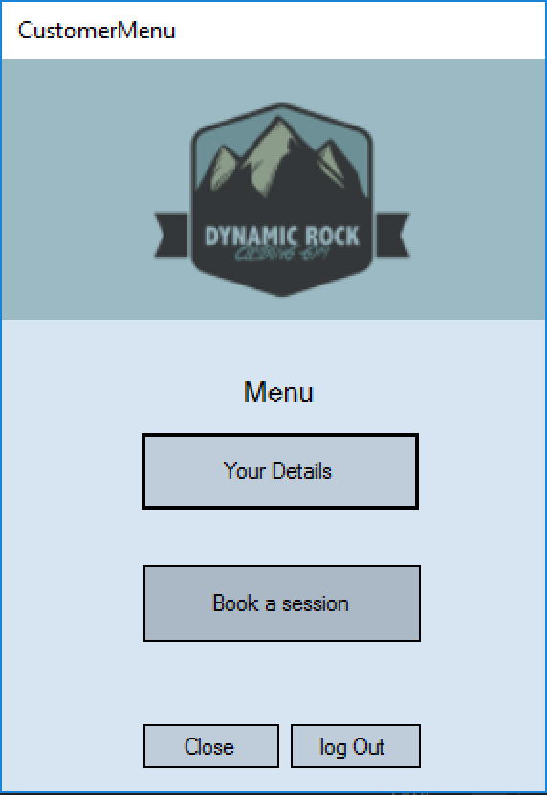

When I clicked the book a session button the booking menu correctly opened. When I press the close button on this form the booking form does in fact close. Another test I carried out here was to test the close and log out button. They both do as correctly stated and close the customer menu and return to the log in screen.

Test 12
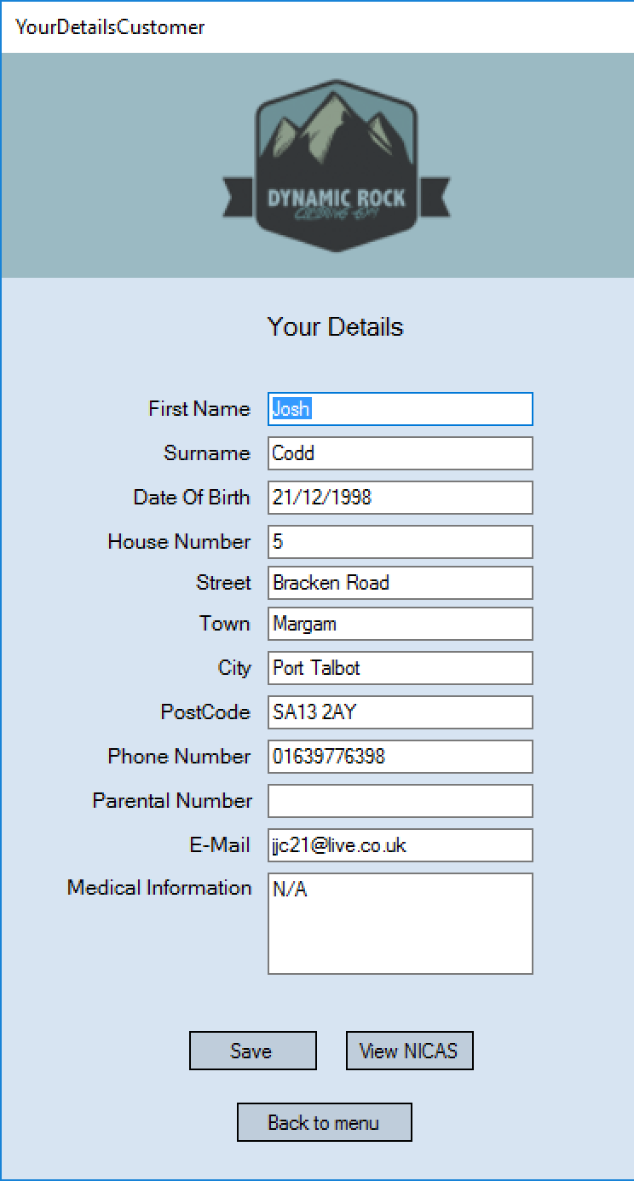
Testing the Your Details form to ensure the correct details are shown and that when saved the details are successfully updated. I am going to do this by showing the user I log in with and the details that are displayed to see if they care correct. I will then also change the house number and save the details. I will then check the customer details folder to ensure its been updated.
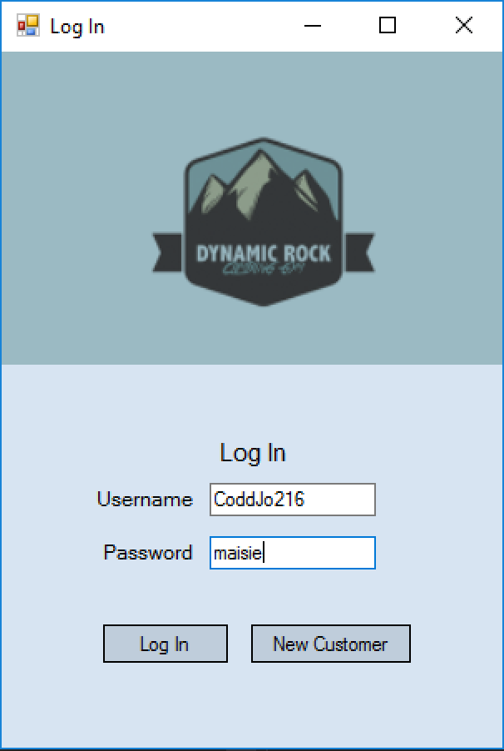

As seen above the details shown above do match the record stored in the customer details file.
I am now going to edit these details to make sure that function works.

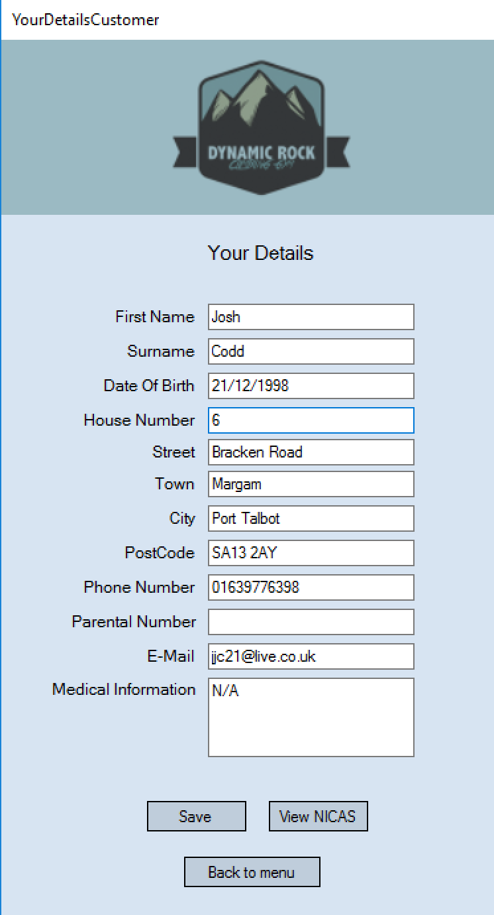
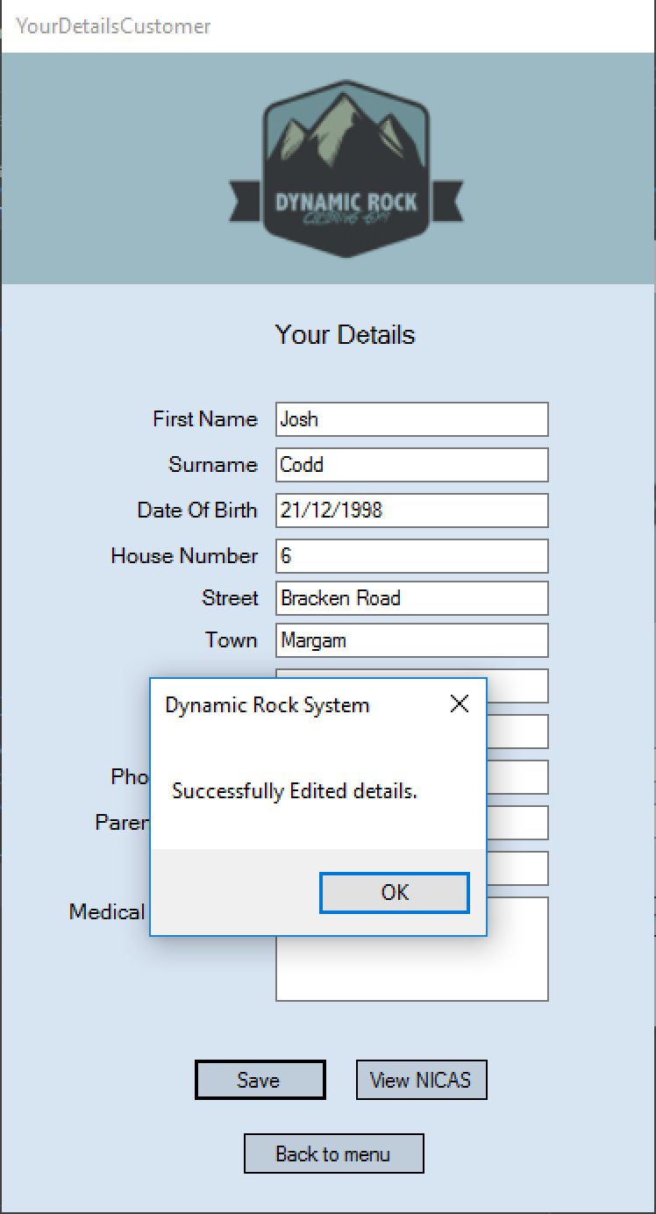

I then changed the house number from 5 to 6 and saved the details. The message box appeared which is correct. I then checked the customer details file and the number had successfully been updated.

Test 13
This test I am going to check that the view NICAS for customer works. I am going to log into the same account I did in test 12 and click ‘view nicas’ on the details page. This should display that customers NICAS details.

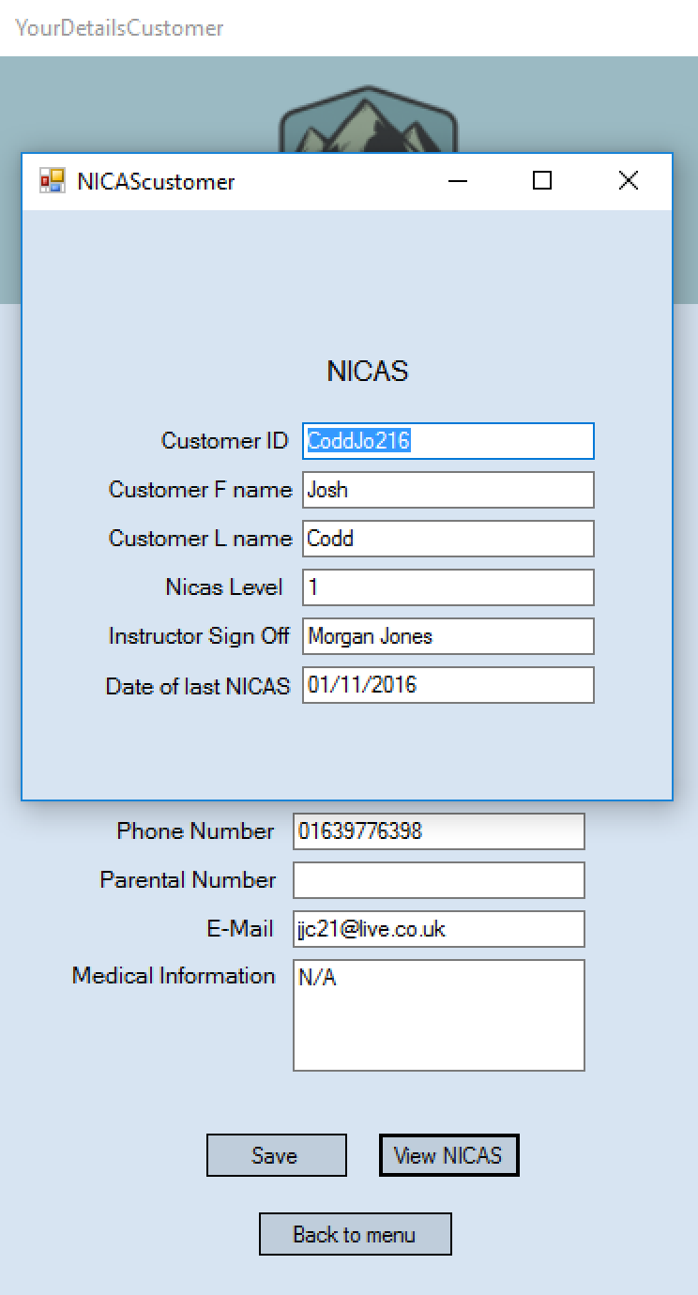

The correct details did appear in the view NICAS form.

Test 14
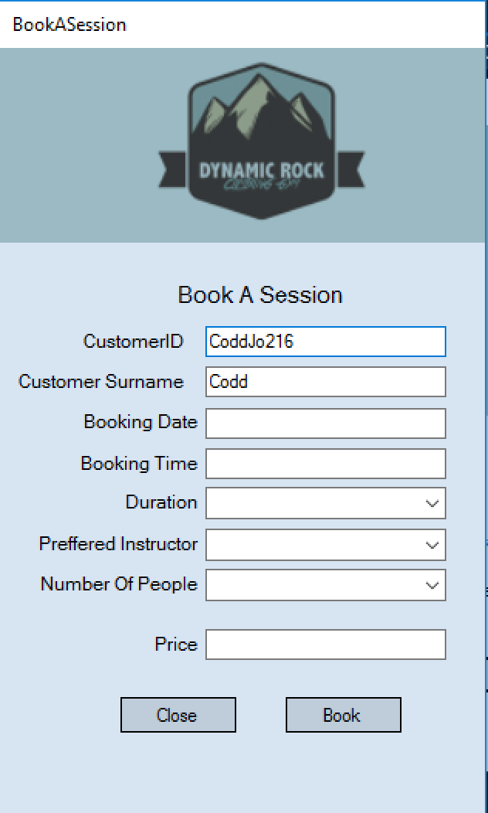
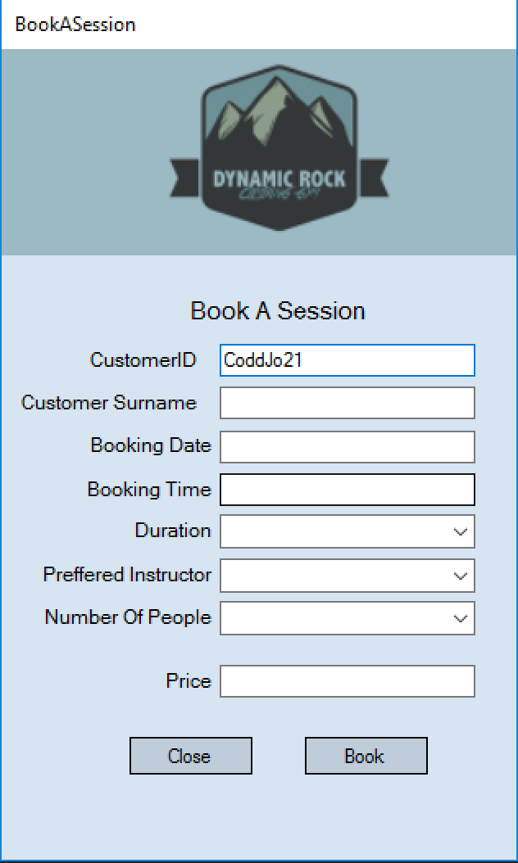
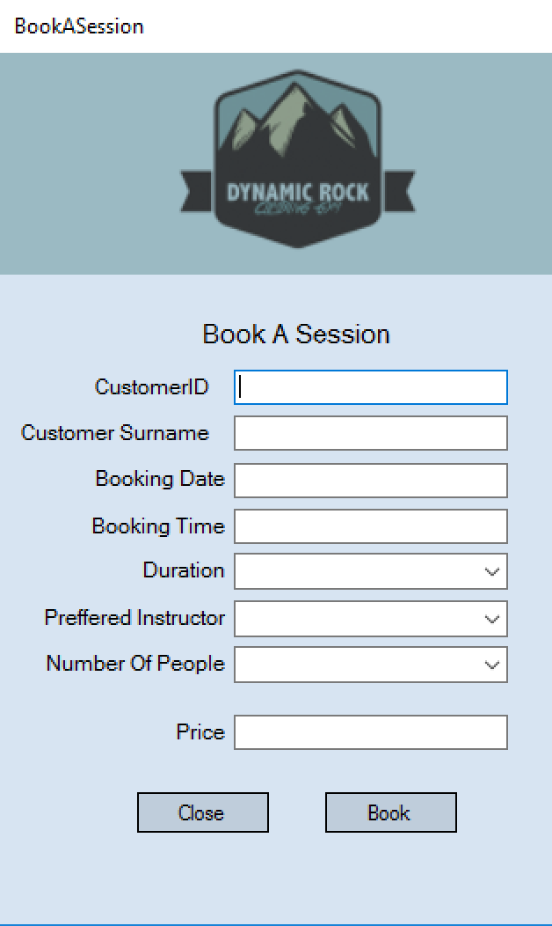
I am going to test the surname search on the booking form. I am going to enter the username used in my previous tests into the customer id field and the correct surname should appear in the surname field.

As seen in the pictures above, the surname was not entered until the correct id had been entered. This therefore shows that this search works correctly.

Test 15, 16 and 17
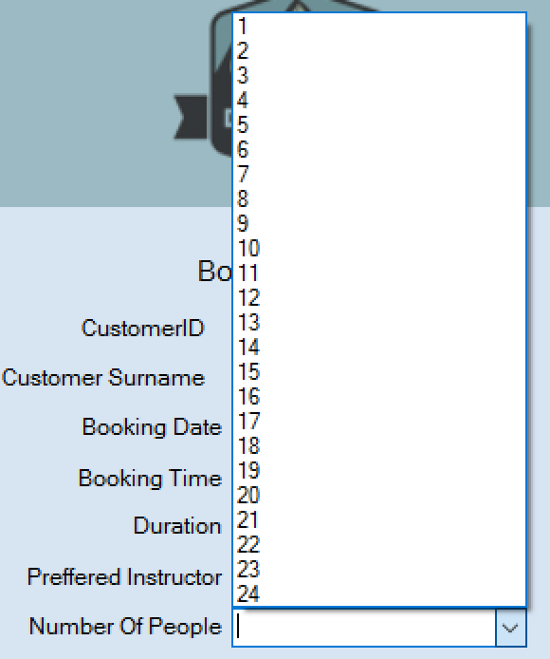
These tests are going to ensure that the combo boxes on the booking form are correctly populated with the correct information. I am going to look in the duration combo box to ensure there are correct durations being displayed. I am going to check the preferred instructor box and ensure all staff names in the staff details file are displayed. I am finally going to ensure there are integers displayed for the number of people box.
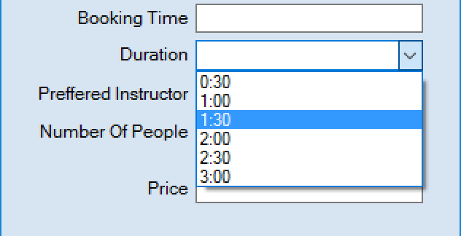

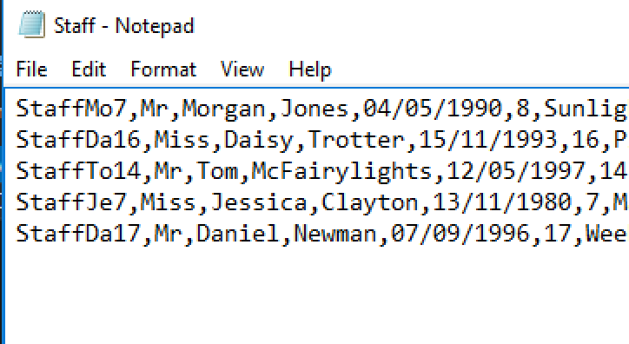
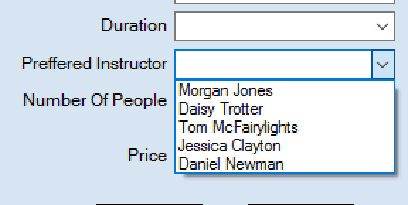

All of the correct information are displayed I the combo boxes on my bookings form. As seen above the staff combo box does contain all the staff members in the staff details file.

Test 18
I am now going to test the calculation of price on the booking form. The price text box should display the number of people multiplied by 10.99 automatically once the number of people has been selected. To test this I am going to change the number of people 3 times to make sure the price updates and is the correct amount.
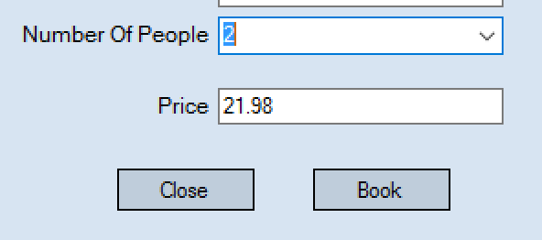
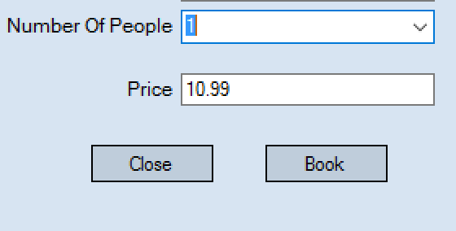
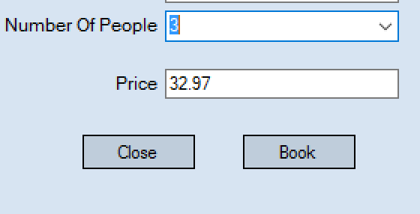

As soon as I changed the number of people then the price updated straight away. I used a calculator to check all values and they are correct.

Test 19
I am now going to save a booking to test that the details do save to the booking record. I am going to test this by making a booking and checking the booking file to see if its been added.
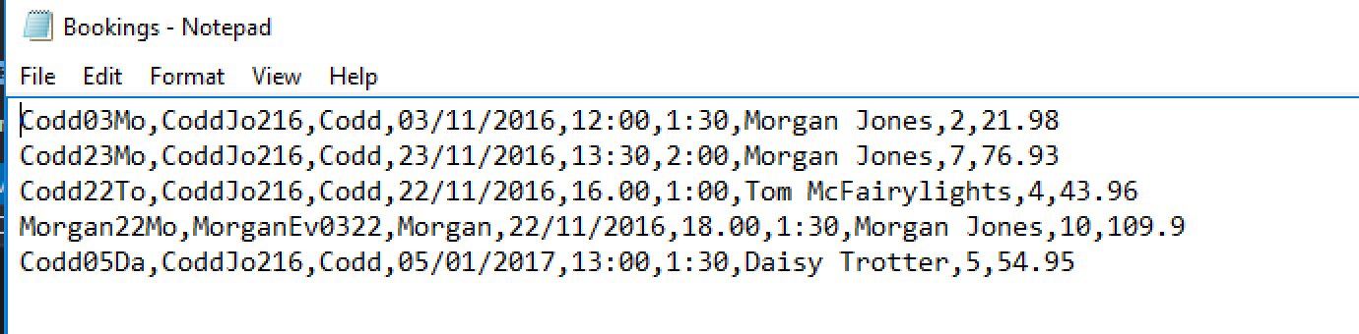
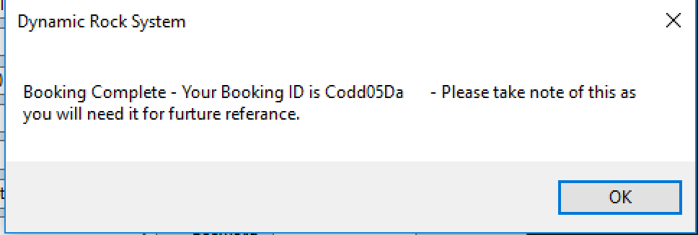
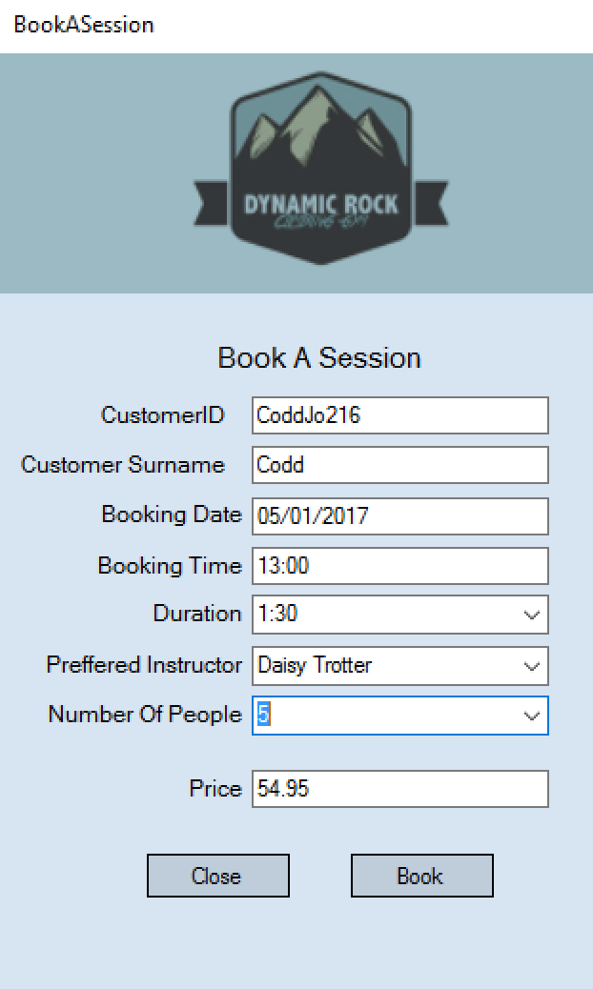

This test shows that bookings do save. As seen above the booking I made can be seen as the last record in the file with the booking date ‘05/01/2017’.

Test 20
I am now going to test navigating around the admin menu to ensure that all buttons work.
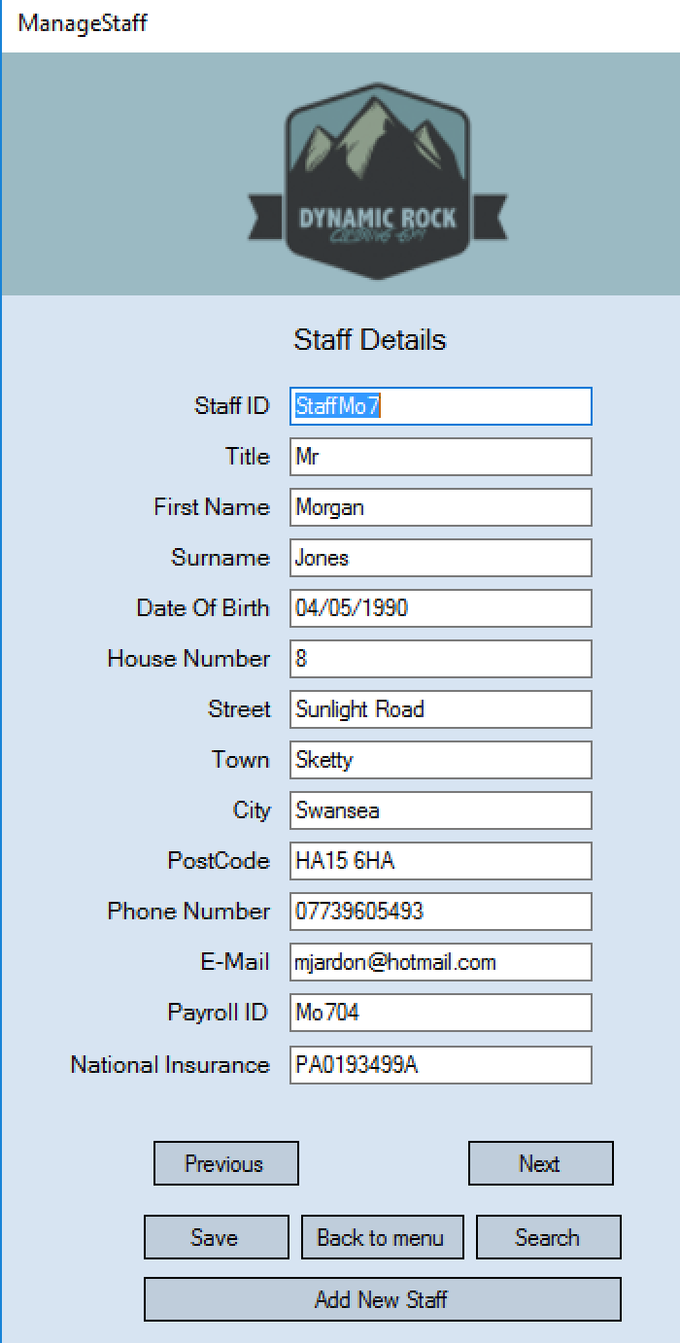
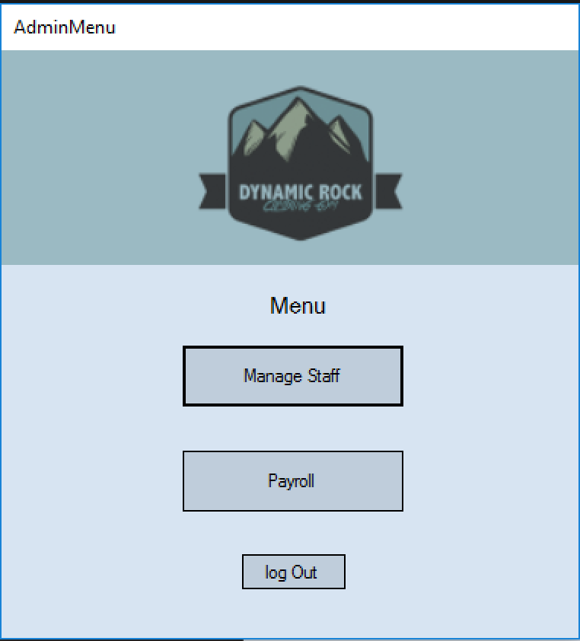

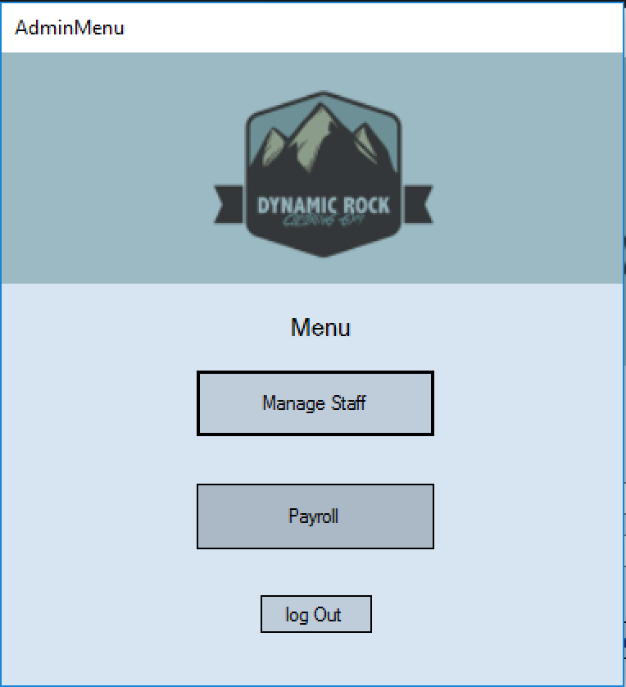
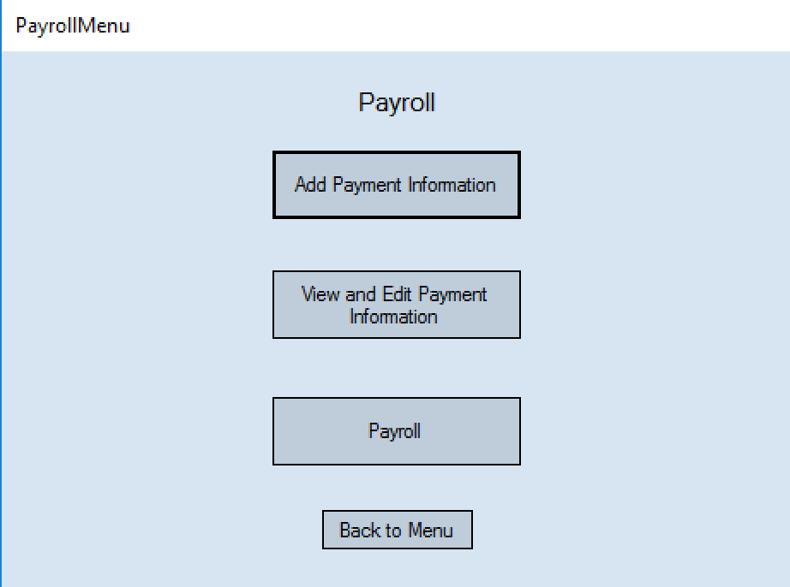
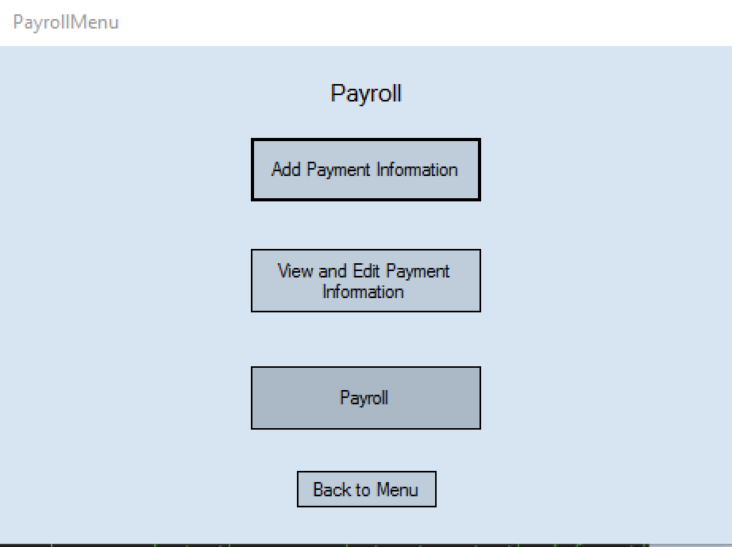
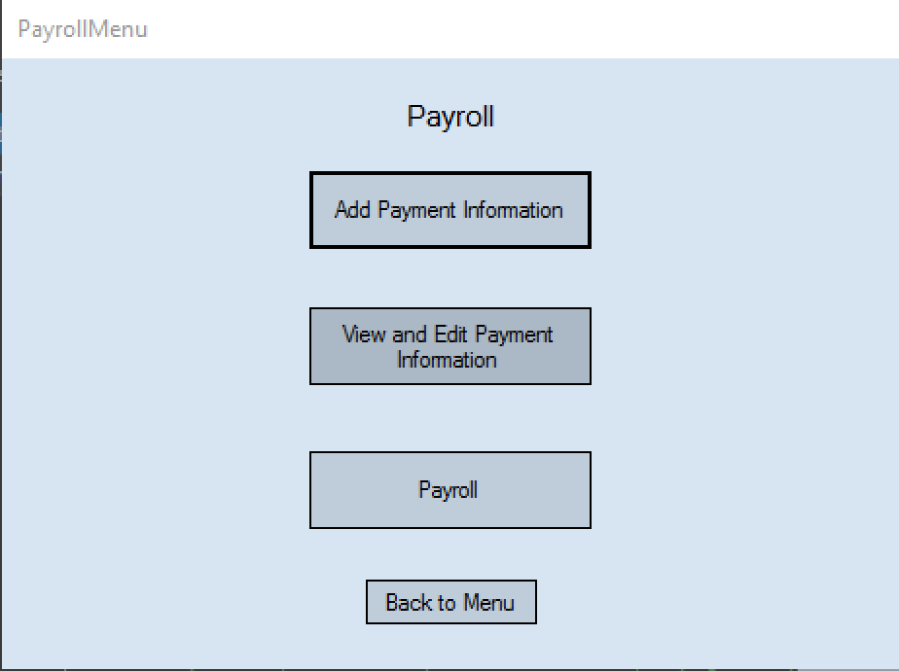
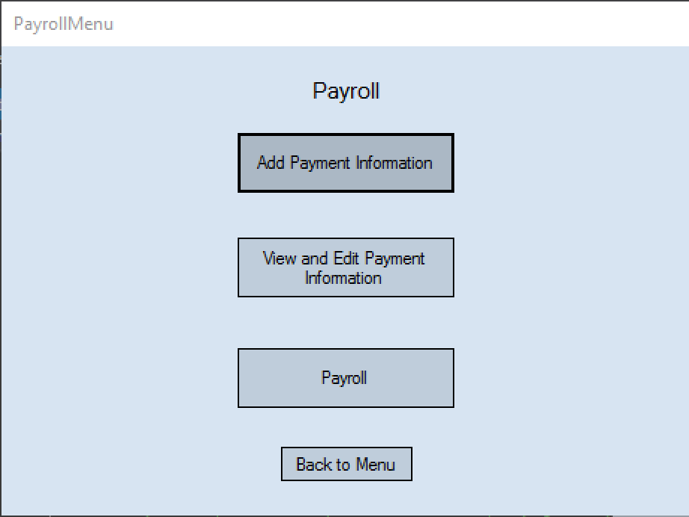

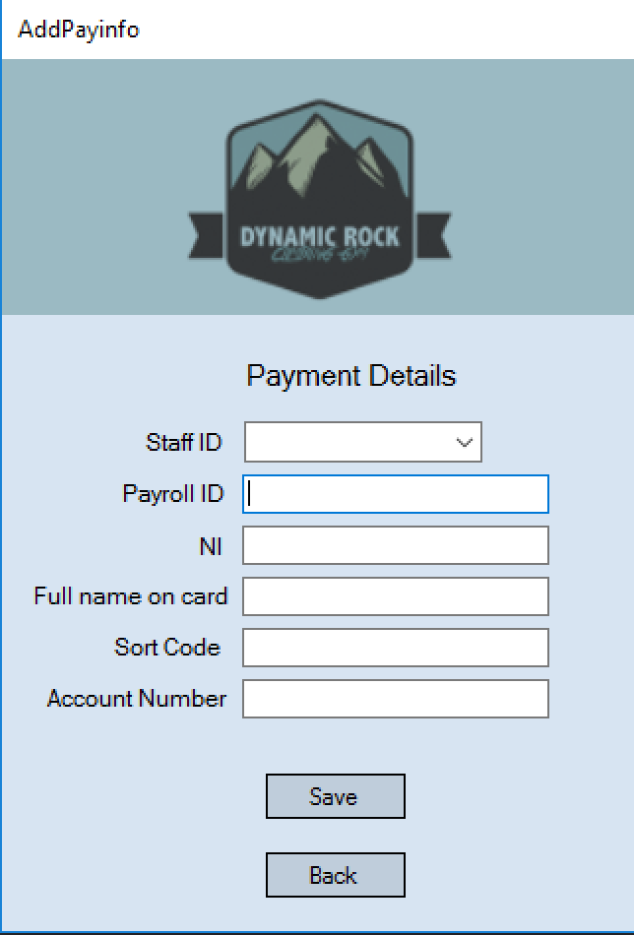

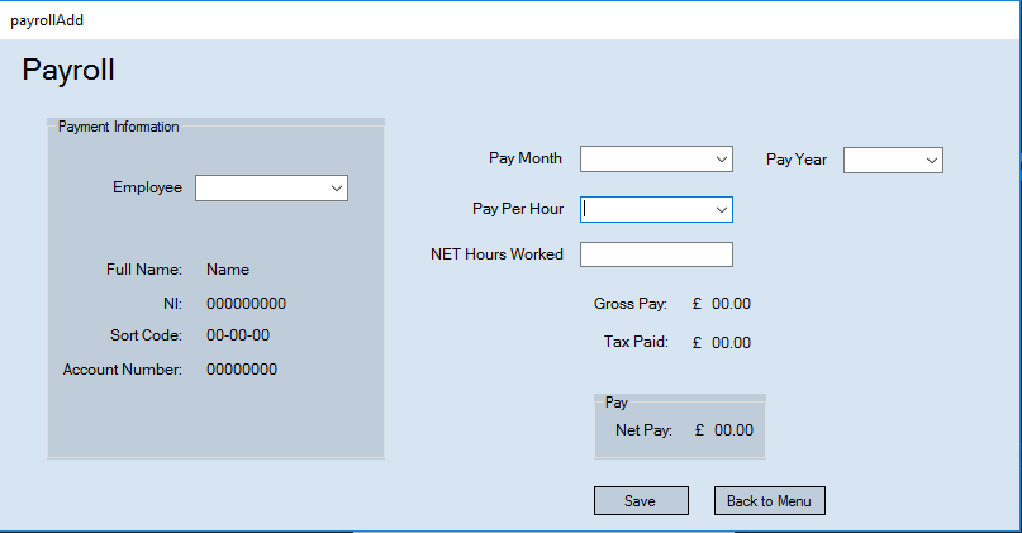
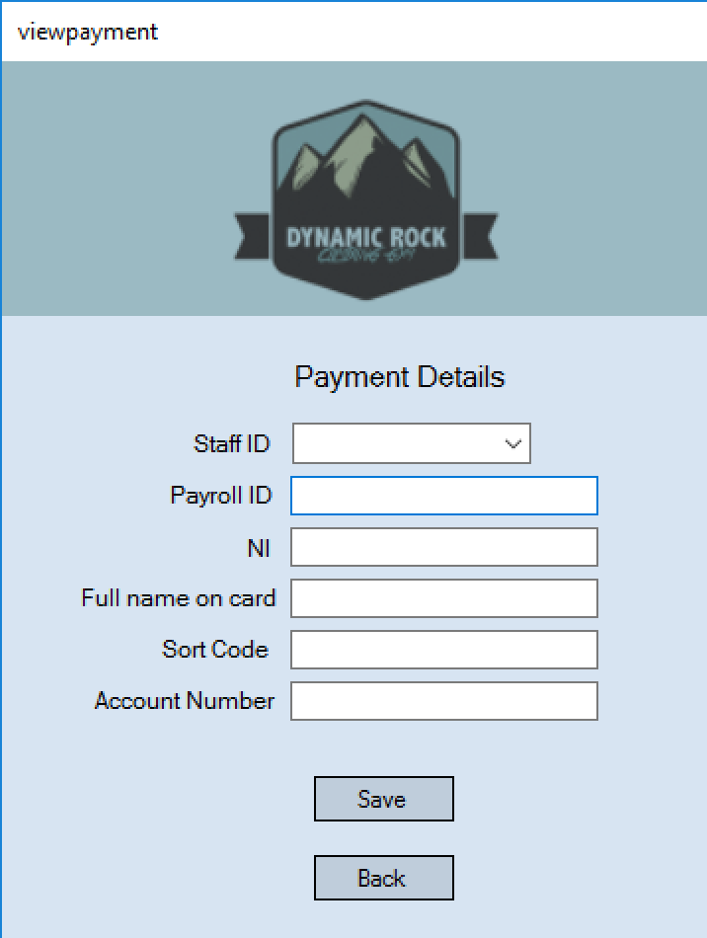

All buttons work correctly as seen above and navigate to all the correct menus. I also tested the back to menu and back buttons and they all return to previous forms as correctly stated.

Test 21
I am now going to test the next and previous buttons on the manage staff form to view staff details. I am going to test this by looking in the staff details file to see the staff details and pressing next and previous to see if the correct details are displayed.
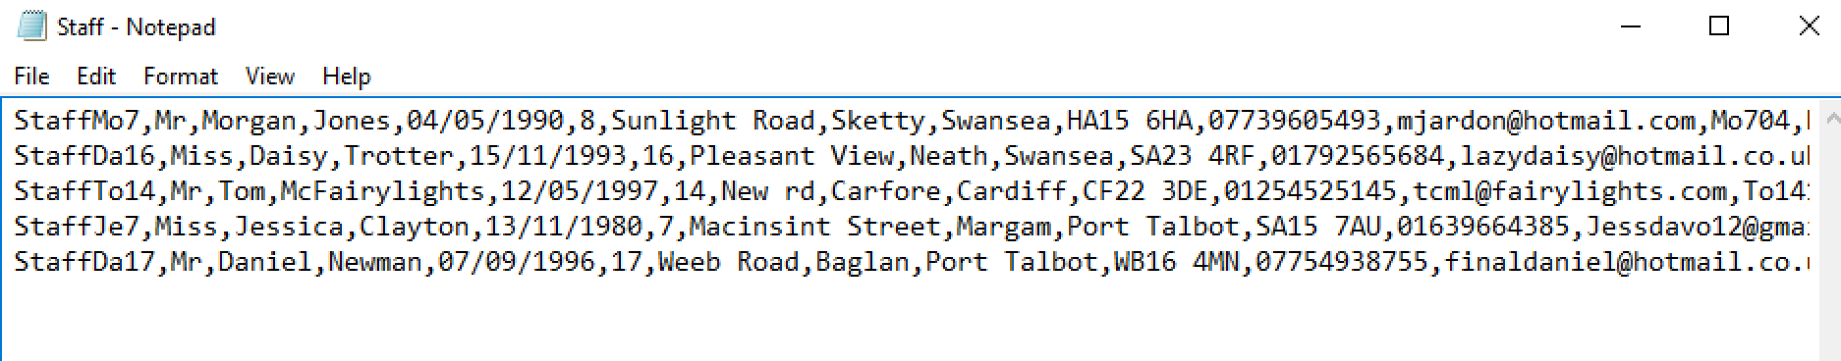
I am now going to press next to see if the records loop back to the beginning.
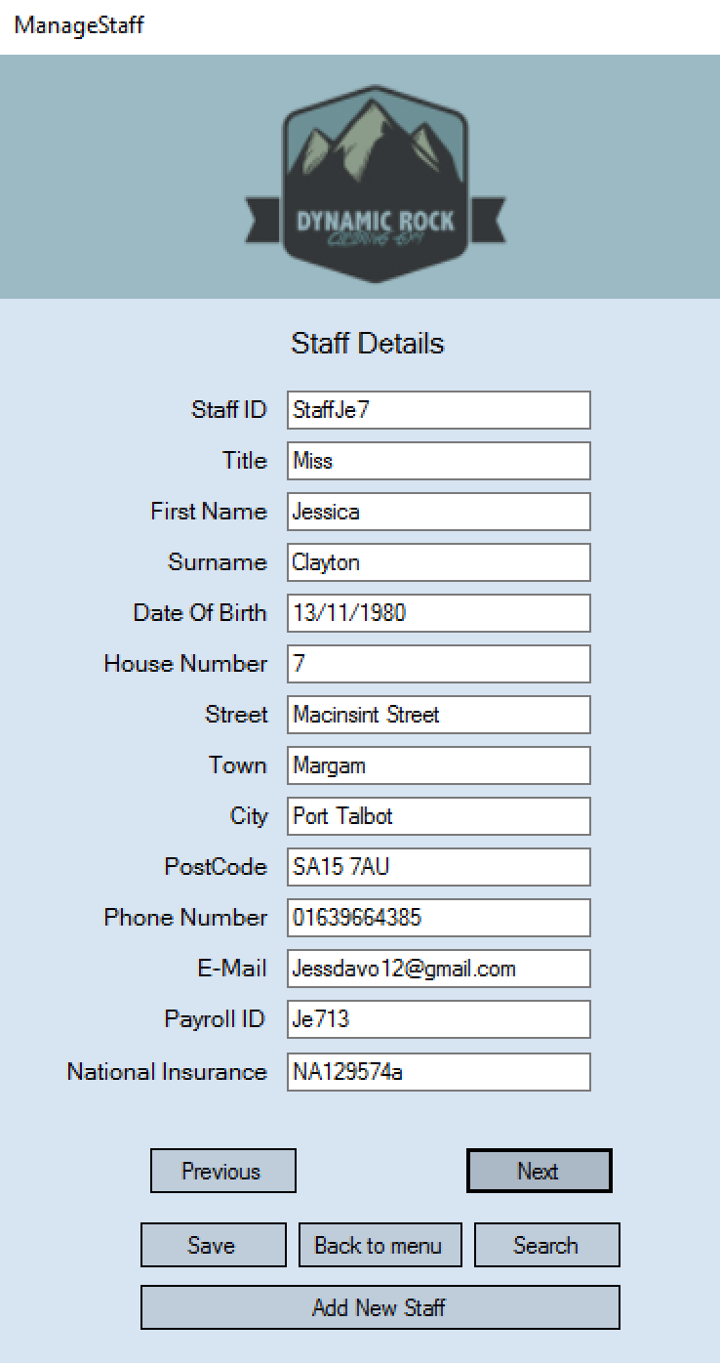
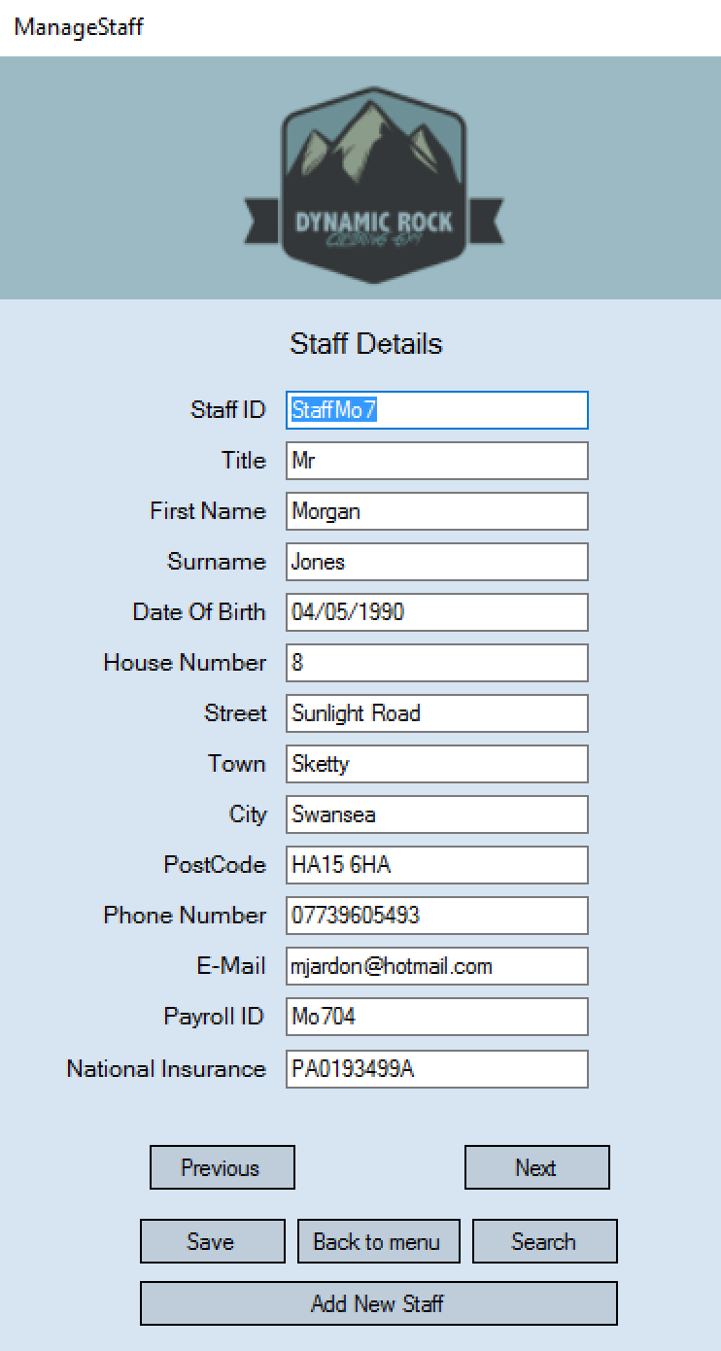
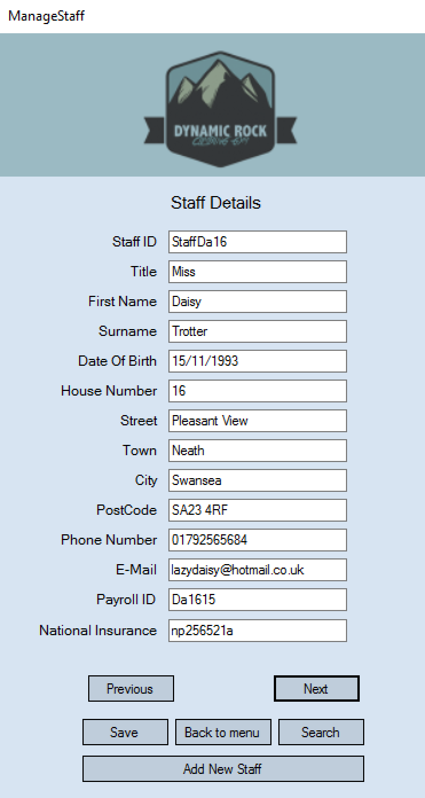
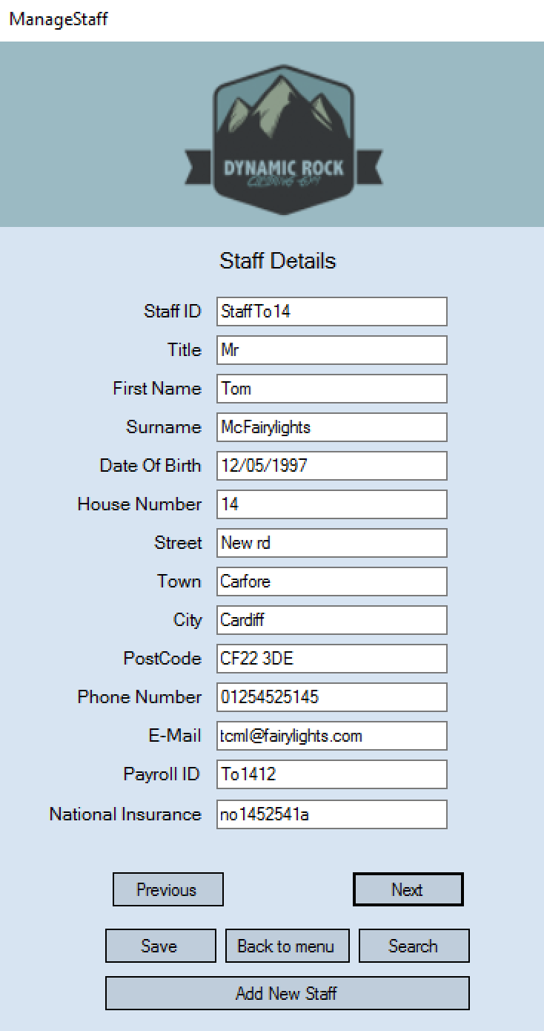
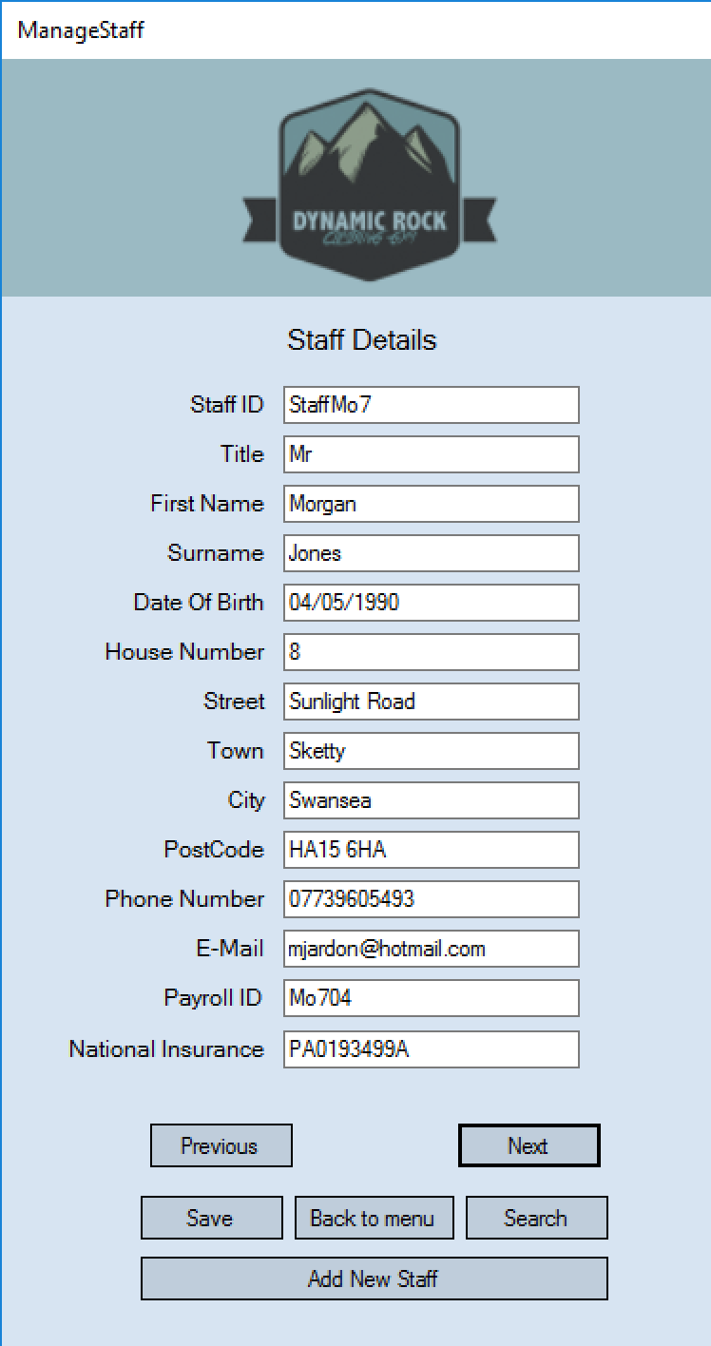
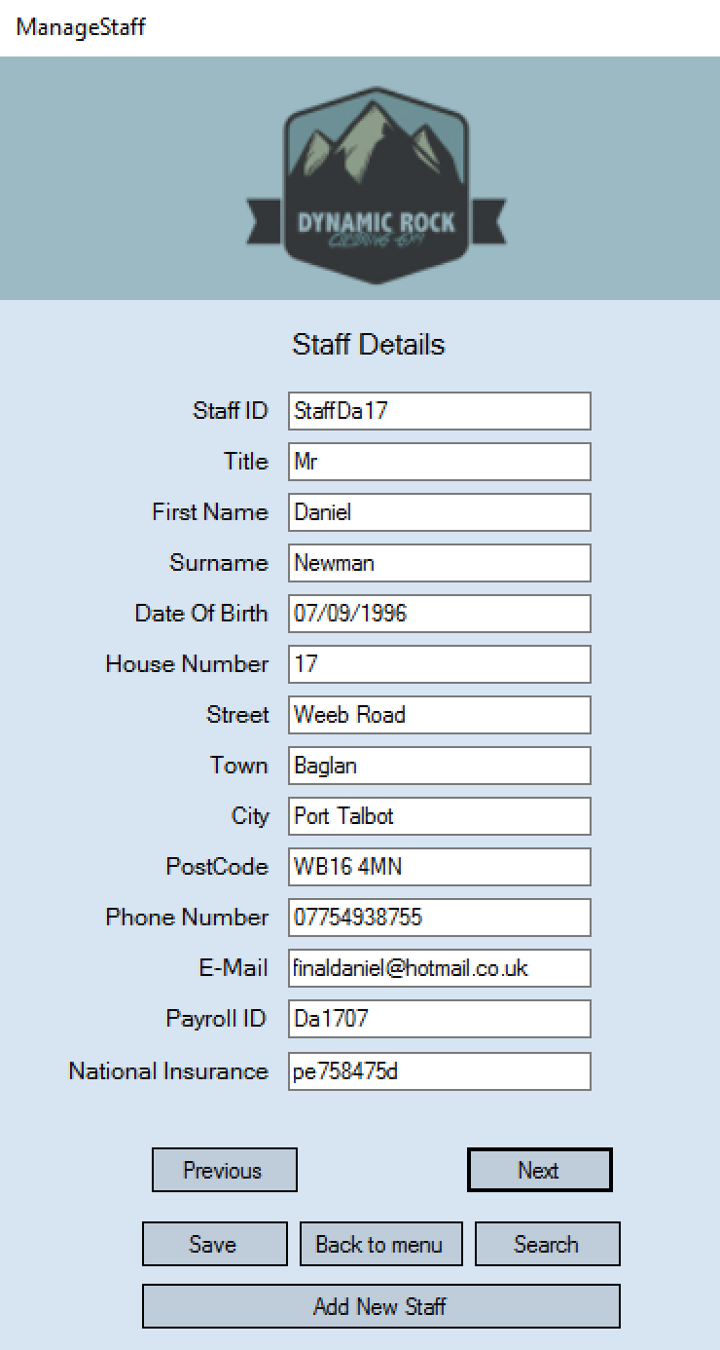

After pressing next through all the correct next records the first record was just displayed again. This shows the next button is working as it should be.
I am now going to press the previous button to see if it works correctly.
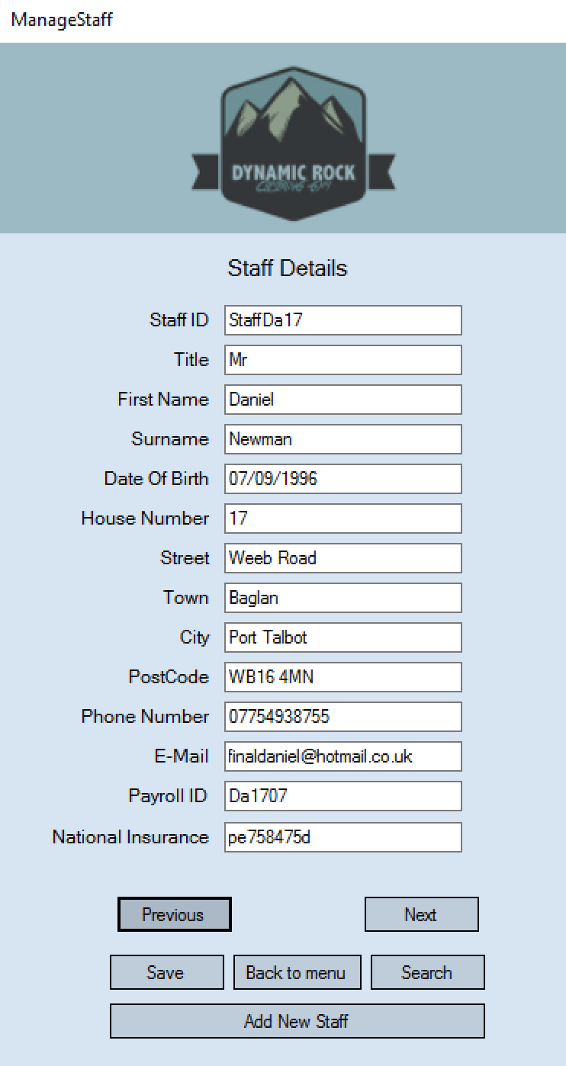
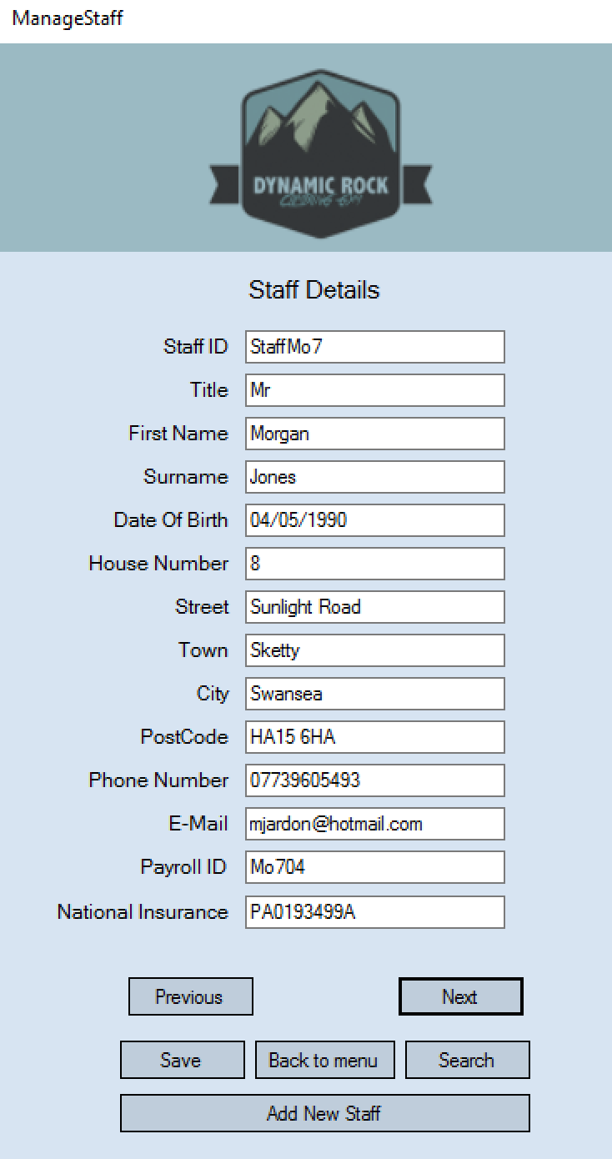

Once I pressed previous, the previous record was correctly displayed. This also shows that the file loops backwards as well. Therefore this test shows that the viewing all staff members works correctly.

Test 22
In this test I will be testing the edit/save function on the manage staff form. To do this I will change the house number of one record on the manage staff form and make sure its changed in the file after.
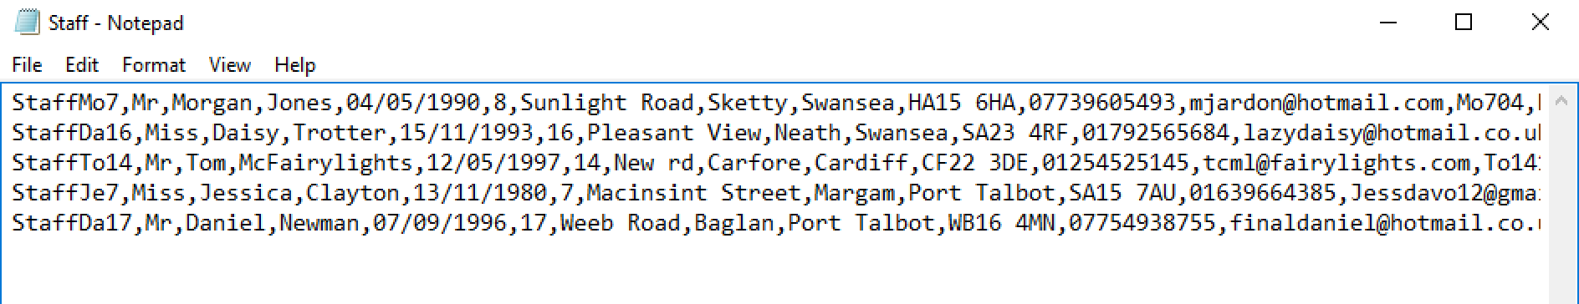

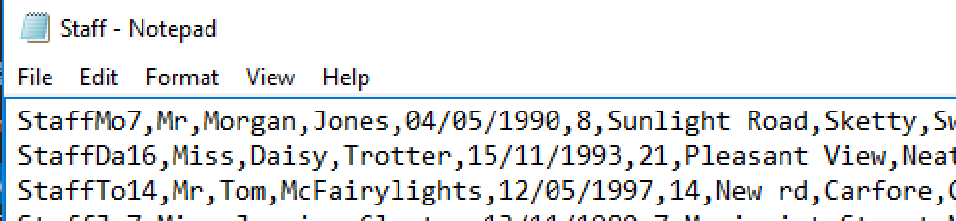
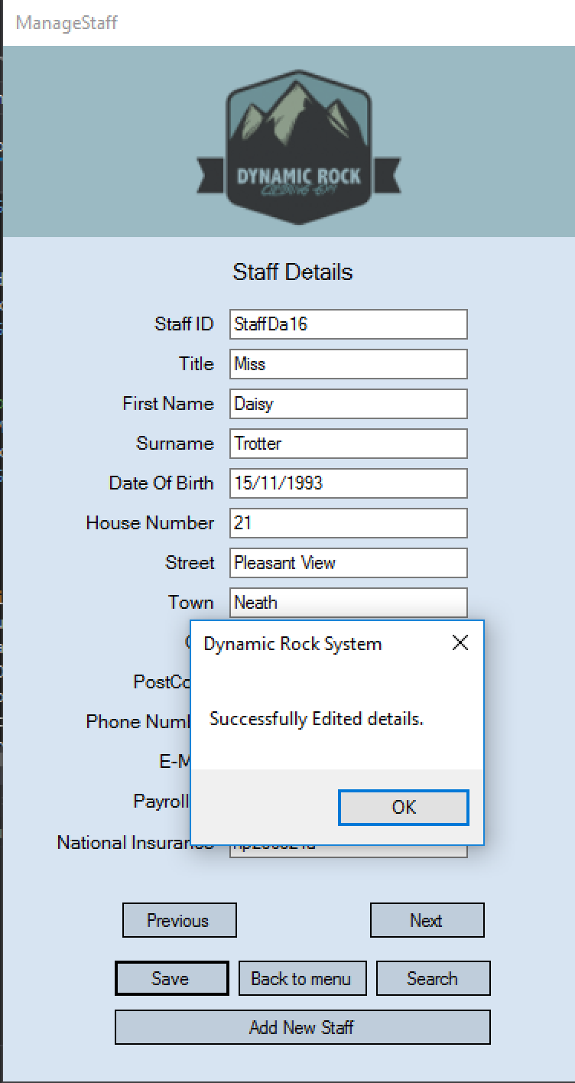
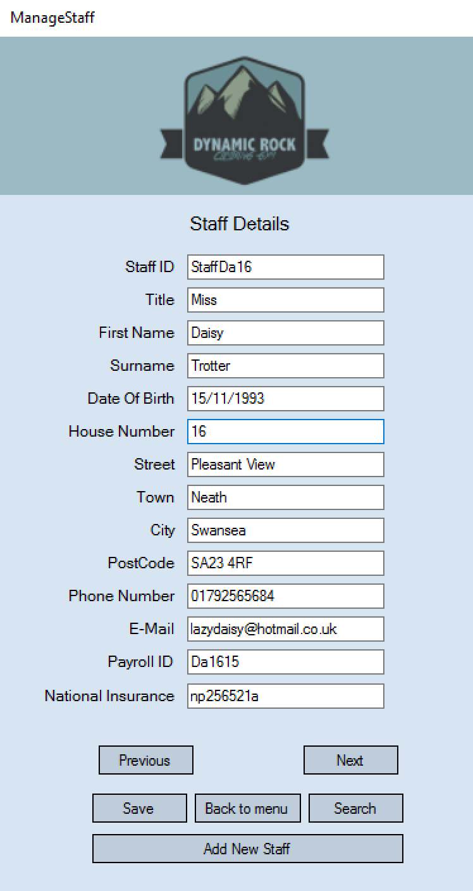

As seen above I changed Daisy Trotters house number from 16 to 21 and it saved perfectly in the staff details file.

Test 24 + 25
I am now going to test the search button/feature on the manage staff form. To test this I will click the search button and enter a staff members first and last name and see if the record is displayed.
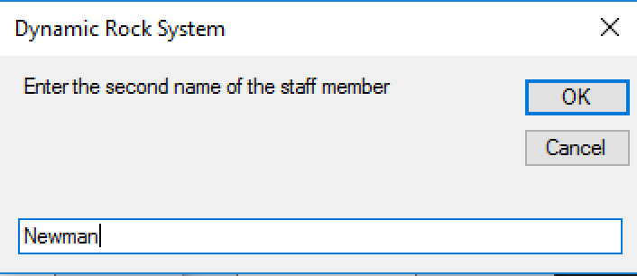
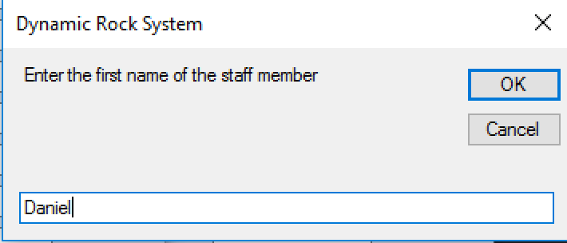

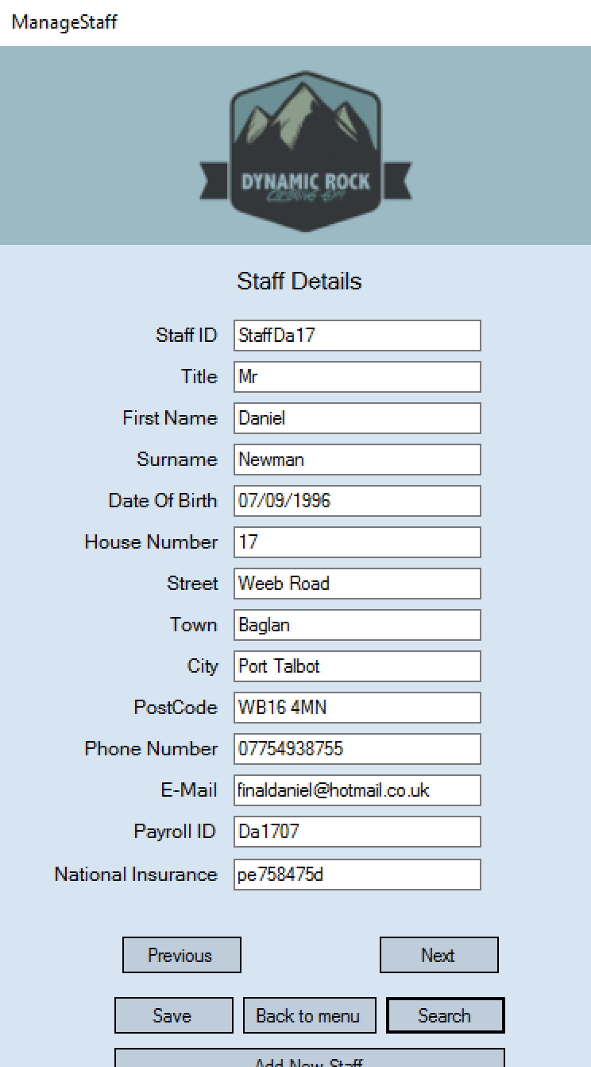

The search was successful and displayed the correct staff member’s details. I am now going to type in to the search boxes names of a non-staff member too see what is displayed when a record is not found
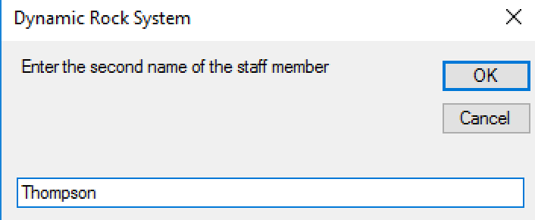
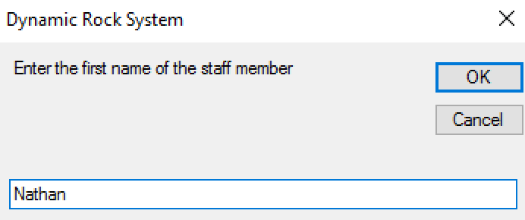
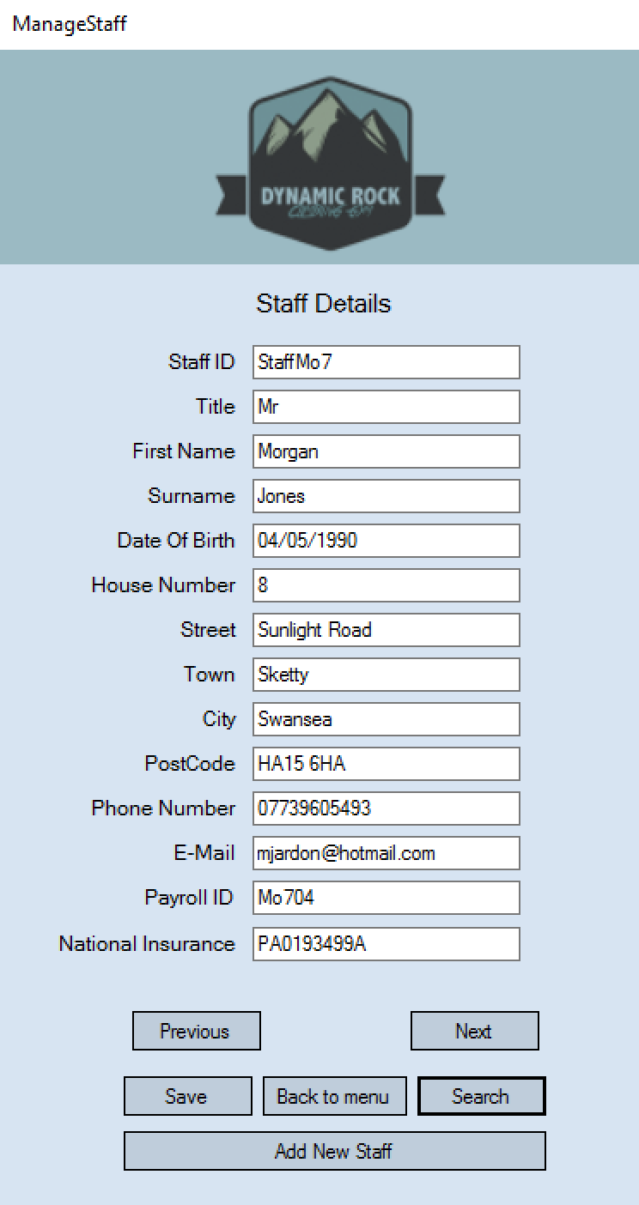

When a record is not found then the current record displayed before searching just stays being displayed. These tests have shown that my search function works correctly.

Test 26
I am now going to test if the add new staff button on the manage staff form does open the add new staff form. To do this I will press the button and see what is displayed.
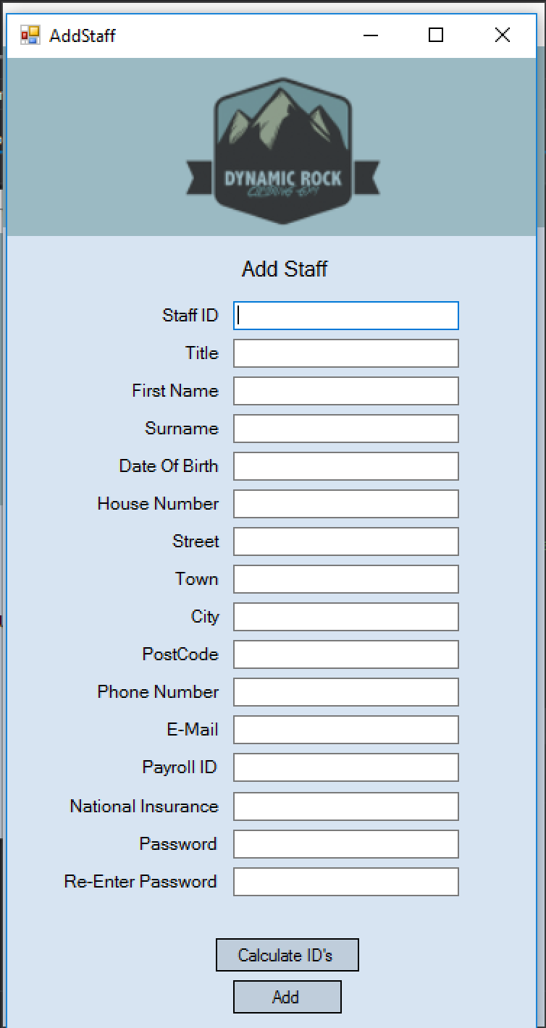
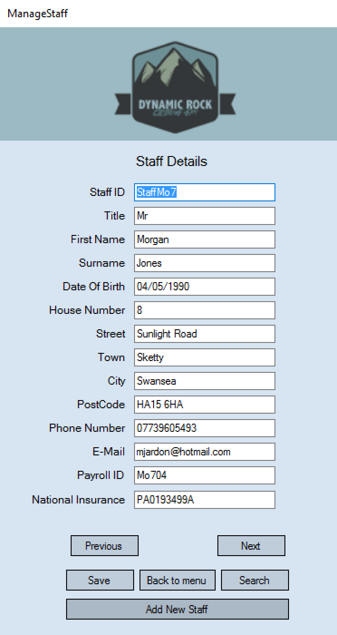

The Add New Staff form was correctly opened when the button was selected.

Test 27
In this test I am going to test the double entry verification used on the password fields on the add new staff form. I am going to do this by first trying passwords that don’t match and then passwords that do.
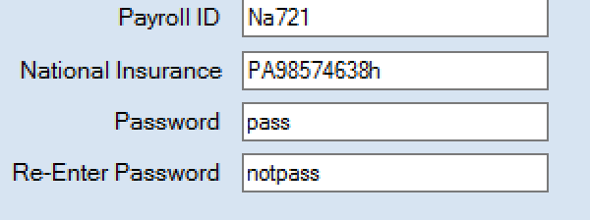

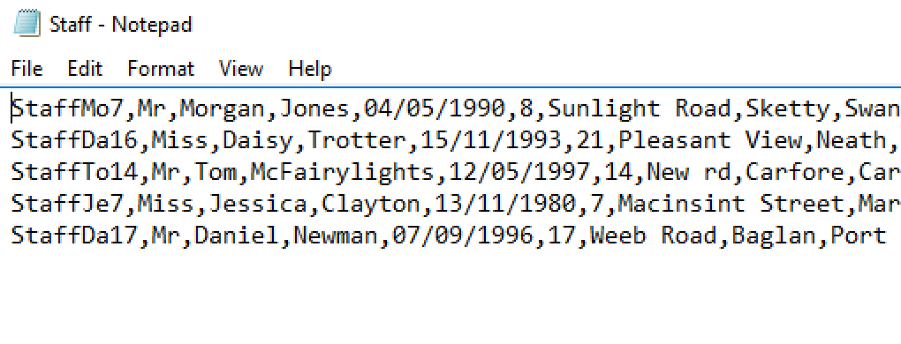
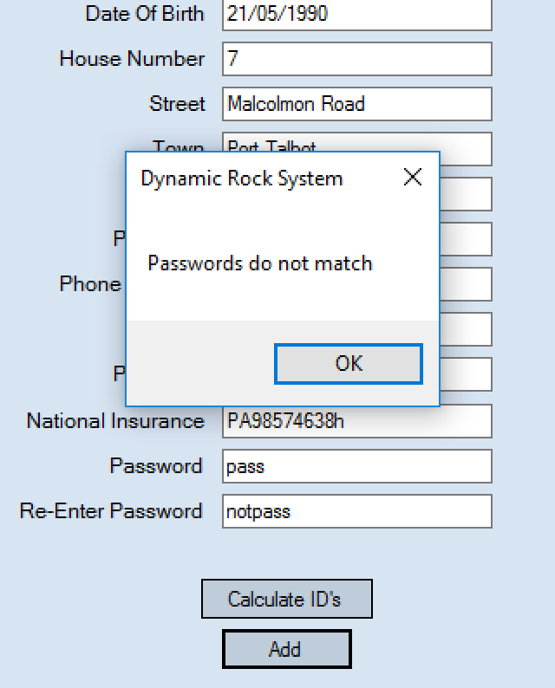

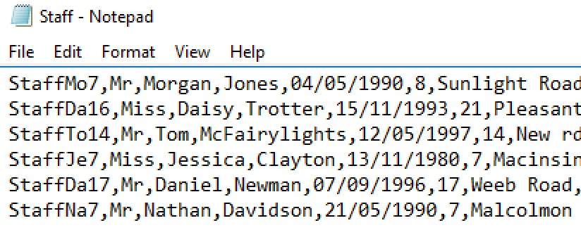
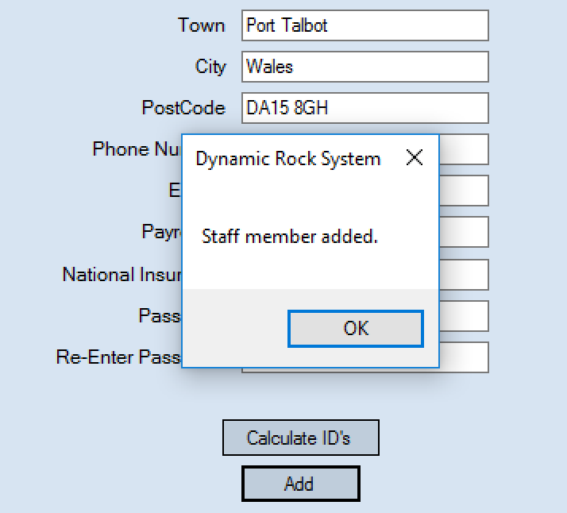
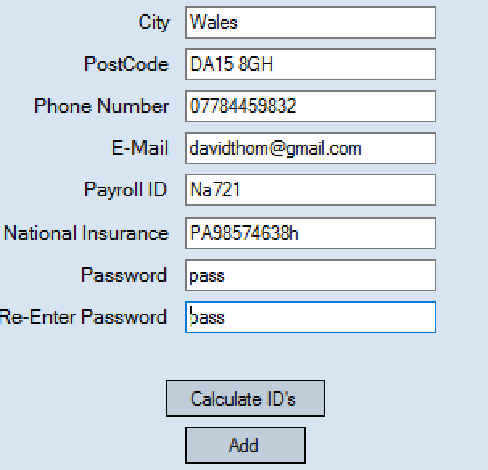
The passwords that do not match were flagged and a message box appeared to inform the user. I checked the staff file and the record was not saved either.

As seen above when the passwords did match the record was successfully saved.

Test 28 +29
I am going to test the length validation checks I have used on the add staff form. The first I am going to test is the check on phone number that has to be 11 characters long. I will test this by entering valid and extreme data.
10 characters
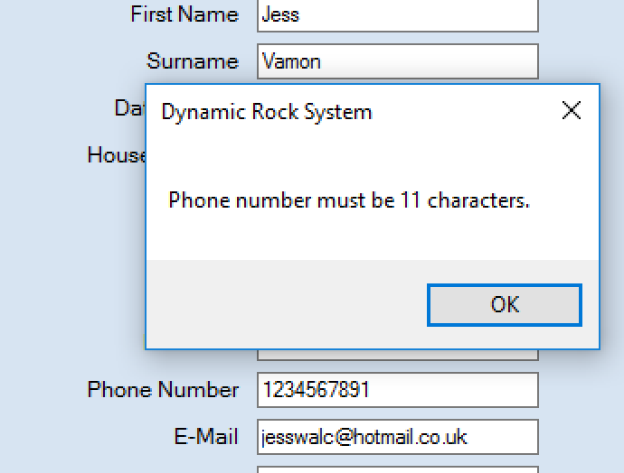

12 characters
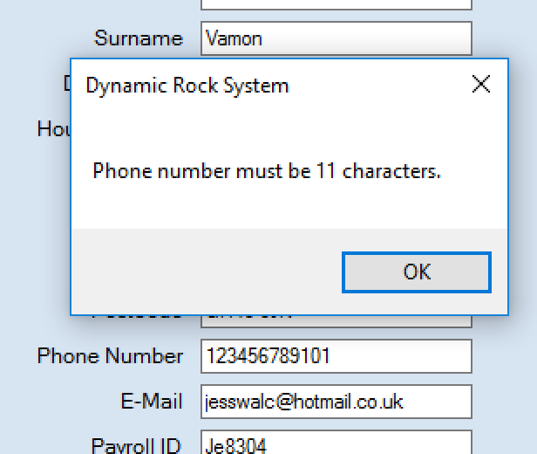

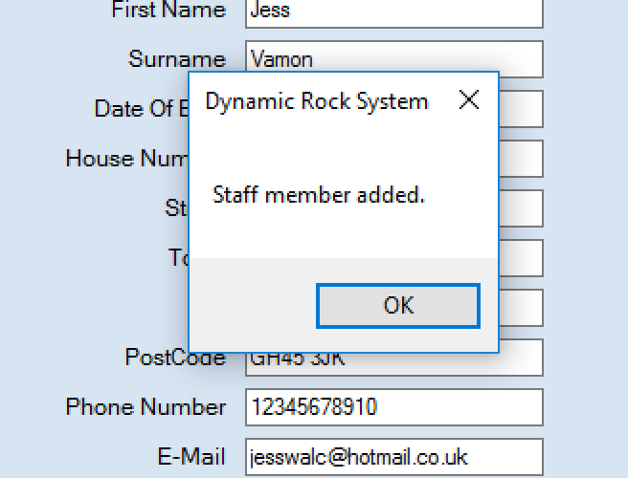
11 characters

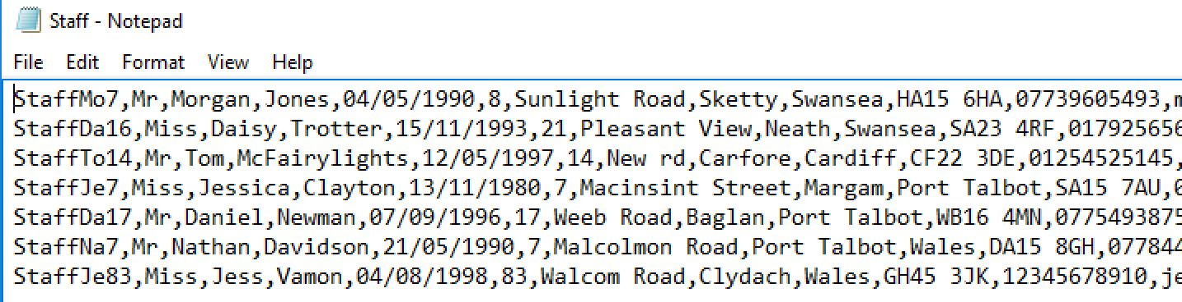

Here it can be seen that my validation on the phone field does work and only saves when the phone number is 11 characters long.
I am now going to test the length validation on the NI number the same way as I did with the phone number. The NI has to be 9 characters long.
8 characters
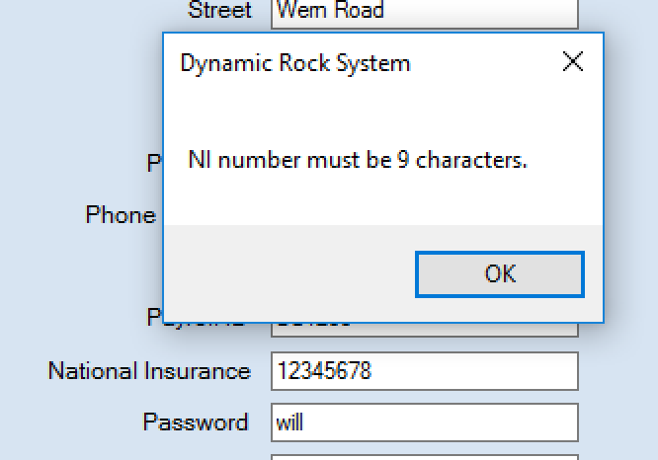
10 characters
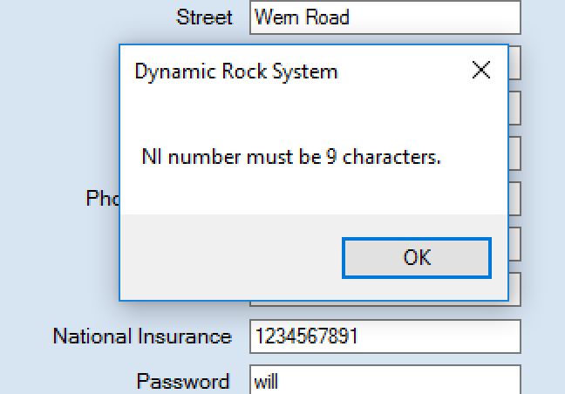
11 characters
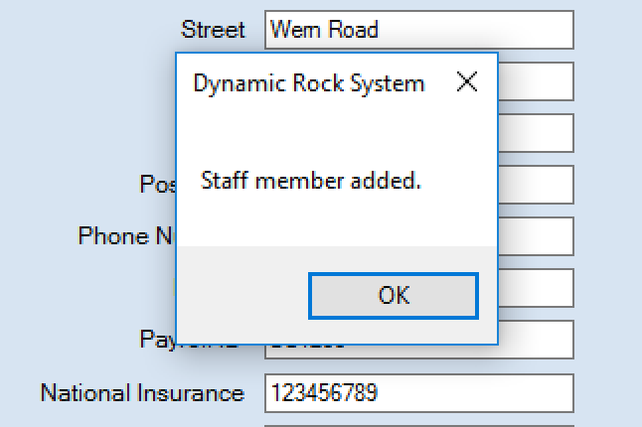

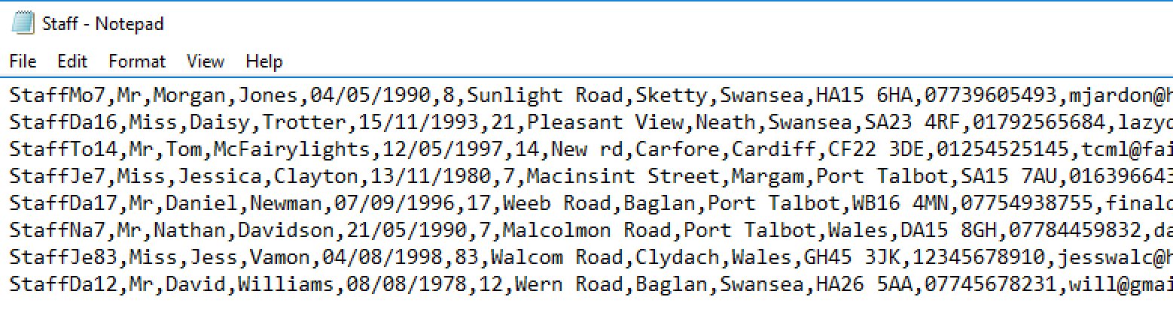
The staff details are only saved when the NI number is 9 characters long. This shows that my length validation is working correctly

Test 30
I am now going to test that the ID’s are calculated correctly when pressed. To do this I will fill in the new staff form and press calculate ID.
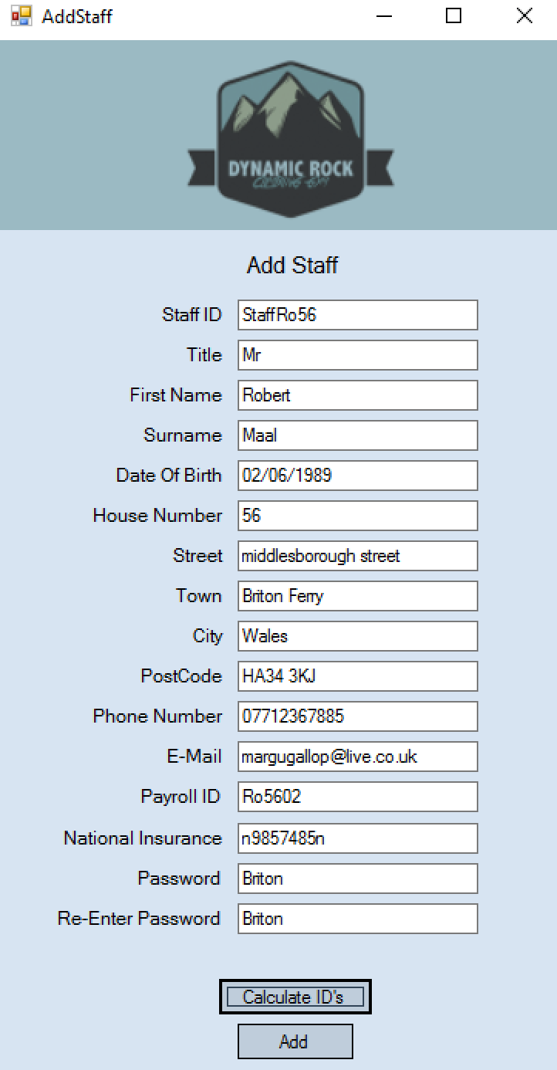
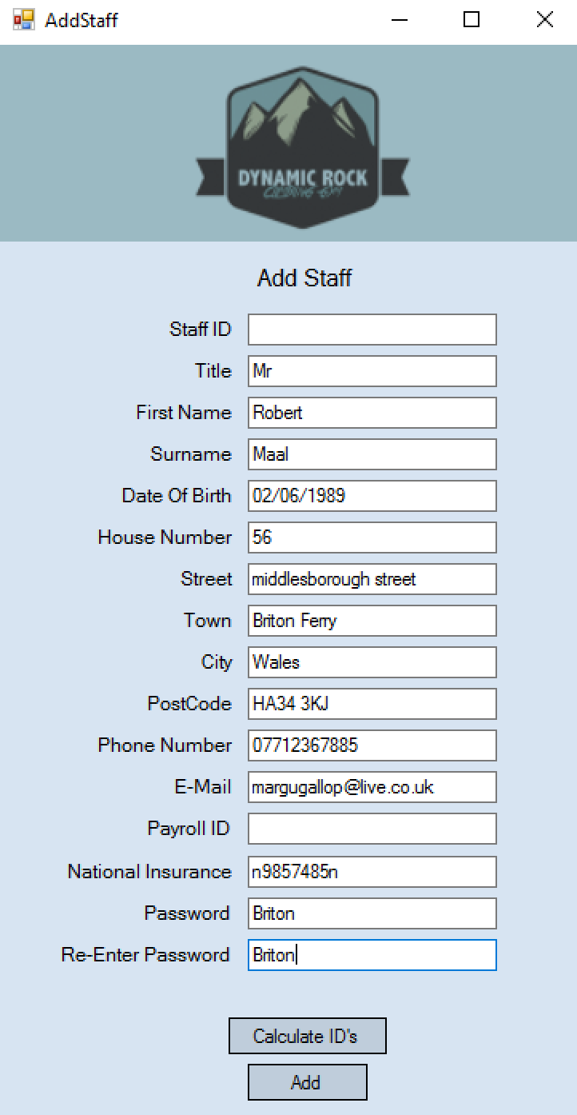

This test shows that the ID’s are calculated uniquely and correctly when the calculate id button is pressed one the other required information has been entered.
Test 31
I am now going to test to see if the search works correctly on the add payment details form. I will do this by selecting a staff member from the combo box and seeing if the search is completed.
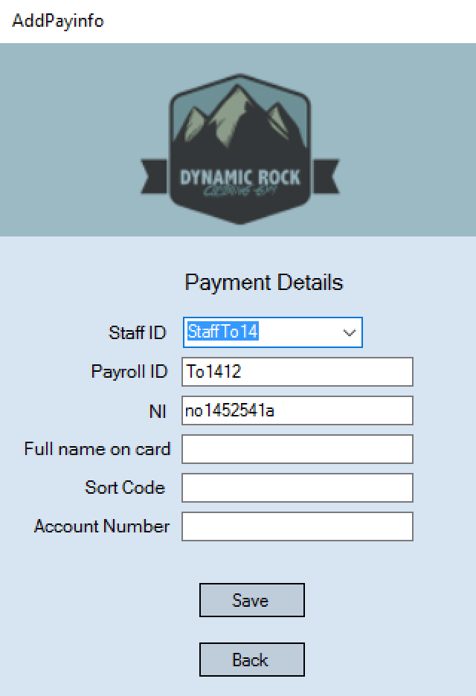
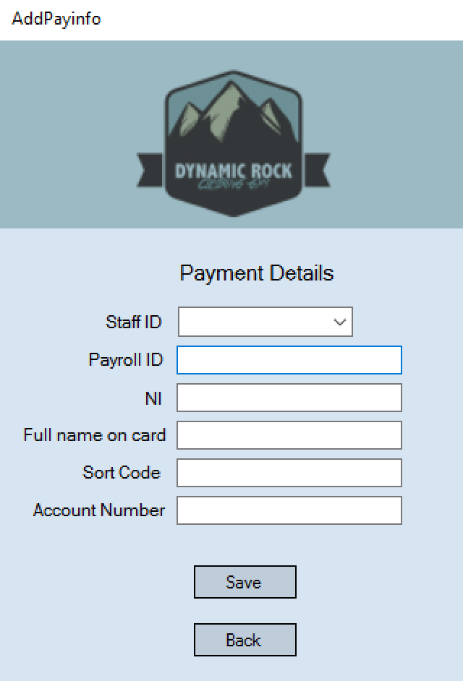
Once I had selected a id from the combo box the search automatically performed and the Payroll id and Ni number was searched and displayed correctly.

Test 32
In this test I will complete the add pay info form for a staff member and see if it saved into the payment information file.
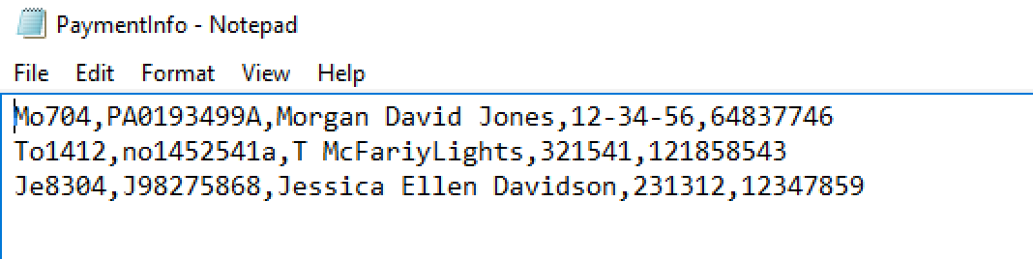
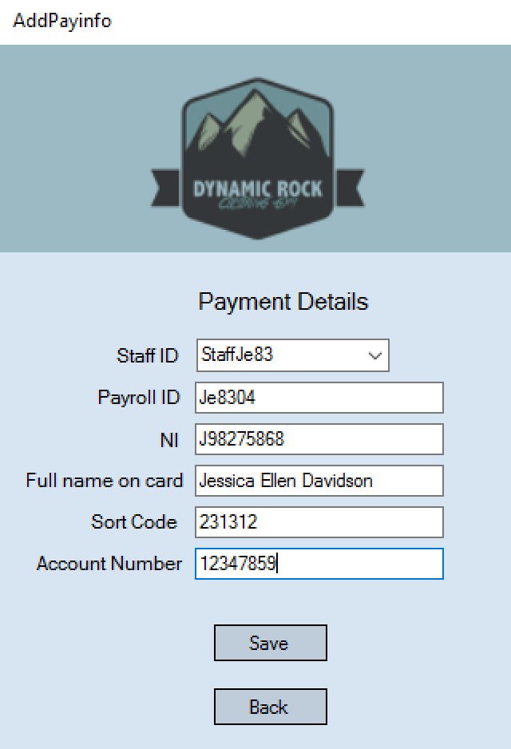

I have checked the paymentinfo file and the record was saved successfully.
On this form there is length check validation on the sort code and account number. It uses the same validation rule as the previous checks. I have tested these and they work corrects with the sort code only allowing 6 characters and account number using 8 characters.

Test 34
This test is to test if the search works to view payment details on the view payment info form. To test this I will select a staff id from the combo box and see if the search if performed automatically to display that staff members payment information in the following text boxes.
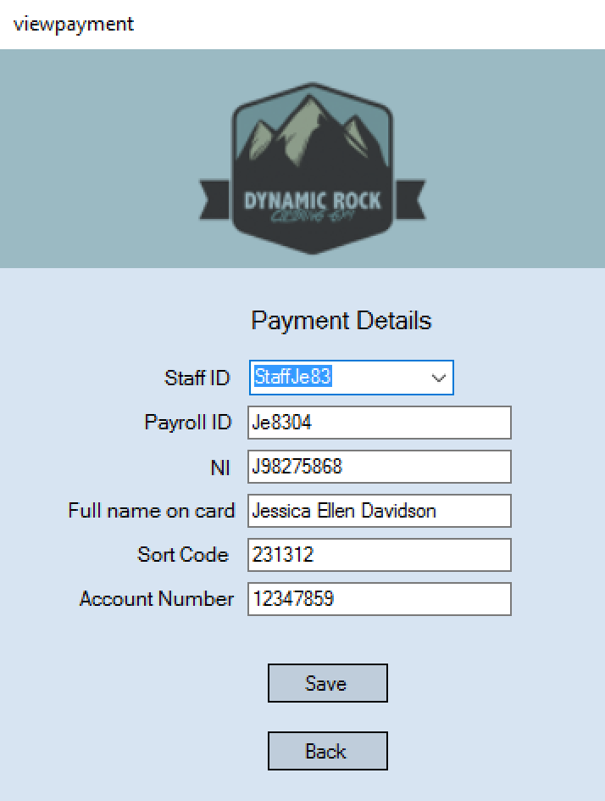
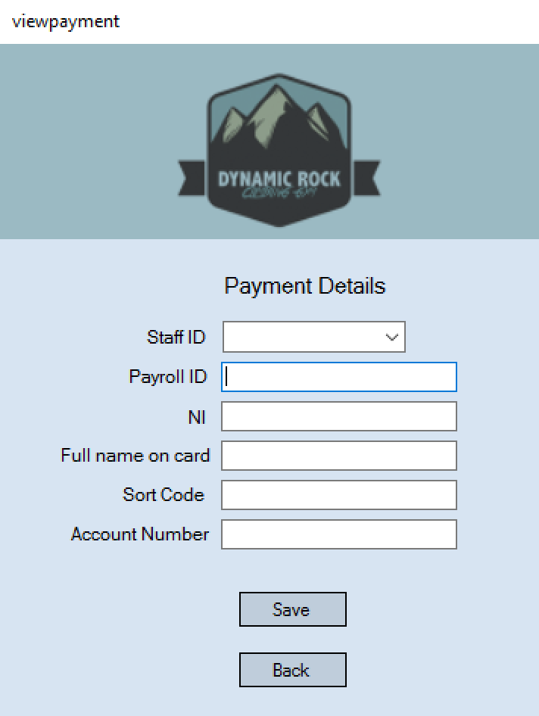

The search was successful and displayed the correct details automatically when an id was selected from the combo box.

Test 35
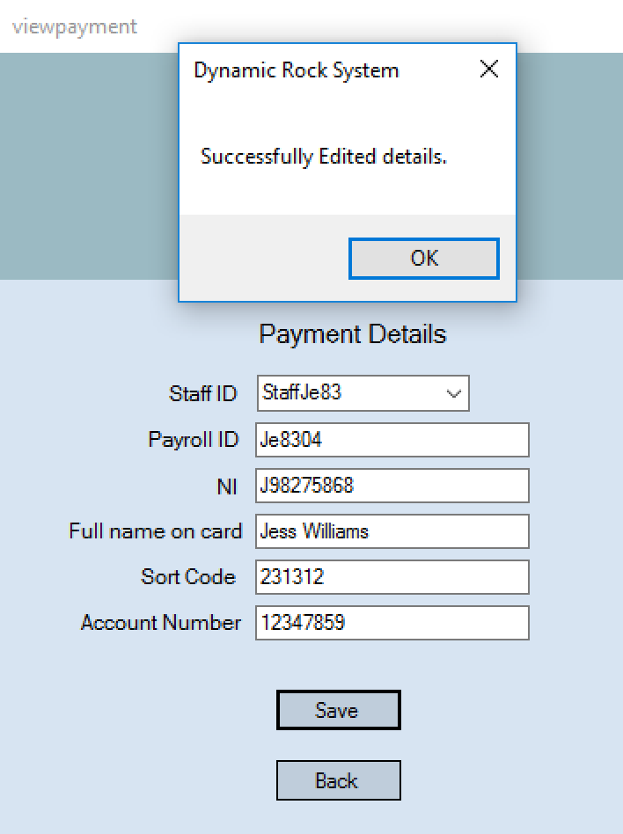
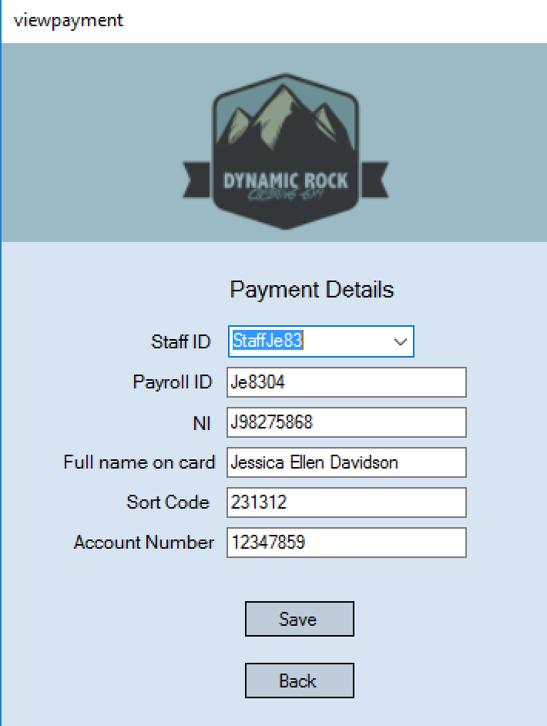
In the following test I am going to test to see if editing payment information is successful. I will do this by changing information of a staff member, clicking save and checking in the payment file to see if it has been changed successfully.

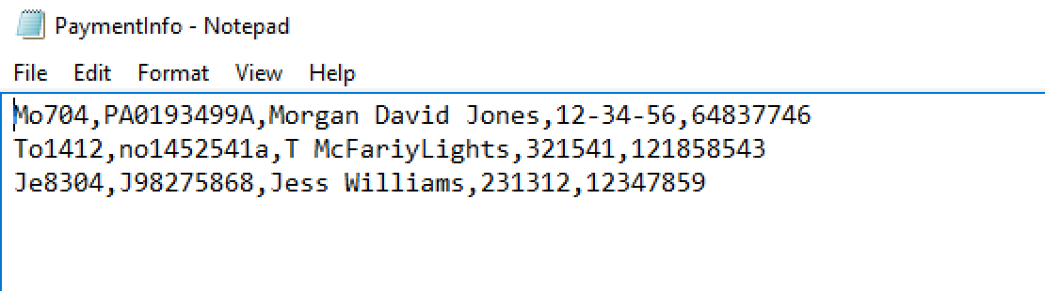
The payment information was changed successfully as can be seen above when I changed the name to Jess Williams.

Test 36
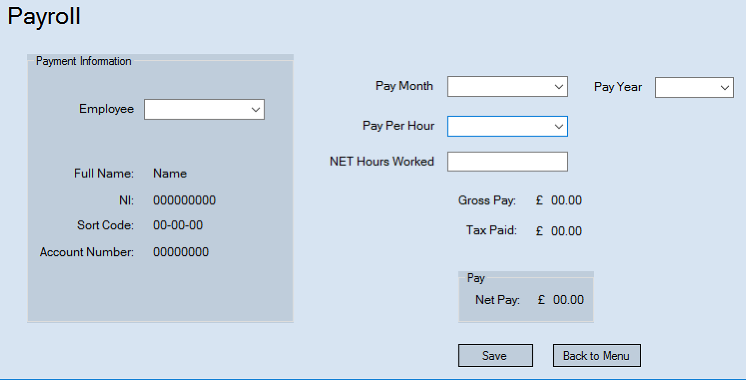
I am now going to test the employee search on the payroll form. I will test this by selecting an id from the drop down list and checking to see if the correct information is displayed.
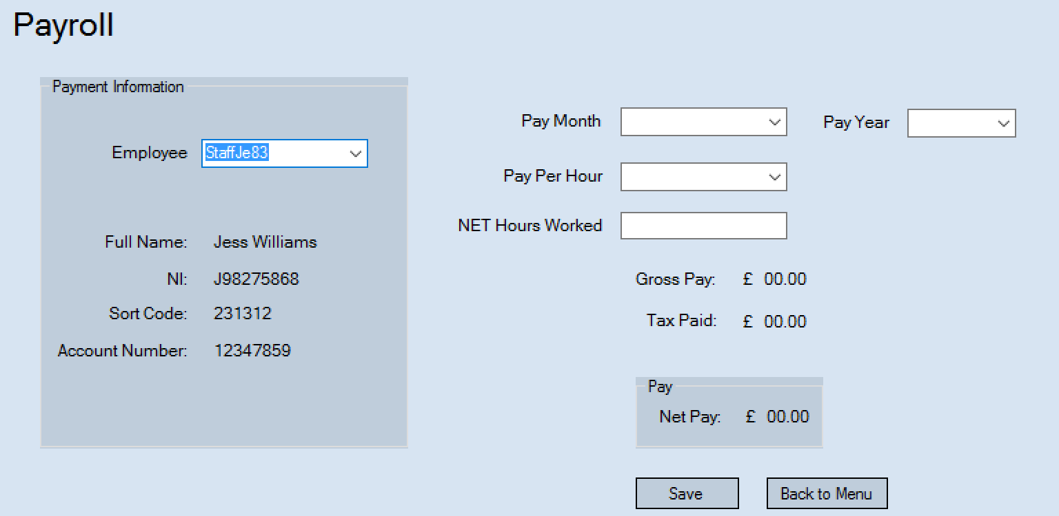

As seen above, when selected the search is performed automatically and the correct information is displayed if the labels below.

Test 37 + 38 +39
These tests will be to ensure that the combo boxes are populated with information. I will do this by clicking on the boxes and seeing what information they hold.
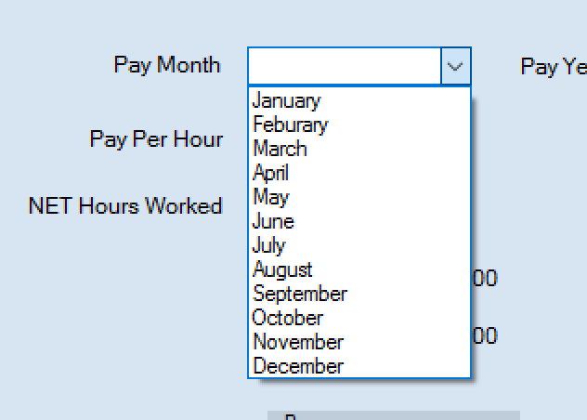
Pay month should have all the months on the year

Pay year should have some years in the future in it
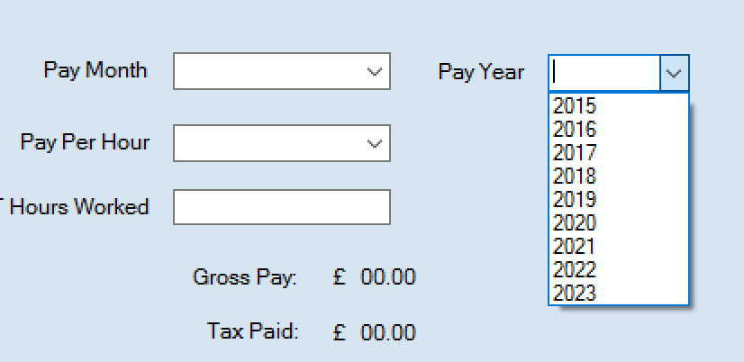
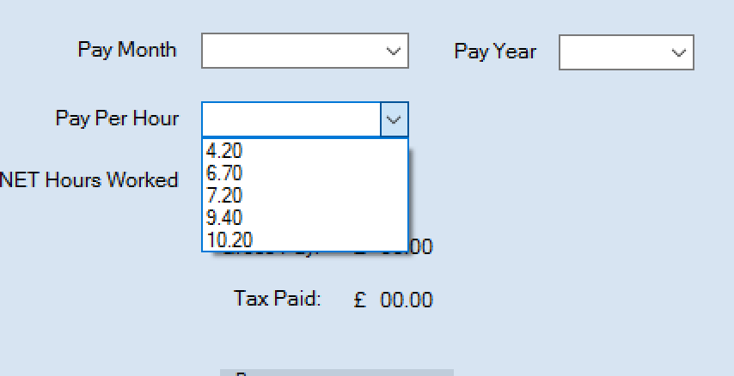
Pay per hour should have all dynamic rocks pay rates within

The combo boxes have all the correct information within them.

Test 40
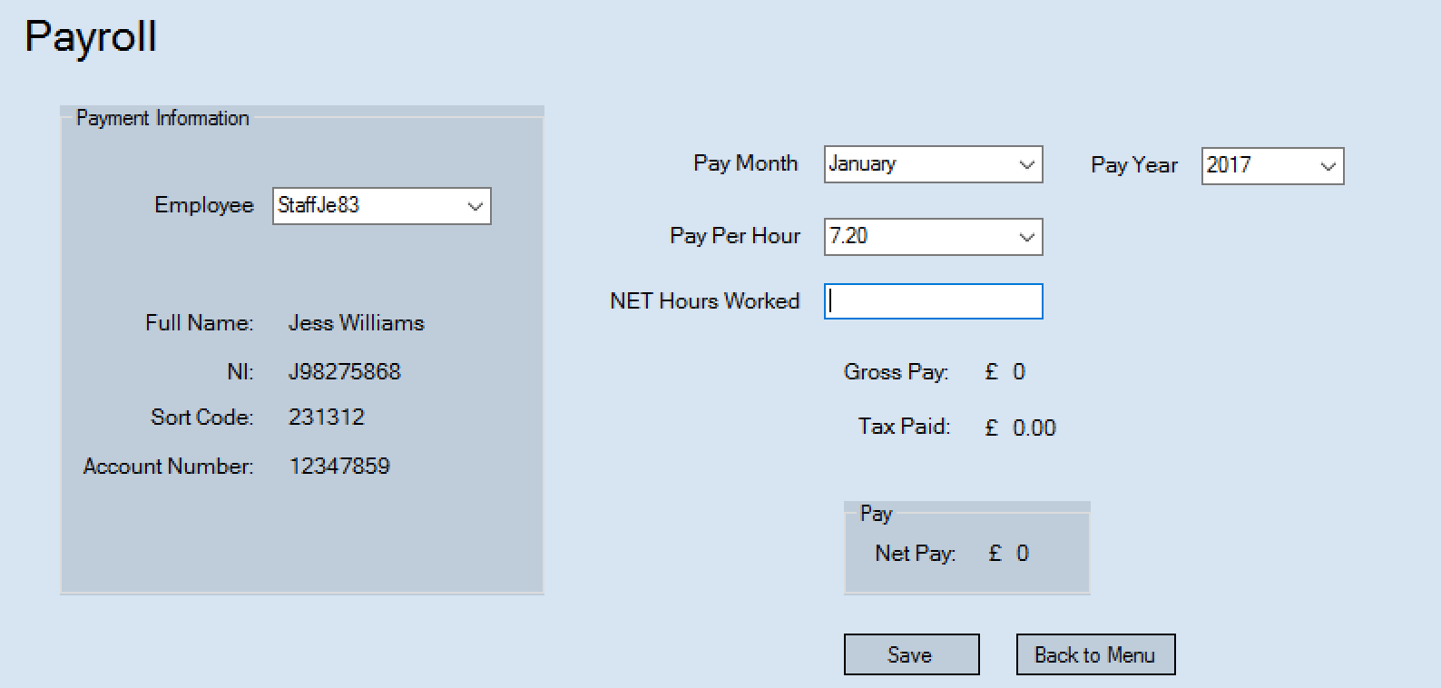
This test will be to ensure the calculations on the payroll form, work correctly. The calculations should automatically be worked out once the pay has been selected and the hours have been entered.

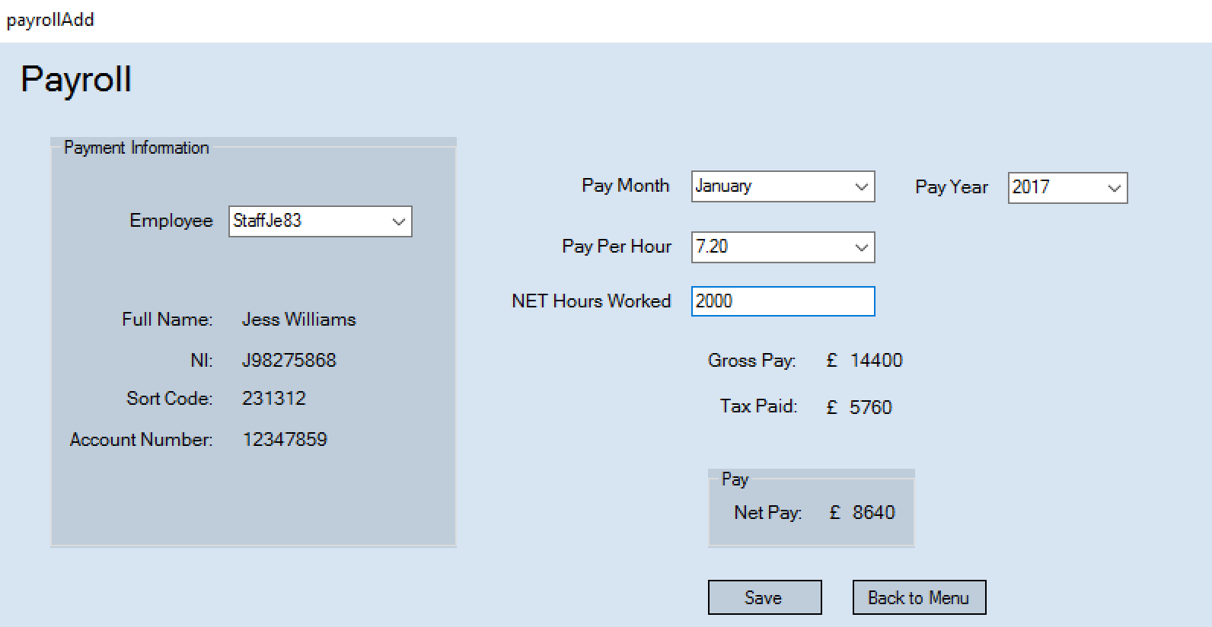

The calculations above worked out automatically once the hours worked had been entered.

Test 41
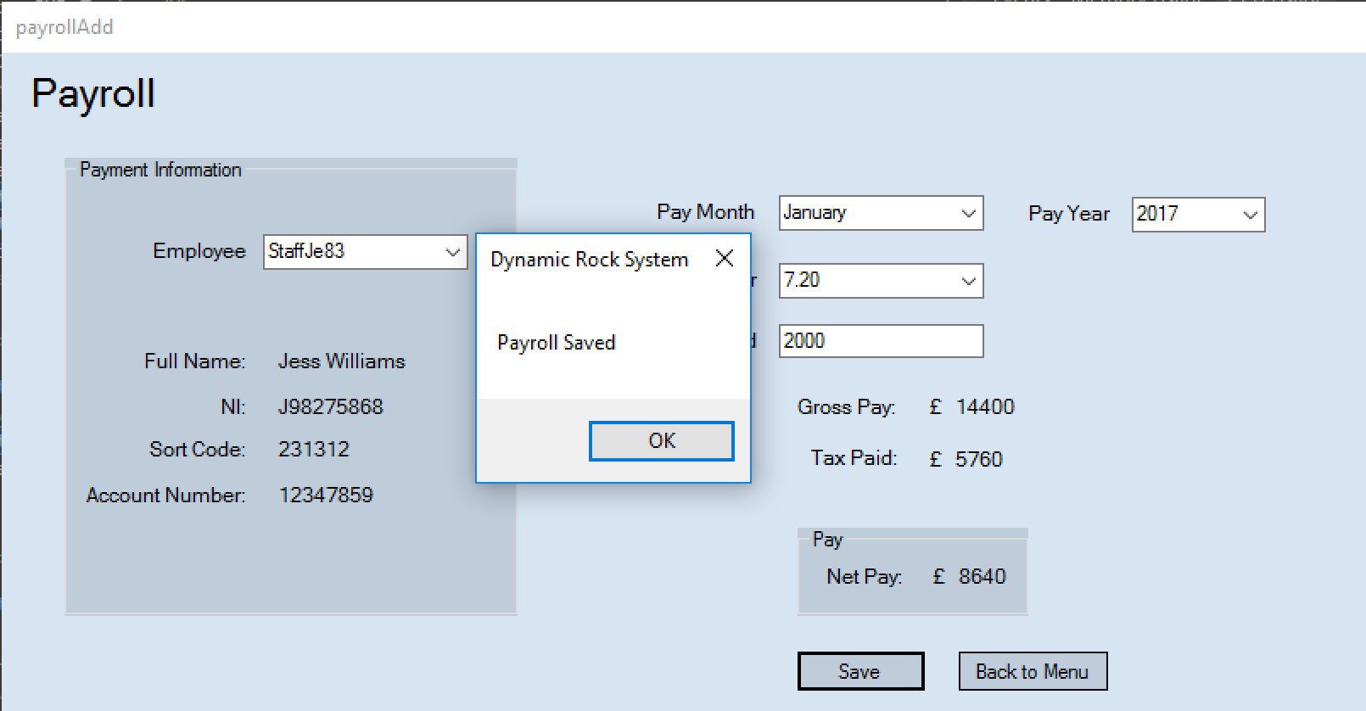
I am now going to test to see if the payroll data saves successfully. To do this I will save a record and check the file to see if its been added/saved.

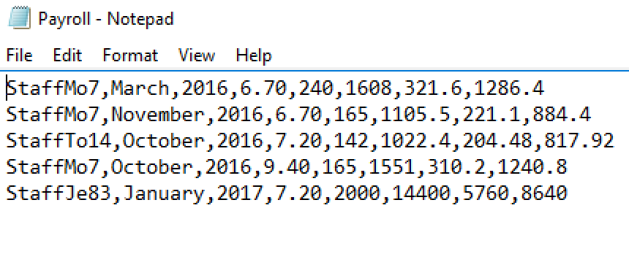
The payroll record was saved correctly. Therefore, the payroll form all works as designed and is successful.

Test 42
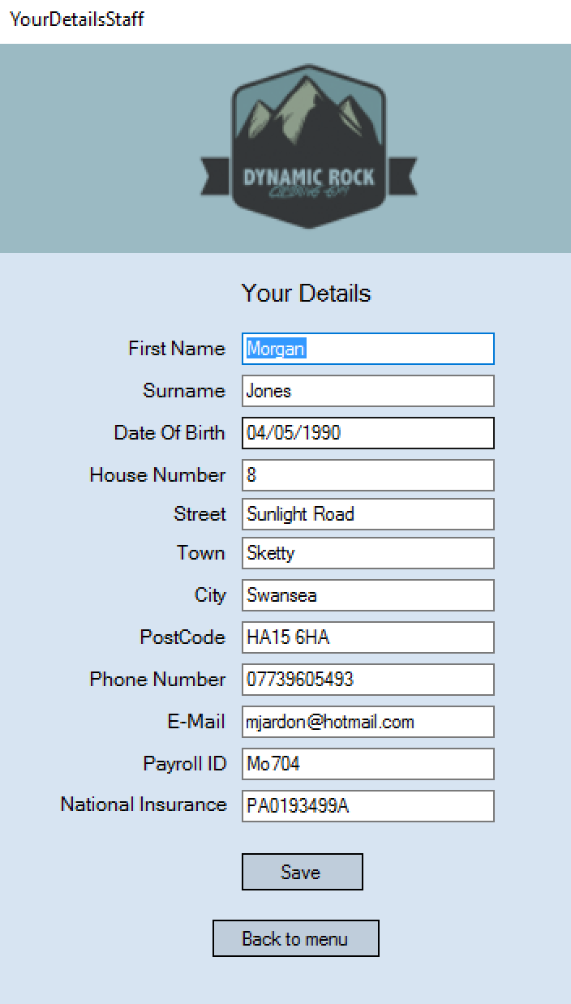
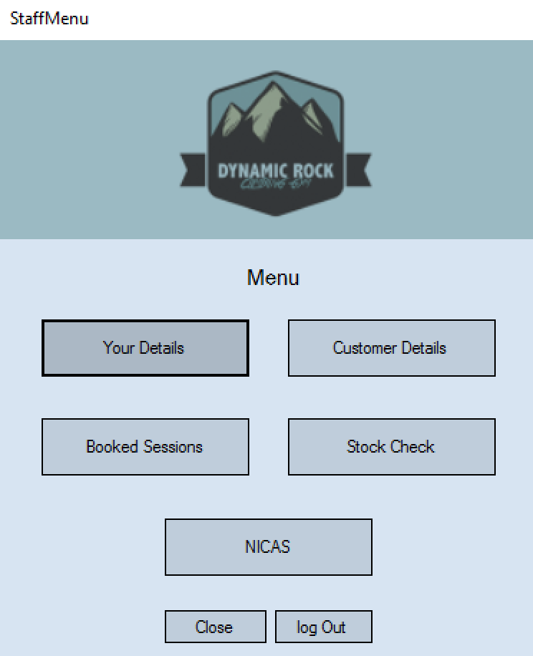
I am now going to check to ensure navigation around the staff menu and make sure buttons open the correct forms. I am going to test this by clicking each button and making sure it opens the correct form.

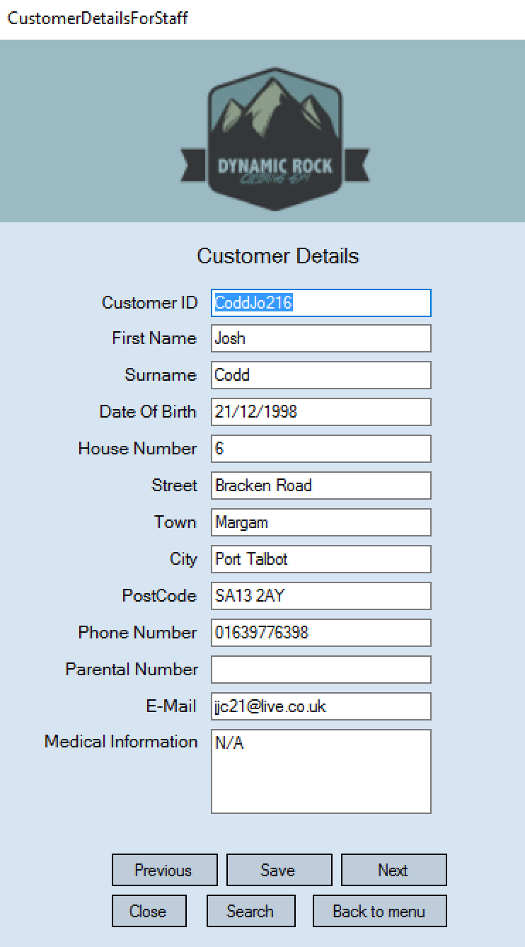
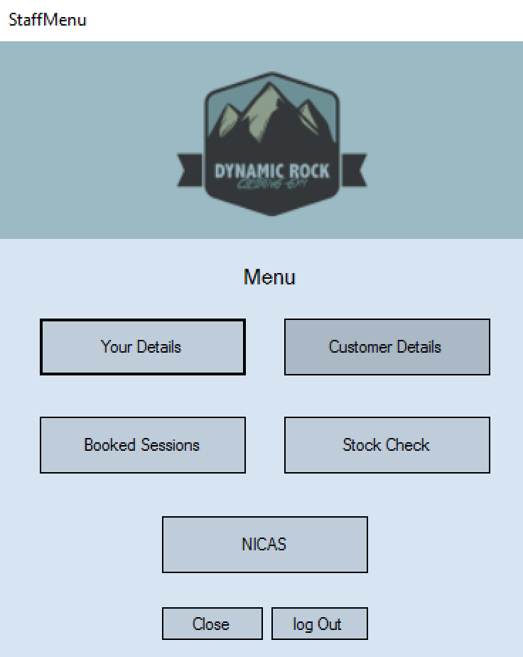

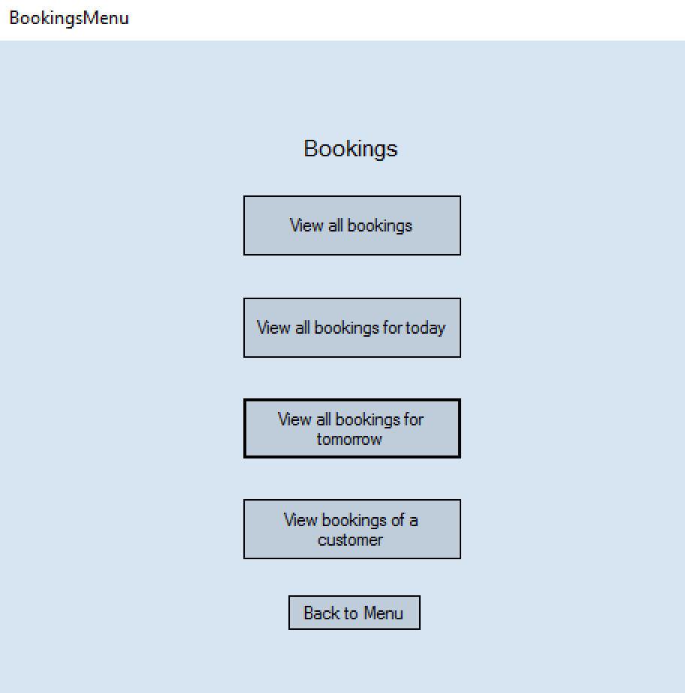
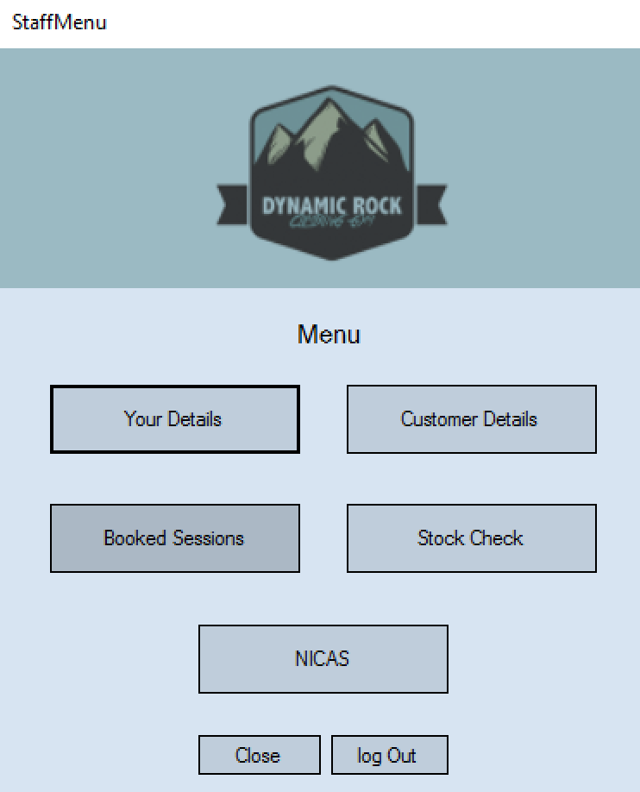
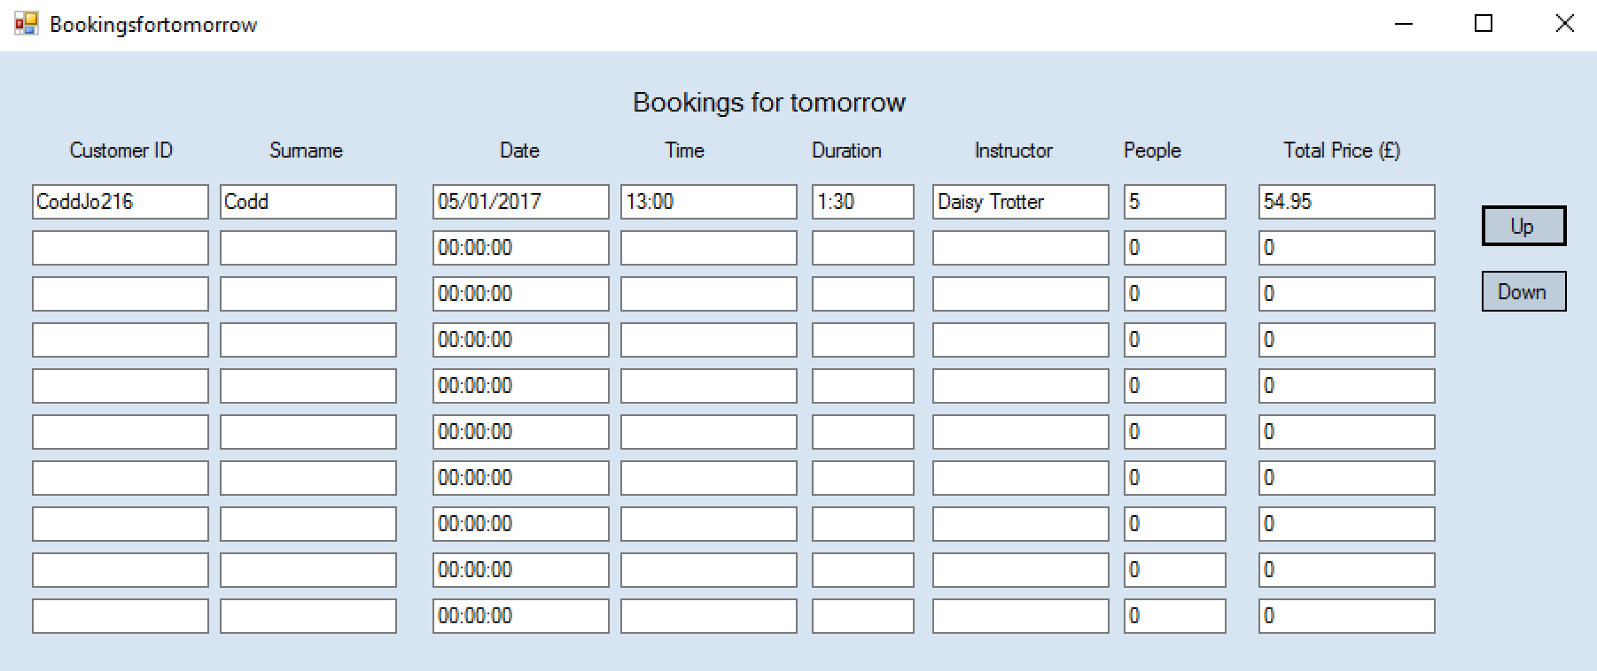
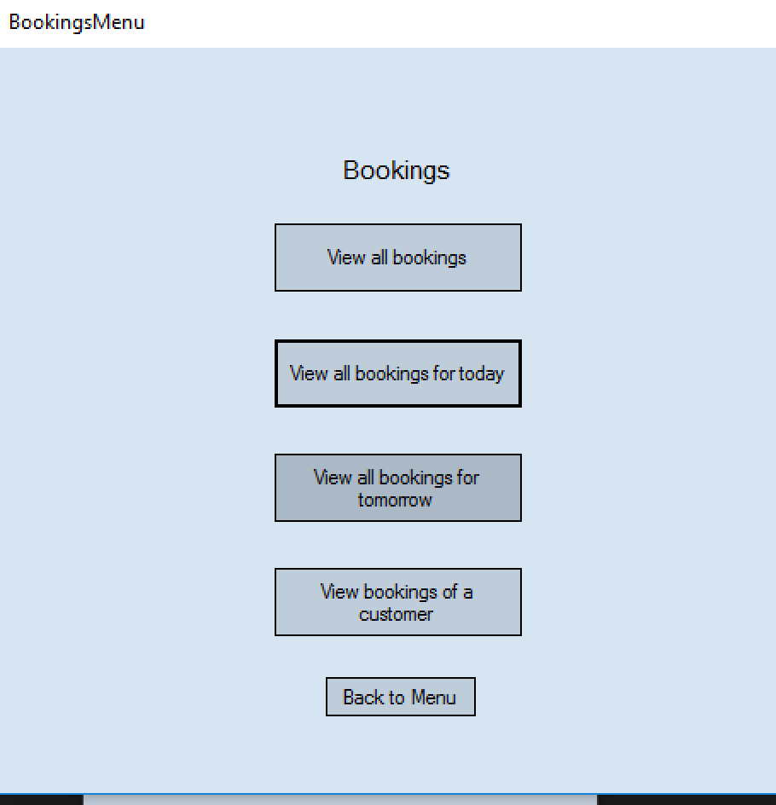
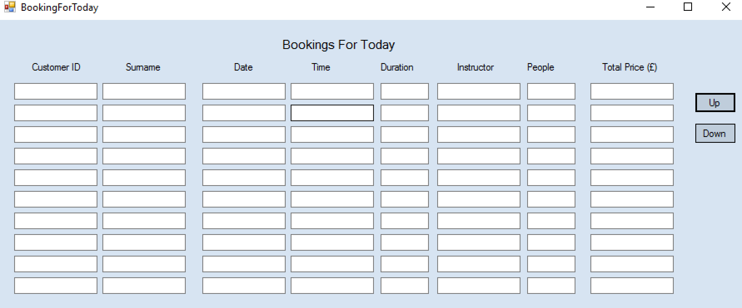
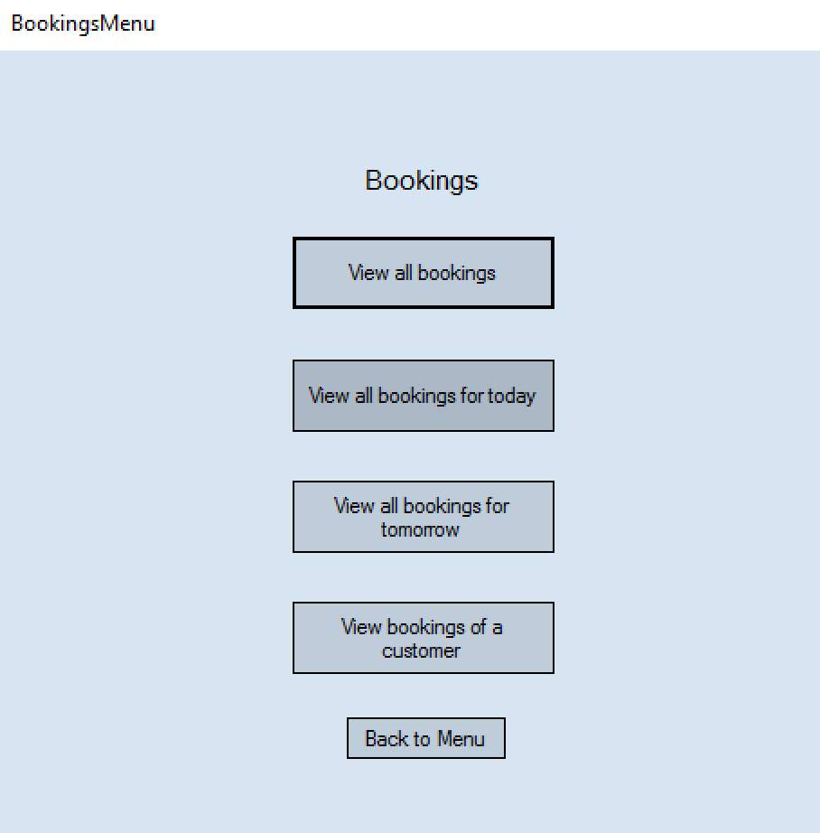
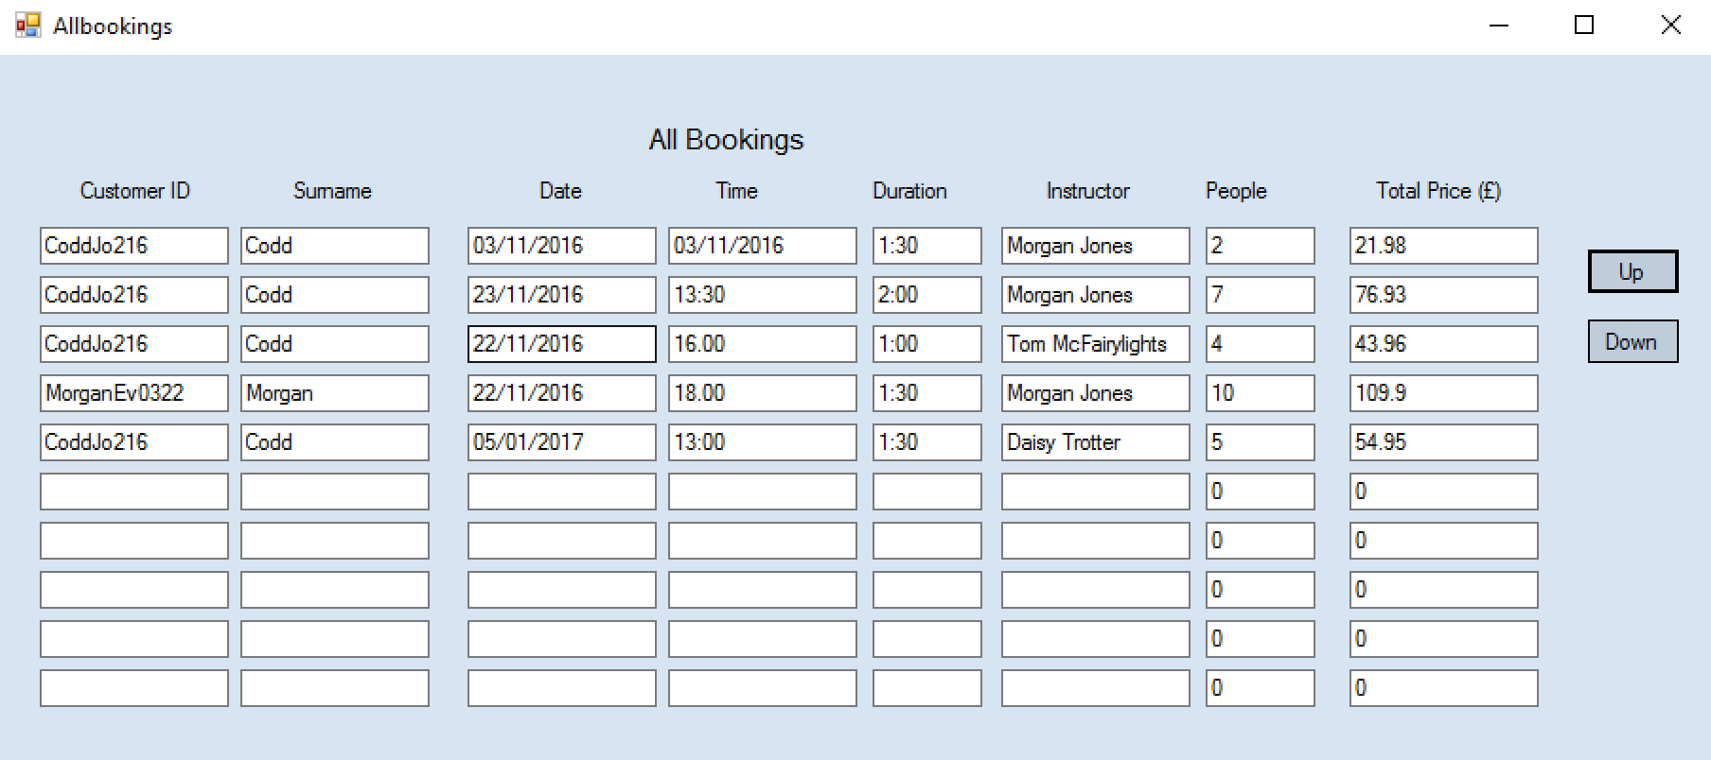
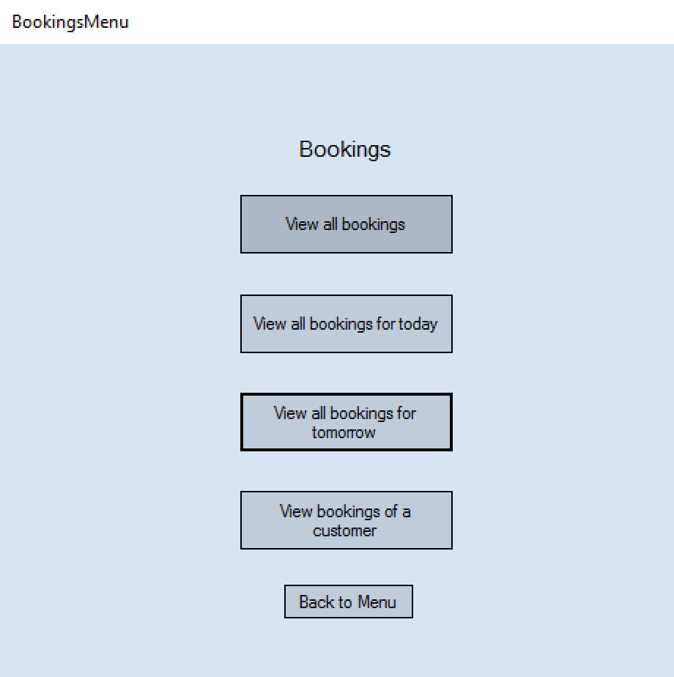

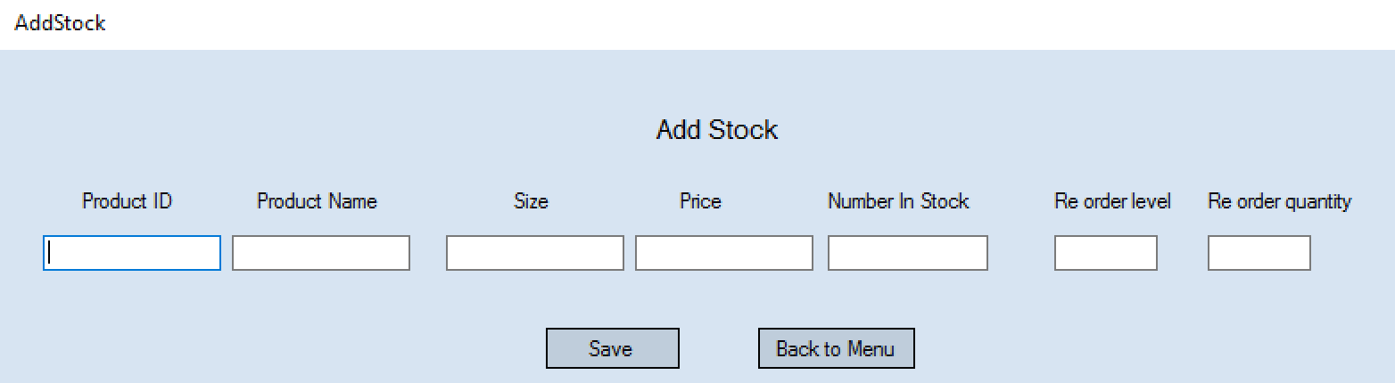
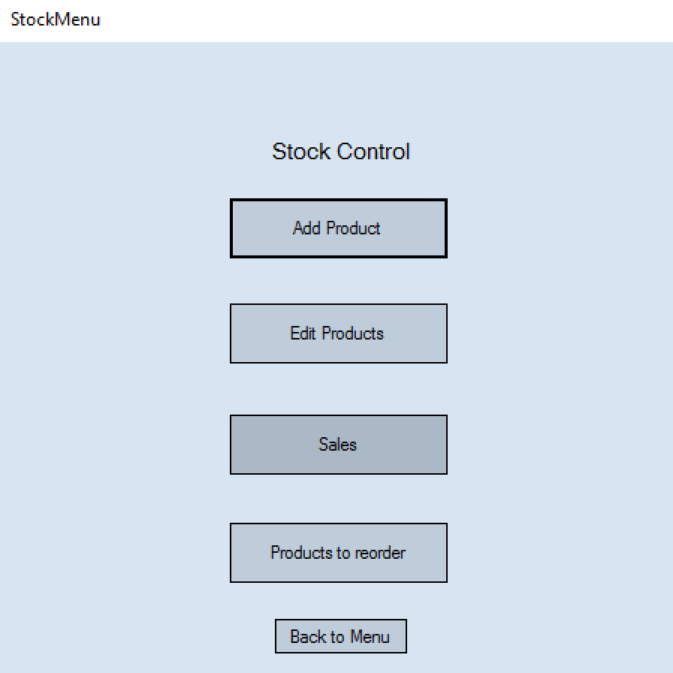
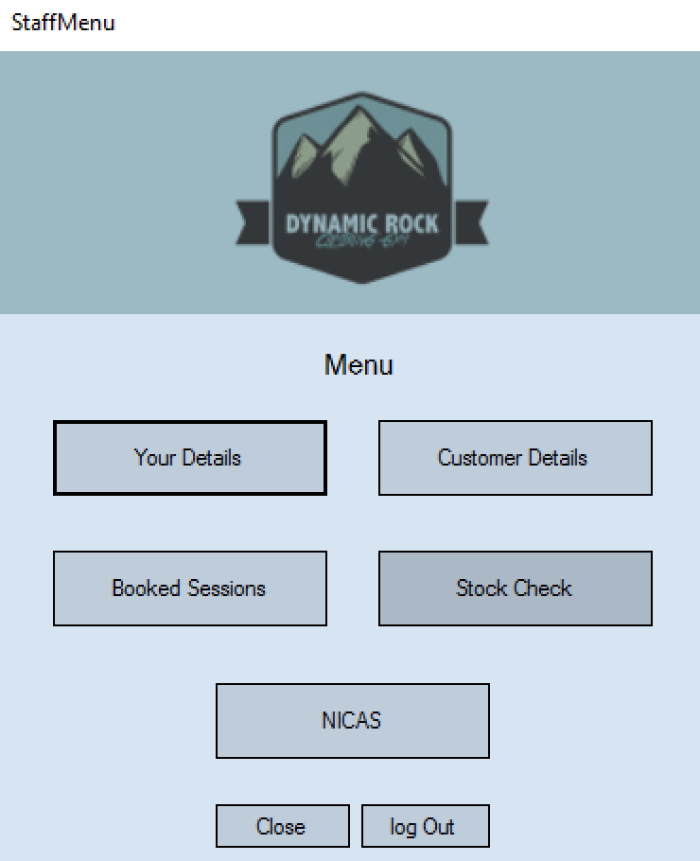
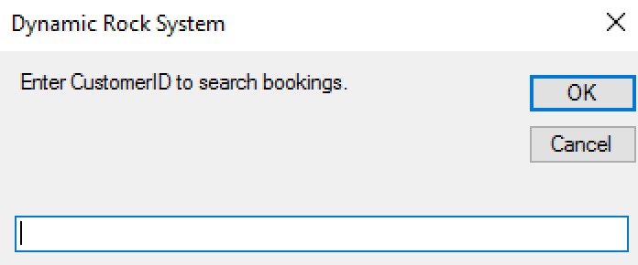
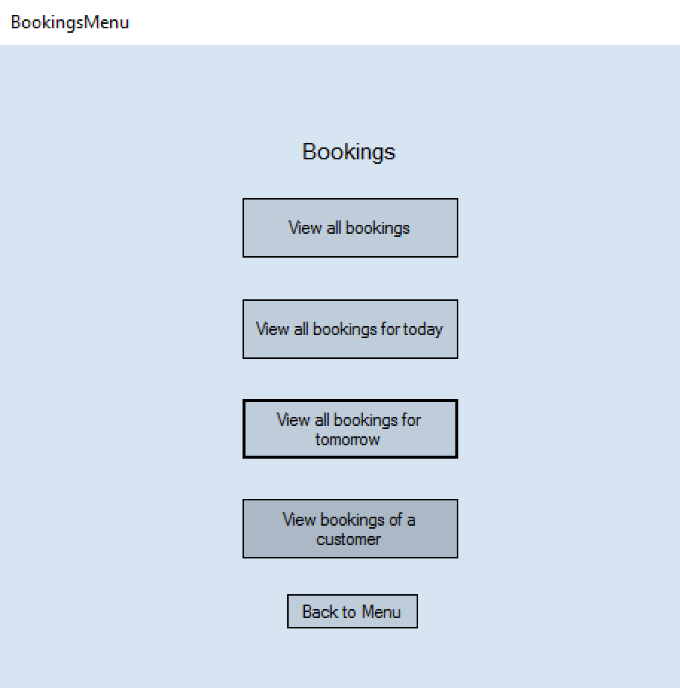

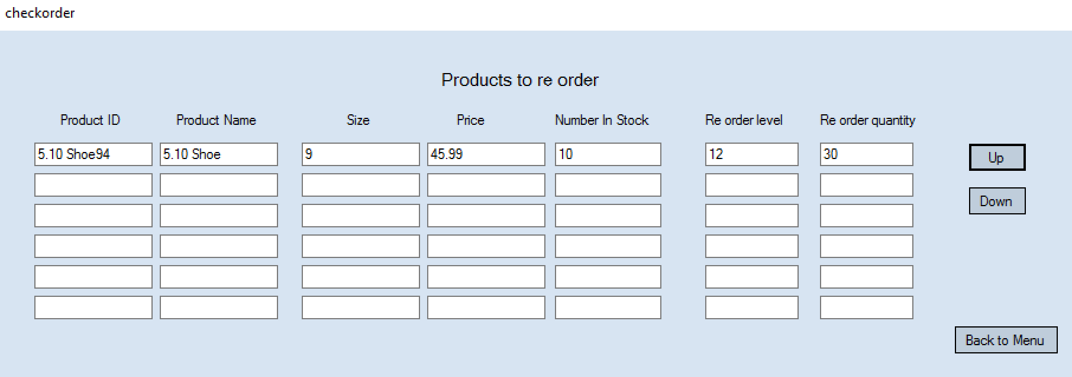
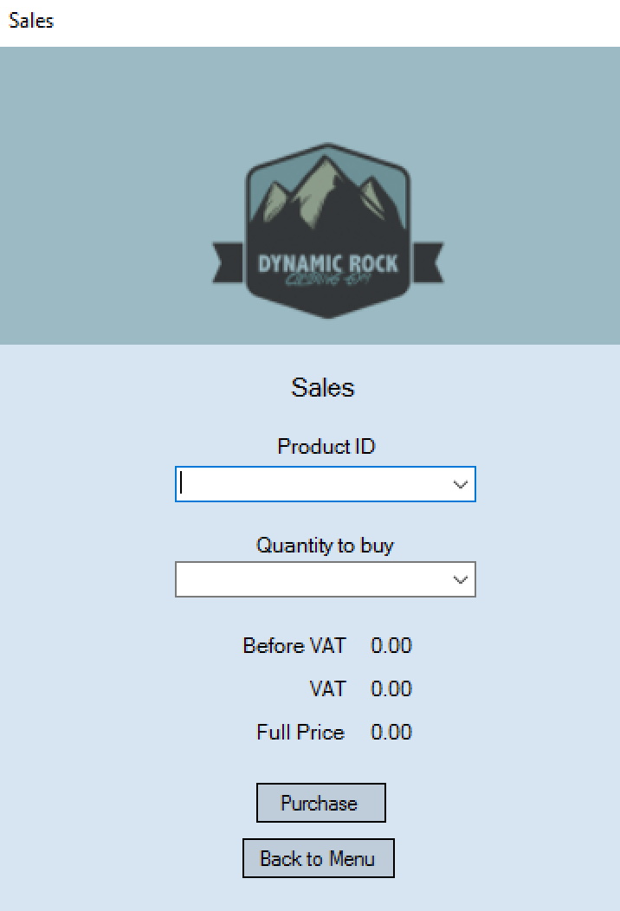
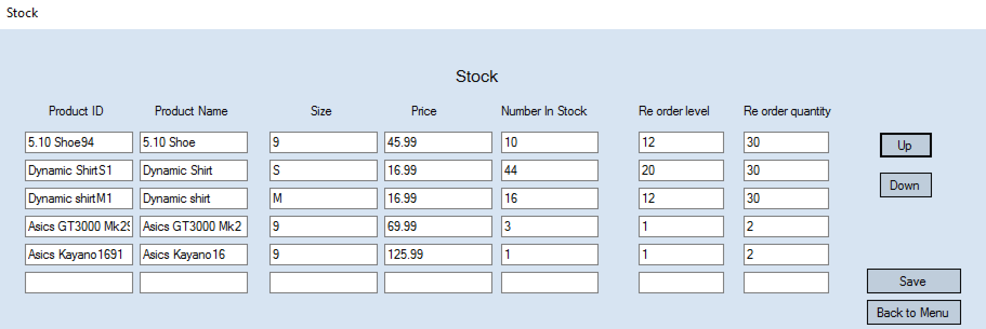

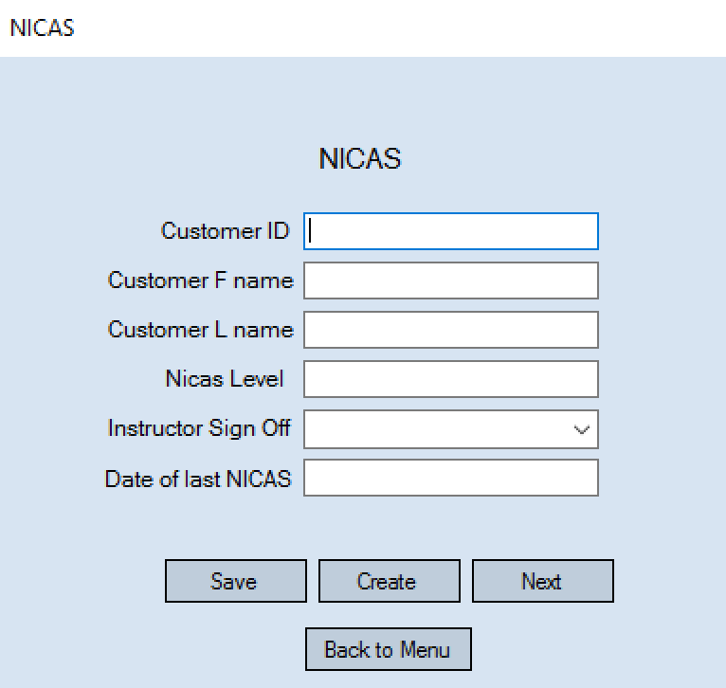

As seen in the images above, the buttons and paths through the staff menu work successfully with all the right menus opening. I have also tested the back to menu and back buttons and they also work successfully.

Test 43
For this test I am going to make sure that the staff ‘Your details’ form works and displays the details of only the account logged in with. I am going to do this by logging in with a staff members account and making sure the details displayed are those of that account.
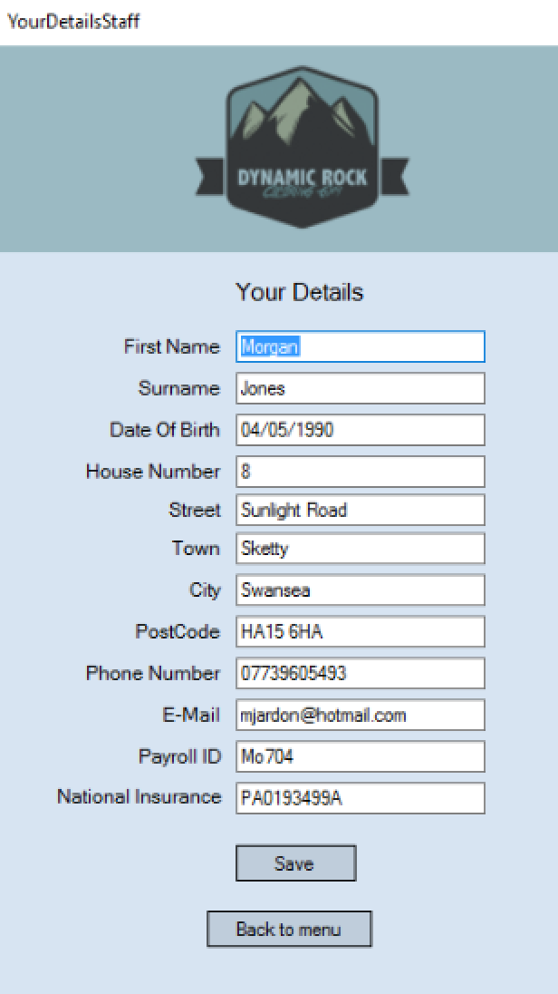
I am logging in with the Morgan Jones account so that is the persons whose information should be displayed.
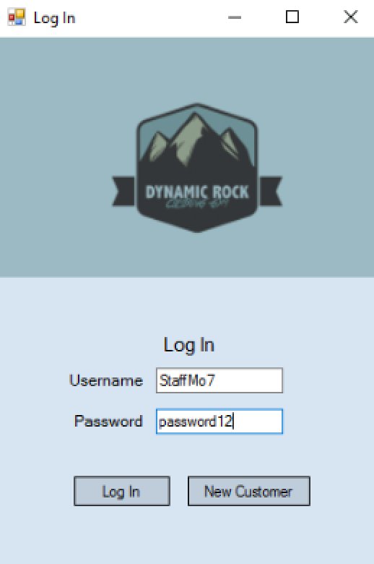

The test shows that the your details form for staff does only display the details of the account logged in as. This therefore shows the system is secure at only showing the relevant persons details and not breaching the data protection act.

Test 44
I am now going to test to see if the ability for a staff member to edit their details works. I will test this by changing Morgan Jones’ house number to 10. I will then check the staff file to make sure this has saved correctly.

before
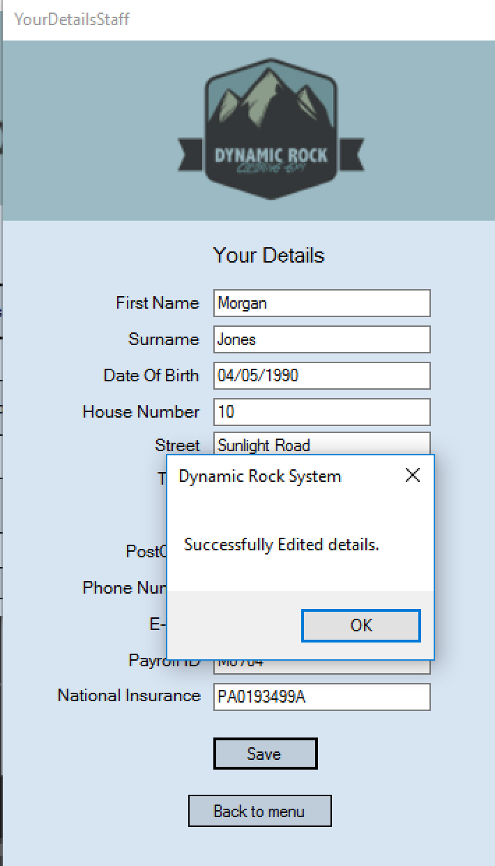

After
This test shows that the details are successfully updated once edited.
Test 45 + 46
This test will involve me checking to see if the next button to view the next record in the customer details form works correctly. I will test this by checking the view customer details file to see what records are in there. I will then press the next button 3 times on the view customer details form to see if the correct next records are displayed. This will also test to see whether my code to sort the records into alphabetical order works. It should sort by second name.
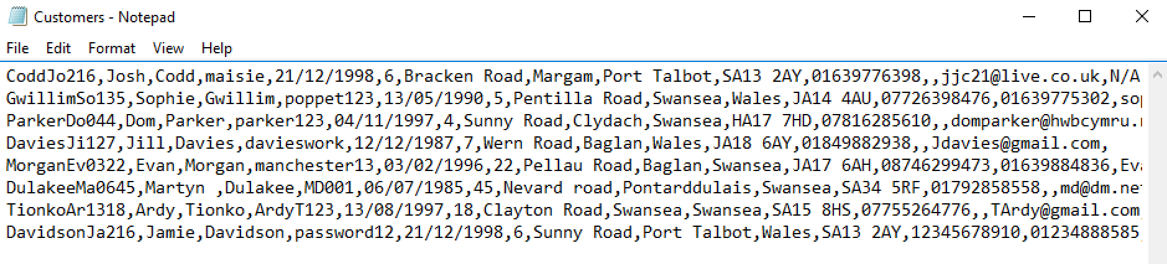
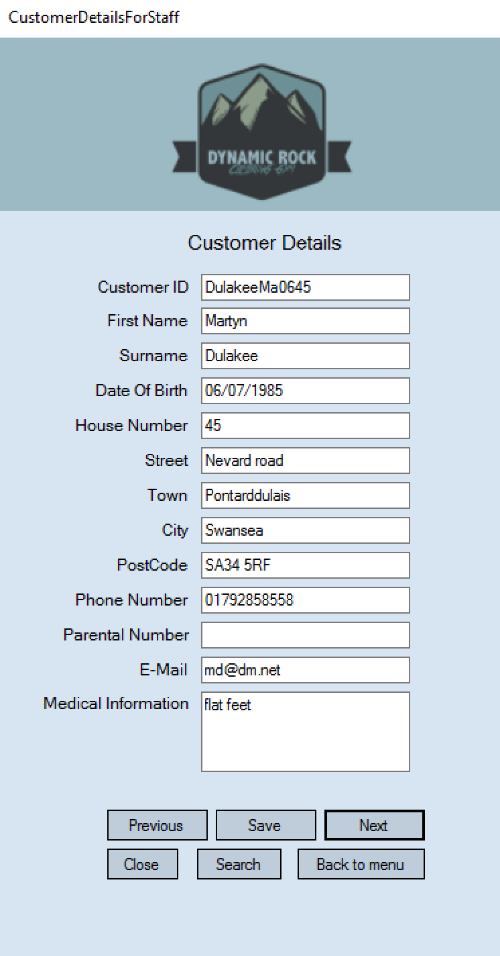
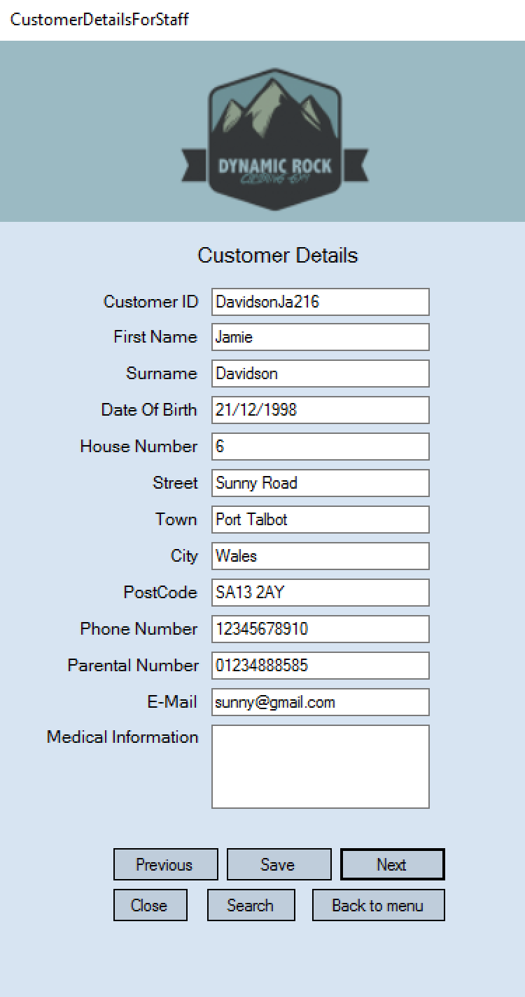
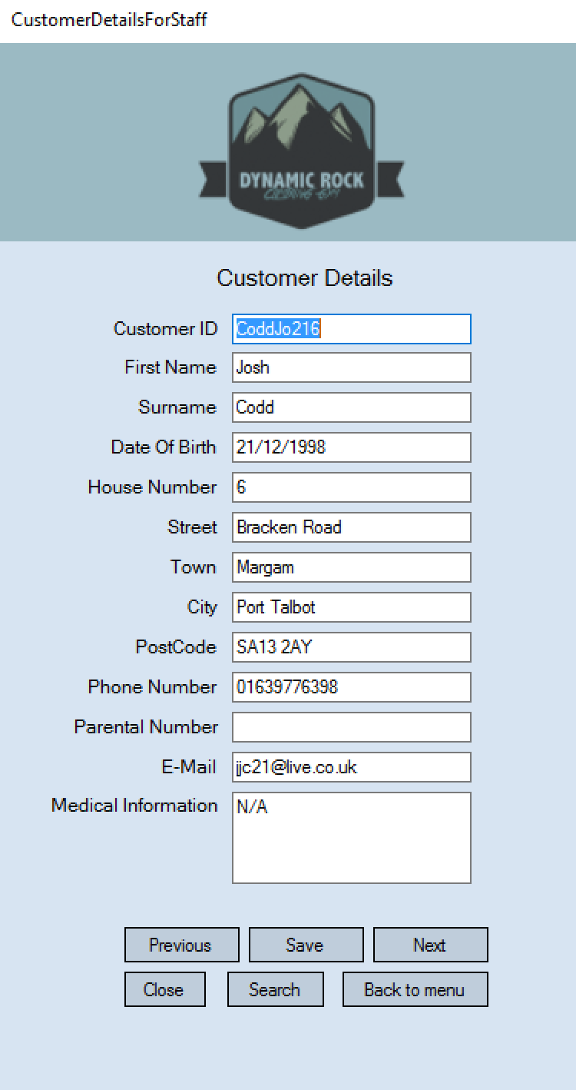
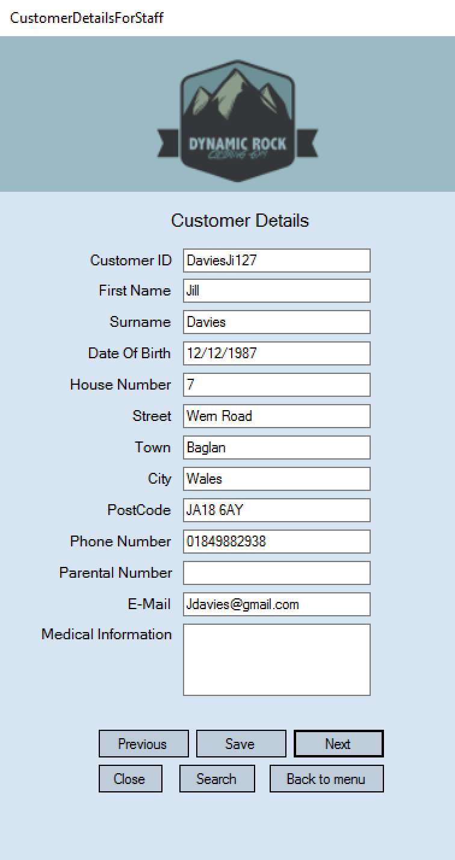
If the alphabetical sort works then the first record displayed should be Jamie Davidson, then Jill Davies and finally then Martyn Dulakes.

These tests show that the alphabetical sort does work as the records were shown in order of their second name. The next button did also work correctly.

Test 47
This test will be to see if the ‘previous’ button works on the view customer details form. I will test this by clicking previous and looking to see if the previous record is displayed. I will click the previous button twice to ensure this works correctly.
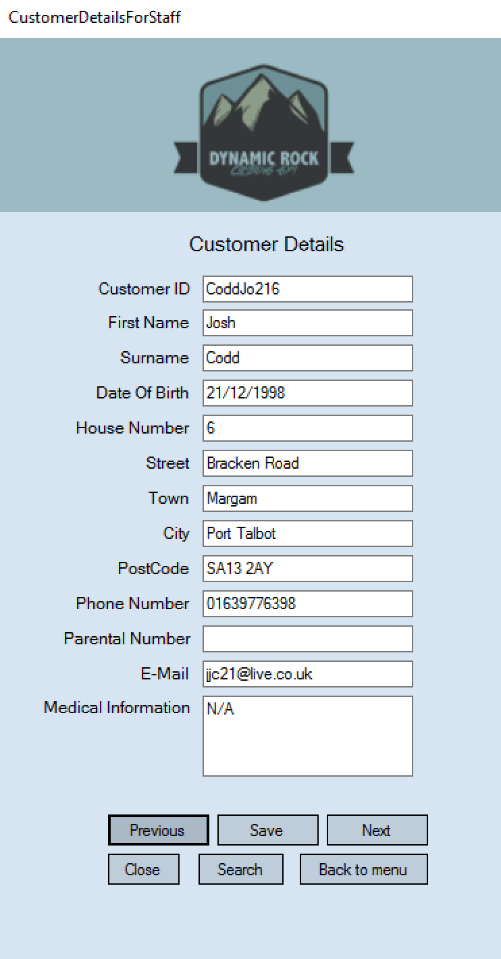
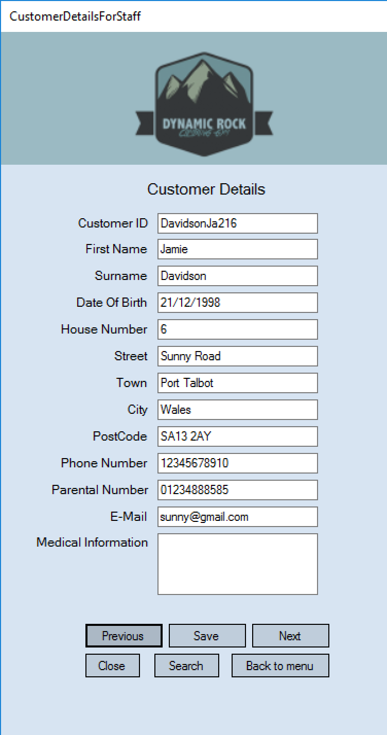
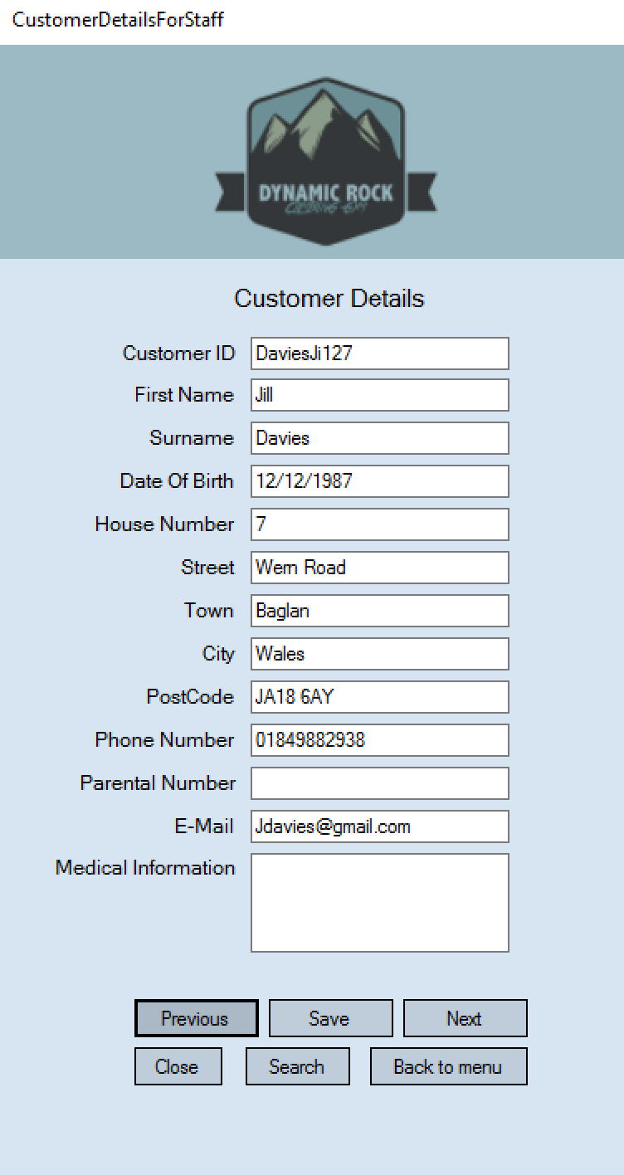

This test shows that the previous button works correctly. I can see this as when it is pressed it displays the previous record.

Test 48
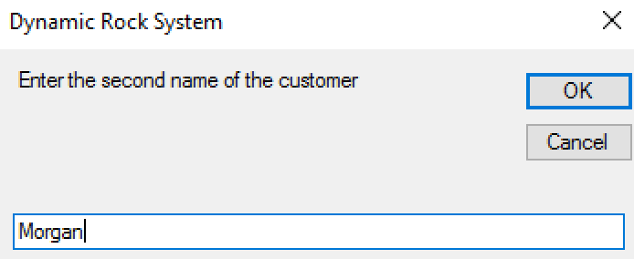
This test will involve me checking to see if the search function works on the view customer details form when a correct existing name is entered. To test this I will search the name of an existing customer to make sure it is displayed correctly.
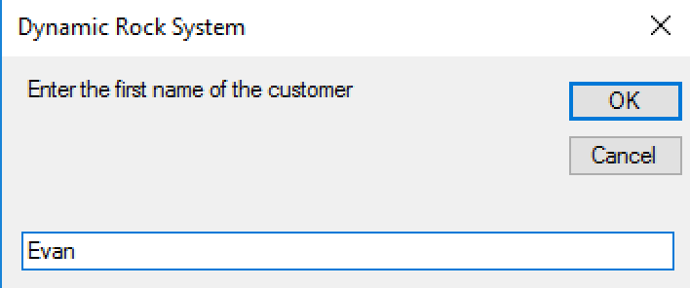

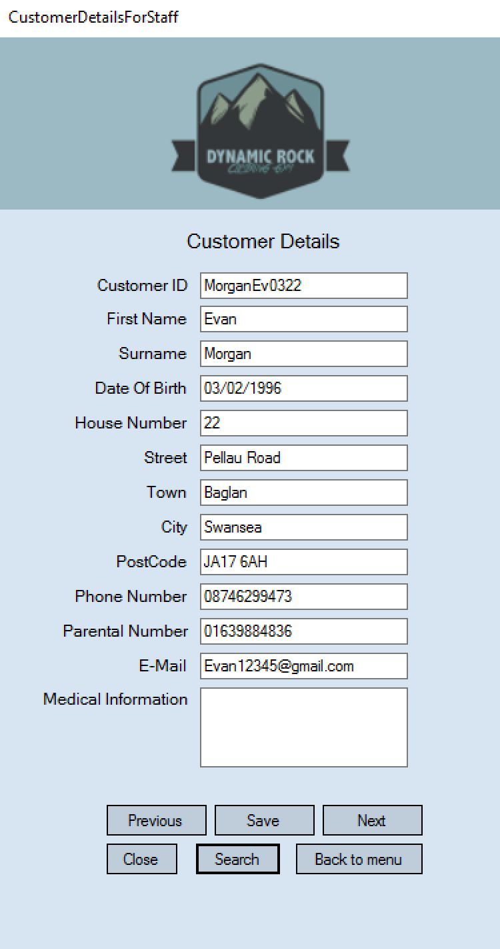

When I searched for the name Evan Morgan then the details for the customer Evan Morgan were displayed correctly.
Test 49
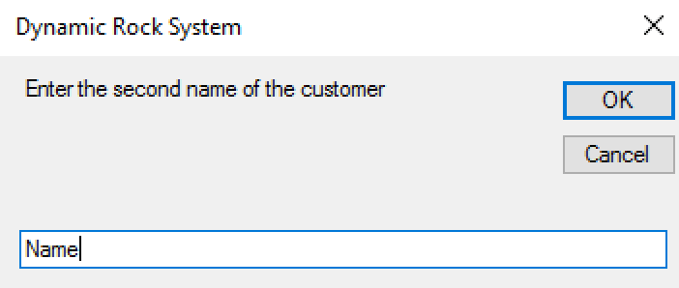
I am now going to test to see what is displayed when a name is searched for that is not in the customer file. I am going to test this by entering a name that is not in the customer file into the input boxes. I will then see what is displayed.
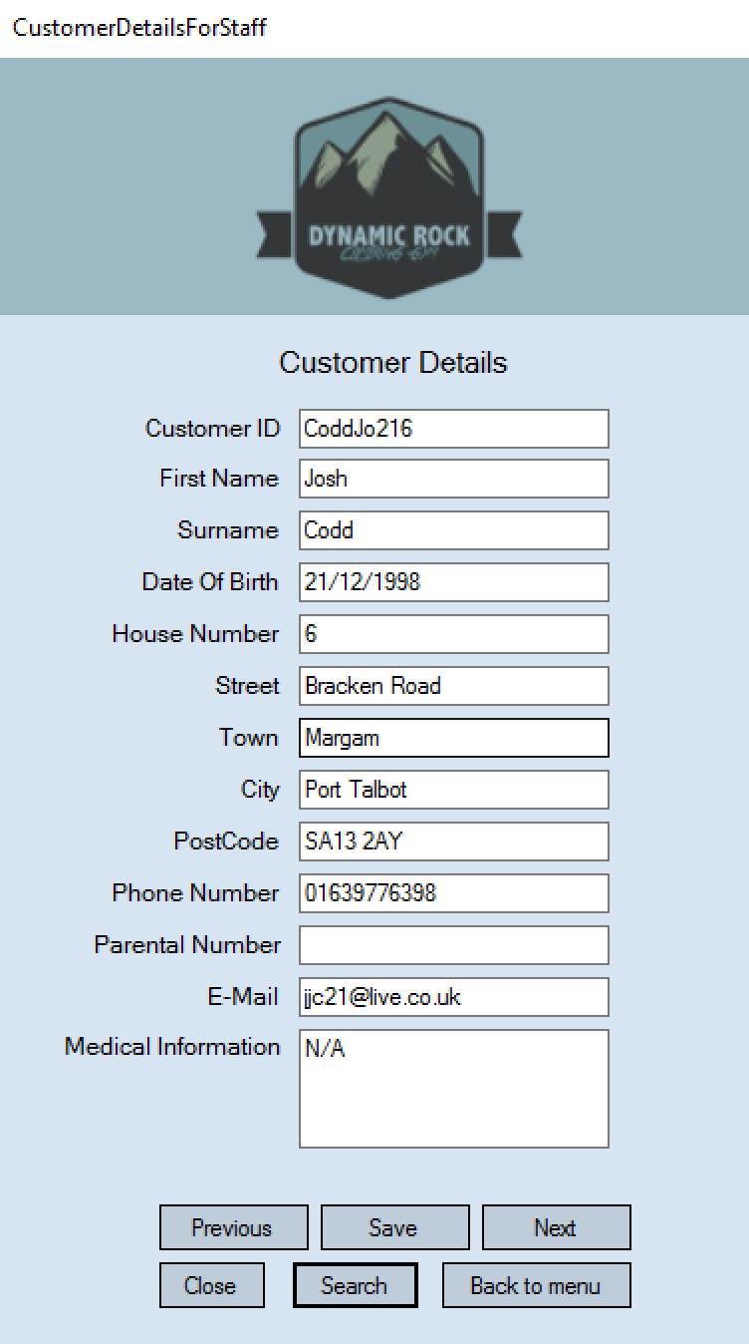
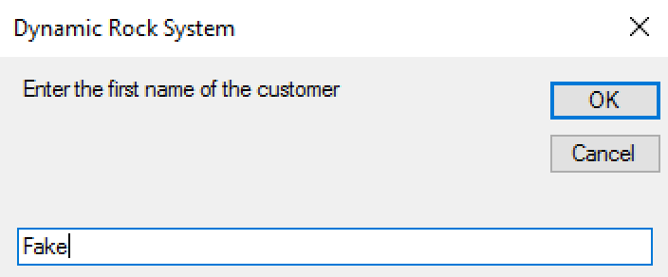

As seen in these pictures when a name that is not found is
Searched for then the starting/first record in the file is displayed
as it is when you open the view customer details form.

Test 50
I am now going to test the ability to edit a customer’s details on the view customer details form. I will test this by changing a customer’s house number and pressing save. I will then check in the customer file to ensure this change has been saved.
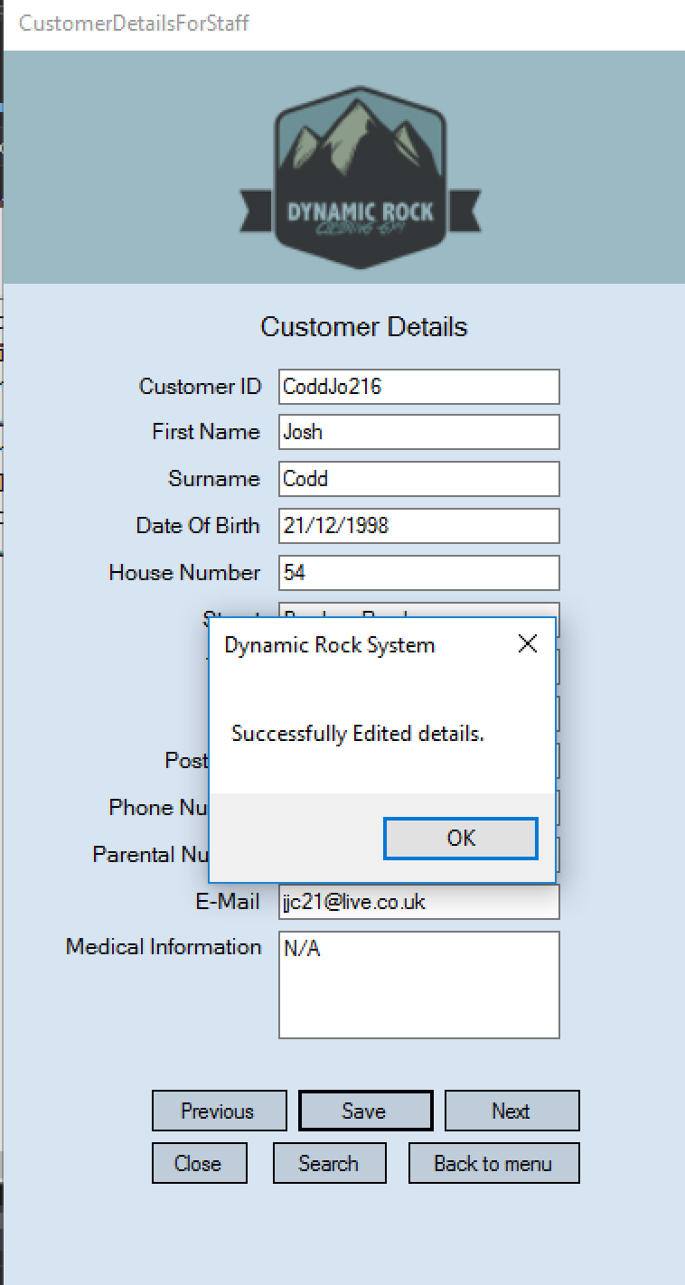

This test has shown that the edit/save function on the view customers form works correctly and successfully.

Test 51 + 52 + 53
These tests are to check that the view all bookings form is working correctly. For the first test I am going to click on the button to view this form and make sure all bookings are displayed by viewing the booking file. For the second test I am going to click the up button to make sure the records move up. For the third test I am going to click the down button and make sure the records move down.

1.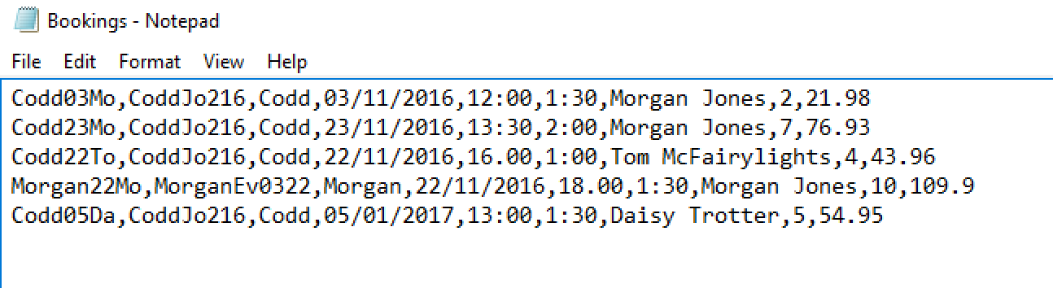
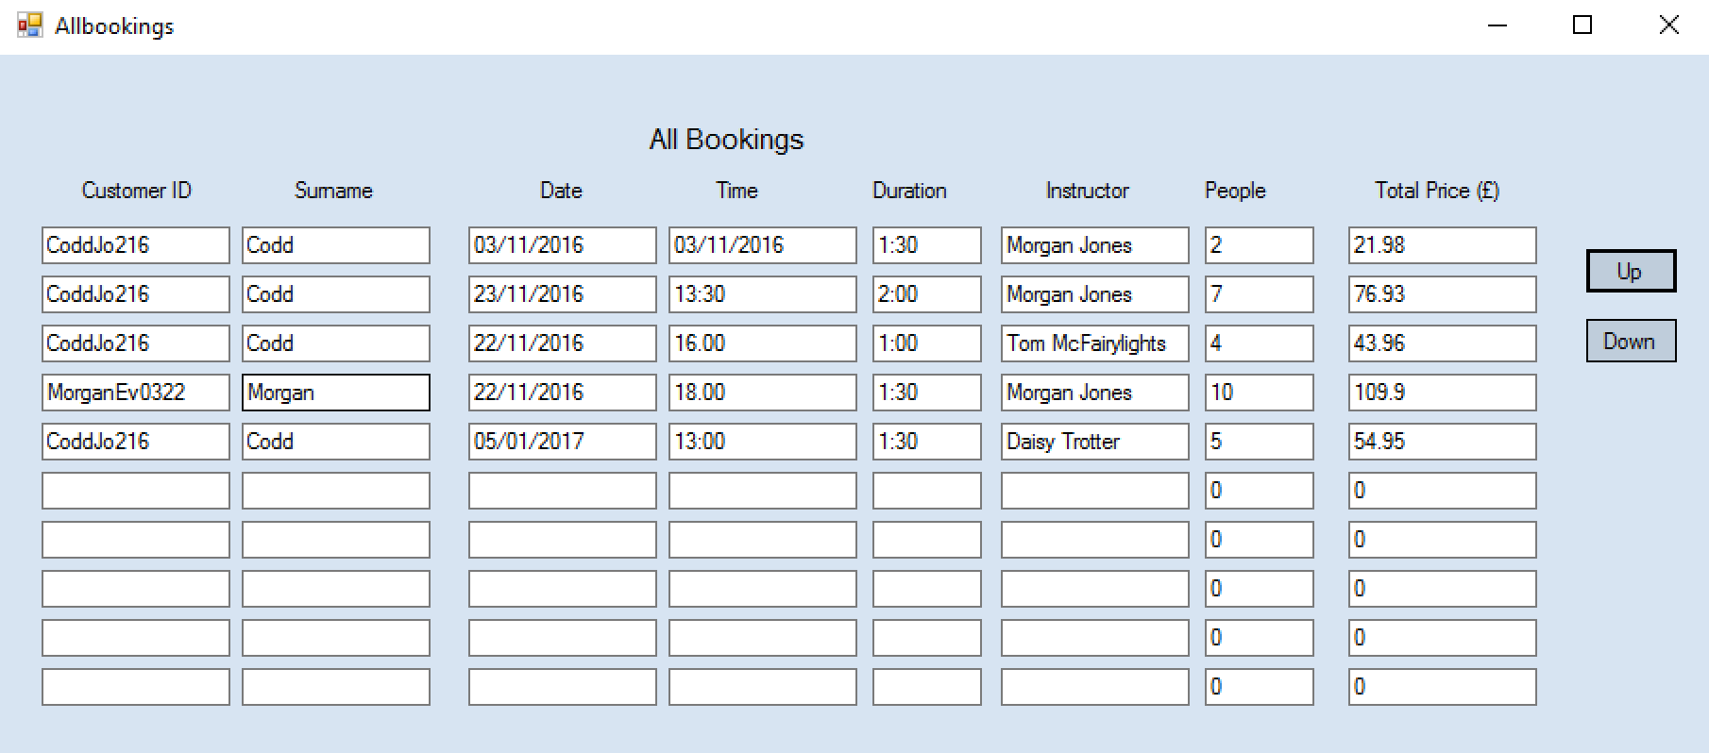
This shows the first test to be successful as all bookings are displayed correctly.

2.
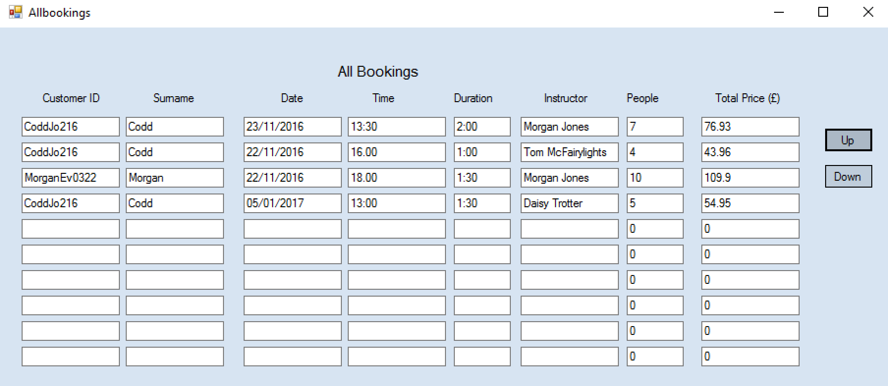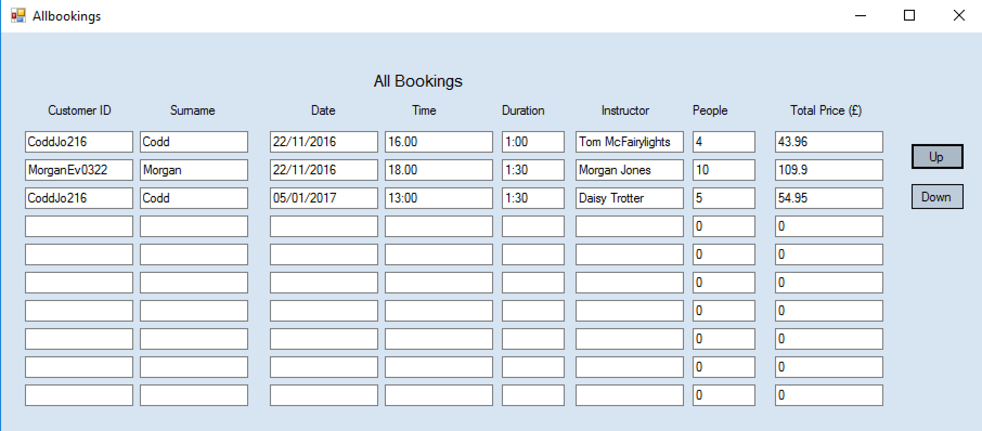
This second test shows the up button works correctly as when pressed, the records move up. If there were more bookings then more bookings would be shown when moving up.

3.
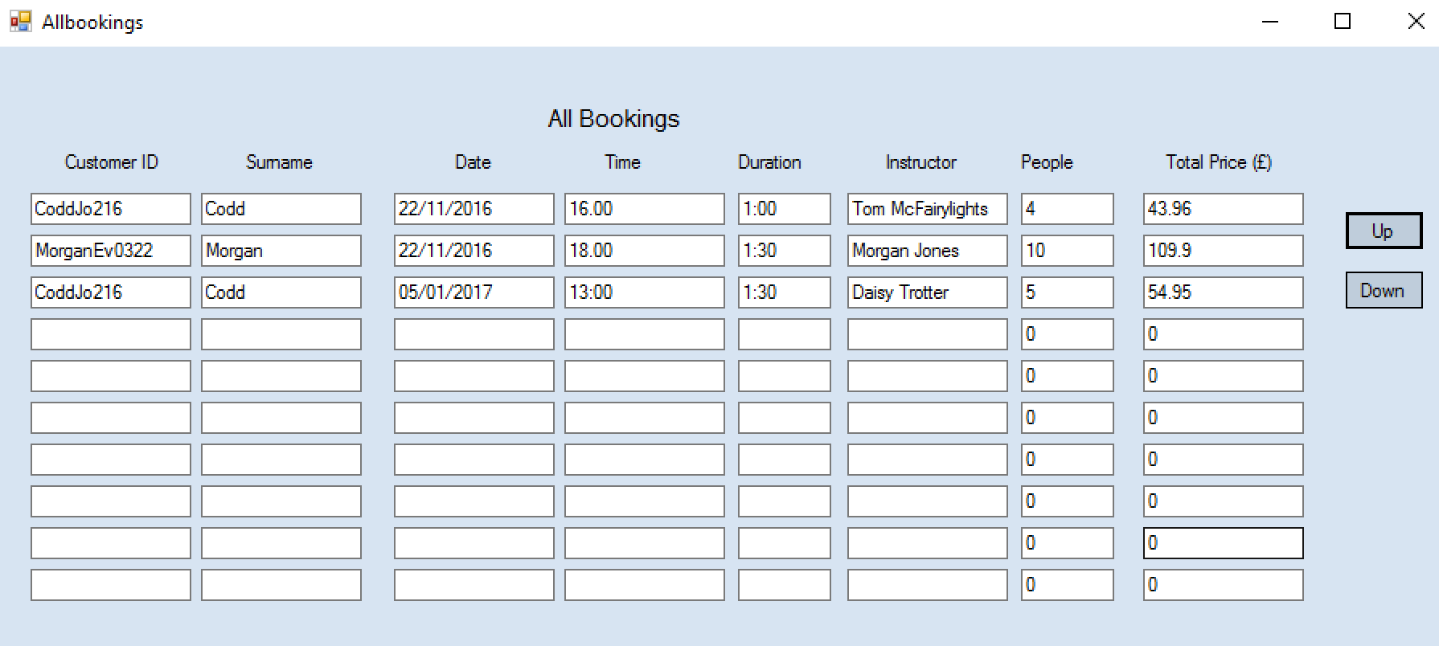
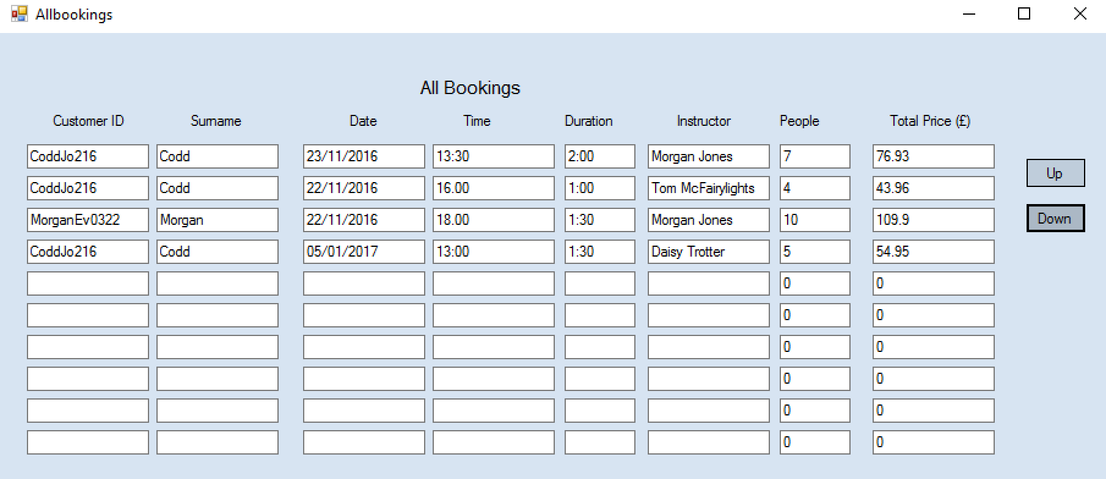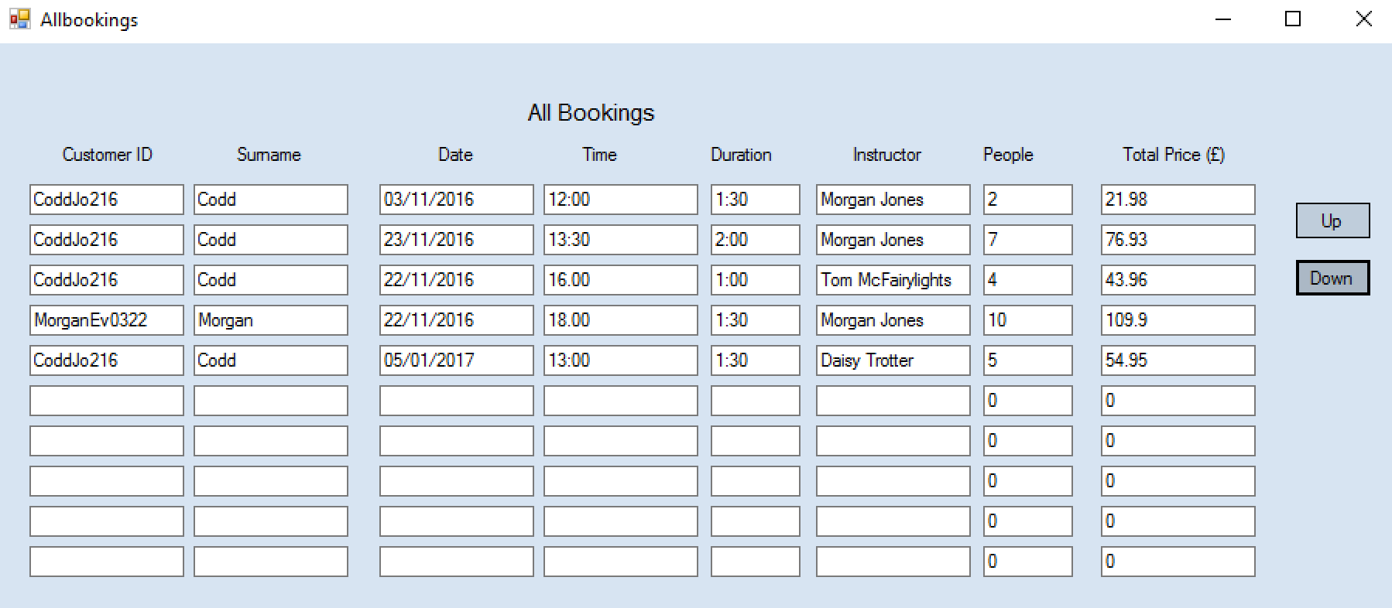
This test shows that the down button works correctly also. When clicked the records above are moved back down to be displayed.

Test 54 + 55 + 56
These tests are to check that the view all bookings for today form is working correctly. For the first test I am going to click on the button to view this form and make sure all bookings with todays date are displayed by viewing the booking file. For the second test I am going to click the up button to make sure the records move up. For the third test I am going to click the down button and make sure the records move down.
The date is : Thursday the 5th of January 2017 – there is only 1 booking in file for todays date.
1.
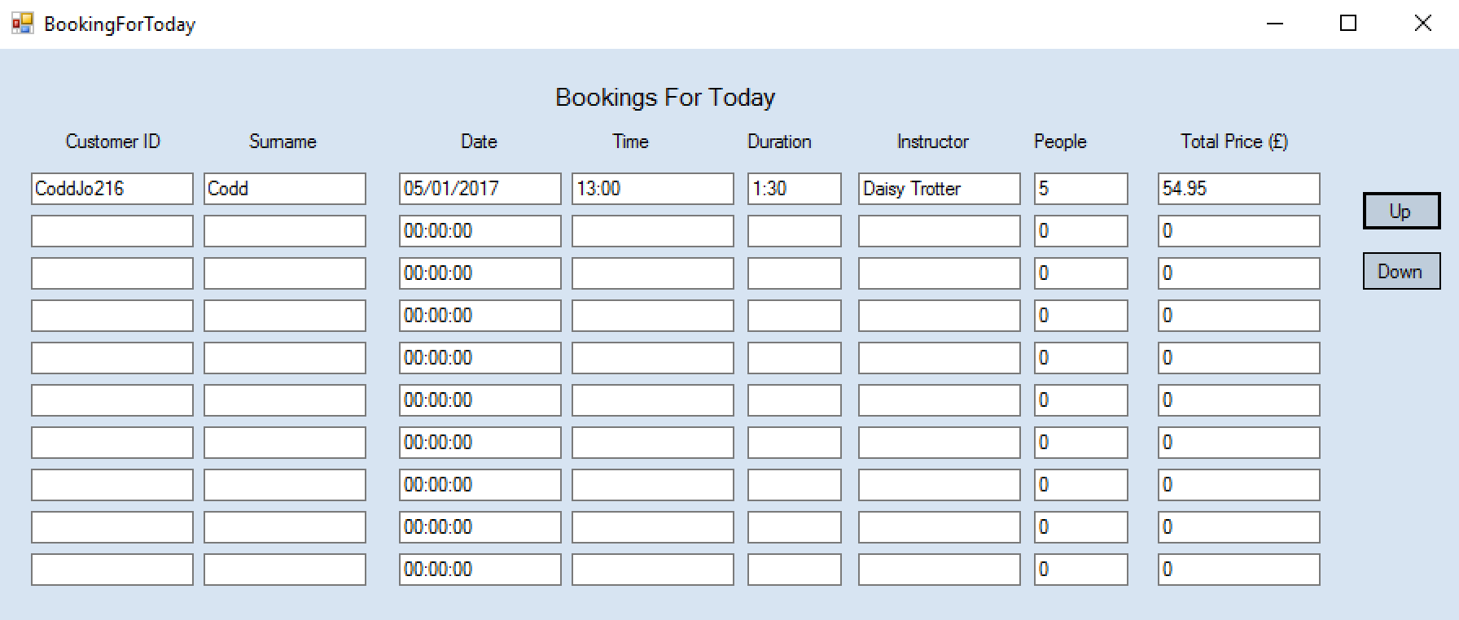
This test shows the bookings for today are being displayed correctly as the only booking with the date for today is being displayed.

2.
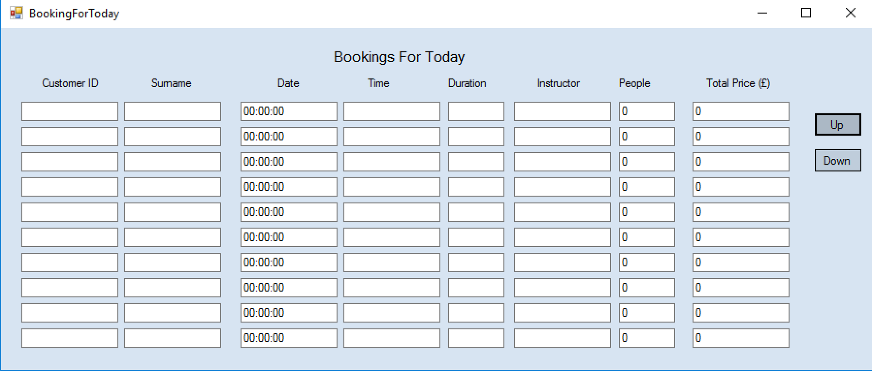
When the up button is pressed the record/s successfully move up.
3.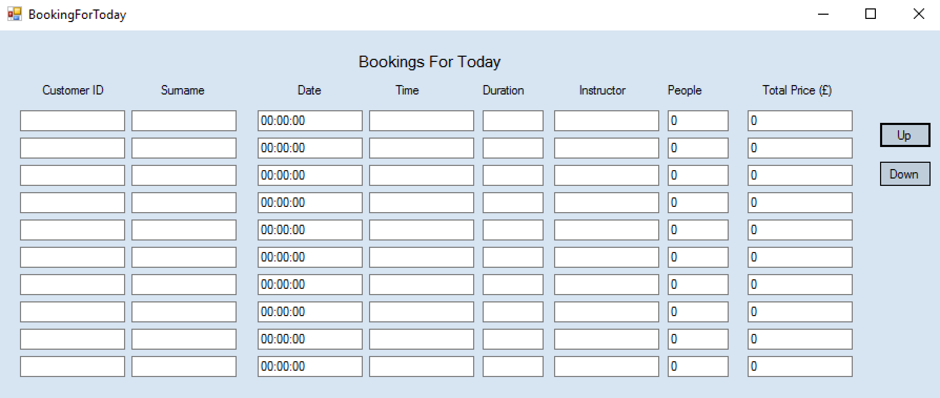 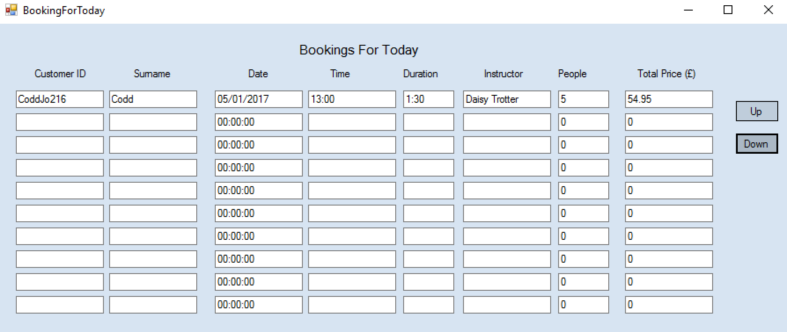

When the down button is pressed then the record is successfully moved down and displayed back on screen. These tests have shown that the bookings for today form all works correctly.

Test 57 + 58 + 59
These tests are to check that the view all bookings for tomorrow form is working correctly. For the first test I am going to click on the button to view this form and make sure all bookings with tomorrows dates are displayed by viewing the booking file. For the second test I am going to click the up button to make sure the records move up. For the third test I am going to click the down button and make sure the records move down.
Tomorrows date is : Friday the 6th of January 2017
I have added booking for tomorrows date.

1.
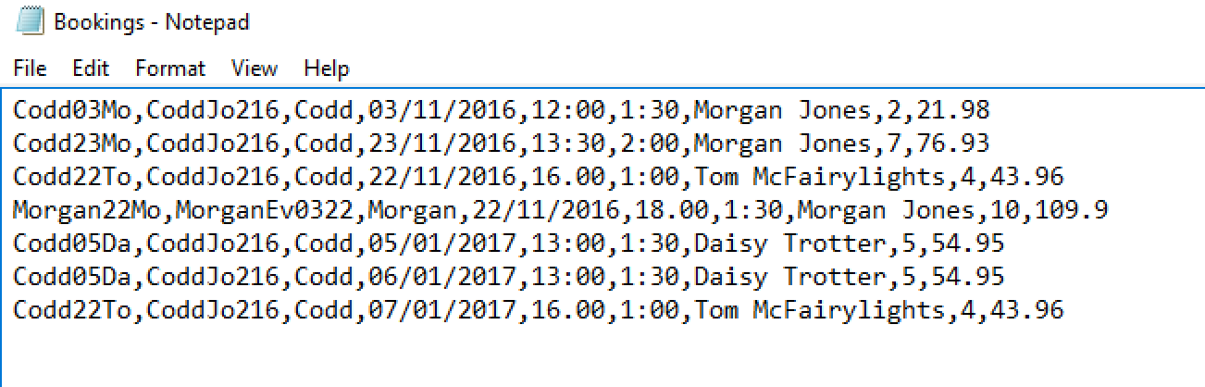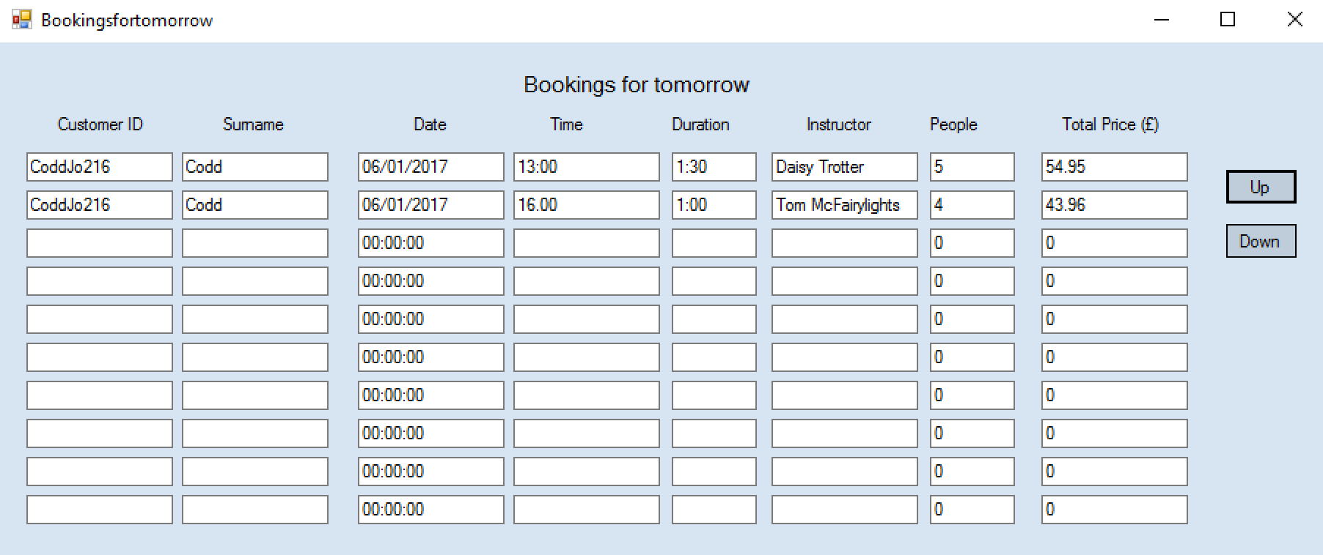
When the bookings for tomorrow form is opened then the correct bookings with tomorrows date are successfully shown.

2.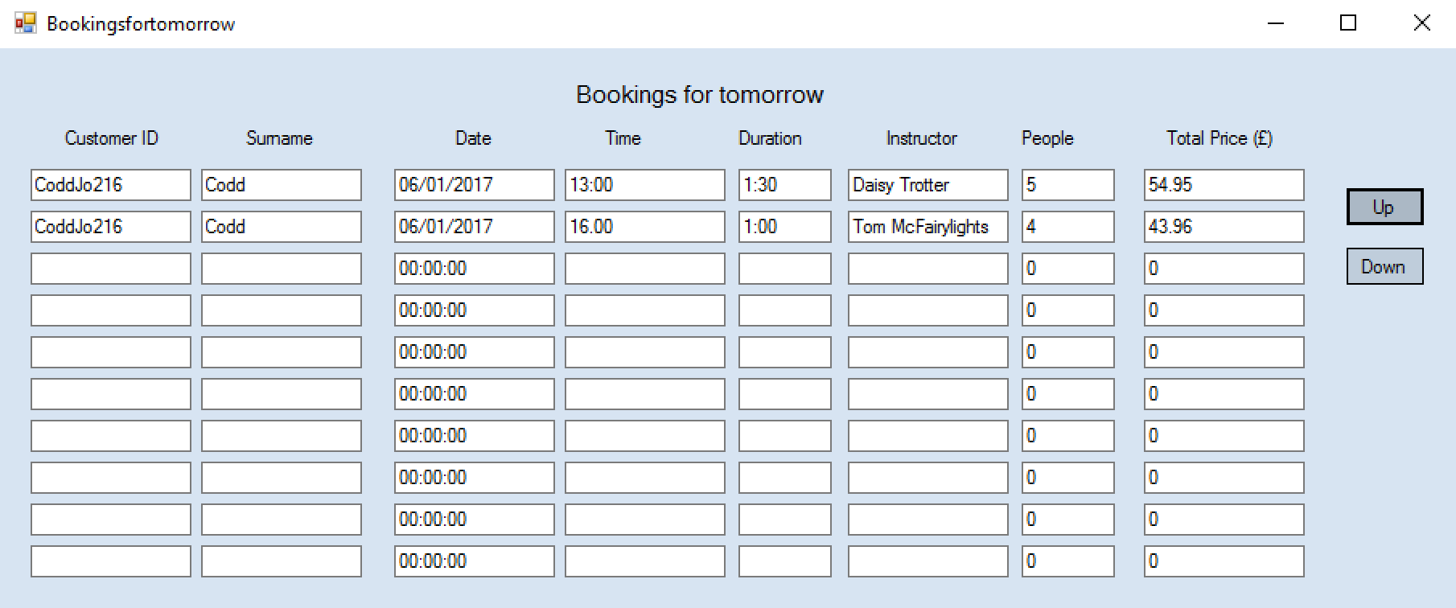
When the up button is clicked then nothing happens. After some searching I have discovered I have no added any code for the up or down buttons to work. This is a problem I have now fixed by adding the code, As seen below.
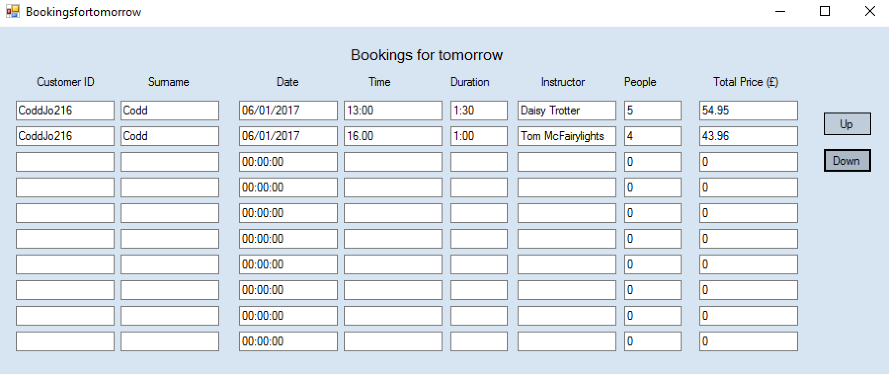
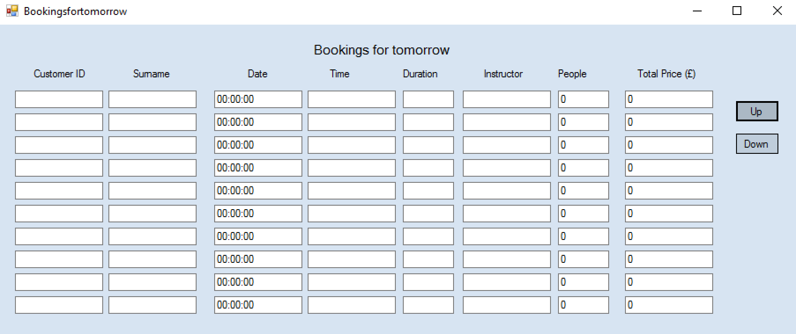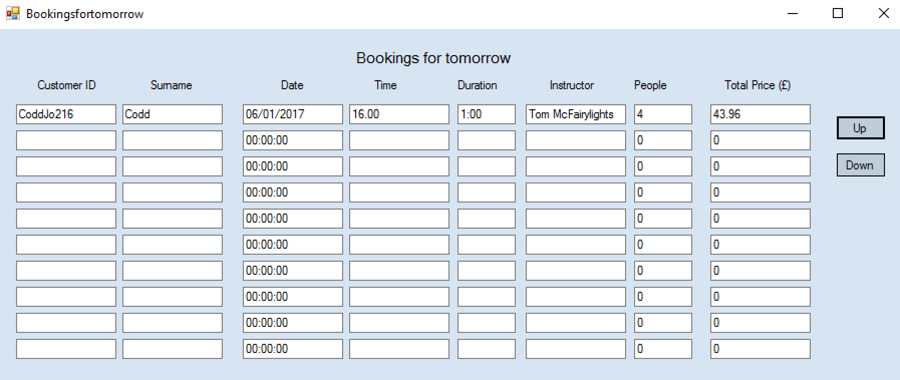

3.
When the down button is clicked then nothing happens. After some searching I have discovered I have no added any code for the up or down buttons to work. This is a problem I have now fixed by adding the code, as seen below.
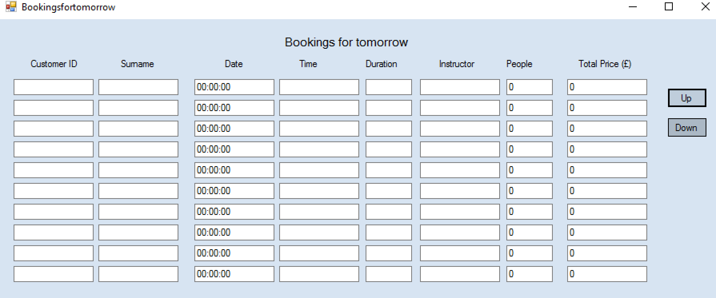
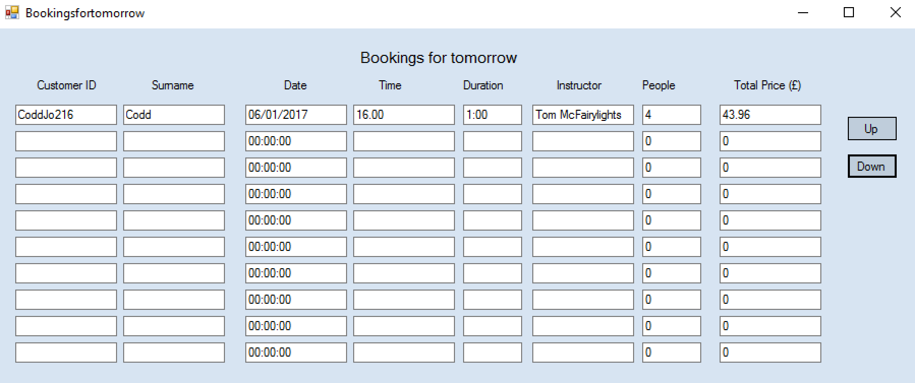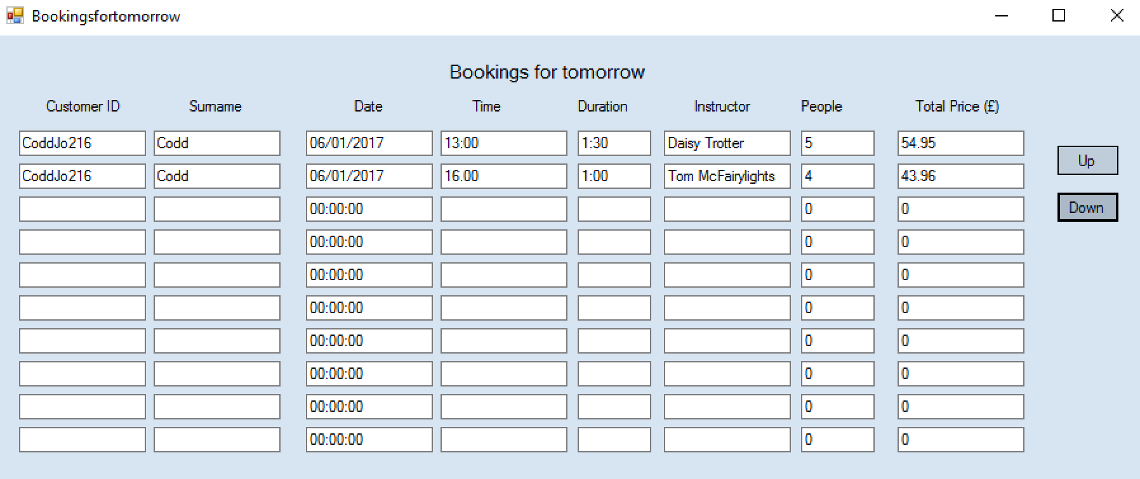
After some fixes the bookings for tomorrow form successfully works.

Test 60 + 61 + 62
These tests are to check that the search for bookings form is working correctly. For the first test I am going to click on the button to view this form and make sure all bookings searched for displayed by viewing the booking file. For the second test I am going to click the up button to make sure the records move up. For the third test I am going to click the down button and make sure the records move down.
1.
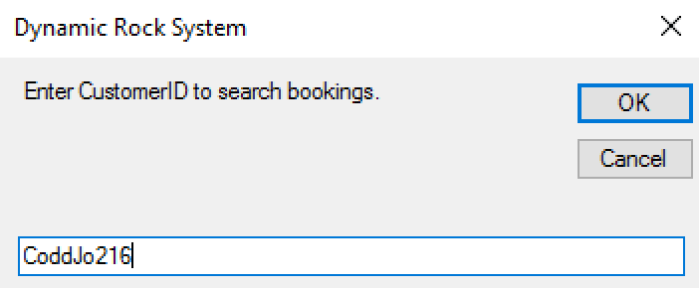

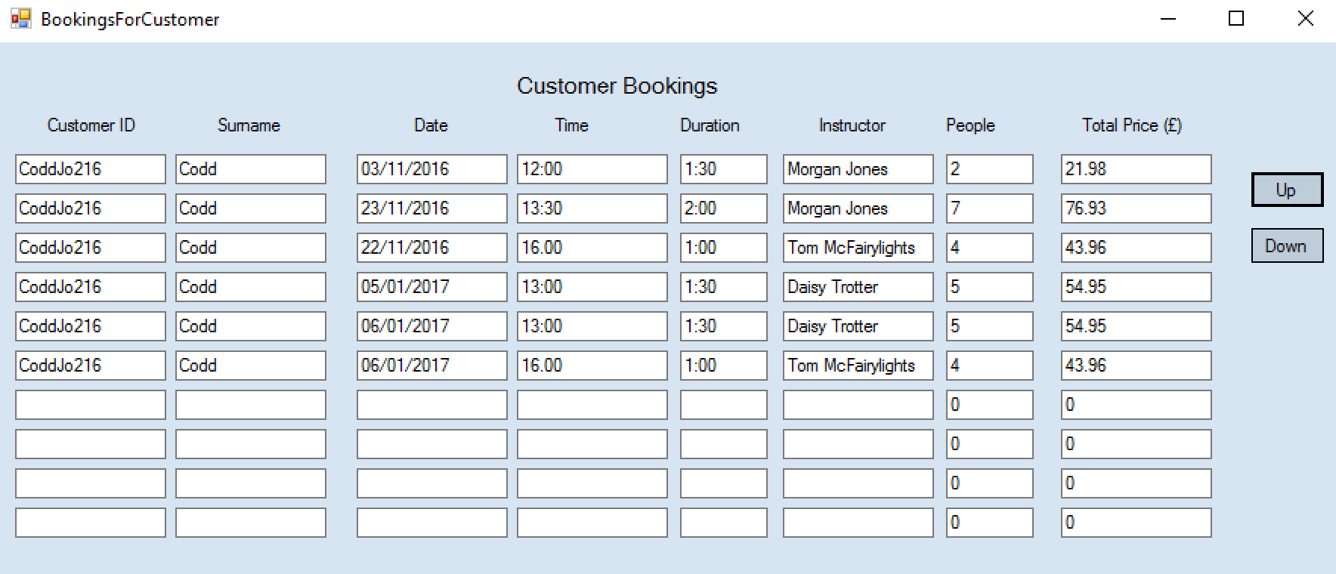
This shows that the bookings displayed are only the ones of the username I have searched for. Therefore this shows that the search and display function works correctly.

2.

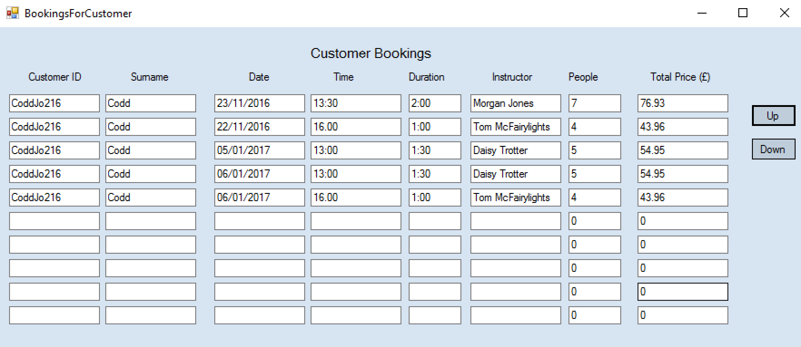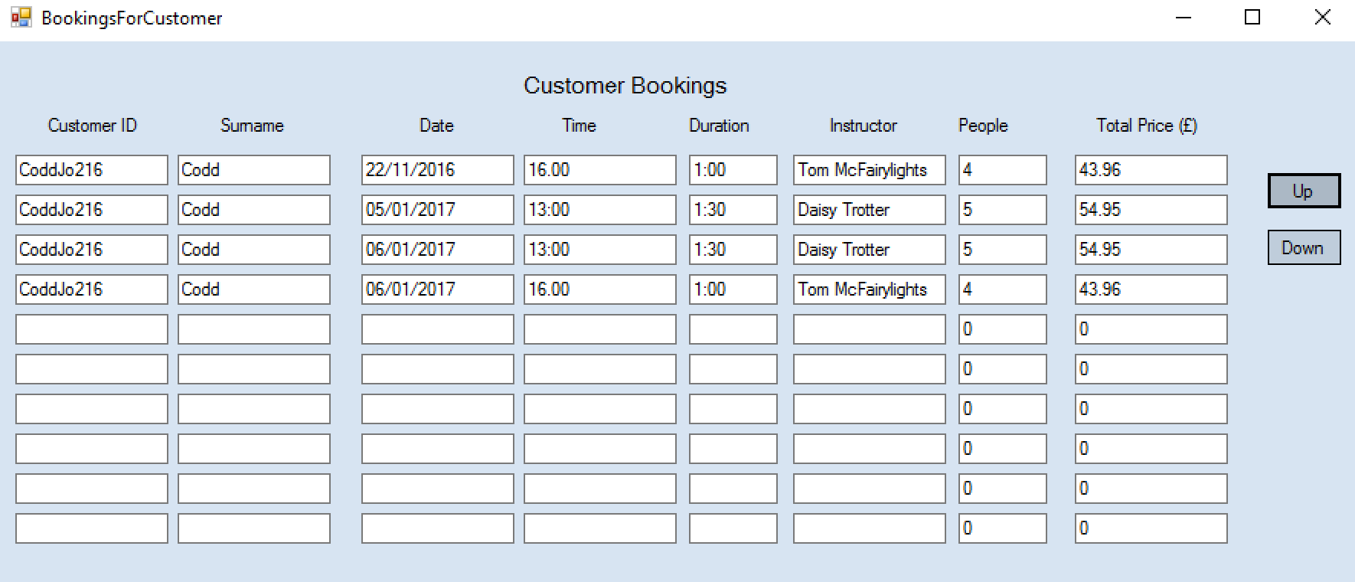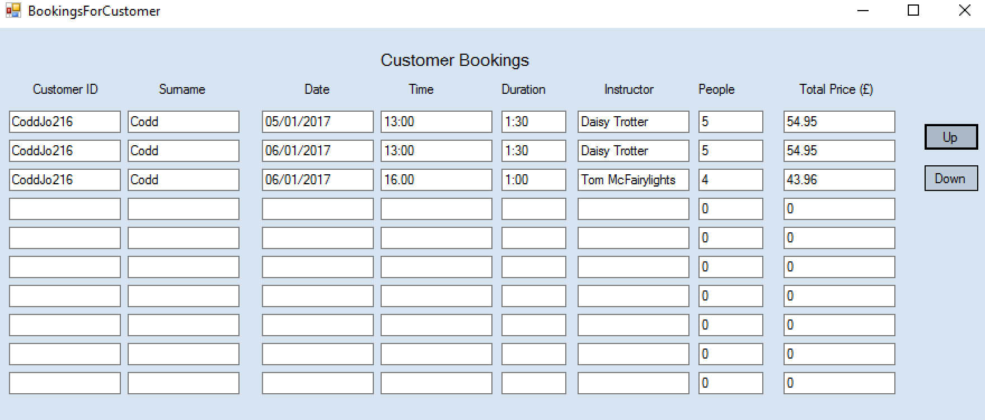
When the up button is pressed the record/s successfully move up.

3.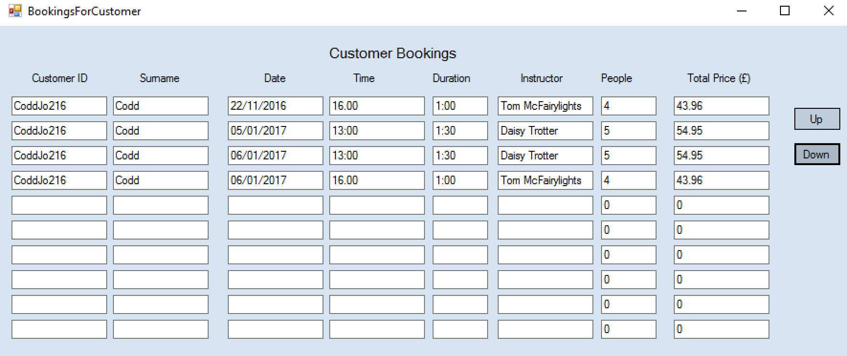
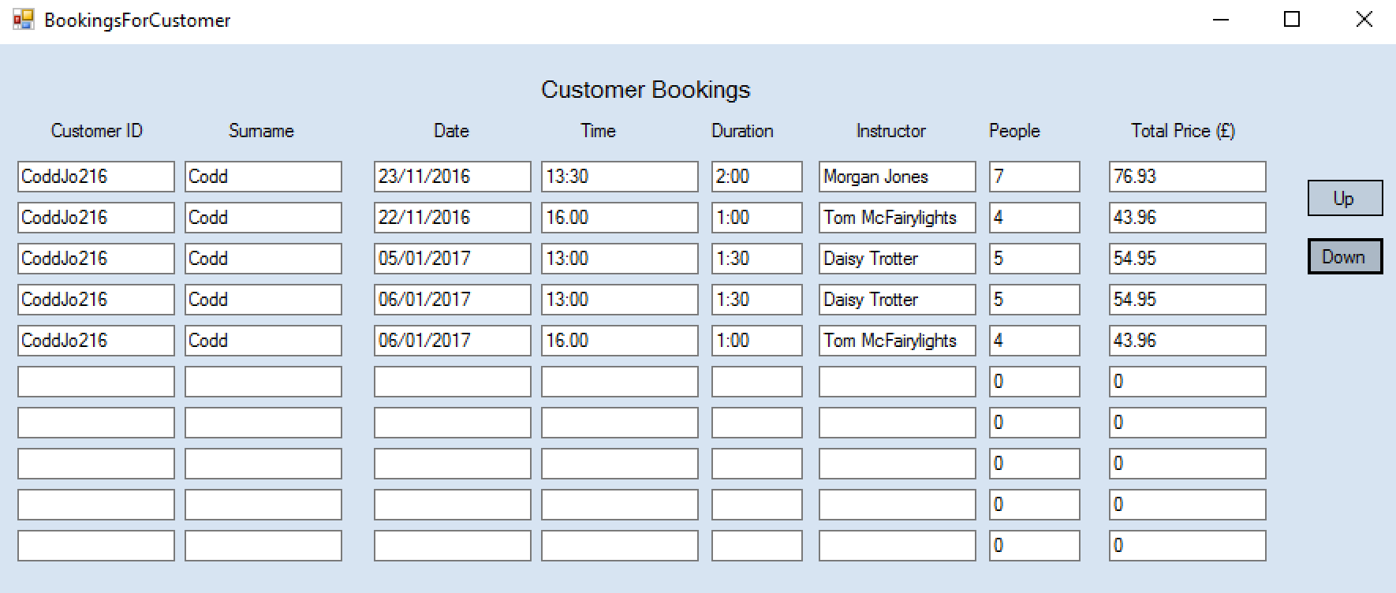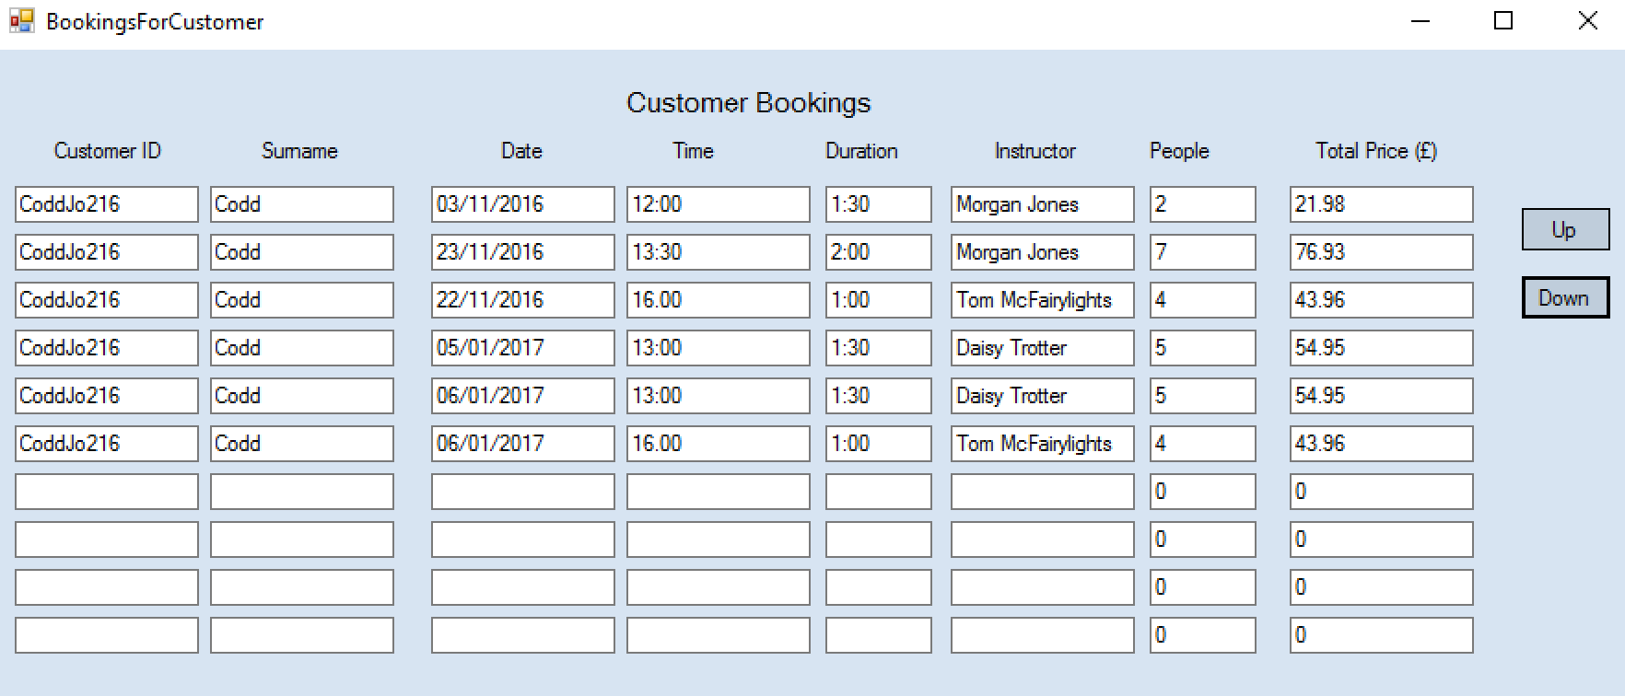
When the down button is selected then the records move back down. Therefore this search bookings form all works correctly.

Test 63 + 64
I am going to test the add product form to ensure it saves and that a unique ID is assigned. To conduct the first test I will add a product and ensure it saves. As part of the second test I will also ensure a ID is assigned automatically once saved.
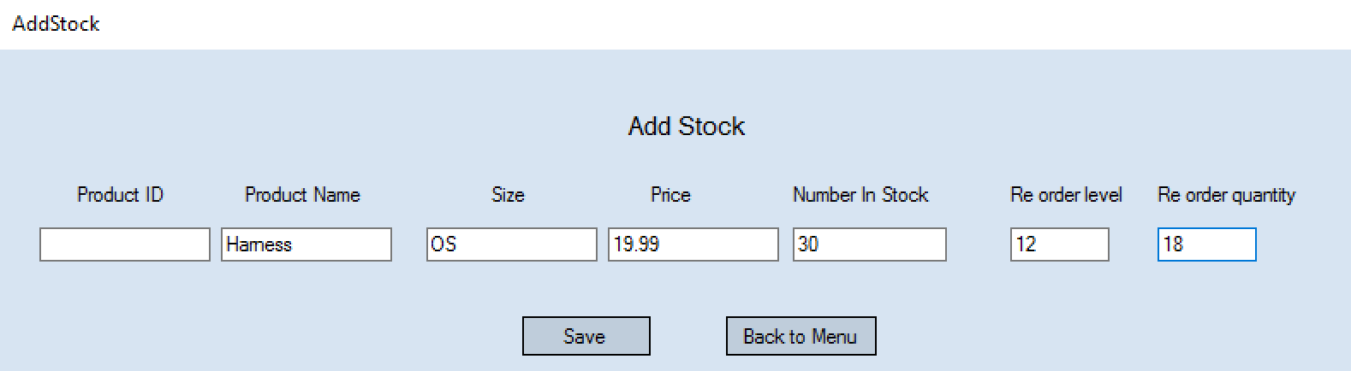
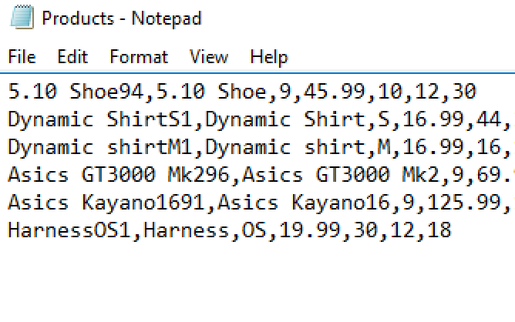
As seen above the record does successfully save and a ID is assigned to it. An improvement I could make here is to remove the Product ID textbox from the add stock form. I should do this to avoid confusion, as the id is not actually written/displayed in it. The ID is automatically saved when the other product info is.

Test 65
For this test I am going to ensure the edit products form displays all products. To test this I will open the form and the file and look to make sure all records are displayed.
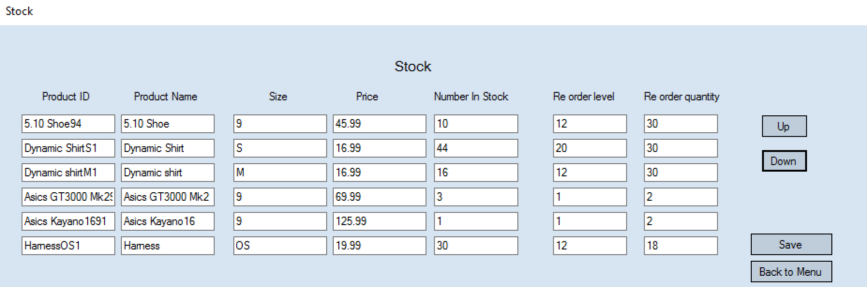
The edit stock form does display all products as can be seen above. Therefore this test was successful.

Test 66 + 67
For this test I will be checking to ensure that the up and down buttons on the edit stock form work correctly. To test this I will click the buttons and make sure the records either move up or down correctly.

1.
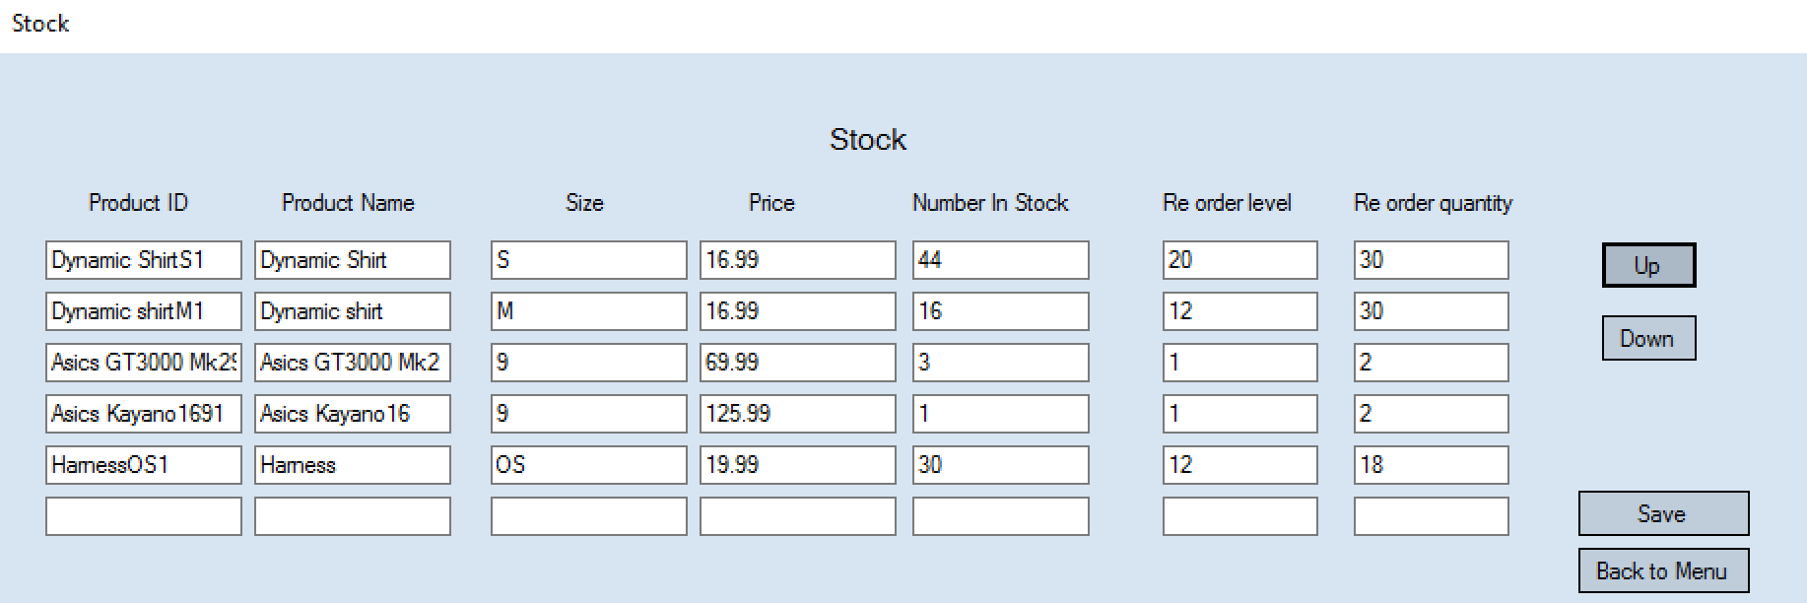
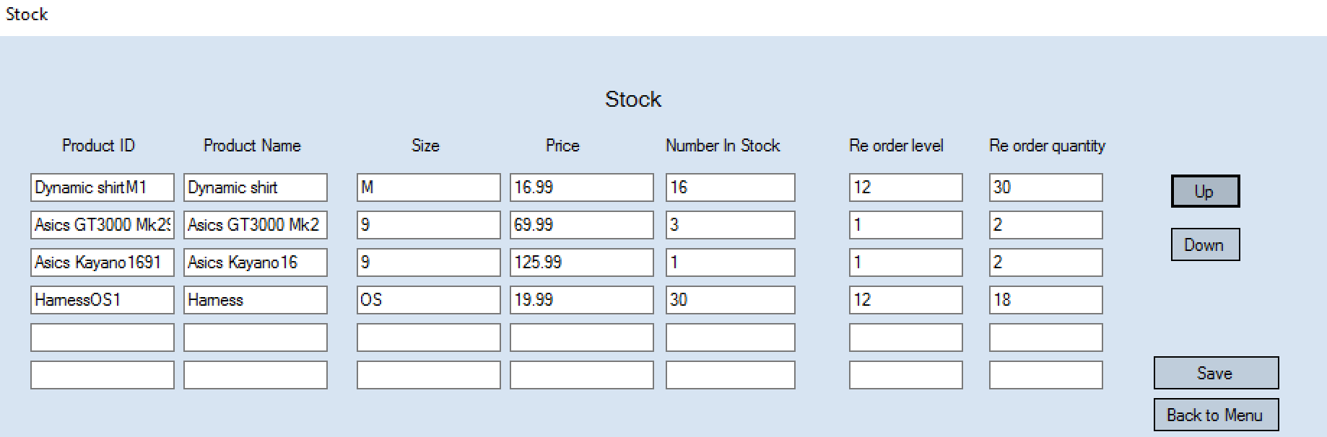

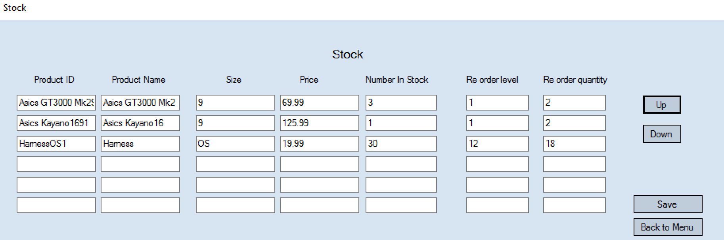
As seen in the pictures above the up button works as designed as it successfully moves the records up.

2.
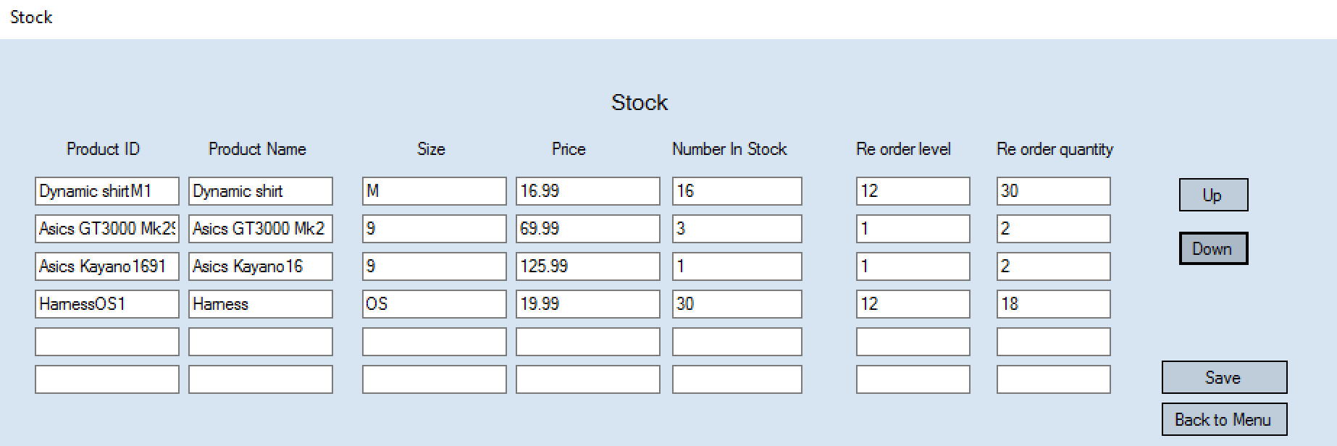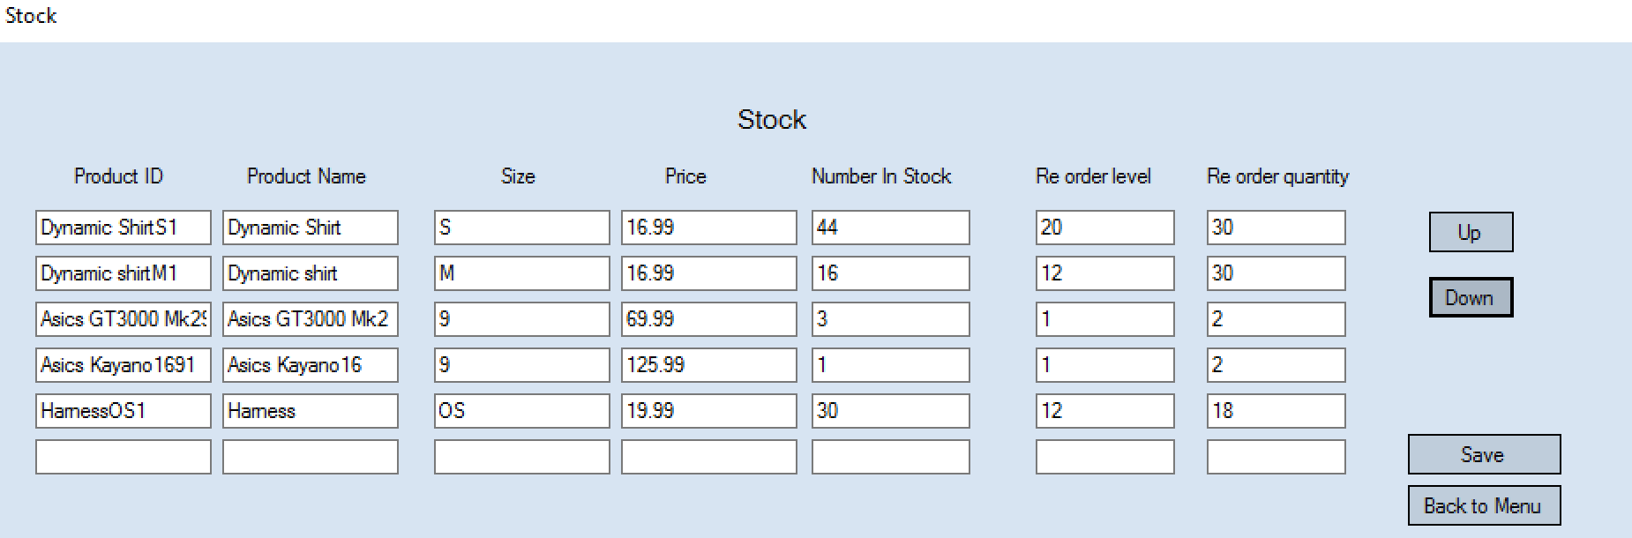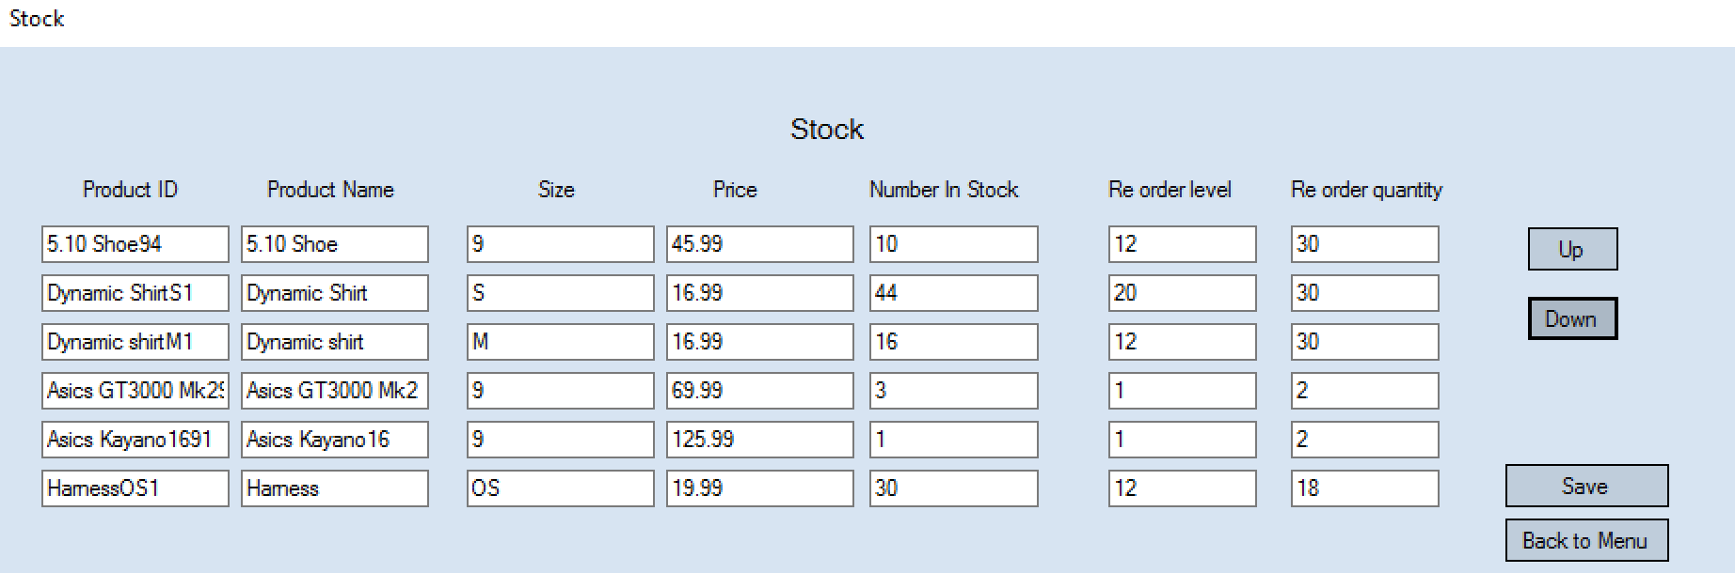
As seen in the pictures above the down button works as designed as it successfully moves the records back down.

Test 68
For this test I am going to ensure that the edit products successfully has the ability for products to be edited and saved back. To test this I am going to change the size of the 5.10 shoe from size 9 to size 10 and click save. I will then check in the products file to check that its been changed and saved.
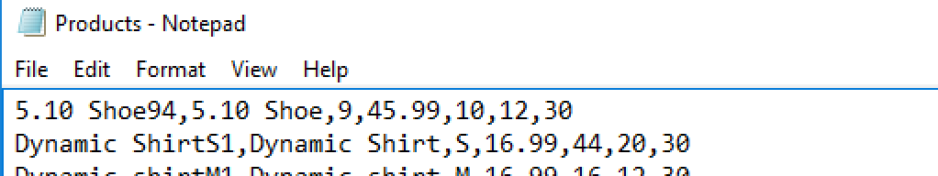
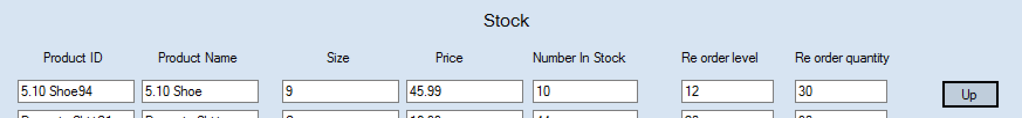
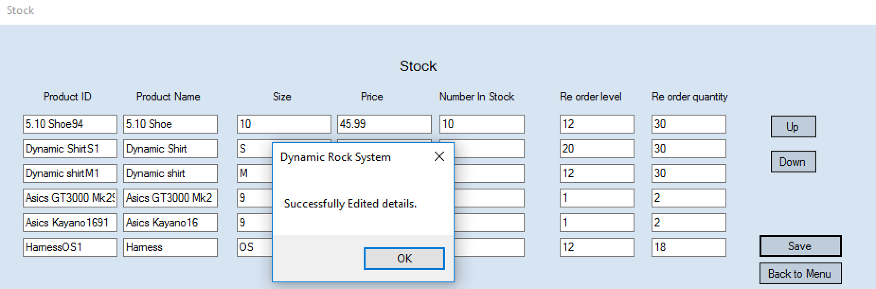
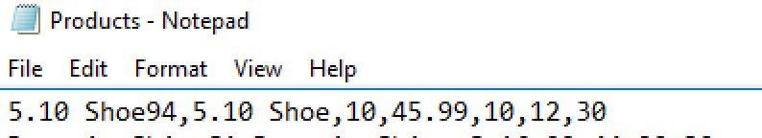
As seen in the above pictured the product was edited and saved back successfully. Therefore the edit stock form all works well and correctly.

Test 69 + 70
For these tests I am going to test to see if the combo boxes on the sales form are populated. To do this I am first going to select the product combo box and ensure all products in the product file are within the combo box. I will then test the quantity combo box to ensure that is populated with numbers.

1.
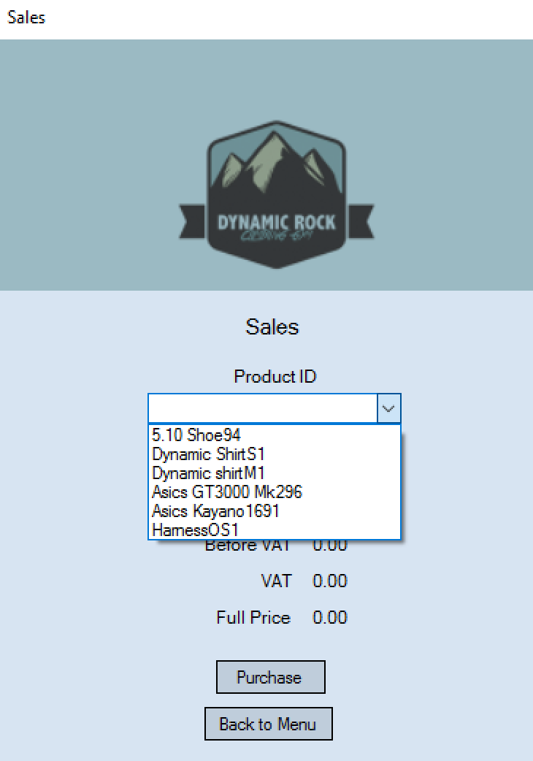

As seen in the pictures above the product combo box is populated correctly with all the products from the products file.
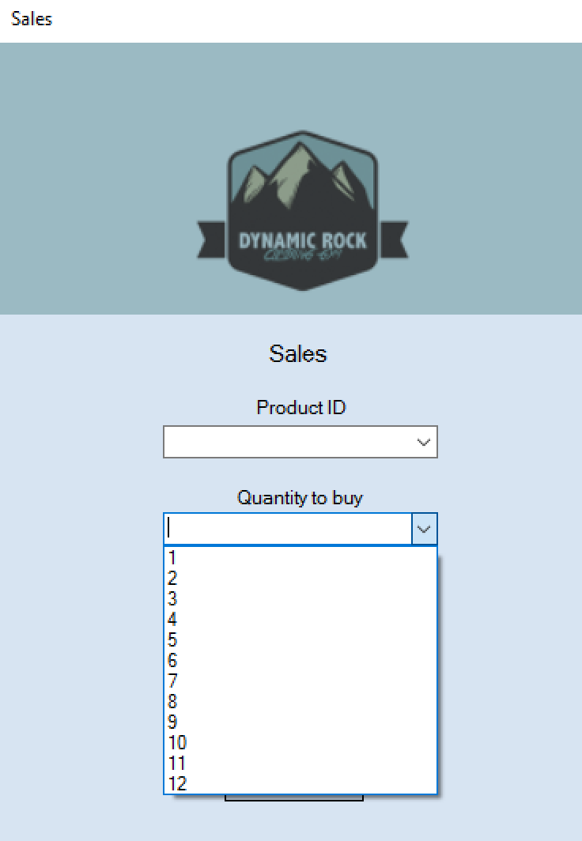
2.

The quantity box is populated with correct numbers so therefore these combo boxes work correctly.
Test 71
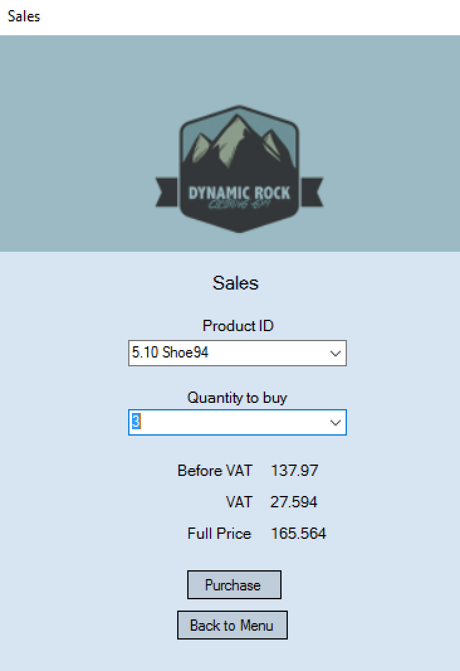
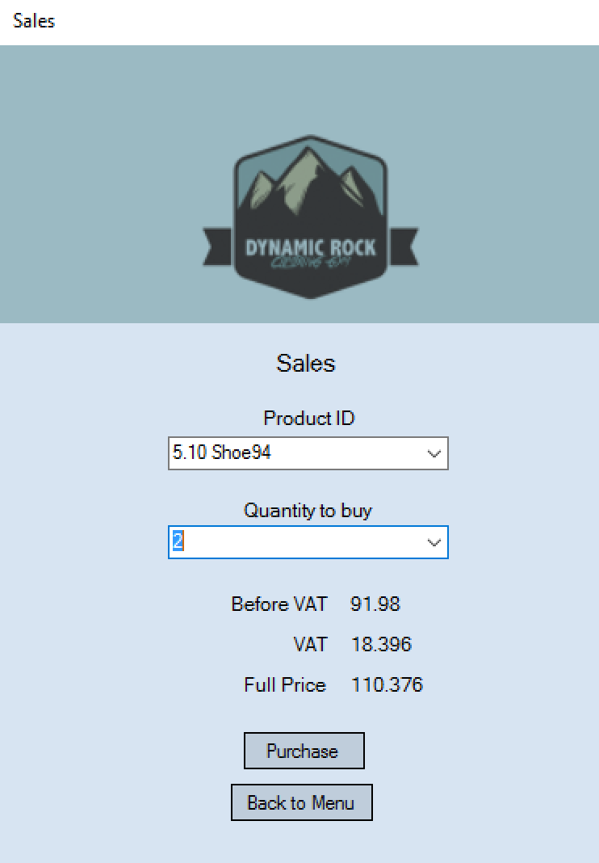
I am now going to test to see if the calculations such as price are displayed correctly as soon as both combo boxes have been selected correctly. To do this test I will select both combo boxes with information and see if the calculations are correct by checking the product price in the product file.
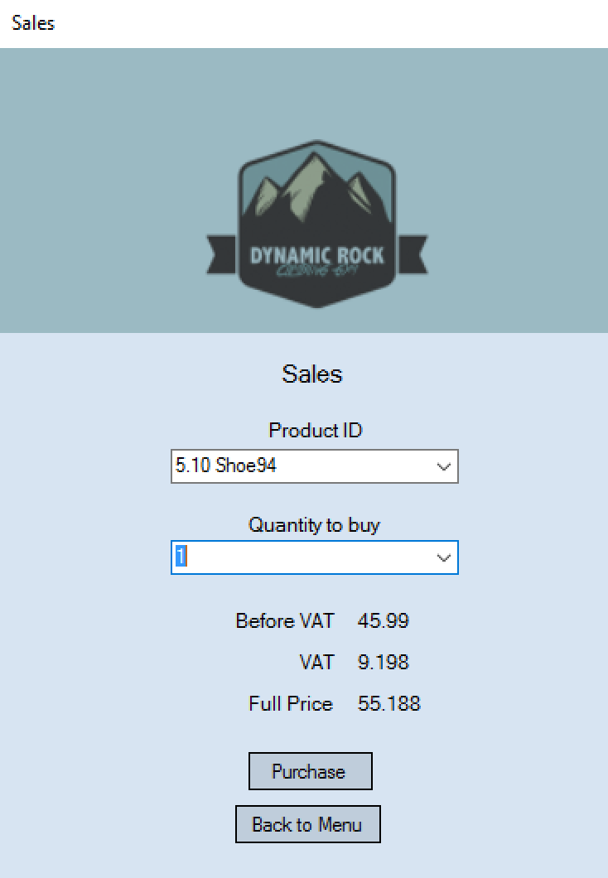

The calculations automatically update once each combo box is changed. The calculations are also correct.

Test 72
I am now going to test to make sure the quantity selected in the combo box is taken of the number in stock of the product also selected in the sales form. To test this I am going to select the 5.10 shoe and select the quantity to 3. I will then click purchase and check to see if the quantity has been removed.
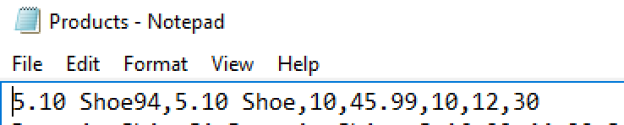

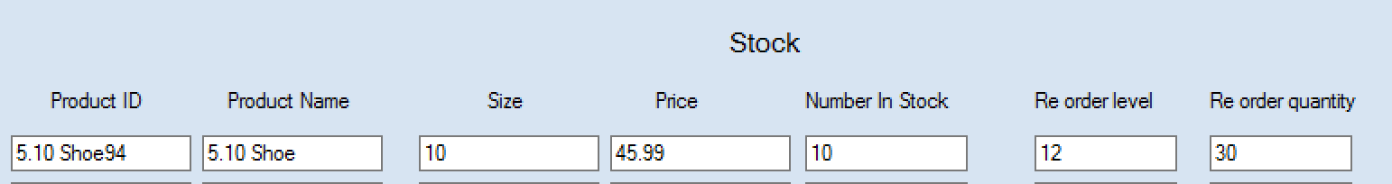

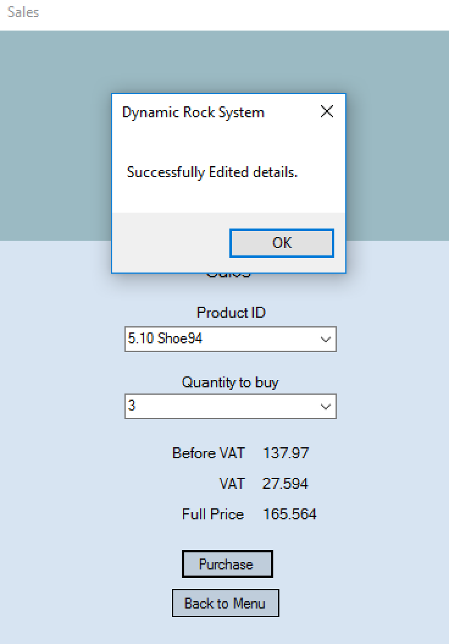
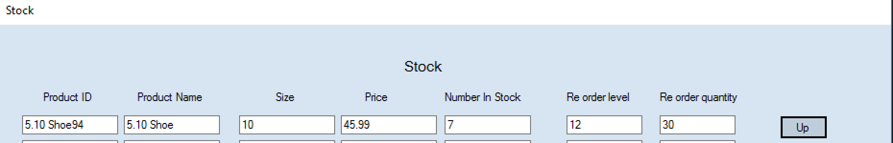
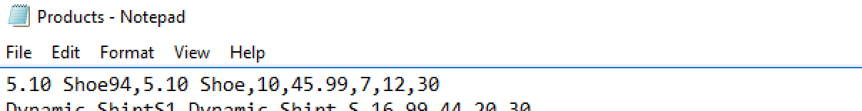
As seen above the number in stock was successfully decreased by the quantity purchased in the sales form. Therefore the sales form works correctly and very successfully.
Test 73
I am now going to test to ensure the re order form shows all products that’s number in stock is lower than the re order level. To do this I will look at the edit form to see what products should be on the re order list. I will then go to the re order form and ensure all of these products are displayed.
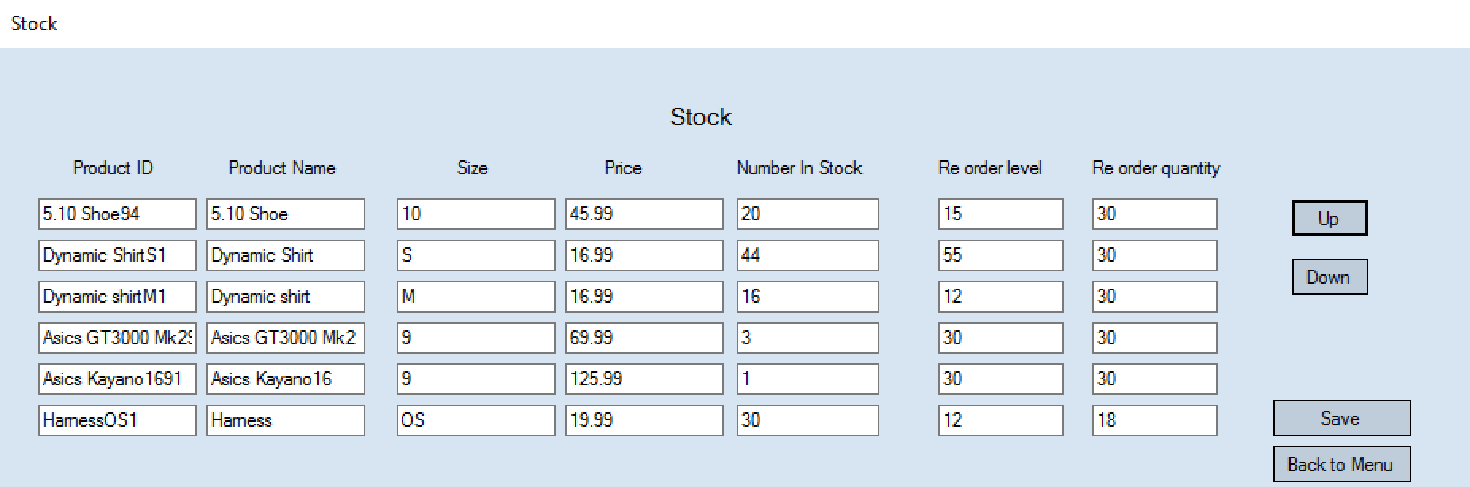
As their number in stock is lower than their re order level, both Asics shoes and the Dynamic ShirtS1 should be on the re order form.
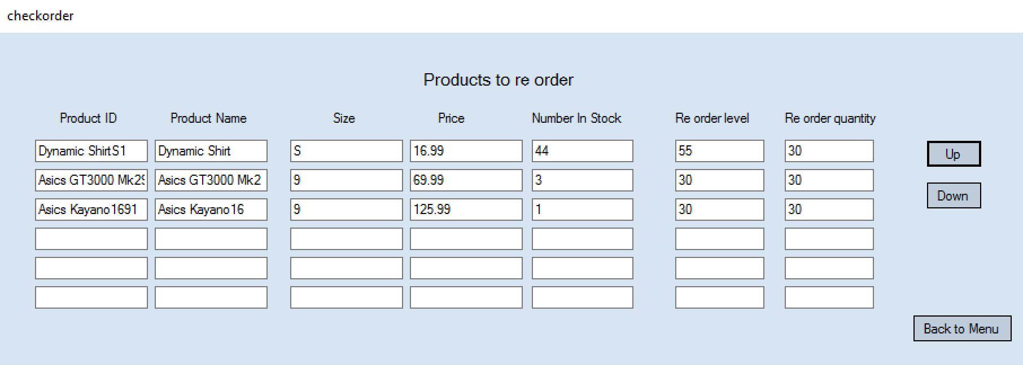
The test shows that the re order form works as all products that’s number in stock is less than their re order level are displayed.

Test 74 + 75
This test will be to ensure that the up and down buttons on the re-order form, work correctly. To test this I will click both buttons and look to see if the records move up and down correctly.
1.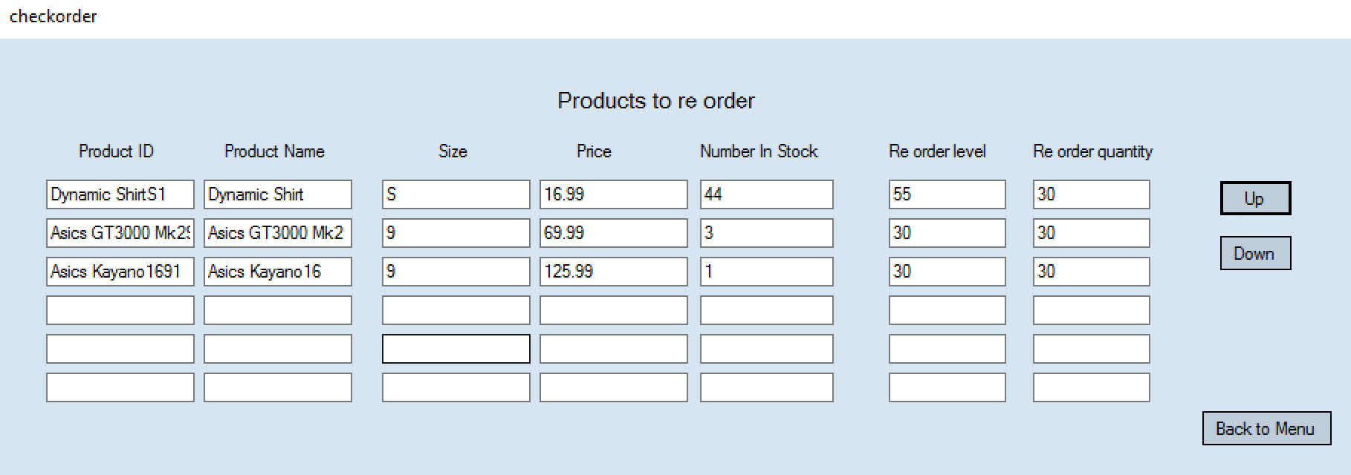
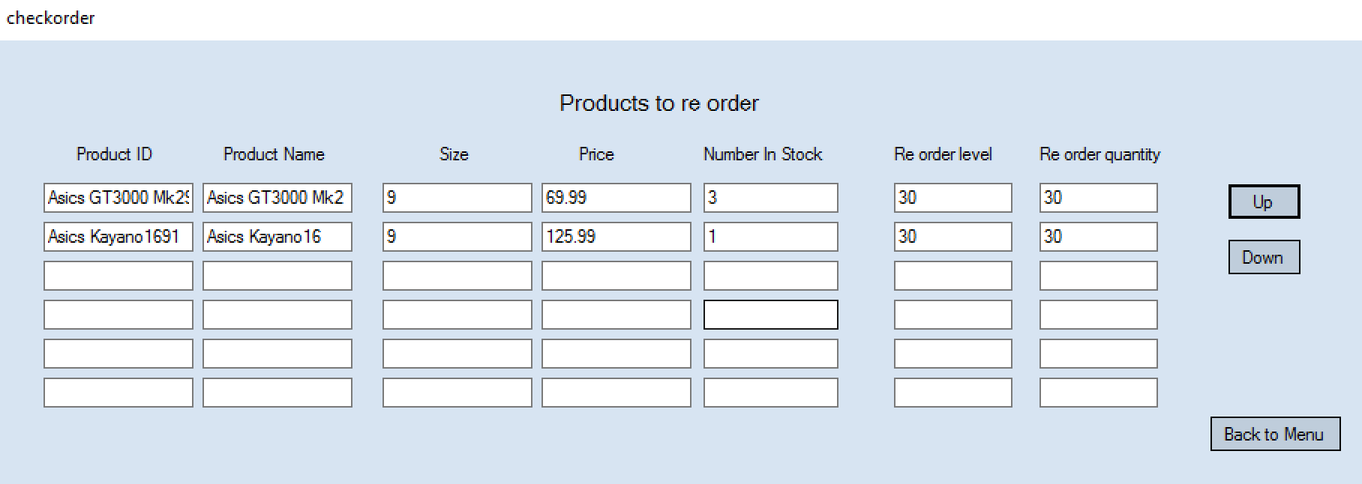

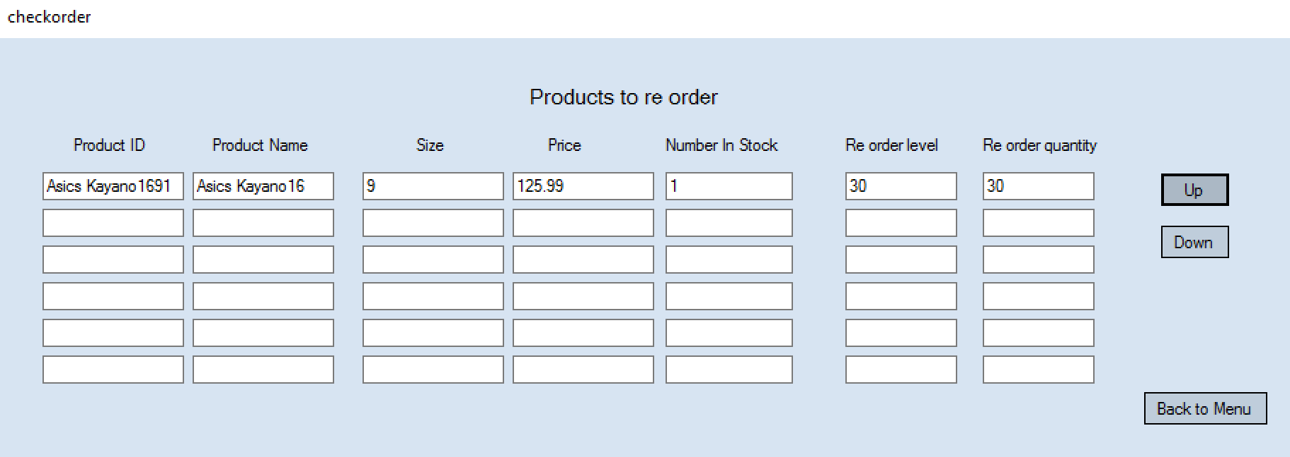
As seen above the up button does work. When the button is pressed the records move up correctly, as they were intended to.

2.
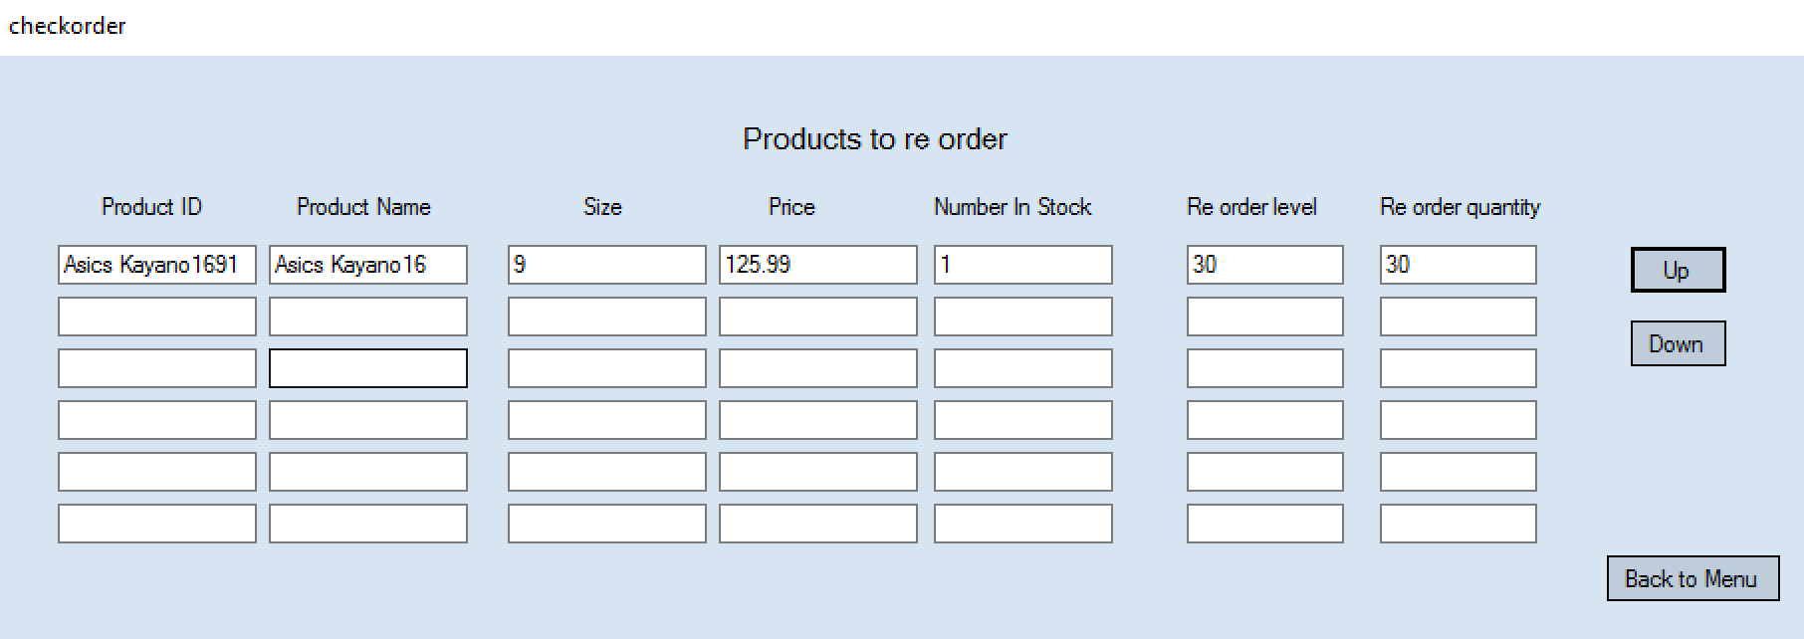
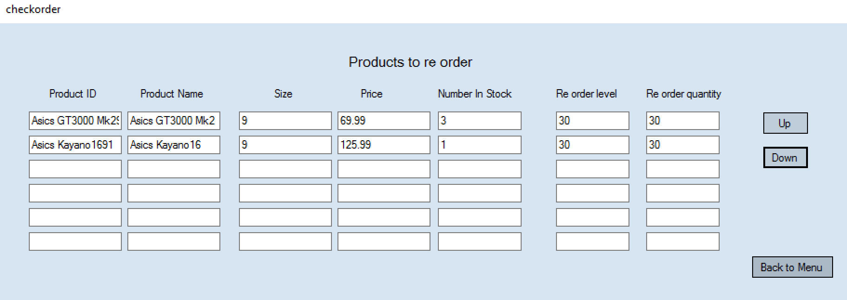
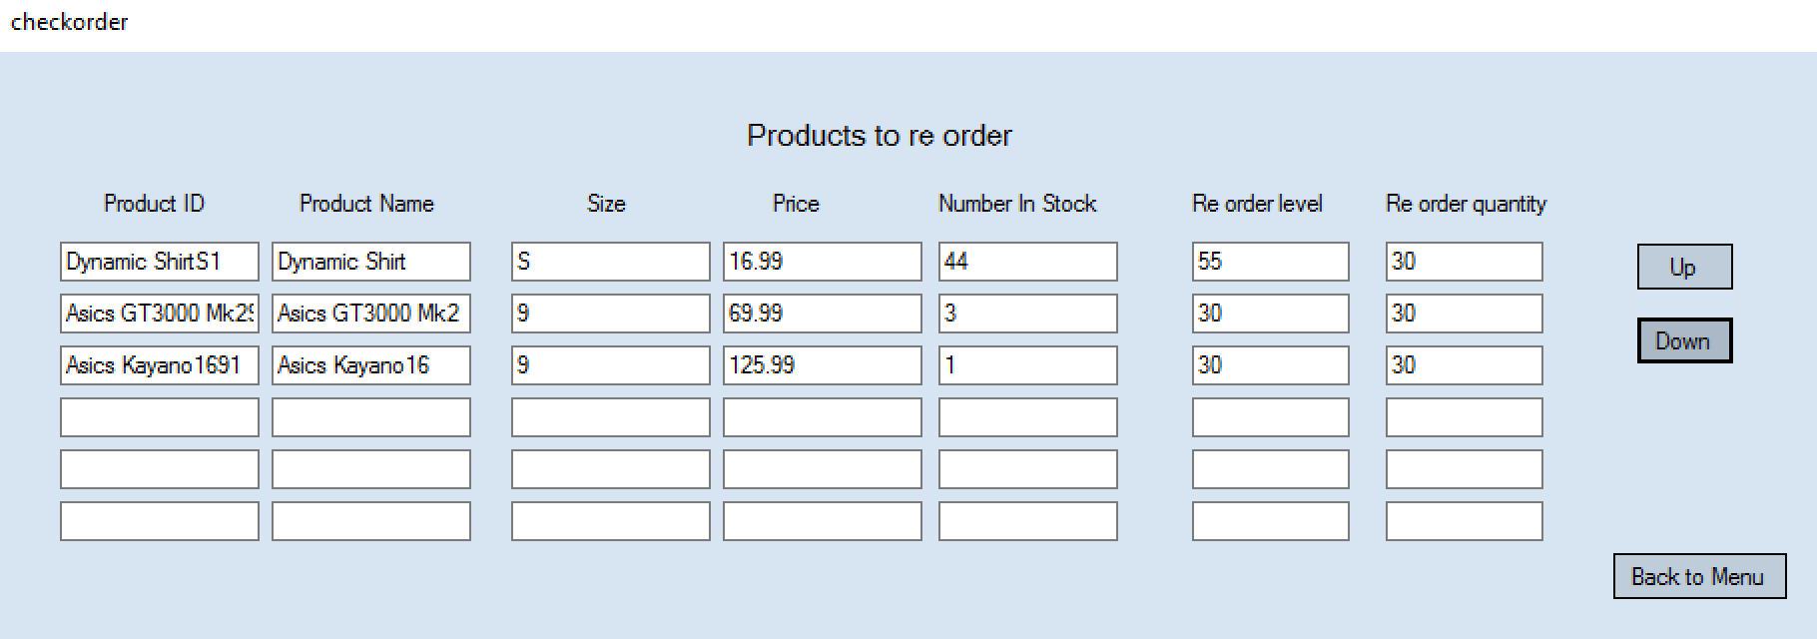
As seen above the down button does work. When the button is pressed the records move down correctly, as they were intended to.

Test 76
This test is to make sure that the items shown on the re order form are automatically saved into the re order list file. I will do this by checking the re order form and then checking the re order file to make sure that all items on the form are in the file.
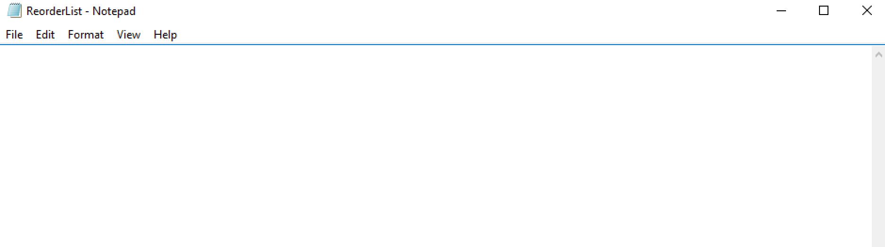

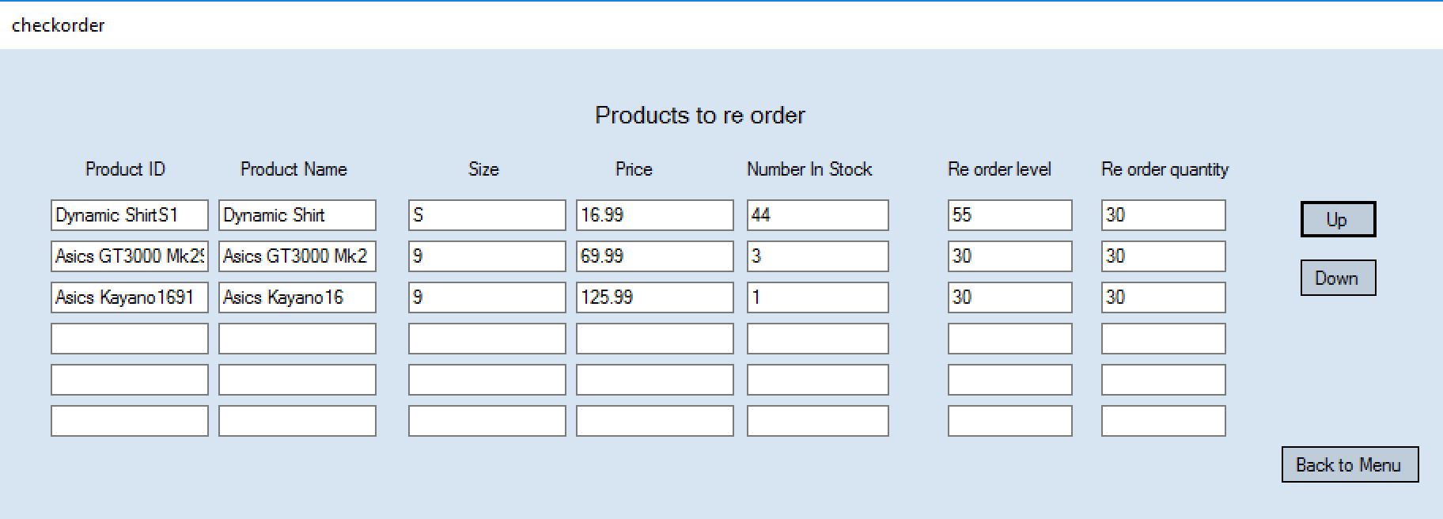
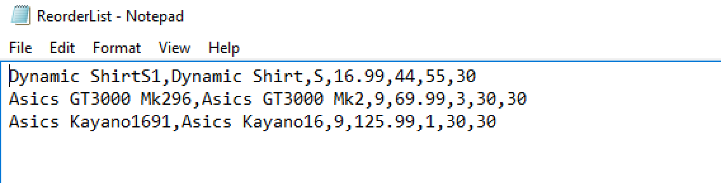
The re order list automatically saved when I opened the re order form. The list contained all information shown on the re order form. Therefore the re order file and form work as intended and correctly.

Test 77
I am now going to test the NICAS form on the staff menu. I am going to test if the instructor sign off drop down list is populated with instructor’s names. I will test this by selecting the combo box and looking at the data it contains.
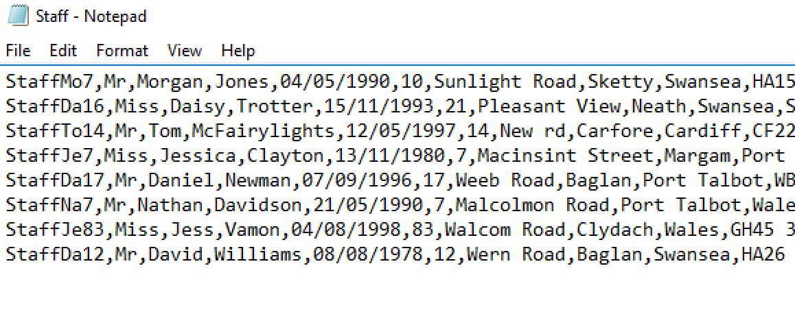
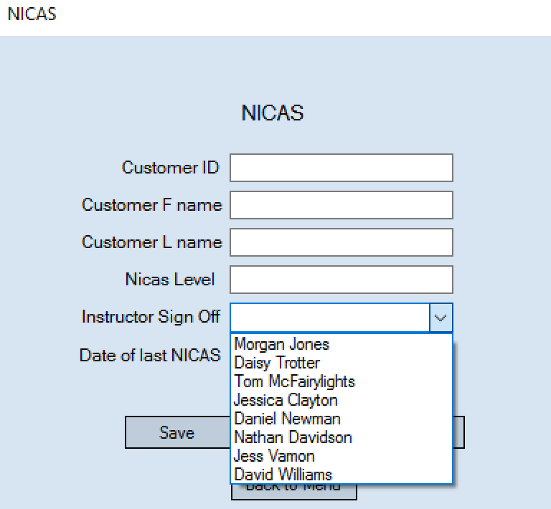
The drop down list is correctly populated with all staff names.

Test 78
I am now going to test the automatic search that should be performed when typing into the customer id text box on the NICAS form. I am going to test this by typing in a customers id and seeing if the search is performed and data is displayed.
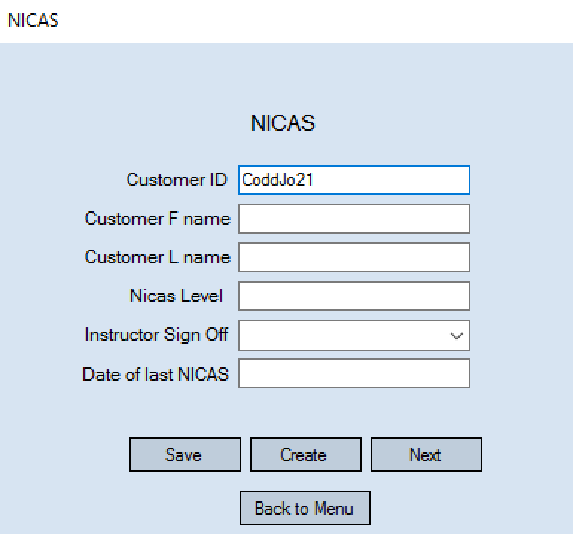
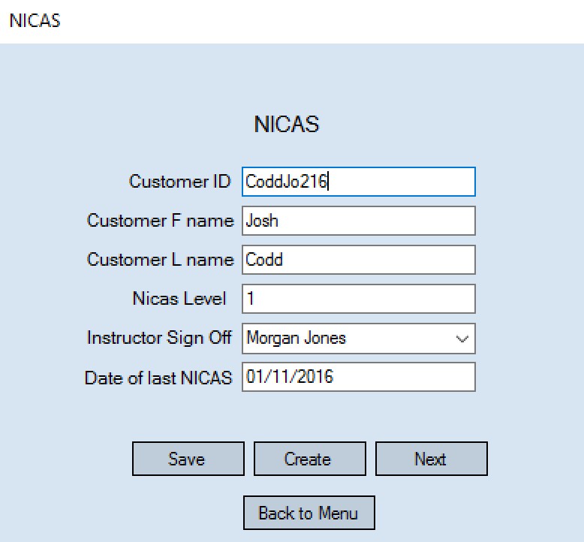
As soon as the full id is entered into the text box then the information is displayed. If the id does not match then the textboxes are left blank as seen above.

Test 79
I am now going to test to see if the feature of editing an existing NICAS record works and is saved. I am going to test this by updating a NICAS level of a customers to the next level and checking it saves.
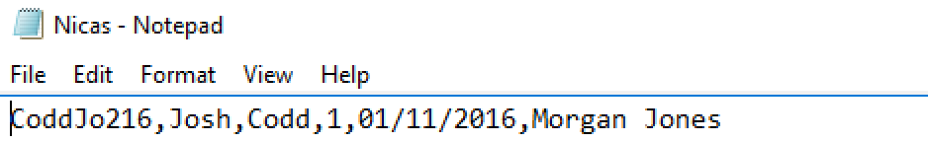
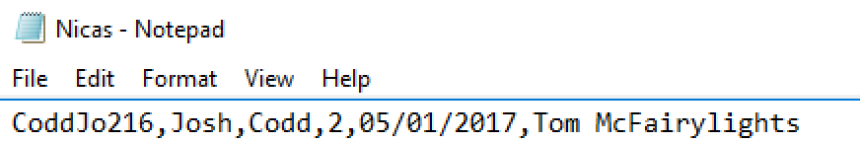
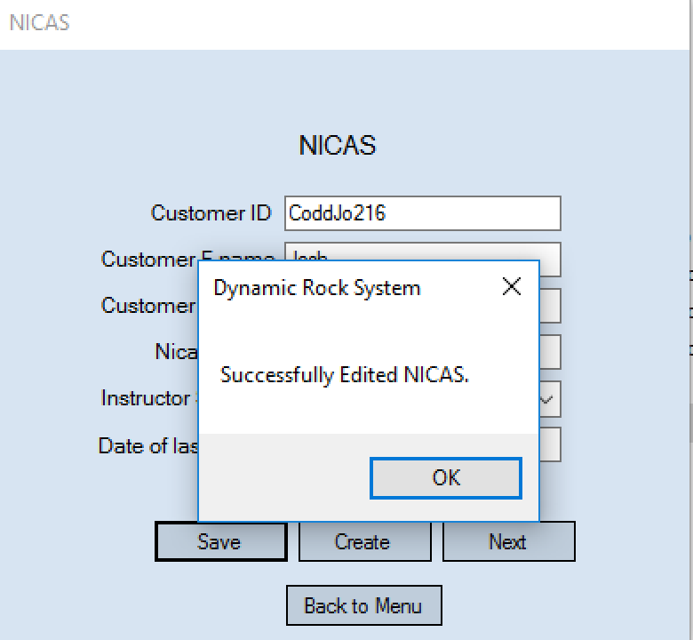
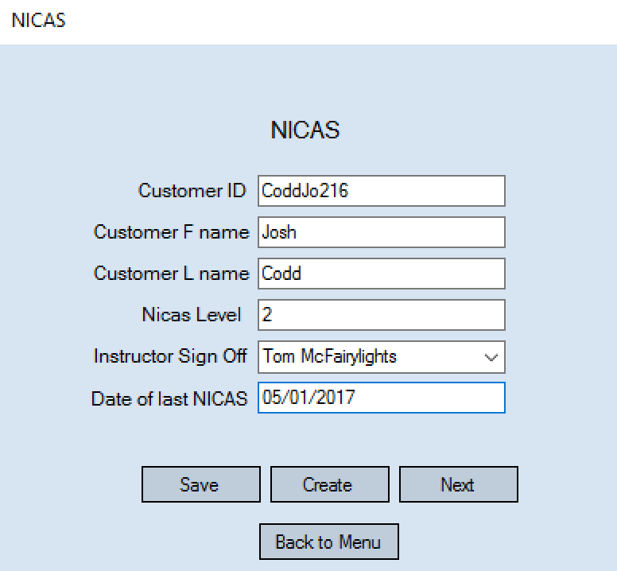

As seen above I updated the level of a customer. The new level and data was successfully saved.

Test 80
I am now going to test to ensure the Create NICAS form opens when the create button is selected. I will do this by selecting the button and seeing if the Create form opens.
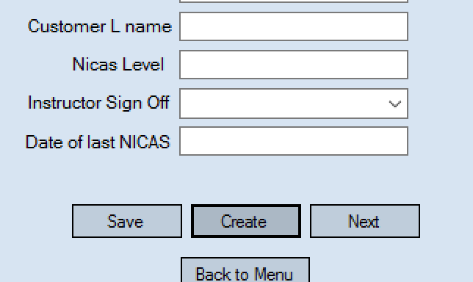
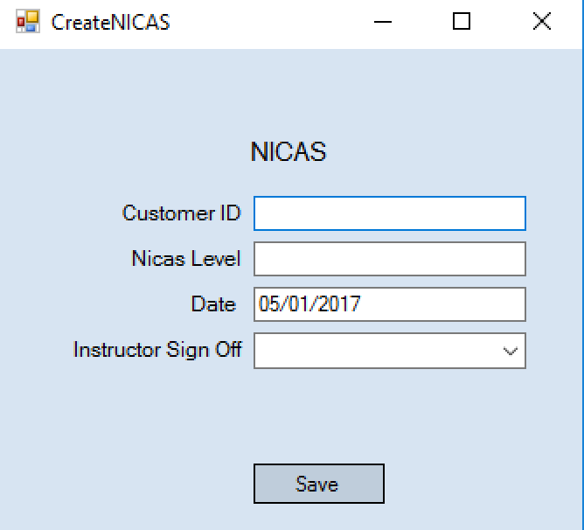
When selected the Create NICAS form successfully opened.
Test 81
I am now going to test to ensure the Date that automatically appears in the date text box is todays date. I will do this by opening the form and checking that it is todays date.
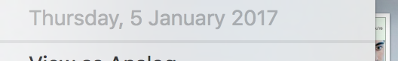
The date is today’s date which is correct.

Test 82
I am now going to test to ensure the instructor sign off box is populated with all staff member’s names. I will do this by looking in the staff file and the instructor sign off combo box to check that all staff members are there.
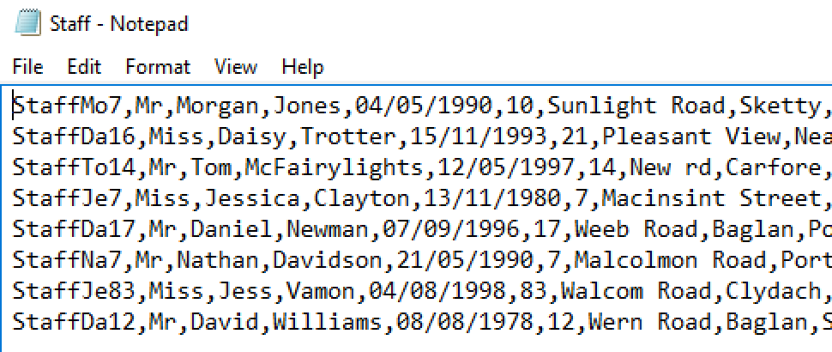
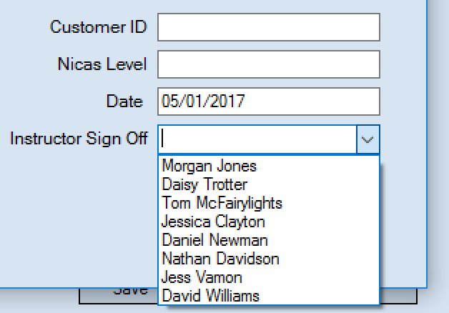
As seen above the combo box is populated with all of the staff member’s names.
Test 83
This test will be to check if the create NICAS form will save a new NICAS record. I will test this by filling in the Create form and saving it. I will then check the NICAS file to see if it was saved successfully.
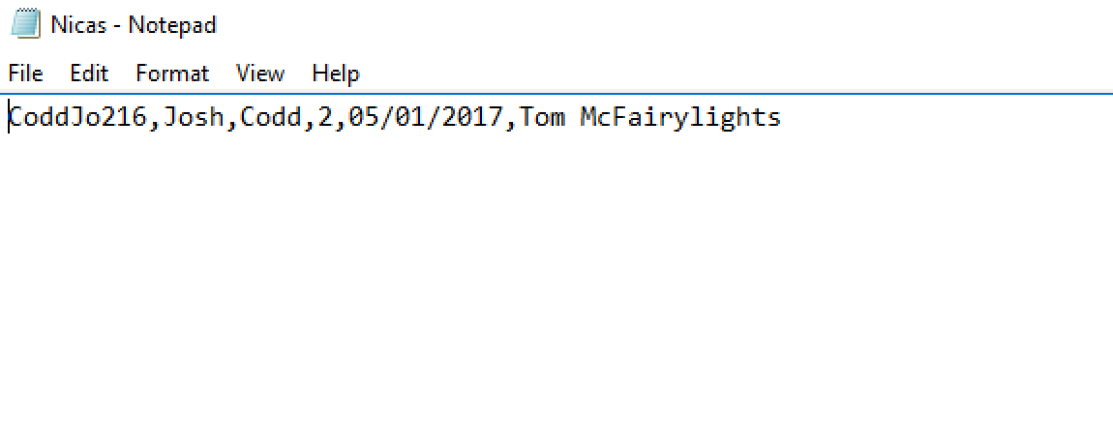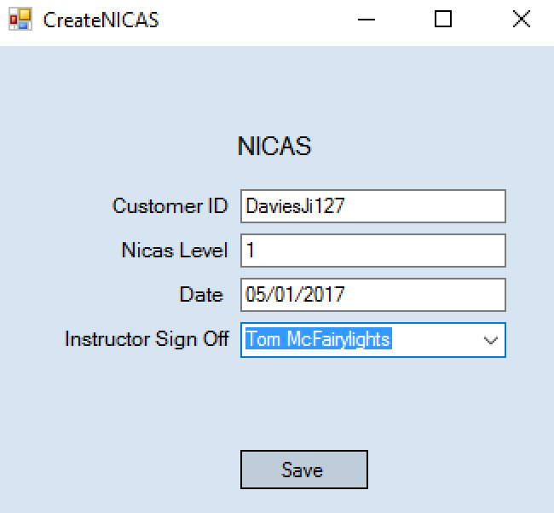
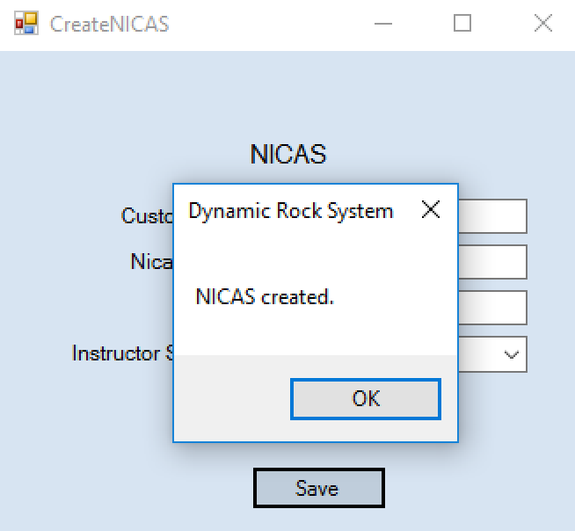
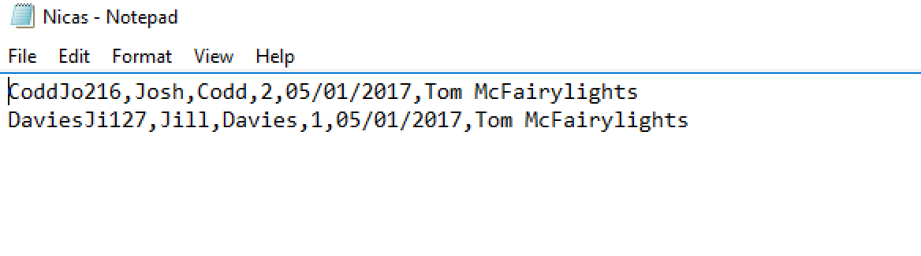
As seen above when a new NICAS record is created then it will be successfully saved. Therefore the create NICAS and NICAS forms both work as designed and correctly.
Improvements to refine Dynamic Rock System derived from testing
Within test 80 you can see a next button on the create form. During this testing phase I discovered that this has no real function or is not needed. Therefore to refine this part of the system I will remove the button to avoid possible confusion.
Another refinement to be made is visible in test 63 + 64. This refinement would be to remove the Product ID text box. I feel this text box would cause confusion as the user might think that they have to fill it in when really you have to leave it blank. Even when left blank nothing is ever displayed within the textbox. This is because the ID is just automatically generated and saved into the Product file once save has been clicked.
Another refinement I have noticed within this testing is visible in test 26. I would remove the payroll and staff id textbox as yet again these are to be left blank and are only filled in after once calculate ID has been selected.
Instead of removing this I am going to instead just remove the button to calculate ID’s and have them automatically be calculated one all the relevant text boxes have been filled in.
I would then move the ID text boxes to the bottom of the form so that they will already be calculated as the form is filled in from top to bottom. This will remove confusion by having to leave the ID text box at the top blank.
Another refinement I would make is visible in test 80. It would be to add more combo boxes as a form of validation I would use a combo box as the NICAS level so only the numbers 1 to 16 can be selected. This would make filling this in easier and avoid invalid NICAS level figures past 16.
Another refinement I am going to make that I have noticed during testing is to change the message box text shown when presence checks are flagged. I am going to change the text to tell the user what information is missing instead of just “Information missing”. For example the message box would then read “E-mail address missing”. I noticed this as it is more accurate and helps the user fix their information entered.
As seen in test 41, to view payroll files you have to look in the payroll file. To make these easier to view I am going to make a form to search and view payroll records. This would make it easier to find specific records after time when there are hundreds of payroll files saved.
When testing I realised that on the menu’s buttons ‘close’ and ‘log out’ both do the same thing of just closing the window. To refine this I will remove the close buttons so that there is just a log out button as this is all that’s needed, reduces clutter on forms and also avoids confusion between buttons.

