Prototype

Start

Welcome Screen
Log in screen
Staff
Admin
Customer
Your details (for customers)
Book a session
Bookings
NICAS
Your details
(for staff)
Customer Details
Stock Check
Staff Details
Log in confirm
View all/edit
Add new
View all/search
Add
New
View
-
Search
-
Edit
Log in confirm
View/edit
View / Search
Add
New
View
-
Edit
Add
New
View
-
Search
-
Edit
Forgot Password
New customer
Back to log in
Back to log in
Payroll
Add new
Print payslip

Key : Highlight – Areas included in prototype
Solution for prototype

The reason and aim for completing a prototype program for Dynamic rock is so that the business can ensure that the programs direction meets their standards before the full program has been made. The prototype of the system will also enable the business to suggest any changes to be made in-case they want the program to have any other features. As well as giving time for changes it also allows the staff at Dynamic Rock to become more familiar with the system by using it more.

In order for the system to give an accurate early representation of what the final version will be like the prototype must cover sufficient areas of the system. It is important to give an accurate representation so that it is realistic and therefore any suggestions can be made beforehand instead of the company being disappointed with the final product. The above diagram shows the areas of the program that I have decided to include in the prototype of my system for Dynamic Rock. I have decided to include all of the aspects that cover the customer section of the program. I have chosen to do this as it includes the majority of features also available for staff but just in customer terms instead of the staffs.

I have decided to create the log in form for my prototype but not include the actual log in system. Instead am going to include buttons that lead to the customer and staff menu for quick access. I do not feel it is necessary to include the log in system as it is only used for security which will not be needed for the prototype. By including the log in system it would take a lot of time to test the prototype as you would have to keep checking log in users and passwords to log in each time. By just using buttons it allows both menu’s to be accessed quickly and efficiently to allow the program to be tested to the best standard. As I am not creating staff details in this prototype then I would not be able to log in to the staff menu as there would be no accounts to use.

I have decided not to include the staff aspect of the program in my prototype as a lot of the features for staff such as editing staff details can be seen in editing customer details. I therefore do not feel it is necessary for this to be included in the prototype.

I am also not going to add any admin features in my prototype. This is because both of the admin features require the staff portion of the program to be running. Therefore, the admin section would not work due to the staff section not being implemented yet.

I am also not going to add any professional looking design such as the logo or a color scheme to buttons and the backgrounds of forms. I am not doing this as I feel it does not affect how the system works and is something that I will add as I begin to develop the full system.

Solution for prototype

Navigating to menus from the log in screen
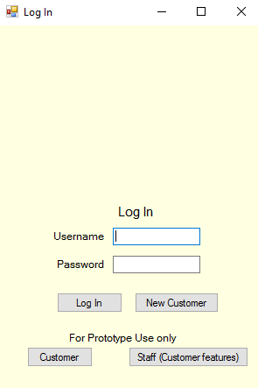

The first form displayed on the system is the log in form. This is where users will navigate to the menus. For the prototype, the only functions that are working on this form is the New Customer button, Customer button and Staff button.

The New customer button will direct the user to the add a customer form so that they can add a customer.

The customer button will direct the customer to the customer menu.

The Staff button will direct the user to the staff menu.

When the log in button is pressed a message is displayed so that the user knows this section does not work for the prototype.

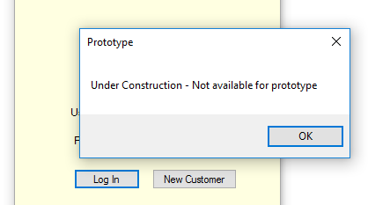

Adding a new customer

- To add a new customer, the add customer form needs to be opened. This is done by clicking the button labeled ‘new customer’ on the log in form.

- The customer/user should then input their information in the textboxes. The information should be that of the label placed next to each textbox. The information should be valid. I will ensure this is valid by placing validation checks in the full program.

- Information does not have to be entered into the parental number and medical information field. This is because parental number is only needed for children under 16 and not all users will have medical information. Therefore, these fields should be left blank under these circumstances.

- Once valid information has been added the user should click the save button. This will save the details of the customer.

- A message box will be displayed ensuring the user that their details have been saved. The message box will also display the unique customer ID that they will use to log in. The customer ID is derived from various parts of their information that they have entered.

- The new customer form is then closed automatically.

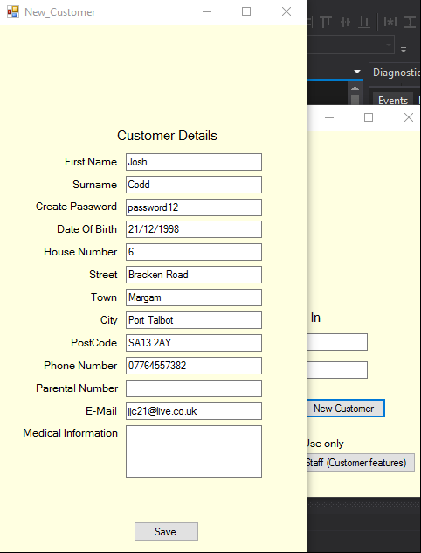
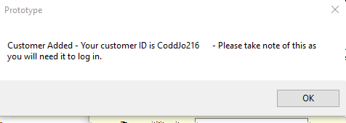
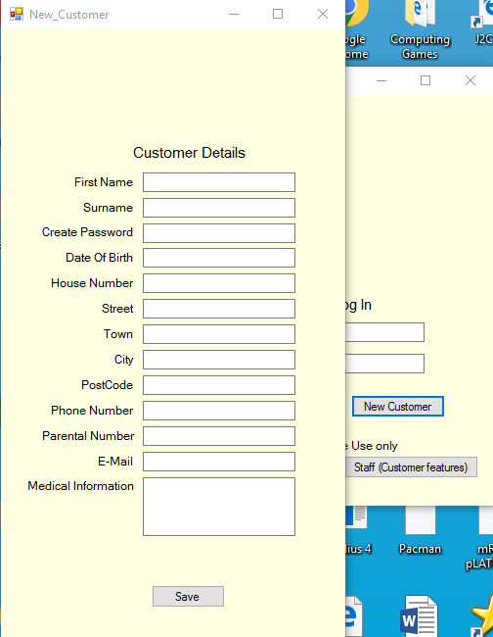
An example of the message box displayed when save is clicked.
An example of a completed and valid customer details form – before save has been clicked.
Once the new customer button has been clicked.

Accessing and navigating around the Customer Menu
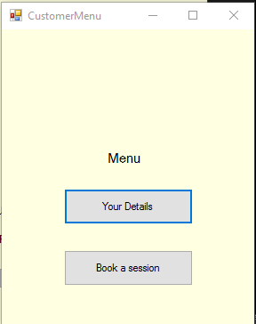
- To access the Customer Menu in the prototype the user must click on the ‘Customer’ button at the bottom of the log in form. This is just for the prototype as in the full program the customer would just log in using the text boxes and the relevant menu would be displayed.

- Once the customer button has been clicked the Customer Menu will open.

- The customer menu has two buttons that when clicked will allow you to access the customer features of the system. The features that can be accessed as a customer are ‘Your Details’ and ‘Book a session’.

The customer menu

How a customer can edit and view their own details
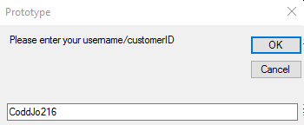
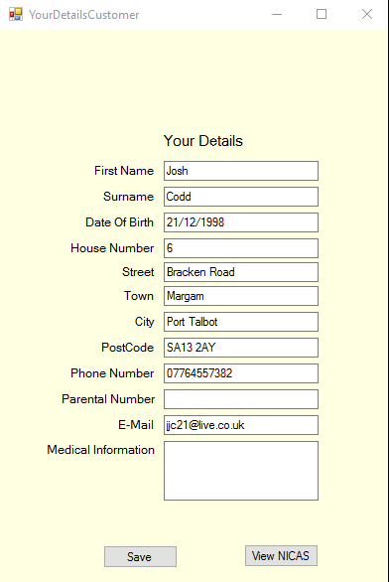
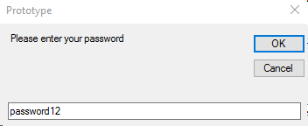
A successfully found ‘Your Details’ form
The password input box
The customer id input box
- For a customer to edit/view their own details they need to open up the ‘Your Details’ form from the customer menu. The form is opened by clicking the button labeled ‘Your Details’.

- Once the ‘Your Details’ button has been clicked then a series of two input boxes will be displayed.

- The first input box will require the customer to enter their ID.

- The second input box will require the customer to enter their password.

- If both of the details entered are correct and match an existing customer account, then that customer’s details will be displayed in the ‘your details’ form that will open automatically. If the details are not correct or the user cannot be found, then the ‘Your Details’ form will still open but the information will be blank.

- To edit your details then just change the information in the textbox to the updated information and then press the save button.

- A message box will be displayed to ensure the customer that their details have been successfully edited.

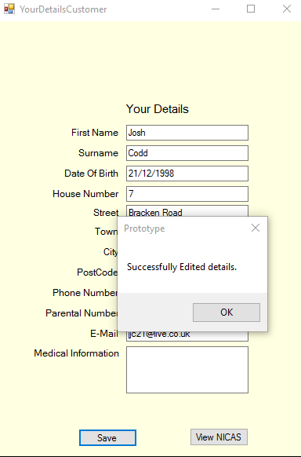
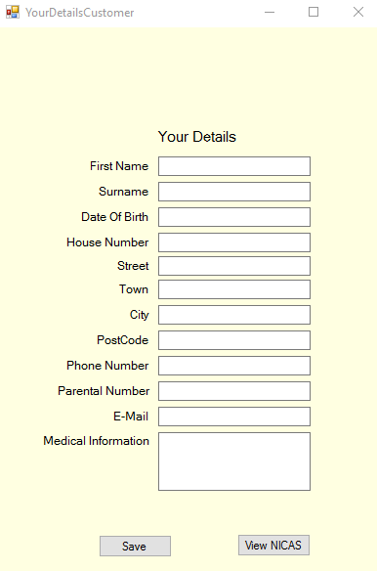
An unsuccessfully found ‘Your Details’ form
Message box displayed after updating the house number from 6 to 7

How a customer can view their NICAS details

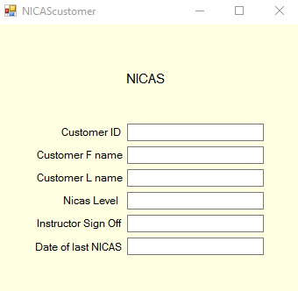
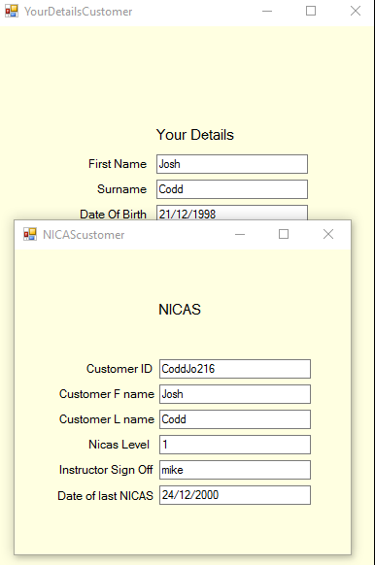
A NICAS form being viewed if customer is no registered to the NICAS program. In this case they should speak to a member of staff to register them
- For a customer to view their NICAS details then they must first open their ‘Your Details’ form successfully.

- Once the ‘Your Details’ form has been opened successfully then the customer should click the ‘View NICAS’ button. This is located towards the bottom of the Your Details form.

- If a customer has been registered for NICAS by a staff member then their NICAS information should be displayed on the NICAS form.

- If the customer has not been registered for NICAS by staff, then the form will be blank. In this case the customer should speak to a staff member so that they can register them for the NICAS program. Their information will then be displayed on this form.

A successfully registered NICAS form being viewed by customer
How a customer can make a booking to climb
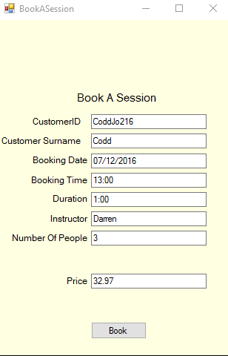
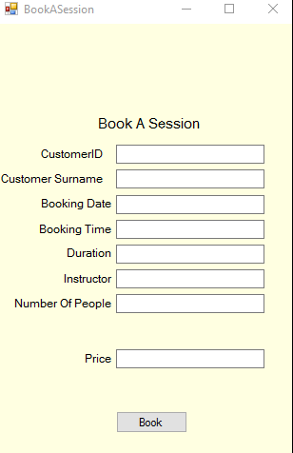
- For a customer to make a booking to climb they need to access the book a session form. You access this form from selecting the ‘Book a session’ button that is located on the Customer Menu.

- Once this button has been selected the Book A Session form will be displayed.

- The customer should then begin to enter the specified information into the textboxes. Once the Customer ID has been entered a search will be conducted and the surname will automatically be entered.

- The customer should then enter information about their booking such as date, time, duration, instructor and finally number of people.

- Once the number of people has been entered then the price will automatically live update with the price the customer will have to pay upon arrival of the booking.

- Once the customer has entered all information then press the save button to complete the booking. A message box will be displayed to ensure the customer the booking is complete and will also display the booking id which the customer should take a note of.
The book a session form after initially being opened

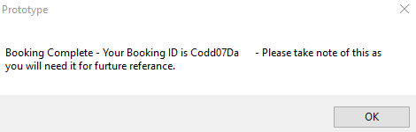
A completed book a session form before clicking the save button
A completed book a session form before clicking the save button

Accessing and navigating around the Staff Menu

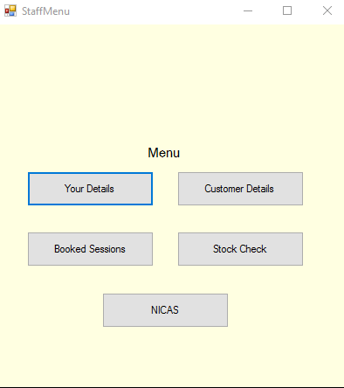
- To access the Staff Menu in the prototype the user must click on the ‘Staff(Customer Features)’ button at the bottom of the log in form. This is just for the prototype as in the full program the staff member would just log in using the text boxes and the relevant menu would be displayed.

- Once the staff button has been clicked the Staff Menu will open.

- The Staff menu has three buttons that when clicked will allow you to access the staff’s customer features of the system. The features that can be accessed as a customer are ‘Customer Details’ and ‘Booked sessions’ and ‘NICAS’ Only these features are available in the prototype as they are required for the customer features on the customer menu to run.

- If any other buttons are selected, then a message box will be displayed to let the user know they are not in use for the prototype.

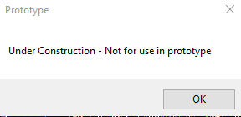
The message box that is displayed when any buttons not in use are clicked.
The staff menu

Staff member viewing all customer details and editing a customer’s details
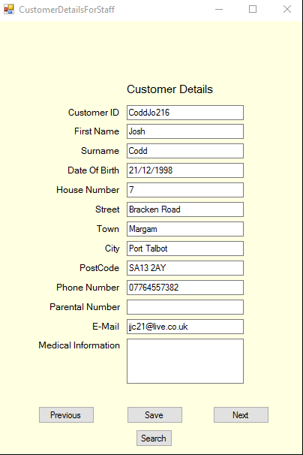
- For a staff member to view all customer details then they need to open the customer details form. To open this, go to the Staff Menu and click the ‘Customer Details’ button. This will open the customer details form.

- When opened the first record of customer details will already be displayed in the textboxes.

- To view the next customer’s details, press the ‘next’ button towards the bottom right hand side of the form. The next record will then be displayed in the text boxes.

- To view the previous customer’s details, press the ‘Previous’ button that is located towards the bottom left hand side of the form. This will display the previous record of customer details in the text boxes.

- To edit a customer’s details then first find the record that you want to edit.

- Then change the information in the textbox that you would like to edit.

- Once you have edited the information, press save to save the changes made.

- A message box will be displayed to inform the user that the changes have been saved successfully.

When the customer details form is opened initially

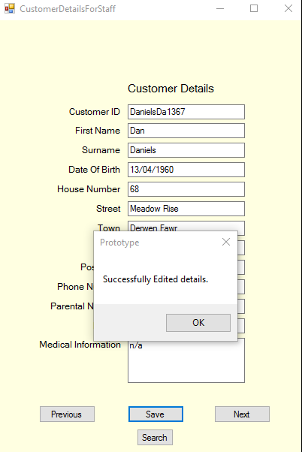
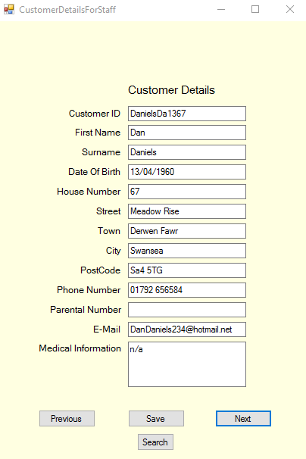
Editing a customer’s house number from 67 to 68. The message box once save has been clicked is also displayed
When the next button has been pressed and the next record has been displayed

Staff member searching for a customer
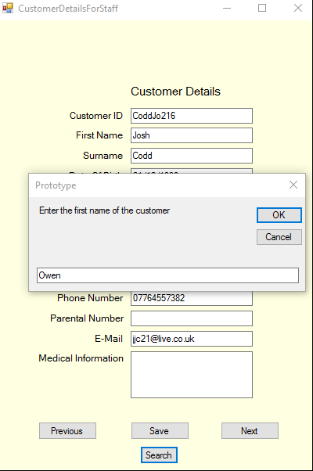
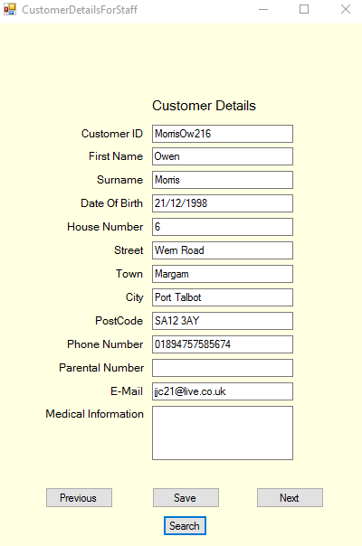
- To search for a customer’s details by first and last name then firstly, open the customer details form from the staff menu.

- Then to perform the search, click the search button located at the very bottom of the form.

- The first input box will then open asking to input the first name of the customer. Enter this information.

- The second input box will then open asking to input the second name of the customer. Enter this information.

- If the name matches a record in the system, then this record will be displayed in the textboxes.

- If there is not a record with this name in the system, then the record will not be displayed in the textboxes.

First input box asking for first name

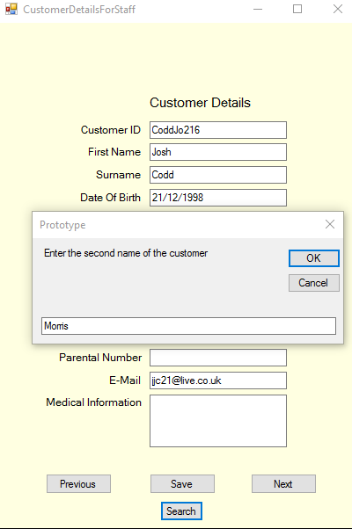
The record being displayed after being searched for
Second input box asking for second name

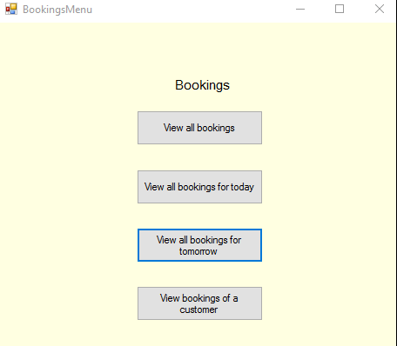
Accessing and navigating around the Bookings Menu to view bookings
- To access the bookings menu in the prototype the user must click on the ‘Booked Sessions’ button that is located on the staff menu.

- Once the Booked sessions button has been clicked then the bookings menu will open.

- The bookings menu consists of four buttons that allow you to view different criteria of bookings. You can view all bookings, bookings just for today, bookings for tomorrow and searching for all bookings a customer has made.
The bookings menu

Viewing all bookings
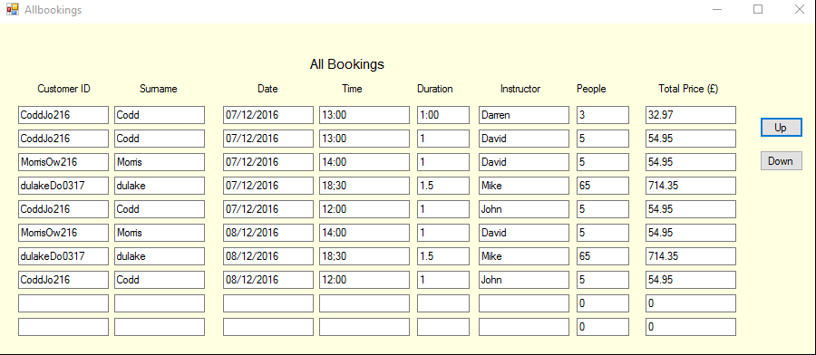
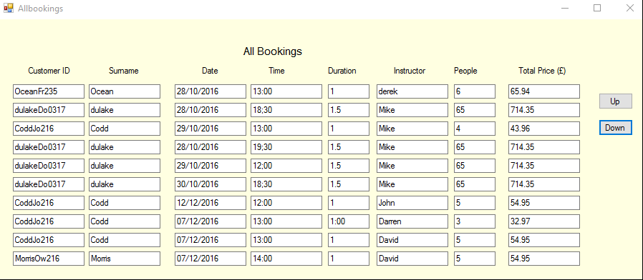
- To view all bookings, you will have to click on the ‘View All Bookings’ button that is located in the bookings menu.

- This will display the all bookings form and all of the bookings that have been made

- Press the up button to view the next records.

- Press to down button to view the previous records.

- If there are no bookings, then a message box will appear to let the user know there are no bookings.

The view all bookings form once the up button has been clicked. Therefore, showing more records
The view all bookings form when initially opened

Viewing bookings for today or tomorrow
Today’s date
- To view bookings for today or tomorrow then click either the button the view bookings for today or bookings for tomorrow from the bookings menu.

- The relevant form will then be displayed with the corrects bookings for time being displayed in the textboxes

- If there are no bookings, then a message box will appear to let the user know there are no bookings.

- The up and down buttons can be used as in previous forms to view the next or previous bookings

Bookings for tomorrow
Bookings for today
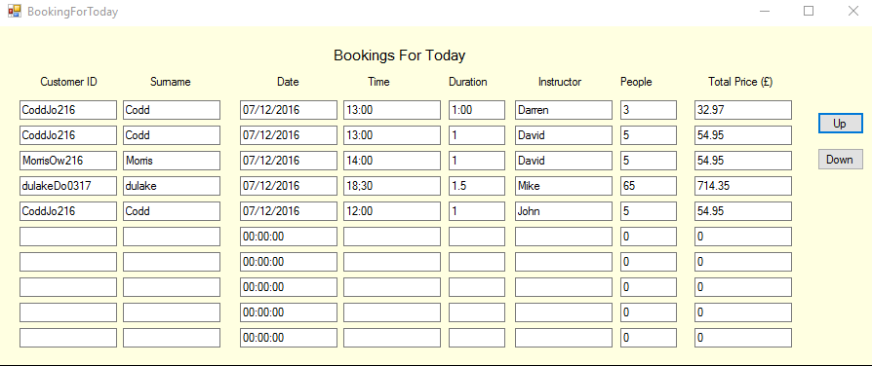

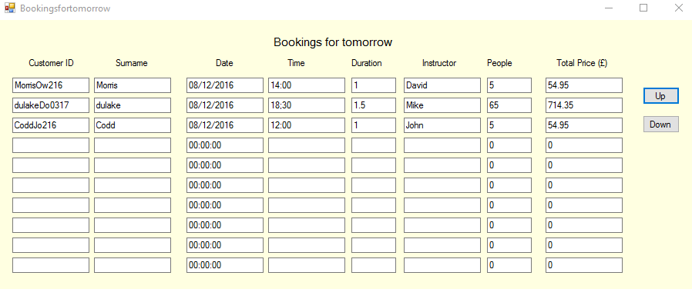

Viewing bookings for a customer
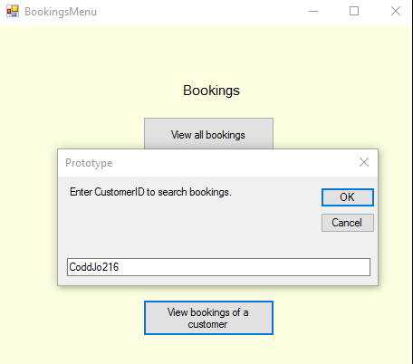

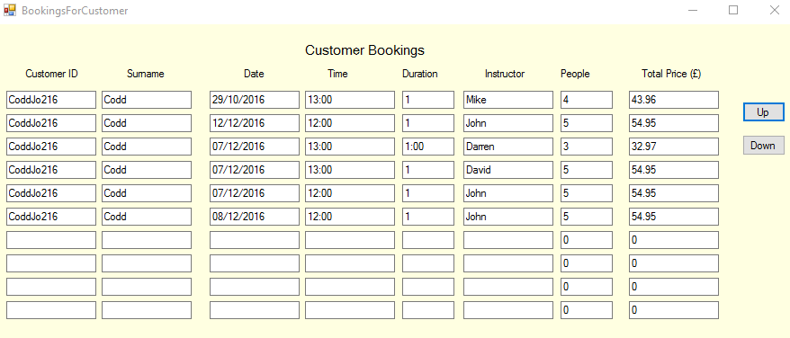
- To view all booking a customer has made then click the ‘View bookings of a customer’ button that is located on the bookings menu.

- An input box will then be displayed requiring the customer ID you want to search for. Enter this information.

- The bookings of this customer will then be displayed if the customer id matches a customer id with existing bookings.

- If there are no bookings with that customer ID then a message box will be displayed informing the user of that.

- The up and down buttons can be used as in previous forms to view the next or previous bookings

Viewing bookings for that customer
Input box for customer id

Editing a customer’s NICAS level as a staff member
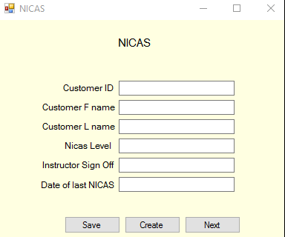

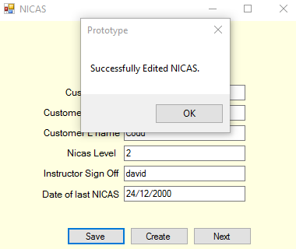
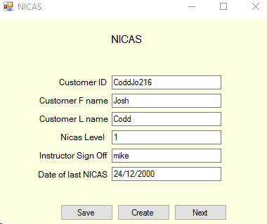
- To begin the NICAS process then you will have to access the NICAS form. To do this click the NICAS button on the staff menu.

- To edit an existing customer registered to NICAS’s level then just enter the customers’ ID into the ID textbox.

- The rest of the customers NICAS details will then be searched and displayed automatically.

- To edit the information just change the information in the textbox.

- Once you have completed this press the save button and a message box will be displayed informing the staff member that it has been saved successfully.

After editing the level to ‘2’ and pressing save. Message box is displayed
Once the customer id has been entered
The NICAS form once opened initially

Registering a customer for the NICAS program

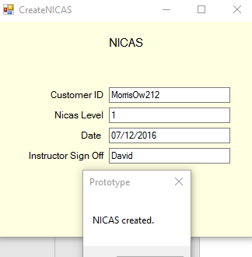
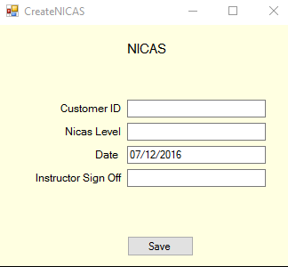
- To register a customer for NICAS then you will have to open the create NICAS form. You do this by clicking the ‘create’ button on the NICAS form.

- Then fill in the create form with the specified information.

- Once completed press the save button.

- The customer has then been registered to NICAS. A message box will be displayed informing the user that the information has been saved successfully.
The create NICAS form after being completed and the save button clicked. The message box is displayed.
The create NICAS form after being initially opened

Feedback of the prototype
In order to evaluate and further develop the system I need to receive feedback on the prototype to find out whether the beginning of the system works well for the users. I need to do this to find out changes that I will make in the final version of the system.

In order to get this feedback I have decided to receive it from the people who will have to use the system on a daily or regular basis, the staff of Dynamic Rock. I will sit down one to one with 5 members of staff at dynamic rock and go through the staff section of the system showing how it works. I will also give them a chance to use the system and have a go themselves so that they can get a feel for how the system runs. To get results for this I will ask the member of staff a set of pre written questions and write down how their answer sounds and any changes that they would like to see in the full system. In order to get improvements we will discuss system performance and ease to come up with some changes to fix any issues they have.
I am also going to do the same task with 5 regular customers at dynamic rock for them to test the customer section of the prototype.

For the first series of questions I will ask the staff member about the feature and ask for a rating out of 10.

Staff Member 1
Question | Rating out of 10
How easy did you find it to navigate the log in screen? | 10
How easy was it to find a customers information? | 10
How easy was it to add and update NICAS files? | 9
How easy was it to view bookings | 10
Favourite features | Different booking options e.g tomorrow and search  Next and previous buttons on search customers
Improvements to be made | Change colour scheme and add pictures or branding  Add back buttons instead of using the x button

Staff Member 2
Question | Rating out of 10
How easy did you find it to navigate the log in screen? | 10
How easy was it to find a customers information? | 10
How easy was it to add and update NICAS files? | 8
How easy was it to view bookings | 10
Favourite features | Bookings menu and booking options  NICAS being separate from customer information
Improvements to be made | Colour scheme bland  Remove next button on NICAS search as it is confusing

Staff Member 3
Question | Rating out of 10
How easy did you find it to navigate the log in screen? | 9
How easy was it to find a customers information? | 10
How easy was it to add and update NICAS files? | 9
How easy was it to view bookings | 10
Favourite features | Booking search  Simplicity of user interface
Improvements to be made | Colour scheme  Easier to input information especially in the NICAS section

Staff Member 4
Question | Rating out of 10
How easy did you find it to navigate the log in screen? | 10
How easy was it to find a customers information? | 10
How easy was it to add and update NICAS files? | 10
How easy was it to view bookings | 10
Favourite features | Ease of use overall  Ease to find customer information fast  Browse all customer information using next buttons
Improvements to be made | None to be suggested

Staff Member 5
Question | Rating out of 10
How easy did you find it to navigate the log in screen? | 8
How easy was it to find a customers information? | 10
How easy was it to add and update NICAS files? | 8
How easy was it to view bookings | 10
Favourite features | Searching customers
Improvements to be made | Improve ease of use of NICAS

Customer 1
Question | Rating out of 10
How easy did you find it to navigate the log in screen? | 9
How easy was it to create an account? | 9
How easy was it to make a booking? | 7
Favourite features | Ease of use
Improvements to be made | Booking is very confusing. Don’t like having to specify instructor to have

Customer 2
Question | Rating out of 10
How easy did you find it to navigate the log in screen? | 10
How easy was it to create an account? | 9
How easy was it to make a booking? | 8
Favourite features | Choosing instructor when booking  Viewing own details and changing them themselves, way easier.
Improvements to be made | Not having to log in twice when viewing details.

Customer 3
Question | Rating out of 10
How easy did you find it to navigate the log in screen? | 10
How easy was it to create an account? | 8
How easy was it to make a booking? | 8
Favourite features | Ease of use
Improvements to be made | Make booking easier, entering information can be confusing.  Colour scheme bland  Not having to log in twice when viewing details.

Customer 4
Question | Rating out of 10
How easy did you find it to navigate the log in screen? | 10
How easy was it to create an account? | 8
How easy was it to make a booking? | 9
Favourite features | Having own account  Viewing own NICAS details
Improvements to be made | Specify what fields don’t need to be entered when making an account.  Not having to log in twice when viewing details.

Customer 5
Question | Rating out of 10
How easy did you find it to navigate the log in screen? | 10
How easy was it to create an account? | 10
How easy was it to make a booking? | 9
Favourite features | Easily view own details  Update details yourself  Track NICAS yourself
Improvements to be made | Make it easier to enter bookings  Make booking less confusing (don’t know instructor names?)

The results from my one to one sessions with customers and staff members have brought forward many issues with the current system I have produced.

After looking at the results from staff members It can be seen that the colour scheme of the system is not liked. The staff member’s suggestions also seem to point that there needs to be images such as logos added to add professionalism to the system. The staff members also find it a bit confusing when creating and updating the NICAS records. Another suggestion that was made by a staff member suggests to add back buttons to the system instead of using the exit button to close forms. I feel this would be a nice touch to be added and could also add to the professionalism of the system. However there are many features the staff members like such as the ease of use of the system and how quick it is to find customers.

After looking at the results from the customer side of the system it can be seen that the customers like having their own accounts and being able to view their own details, they also like the ability of being able to book a session themselves. However there are also a few issues with the booking system, as it seems to be confusing customers. Some customers specifically mentioned they did not like having to select an instructor, as they did not know a name to type in the box.
However one customer liked the idea of selecting an instructor. There was also a minor issue mentioned when creating an account as customers did not know whether to write anything In the medical conditions box if they did not have anything to write in there. Another feature than was not liked is that the customer has to log in right after logging in to view their details.

Conclusion
In conclusion the system works efficiently with ease of use and access for all users. There are minor and few improvements to be made towards visual aspects of the system but the functionally and coding of the system works perfectly. I will carry out some Improvements to the system as seen on the following pages. Most of the problems with the system are to with the look of the forms and the method of input on some forms, which confuses some customers. These problems can be easily fixed.

Improvements to be made

Throughout the system:
- Change the background colour from info to gradient inactive caption
- Add logo to top of forms to add professional look to the system
- Add ‘Back to menu’ buttons throughout the system for easier navigation around the system – adds professional theme
- Remove the exit buttons from the top of forms ‘tool bar’

Add Customer form:
- Add “Leave blank if N/A” label by medical information

Your details for customers form:
- Remove having to log in twice/again to view details – create a variable in a module that saves username and password when logged in and uses this for security purposes to search to view the customers details.

Your details for staff form:
Remove having to log in twice/again to view details – create a variable in a module that saves username and password when logged in and uses this for security purposes to search to view the staff details

Book a Session form:
- Change “Instructor” label to “Preferred instructor”
- Use a combo box for preferred instructor with a list of all instructors within it
- Use a combo box for duration with the different durations within it
- Use a combo box for number of people with numbers of people values within it

NICAS view form:
- Use a combo box for instructor sign off with a list of all instructors within it

NICAS create form:
- Use a combo box for instructor sign off with a list of all instructors within it

Welcome form:
- I have decided not to use a welcome screen as I feel it is not needed for the program and may get annoying to frequent users including staff

