The Investigation
Understanding the current system

1. Stakeholders
Every existing business has stakeholders. By definition a stakeholder is a person who for various reason has concern or an interest in the company. Dynamic Rock as a business has stakeholders that are financially and passionately invested into the company. I am investigating what stakeholders Dynamic Rock has in order to plan how i can extract information from these key people in order to find out how the current system runs.
The stakeholders of Dynamic Rock are the :
- Owner
- Manager
- Staff/Instructors
- Customers
- Suppliers

2. Interviews
I believe that the first step of my investigation of the current system at Dynamic Rock is to understand what it is like to use. To find out what it is like to use daily I am going to be undergoing interviews with stakeholders of the business. I have chosen the manager and a member off staff to conduct these interviews with. I have chosen these stakeholders because i feel these are the people who use the current system the most, most likely daily.
I have arranged my first formal interview with an instructor at Dynamic Rock named Owen Morris. For this interview he will go under the title Mr Morris. It is very important that i know what information i need to retrieve from Mr Morris before hand so I know what questions I intend to ask in order to ensure i can understand the system thoroughly. The areas that I aim to obtain information from are the following :
- What files the system contains and what data is within these files
- How are the files stored
- How are the files retrieved on demand
- How are new staff members and customers added
- How secure are the files
- How do you feel the current system runs and would you benefit by a computerised system

Interview 1
Name of Interviewer : Josh
Name of Interviewee : Mr Morris
Interviewee job title : Instructor at Dynamic Rock
Josh : Good Morning. Ive chosen to conduct this interview with you today in order to gather an inside look into what its like to use the current paper based system your using at Dynamic Rock. I’m doing this to fully understand what i need to achieve when creating this new system for you to ensure that it provides all the features required to vastly improve your day to day job as well as the customers experience at Dynamic Rock.
Mr Morris : Good Morning Josh. I am open to answer any questions that you may have.
Josh : My first requirement is to understand what the current system includes. What files does the current system store?
Mr Morris : There are several different areas to our current system which are complex when looking at. The files we store are the details of our customers, we also store details of our staff as well as bookings for climbing, the stock levels for our on site shop, payroll data and NICAS qualification information.
Josh : I see, so what are these files called and where are they stored?
Mr Morris : We have 6 filing cabinets in our office. They're getting kind of full now and we’re running out of room. We have a filing cabinet for each of the different files we collect. Each filing cabinet has a paper label on it saying what the contents are. So we have a separate one of these for Customer details, Staff details, bookings, payroll, NICAS and Store Stock.
Josh : This is becoming more clear already. I hear you mentioned them getting full. Is this already an issue or is it becoming one?
Mr Morris : Yes the majority of them are coming very close to holding as much as they can. Except customer details become full about 2 months ago. This has become a real problem as we have just had to store them in one of the spare draws in the reception desk, not only is this very insecure but when certain customers come in, we don't know if their details are in the cabinet or draw. Its very confusing. We priced up extra storage but we don't have room for anymore and it was expensive.. Plus when the others become full we’d have to purchase even more storage. Its just not working out. That’s when we contacted you to look into a computerised system.
Josh : I can see where you’re coming from, I can see that being a big problem in the near future! You mentioned security. That brings me to my next point. How are you keeping these files secure?
Mr Morris : We have number combination padlocks of each of the filing cabinets. The do the trick but the doors still open a little but so that you can see inside a little. The problem is that these cabinets could be picked up and moved if somebody really wanted the data we keep. This could potentially be a problem but its done the job.
Josh : Doesn't sound very safe, I'm sure we’ll be able to fix this and add complex security measures into the computerised system. Back to the files and the data you store. What data do these files consist of? Are any of these files linked together?
Mr Morris : Well to begin with, the customer details file consists of general information about the customer such as Name, unique customer ID number, Date of birth, contact information such as phone, email and address, medical details as well as a parental number if the customer is young. The staff details file consists of their unique staff ID number, Name, date of birth, address, phone, email as well as their payroll ID and national insurance number. You mentioned files being linked. Well staff details is linked to the payroll file. The payroll sheet consists of the employees ID as well as all of their financial data such as their hourly salary, how many hours they have worked, gross pay, net pay as well as how much tax they have paid. Their sort code and full name is also stored here for a pay method. The store stock file then consists of the product name, price, size, supplier, number in stock and a re-order number.In the Bookings file we collect the data for booking time, duration, instructor, number of people and price. Finally, the NICAS file. The NICAS file is also linked in with the customer details file. The NICAS file consists of customerID, NICAS level, date of last award and if the level has been approved by staff.
Josh : I see. Now that i understand all of the data that you keep and how its stored. I would like to know how this information is collected. For example how is a new customer added to the system?
Mr Morris : When a customer first comes to Dynamic Rock they fill i the customer details sheet themselves. We then file it in the cabinets. This is a similar process to how we add a new staff member too!
Josh : I understand. On demand then, how would this information be retrieved. For example, if a customer changed their phone number. How would they change that in your system?
Mr Morris : When the customers details have changed we advise them to come in to the centre and change their customer details. On arrival we would ask for their name and then a member of staff would search through the customer details cabinet for that customers record. This can sometimes take a while. The customer would then scribble out their number and write their new one. The record is then placed back in the filing cabinet.
Josh : That sounds very time consuming. How do you cope with constantly searching through files?
Mr Morris : It does take a long time. It can also be very stressful for us because sometimes we cant find the record, but it turns out we just missed it somewhere in the hundreds of records.
Josh : That’s no good, would you be able to explain to me how the stock check works at Dynamic Rock?
Mr Morris : The store stock file is used every time somebody purchases something at the shop.
The sheet has all of the product information and the stock on there. When a item is purchased the number in stock is decreased. When the number in stock reaches the re-order level then more stock of that product is re-ordered.
Josh : Do you or any other instructors deal with any of the payroll information or is that done with the managers?
Mr Morris : All of the payroll information is dealt with by Steve, one of the managers here. I’m glad i don't have to handle that as well. I’ve seen some of the calculations he has to do and it looks very complex!
Josh : I bet, i’ll have to speak to him about that! Coming to the end of this interview, overall how do you feel about the current system, and how do you feel a computerised system would benefit you as an instructor?
Mr Morris : I feel that the current system is getting old. It takes so long to find things. I think this is not only beginning to be a problem for us instructors, but is also becoming a problem for our customers as they are always waiting for files to be found as well. A booking takes a good 10 minutes to complete when it should take much less time than that. I feel that a computerised system would be much better for our job. It would relieve the stress of always running around to find things. I also think it would be good for our security as you said. I think our security measures on our data should be much more secure than they currently are. We could get into some legal trouble if anyone was to access our customer and staffs data.
Josh : I understand how stressful this could make your job. I am going to use the information you have provided me with to ensure that the system that i produce will make your job of searching through files much easier. Thank you for lending me your time. You have helped me understand the system a lot more than i did beforehand. Take care Mr Morris.
Mr Morris : Thank you for your questions and effort as well! Much appreciated. Good bye now.
End of interview.

Results from Interview 1
After speaking to Owen Morris I now understand how Dynamic Rock keep and store their data. I know how what files they store and what data these files consist of. I also know how new customers and staff are added so i will be able to use this when adding this feature to the system i produce for Dynamic Rock. I have also listened to how Owen said it takes a long time to find records. To combat this in my program i will add a search bar so staff can easily search for customers and find the details instantly instead of wasting time searching through cabinets.
I feel that this interview went well. However, there is still some information i would like to know.
For example, I would like to find out how the payroll system works as well as the booking system. I tried to ask Owen about the payroll system but this is managed by the manager, Steve Jones. Since my interview with Owen i have arranged a formal interview with Steve Jones who i hope to get more information about the payroll system from. the areas that I aim to obtain information from are the following :
- How the payroll system works
- What calculations are made and how are they made
- How does a customer book climbing
- Steve’s opinion on how the current system runs and how a computerised system would benefit his work

Interview 2
Name of Interviewer : Josh
Name of Interviewee : Mr Jones
Interviewee job title : Manager at Dynamic Rock
Josh : Good Morning. Ive chosen to conduct this interview with you today in order to gather an inside look into what its like to use the current paper based system your using at Dynamic Rock. I’m doing this to fully understand what i need to achieve when creating this new system for you to ensure that it provides all the features required to vastly improve your day to day job as well as the customers experience at Dynamic Rock.
Mr Jones : Good Morning Josh. I heard your interview with Owen went well. I hope you got the information that you needed!
Josh : Yes it went very well. I got everything that i feel that i needed. He informed me that you were in charge of the payroll system at Dynamic Rock. Firstly, would you be able to confirm with me what data the payroll file contains?
Mr Jones : Of course! The payroll file contains a lot of data. The data that is collected is the employee ID and their payment card information such as their sort code and full name. Other data in the payroll file is the number of hours the employee has worked, how much they get payed hourly, their gross pay, their net pay and how much tax they have paid.
Josh : Sounds just like what Owen told me! Would you be able to explain how this payroll system works?
Mr Jones : Yes! Payroll is calculated every month for each employee. Ill give you an example.
Each month i fill out a blank payroll sheet for each employee. I write down their employee id and name as well as their sort code each on this sheet. I have this data from last months payroll form for this employee. I then look at the rota to see how many hours the employee has worked this month. I have to calculate this just using my vision and in my head. I then multiply this by their hourly pay and write that in the gross pay section. I then deduct their taxes and write this in the net pay section. I then store the payroll sheet back in the filing cabinet.
Josh : Do you do all these calculations in your head? Or do you use a calculator?
Mr Jones : I work out gross and net pay using a calculator, correct.
Josh : Do you believe it is possible for you to make mistakes in this case?
Mr Jones : I agree. I’ve made a few mistakes in the past. Its all down to human error, we cant get everything right ha ha ha.
Josh : I agree, it must be really time consuming doing this manually for all of your employees, Am i correct?
Mr Jones : Yes, it takes such a long time to complete. It takes even longer because i have to keep looking back at previous payroll sheets to copy some of the data over.
Josh : I can see. What about the booking system, how does that work?
Mr Jones : When a customer wants to book a session they tend to usually ring the centre but they also book by calling in person. They are asked by a member of staff what time they would like to book for and what date. The staff member will then write the time and date in the booking time field. The staff member will then ask if they want a one, two or three hour session and then write it in the duration field. An instructor that is working will be checked on the rota and then put in the instructor field. The number of people will then be asked and wrote in the number of people field. This is then multiplied by the entry free and a price is given to the customer. The booking is then complete. And to add about your question about calculations earlier, sometimes the price is wrong and we get some unhappy customers.
Josh : I see how the calculations can be a problem. In the computerised system we will be able to make that automatic and easy for you! I understand the payroll and booking system really well now, thank you for the explanation! Coming to the end of this interview, overall how do you feel about the current system, and how do you feel a computerised system would benefit you as a manager?
Mr Jones : Automated calculations is something I'm really looking forward to using in this new system. I know that it will make my job so much easier and reduce customer and employee stress as the calculations will be faster and more accurate. I feel that the current system is lacking the fluidity and accuracy that we need here to provide a good experience to our customers. Its not only me that feels this way as i get a lot of complaints from employees about how slow this paper based system is.
Josh : I am going to use the information you have provided me with to ensure that the system that i produce will make your job of searching through files much easier. Thank you for lending me your time. You have helped me understand the system a lot more than i did beforehand. Take care Mr Jones.
Mr Jones : Thank you for your time too Josh, Good Bye!
End of Interview

Results from Interview 2
After speaking to Steve Jones I now understand the system in a whole and what the limitations are. I understand how bookings and payroll is calculated. I see that there are quite a lot of calculations that are carried out in the current system at Dynamic Rock. This means that there is a great chance for human error. Here i feel my system will help a great deal as calculations will be automated so they will be instant and also correct all of the time.

3. Data Flow Diagrams
Data flow diagrams represent a system by showing the processes within it. I am using these Data Flow Diagrams to visually show how the system works. These diagrams are also a very good way to look into how data is input and what is outputted from the system. A Data Flow Diagram uses the following symbols:
Process:

This is an action that is performed on the data.

External Entity: This is the destination or source of the data.

Data Flow:
This is the direction in which data is travelling.

Data Store:
This is where data is stored.
(in this case files in a filing cabinet)
I am going to produce these flow diagrams on the software Pages on Mac. I have chosen to do this as it is much easier to design with. Below are images of my designs that show my understanding of this system following the interviews i have conducted.
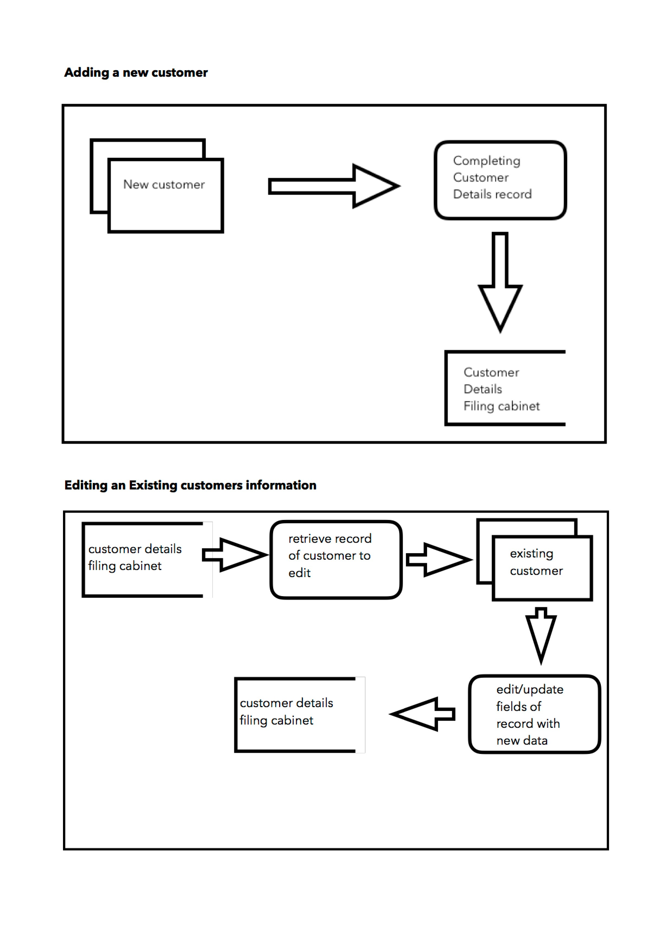
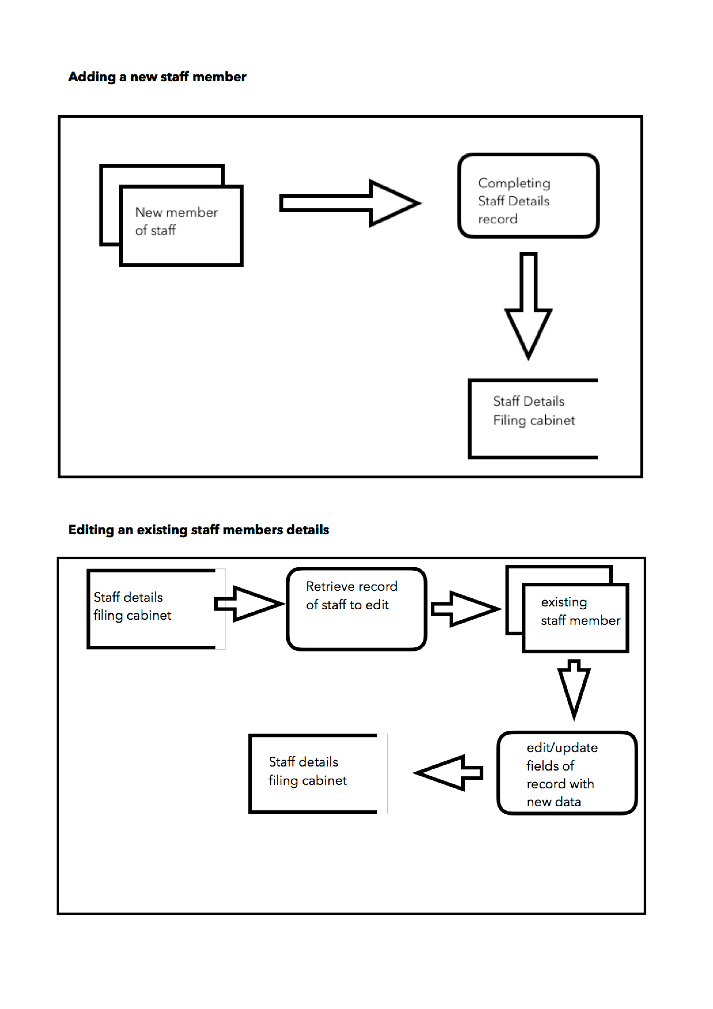
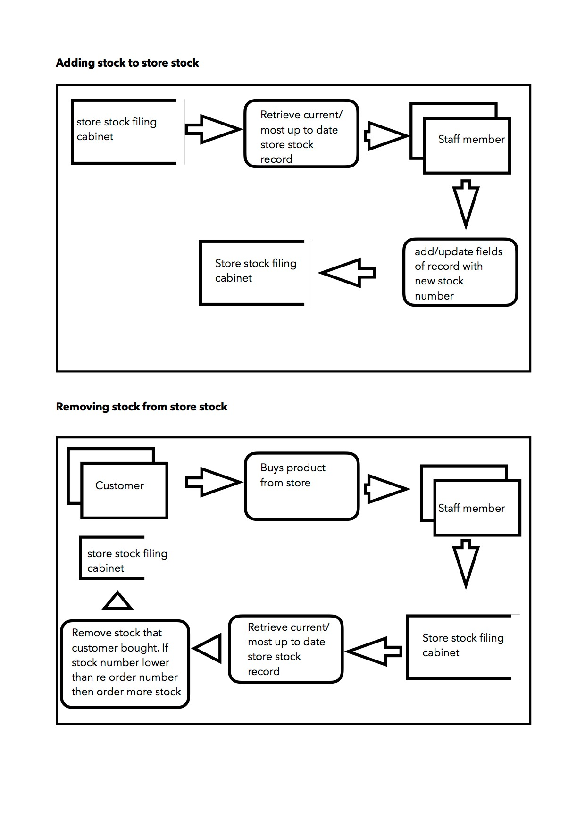
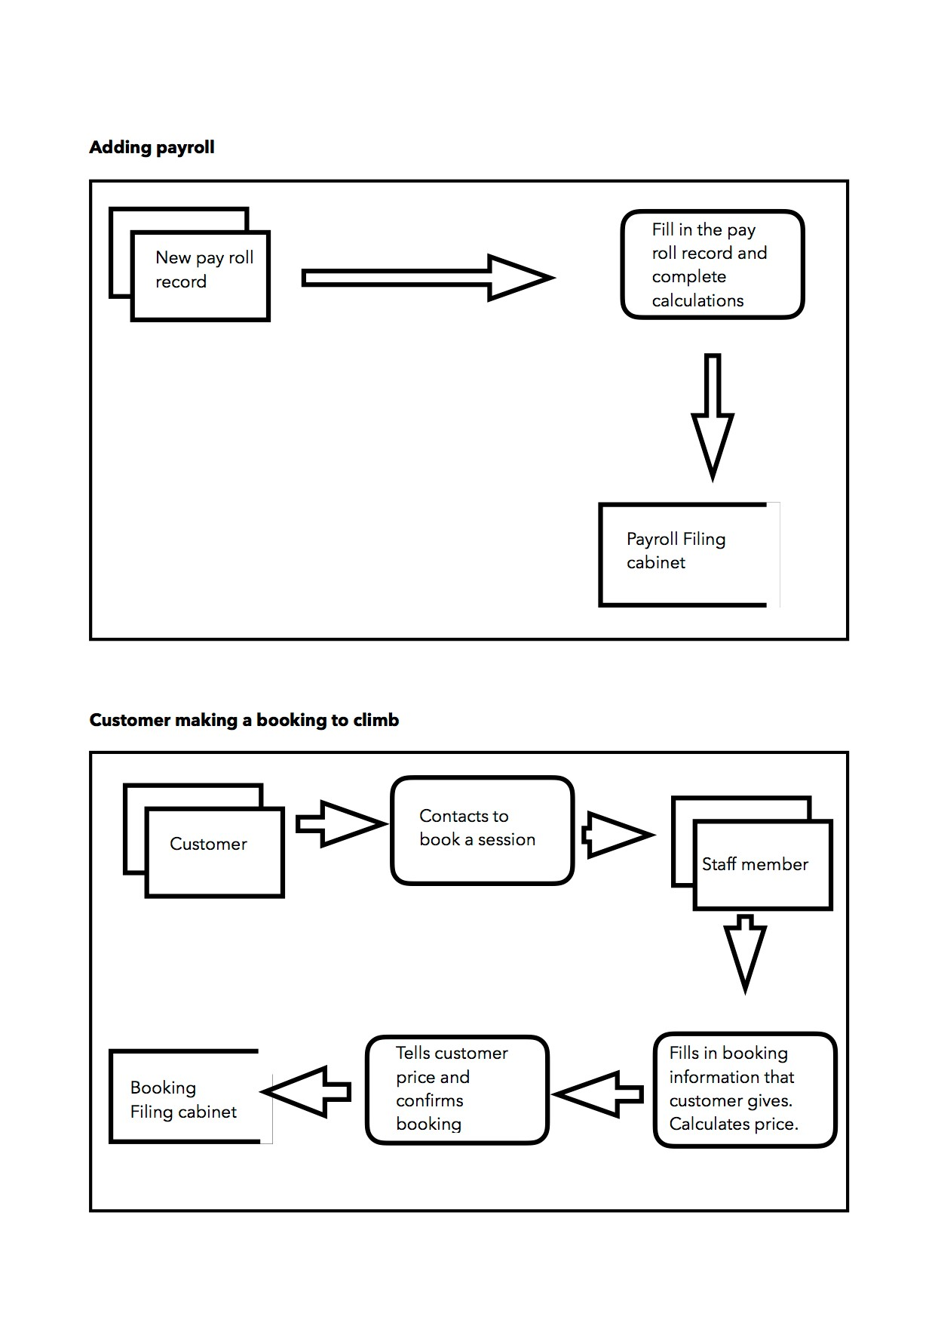
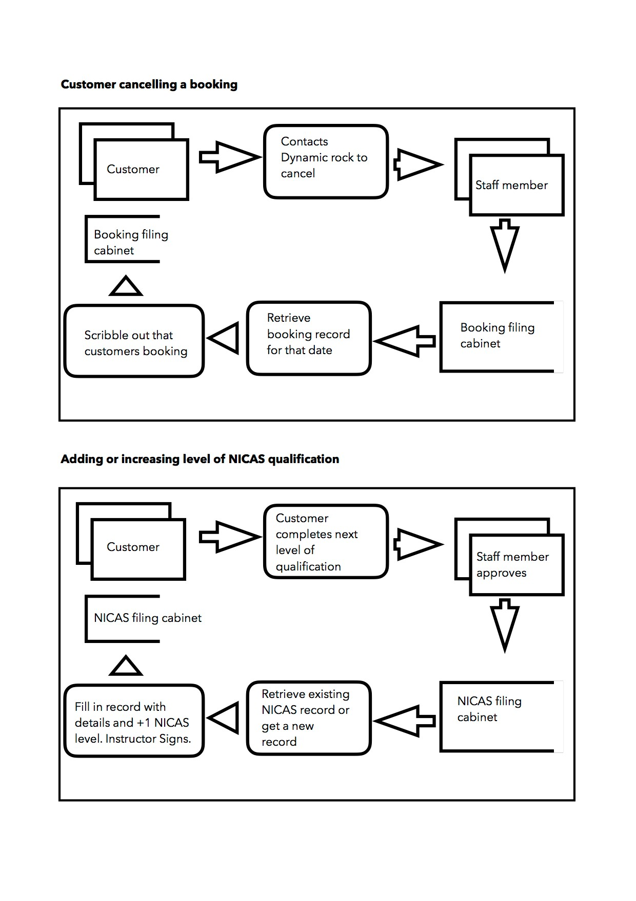

4. Questionnaire
I am going to collect more information about the system by producing a questionnaire to hand out to all staff members at Dynamic Rock. Below is a blank copy of the questionnaire i have made.
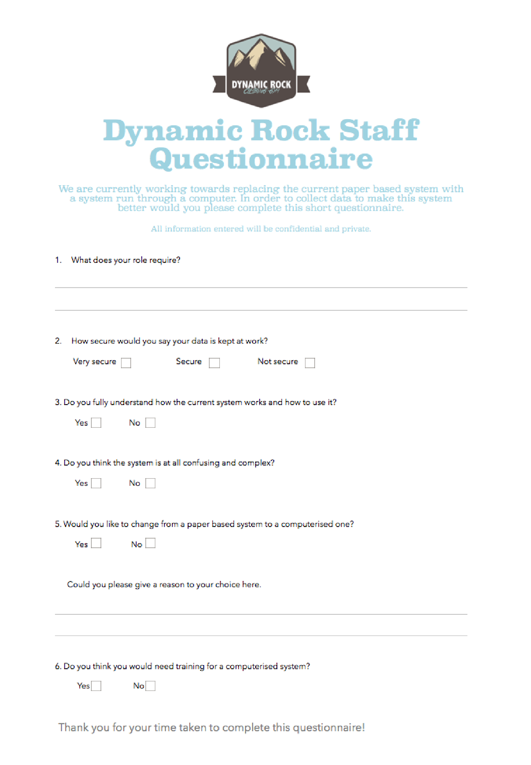

Below is an example of completed questionnaires completed by staff at Dynamic Rock.

The results of my questionnaire
To summarise the results of my questionnaire, I am going to calculate the answers i received and put them into graphs. I am doing this to fully understand all of the staff a Dynamic Rocks opinion on having a computerised system. The numbers on the side of the graph represent how many people out of 23 staff members answered the stated answer
Question 2 - How secure would you say your data is kept at work?

0
5
10
15
20
Very Secure
Secure
Not Secure
Question 3 - Do you fully understand how the current system works and how to use it?
12
11.5
11
10.5
10 Yes No
Question 4 - Do you think the system is at all confusing and complex?

0
5
10
15
20
Yes
No
Question 5 - Would you like to change from a paper based system to a computerised one?

0
7.5
15
22.5
30
Yes No

Question 6 - Do you think you would need training for a computerised system?

10.5
7
3.5
0 Yes No
These results show that the current paper based system that they have in place at Dynamic Rock is working but some of the staff still do not know how it fully works. This could be a problem as they may be unable to complete certain tasks if a customer asks. We can see this through the 11 out of 23 people who work at Dynamic Rock admitting they don't understand how the system fully works.
Another possible problem that arises from this questionnaire is that 19 out of 23 employees find the system to be confusing and complex. This shows me that the system could be slow to use if the employees find it confusing. This seems like it could possibly ad stress onto their job. This is where i feel a computerised system would really help them out.
When asked if the staff would need training for a computerised system to be put in place they seemed to be a bit undecided. To combat this i feel that training sessions for the new system will be put into place so that they can be taught the ins and outs of the system. Overall I think Dynamic Rock would really benefit from a computerised system and the employees seem to agree with me with a solid 22 employees wanting a computerised system. When asked why they wanted this the majority of answers were that they feel it would be faster and easier for them to use.

5. Observing the system in use
After analysing the results from my questionnaires and interviews with staff from Dynamic Rock i feel like i need to observe, first hand, how the system works and how employees use it on a day to day basis. I contacted Steve Jones, one of the managers at Dynamic Rock who i spoke to in my previous interview. I contacted him to question about observing the system for a couple of hours during a working day. He was happy to allow me to do this. Mr Jones informed me that he had mentioned to the staff that they are to “pretend I am not there”. This will allow me to see any problems that arise as the staff will not be caucsious because of my presence.
I arrived at Dynamic Rock at 12pm on a Saturday morning. I chose this time because Steve mentioned that it was their peak time for customers. When i arrived the walls were already busy with many climbing already training. I met Owen Morris who was another employee i interviewed in the early stages of my investigation at the reception. Due to it being such a busy time most of the instructors were helping climbers on the wall. This left only Owen at reception.
Within 5 minutes of my arrival a customer came to reception and wished to climb at Dynamic Rock for the first time. Owen greeted him kindly and mentioned that he had to fill in a customer details form. Owen went to find a form for him. after about 5 minutes of looking for a form Owen decided to print out another batch because he could not find any. He was adamant that they had all been used because it was so busy. Anyway, 10 minutes past and the customer had signed the form and Owen had filed it away in the mentioned filing cabinets. I noticed when he did this that none of the filing cabinets were actually locked. I asked him about this and he said that they only lock them up when they leave for the night.
Shortly after another new customer came to reception Owen again, greeted them and gave them a customer details form, this time the process was a lot quicker because he had a fresh batch of forms. This exchange was a lot smoother than the first one.
For the next 30 minutes the reception was quiet. The climbing wall was already full so i presumed i missed the main rush of customers coming in. Then a group of boys came in wishing to climb. 2 of which had been before. Owen’s procedure this time was to check the customer details filing cabinet to ensure that the customer had already signed a form. He asked the customers names and then proceeded to search the stack of forms. After 5 minutes of searching he found them both. he informed me that that was quite a quick find as it normally takes longer. The other boys who had not been before signed there forms and they were filed away.
I had agreed with Mr Jones to stay for 2 hours to observe the system at dynamic rock as he was sure this would be enough time to see what goes on. Over the course of these two hours there were many smooth exchanges between customer and employee and some that took quite a while as quite a bit of searching had to be done.
Just as i was scheduled to leave at 2 o clock, the phone rings for a booking. Owen answers and puts them on hold while he goes to find a booking sheet. He ran quickly to the booking filing cabinet at retrieved on of these sheets. He then asked for the required information from the customer and filed the booking away. This was the only booking i managed to see in my time at Dynamic Rock. Just before I left i decided to ask if i would be able to see the store stock system in use. The store was upstairs so we went to have a look. It was closed. Owen went to ask the duty manager why it was closed. He informed me that there was an error and not enough stock for the shop to run. They were expecting stock the following day and for the store to re-open.
It was 2:20 when I left Dynamic Rock. I had observed the system for 2 hours and 20 minutes. I feel that i had a much more personal and detailed idea now of how the system works on a daily bases. Through my time there i viewed some smooth exchanges, these were smooth but still quite lengthy. Apart from the smooth exchanges there were some extra lengthy ones such as when there were not enough forms ready. This was a problem that i noticed. The problem was that Dynamic Rock has to keep printing out loads of forms for their paper based system to remain even the slightest bit smoothly. Not only must this cost a lot of money to maintain but also a lot of time. I feel like the error of forgetting to print more out is made a lot and makes encounters with customers a lot longer and slightly annoys the customer. This is not good for Dynamic Rock. This is where i feel a computerised system would benefit them as it will save them the cost of ink to print as they will never have to print any forms as they will already be on a computer ready to use. Neither will they be able to forget to print. I feel this will help the business run more smoothly. Another problem that i noticed with Dynamic Rock is with their security. During this observation i noticed that the filing cabinets are not locked during the day. If for some reason the reception is unmanned then anybody would be able to access those files. Dynamic Rocks data could therefore easily be stolen and land them in a lot of trouble. Especially with the current Data Protection Act. I also feel that the fact that the store was closed due to stock may also have been a problem with the paper based system. I think that this may be down to a human error and forgetting to check the stock re order level. This could be fixed with the computerised system as a notification will alert the user when a product gets to the re order level. Overall i feel that the main problem with Dynamic Rocks paper based system is how slow it is to complete even the simplest of tasks.

6. Desk-based research

Booking Systems
I have researched into a range of booking systems for other existing businesses that use a computerised system. I used the internet to search for activities that use an online booking system such as restraunts, gyms and other family activities such as go karting. I am doing this to find out the main features and characteristics the booking system i produce must have. By looking at these similar systems I have identified the following features a booking system consists of :
- Select Location
- Number of Adults
- Number of Children
- The date you wish to book for
- Time to start activity
- Time to finish activity
- Duration
- Shows the price
- Shows confirmation of the booking with all of the booking information
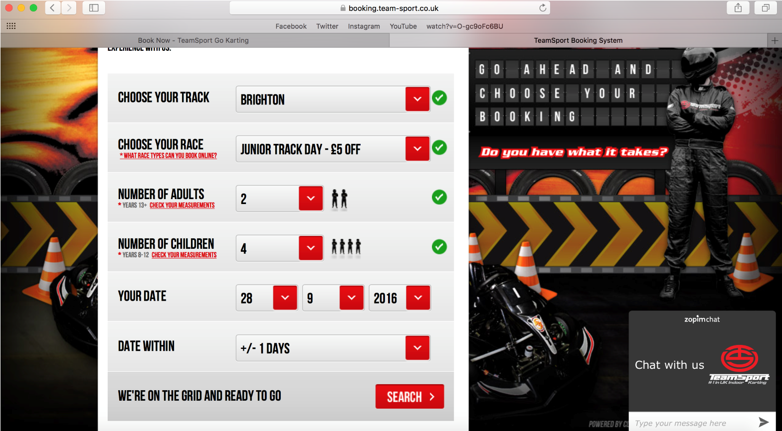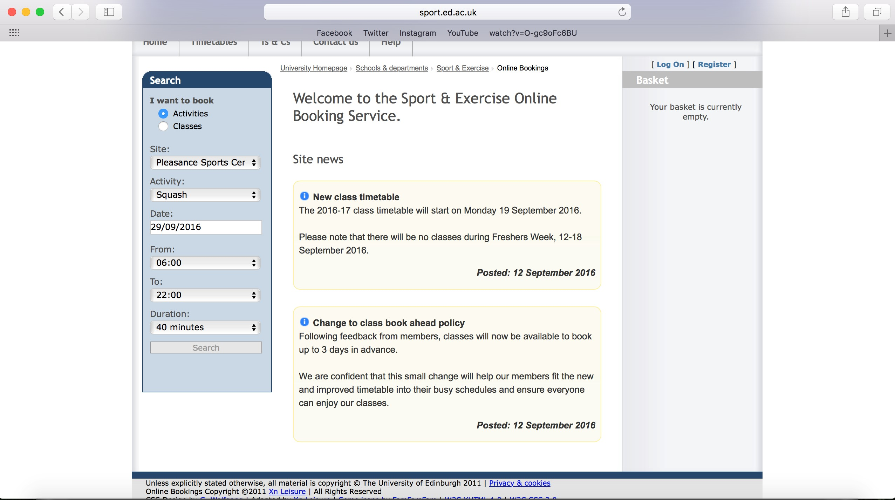

Store Stock System
I have also researched into existing stock check systems. I am doing this to see what features these existing computerised stock control systems have in order to decide on the features i am going to add when i produce a store stock system for Dynamic Rock. The features that I have found a store stock system to include are:
- What products are held in stock
- How much of the product is in stock
- The price of each product
- The sizes of items in stock
- Reduce the number in stock when product is purchased.
- Re order number
- Supplier details to re order
- Warn if a product sells out
- Add new products
- Update the amount of products in stock upon a delivery of stock

7. Looking at the paper based system documents
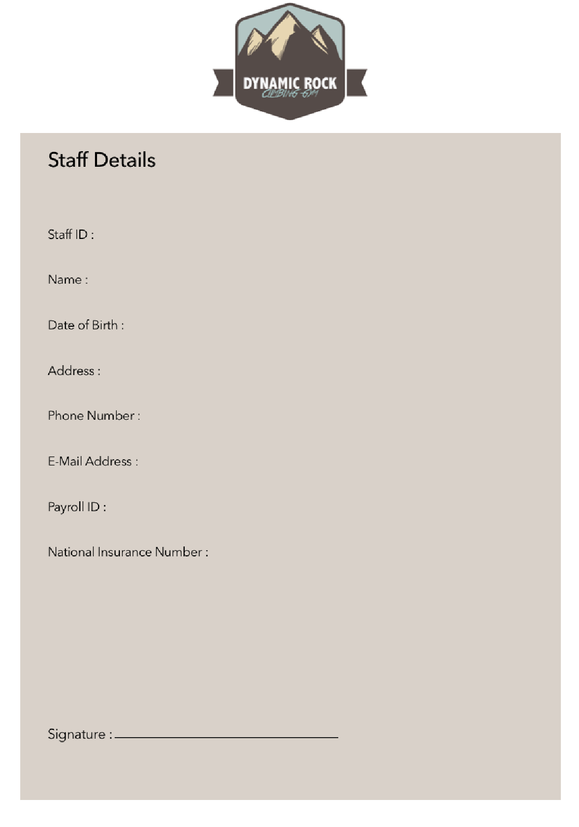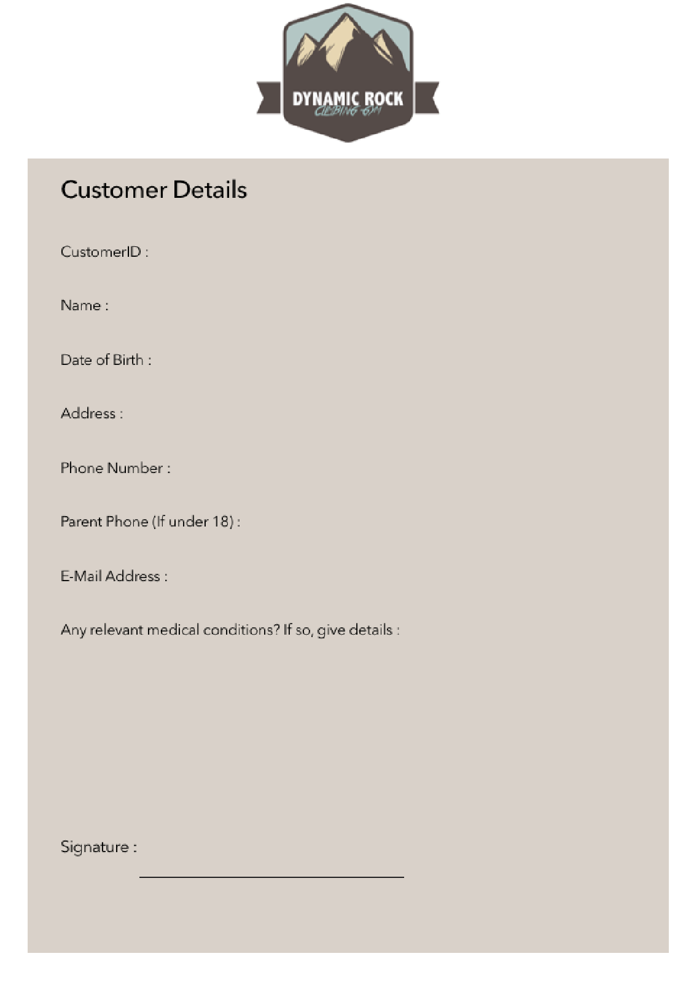
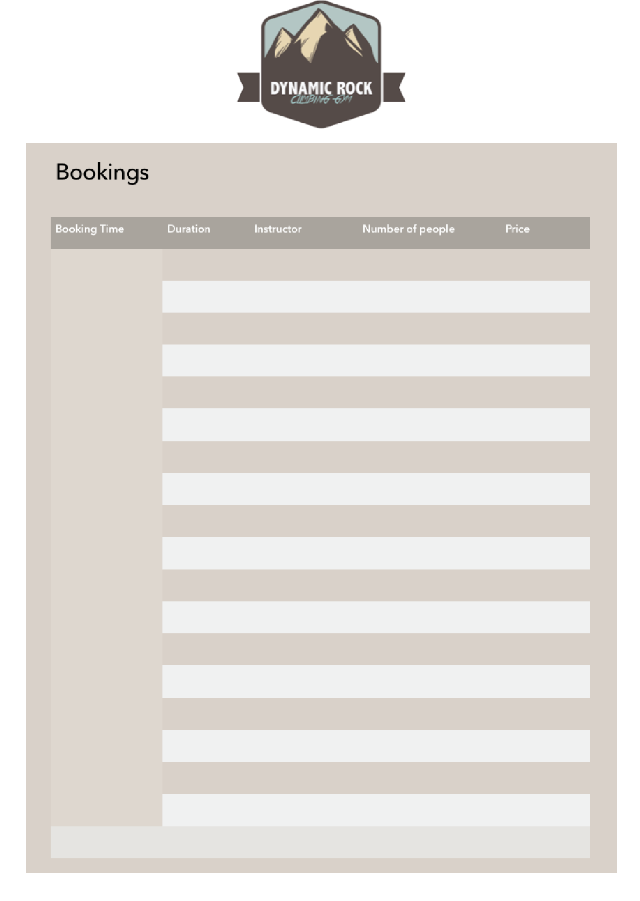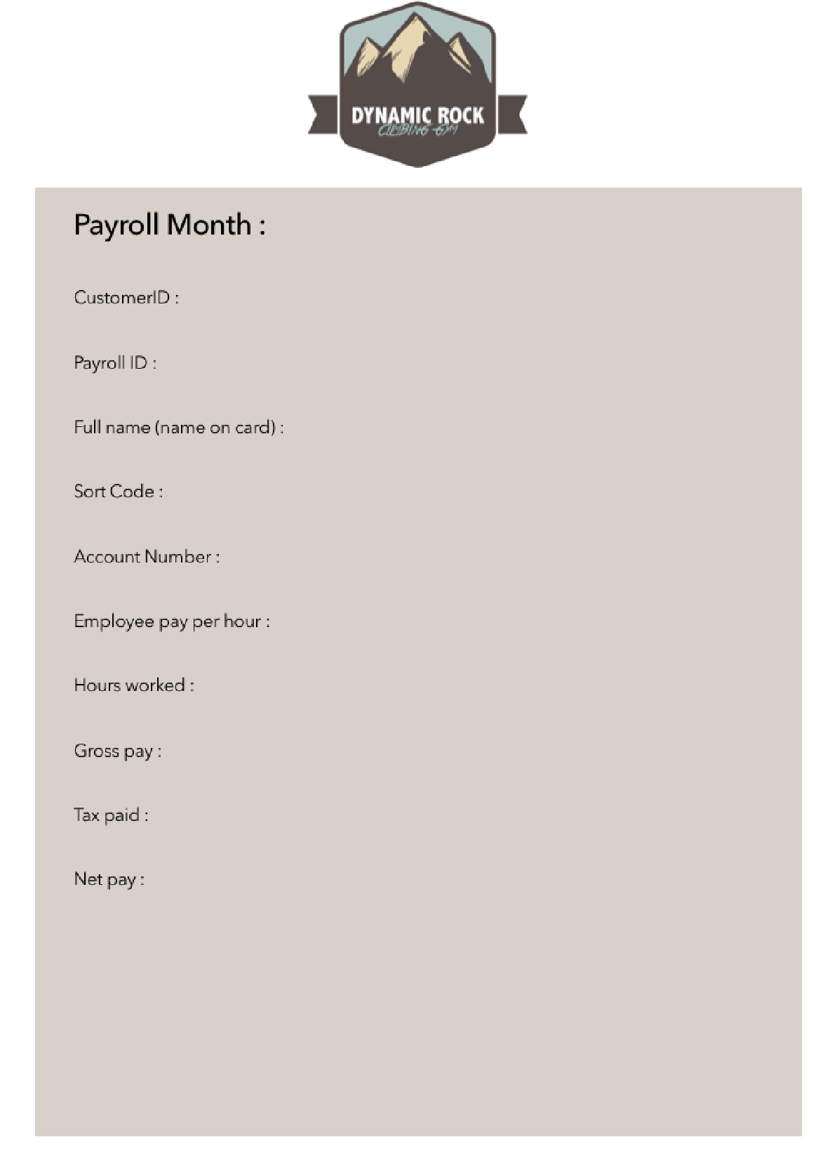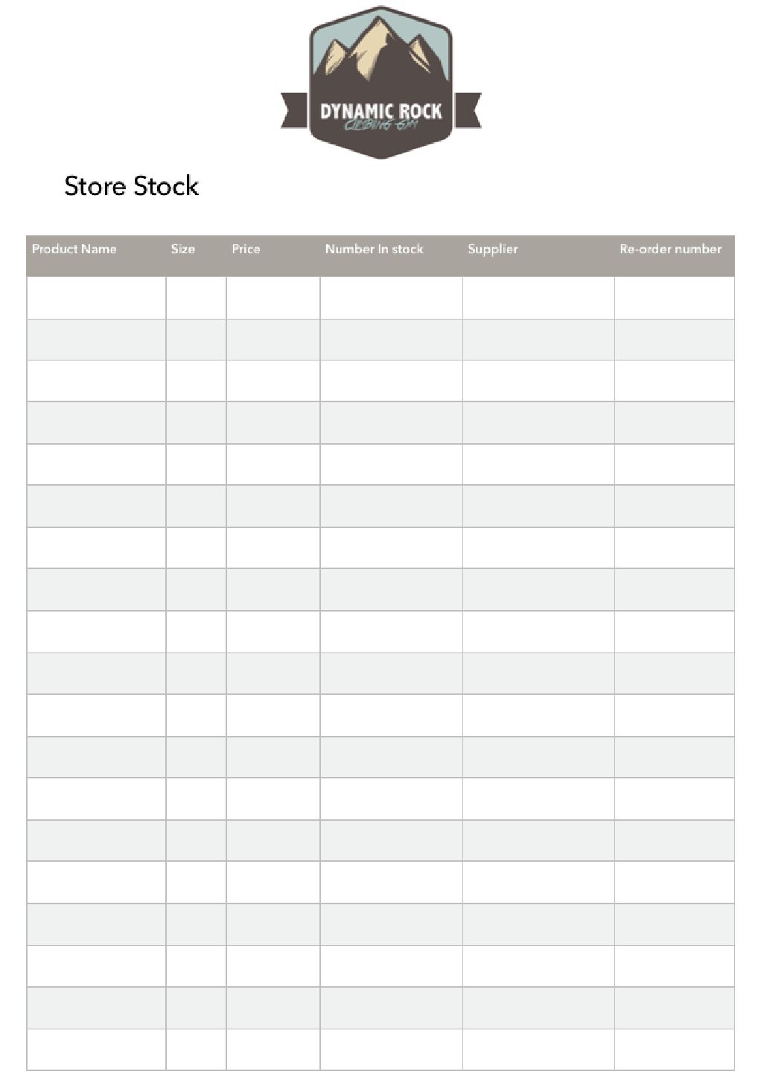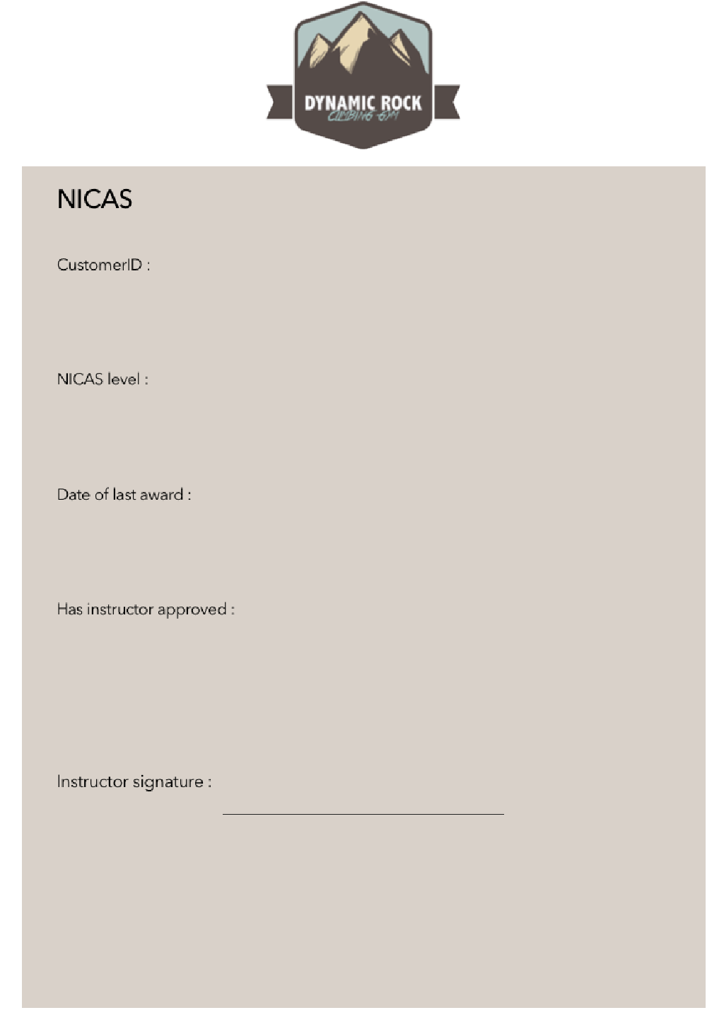

7. Summary and conclusion of Dynamic Rock’s paper based system
Currently Dynamic Rock use a paper based system as seen in the pictures above. This system is used to record all information within the business. This means data is printed out and written on by hand. It is then manually stored in filing cabinets in the rock climbing centre. The cabinets are locked during the night but are left open during hours so that they don't have to be opened via lock combination each time the data is needed. The system can run well as long as all resources such as the print outs are stocked up on. Even with this, processes take some time to complete. In the current system there are 6 sections to the system. These are Payroll, Customer Details, Staff Details, Stock check, NICAS and bookings.

Customer Details
Following the observation and analysis of how customer details are stored in Dynamics Rock’s system I believe that there are 3 actions that these details are used and processed for.
Adding a Customer
Like all other documents in the system, customer details are stored in a filing cabinet. On a customers first arrival at dynamic rock they are asked to fill in a customer details form. They fill in this form themselves, a staff member then adds a unique customer id number to the form. It is then stored by a member of staff into the filing cabinet. Only staff are meant to access these cabinets. The information that is stored on this document is
- Customer ID
- Customer name
- Date of birth
- Address
- Phone
- Email
- Parent phone
- Signature
Viewing a customers information
If a customers details are requested to be viewed then a member of staff must manually search through the filing cabinet in order to find the customers record. Once the record has been found it can be viewed. This can be a lengthy process.
Editing a customers information
Similarly to viewing a customers details, the record is manually found by a member of staff. Instead of viewing it the customer will scribble out the data they want to change and write the updated information next to it. This can be confusing when viewing.

Staff Details
Following the observation and analysis of how staff details are stored in Dynamics Rock’s system I believe that there are 3 actions that these details are used and processed for.
Adding a Staff member
Like all other documents in the system, staff details are stored in a filing cabinet. When a new staff member is hired at dynamic rock they are asked to fill in the staff details form. They fill in this form themselves under supervision from a manager, a manager then adds a unique staff id number to the form as well as their payroll number. It is then stored by a manager into the filing cabinet. Only staff are meant to access these cabinets. The information that is stored on this document is
- Staff ID
- Name
- Date of birth
- Address
- Phone
- Email
- Payroll ID
- National Insurance number
- Signature
Viewing a staff members information
If staff details are requested to be viewed then a member of staff must manually search through the filing cabinet in order to find the staffs record. Once the record has been found it can be viewed. This can be a lengthy process.
Editing a staff members information
Similarly to viewing a staffs details, the record is manually found by a member of staff. Instead of viewing it the staff member will scribble out the data they want to change and write the updated information next to it. This can be confusing when viewing.

Store Stock
Following the observation and analysis of how store stock is stored and recorded in Dynamic Rock’s system I believe that there are 2 actions that these details are used and processed for.
Adding new products
All of the stores stock are recorded on a paper form. It is also stored in a filing cabinet at reception. Only staff members are allowed access to these filing cabinets. A staff member will add new products when a new product is ordered and comes in that hasn't been sold at Dynamic Rock before. The data that is recorded onto this sheet is :
- Product name
- Size
- Price
- Number in stock
- Supplier
- Re-order level

Editing the existing products on store stock
When a product is bought or a existing product is re-ordered and stocked up then the number in stock is either increased or decreased. To do this a member of staff will cross out the number in stock and add the new stock number next to it. This can be confusing for the staff and look messy.

Payroll
Following the observation and analysis of how payroll is stored and recorded in Dynamic Rock’s system I believe that there are 21actions that these details are used and processed for.
Adding payroll
One of the managers of Dynamic Rock, Steve Jones, is in charge of organising the payroll. He has to do this for each member of staff every month. It has to be written out by hand and the calculations are done through a calculator or just worked out in his head. I have also recently been informed that he uses carbon paper to make 2 copies of each payroll slip. One is stored in a filing cabinet and the other is given to the employee for reference. The details stored on a payroll record are the following.
- Payroll month/date
- Customer ID
- Payroll ID
- Full name (name on card)
- Sort Code
- Account Number
- Employees pay per hour
- Hours worked
- Gross pay
- Net pay
- Amount of tax paid

Bookings
Following the observation and analysis of how bookings are made in Dynamics Rock’s system I believe that there are 2 actions that these details are used and processed for.
Adding a booking
The process of adding a booking at Dynamic Rock begins with a customer coming into the centre or phoning in. A member of staff then goes to the filing cabinet and gets the most recent booking sheet. He will then ask the customer for information about their booking such as date and time. The staff member will then confirm the booking and file the booking sheet away. The details recorded on the booking sheet are the following.
- Booking time
- Duration
- Instructor
- Number of people
- Price

NICAS
Following the observation and analysis of how NICAS works at Dynamics Rock I believe that there is 1 action that these details are used and processed for.
Adding a NICAS level
NICAS is a climbing qualification that dynamic Rock provides at their centre. The qualification comes in levels (eg. level 1, 2, 3, 4…). To record what level customers are they fill in a NICAS form for them if they would like the qualification. An instructor will watch a customer climb and decide whether they feel their qualification level should increase. When a level is increased or a customer wants to start it they go to reception. At reception a member of staff will give them the NICAS form to fill in. The form requires the customer ID so often the staff member will have to retrieve the customer details form to view this. This can be a lengthy process. The climber then fills out the form and the instructor is to sign to approve that they have completed this level. The record is then stored in the NICAS filing cabinet. The NICAS form contains the following data.
- Customer ID
- NICAS level
- Date of last award
- Instructor approval
- Instructor Signature

8. Limitations and Problems with the current paper based system
After summarising and concluding my understanding of how the system runs and works i have encountered and undercover some problems with the current paper based system that Dynamic Rock are using.
The first and one of the main problems i have encountered with their system is the speed in which tasks are carried out. I have noticed especially during my observation that most tasks with this system take a long time to complete. I believe one of the main causes of this is speed of searching. I have noticed when a staff member has to search for a record. For example, when viewing a members details a staff member has to search through a whole filing cabinet of forms. This takes a long time to do. I feel this problem could be fixed in the computerised system by having searches. I will be able to add a search box for a user to search for a customers name and all of their details will appear instantly. Another reason i believe causes the slow speed is human errors such as forgetting to print out records to complete. I noticed this majorly during my observation as Owen was unable to find a record for a new customer. He then had to go and print some more out. This took at least 10 minutes and you could see the customer was getting fed up. This would not be a problem with the computerised system as records to not need to be printed out and written by hand. On the computer there will be a pretty much unlimited amount of forms to be able to fill in instantly.
The second problem that i have discovered is the massive problem of human error while making the calculations needed both in the payroll and the booking system. The smaller problem is that a human error could easily be made when working out the price for multiple customers while booking. This could lead to over or undercharging customers. This could either loose the business money or risk loosing customers and therefore trade. The bigger problem is when working out the calculations in payroll. The manager has to do multiple calculations for each and every employee for Dynamic Rock. Due to the large amount of work it is very probable for a human error. This could lead to a staff member getting over or under paid. This would lead to either a unhappy employee or the company loosing or accidentally spending more money than they need too. In the computerised system calculations would be automatically calculated by the computer. This increases the accuracy and efficiency which leads to virtually zero human error problems.
Another problem that i uncovered during this investigation was how messy and time consuming updating records can be. For example when examining what a used stock control sheet looked like i can see how messy the number in stock column is. This is because they just cross out the old number when they want to update stock. I feel like this could confusing staff members and possibly be the reason for the store being unable to open sometimes. A staff member could be confused by the clutter and see the wrong number and not realise that more stock needs to be ordered. This could be fixed by the computerised system as staff will be able to just overwrite the number of stock on a product so its just the updated amount This will remove any mess and confusion. Another potential problem i see with the system is staff forgetting to order more stock when the number in stock gets lower than the re-order level. I could fit this within the computerised system by adding a warning or notification for the staff member when the stock level gets lower than re order level. Therefore the staff member will be alerted to order more stock without having to check.
Another problem i have uncovered with the manual system is that the filing cabinets where all customers data is kept is only locked during the nights. This means that during work hours, if the reception is unmanned then anybody could access these records of customers and payroll information. This could cause serious problems for customers and even lead to legal problems as it would be a breach of the Data protection Act by Dynamic Rock. I cam going to fix this with the computerised system by having passwords to protect the data. Before you use the system you will have to log in and only admin/staff will be able to view all customers data and only admin accounts will be able to view payroll information.
Due to the system being all paper based this means that most of the system is also handwritten. I have noticed that this can cause a lot of problems within the business. For example bad handwriting by a customer may be unable to be read by a member of staff if needed to be viewed. This would be a irrelevant problem with a computerised system as all type is the same. Another problem with handwritten documents is that they are loose and can often be lost. This leads to the problem about backing up data. It would be incredibly hard for dynamic rock to perform backups of their paper based system. They would have to scan the documents and print copies of every one. This would be a waste of time and use a lot of resources that cost the business a lot of money. With the computerised system once a day the data saved in files on the system hard drive could be easily and quickly copied to an external hard drive and stored in a off site location away from any potential hazards in the building.

9. Aims for the computerised system
The aim I believe to be the most important that I have for this system is to improve the experience of Dynamic Rock for both the customer as well as the employee. The system should be accurate in order to produce the correct results and lead to no upsets on either side, company or employee.
Another main aim is for the data that Dynamic Rock record and save with this new system is secure so that nobody without unauthorised access can view the data. I will Do this with the use of passwords.
Speaking of password I also aim for customers to be able to create their own accounts without the need of a staff member. However the admin accounts will be the only people able to create new staff accounts. This is secure and also makes all employees data secure.
I aim for the system to be visually attractive to use so that it appeals to the user. I feel that this will add to the experience and ensure that the company looks professional. This will also allow the aim for the system to be user friendly to be possible. I am aiming to ensure that the system is user friendly so it can be used by anyone, even if they have not used a computer much in the past.
The system should also make information to be displayed clear with no clutter so that there is no confusion which often leads to mistakes.
Another aim of mine is to ensure that all employees are paid correctly and know what they are being paid and when they are being paid. This will add a schedule to their pay and financial tracking. I also aim for this to be accurate using automated calculations.
The store stock system should also require very little input from any staff making this job much easier. All the staff should have to do is remove stock when purchased.
I also aim for the booking experience to be quick and simple on both ends. Service should be fast so that customers have a booking within a short time.
I aim for the system to be able to be easily backed up by Dynamic Rick. I aim to do this because if Dynamic Rocks data was to be destroyed then this would cause a lot of problems for both customers and employees.
To help the staff my final aim is that customers will be able to book a session themselves using their accounts so that no staff interaction is needed. Therefore staff can carry on with other important tasks. Customers should also be able to reset their passwords themselves so they don't bother staff with this request.

10. Objectives for the computerised system
Since i have analysed the problems with the current paper based system i am now clear with what objectives i have when producing the computerised system for Dynamic Rock. My objections that i wish to include are as follows.
- Automatically complete calculations without having to click
- Allow customers to change password via security questions
- Add new customers
- Edit customer details
- Search for a customer
- Only admins can add staff
- Customers can book from their account
- Staff can also book for customers
- Monthly reports for payslips for employees
- Easily back up system
- Add and remove products for the store
- Get alerts when stock needs to be bought
- Edit re-order levels
- Add company logo for professional look
- System looks professional
- Only staff can change a customers NICAS level
- User friendly
- Clearly displayed information
- Cancel booking if needed

11. Limitations of the computerised system
I will be unable to automatically remove stock when bought in the store. I am unable to do this as Dynamic Rock currently do not have the equipment such as scanners to scan barcodes. However, this would be easy to expand to the system if Dynamic Rock decide this is something they want to do in the future.
I will be unable to hook the system up to an EPOS system to complete card transactions at Dynamic Rock as the resources are not available currently to do so. However, yet again this could easily be added to the system in the future

