Dynamic Rock Climbing Gym
I have been contacted by Dynamic Rock about the problems they are receiving with their current paper based system and enquiring into me producing a computerized system for them.
Dynamic Rock is a climbing gym based in Swansea, Clydach. They have many large climbing walls as well as a bouldering gym that have many different grades of routes from beginner to professional standards. Dynamic Rock also provide the NICAS (National Indoor Climbing Award Schemes) qualification system. This is a system to accredit individual achievement of the skill level of a climber. Dynamic Rock also have an on-site shop where they sell many of the top climbing brands and equipment. The on-site shop is having problems with stock control due to having to be notified when stock is low and forgetting to order this stock. This results in the shop having to be closed due to have no stock. This results in dynamic rock loosing profit by losing many sales. By having a computerised system then notifications will be received when a products stock gets low and the stock will then be able to be reordered through the computerised system. This results in stock always being available and therefore increases sales and profits within the business.
One of the main problems with their current paper system is the physical room for their customer records. The number of members that they now have at the gym is increasing rapidly and have found themselves running out of room to keep and store the paper records of these members. This would be fixed by a computerised system as hard drive can store millions of records in a physicals small and compact device.
- When creating this system, I am going to have a log in screen where members can register and log in. This will allow them to edit their details and view and record their NICAS progress. From this menu they will also be able to book a session to climb.
- Staff will have a separate log in menu which they will be able to search for customers, view booked sessions and authorise the members level of NICAS. Staff will also be able to control the shop stock to view and edit products as well as place orders for customers.
- There will also be a admin account that will be able to register new staff and organise their payroll.

A limitation having a computerised system is that Dynamic Rock are going to have to buy computer equipment to run the system which could be expensive. Another problem is that the computer systems could get a virus. This could possibly allow unauthorised people access to customer details which is a breach of the Data Protection act which could land Dynamic Rock in legal issues. With computer systems, whatever is input into the system is as good as what is given out. For example, if a user enters wrong details time then the output is going to be wrong or inaccurate too. Also the user ability is a limitation as if they do not know how to use the system then they will not be able to use it properly.

Another limitation is that it can only be used in store and not online. This means that you would have to go in to Dynamic Rock to check their progress.
To get feedback for my system plan I e-mailed Steve, the manager at Dynamic rock my plan. Below is a screen capture of the e-mail I sent to steve.

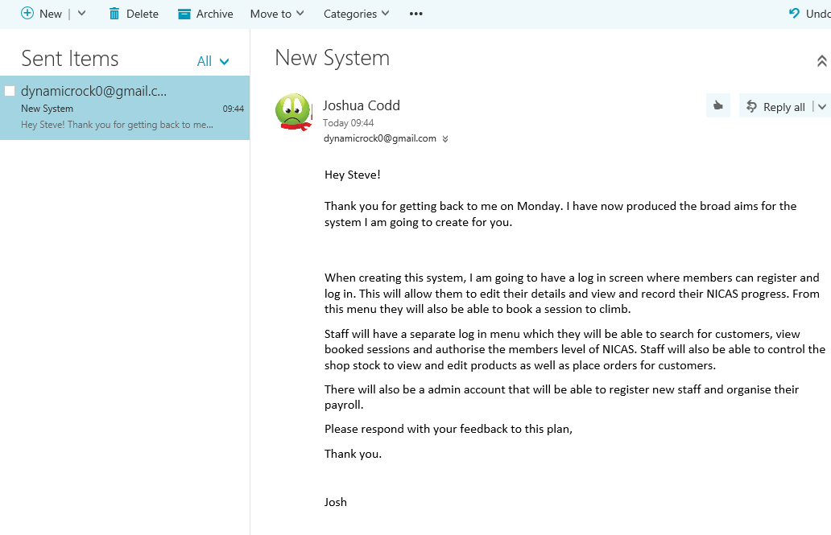

I then received an e-mail back from Steve with feedback on my system plan. As seen below, Steve suggested that I add a feature to the member menu but other than that he is happy with the system.

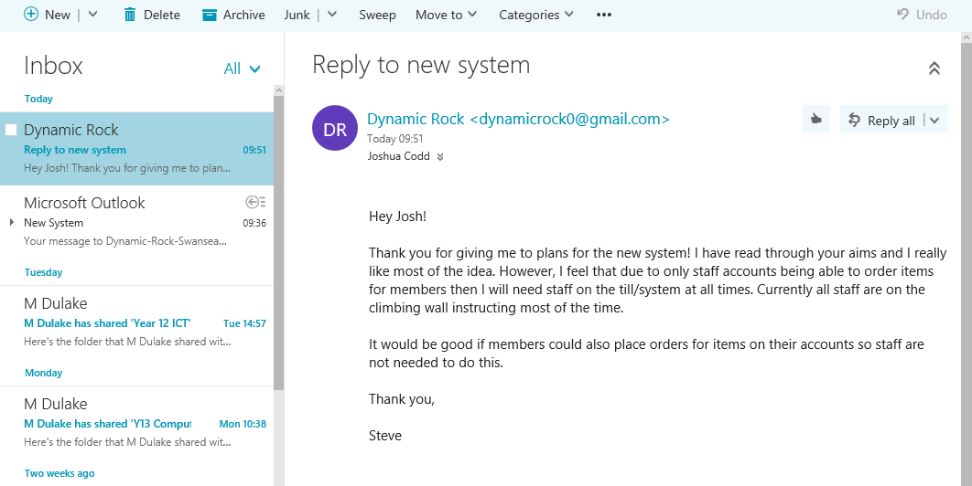
I have listened to Steve’s feedback and have now changed my aims for the system. The updated aims are the following:
- When creating this system, I am going to have a log in screen where members can register and log in. This will allow them to edit their details and view and record their NICAS progress. From this menu they will also be able to book a session to climb.

- Staff will have a separate log in menu which they will be able to search for customers, view booked sessions and authorise the members level of NICAS. Staff will also be able to control the shop stock to view and edit products as well as place orders for customers.

- There will also be a admin account that will be able to register new staff and organise their payroll.

