Developmental Testing
Viewing Staff details as admin
When testing to see if the viewing staff details was working I was getting the following error when opening the manage staff form.
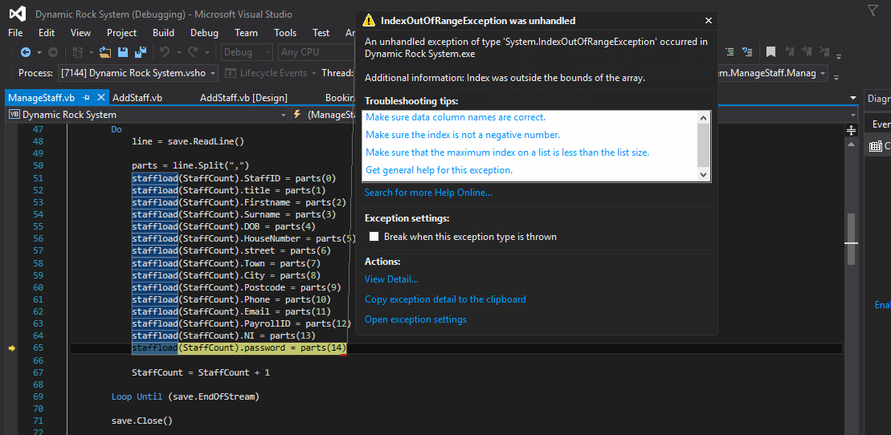
I scanned through all of my staff code to find a solution for this. I have now fixed it, The problem was that there was not enough data in the file to be opened and spit up into the array, therefore showing the error. The reason there was not enough data is because I missed/forgot to add the city variable when saving staff details. I have added this and now is correctly working as seen below.
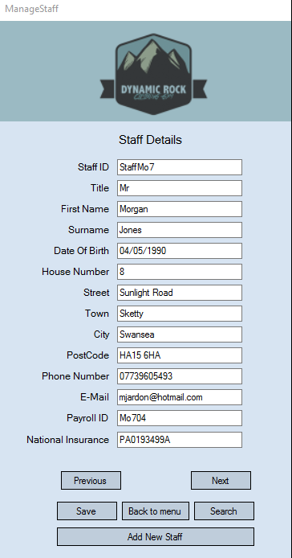
Bookings for customer
When testing to see if I could view bookings by searching by customer ID I discovered a problem. The problem is shown below as only parts of the booking is being shown. The missing information is duration instructor, people and price.
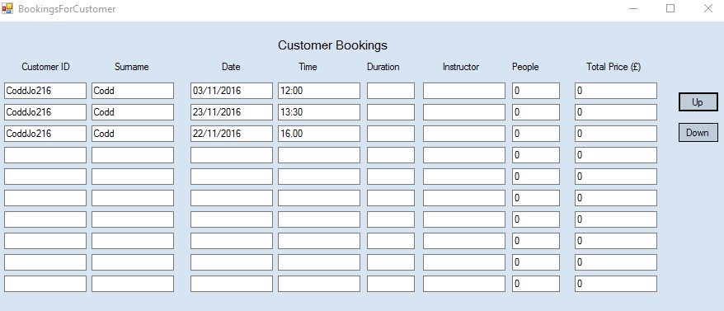

I have now fixed this problem. I fixed it when noticing an error in the code. The error can be seen below as I had missed out duration and price etc when loading in the information.
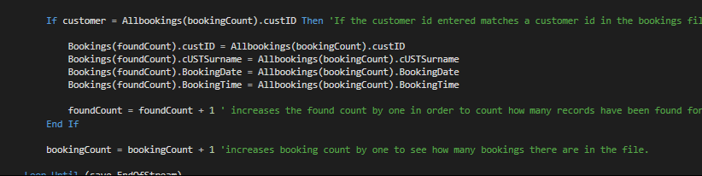

Here is the fixed version.
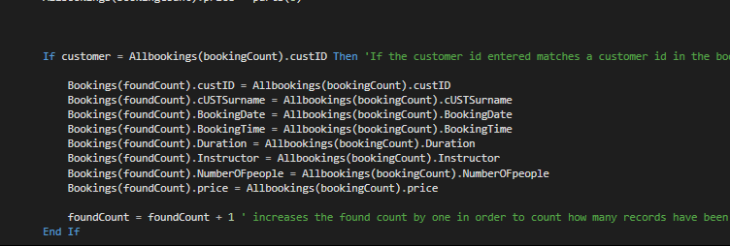
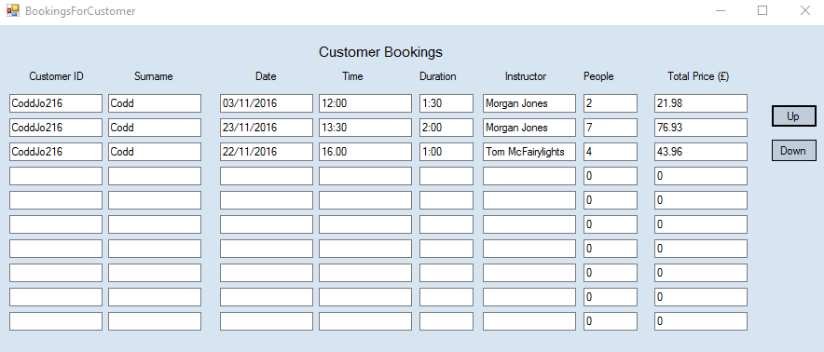

Booking a session
When testing booking a session everything seemed to be working until I realised that the instructor combo box had no information in it. The combo box can be seen below.
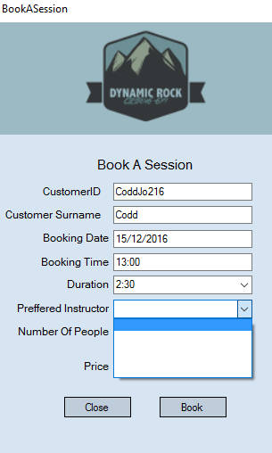
This took me a while to fix as when I scanned the code I had put in the code to load information into the combo box as seen below.
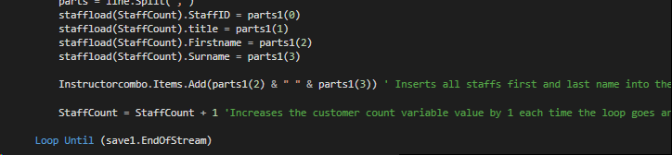
I then realised it was because I forgot to add a 1 to the parts and line variables and therefore wasn’t using the staff details.
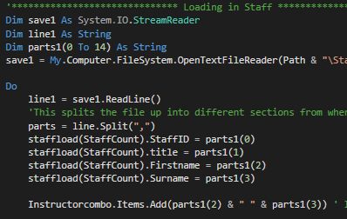

Below are the fixed versions of this problem.
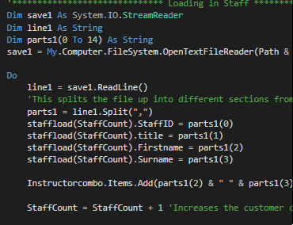
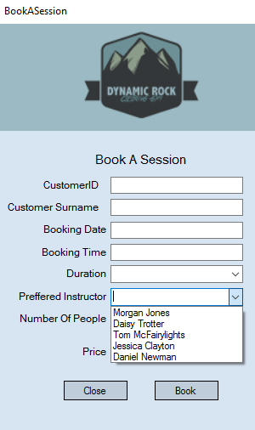

Testing Payroll
When testing payroll everything worked until I entered the numbers of hours worked. I then got the following error message.
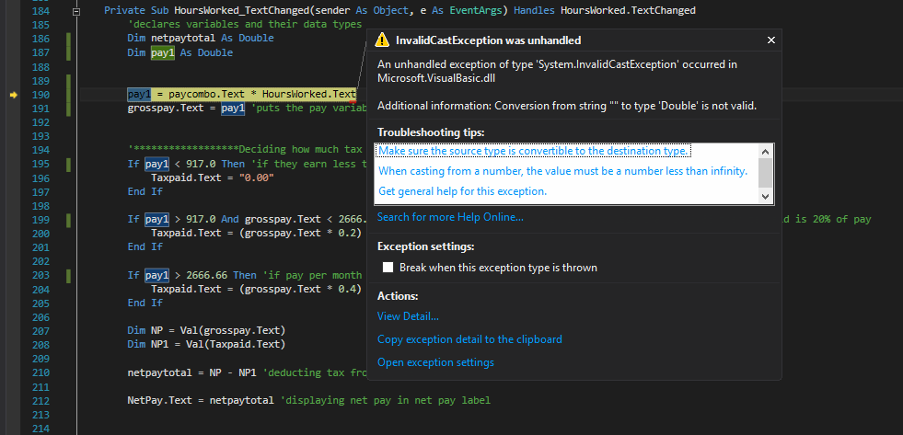
To find a solution to this I decided to add code that used the val function. I figured out this would remove this error as it occurred because string could not be converted to double. Below is the code that I have used to try and fix this error message.
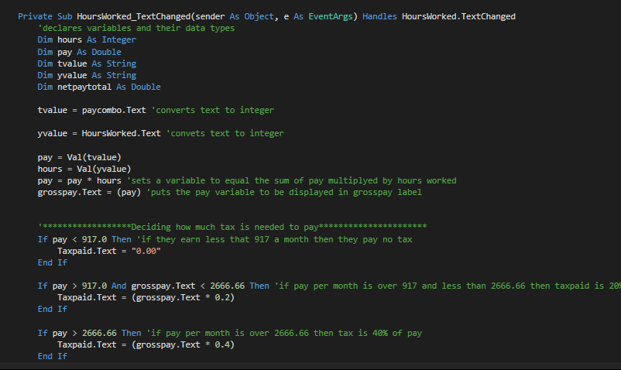
After testing again, I discovered that my new variation does work and correctly displays the correct payroll amounts. An example of it working can be found below.
